1 | 4 | Lekcija 2: Razgovor
Performance-Based Task

| Pre-class assignment preparation
Prepare this assignment for your next class session. The goal of this assignment is to act out a natural conversation between (at least) two people who are getting to know each other. This is something that in a real-life situation can easily happen.
 | 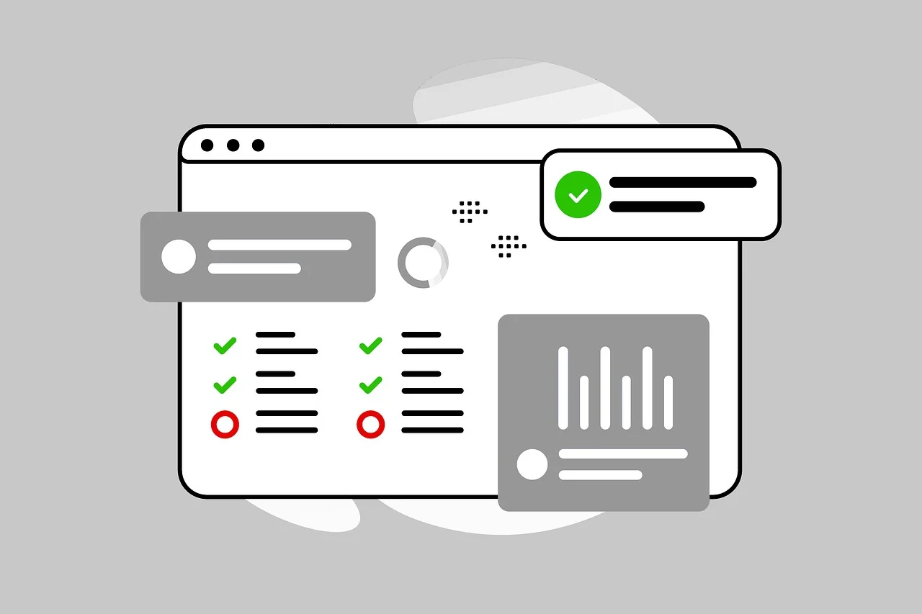

You will have this dialogue with your instructor. Prepare yourself for the dialogue. You will not have an option to read off of a script or your notes. A situation that you can find yourself in can include (you do not know which situation you will need to play):

 | A dialogue between two students who met for the very first time
 | A dialogue between a new student and a professor

The conversation will last approximately for 10-15 minutes. Be prepared, this is a lot of conversation, which at this point you are capable of doing – even if it may seem unrealistic to you. After you are done with your dialogue, I will ask you questions about your classmates/colleague/professor/student. I will play the role of an outsider who wants to know more about your friends. Be creative, explore your limits!

| In-class assignment
Listen to each of your classmates performing their dialogues. Take notes about their cultural performance in the table below. Your homework assignment will be to write a reflection on the cultural components that you noticed in each of your peers’ dialogues. When your classmate writes a response to your own performance, you will need to provide them with a follow-up and comment on their reflection.
 | 

As a person who is evaluating your peers’ performance, reflect on the following components:
1 | Evaluate how successful they were in navigating the conversation in a culturally appropriate way.
1 | -
2 | Did they recognize and-or use expressions that present a figurative meaning?
2 | -
3 | Were they able to recognize, understand, and react to non-verbal cues in dialogues with the instructor?
3 | -
4 | What else could they have done in performing real-life situational discourse?
4 | -

| Post-class assignment
 | 

Submit your notes from the class session on your peers’ performance. As a person who is reading responses from your peers, be sure to include in your comment:
1 | Do you agree with them? If yes/no – why?
2 | What will you do to improve (if needed) your future dialogues?
3 | Any other comments?

Submit this assignment also online.

Images used in this document are from these sources.

