2 | 1 | Lekcija 2: Što posjetiti?

| Gradovi i znamenitosti
Choose the correct word from the drop-down menu.
[h5p id="597"]

| Priroda i okoliš
 | 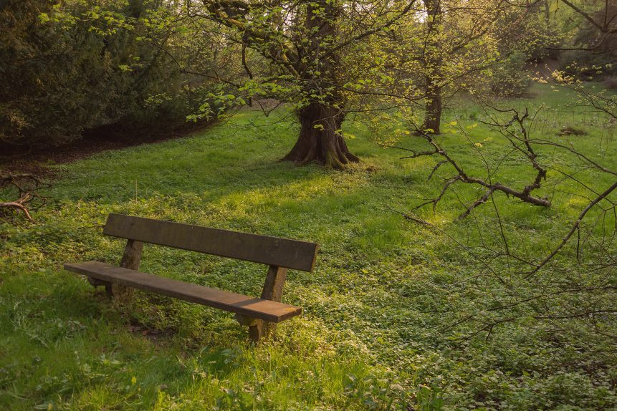 | 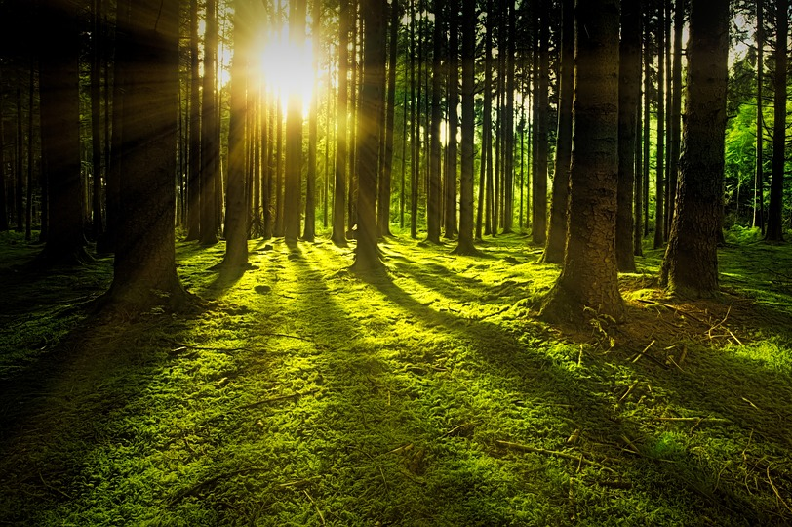
vrt | park | šuma
(audio) | (audio) | (audio)
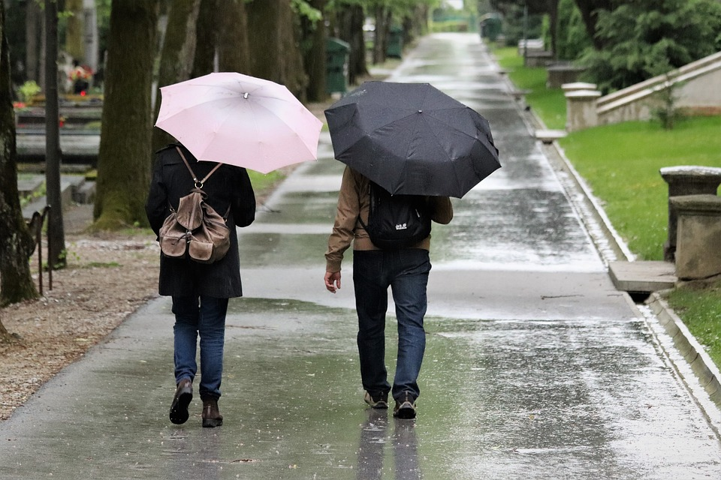 | 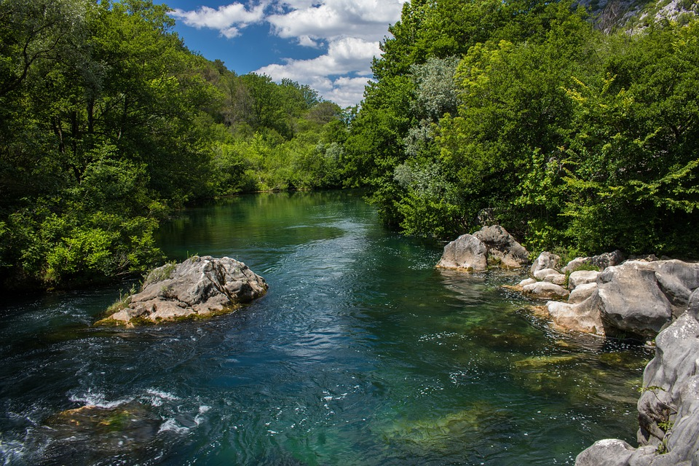 | 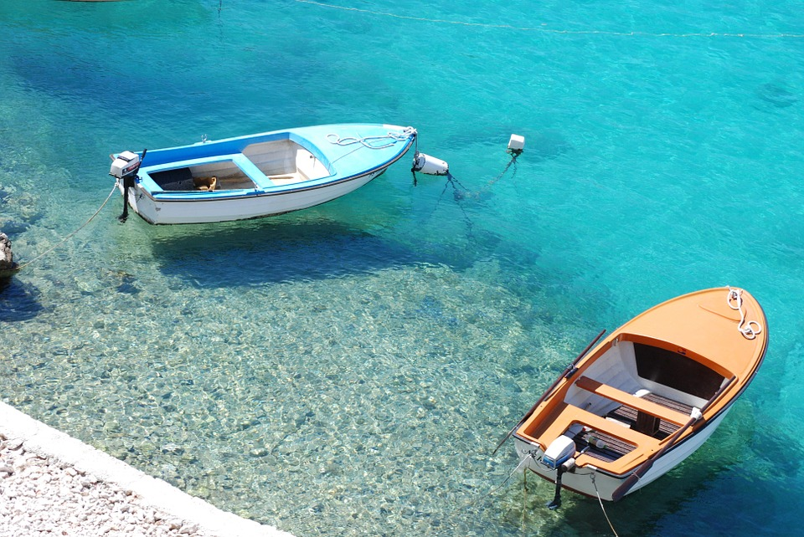
šetalište | rijeka | more
(audio) | (audio) | (audio)
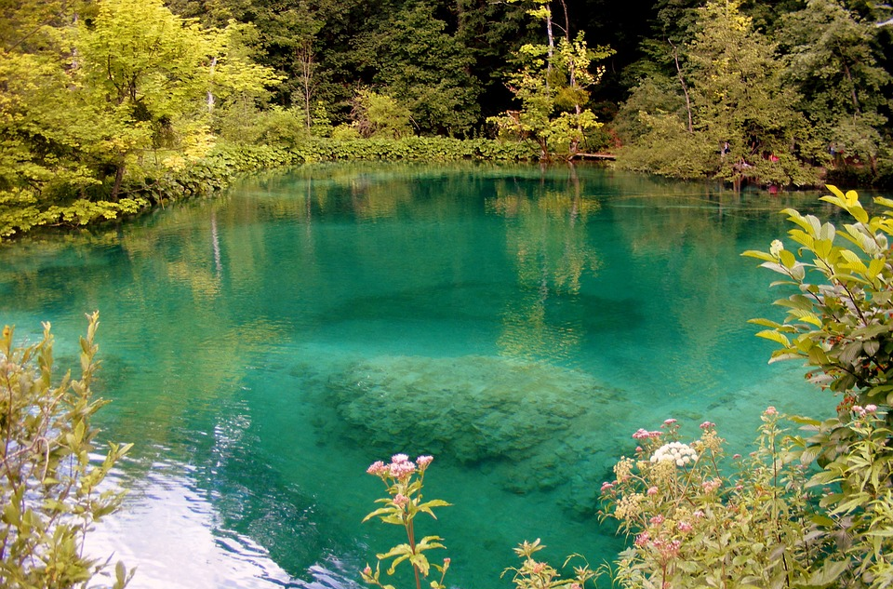 | 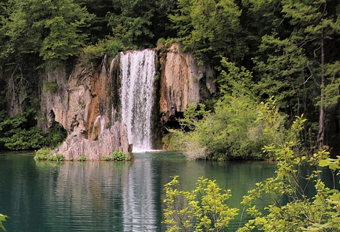 | 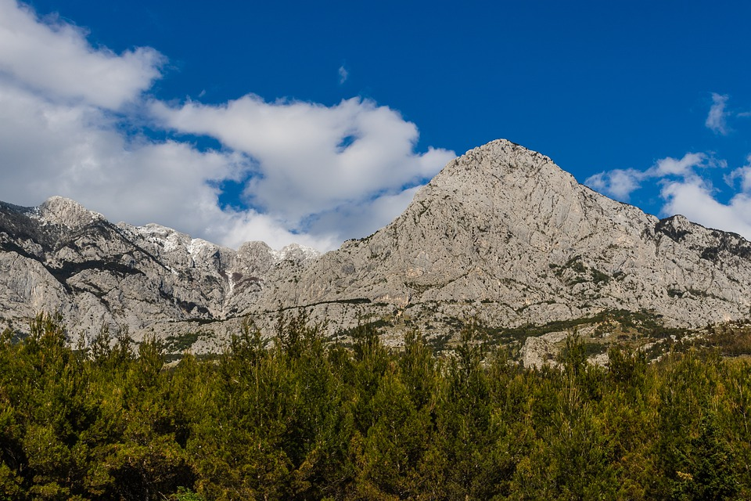
jezero | slap | planina
(audio) | (audio) | (audio)
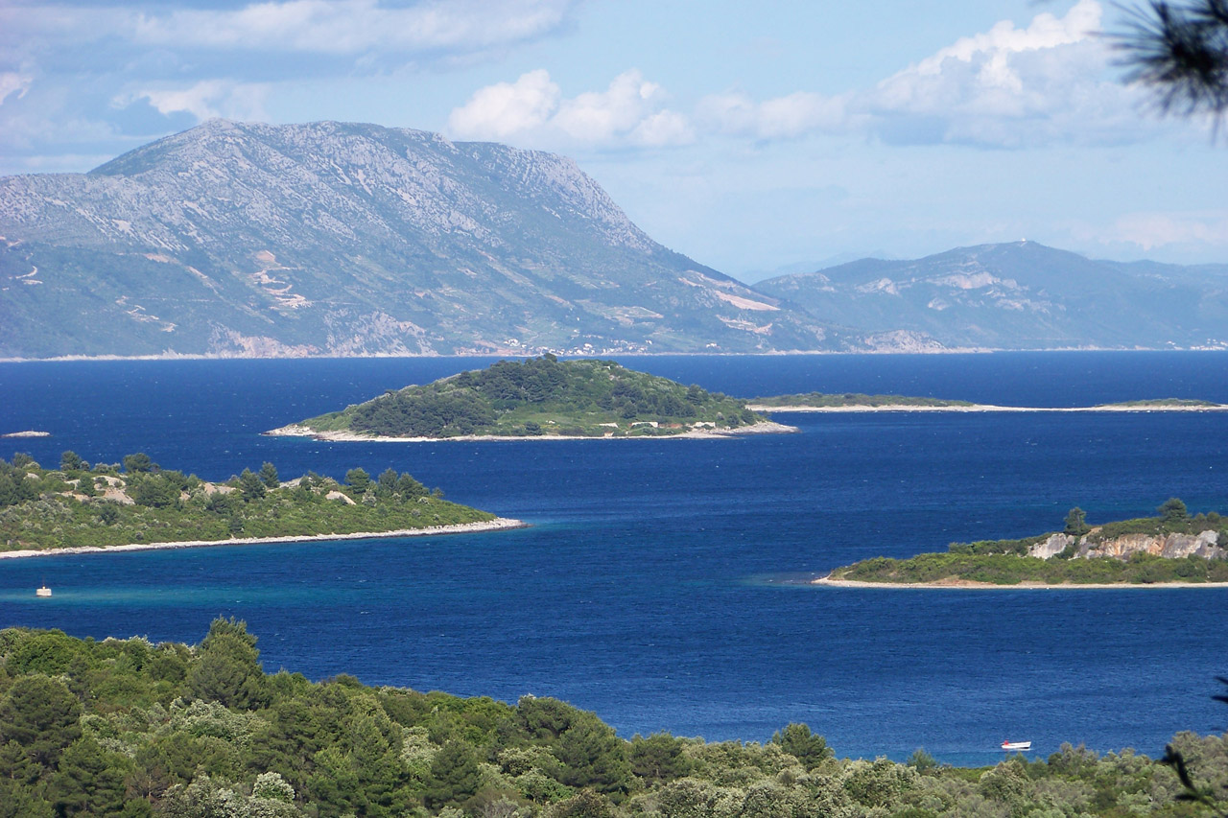 | 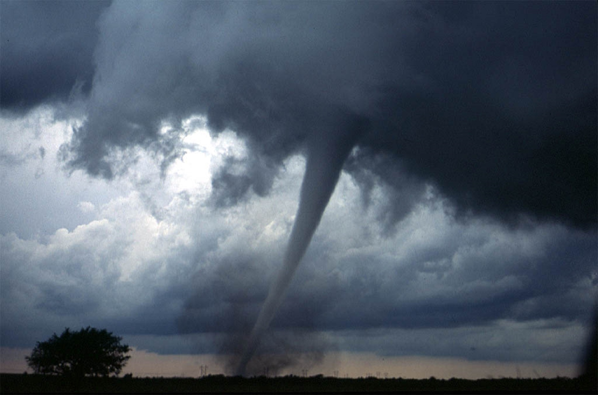 | 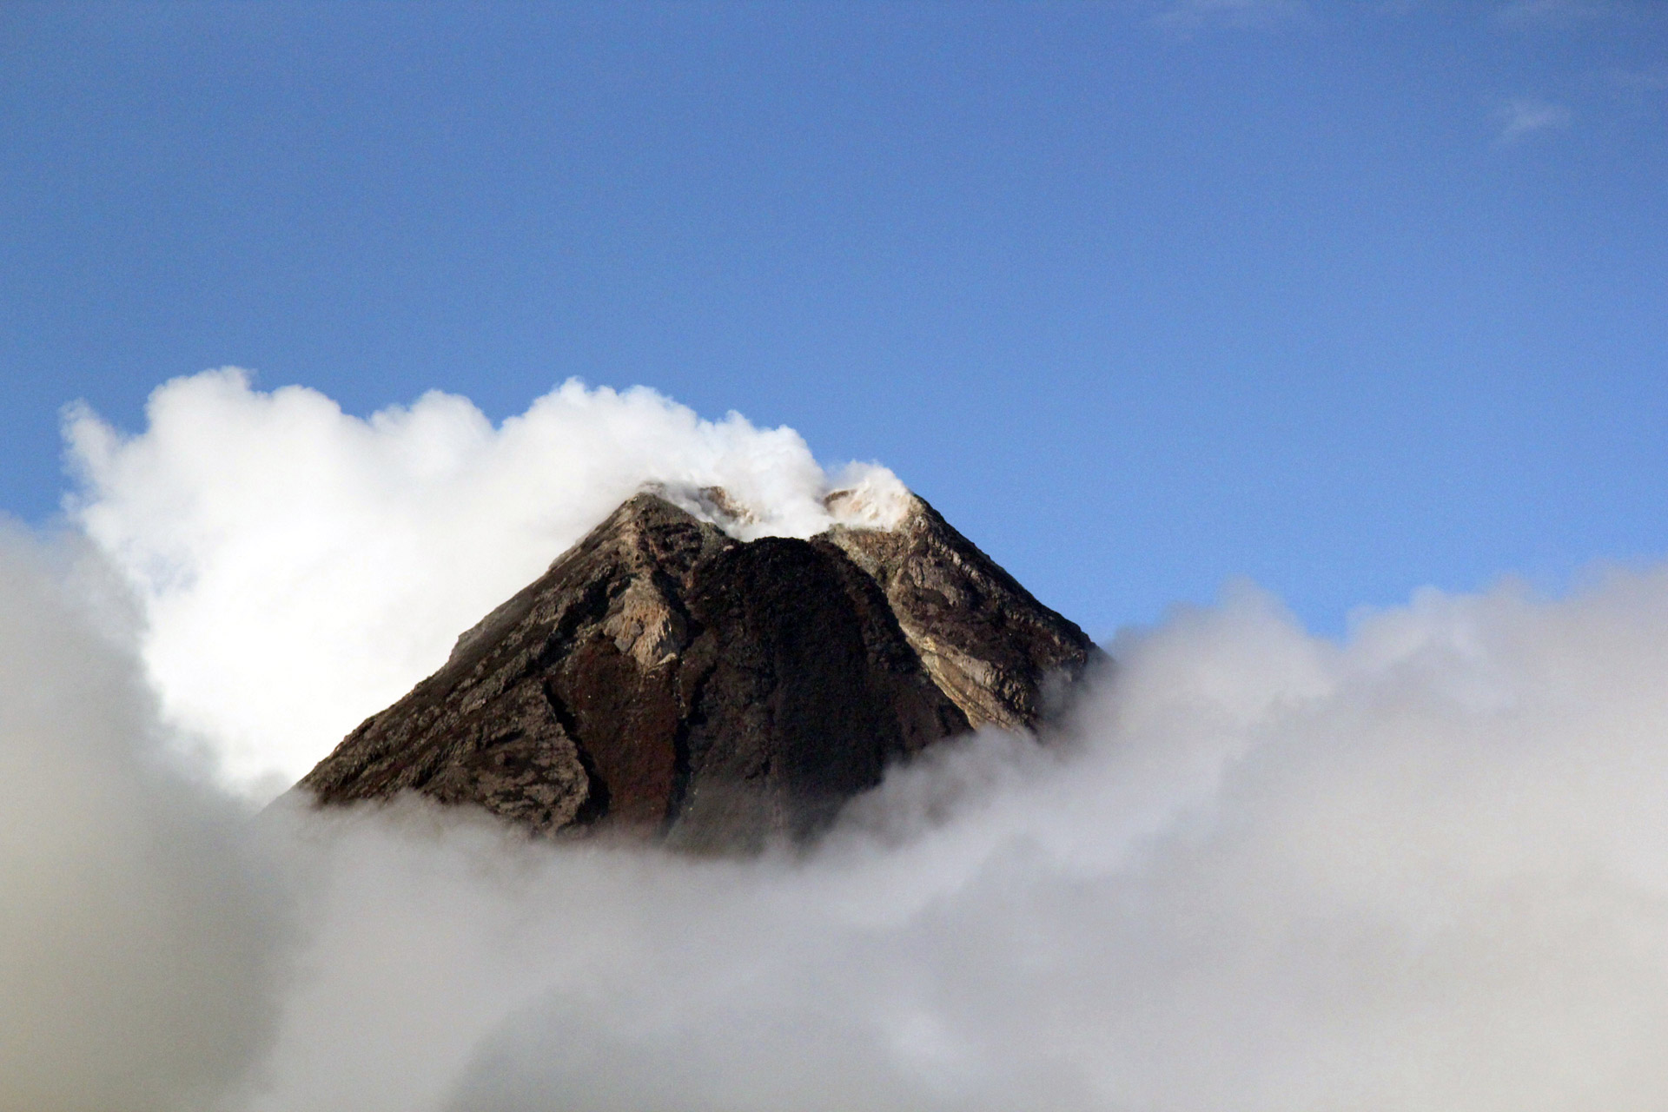
otok | tornado | vulkan
(audio) | (audio) | (audio)
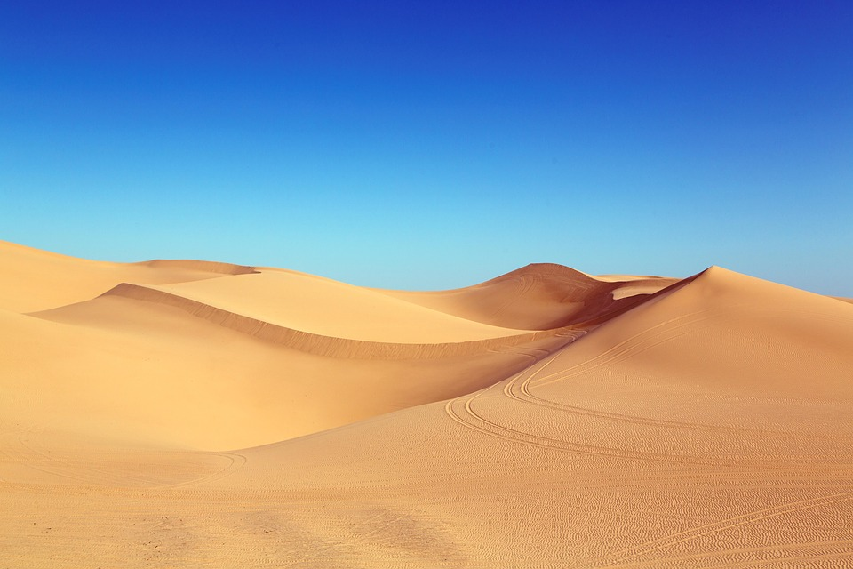 | 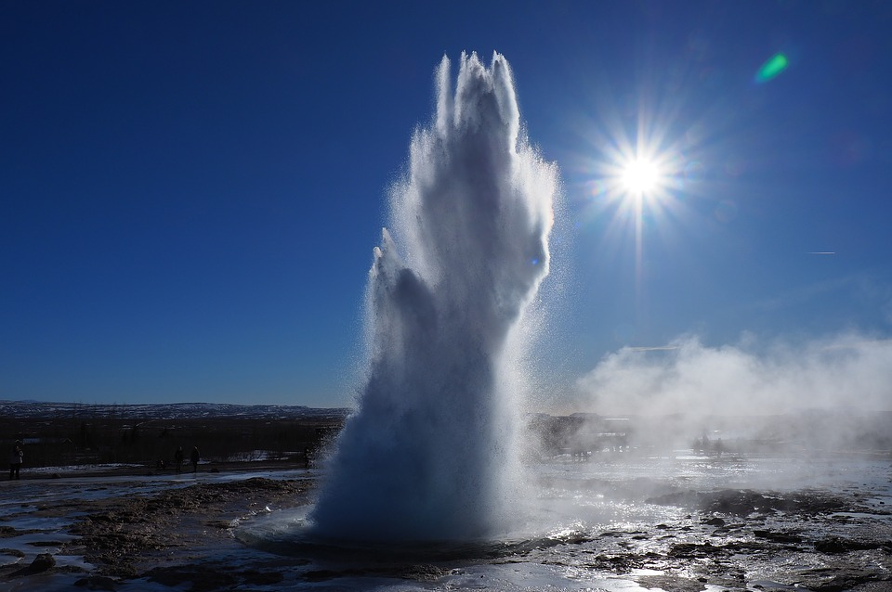 | 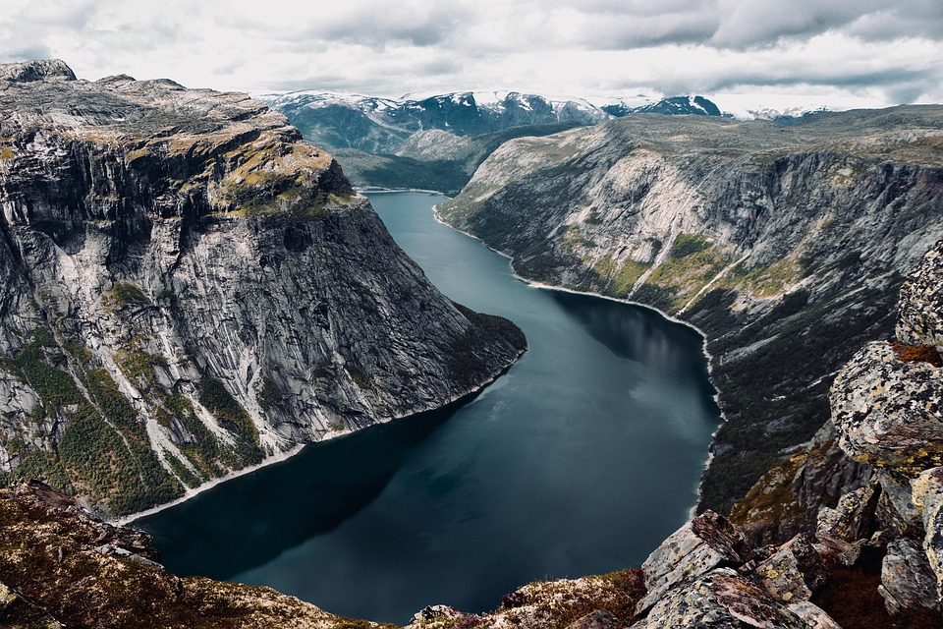
pustinja | gejzir | fjord
(audio) | (audio) | (audio)
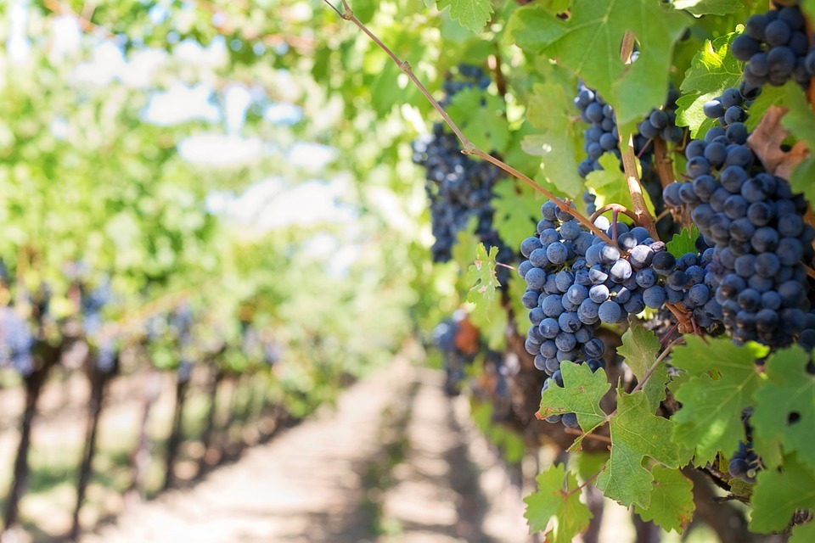
vinograd
(audio)

2.1 Zadatak 12. Kakav je grad?
Look at the following set of images and choose the appropriate English equivalent.
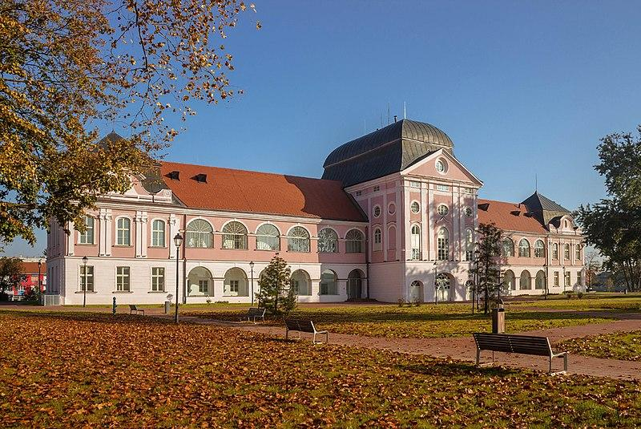  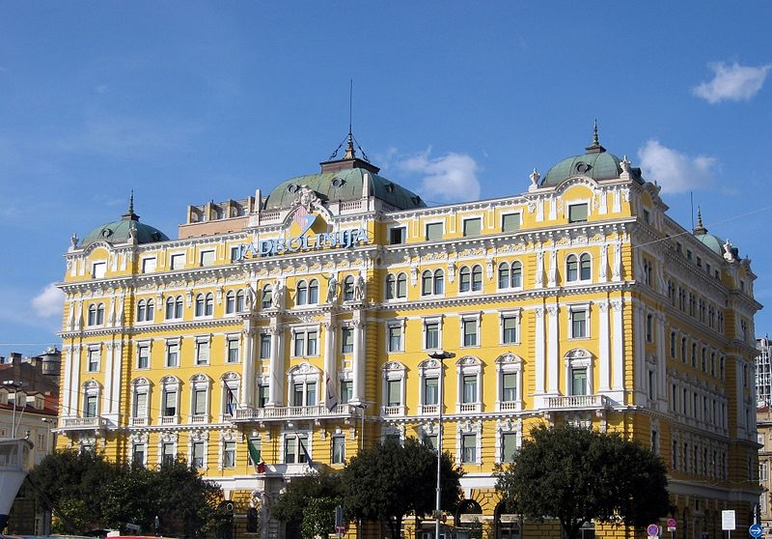 | 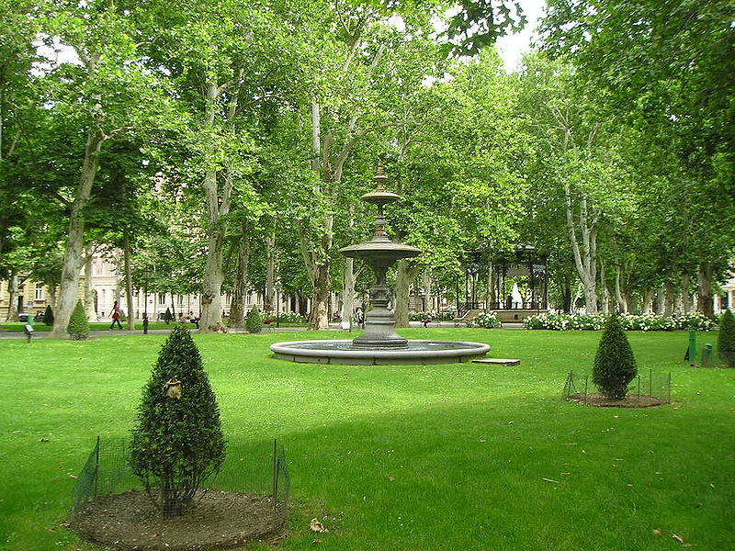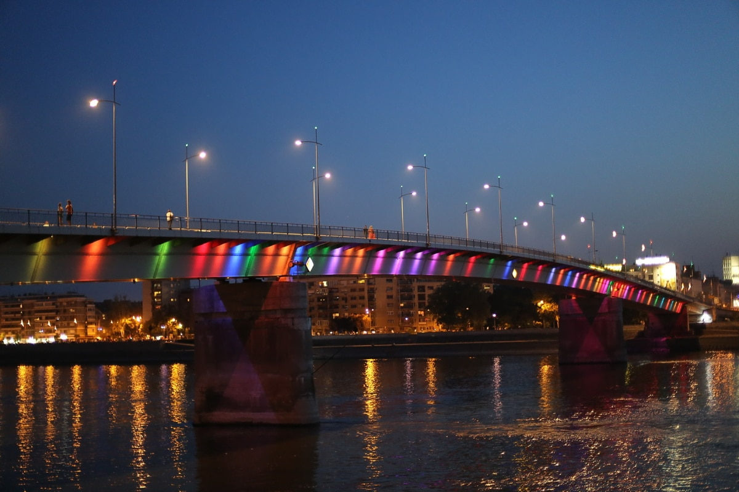
[h5p id="233"]

2.1 Zadatak 13. Kakvi su?
Look at the following set of images and choose the appropriate English equivalent.
 | 
  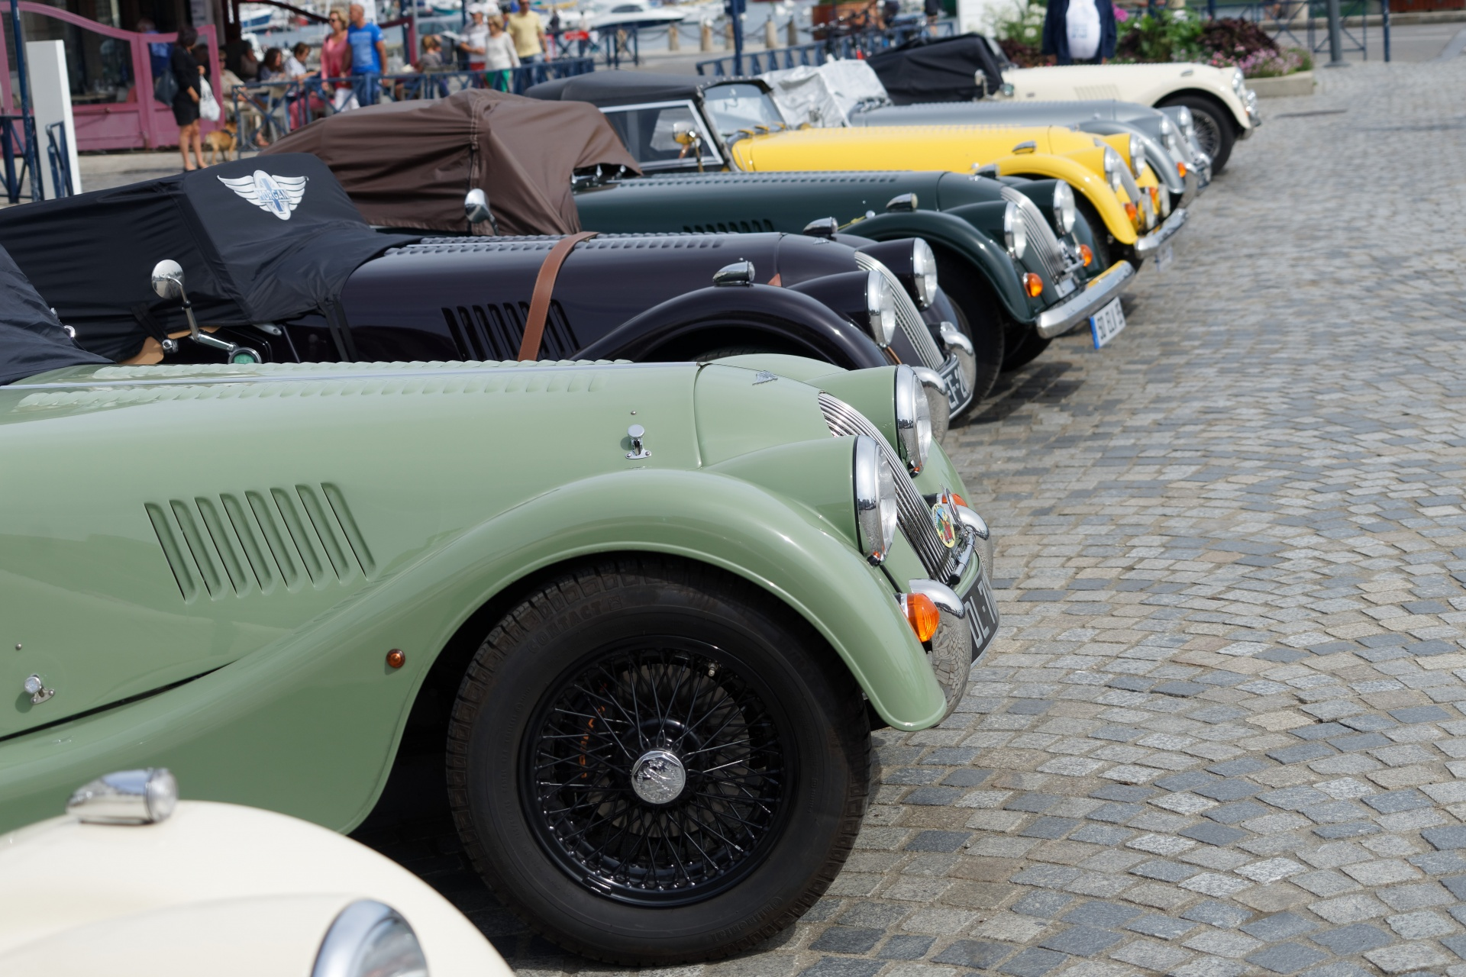 | 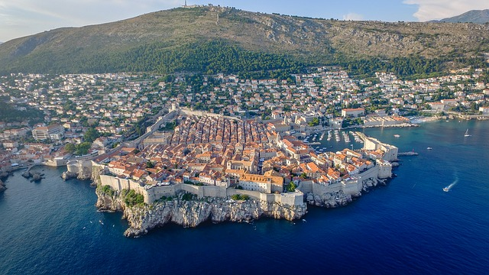
[h5p id="234"]
For the following task use the adjectives listed above on the previous task. According to your opinion, associate only one adjective (in Nominative) with one of the following places. Be careful about what gender you need to use.
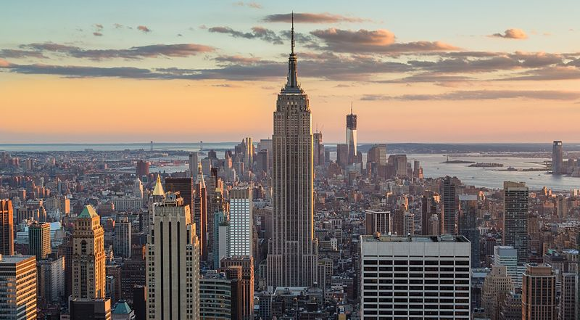 | 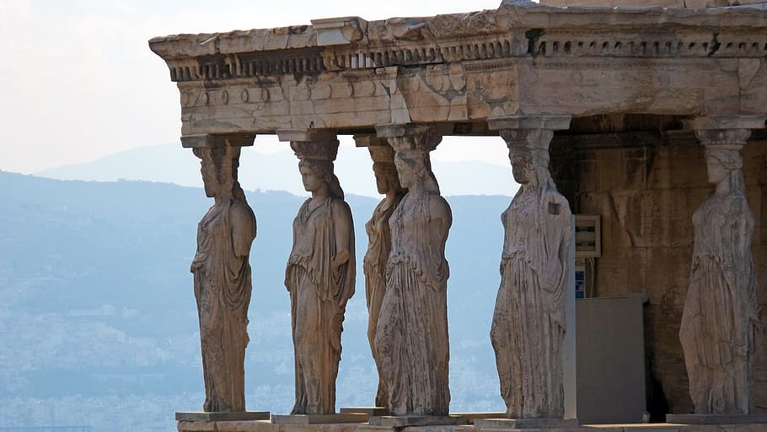 | 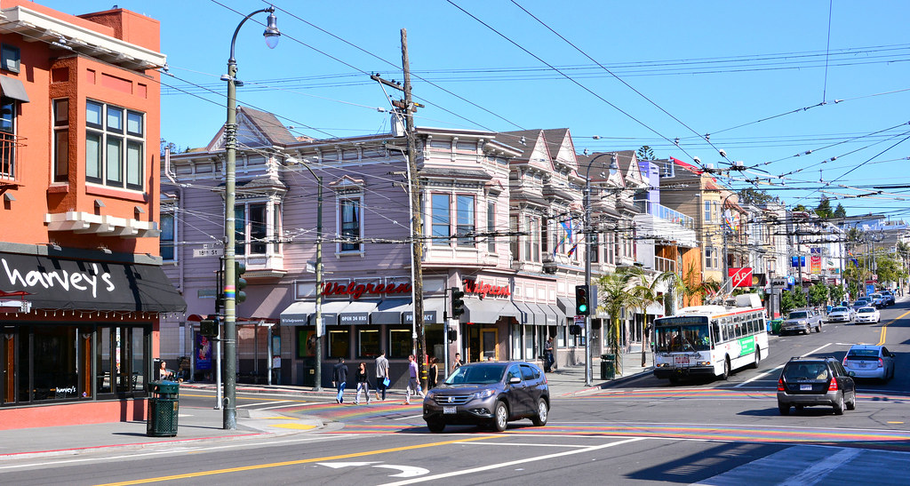
destinacija | povijest | četvrt
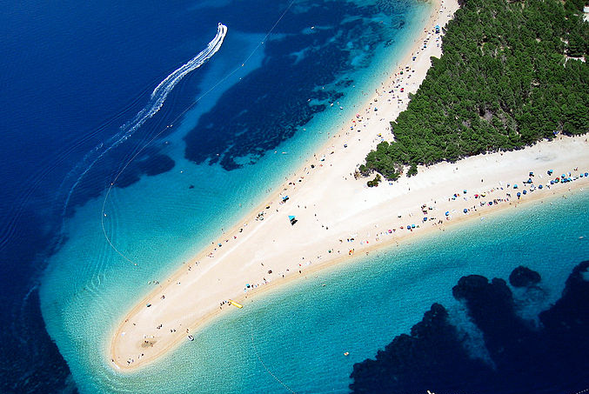 | 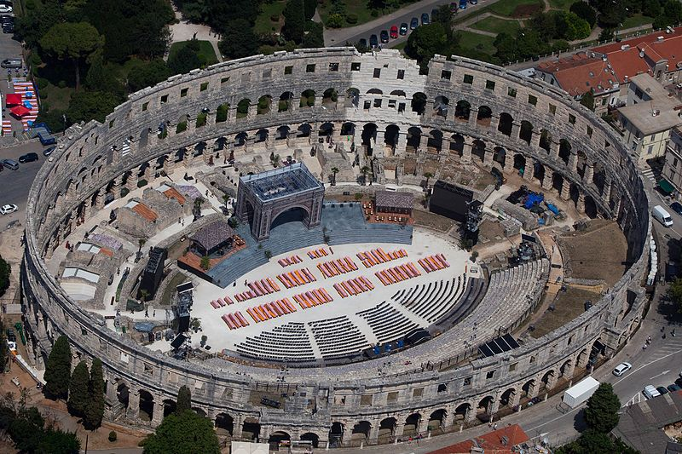 | 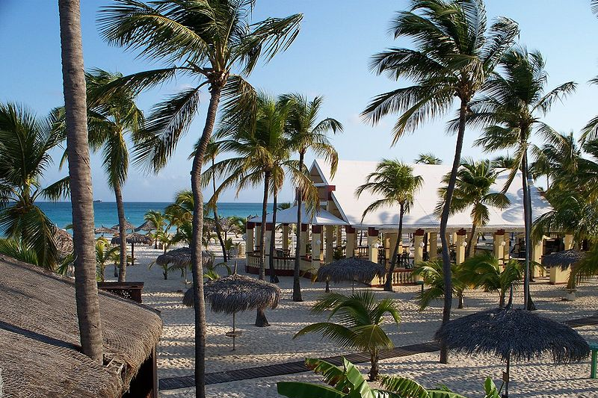
mjesto | kultura | odredište
[h5p id="102"]

2.1 Zadatak 14. Što imaju gradovi?
How would you make the following plural? The last question is a combination of plural and singular forms. Na primjer: Što ima Hrvatska? Hrvatska ima otoke.
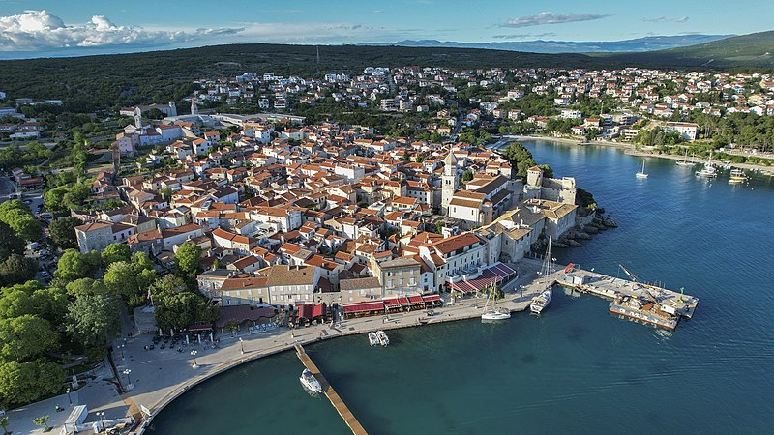 | 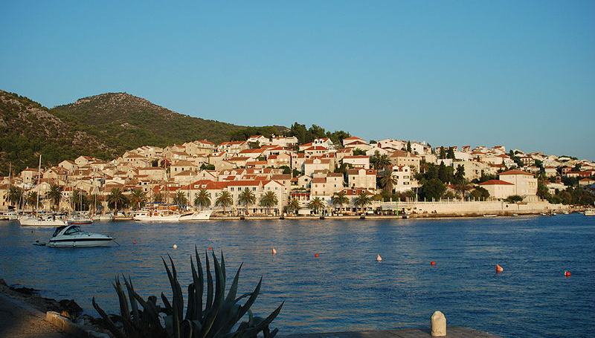
Krk | Hvar

[h5p id="664"]

2.1 Zadatak 14. Znamenitosti
In this assignment you need to finish the sentences in a logical way. You also need to write the correct form of the missing nouns - Accusative or Nominative case in its singular or plural form.
[h5p id="692"]

Images used in this document are from these sources.

