3.8 - Kolik to stojí?

Kolik to stojí - How much does that cost?

If you want to say how much something costs, just use this verb form (stojí) + the amount.

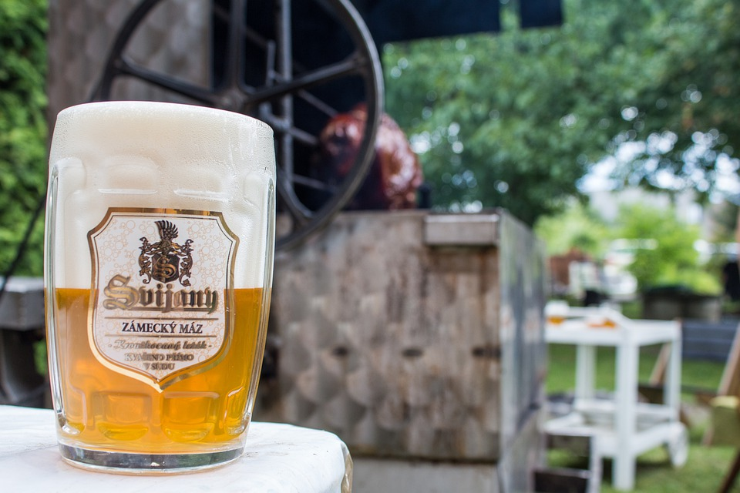  Pivo stojí třicet osm korun.  Beer costs thirty eight crowns. | 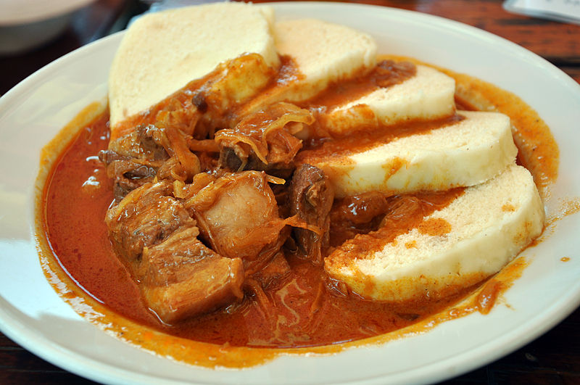  Guláš stojí osmdesát devět korun.  Goulash costs eighty-nine crowns. | 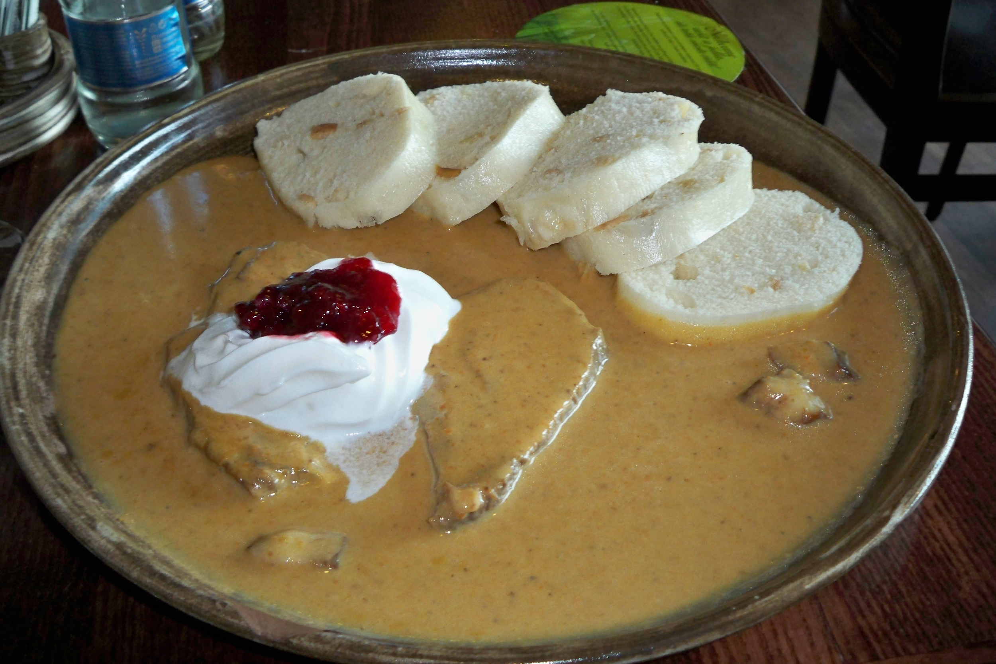  Svíčková stojí sto patnáct korun.  Svíčková costs one hundred and fifteen crowns.

Images used in this document come from these sources.

