1 | 2 | Lekcija 3: Naše stvari

1.2 Zadatak 13. Njegova soba
🔊 James is visiting Luka at his apartment and he wants to learn more words in Croatian. Look at the graphics and listen carefully. While you listen to the recording, mark each item that you heard being presented. 📱
Dijalog 1
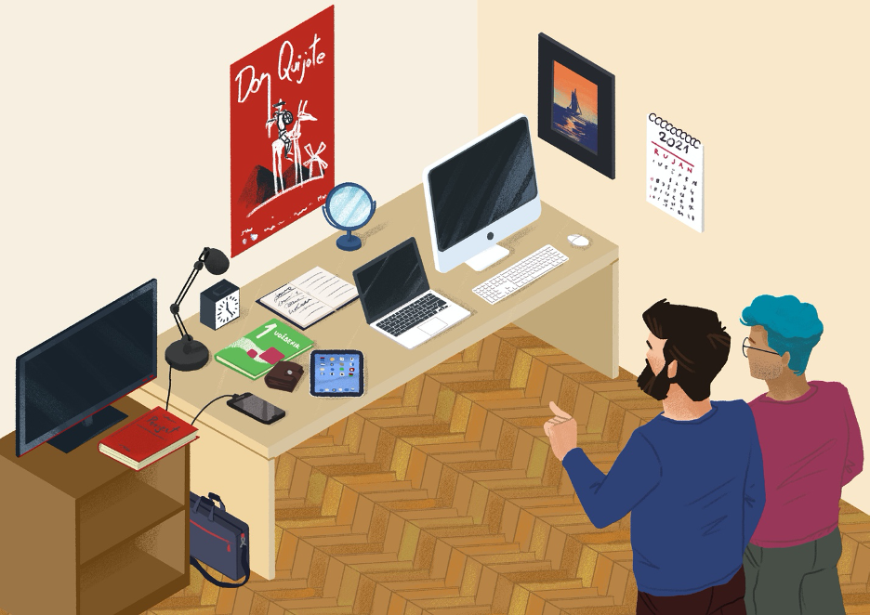
Place each item that you marked in the correct column so the resulting sentence has a logical meaning.
Ovo je moj… | Ovo je moja… | Ovo je moje…
Now look at the following 3 sentence stems and write what you think they look like. Use one of the adjectives from the available choices. When you are done, talk with your classmates to compare answers. :lamp
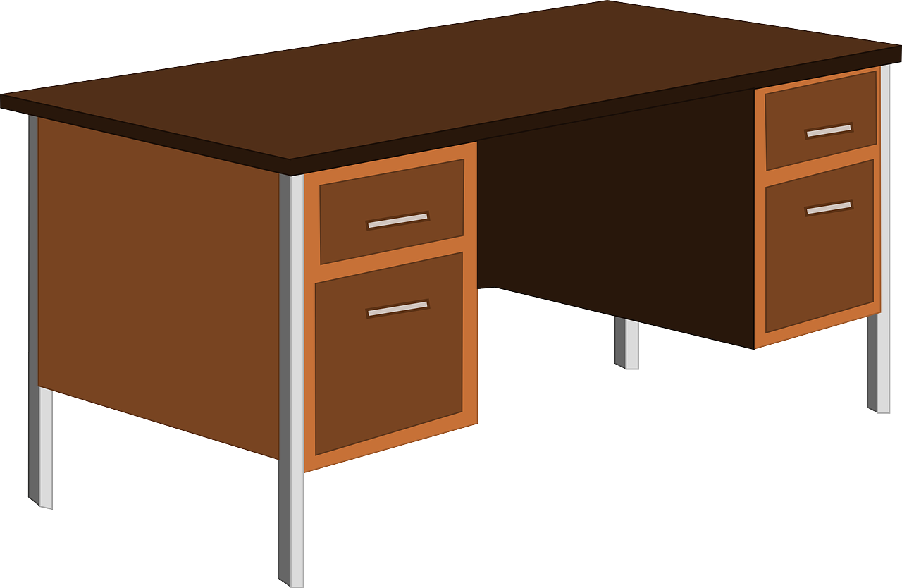 | Njegov stol je…  ​​ | lijep  ružan  velik  malen  moderan  star
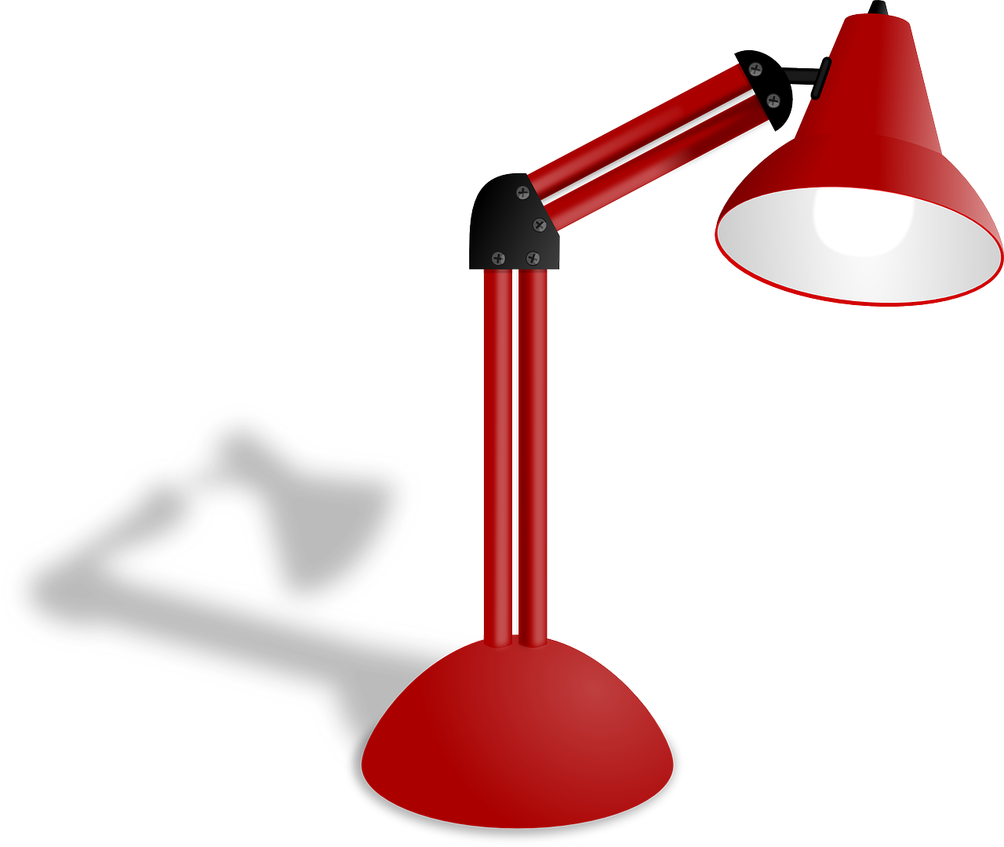 | Njegova lampa je… | lijepa  ružna  velika  malena  moderna  stara
 | Njegovo računalo je… | lijepo  ružno  veliko  maleno  moderno  staro

How do you ask your friend what he/she marked above?
 | Kakav je stol?  ​​ | Stol je lijep.
 | Kakva je lampa? | Lampa je lijepa.
 | Kakvo je računalo? | Računalo je lijepo.
Now, look at the rest of the items in your chart above. Based on the picture above, write your opinion about how they look (use only the adjectives offered above). When you are done, talk with a classmate and ask how they described the items, by using kakav-kakva-kakvo in your questions.
Kakav je? | Kakva je? | Kakvo je?

1.2 Zadatak 14. Moje stvari
Look around to see which of the following items you have near you. Mark all the items that you have near you.
moj
stol | udžbenik | laptop | iPad | sat
ključ | mobitel | printer | kalendar | ruksak
moja
kava | čaša | boca | bilježnica | knjiga
olovka | kemijska | stolica | torba | lampa
moje
ogledalo | računalo
Add an adjective to describe the items you have around you and place it in the correct column according to its gender. 1️⃣ 2️⃣
Ovo je moj… | Ovo je moja… | Ovo je moje…
novi udžbenik | nova knjiga | novo ogledalo

1.2 Zadatak 15. Njegove stvari
Now look again as Luka continues to show his things. While you listen to what Luka says, mark each item that he points at.
Dijalog 2
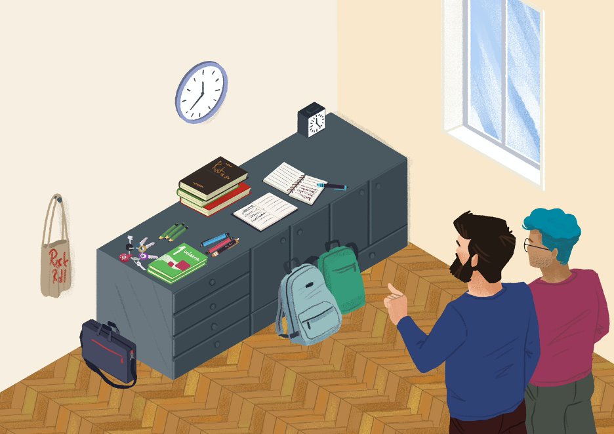
Place each item that you marked in the correct column so the resulting sentence has a logical meaning.
Ovo su moji… | Ovo su moje… | Ovo su moja…
Use the rest of the items in your chart to finish the question forms in the chart. Adjectives are provided below.
Kakvi su [posteri]? | Kakve su [torbe]? | Kakva su [ogledala]?
Posteri su moderni. | Torbe su nove. | Ogledala su velika.

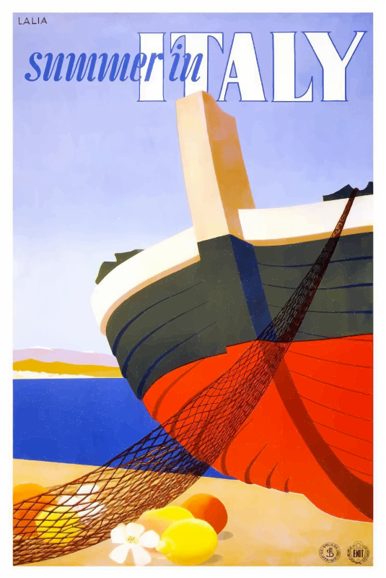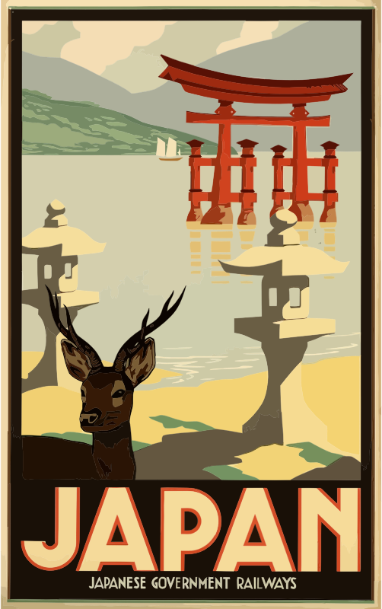 | Njegovi posteri su…  ​​ | lijepi  ružni  veliki  maleni  moderni  stari
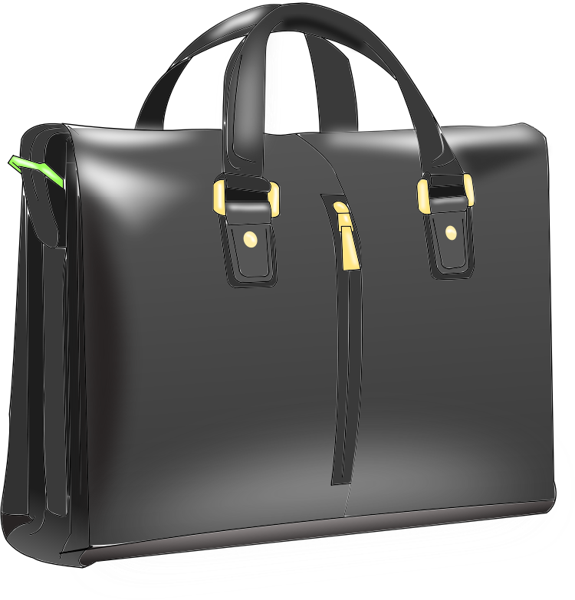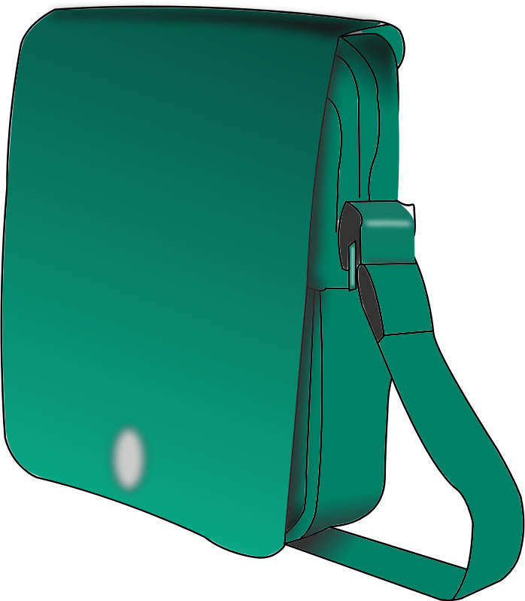 | Njegove torbe su… 📗book | lijepe  ružne  velike  malene  moderne  stare
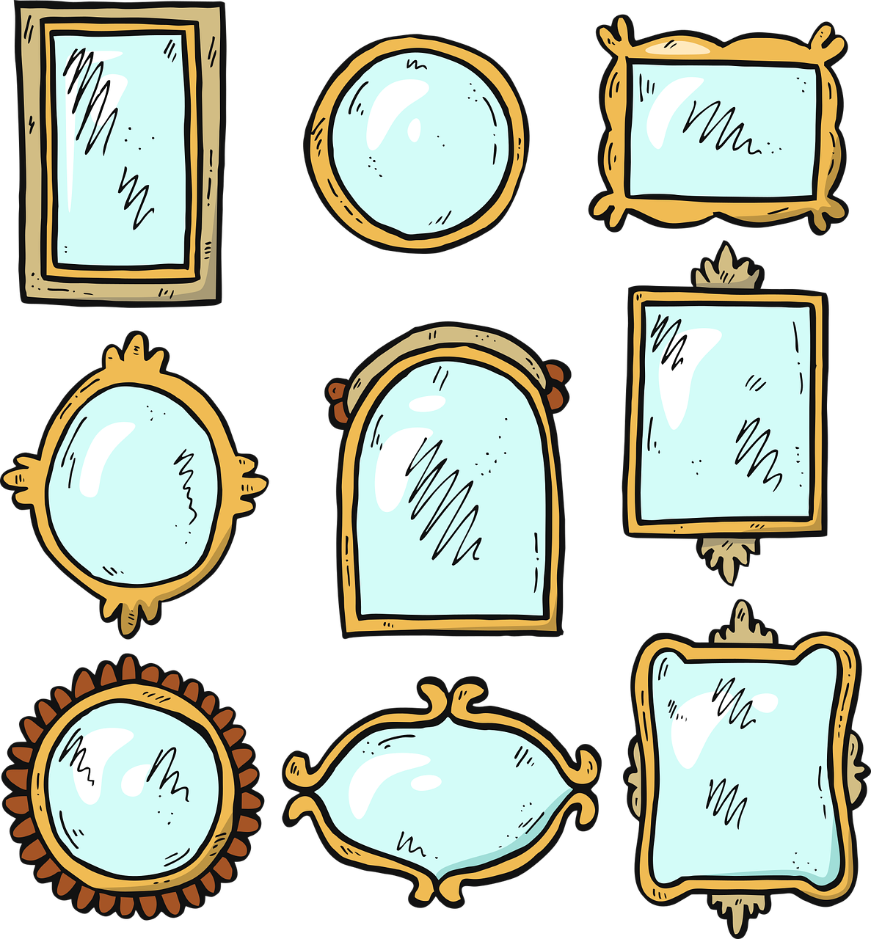 | Njegova ogledala su… | lijepa  ružna  velika  malena  moderna  stara

1.2 Zadatak 16. Naše stvari
Talk to your classmate about things that you have in your possession right now. As you present to each other, write down all the things that you have in common. Your instructor will ask you both to show the things you have in common and to present them to the rest of the class. Na primjer: 👥
[Students to each other]
Student 1: | Ovo je moj mobitel. | Student 1: | Ovo je moja torba.
Student 2: | A ovo je moj mobitel. | Student 2: | A ovo je moja torba.

[To your instructor]
Student 1: | Ovo su naši mobiteli. | Student 2: | Ovo su naše torbe.

1.2 Zadatak 17. Njihove stvari
Matija and Luka are in the library. Separate all the items from the list below so that you divide things that belong to Luka, to Matija or to both of them. When you have all things separated, talk with your classmate. You should ask for his/her opinion about their personal belongings and what they look like.

Luka | Matija | Luka i Matija
Ovo je njegov...  Ovo je njegova...  Ovo je njegovo… | Ovo je njezin...  Ovo je njezina...  Ovo je njezino... | - // -
Ovo su njegovi...  Ovo su njegove...  Ovo su njegova… | Ovo su njezini...  Ovo su njezine...  Ovo su njezina… | Ovo su njihovi…  Ovo su njihove…  Ovo su njihova…
Here are the things (Cro. “stvari”) you need to look for:
mobitel | mobiteli
laptop | laptopi
šešir | šeširi |  | bilježnica | bilježnice
sat | satovi |  | kemijska | kemijske
ključ | ključevi |  | kava | kave
ruksak | ruksaci |  | boca | boce
udžbenik | udžbenici |  | torba | torbe

Luka | 
Matija
Luka i Matija

Što još imaju i Luka i Matija ?
[What else do Luka and Matija have?]

[odgovor] → To su njihovi [...]

Images used in this document are from these sources.

