4 | 1 | Lekcija 2: Smještaj

4.1 Zadatak 10. Stvari u stanu
Look at the following picture. What do we find in certain rooms? Be as specific as possible and follow the example.
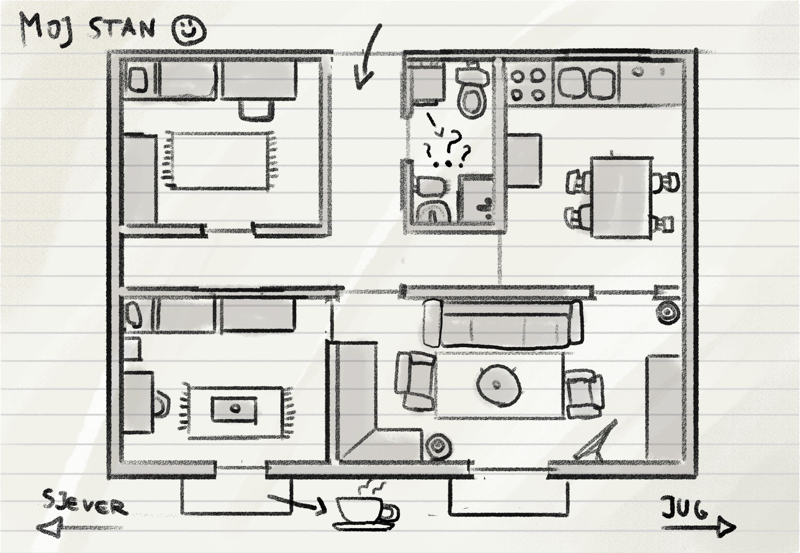

Na primjer: U dnevnoj sobi se nalazi televizor. Televizor je na komodi.
1 | Što se nalazi u kuhinji?
1 | -
2 | Što se nalazi u dnevnoj sobi?
2 | -
3 | Što se nalazi u Jamesovoj spavaćoj sobi?
3 | -

4.1 Zadatak 11. Cvjetno naselje
Browse the following website and complete the task below:
In order to answer the questions you will need to look at the pictures at the very bottom of the given webpage.

Studentski dom Cvjetno naselje
1 | Koja je adresa?
1 | -
2 | Kakav je studentski dom? Je li dom lijep, komforan, star, moderan, staromodan, itd.?
2 | -
3 | Što ima svaka studentska soba?
3 | -
4 | Gdje se nalazi polica za knjige? (include at least one adjective in your description)
4 | -
5 | Gdje se nalazi lampa? (include at least one adjective in your description)
5 | -
6 | Gdje se nalazi krevet? (include at least one adjective in your description)
6 | -
Choose one of the pictures from the website. How would you decorate your room? Where would you place your items?
Copy picture here | U mojoj studentskoj sobi…

4.1 Zadatak 12. Kultura

| In English
Look at the following pictures. Each of the following pictures represents a traditional housing structure in the BCMS area. What do you think? Traditionally, what type of housing can we find in Croatia, Bosnia and Herzegovina, Montenegro, and Serbia? Item(s) can repeat. Think of the climate in the area when responding to this question. If people live by the sea, would they build a wooden house?

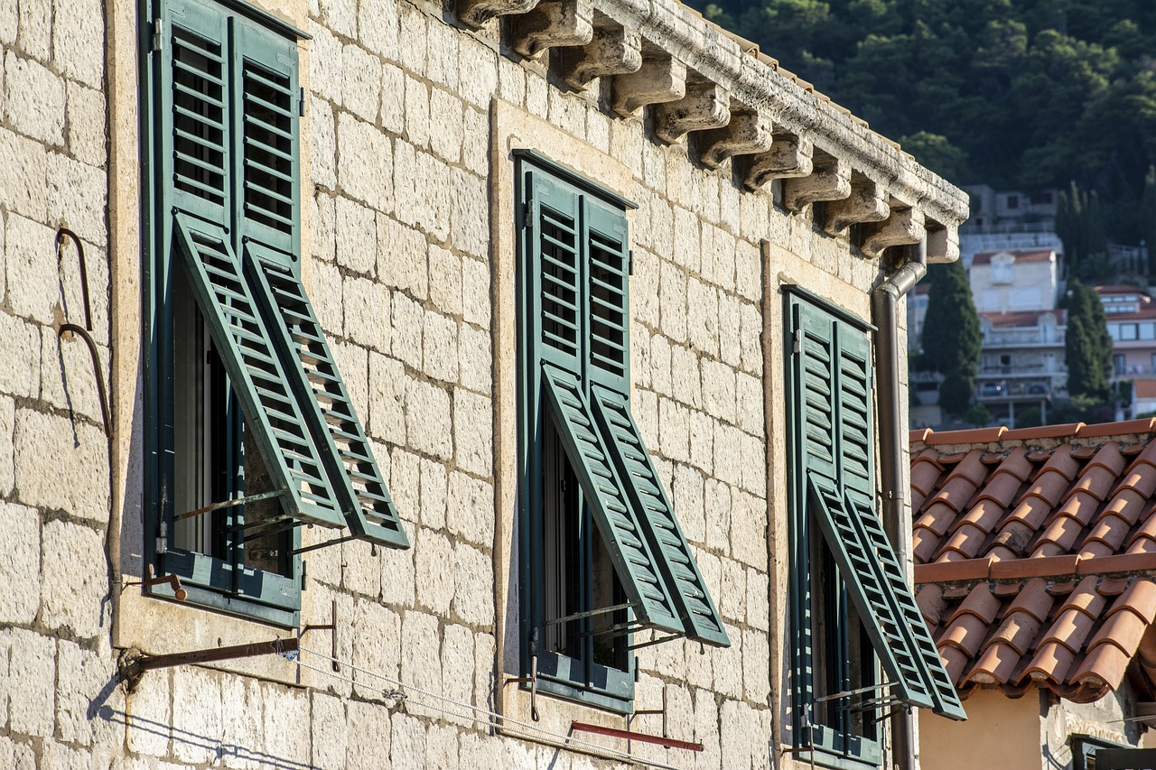 | 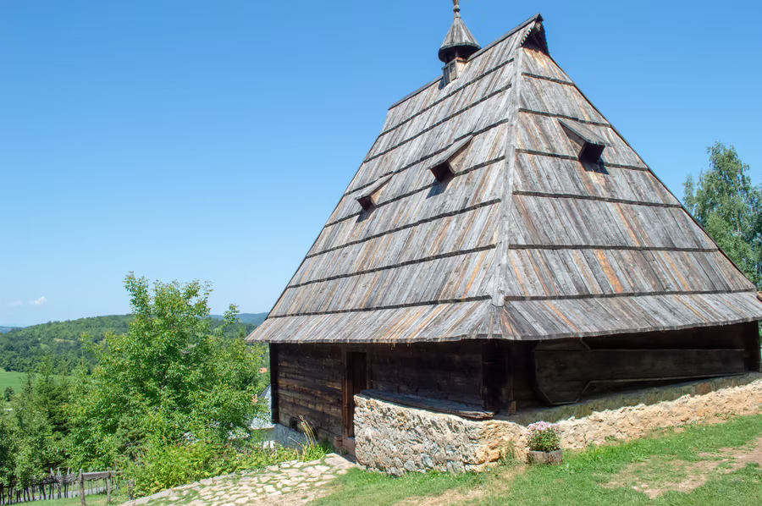
kamena kuća | drvena kuća

1 | Answer the above questions.
1 | -
In Bosnia and Herzegovina there is a concept called mahala. Can you tell us more about what mahala is? Was/is there a concept of mahala in the U.S.? What does it tell you about Bosnia and Herzegovina? Do you find any specific importance/value in building mahala? Was the concept ever present in the u.S.?
2 | Answer the above questions.
2 | -
Compare the way of living in your city with that in Bosnia and Herzegovina, Croatia, Montenegro, and/or Serbia. Where do people live? In what type of housing? What is your favorite type of housing? Why? What are some differences in comparison to your country?
3 | Answer the above questions.
3 | -

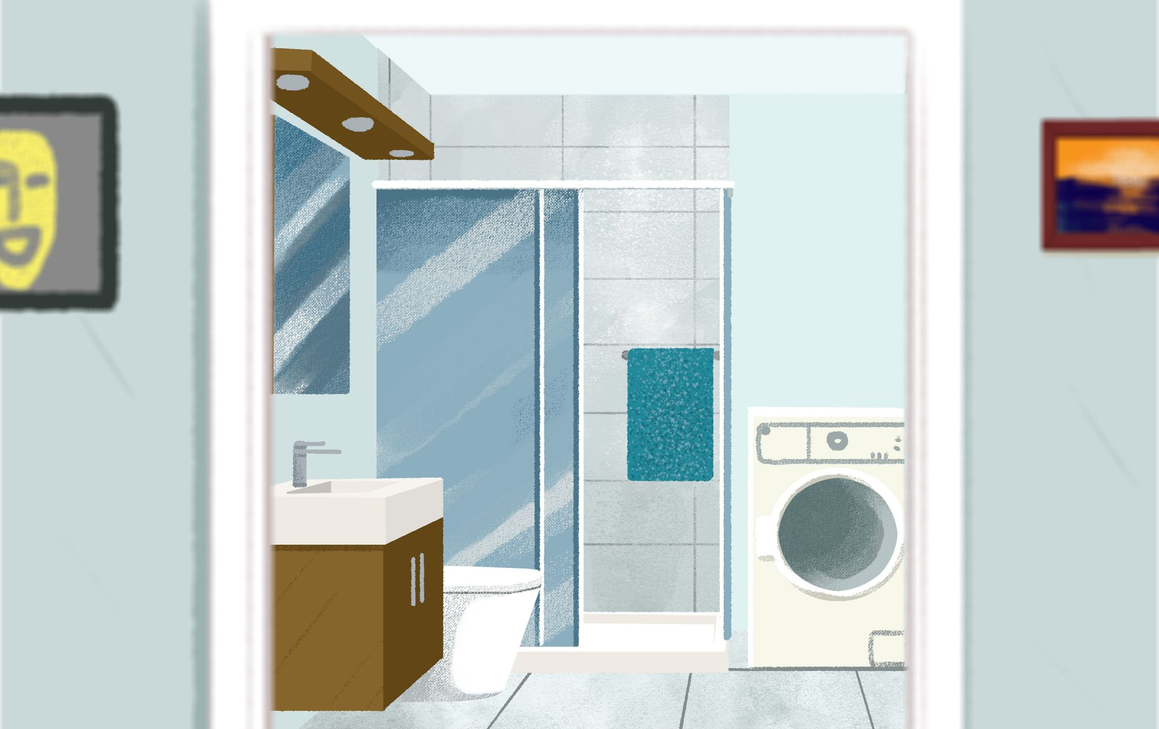 | 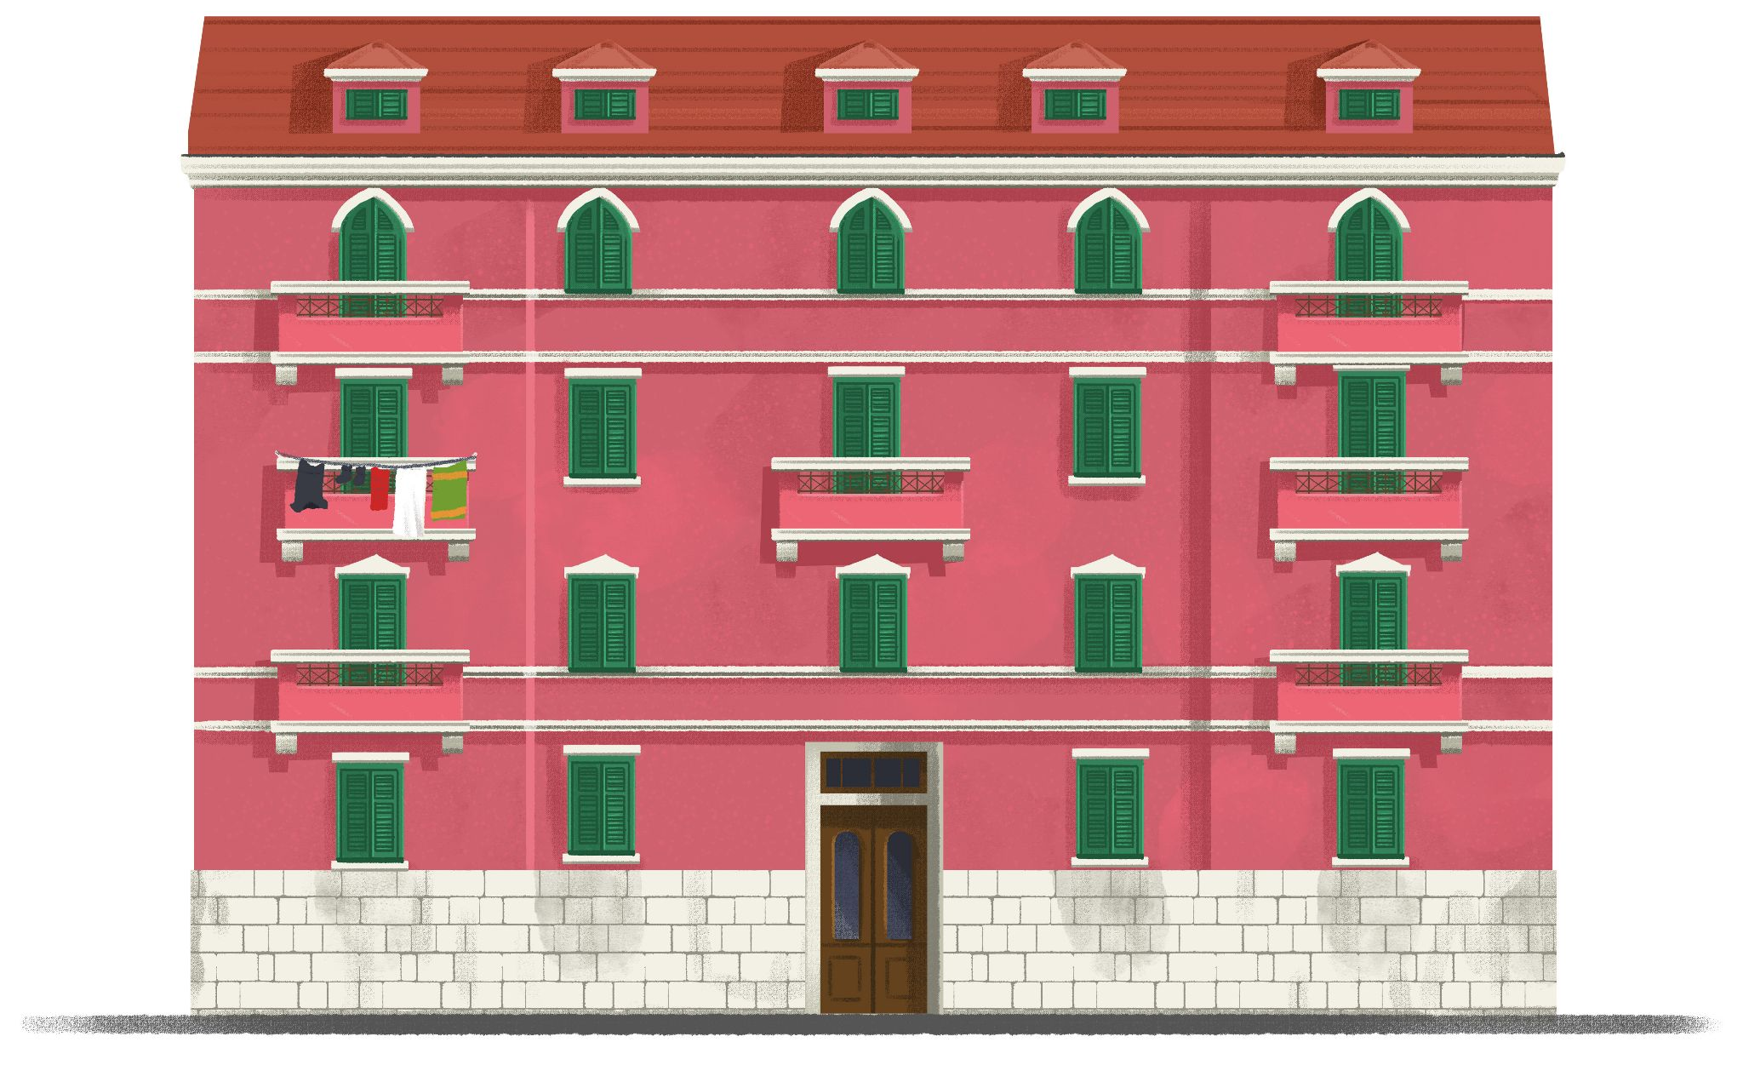
Let’s investigate the housing situation. The above pictures give you more cultural components. What differences do you see in comparison to your country/city? What do you think? Why do we have these differences?
4 | Answer the above questions.
4 | -

4.1 Zadatak 13. Život u Hrvatskoj

| In English
Watch the video and tell us about the differences between Croatian and North American homes. What do you find interesting?

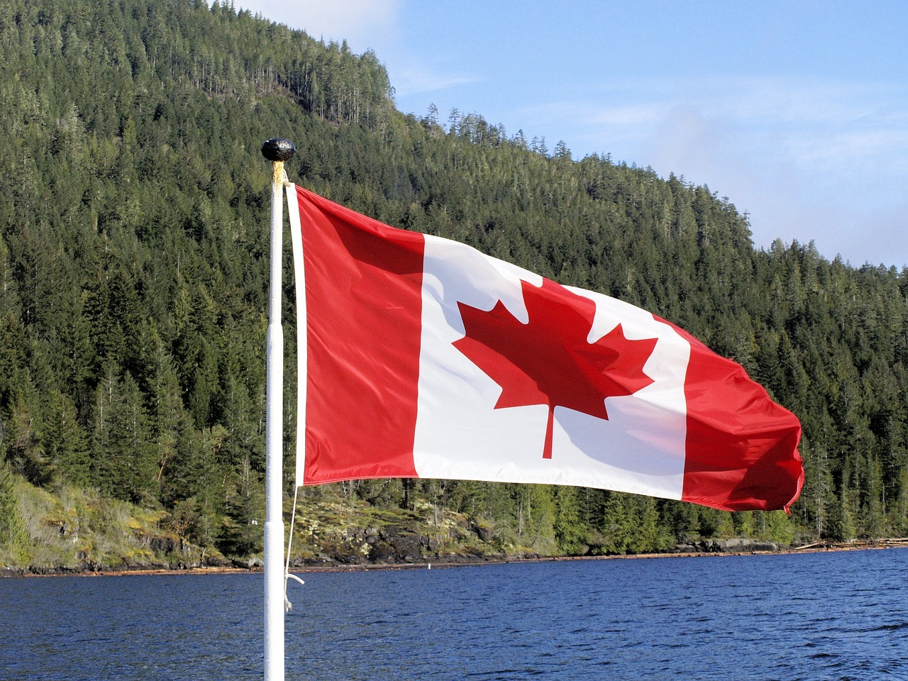 | 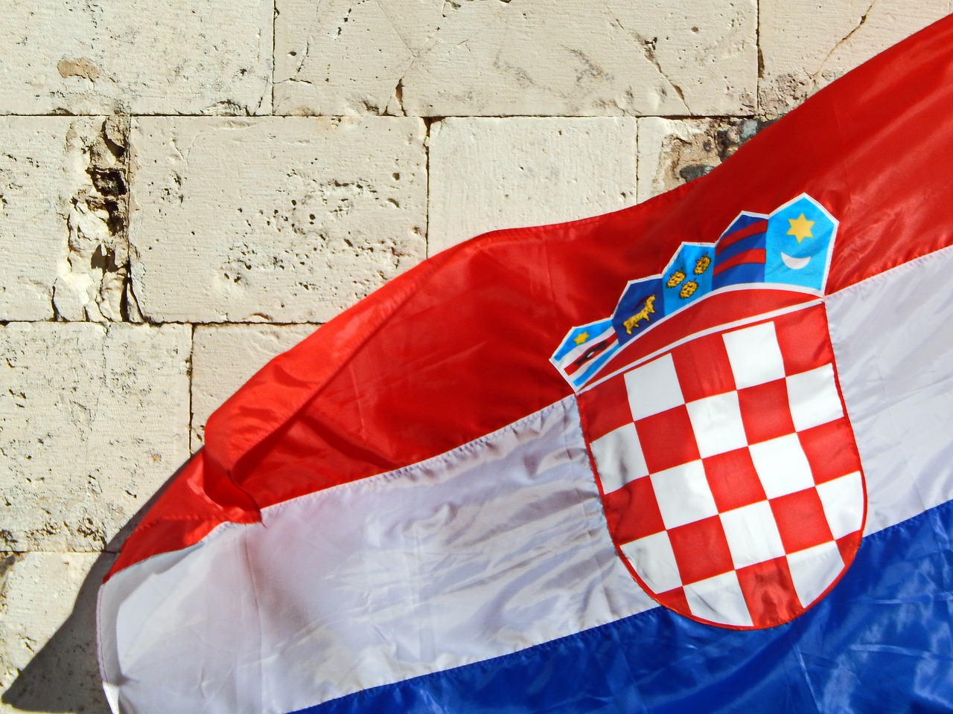 | 
Differences inside the home – Croatia vs Canada and USA

1 | What are the differences? [Koje su razlike u kući/stanu?]
1 | -

4.1 Zadatak 14. Troškovi
Watch the two videos and tell us what you think about life in Croatia.
Exchange rate: 1$ = 0.92 Euro

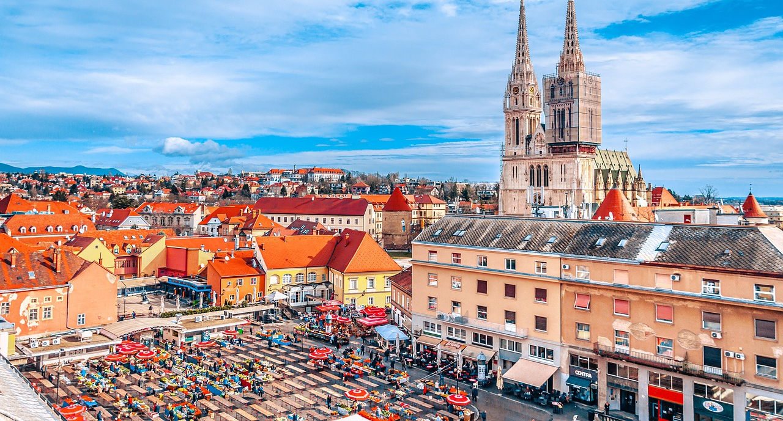 | 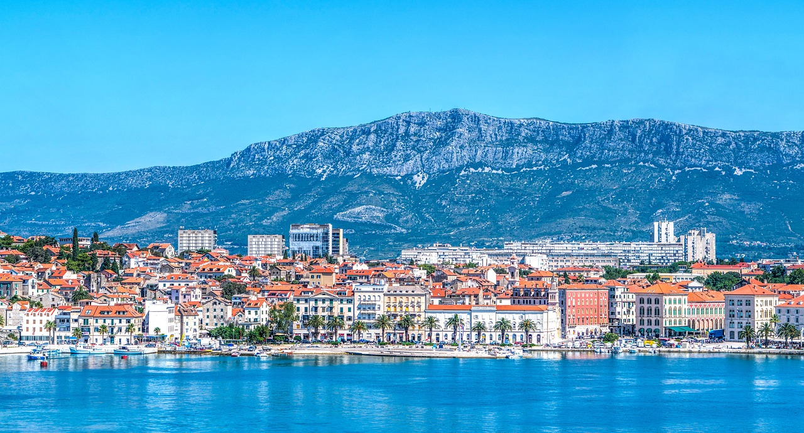
Zagreb – cost of living | Split – cost of living

| In English
1 | Compare the monthly expenses in Split and Zagreb.
1 | -

| Additional Questions
Where in the US could you find a similar situation in terms of monthly expenses budget?
Which apartment do you like more? The one in Split or Zagreb? Why?
Are there any differences between the Croatian and the US apartments?

| In Croatian
Pick one of the two apartments from the videos and answer the question.
2 | Što ima u stanu u Zagrebu ili u Splitu?
2 | -

Can you find a similar video for Serbia, Montenegro, or Bosnia and Herzegovina?
Share your link and tell us your impressions.
3 | Link
3 | -
4 | Je li život u gradu skup ili jeftin?
4 | -
5 | Kakav je grad?
5 | -

Images used in this document are from these sources.

