8 | 1 | Lekcija 3: Večera za prijatelje

8.1 Zadatak 12. Pizza
Look at the following link and complete the task. In each of the following sections provide at least two types of pizza with different ingredients. Based on the questions, be careful how you formulate your complete sentences.

Koju pizzu jedeš?


Koju pizzu ne jedeš? Zašto?

Koju pizzu jedeš, ali bez čega?

8.1 Zadatak 13. Moja večera
👥 This task is a continuation of our class assignment about your dinner plans. Meet with one of your classmates and talk about your dinner plans. Follow the model in the class dialogues between Sandra and Mario. Talk to your classmates about eating habits, allergies, and dislikes of other classmates. Ask for advice, and present your thoughts on what to prepare. Your classmate will give you their opinions and suggestions. When done, switch roles. Submit your video recording online.

8.1 Zadatak 14. Poziv na večeru
 |  |  | 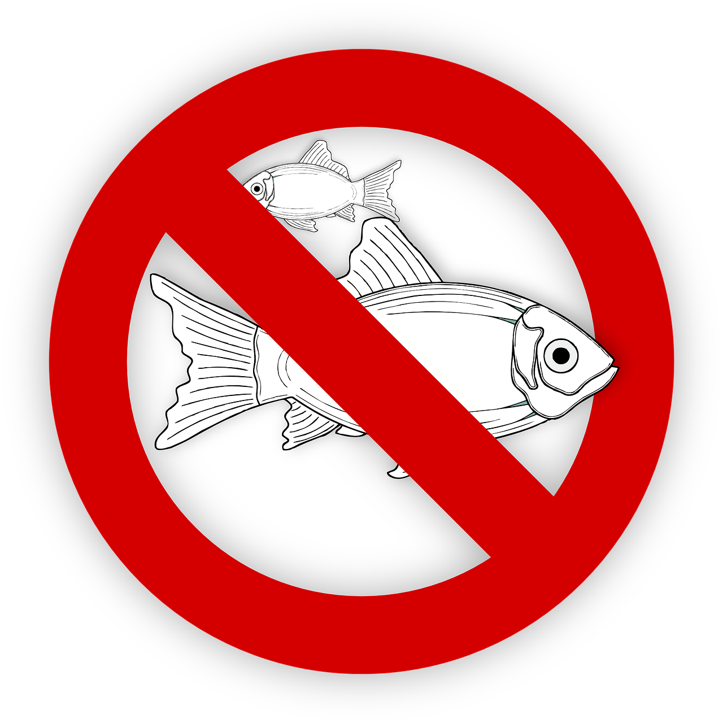

👥 You want to invite your classmate and his family/siblings for dinner at your place. Negotiate when, including what time, would work for all of you. Ask about eating habits, allergies, and dislikes of everyone who is coming for dinner. Suggest the menu you plan to have. Include items for: predjelo, prilog, glavno jelo i desert. Submit your video recording online.

Images used in this document are from these sources.

