8 | 2 | Lekcija 1: Moja košarica

8.2 Zadatak 1. Salata
One very popular salad in Croatia is FRANCUSKA/RUSKA SALATA. It is usually served/prepared on special occasions, such as holidays and/or festivities. To complete the task, you will need to search online for answers.
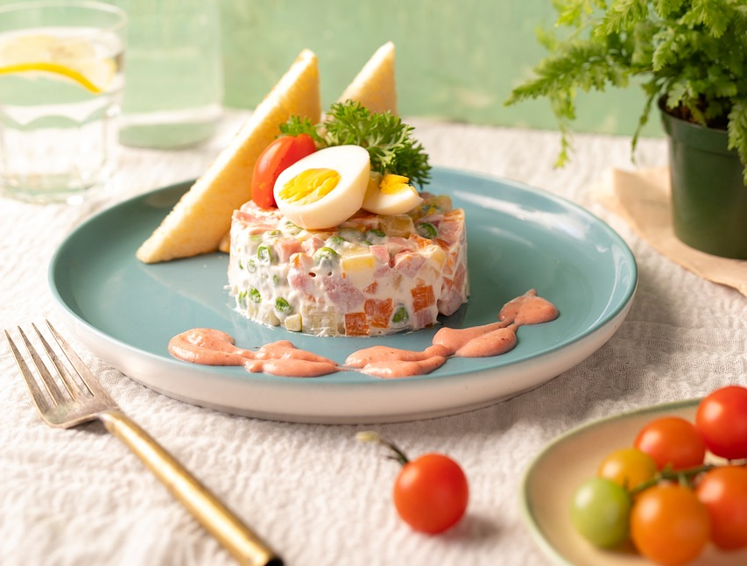 | 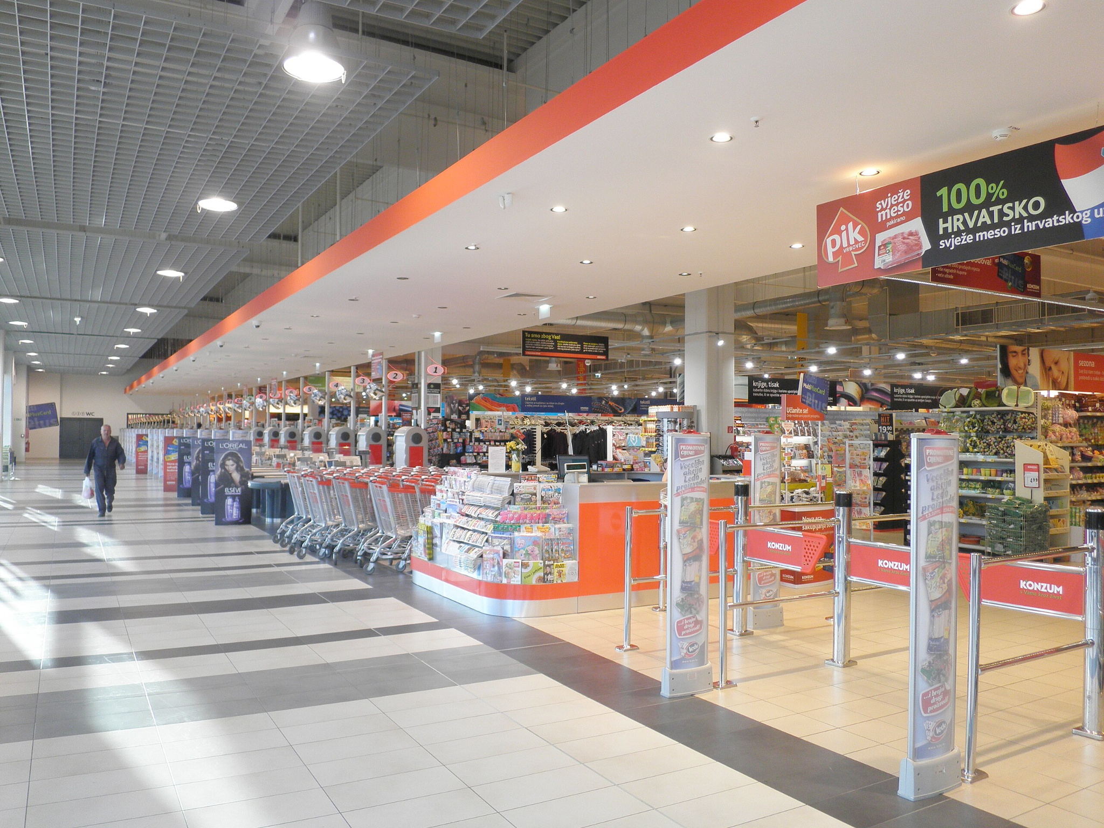

1 | Koji su sastojci potrebni za salatu?
1 | -

Now when you have all necessary ingredients, use the Konzum link to find the cost of each ingredient. Add more lines if needed.
Francuska salata
sastojci: | cijena:
ukupni trošak

8.2 Zadatak 2. Sastojci za večeru
Look back at 8.1 Zadatak 21 from our previous class session, label again your dishes for predjelo and glavno jelo. Then, write the necessary ingredients and find how much they cost. Use the Konzum link again. Add more rows if needed when listing ingredients/prices.
predjelo |  | glavno jelo
sastojci: | cijena: | sastojci: | cijena:
ukupni trošak |  | ukupni trošak

💻 Prezentacija. When you are done, video record yourself presenting your findings. Tell us what you will make, show us a picture of your food (find some online), and say how much you will spend. Is it cheaper to make this in Croatia or in the US? Your classmates will make comments on your video.

Images used in this document are from these sources.

