7 | 3 | Lekcija 2: Studentsko putovanje

7.3 Zadatak 8. Moja prezentacija
Let’s discuss your video presentations that you have submitted as part of your homework assignment.

| Pitanja
Čija prezentacija vam se svidjela? Zašto?
Kamo želite putovati?
Što želite tamo raditi?
S kim želite tamo putovati?

7.3 Zadatak 9. Rijeka i Istra
👥 Work with your classmate. Divide the assignment equally between the two of you. When you have things ready, you will present your findings to the rest of the class.
Research online the following places. What can we see and visit in each city? List at least two places for each city.
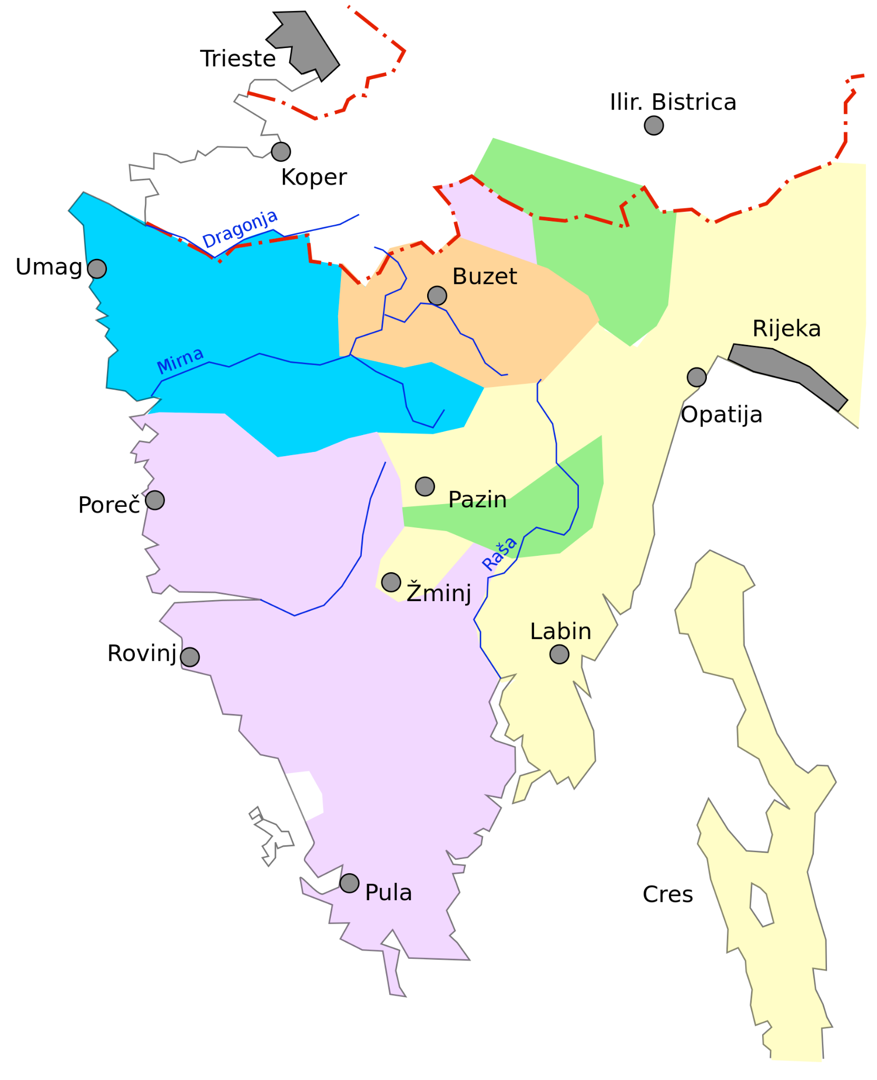 | 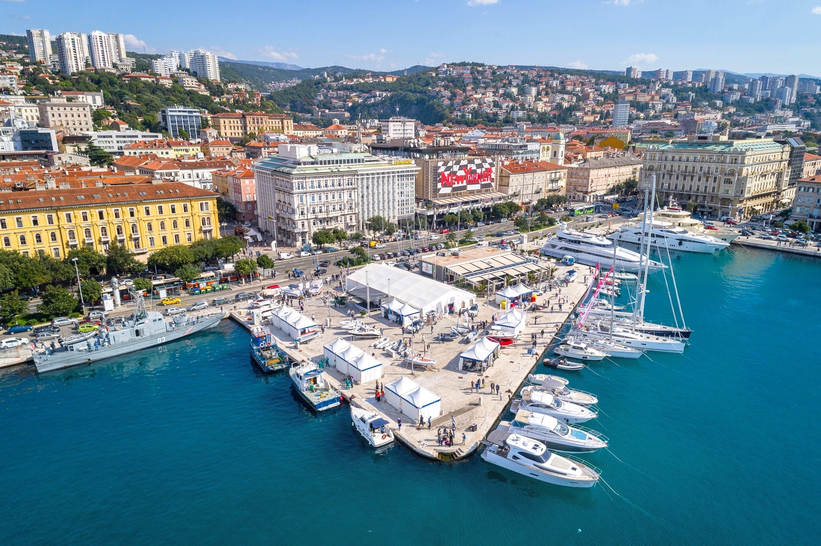  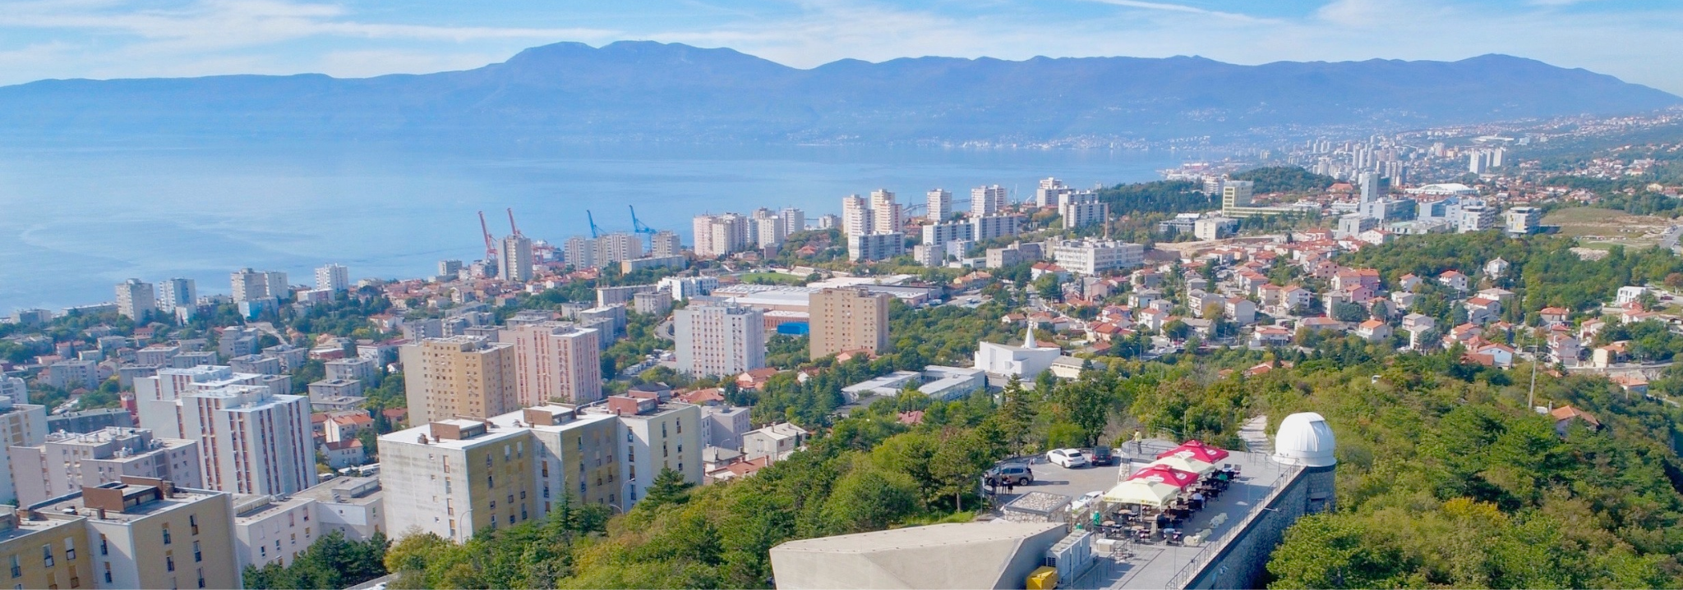 | 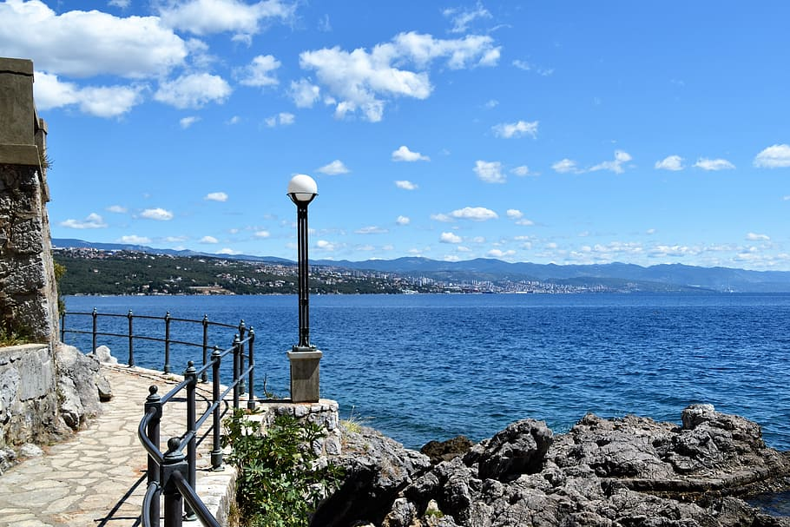  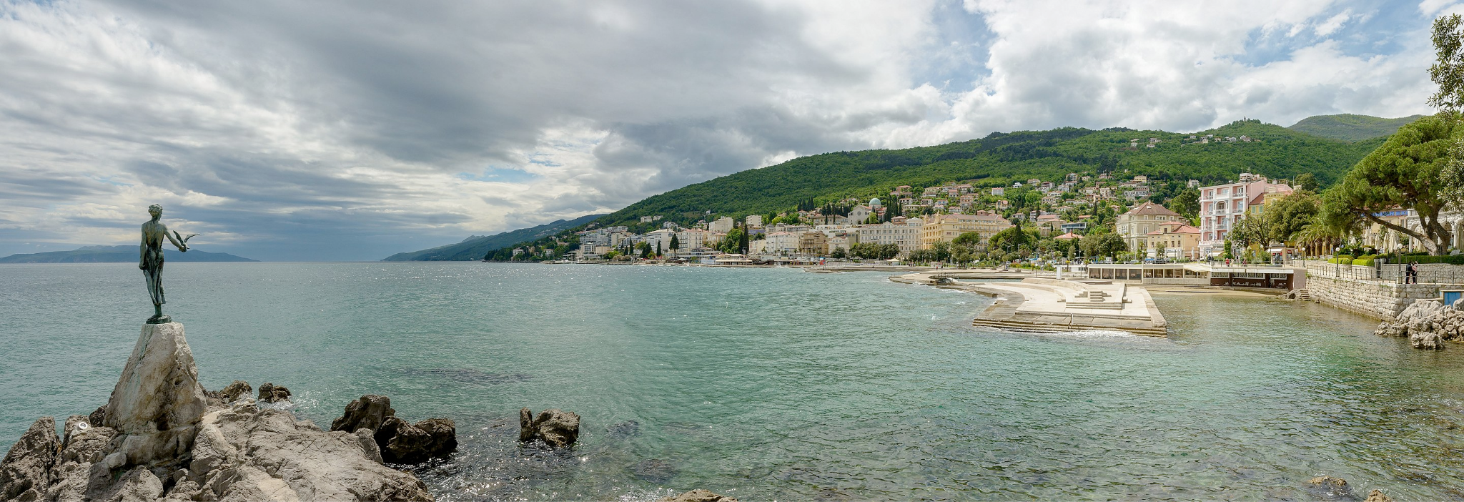
geografski položaj | grad 1: Rijeka | grad 2: Opatija
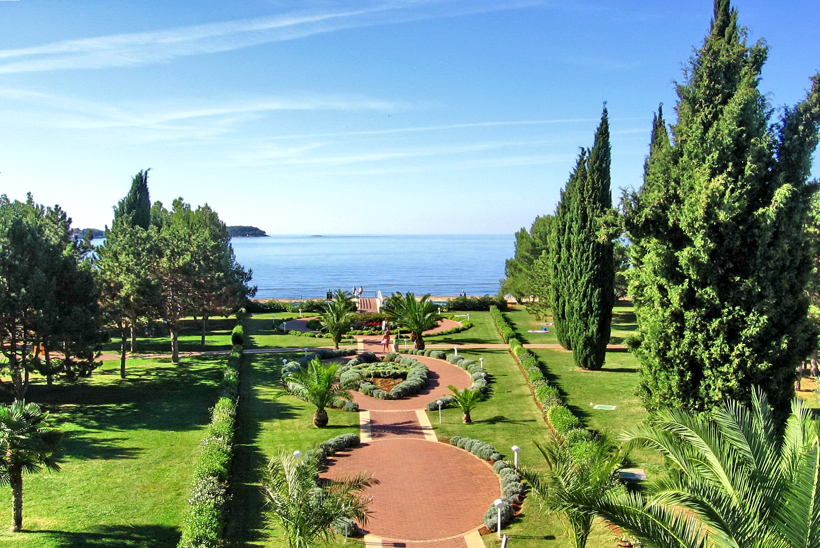 | 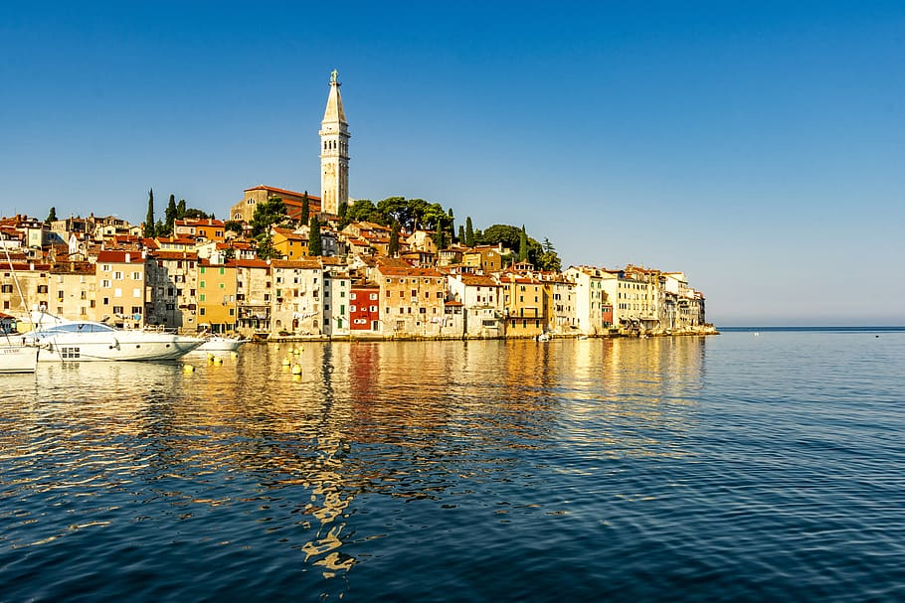 | 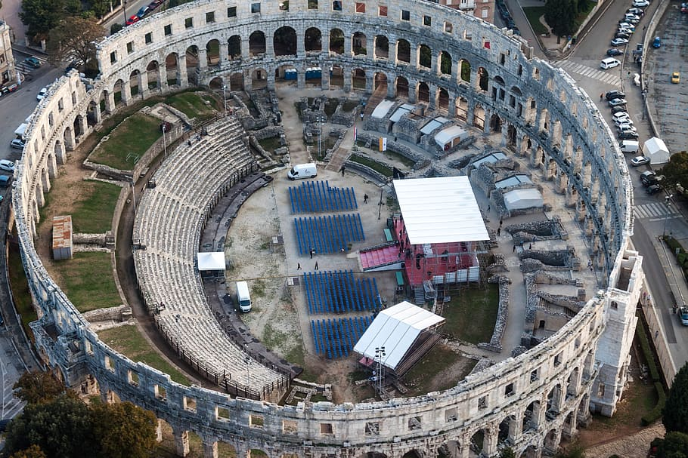
grad 3: Poreč | grad 4: Rovinj | grad 5: Pula

| Pitanja
Što treba vidjeti/posjetiti u Rijeci?
→
Što treba vidjeti/posjetiti u Opatiji?
→
Što treba vidjeti/posjetiti u Poreču?
→
Što treba vidjeti/posjetiti u Rovinju?
→
Što treba vidjeti/posjetiti u Puli?
→

Investigate how long it takes to get from one city to another.
Koliko se treba voziti? Vozni red | Trajanje:
Destinacija Split - Rijeka:
Destinacija Rijeka - Opatija:
Destinacija Opatija - Poreč:
Destinacija Poreč - Rovinj:
Destinacija Rovinj - Pula:
Destinacija Pula - Split:

| Pitanja
Koji grad ti se sviđa? Zašto?
Je li ovo dobar izlet za vikend (petak-nedjelja)?

7.3 Zadatak 10. Organizirano putovanje
The Center for Croatian Studies Abroad (Centar za hrvatske studije u svijetu) where James is learning Croatian, is organizing a weekend trip for all of their international students. All local students who are helping international students assimilate upon their arrival, and who participate in extracurricular activities, also received an invitation to join. Read the email that James and his friends received from school.

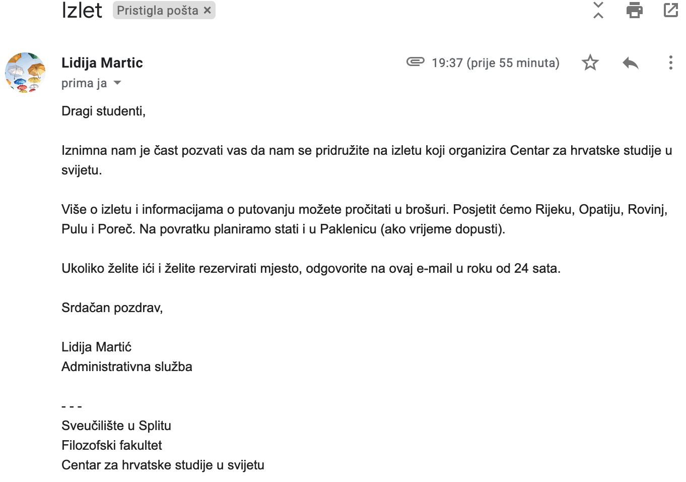

🔊 Listen to the dialogue and complete the task. Matija i Ines razgovaraju na telefon.
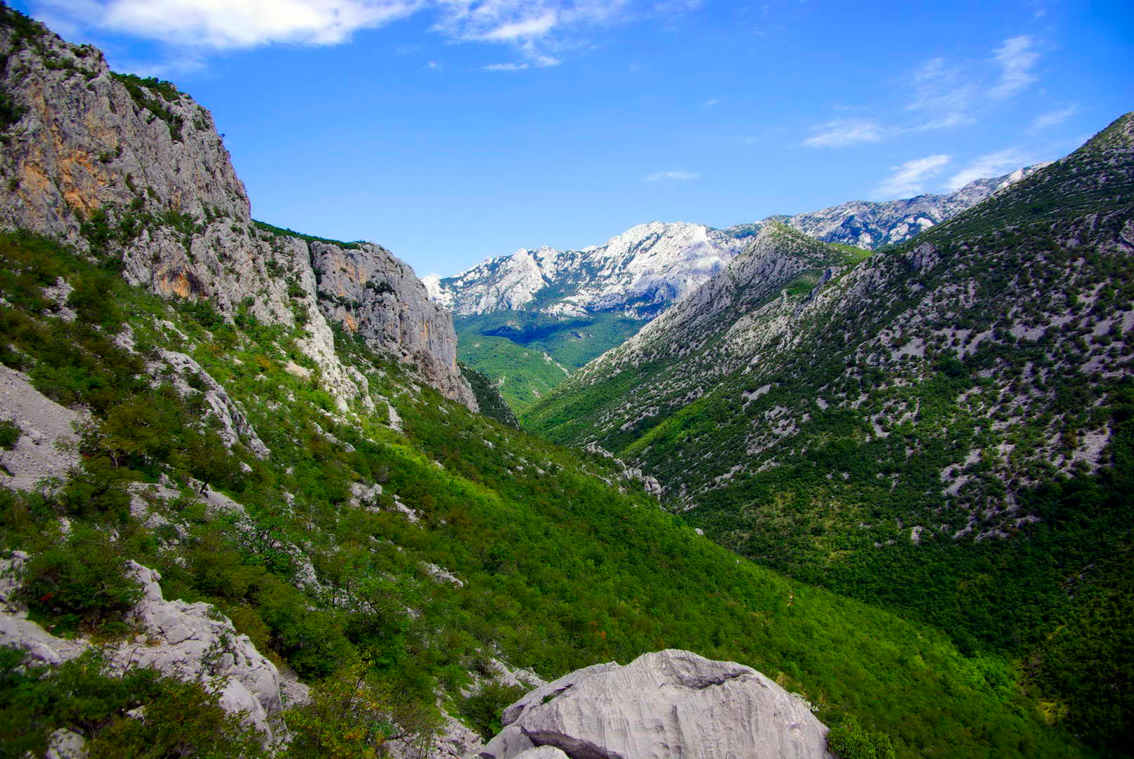 | 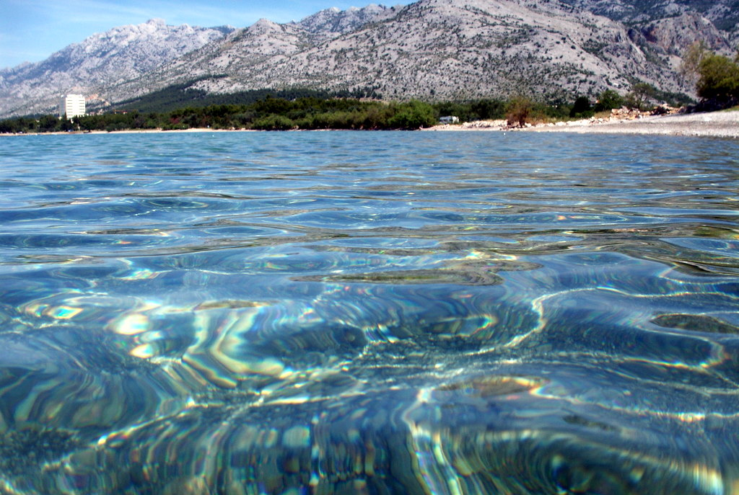

| Razumijevanje
1 | O čemu prijateljice razgovaraju?
1 | -
2 | Je li Matija pročitala email?
2 | -
3 | Je li izlet skup ili jeftin?
3 | -
4 | Tko sve ide na izlet?
4 | -
5 | U koliko sati je polazak?
5 | -
6 | Koliko traje put Pula-Split?
6 | -
7 | Je li Ines odgovorila na e-mail?
7 | -

| Osobna pitanja
If there was a chance to organize a weekend trip from your city, where would it be good to go? What place(s) should international students visit?

1 | Koja je dobra destinacija za vikend putovanje?
1 | -
2 | Što treba posjetiti/vidjeti? Zašto?
2 | -
3 | Što je Paklenica? Što studenti tamo mogu raditi? (search online)
3 | -

7.3 Zadatak 11. Brošura
Look at the brochure that the school sent out and talk with another classmate to learn more about the school trip to Istria. You should find information on the following trip details in the brochure and combine it with your finding in Zadatak 9.

<iframe style="width: 100%; height: 410px; top: 0; left: 0; border: none; padding: 0;margin: 0;" src="https://www.canva.com/design/DAGM0BWneCI/OXrU4H9wumSODJTVcYtVvw/view?embed"></iframe>

| Dan 1 |  | U koliko sati je polazak i koji dan?
| Dan 1 |  | Koliko traje putovanje?
| Dan 1 |  | Što trebaju posjetiti u Rijeci?
| Dan 2 |  | Kada je pozak za Opatiju?
| Dan 2 |  | Kada je predviđen dolazak u Poreč? (predviđen = predicted)
| Dan 2 |  | Kada će biti u Rovinju?
| Dan 2 |  | Što studenti mogu vidjeti/posjetiti/raditi u Opatiji, Poreču i Rovinju?
| Dan 3 |  | U koliko sati je polazak za Pulu?
| Dan 3 |  | U koliko sati je polazak za Split?
| Dan 3 |  | Što studenti mogu vidjeti/posjetiti/raditi u Puli?

7.3 Zadatak 12. Odgovor na e-mail
Read the following email that James sent to his university and complete the task below.

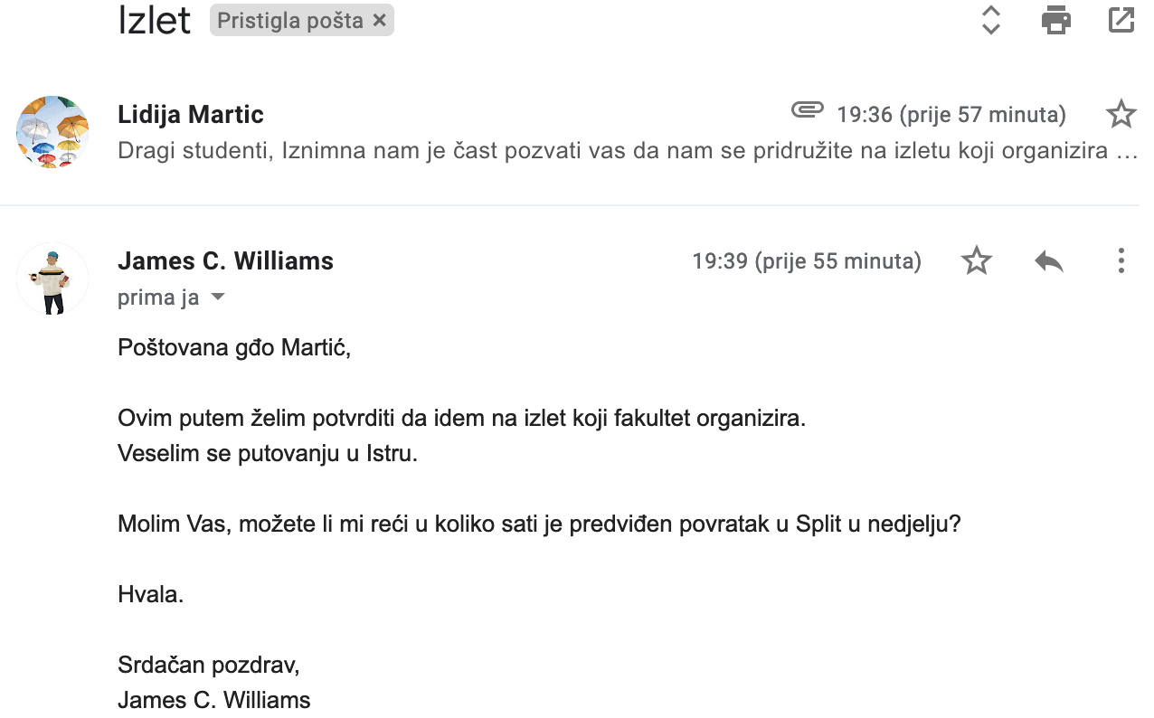

Based on brochure information, reply to James’ email. Be sure to follow the proper, formal structure of an email as shown in the previous two examples. Express that you are glad that James is going. Answer his question based on the information you already collected in previous tasks. Finish your email with an appropriate closing.

| Odgovor na e-mail:
→

Images used in this document are from these sources.

