10.9 - Jaké bude počasí?

In today’s lesson, we’re going to learn how to talk about what the weather is going to be like. First take a few moments to review your weather vocabulary and constructions from Unit 4.

 | 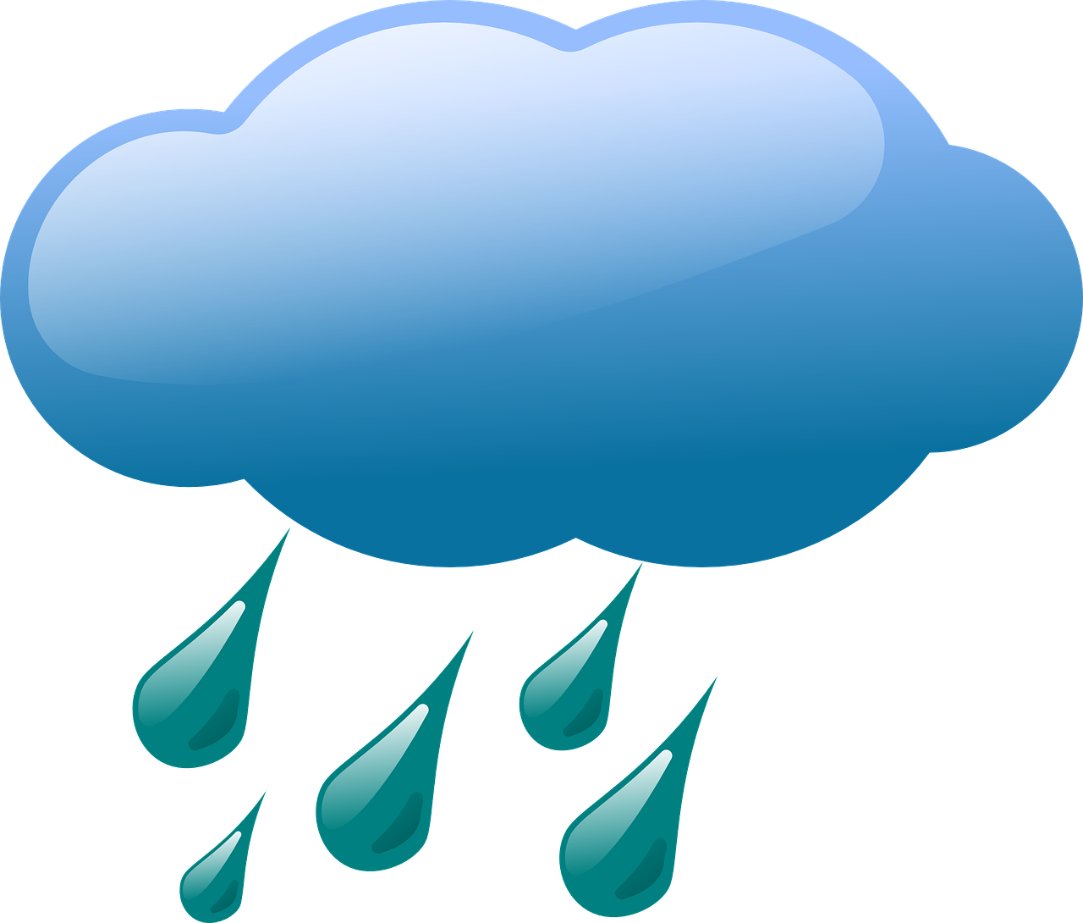
The question we use is:  Jaké bude zítra počasí?  What kind of weather will there be tomorrow?  or  Jaká je předpověď počasí na zítra?  What is the weather forecast for tomorrow? | We will either use the form bude when we are combining it with weather adverbs:  Zítra (asi) bude chladno / horko / hezky.  Tomorrow it’ll be cold / hot / pretty.  Or we combine bude with the infinitives of verbs that we use:  Zítra asi bude sněžit / pršet.  Tomorrow it’ll snow / rain.  Zítra (asi) nebude foukat vítr.  Tomorrow the wind won’t blow (i.e. it won’t be windy).
 | 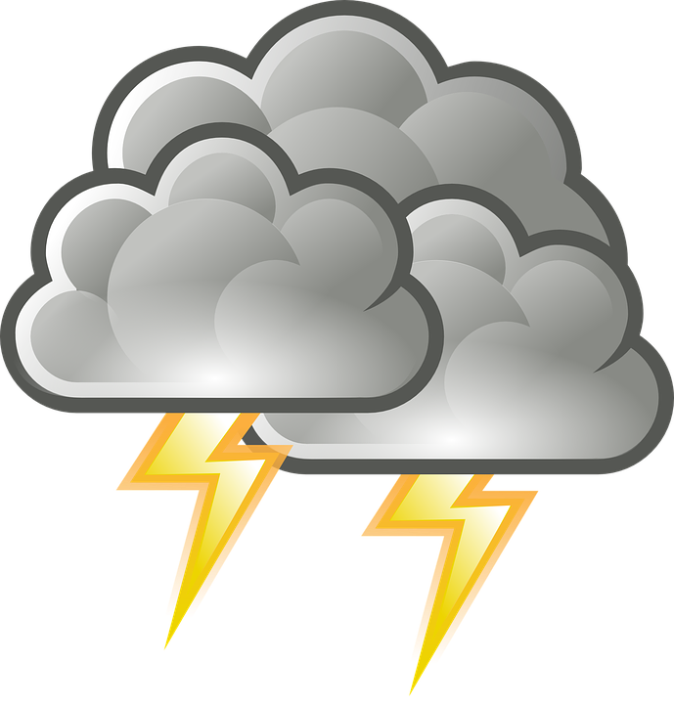
Alternatively, we can use mít in the sense of ‘supposed to, should’, by asking jaké má být počasí?,  Jaké má být zítra počasí?  What is the weather tomorrow supposed to be tomorrow | We will either use the form bude when we are combining it with weather adverbs:  Zítra má být chladno / horko / hezky.  Tomorrow it’s supposed to be cold / hot / pretty.  Or we combine má with the infinitives of verbs that we use:  Zítra má sněžit / pršet.  Tomorrow it’ll snow / rain.  Zítra nemá foukat vítr.  Tomorrow the wind won’t blow (i.e. it won’t be windy).

Images used in this document come from these sources.

