6 | 2 | Lekcija 2: Ti si mi u mislima

6.2 Zadatak 5. Što darovati?
Read the following comments about certain people and write a sentence saying what you will buy for each person. One has been done for you as an example. Use pronouns, not names, in your sentences. Be sure to also include an adjective for each gift.
0 | Darija voli elegantnu odjeću.
0 | - Darovat ću joj lijepu maramu.
1 | Sandra voli kuhati i peći kolače.
1 | -
2 | Toni voli igrati košarku i tenis.
2 | -
3 | Ljiljana i njezina sestra žive u Zagrebu. U Zagrebu je zimi uvijek hladno.
3 | -
4 | Filip voli slušati glazbu i svirati gitaru.
4 | -
5 | Davor i njegova sestra vole umjetnost.
5 | -
6 | Suzana voli biti u prirodi i voli cvijeće.
6 | -
7 | Moja mlađa sestra voli čokoladu i bombone.
7 | -
8 | Slavko često ide u kazalište.
8 | -

6.2 Zadatak 6. Kako se kaže?
 | 
Review the lesson from today and find phrases in the texts that you could use in the following situations. How to:
1 | How do you ask what someone needs?
1 | -
2 | How can you ask where you can buy a certain thing?
2 | -
3 | How do you suggest that you can go shopping together?
3 | -
4 | How do you express that you are glad to help?
4 | -
5 | How do you ask where to meet?
5 | -
6 | How do you ask where to go first?
6 | -
7 | How do you apologize for being late?
7 | -
8 | How do you express gratitude for someone’s help?
8 | -

6.2 Zadatak 7. Što će James kupiti?
In this Unit you already partially learned what James plans to buy for his family members. However, not all family members were mentioned in the dialogues.

Part 1
Read more about each family member.
| Članovi obitelji
Tetak – ekonomist, često ide na poslovne sastanke.
Teta – učiteljica, radi u školi, često čita knjige, voli umjetnost i arhitekturu.
Ujna – modna dizajnerica, voli putovati, u slobodno vrijeme voli fotografirati.
Tata – svira gitaru i violinu, često ide na koncerte i u kazalište.
Rođak – ide u osnovnu školu, voli šetati u parku, šumi i ići na more.

Part 2
Listen to the sentences and based on the given information above mark for whom James will buy each gift. Then, indicate if you think that it is a good or a bad idea.
 |  | 
(audio) | (audio) | (audio)
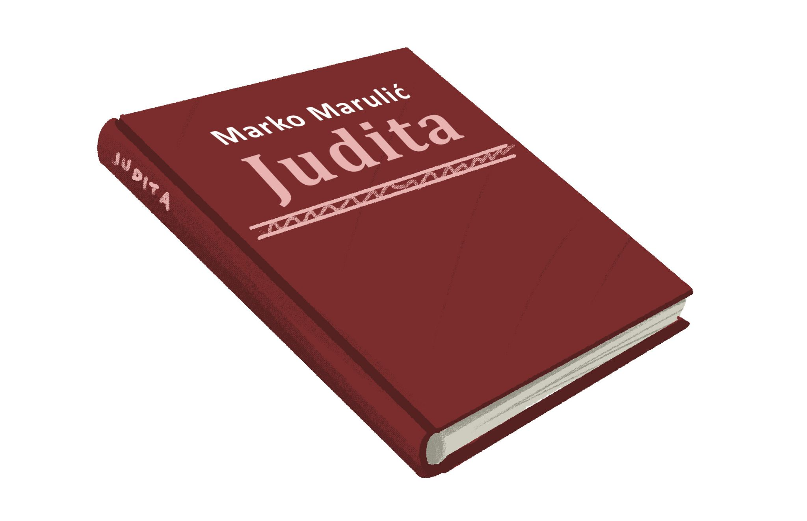 | 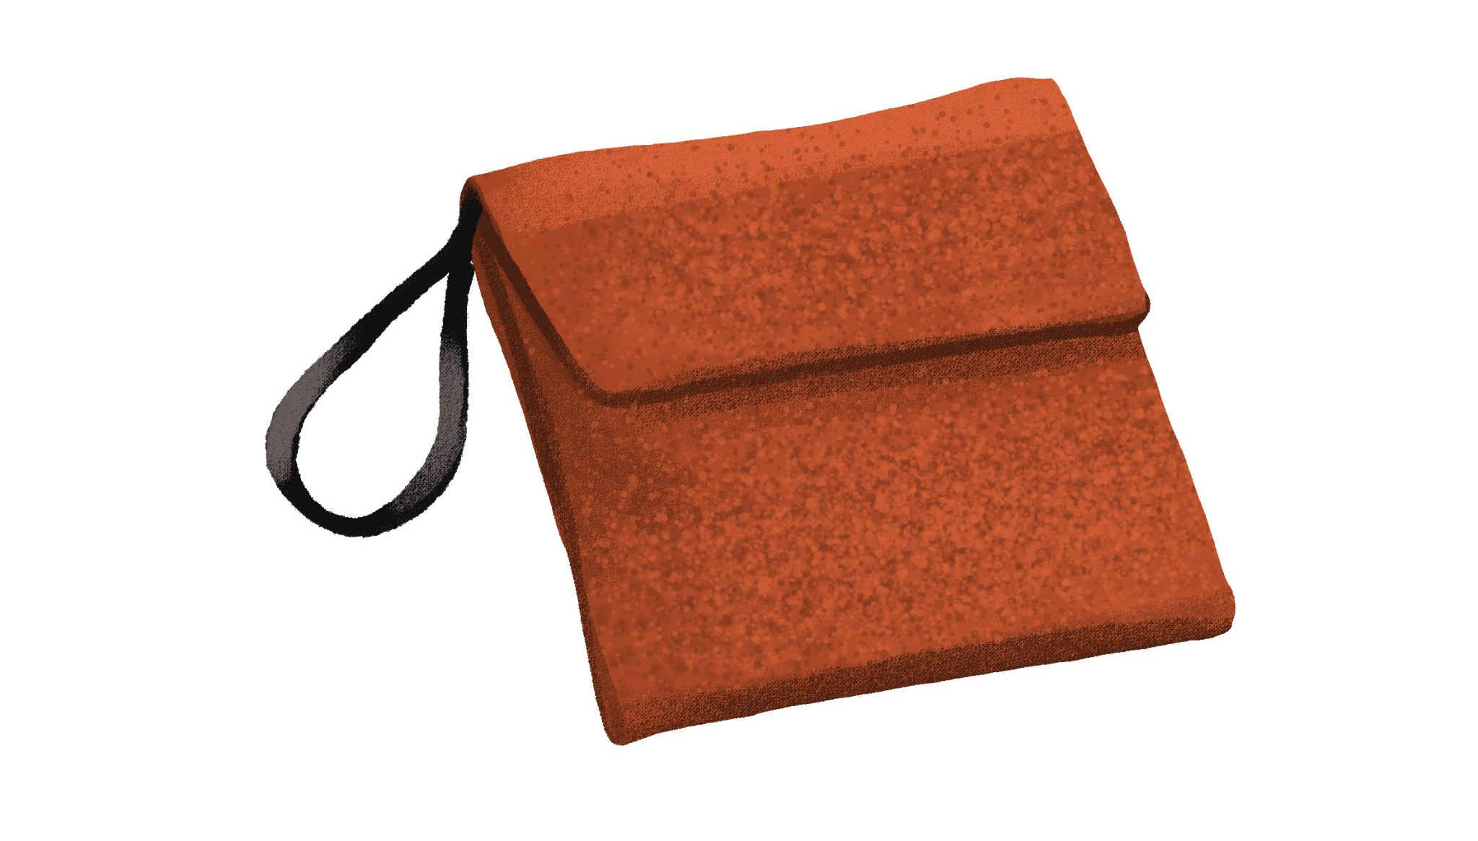 | 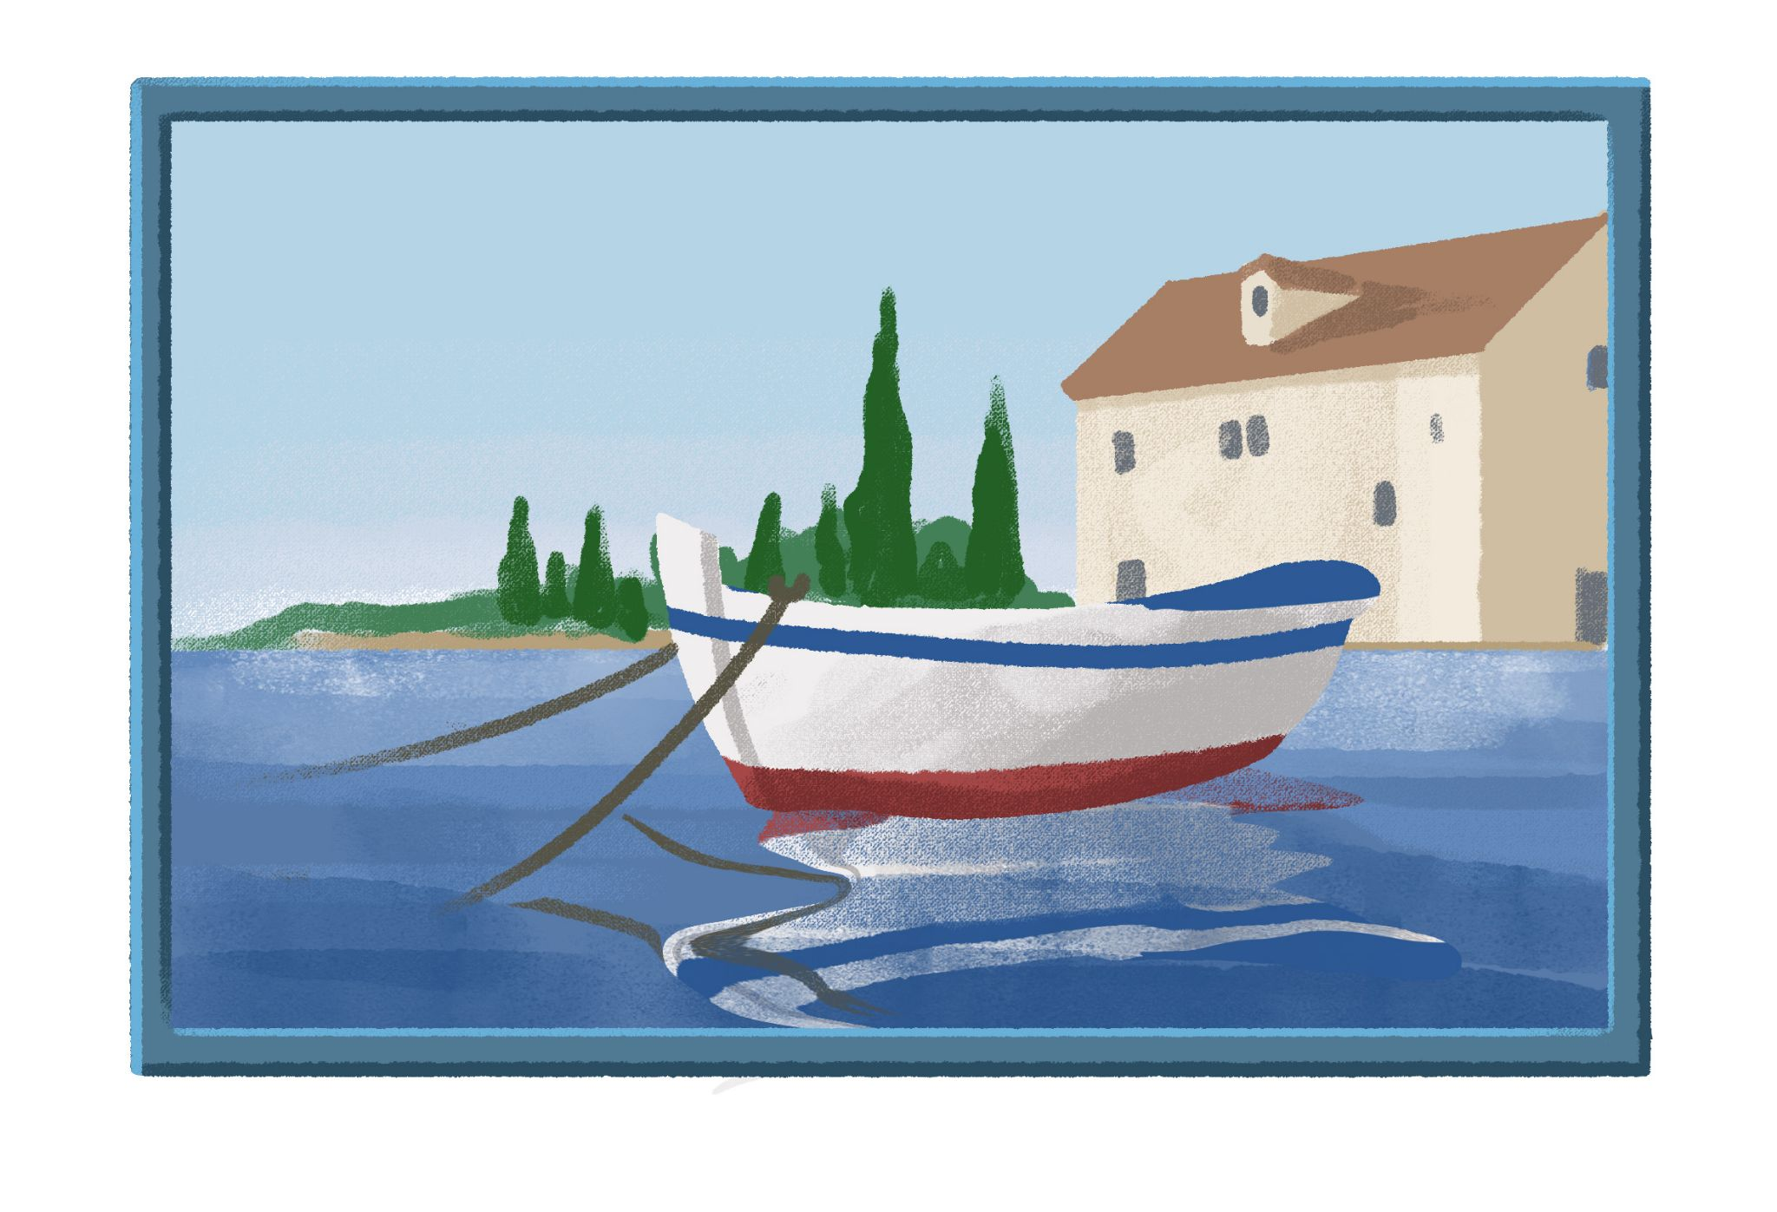
(audio) | (audio) | (audio)

 | tetak | teta | ujna | tata | rođak | dobra ideja | loša ideja
1
2
3
4
5
6

Part 3
Suggest what other gifts James might buy for them. (Možda James može kupiti [kome] [što].)
| Moja preporuka
→

6.2 Zadatak 8. Kome i što darovati?
Answer the following questions in complete sentences:
1 | Kome želiš darovati tradicionalni hrvatski kišobran?
1 | -
2 | Kome ćeš pokazati Austin?
2 | -
3 | Kome često pripremaš večeru?
3 | -
4 | Kome želiš pisati razglednicu?
4 | -
5 | Kome želiš pokloniti souvenir iz Hrvatske? Što želiš pokloniti?
5 | -
6 | Kome možeš kupiti knjigu za poklon?
6 | -

6.2 Zadatak 9. Gdje možemo kupiti poklone?

Part 1
Browse the link and decide where you can buy the following gifts. Write the name of the store next to each gift.
pitanje | odgovor
Gdje možemo kupiti CD?
Gdje možemo kupiti torbu?
Gdje možemo kupiti film na DVD-u?
Gdje možemo kupiti privjesak?
Gdje možemo kupiti maramu?
Gdje možemo kupiti prsten?

Part 2
Now look again at each website and find what you will buy for your parents, brother(s), and sister(s). Find at least one gift for each person. Answer the questions based on your family members.
1 | Što želiš kupiti mami?
1 | -
2 | Što želiš kupiti sestri?
2 | -
3 | Što želiš kupiti tati?
3 | -
4 | Što želiš kupiti bratu?
4 | -

6.2 Zadatak 10. Gdje u šoping?
Look at the internet shopping links by clicking on the word, then decide what present you would most likely buy on that site. All the websites represent traditional gifts from Croatia.

Part 1
Mark the correct answer(s).
Crorec | Ovdje mogu kupiti parfem. | Ovdje mogu kupiti film. | Ovdje mogu kupiti ploče ili CD.
Zaks | Ovdje mogu kupiti maramu. | Ovdje mogu kupiti kravatu. | Ovdje mogu kupiti sat.
Zagreb | Ovdje mogu kupiti šal. | Ovdje mogu kupiti jaknu. | Ovdje mogu kupiti kišobran.
Amara | Ovdje mogu kupiti kravatu. | Ovdje mogu kupiti prsten. | Ovdje mogu kupiti šal.
Aromatica | Ovdje mogu kupiti parfem. | Ovdje mogu kupiti mirisno ulje. | Ovdje mogu kupiti šampon.

Part 2
Find at least 4 gifts you want to buy. Copy-paste images in a Word Doc and write for whom you will buy them.

Part 3
Find at least 2 gifts that you want to buy for yourself and say why. Copy-paste those images in a Word Doc as well.

6.2 Zadatak 11. Što mogu kupiti?
👥 Create a Google doc and write a dialogue.

Student 1: You want to buy traditional souvenirs for your family members. However, you do not know what to buy for them. You need a friend's advice. Give additional information about what they like. In your communication, be sure to:
 | Ask for help/advice.
 | Express your gratitude.
 | Ask when and where to meet based on your friend’s schedule.

Student 2: Give advice for each family member. Ask for additional clarification in order to give appropriate suggestions. In your communication, be sure to:
Express your willingness to help.
Suggest places where to go shopping.
Suggest a meeting place.
Suggest shops / stores to visit.

Use both dialogues from the class session. Don’t forget to share your Google doc with your instructor.

Images used in this document are from these sources.

