7 | 1 | Lekcija 2: Ljetni odmor

| Osobine ljudi
[h5p id="779"]

| Aktivnosti na odmoru
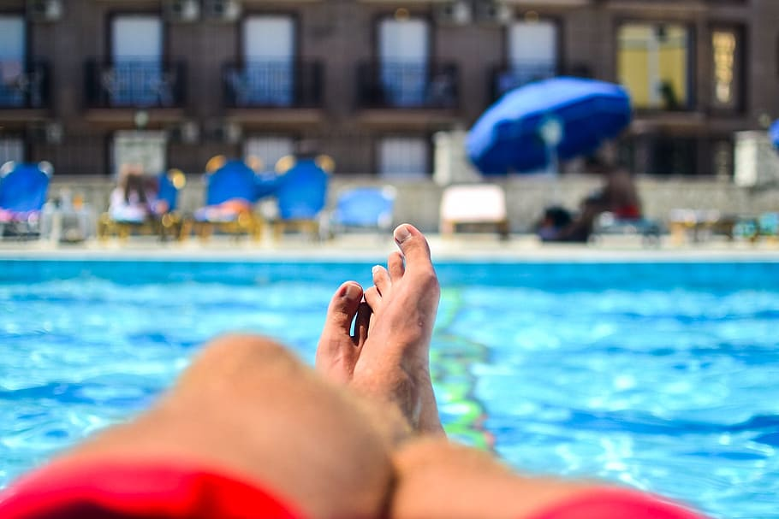 | 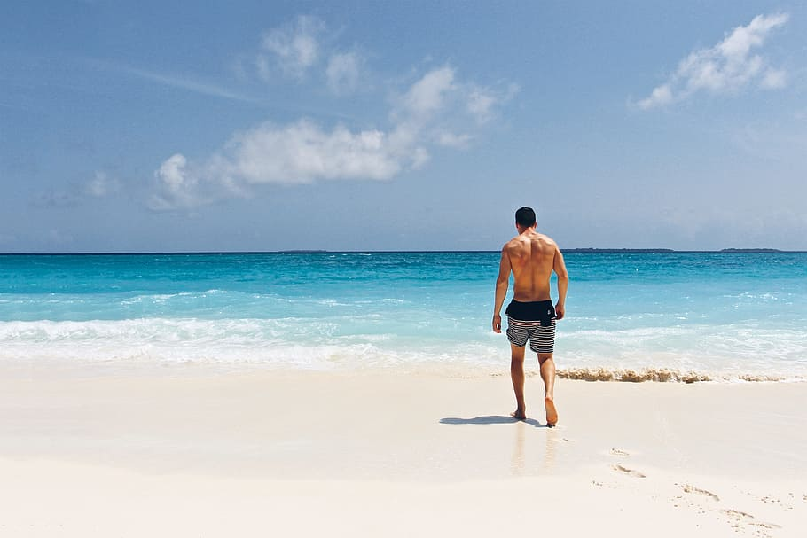 | 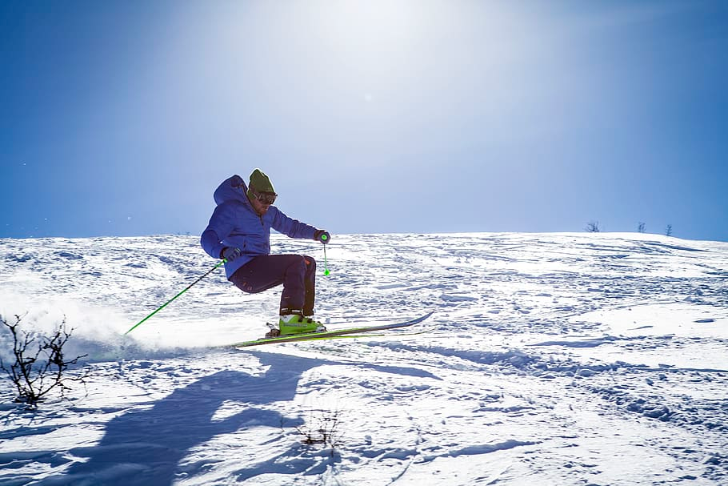 | 
odmarati (se) | biti na plaži | skijati (se) | izlaziti [u klub]
 | 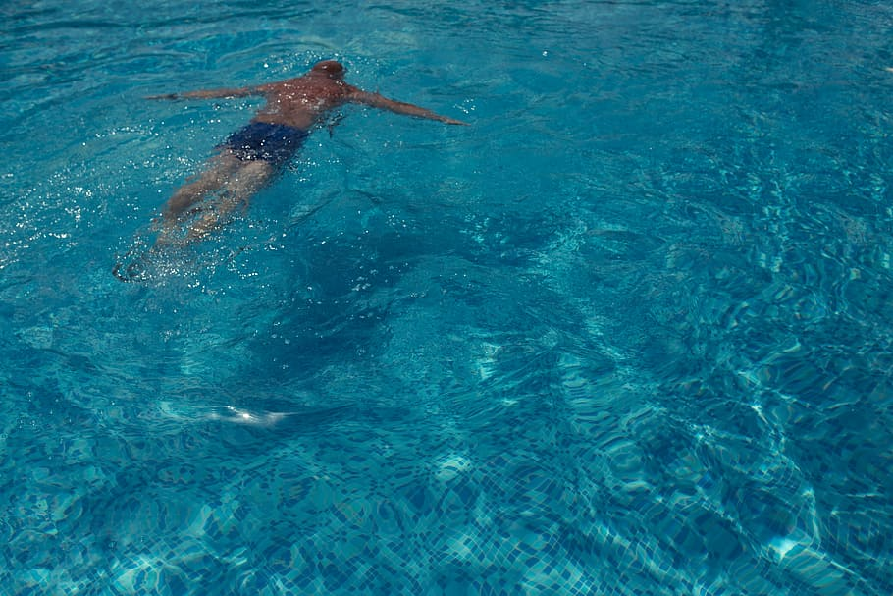 | 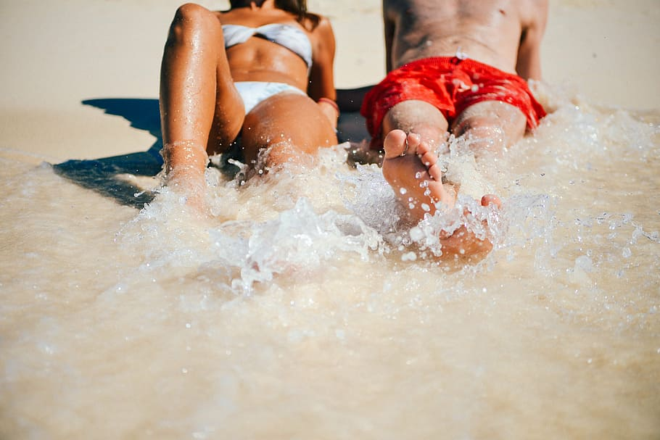 | 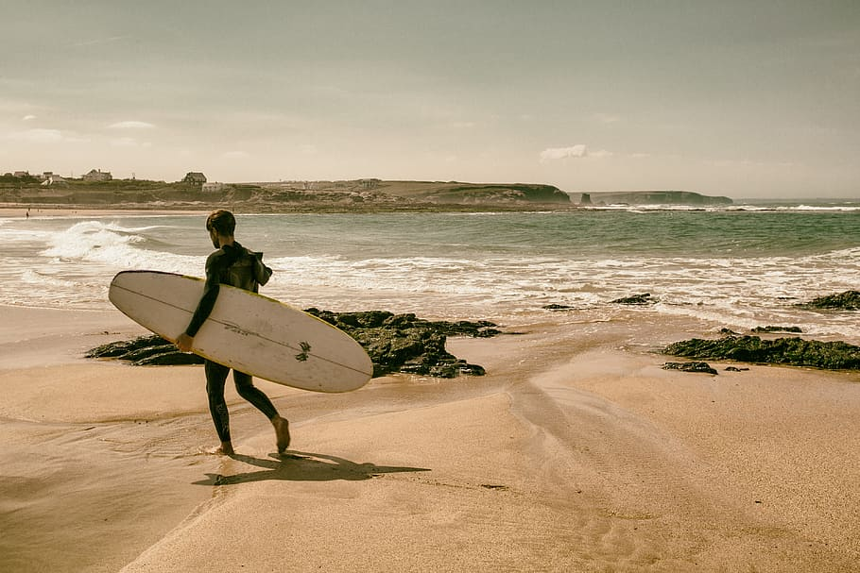
sunčati se | plivati | kupati se | surfati
 | 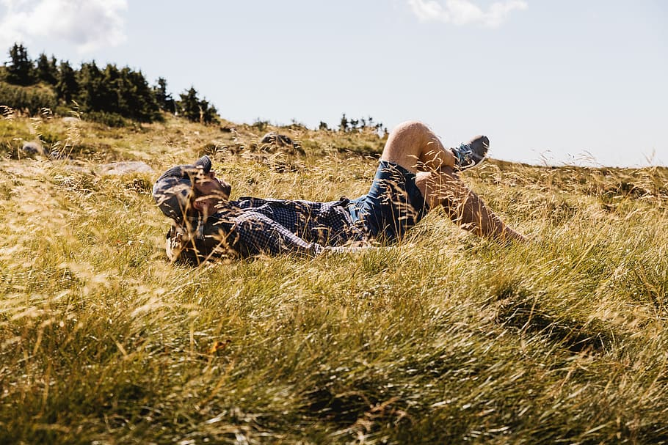 |  | 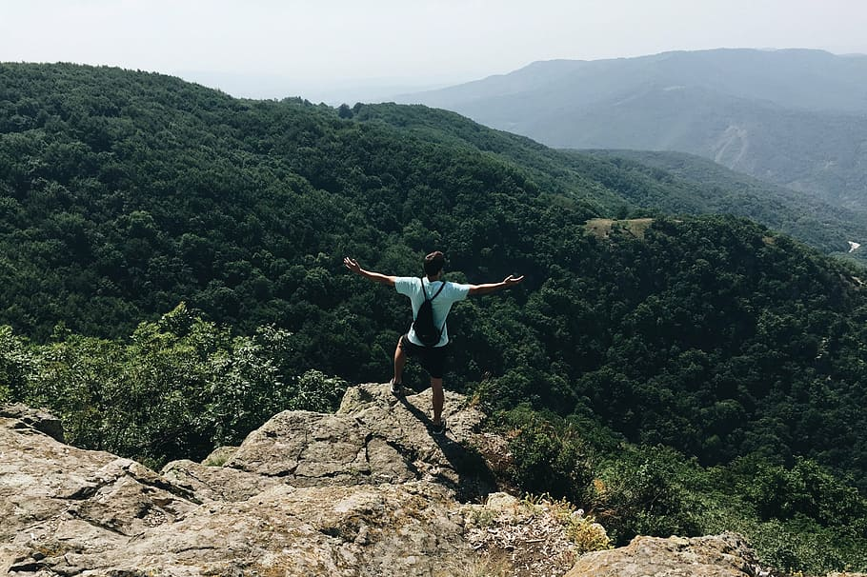
upoznati | uživati | veseliti se | planinariti

7.1 Zadatak 5. Što voliš?
The following task is about verbal nouns (skiing, swimming, hiking, etc.). Use the image attached to each sentence in order to complete the question.
[h5p id="778"]

Images used in this document are from these sources.

