6 | 2 | Lekcija 1: Mislimo na druge

6.2 Zadatak 1. Suveniri
Google search: Look at the following traditional souvenirs from across the region. Match each souvenir with the appropriate country. The possessive adjective is already in the correct form so pay attention to the gender of the noun as well. Note: some of the souvenirs are traditional items from more than just one country. For the purposes of the task, they are associated with only one country at the moment.
 | 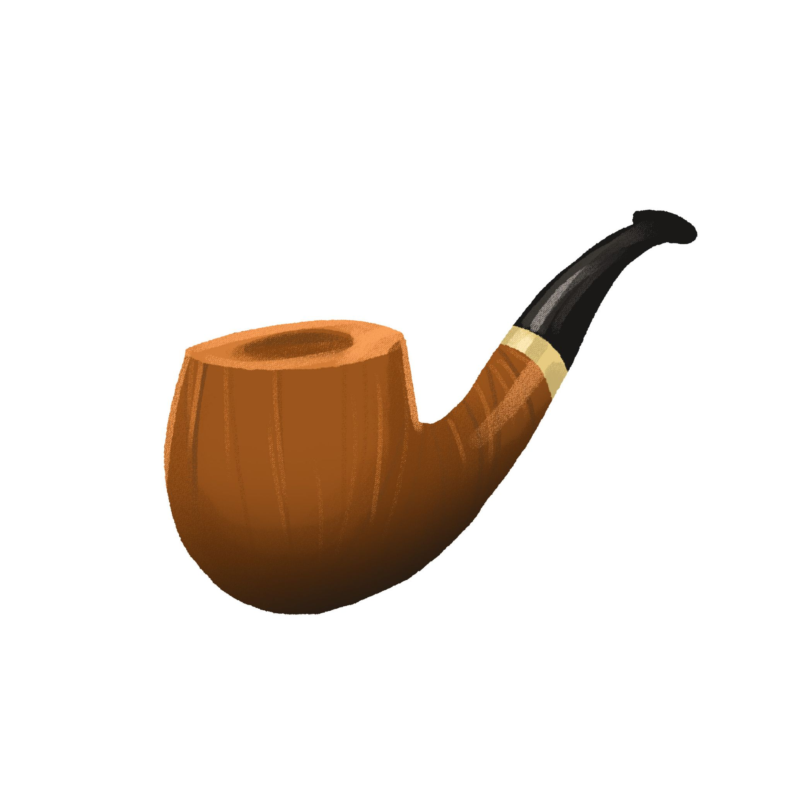 | 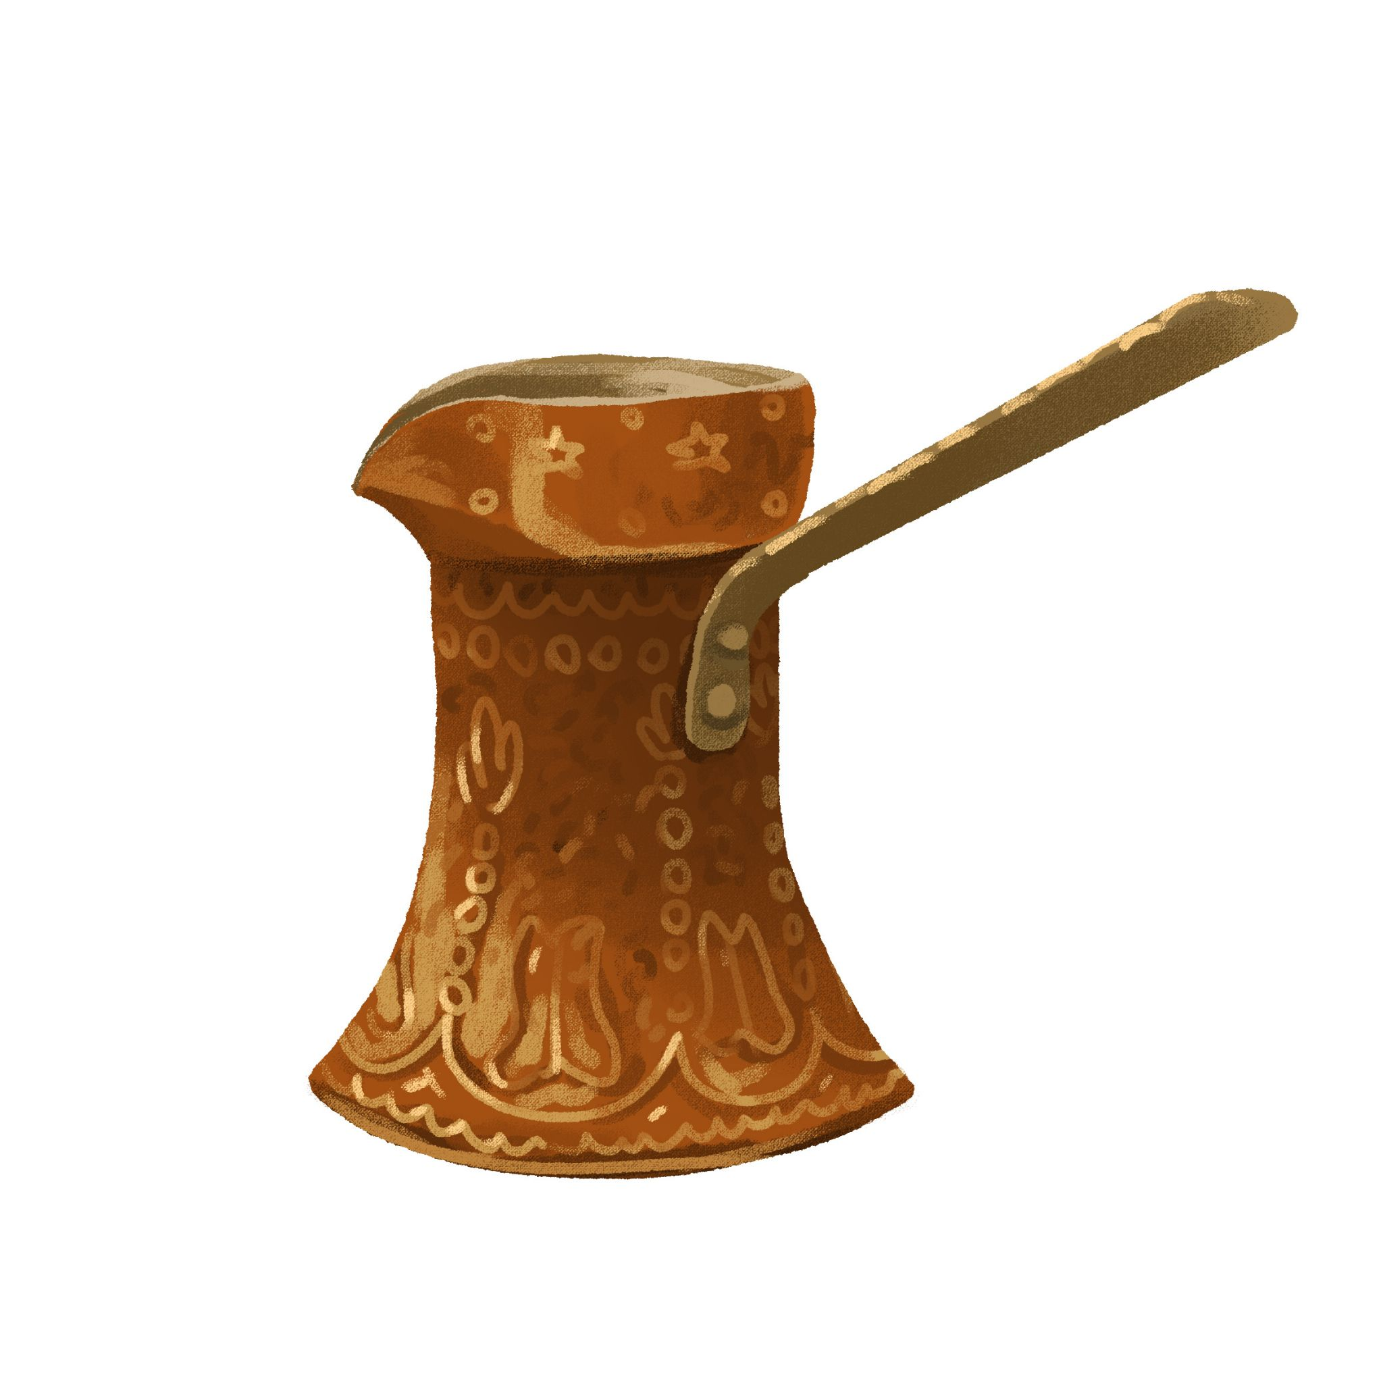 | 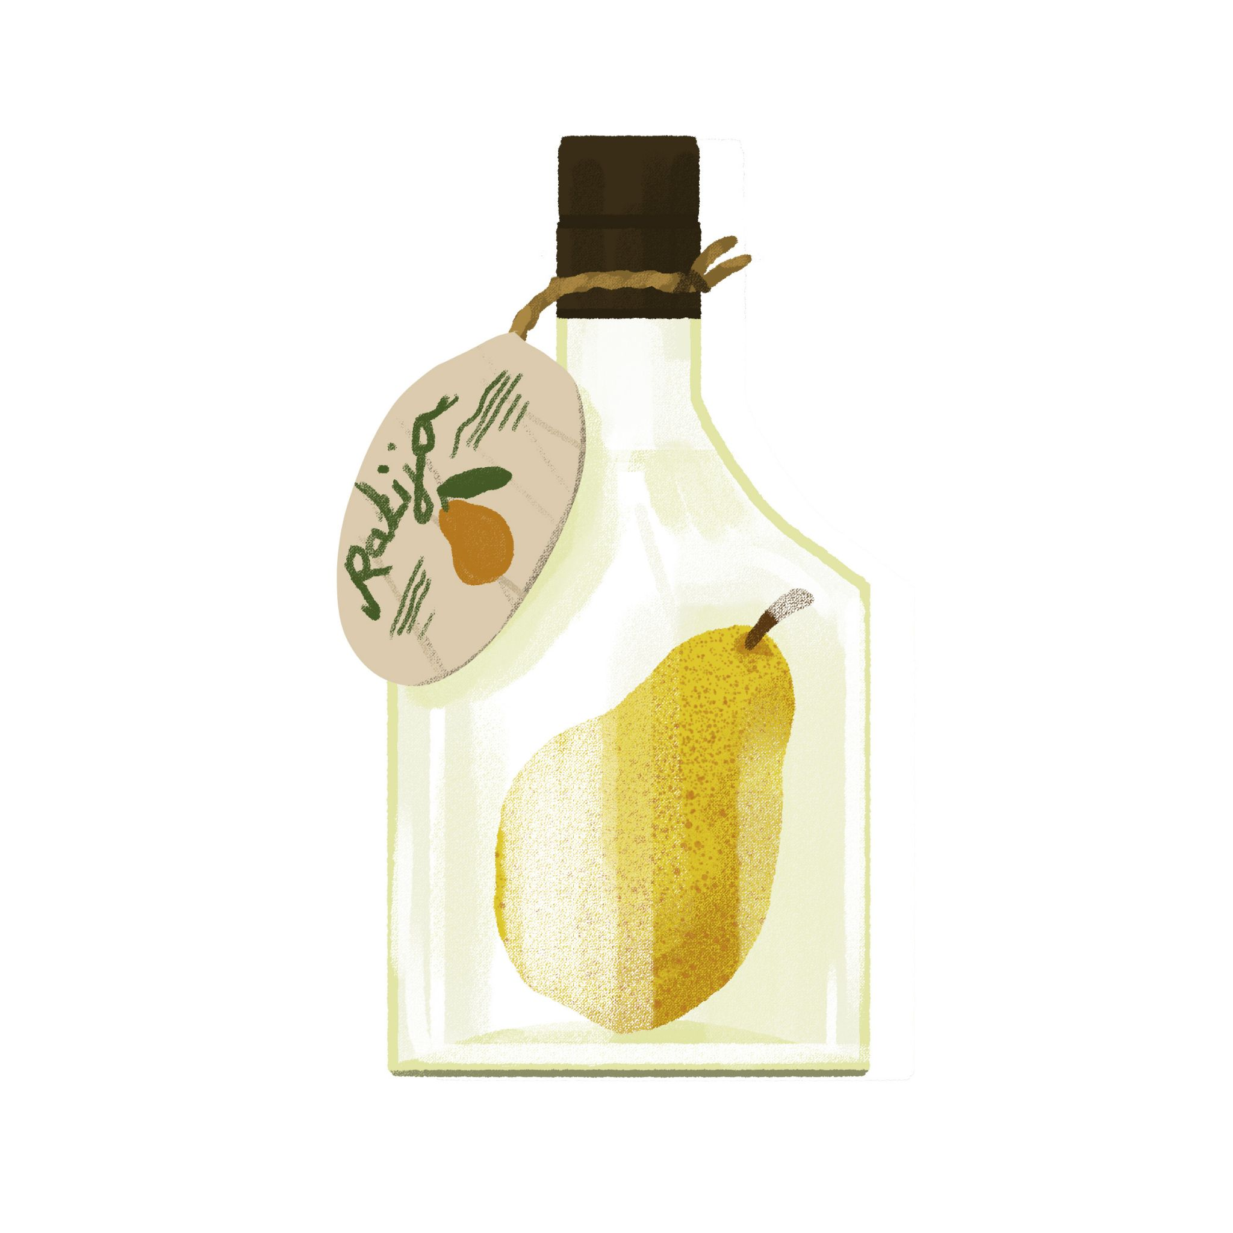
kravata | lula | džezva | rakija
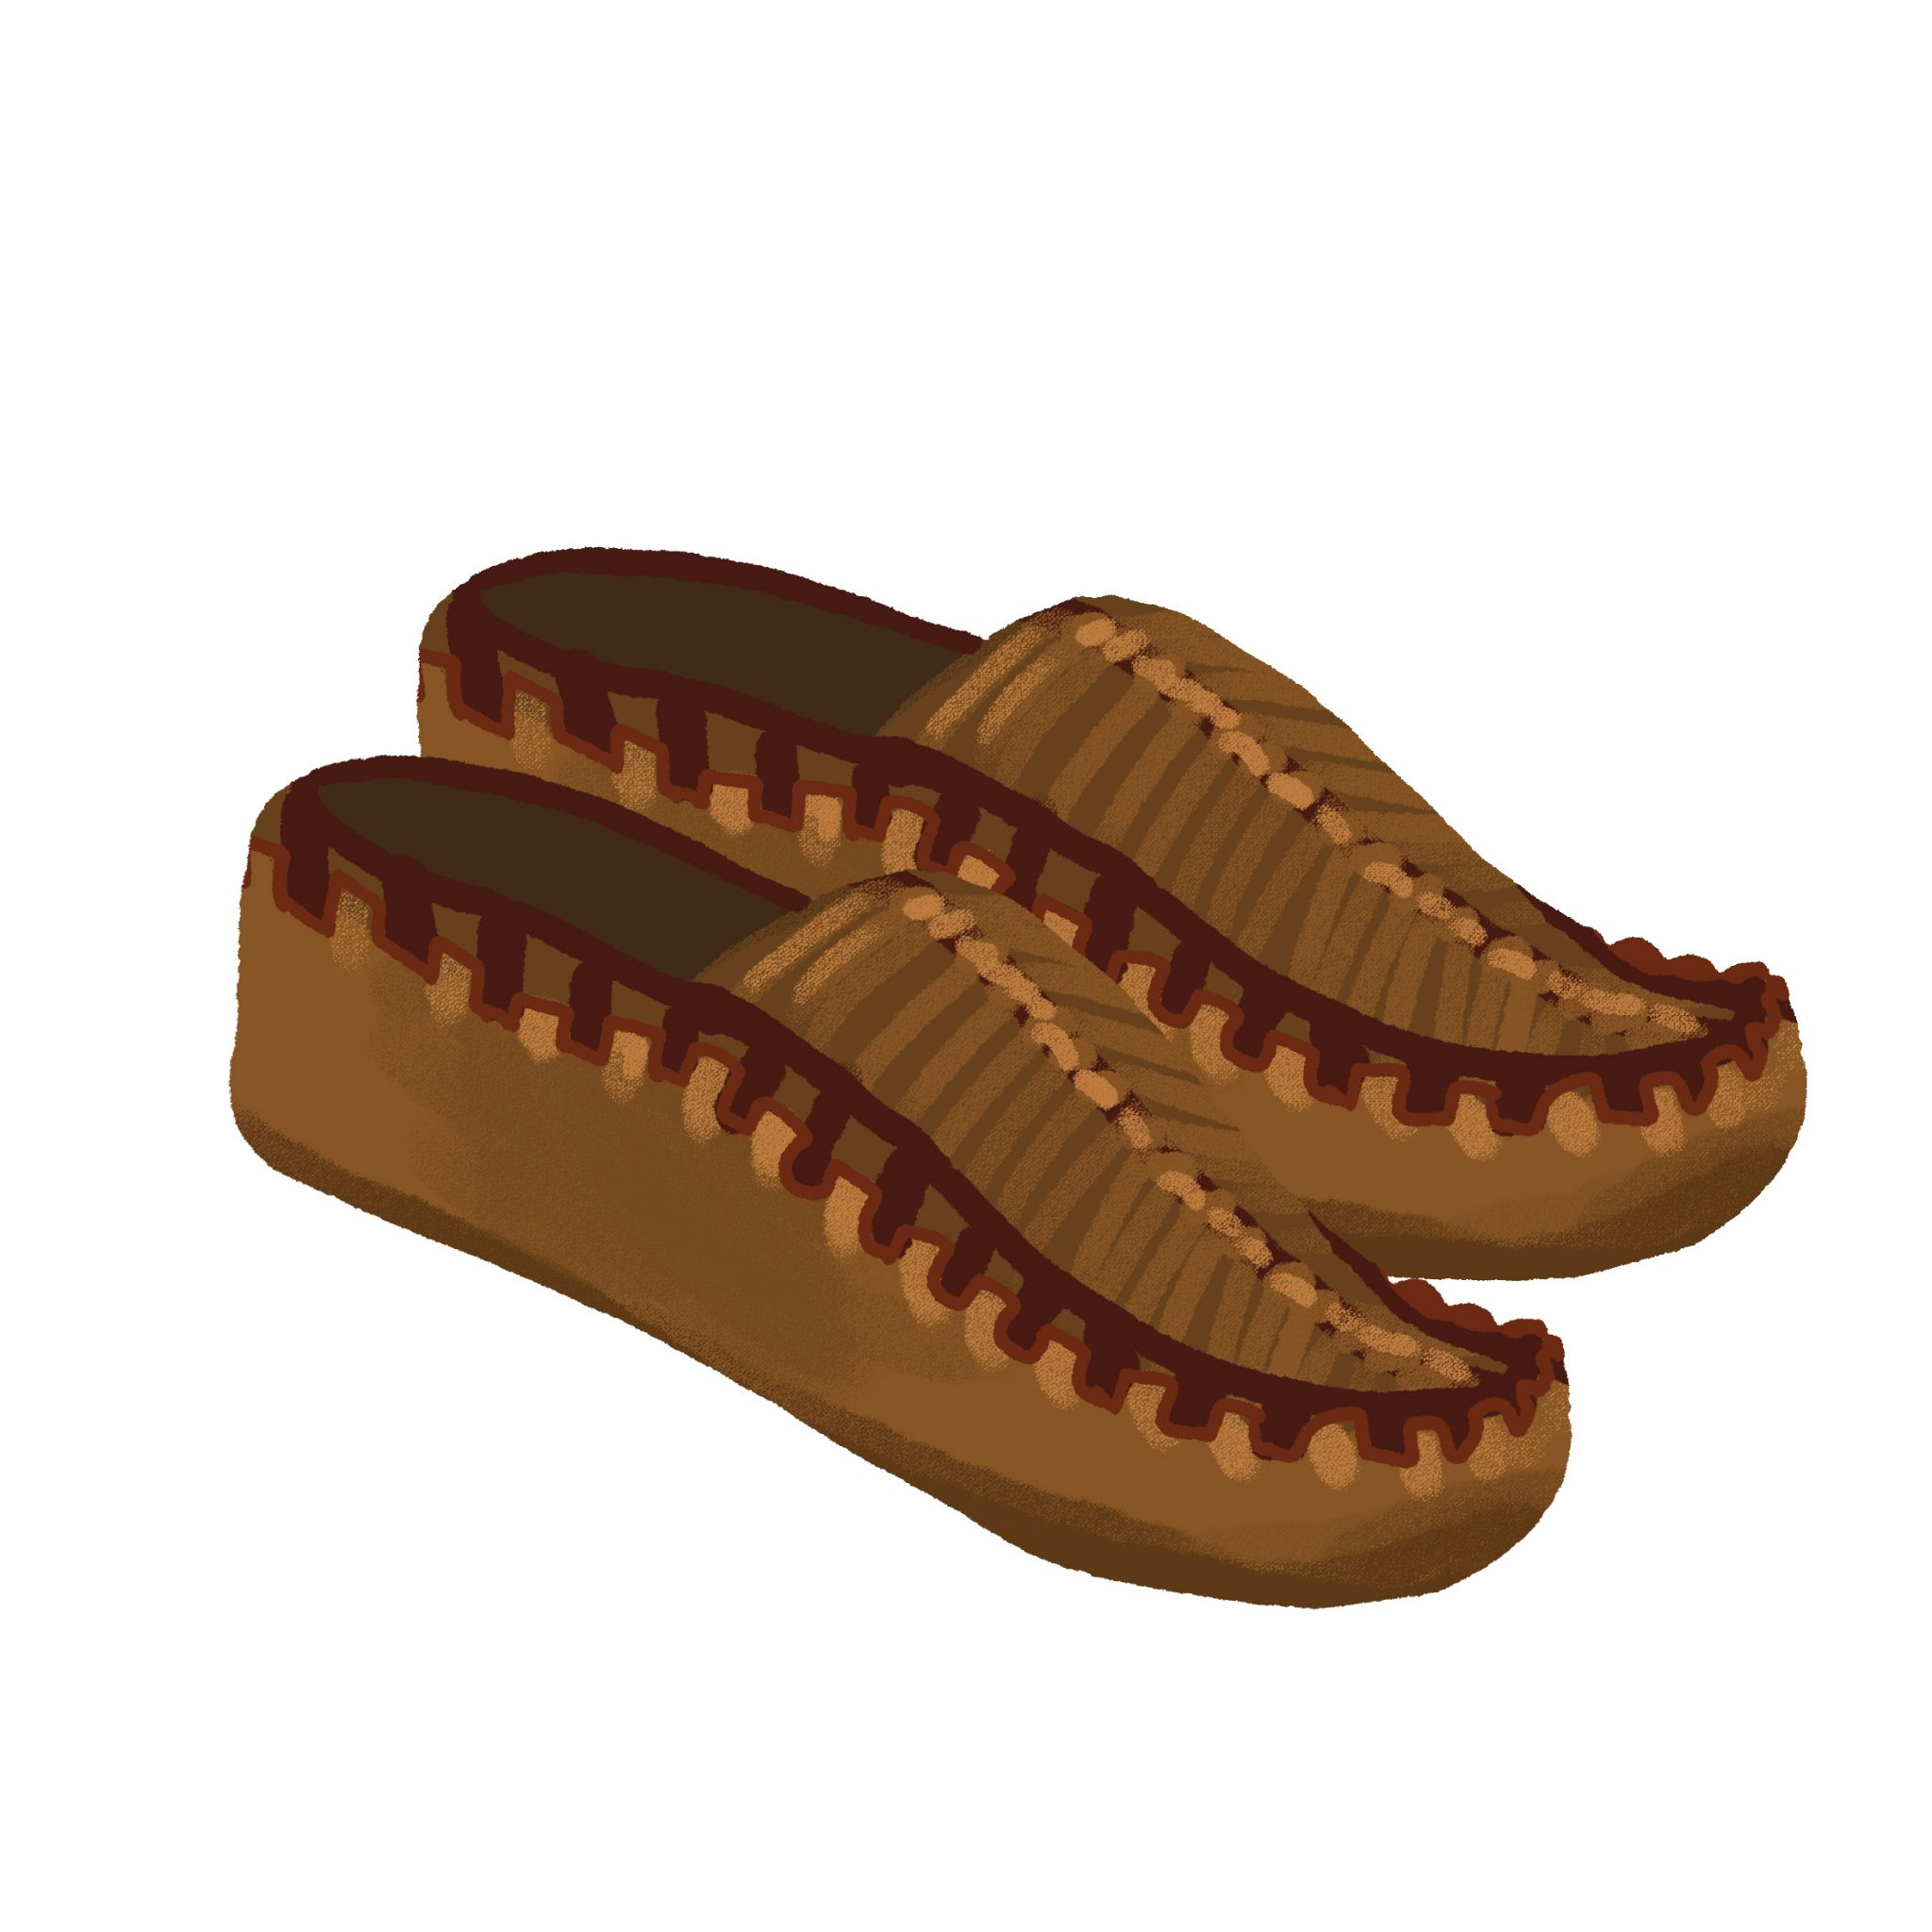 | 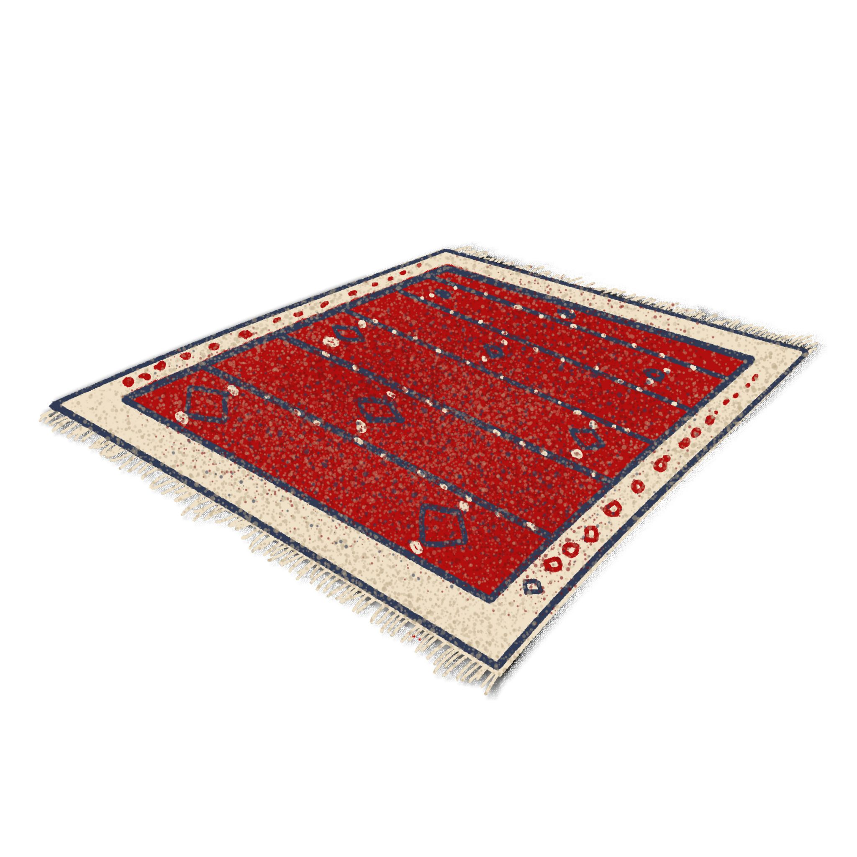 | 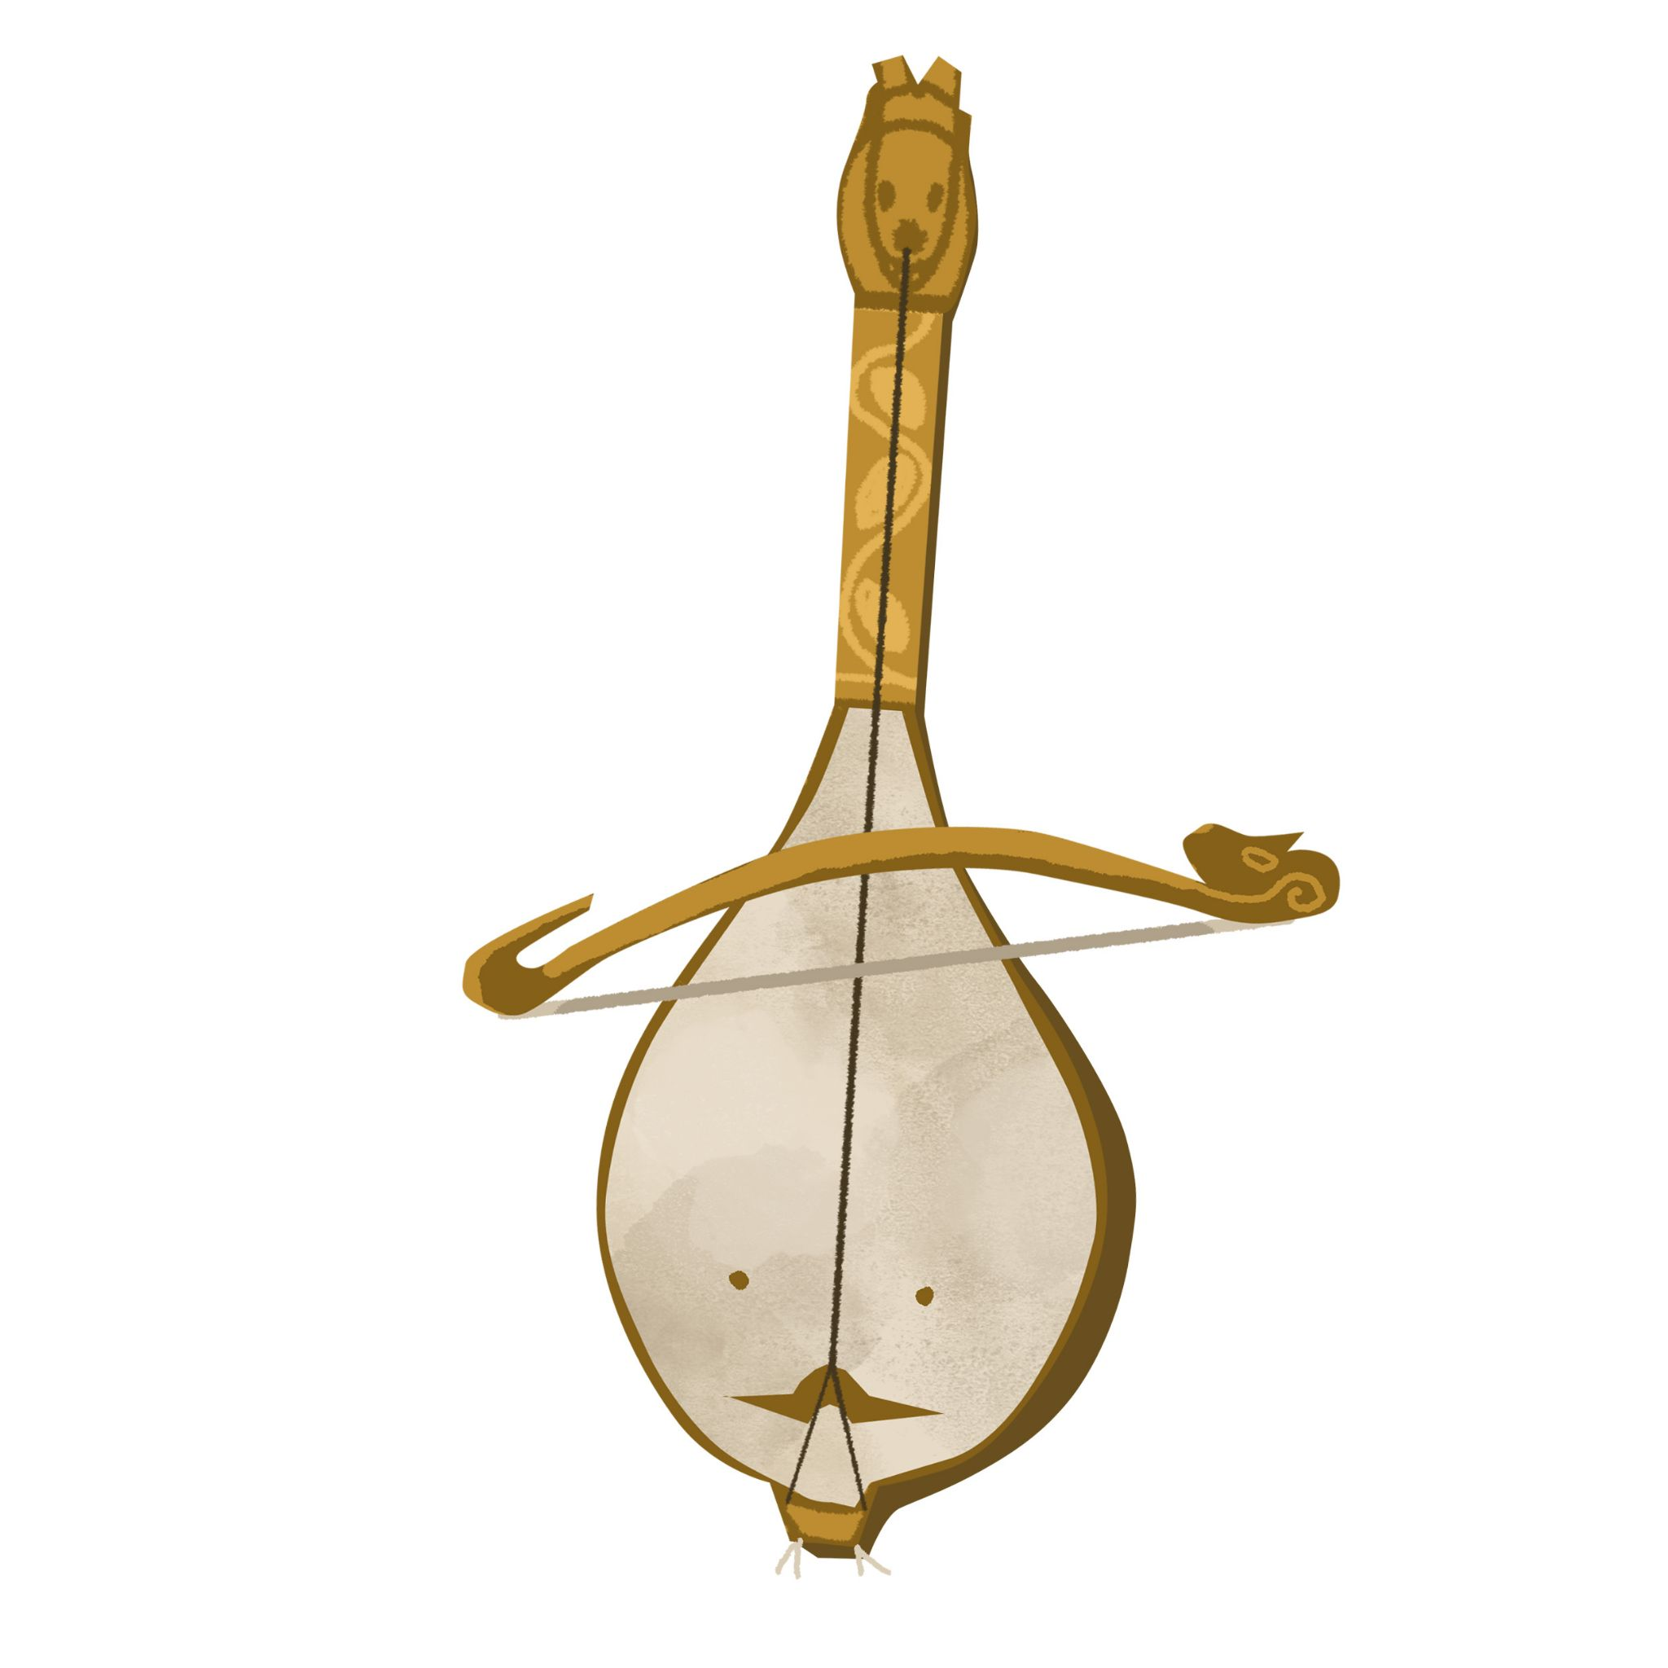 | 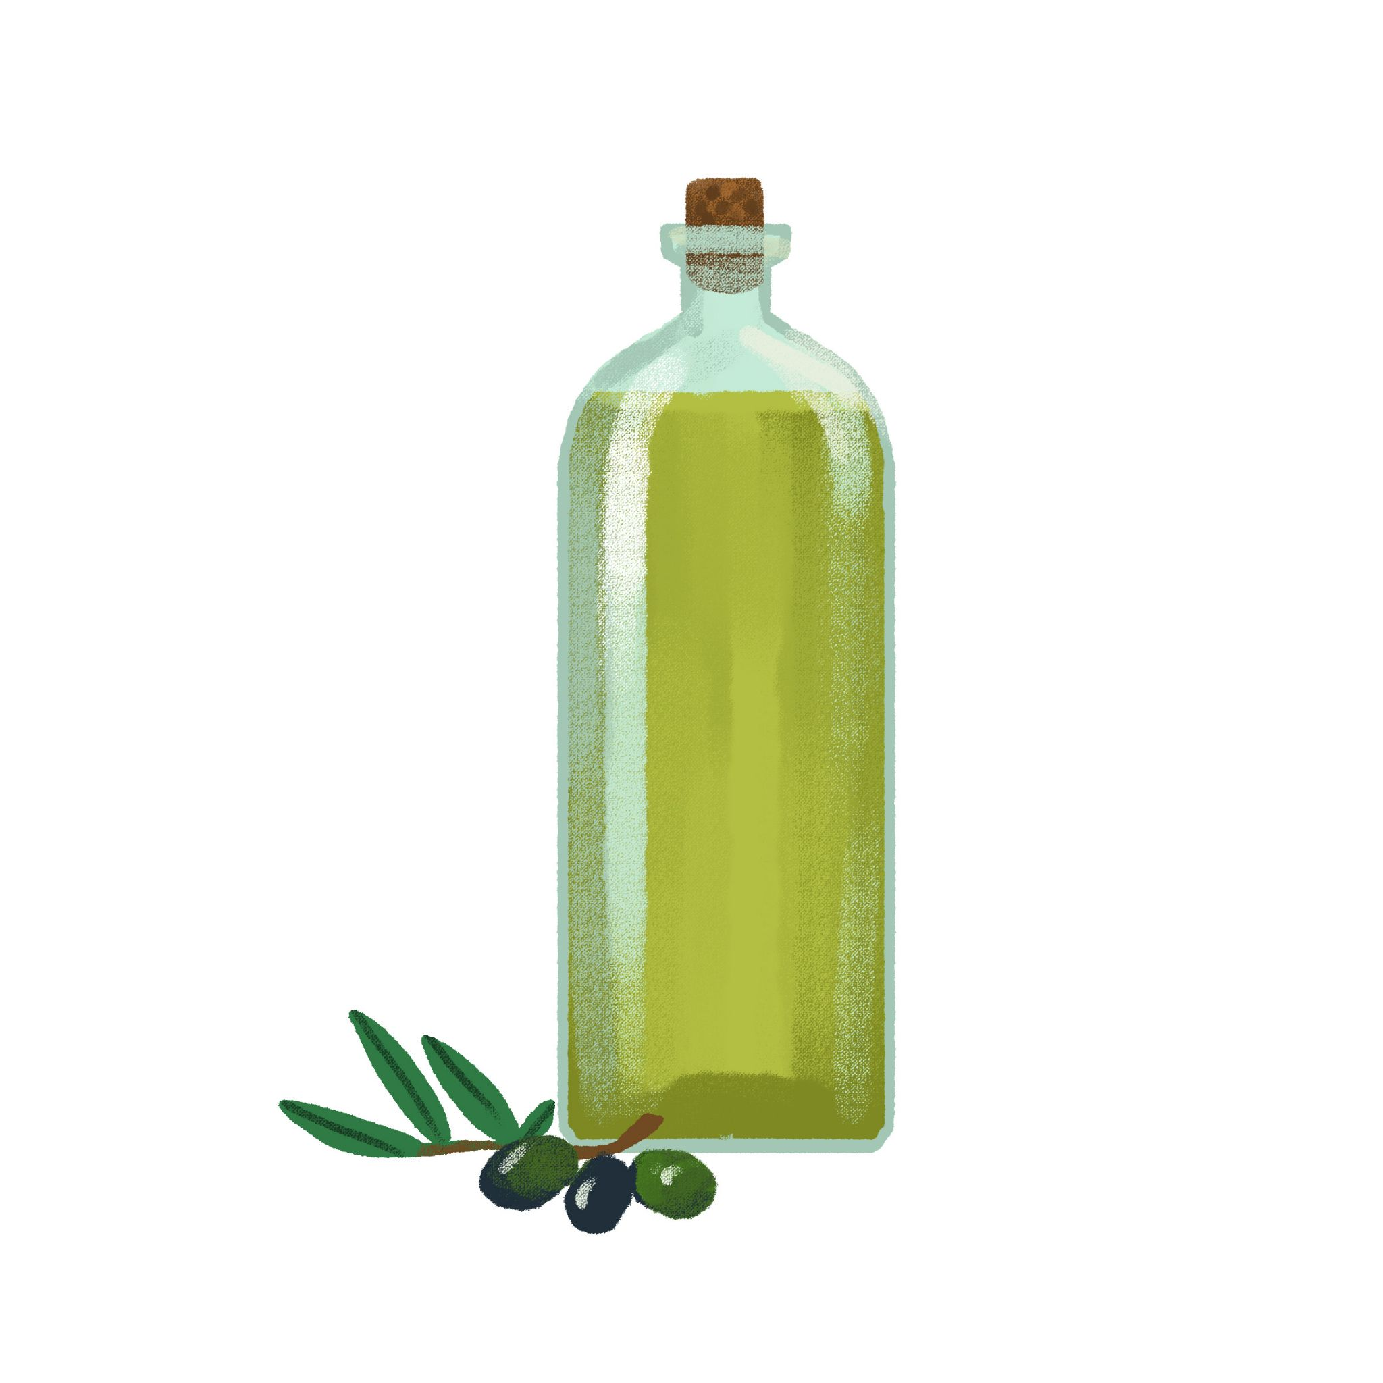
opanci | ćilim | gusle | maslinovo ulje

crnogorske | srpska | hrvatska | bosanski
hrvatsko | bosanska | crnogorska | srpski

6.2 Zadatak 2. Što i kome pokloniti?
Look at the following set of potential gifts and a list of people. According to the example sentence below, write what you will buy and for whom.
Što pokloniti?
kravatu | lulu | džezvu | rakiju | lavandu
maslinovo ulje | čokoladu | vino | sliku | magnet
Kome pokloniti?
prijatelju | bratu | stricu | djedu | tati
prijateljici | sestri | teti | baki | mami

| Na primjer: Ja ću pokloniti kravatu bratu.
→
→
→
→

Talk with your classmates and find out what gifts they will buy and for whom. Mark their answers in order to find out what are the most common things you all want to buy.

Example: Kome ćeš pokloniti [kravatu]? - Bratu ću pokloniti kravatu.
↓ Što / Tko? → | Student 1: | Student 2: | Student 3: | Student 4:
kravatu
lulu
džezvu
rakiju
lavandu
ulje
čokoladu
vino
sliku
magnet

What are the top three gifts? Write your top 3 gifts below.
Top tri poklona su:

6.2 Zadatak 3. Što ćeš kupiti?
Label the following presents by writing the correct term underneath each picture. You may need to make educated guesses.
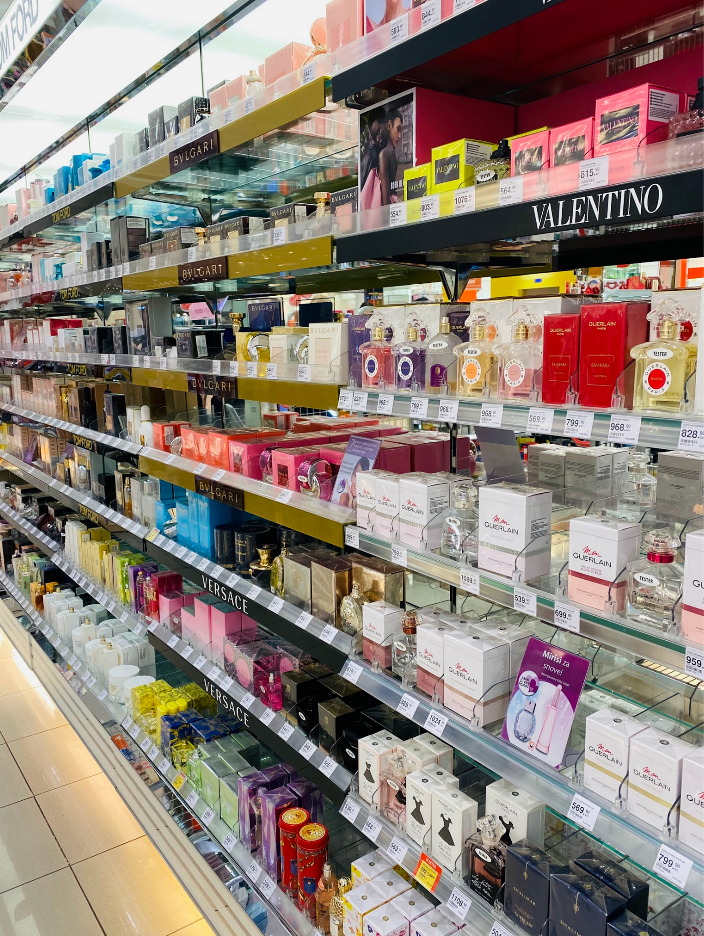 | 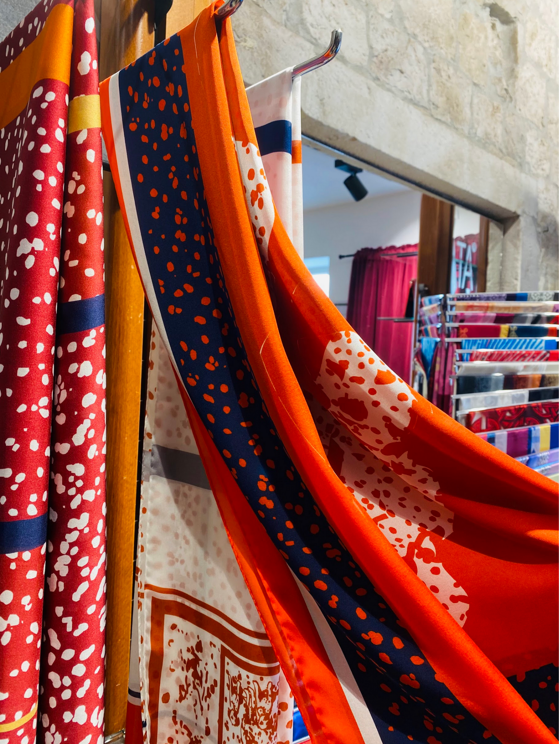 | 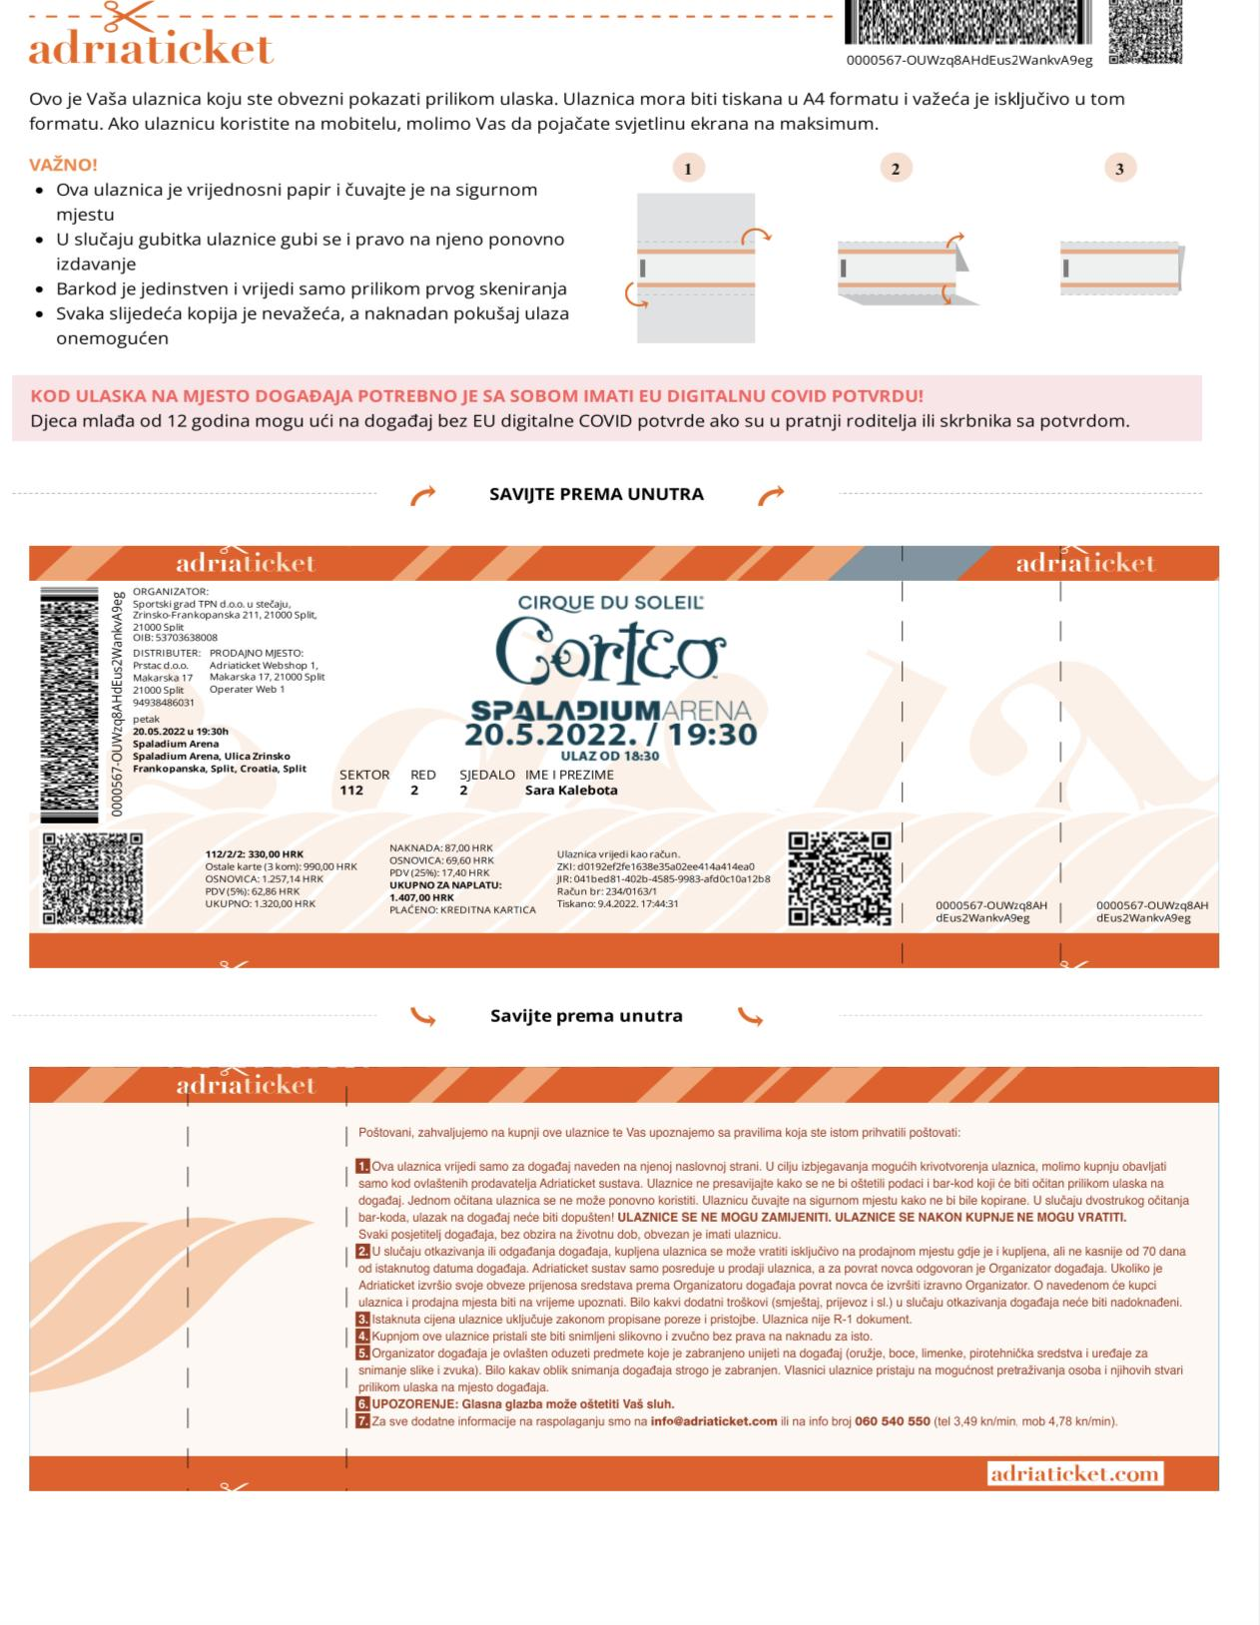 | 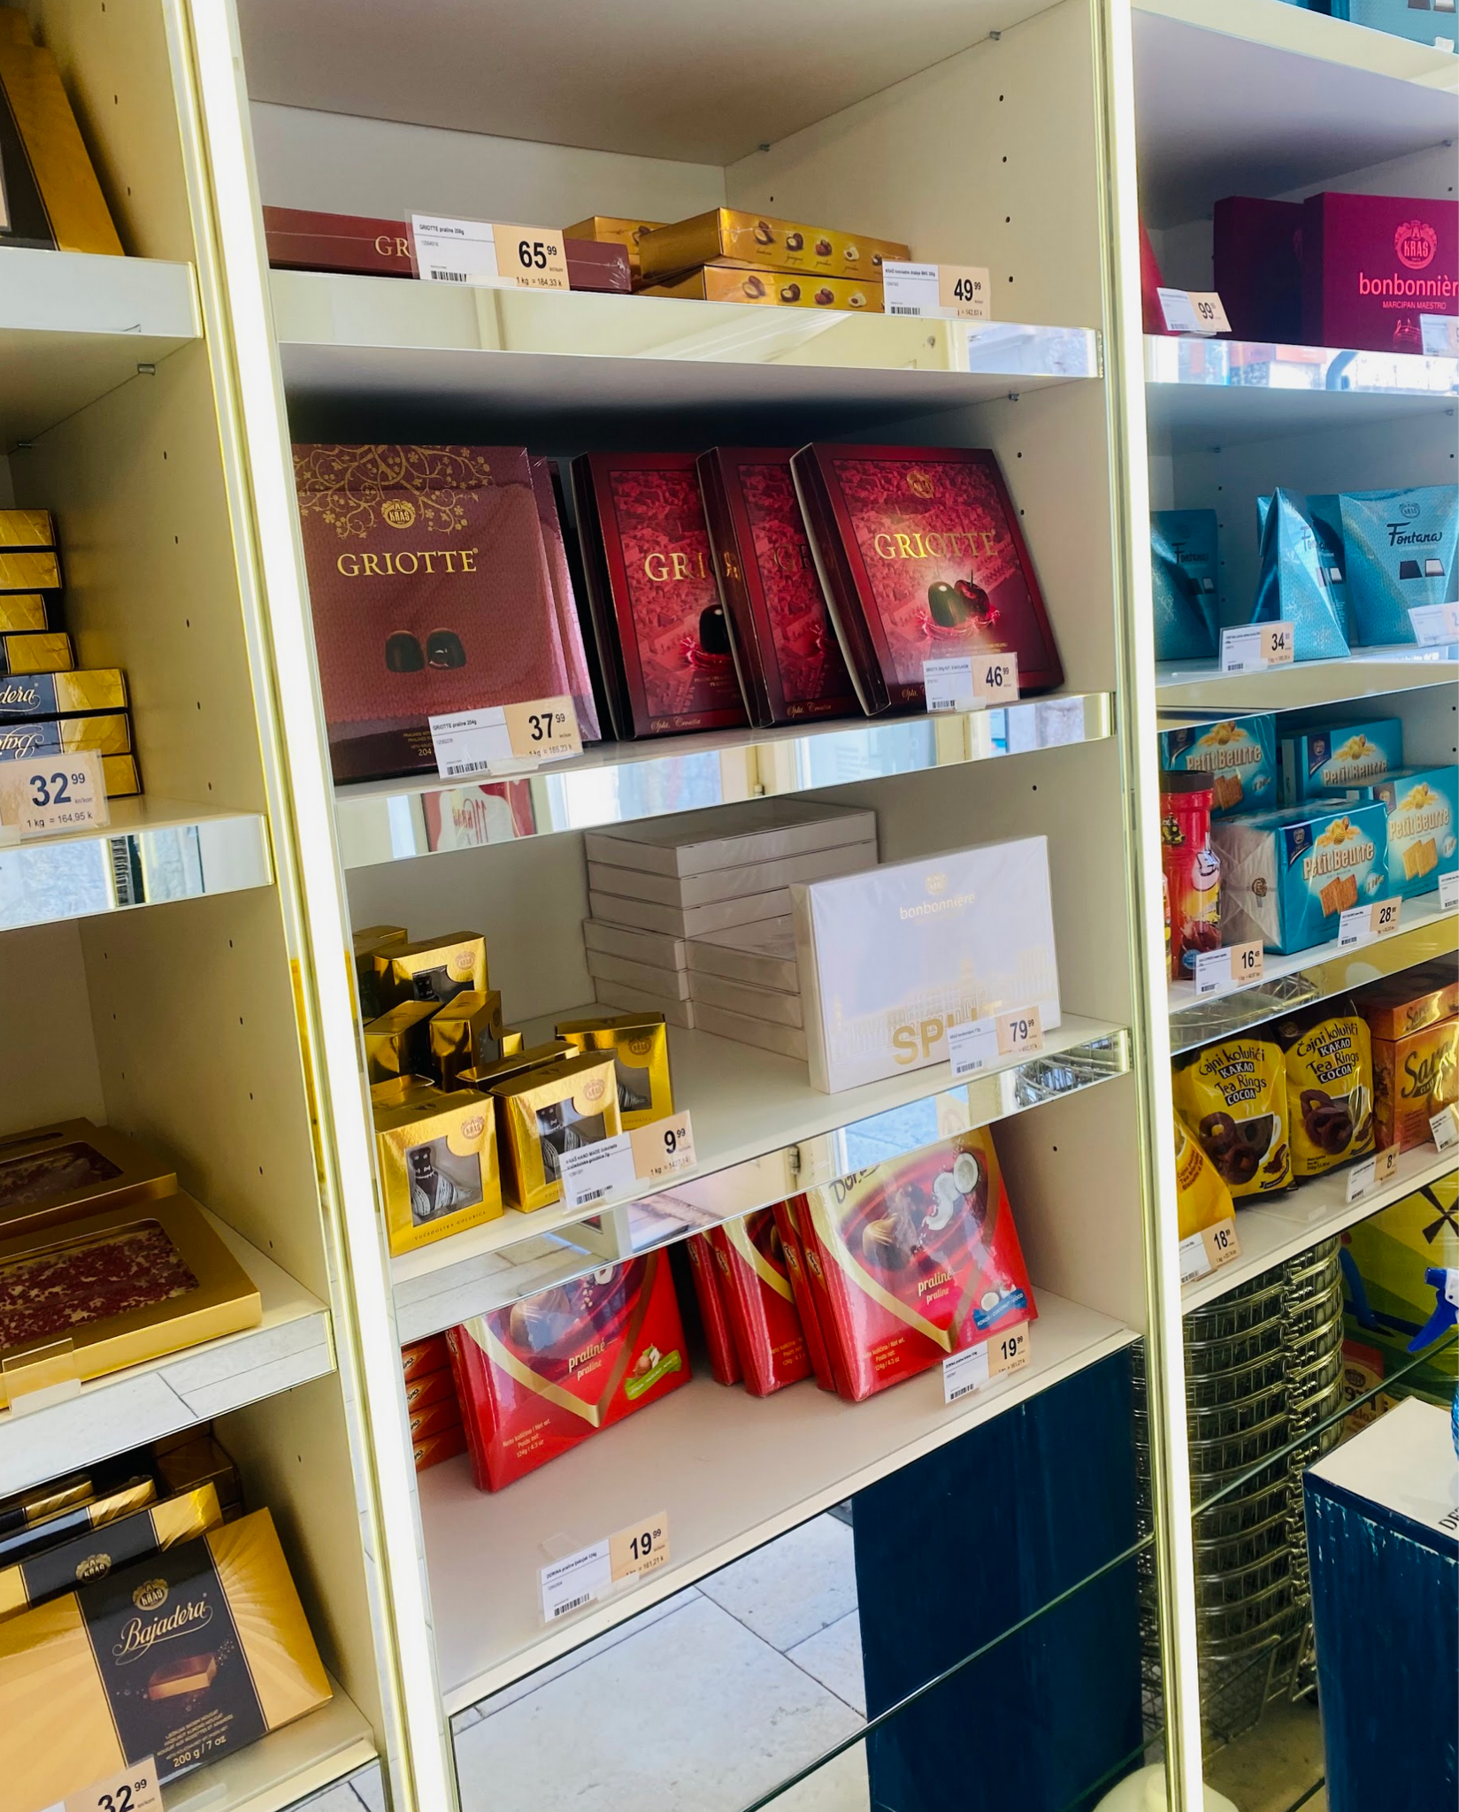
→ | → | → | →
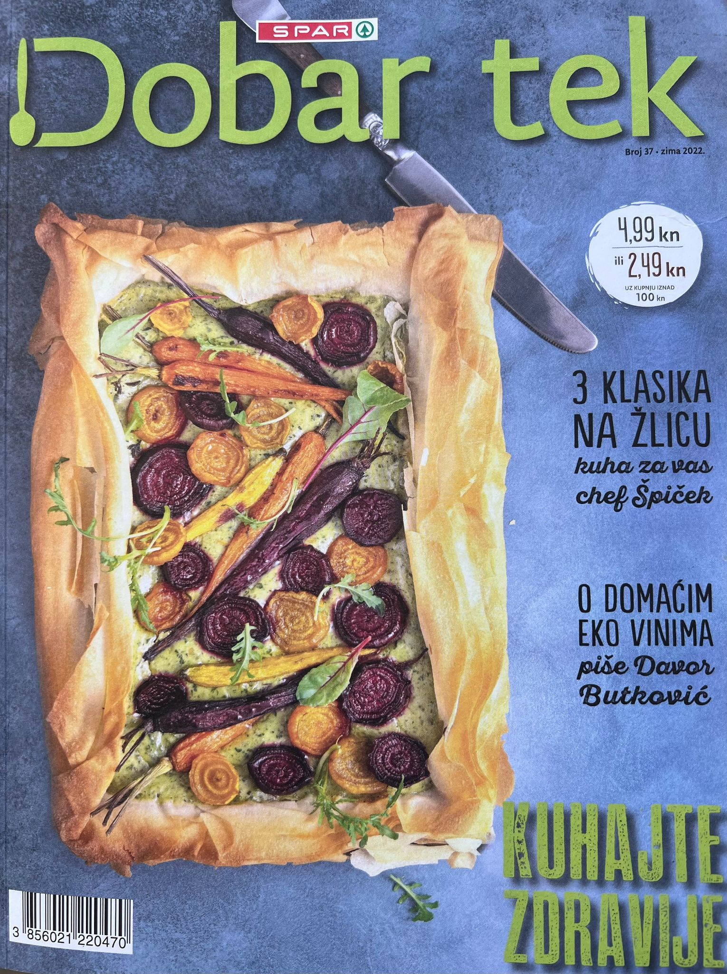 | 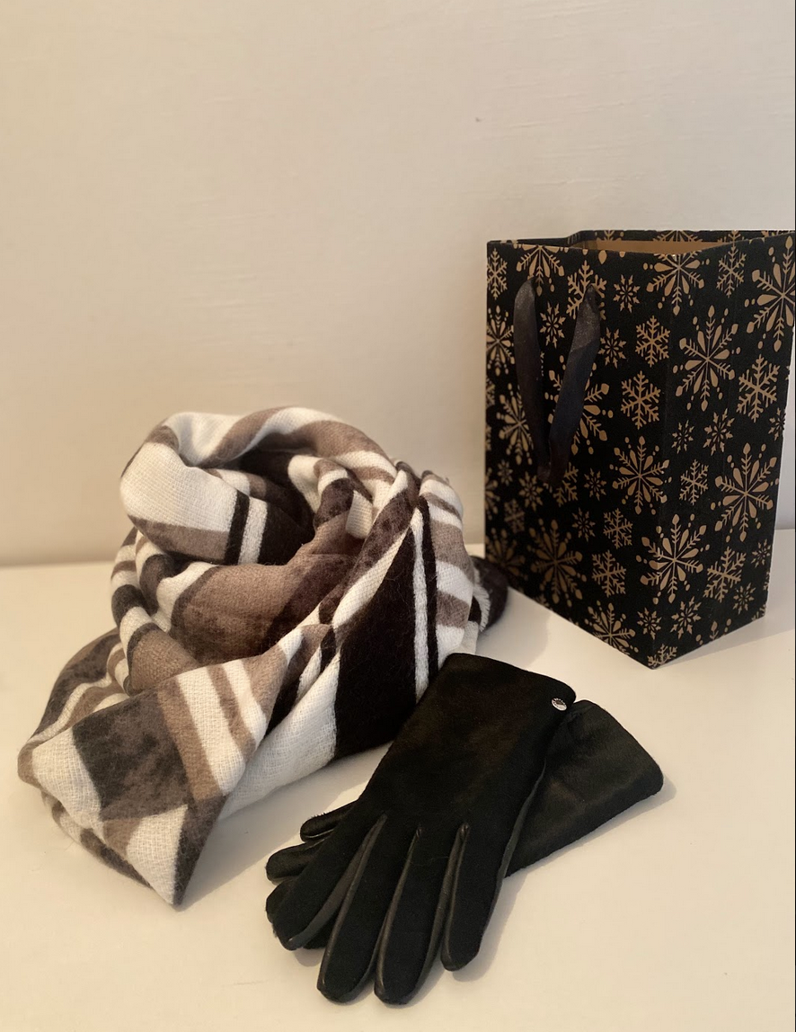 | 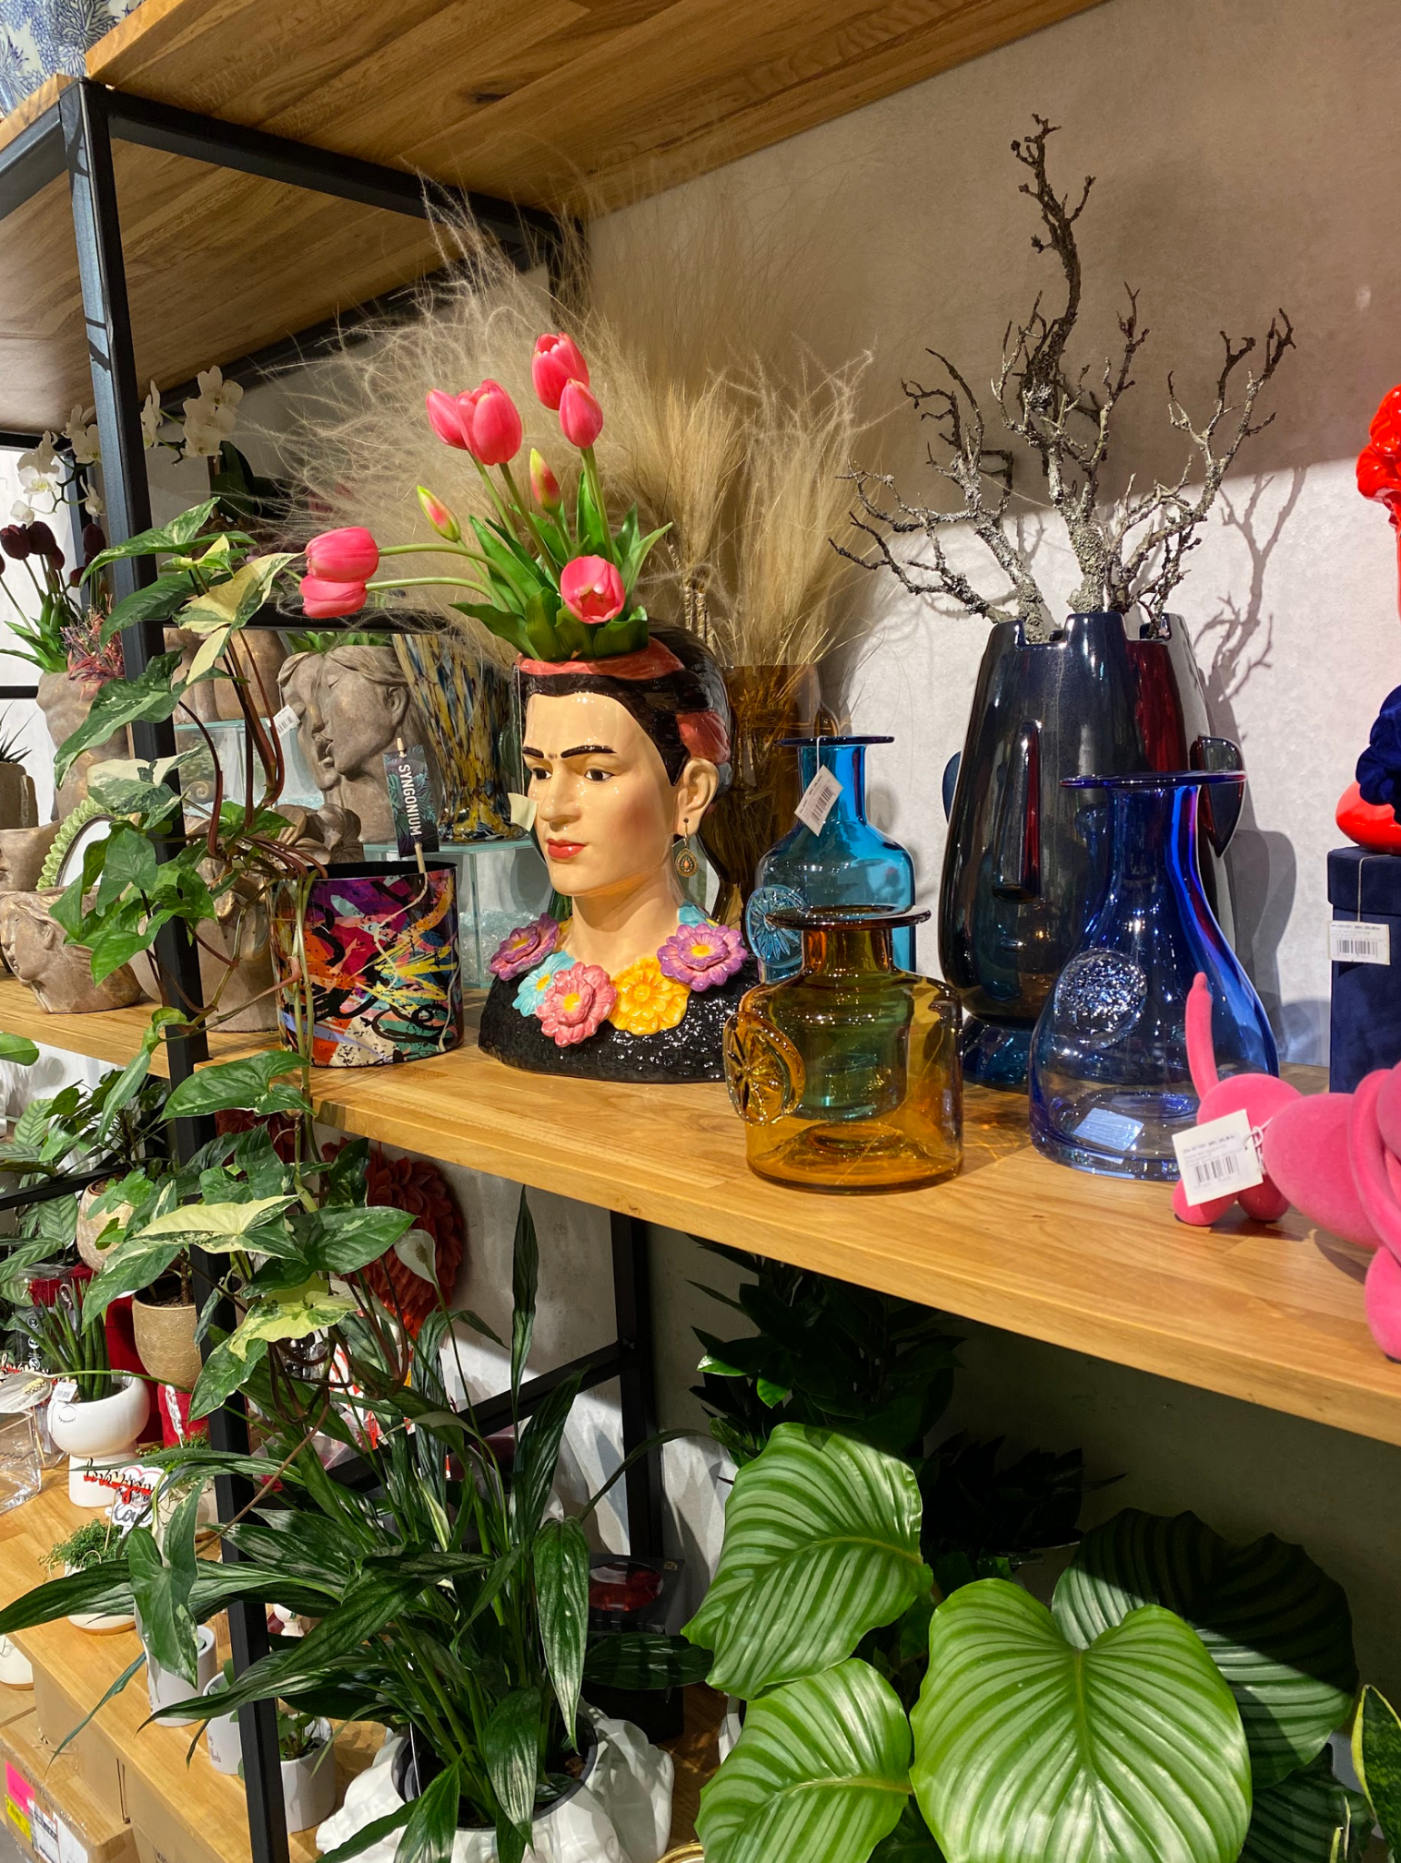 | 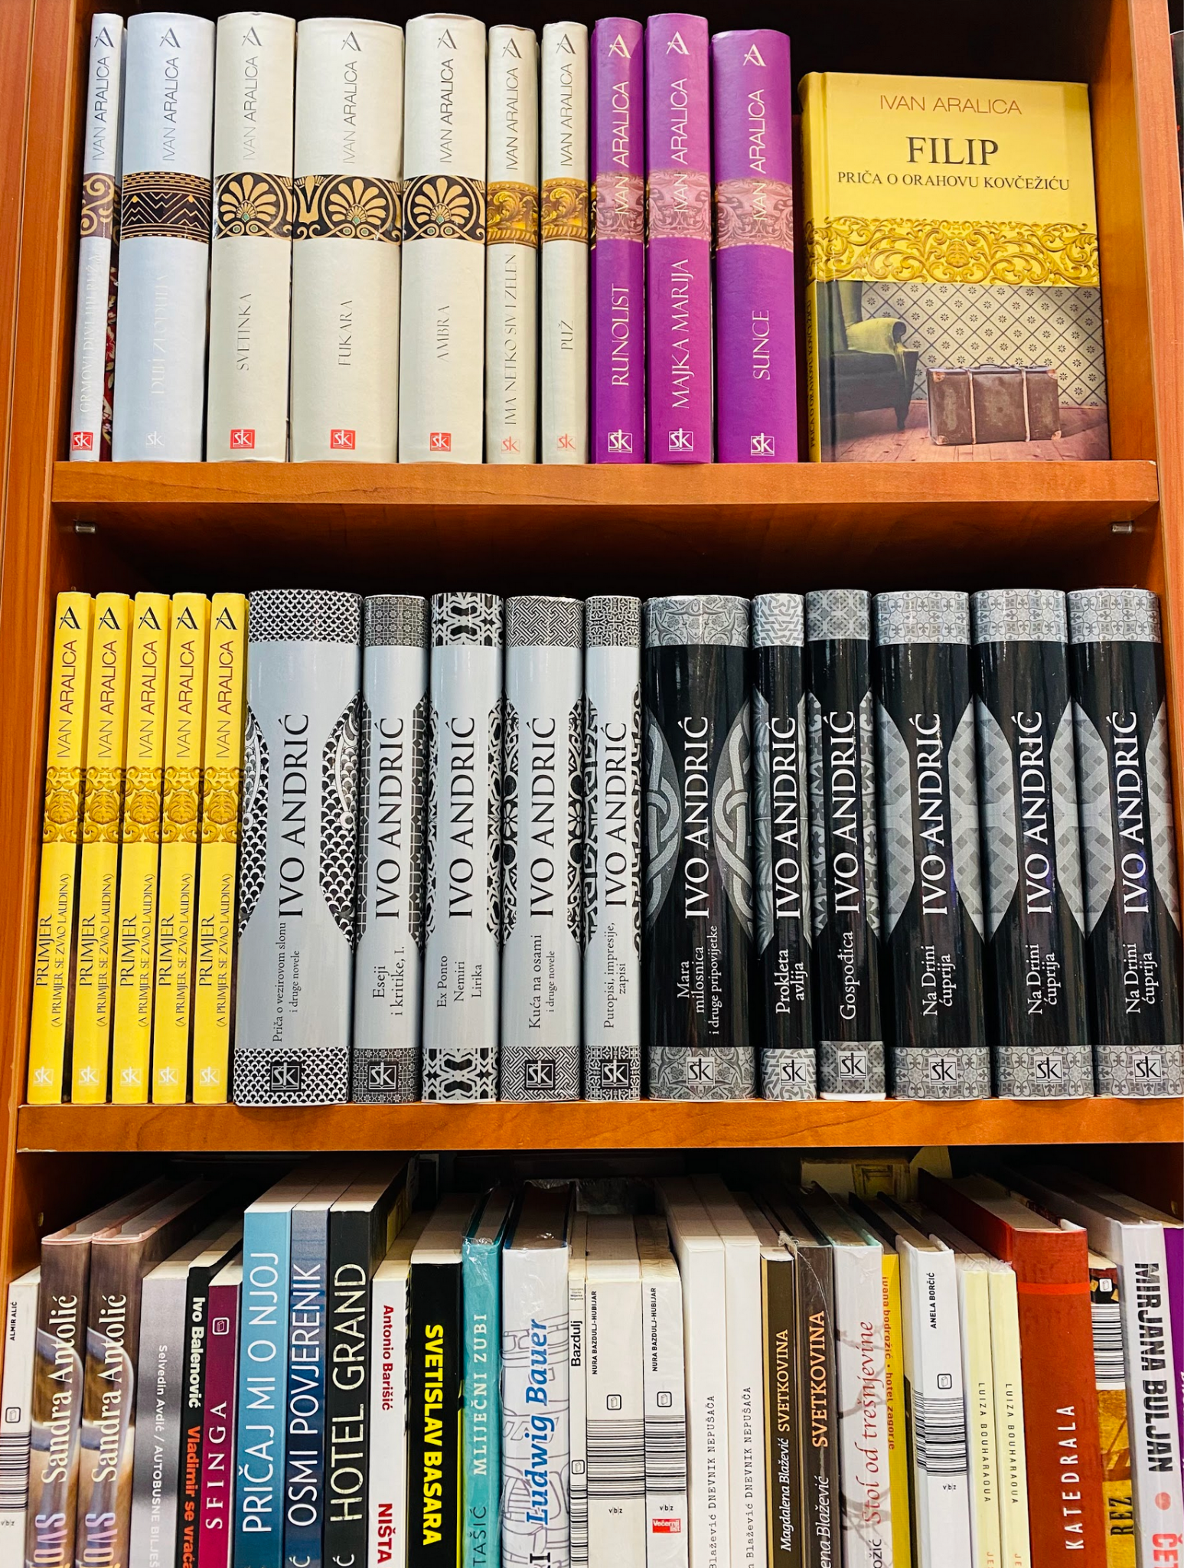
→ | → | → | →

cvijeće | bombonijera | šal i rukavice | knjiga
marama | kuharica | parfem | karte (za cirkus)

6.2 Zadatak 4. Kome pokloniti…?
👥 Which of the items in the table below would be a good present for people that you know? Use the following sentences to share your ideas with a classmate. For example, if you were thinking about buying a copy of Judita, you might say:

Judita, to je odličan poklon bratu. [or you can say] Ne znam kome pokloniti Juditu.
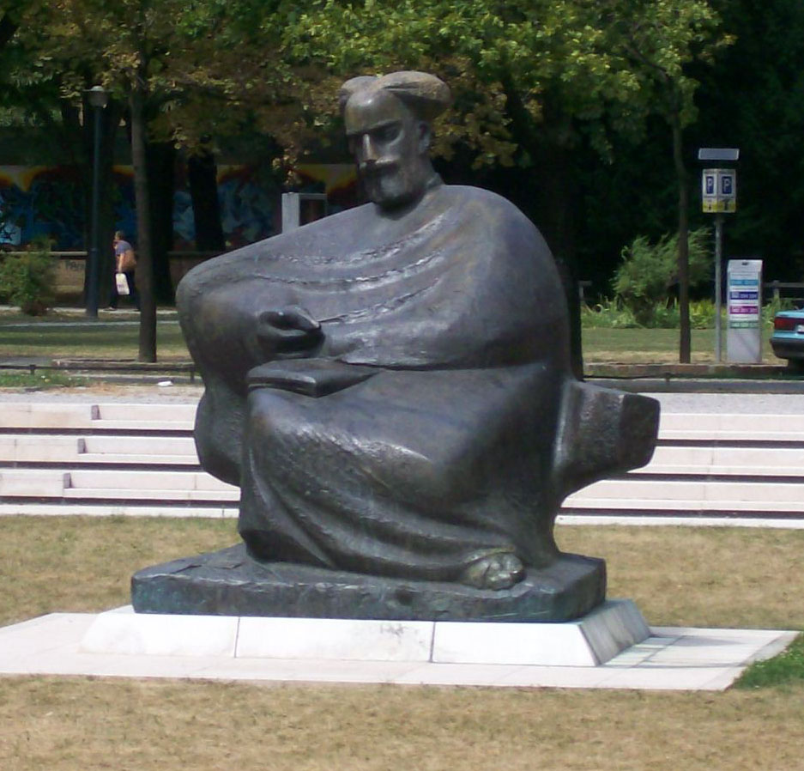 | 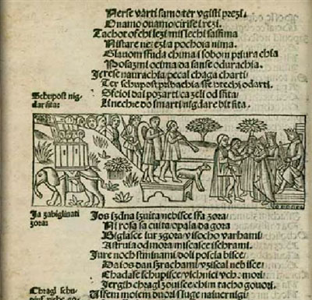

Knjiga Judita  Karte za operu  Karte za rock koncert  Karte za utakmicu  Parfem  Šal i rukavice  Tradicionalna kuharica  Drama Gospoda Glembajevi  Tradicionalna marama  Cvijeće  Bombonijera  Zbirka pjesama | to je odličan poklon… | mami  tati  roditeljima  mlađem bratu  starijem bratu  mlađoj sestri  starijoj sestri  cimeru  cimerici  baki  djedu  bratiću  sestrični  prijatelju  prijateljici

→
→
→
→
→
→

6.2 Zadatak 5. Što kupiti?
🔊 Listen to dialogue one and write down what Laura can buy for her family members.
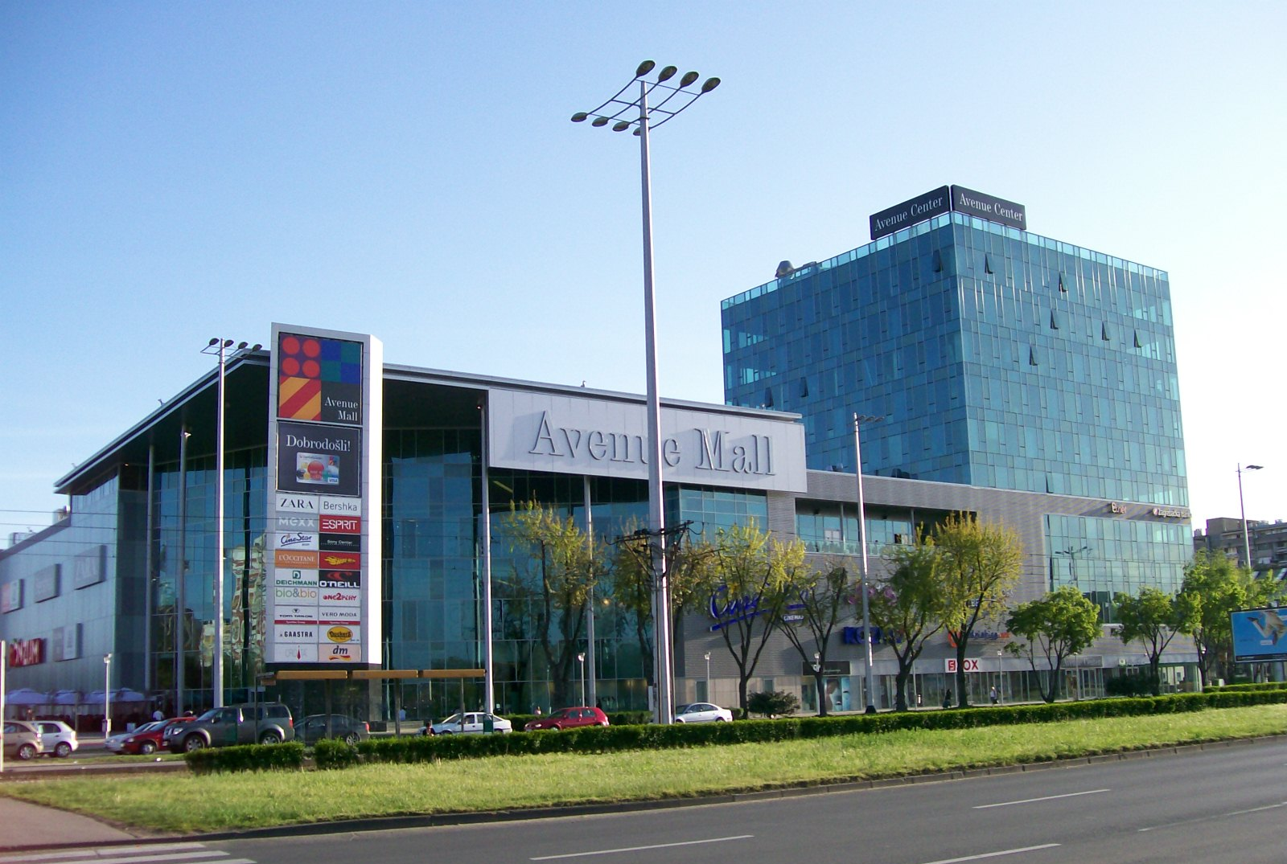 | 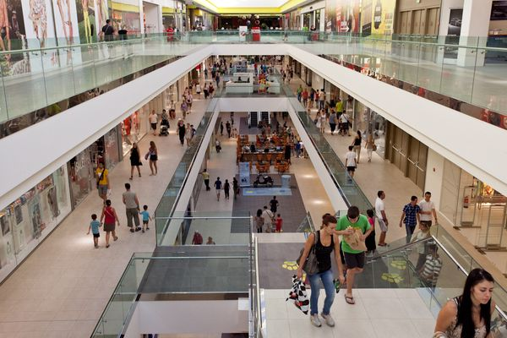
Avenue Mall, Zagreb | City Center One, Zagreb

| Razumijevanje
| Što Laura može kupiti mami i tati?
Laura može kupiti mami…
Laura može kupiti tati…

Mario and Laura discussed gifts for Laura’s parents. However, they did not talk about Laura's sister. Based on what you remember about Laura's family and their interests (Unit 3), what would be an appropriate gift for her sister? Finish the sentence: Laura možda može kupiti sestri…

| Osobna pitanja
If you were Laura, what would you buy for your family? Based on your family members, finish the sentences.

| Što ti želiš kupiti?
Mami želim kupiti
Sestri želim kupiti
Tati želim kupiti
Bratu želim kupiti

6.2 Zadatak 6. Jamesovi pokloni
🔊 Listen to dialogue two and complete the task. Ines i James razgovaraju i gledaju što je James kupio.
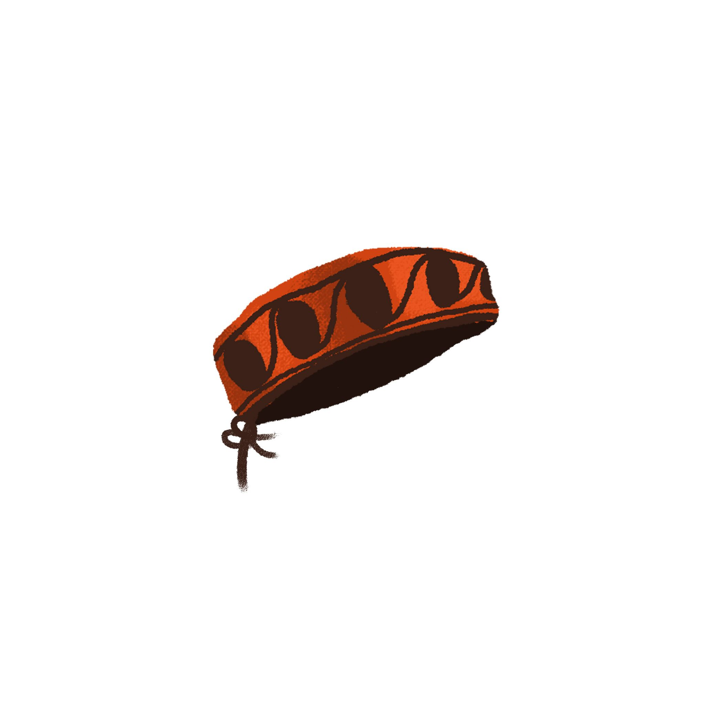 | 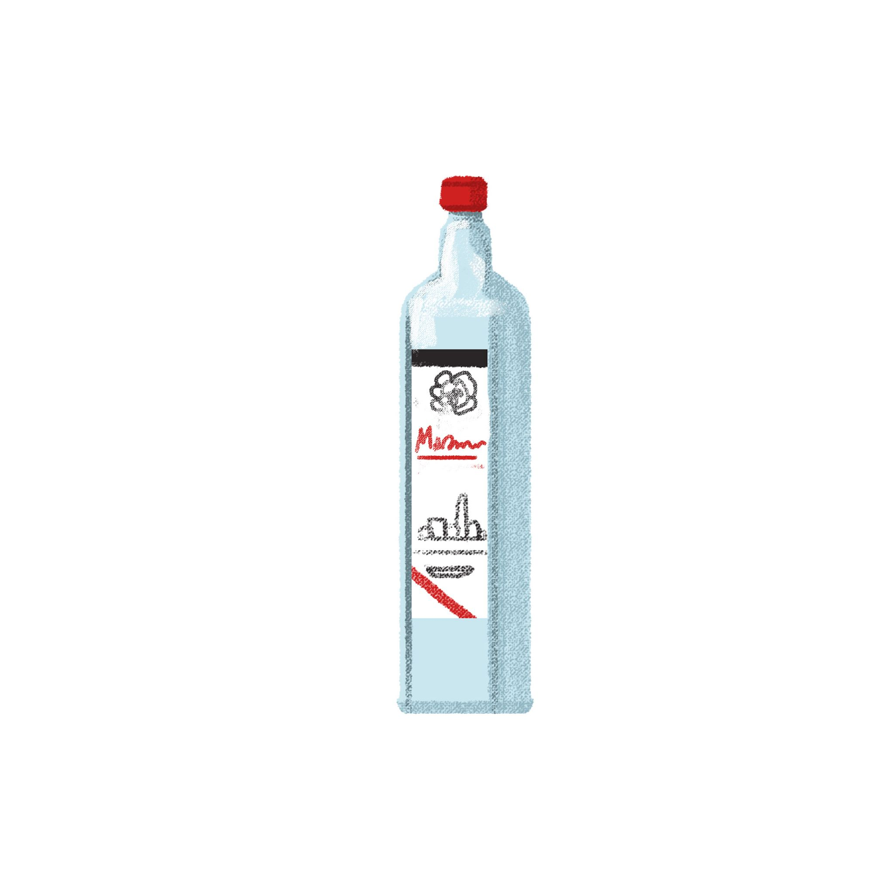 | 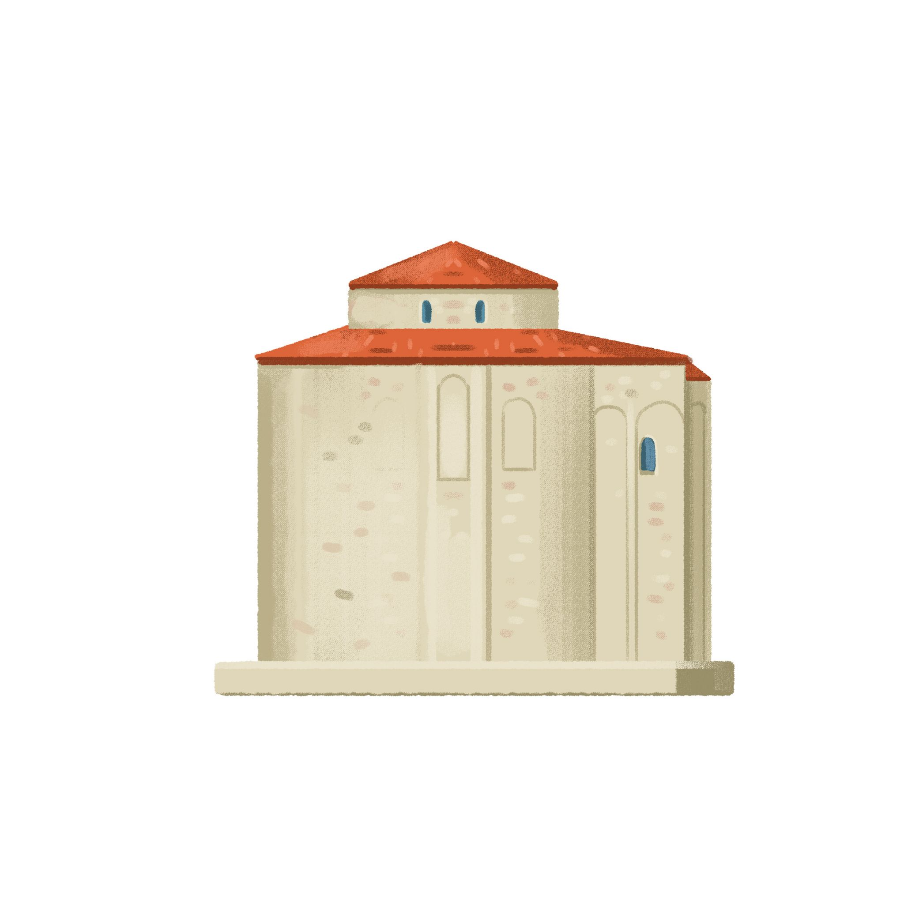 | 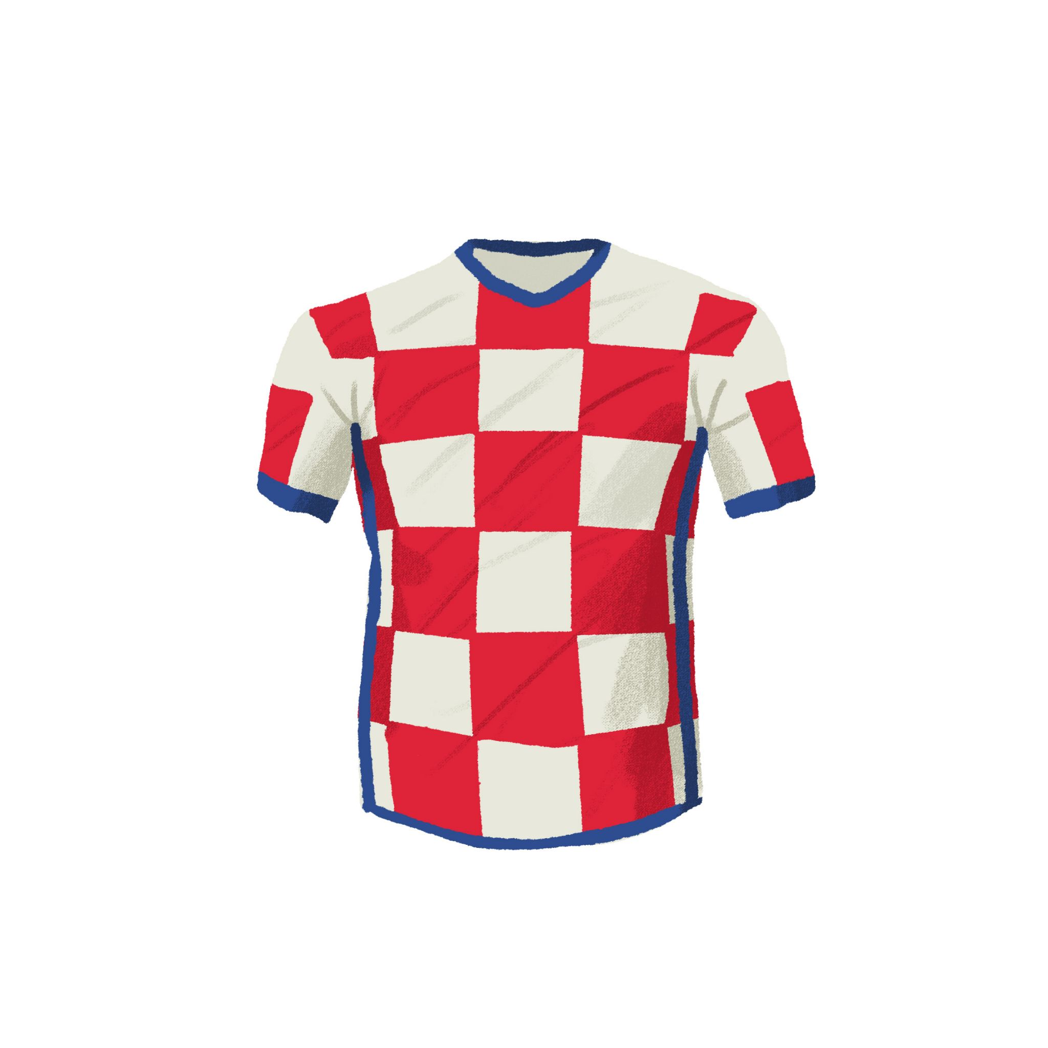

| Razumijevanje
Based on the dialogue and the family tree, answer the following questions. Possible answers are provided in the last row of each column.
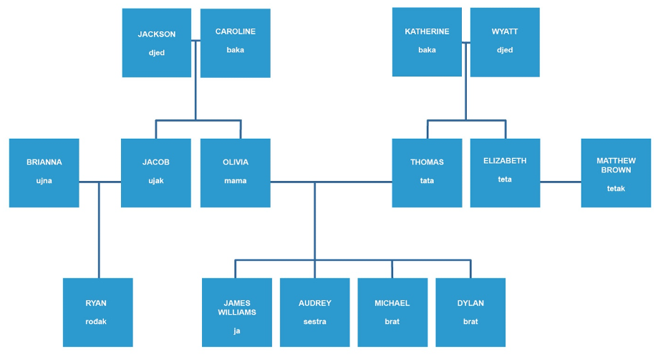
Gdje je James kupio šibensku kapu? | Kome je kupio šibensku kapu?
Gdje je James kupio licitarsko srce? | Kome je kupio licitarsko srce?
Gdje je James kupio repliku crkve? | Kome je kupio repliku crkve?
Gdje je James kupio sliku? | Kome je kupio sliku?
U Splitu  U Zagrebu  U Šibeniku  U Zadru  U Ninu | mami, sestri, teti, ujni, baki  tati, bratu, ujaku, tetku, djedu

6.2 Zadatak 7. Što kupiti?
For the remaining missing information, give your suggestions of what James could buy. Before you finish the sentences, investigate the following link. It will give you ideas on what James can potentially buy. Some other suggestions as well:
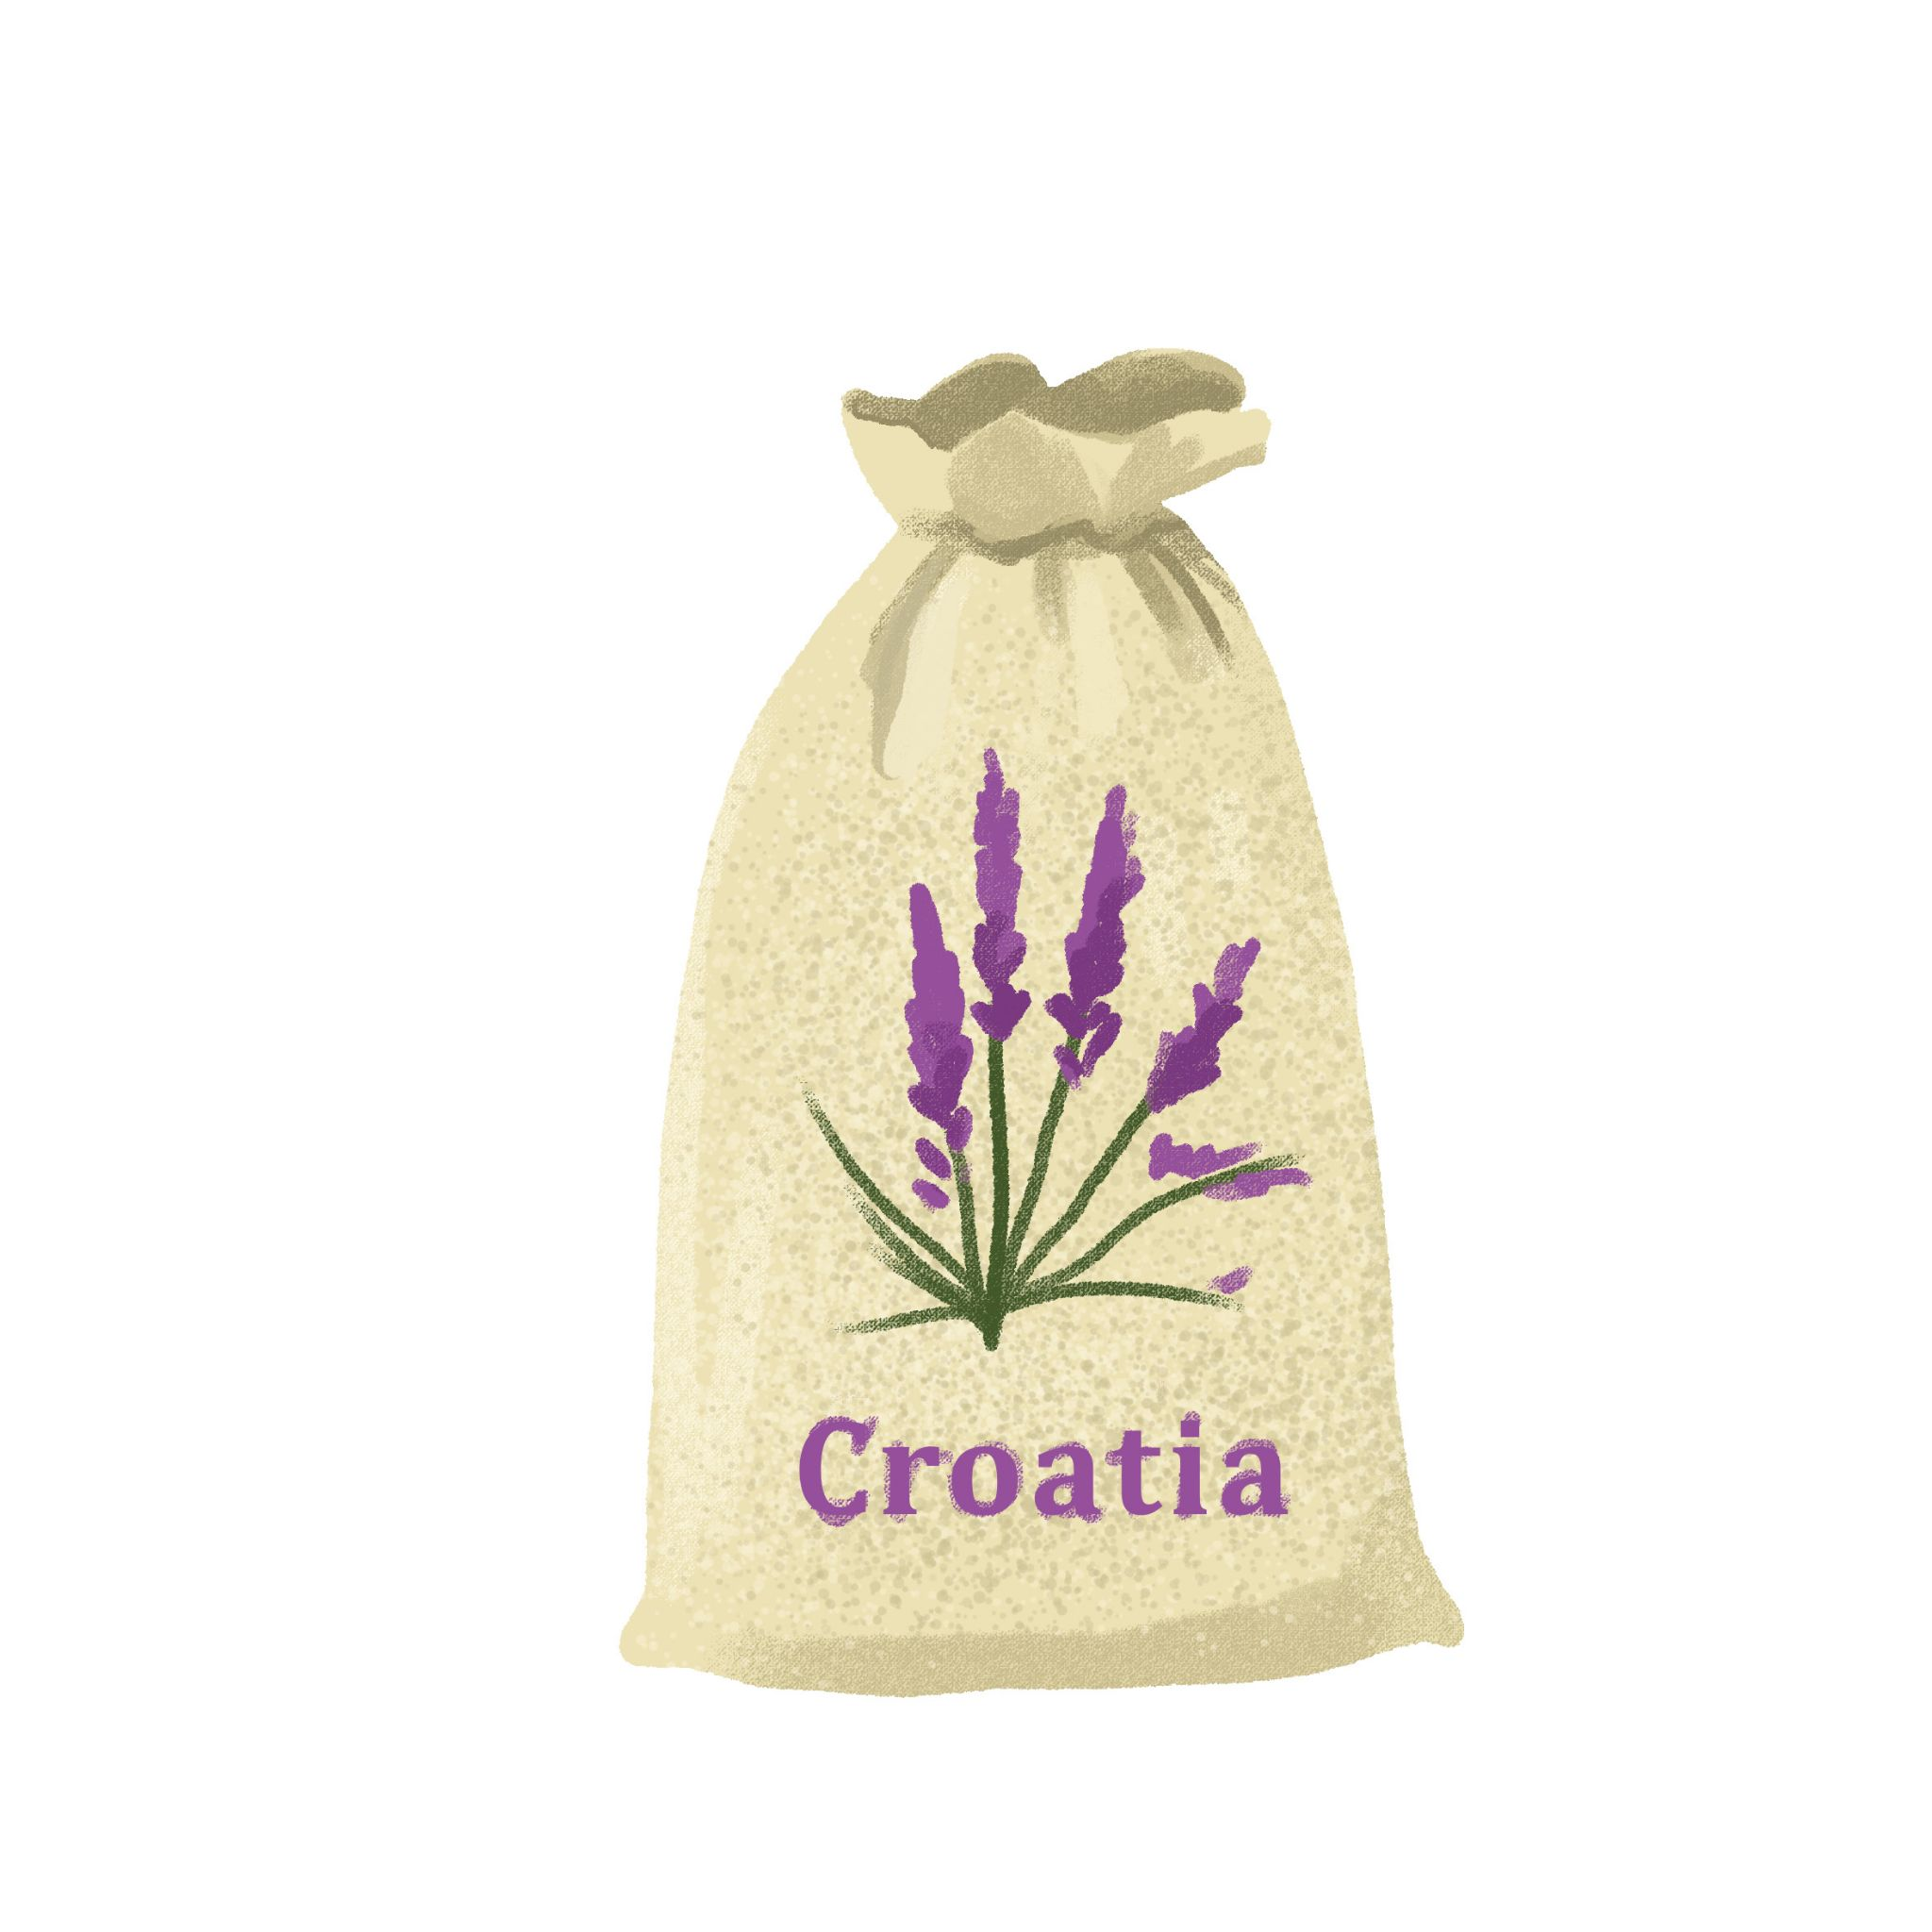
lavanda | kravata | maslinovo ulje | rakija i likeri
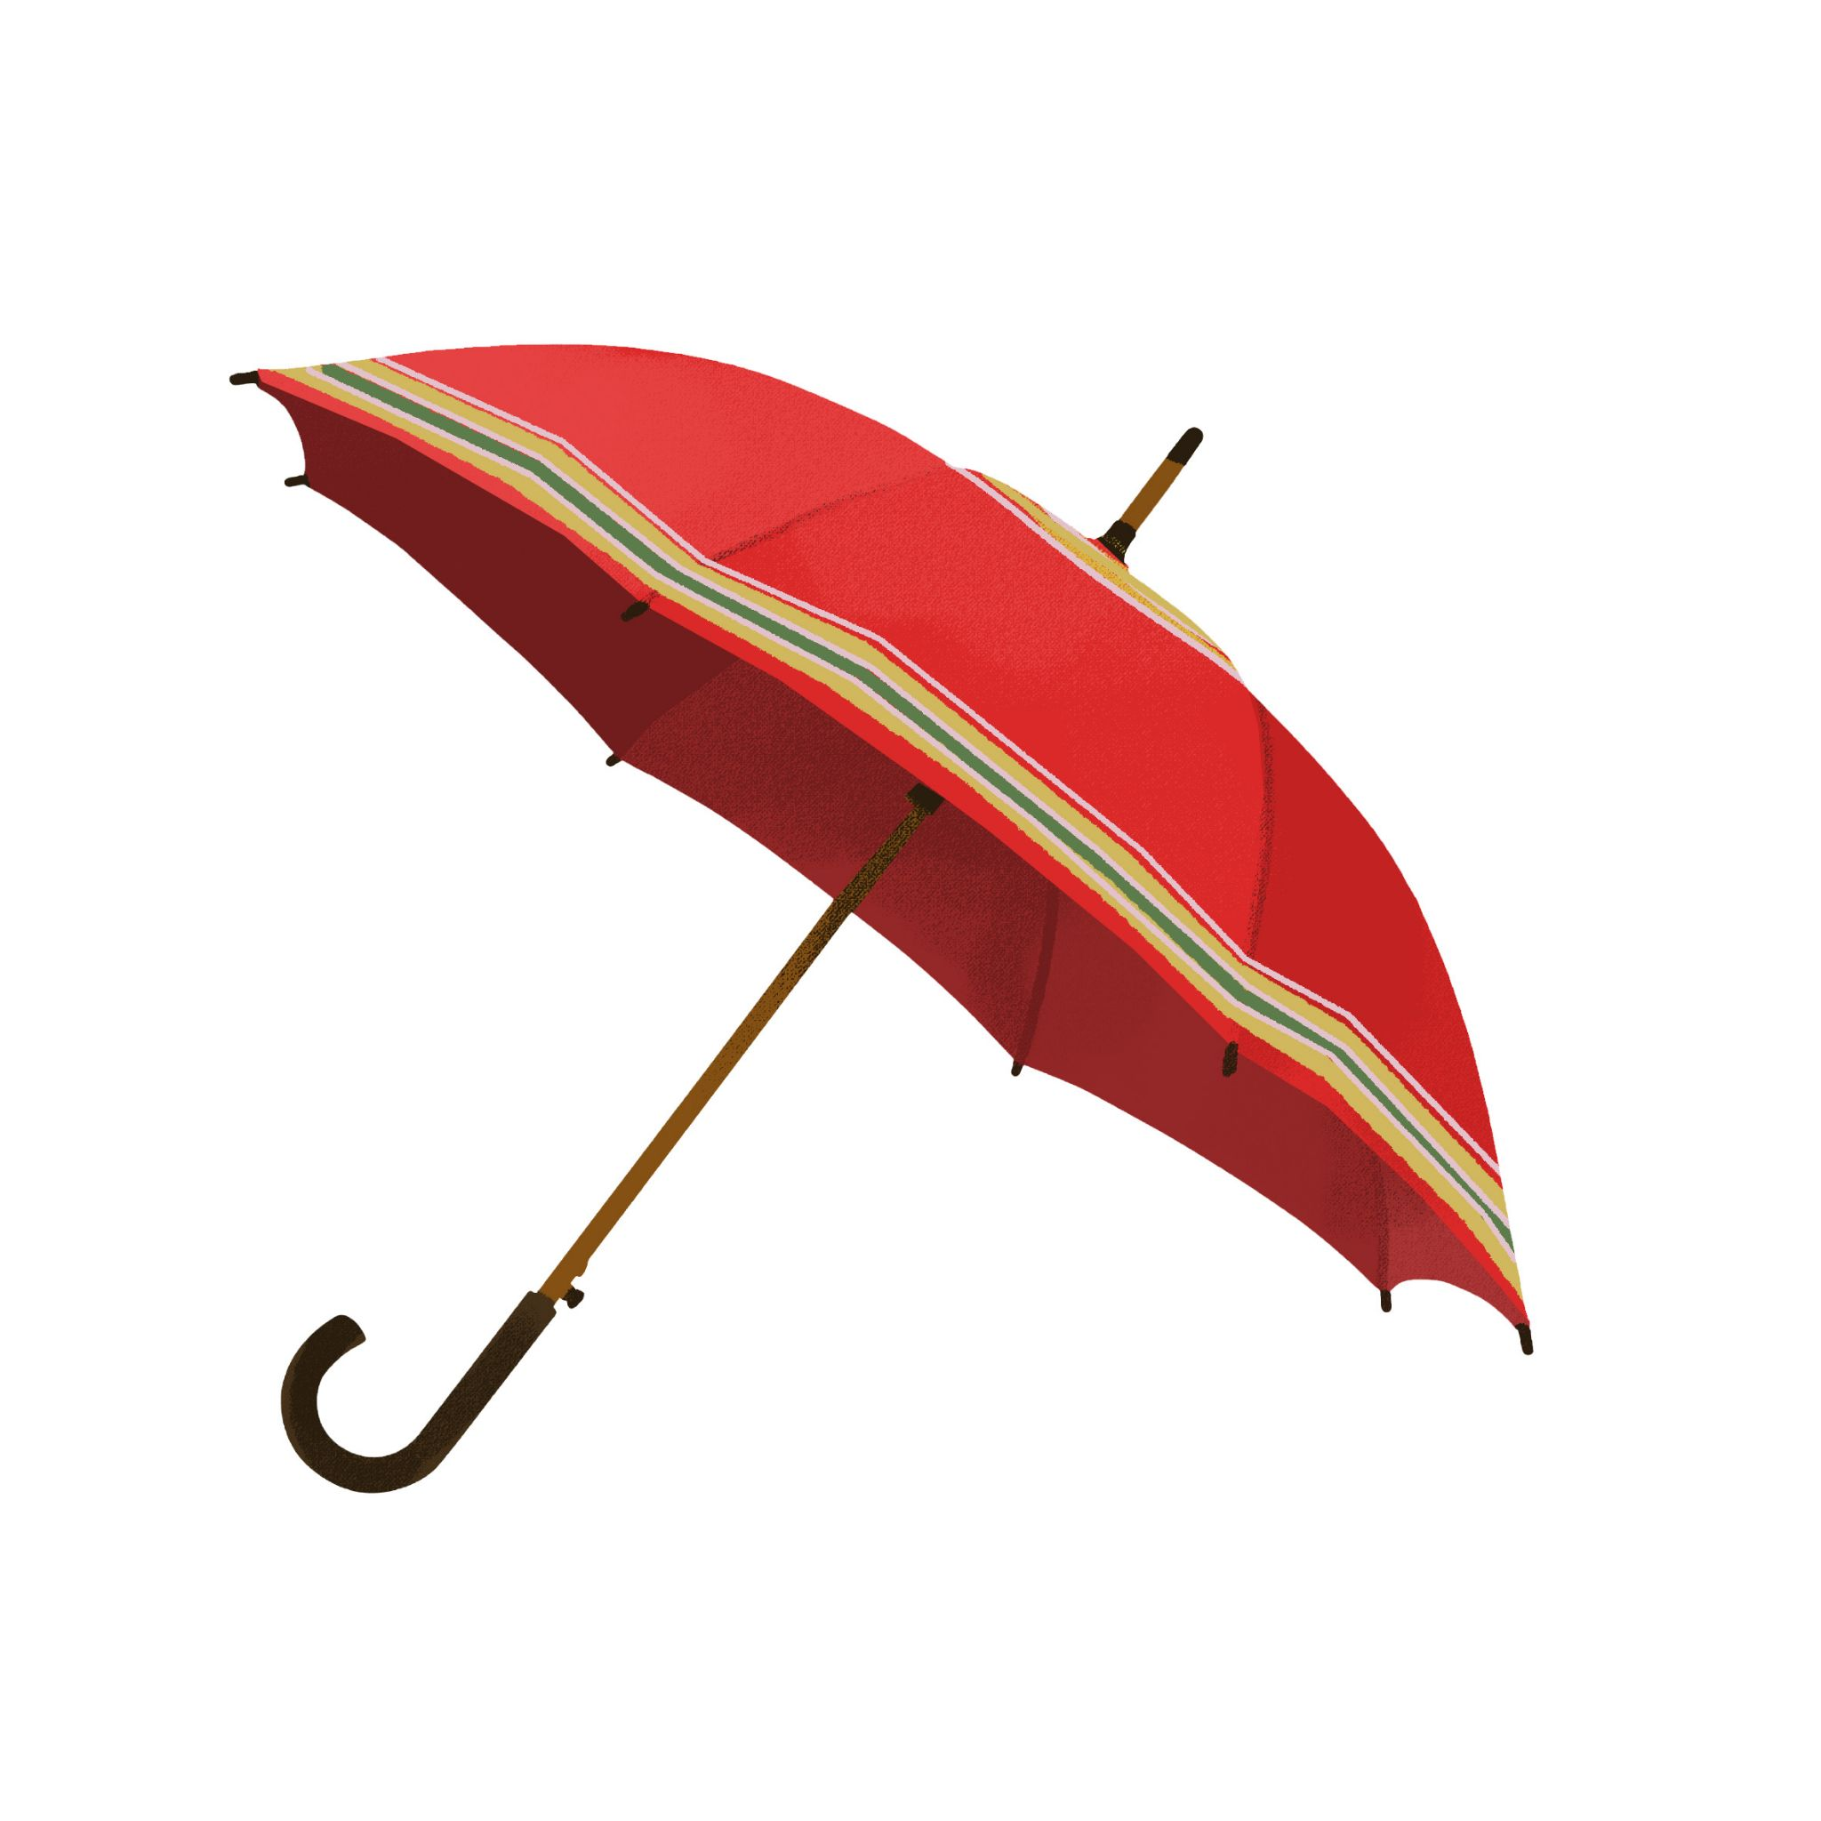 | 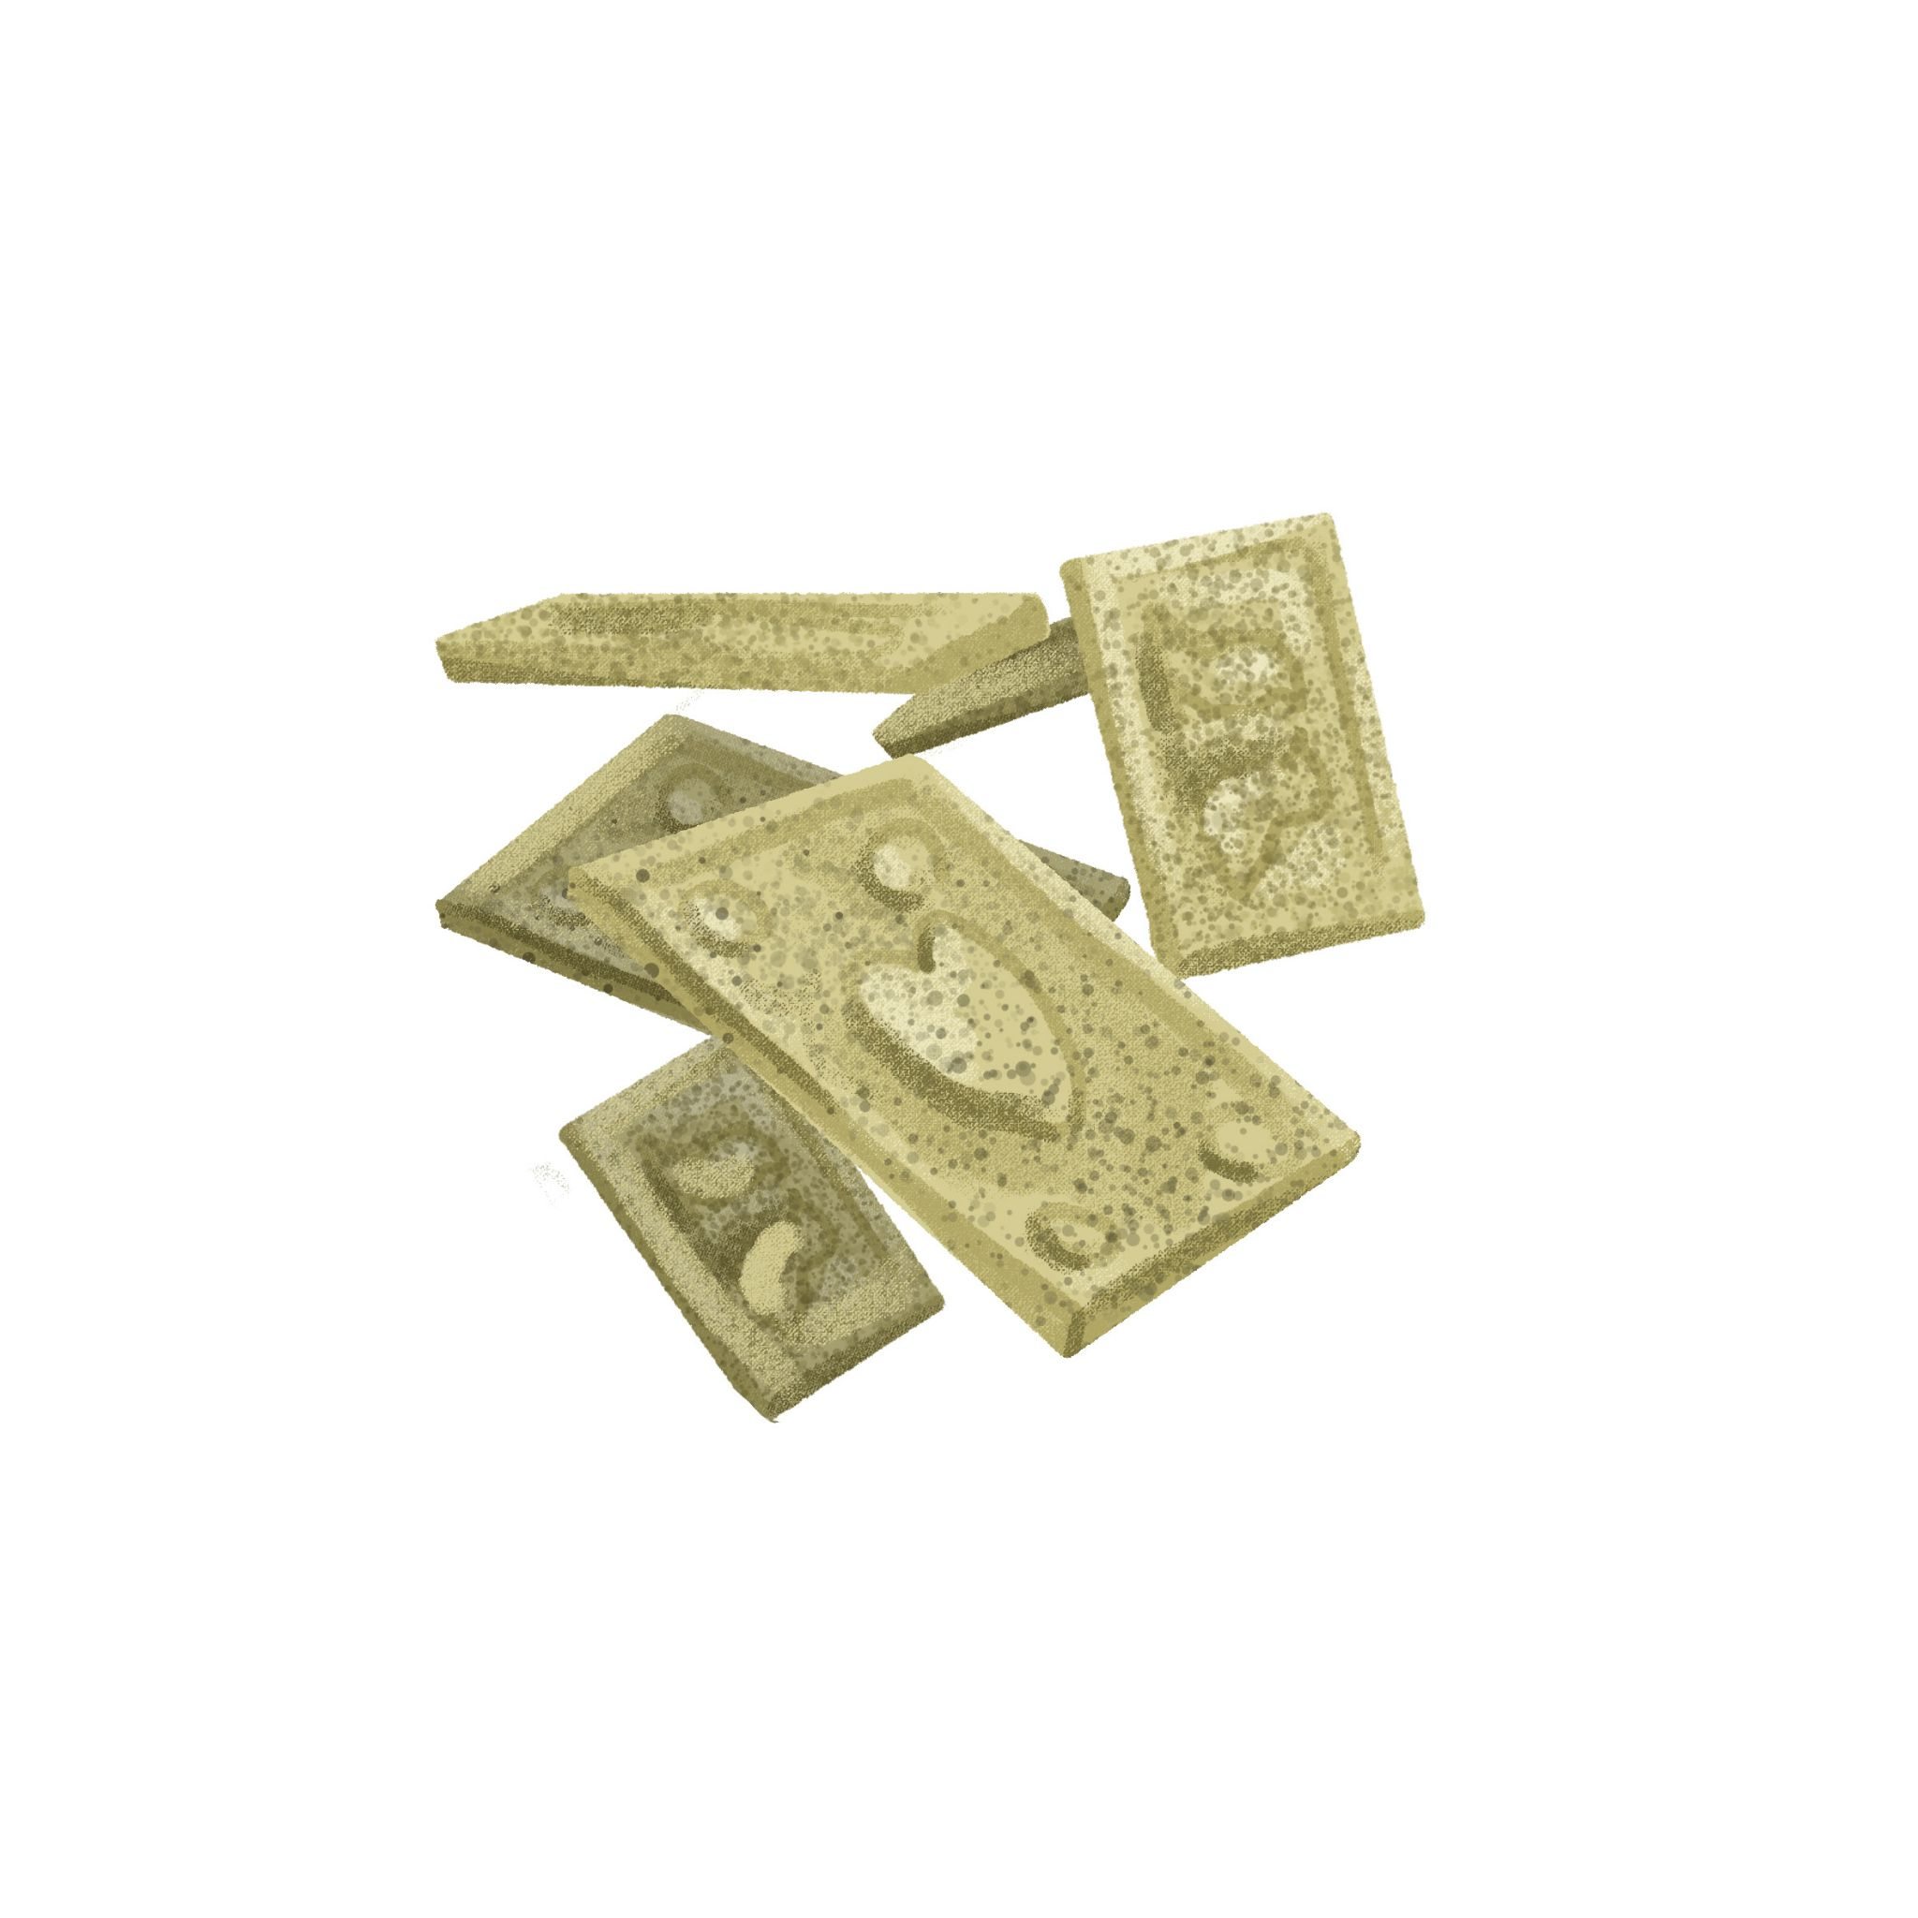 | 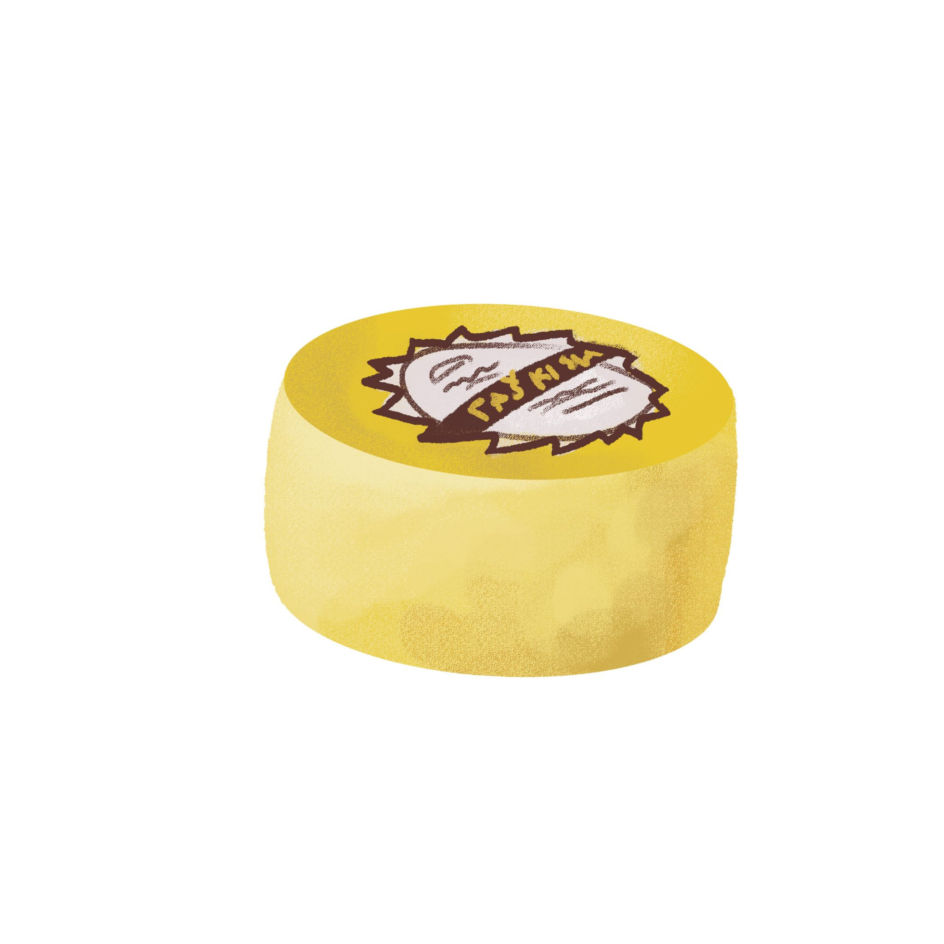 | 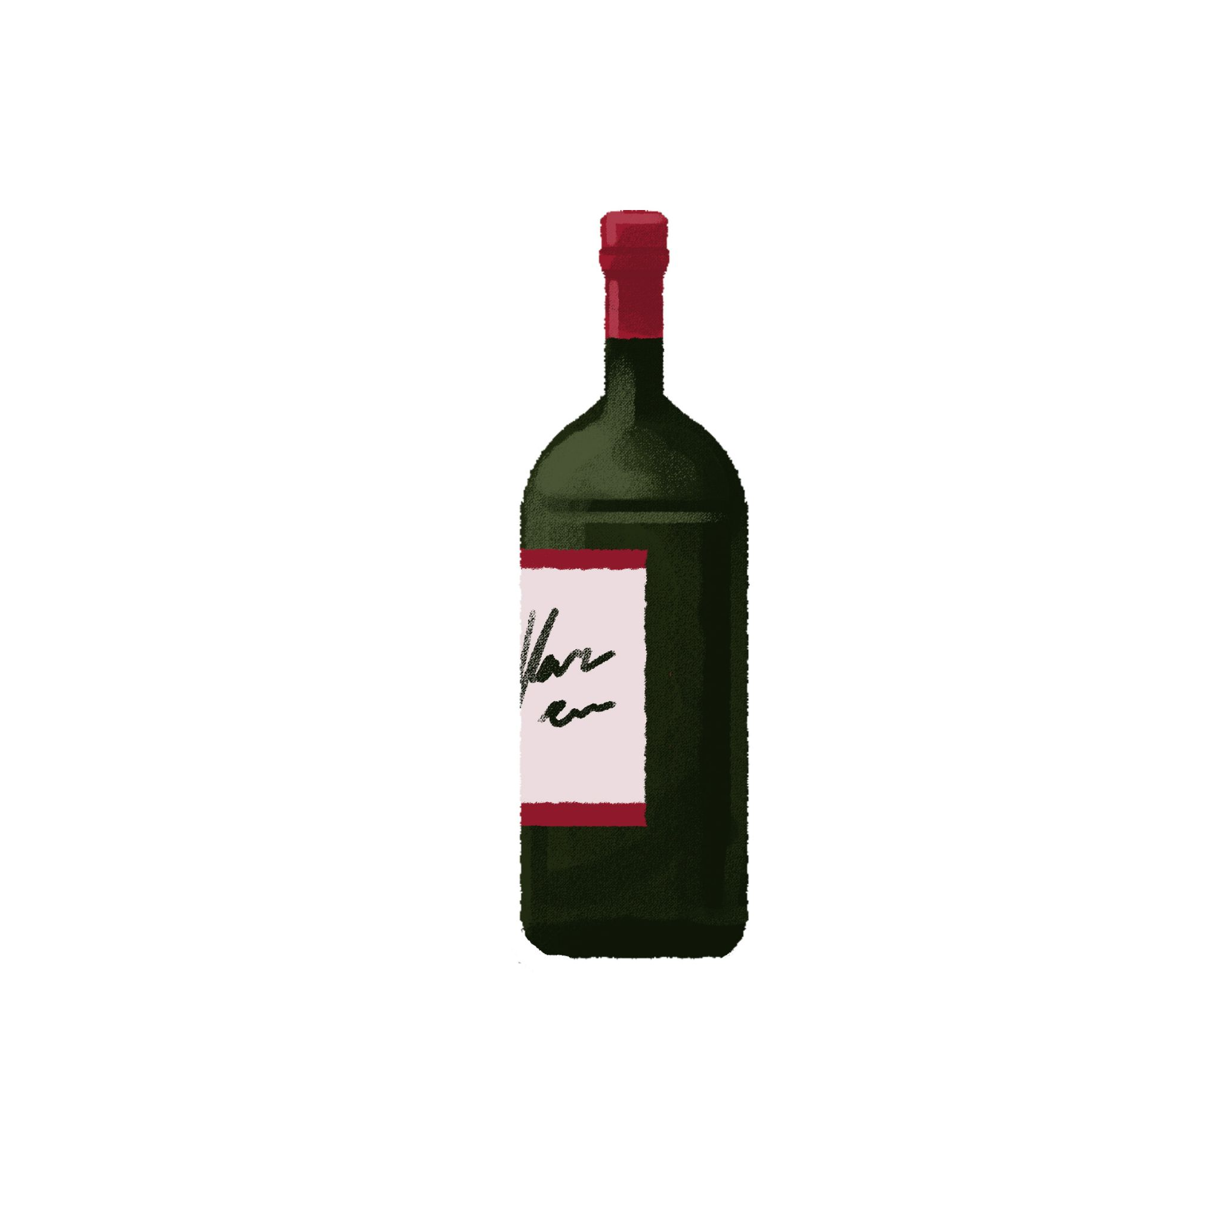
kišobran | paprenjaci | paški sir | vino

| Što James može kupiti:
James može kupiti tati kravatu.
Rođaku Ryanu - James može kupiti…
Mami Oliviji -
Tati Thomasu -
Ujni Brianni -
Teti Elizabeth -
Tetku Matthewu -

| Osobno pitanje
If you were James, what would you buy?
→
What souvenirs do you find to be interesting?
→

Images used above are from these sources.

