Project Title (Cambria 14)

Author1¹, Author2², Author3³ and Author4⁴ (Cambria 10, maximum of six authors)
¹ Faculty/Department, University/Organization, City, Country (Affiliation)
^{2,3} Faculty of Electrical Engineering, Universiti Teknologi MARA Cawangan Pulau Pinang, Permatang Pauh, Malaysia
⁴ School of…

Corresponding author: Author, author@uitm.edu.my

ABSTRACT
The abstract shall present a clear, concise, and coherent overview of the product by summarizing what is proposed or developed, articulating the underlying rationale and methodology that explain why and how the invention, innovation, or design was conceived, highlighting its principal advantages, key features, or distinctive attributes, and outlining its potential impact and commercialization. The abstract must be 150–200 words, written in Cambria, size 10, and presented as a single paragraph. In other sections, all body text shall be formatted using Cambria font, with size 12, with single line spacing, fully justified alignment, and no paragraph indentation. Furthermore, all body content of every section should be presented in black font and placed entirely within an outlined table to ensure a uniform, orderly, and professional layout. The table must be formatted with no visible borders to enhance readability, maintain academic consistency, and ensure compatibility with digital publication formats, thereby supporting clarity, visual coherence, and adherence to established academic presentation standards.
Keywords: Maximum of five keywords and italicized, e.g., Internet of Things, Artificial Intelligence.
- Product Description
Should briefly and clearly outline the physical and functional characteristics of the product, with a maximum of 200 words. This may include its overall frameworks, major hardware components, integrated sensors or modules, system architecture, and any distinctive or value-added features. The description should focus on tangible aspects that demonstrate how the product is constructed and operates, particularly those that support its intended AI and/or IoT functionality. Technical details should be presented concisely, using clear and precise language, without excessive elaboration.
- Product Design and Implementation Overview
This section outlines the overall product design and implementation, including system architecture, workflow, key components, and operation, supported by relevant visuals such as diagrams, flowcharts, screenshots, tables, graphs, or prototype images. The description should clearly explain how the system functions and produces its intended outputs, focusing on practical implementation rather than detailed technical theory. All visuals must be clearly linked to relevant subtopics and explained in the text to convey their purpose and relevance.
Guidelines:
- Use the Insert Picture function rather than copy-pasting to ensure stable formatting.
- Visuals should be high-resolution (300 dpi) in TIFF or equivalent format, with all fonts embedded for clarity.
- Number figures and tables sequentially as they appear in the text (Figure 1, Figure 2, Table 1, etc.).
- Provide centered captions that concisely describe their content (e.g., Figure 1. System architecture of the IoT-enabled monitoring device).
- Italicize the word Figure or Table when referencing (e.g., Figure 1).
- Use font size 10 for all text within tables.
- Ensure consistent formatting across all figures and tables.

Example:
2.1 System Architecture
The overall architecture of the AI-enabled IoT smart monitoring system is shown in Figure 1, comprising sensor modules, a microcontroller, AI edge processing, and cloud data integration. Each component is labeled to illustrate its role in real-time anomaly detection and remote monitoring.

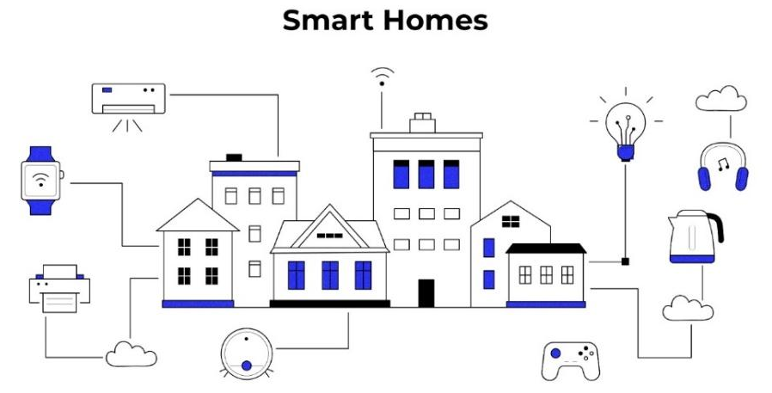
Figure 1. Overall architecture of the AI-enabled IoT smart monitoring system

2.2 Comparison of Key Features: Traditional vs. IoT-Based Systems
Table 1 summarizes the comparison of key features between traditional monitoring systems and IoT-based systems, highlighting differences in performance, efficiency, and data accessibility. Overall, the table illustrates how the IoT-based system outperforms traditional approaches across multiple functional metrics, demonstrating its value and potential for broader adoption in modern monitoring applications.

Table 1. Comparison of Key Features Between
Traditional and IoT-Based Systems (%)

Feature | Traditional System (%) | IoT-Based System (%)
Monitoring Method | 60 | 95
Alert System | 50 | 90
Power Efficiency | 70 | 85
Data Access | 40 | 92
Cost Over Time | 65 | 80

- Novelty and Uniqueness
Briefly explain what makes the product or research original and different from existing solutions, using a maximum of 200 words. Describe the idea or inspiration behind the product, its unique features, and how it stands out compared to other similar products. Focus on the aspects that clearly show its innovation, usefulness, or improvement over current solutions. Avoid too much technical detail and highlight what makes the product special.
- Benefit to Mankind
Briefly describe the advantages and potential applications of the product or research, focusing on its benefit to people or society, within a maximum of 150 words. Highlight how the product improves quality of life, solves a real-world problem, or contributes to safety, health, efficiency, or convenience. Include the target users or communities who will gain from the product and the practical contexts where it can be applied. Keep the description clear, concise, and focused on societal impact rather than technical specifications.
- Innovation Impact and Commercialization Potential
Briefly explain how the project promotes innovation and supports the adoption of AI and/or IoT technologies, while highlighting its potential for commercialization, within a maximum of 150 words. Focus on the project’s innovative contribution, practical impact, and relevance to real-world applications and market needs. Emphasize key benefits such as improved efficiency, scalability, value creation, and potential adoption by target users or industries.
- Acknowledgment
Acknowledge contributors and funding sources that supported the research or development of the project.
- Researchers’ Biography
 | Provide brief profiles for all project members, including name, designation, affiliation, area of expertise, and a short professional background. Photos should be high-resolution (300 dpi) in TIFF, EPS, or JPEG format, and sized 4 × 3 cm. Biographies should be concise and professional, highlighting key qualifications, areas of specialization, professional experience, and research interests, with a maximum of 70 words per profile.
References
Provide a maximum of five (5) references, formatted according to the IEEE citation style.
- Alahi, M. E. E., Sukkuea, A., Tina, F. W., Nag, A., Kurdthongmee, W., Suwannarat, K., & Mukhopadhyay, S. C. (2023). Integration of IoT-Enabled Technologies and Artificial Intelligence (AI) for Smart City Scenario: Recent Advancements and Future Trends. Sensors, 23(11), 5206. https://doi.org/10.3390/s23115206
- Khadam, U. (2024). Exploring the Role of Artificial Intelligence in Internet of Things Systems: A Systematic Mapping Study. Sensors, 24(20), 6511. https://doi.org/10.3390/s24206511

Extended Abstract Guidelines:
- Submission of an extended abstract is recommended for all entries to enable participants to benefit from eISBN publication.
- Prepare the document using the provided template and follow all the guidelines outlined.
- Remove all instructional or guideline text before submission.
- Submit the final document in Word format via the AIoTIE Portal.

