Lizard Island for Small Groups

This version of the Lizard Island activity is designed for groups of 1 to 15 students.

Follow the step-by-step instructions on this printout. There’s no video step-by-step for the “small group” version.

Activity Prep:

Step 1: Print materials
For each group of 3 students, print one set of Adopt A Lizard sheets (labeled A, B, & C).
- For 1 to 3 students, print 1 set.
- For 4 to 6 students, print 2 sets.
- For 7 to 9 students, print 3 sets.
- For 10 to 12 students, print 4 sets.
- For 13 to 15 students, print 5 sets.

For the entire group, print
- A set of Small Group Baby Lizard Cards (3 sheets)
- A set of Small Group Little Lizard Cards (3 sheets)

For each student, print
- One How Many Lizards sheet

Step 2: Cut up the cards

- Cut the Little Lizard Cards along the dotted lines so you have ten A cards, ten B cards, and ten C cards:
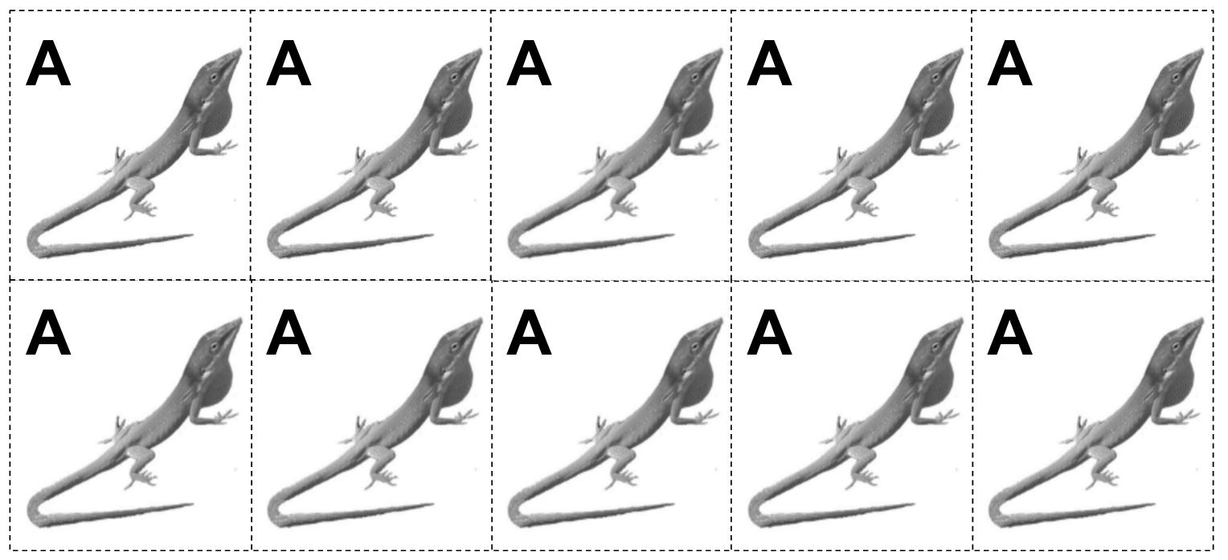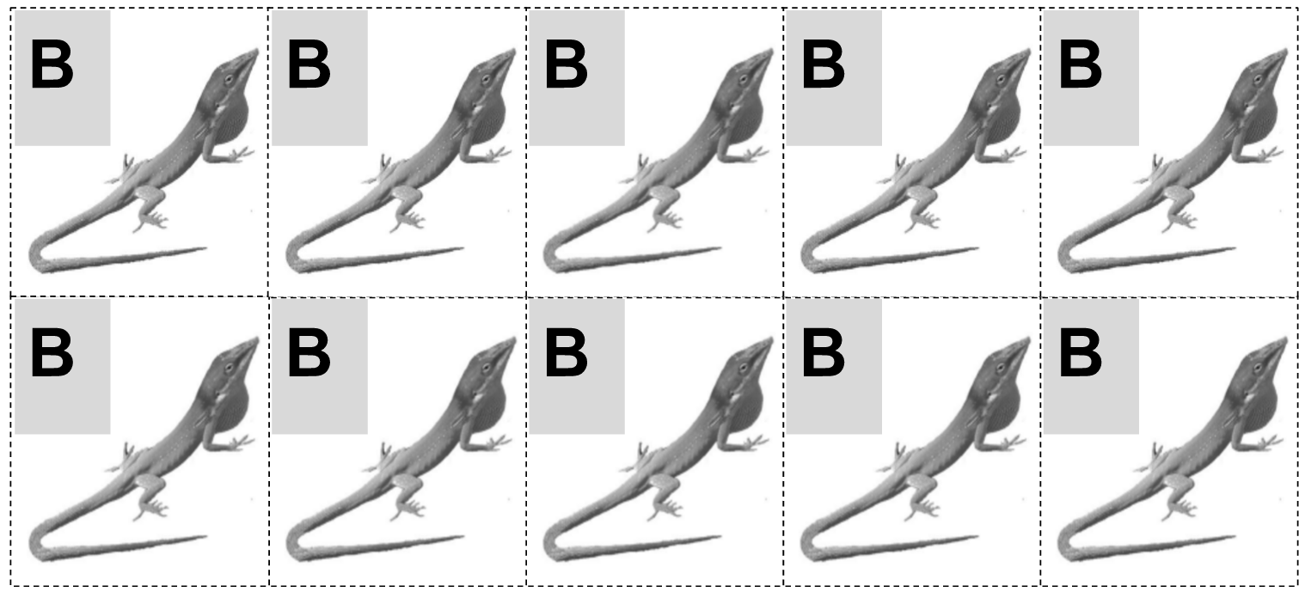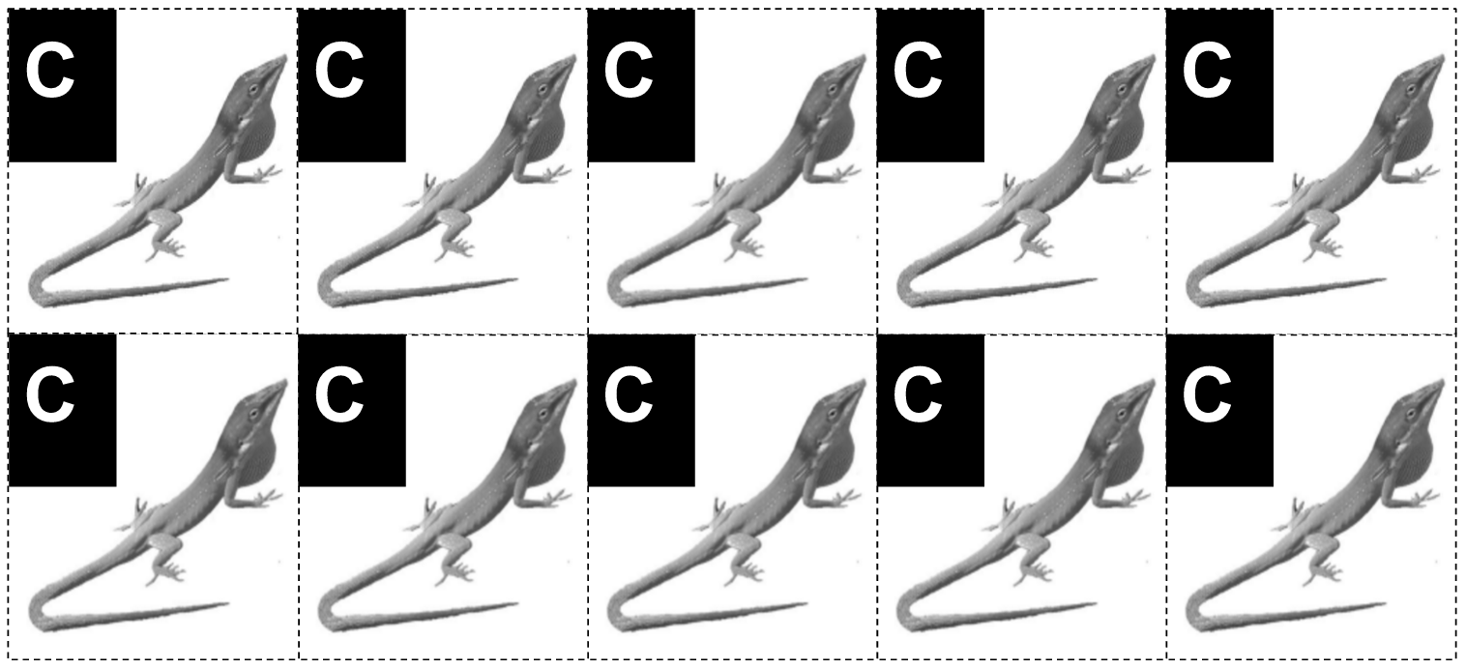

- Cut the Baby Lizard Cards apart on the dotted lines so you have 6 Baby Lizard cards:
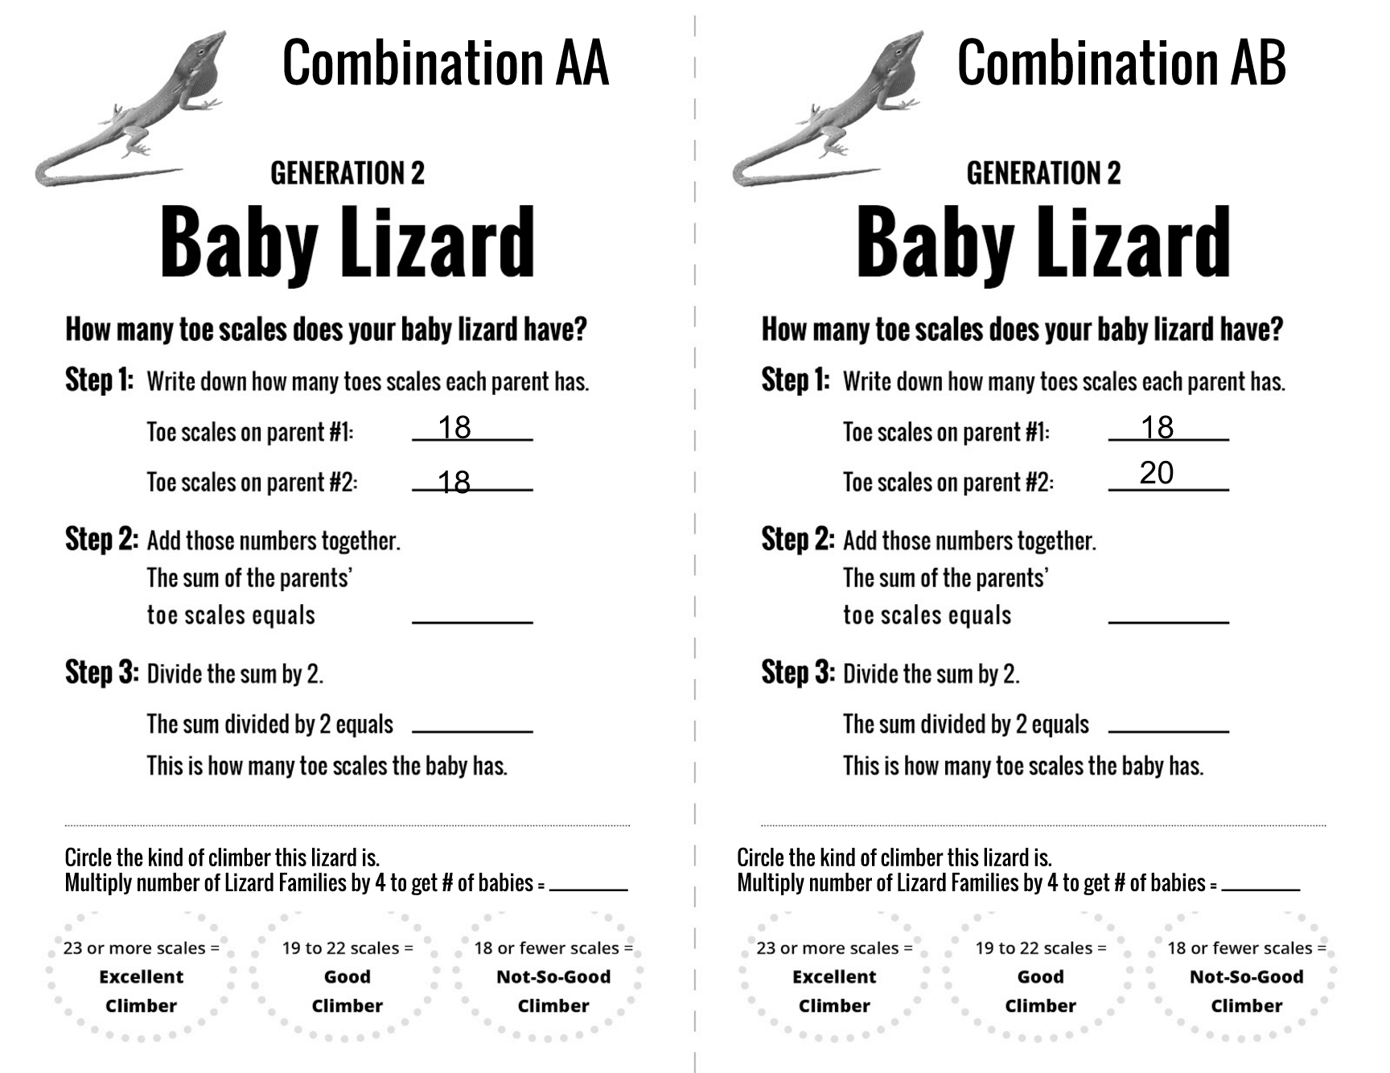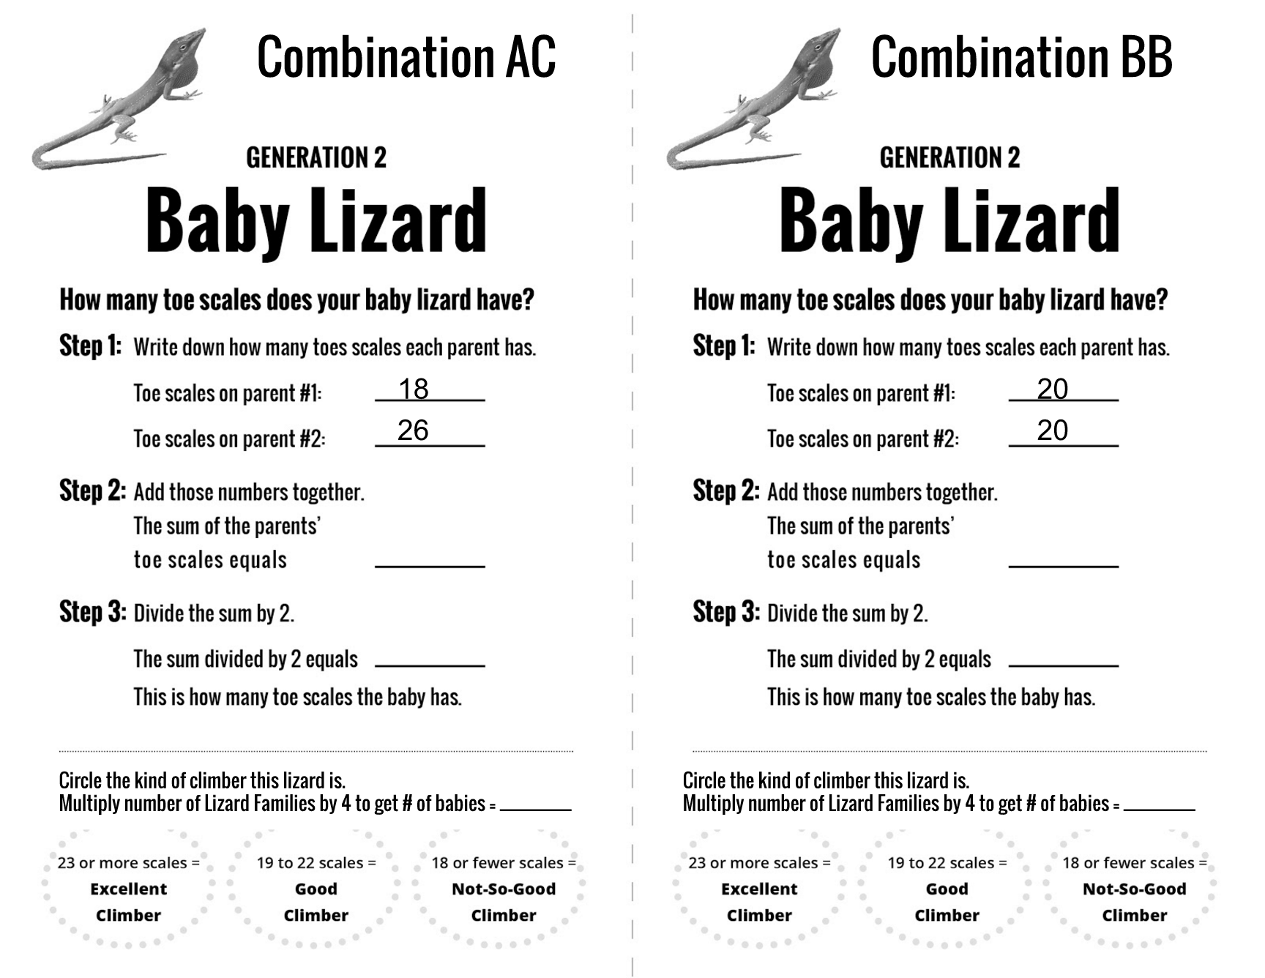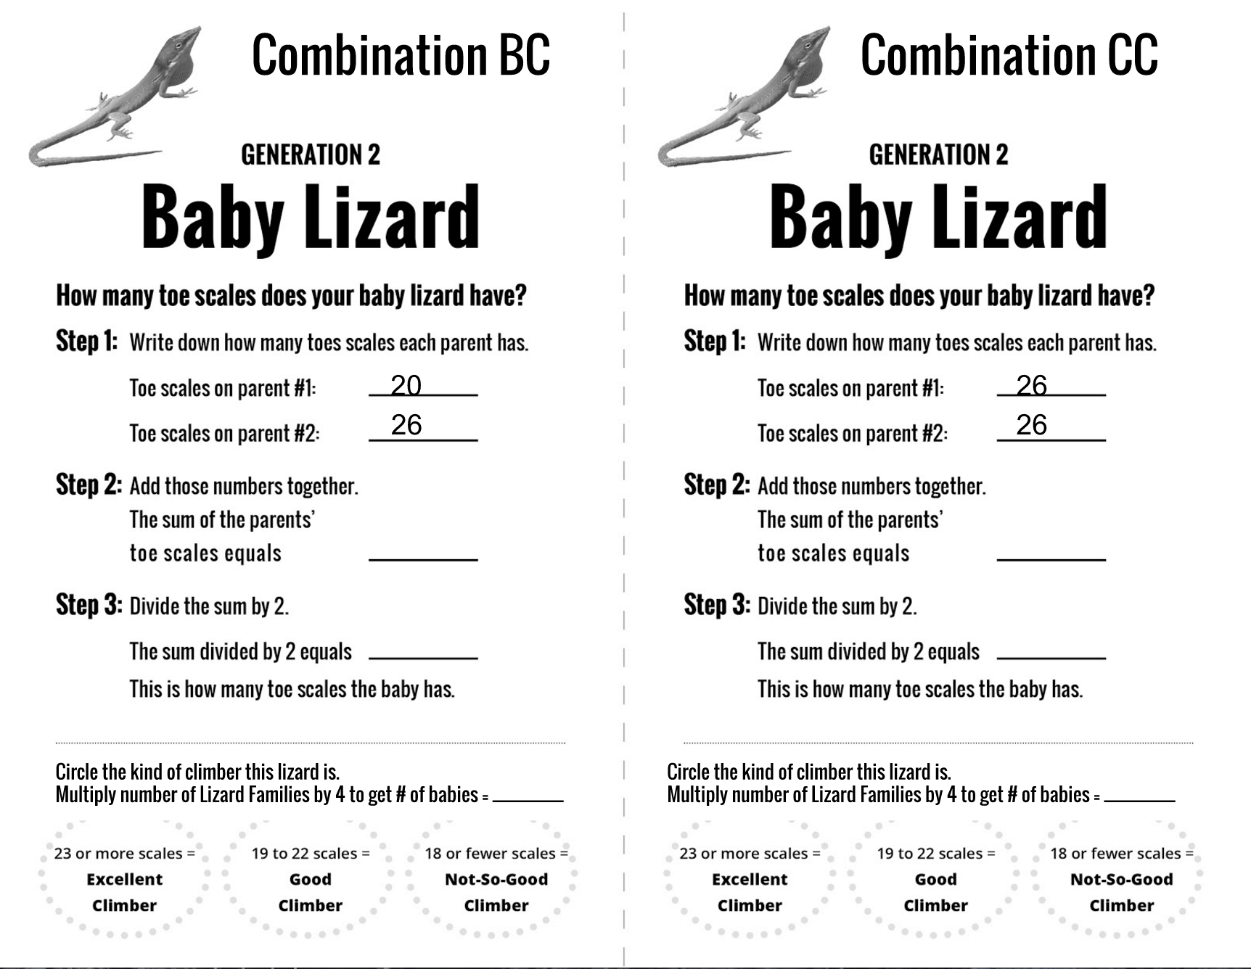

Step-by-Step Instructions

- Tell your students:

There are lizards on Lizard Island that are excellent climbers, ones that are good climbers, and ones that are not-so-good at climbing. To figure out how good a climber a lizard is, you have to count the toe scales on the lizard’s big toe.

- Give each student an Adopt A Lizard card. Each Adopt A Lizard card shows a closeup photo of the big toe of a lizard. There are three different cards, each with a different lizard: A, B, and C.
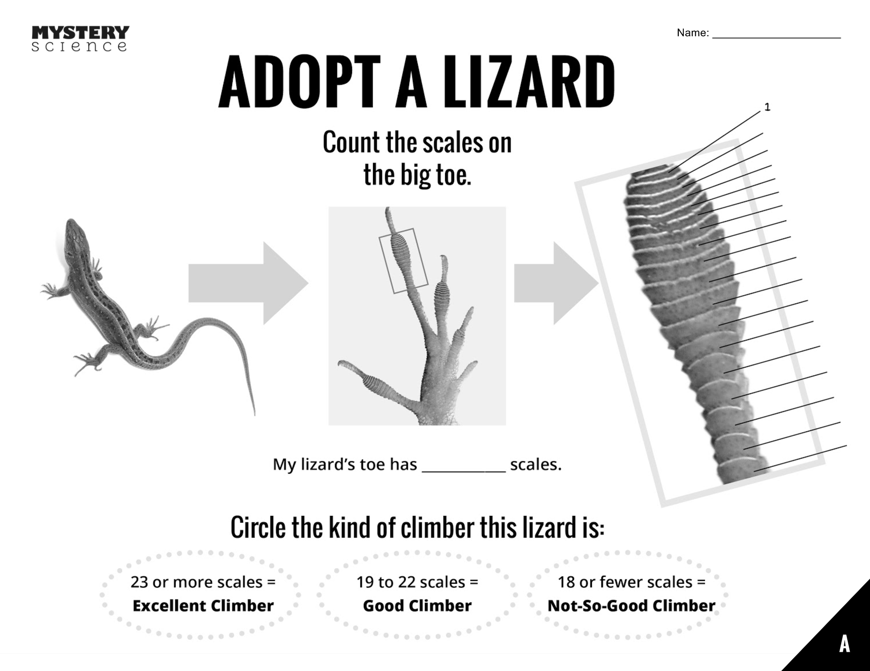 ← Note the bottom right corner. This is Lizard A.

- Ask students to count the toe scales so you know how the number of toe scales each lizard has. There is a line to each toe scale (see picture below) to make counting easy. If you only have one student, they’ll have to count the scales on all three lizard toes!
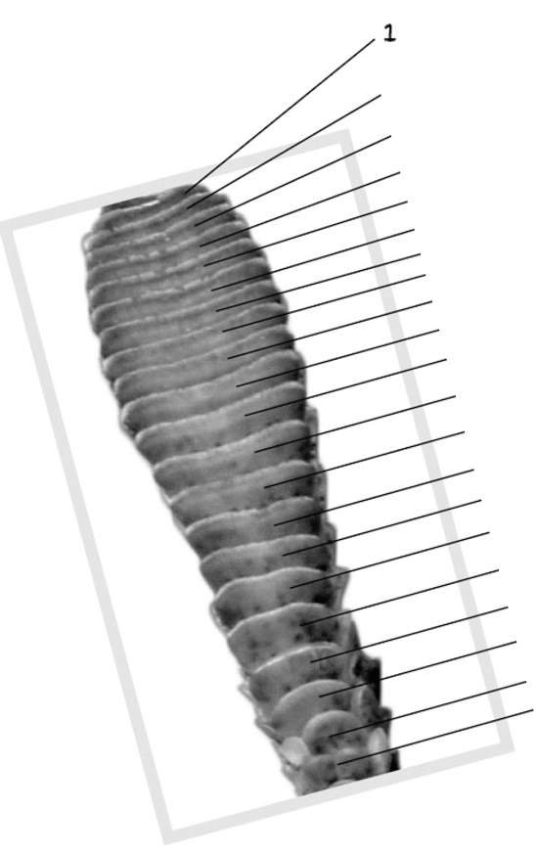
- At the bottom of the card, circle what kind of a climber your lizard is. The number of scales tells you which one to circle. After students count the scales, have them circle what kind of climber their lizard is. If the lizard has 23 or more scales, it’s an excellent climber. If it has 19 to 22 scales, it’s a good climber. If it has 18 or fewer scales, it’s a not-so-good climber.

- Tell your students:

Before the brown anoles get to Lizard Island, there are 30 green anoles living on the island. Ten of them are excellent climbers, ten are good climbers, and ten are not-so-good climbers. Fill those numbers in on the Original Lizards side of your How Many Lizards printout. Use your Little Lizard Cards to represent all these lizards.
Fill in the graph on the TOP of the page (“Original Lizards”) 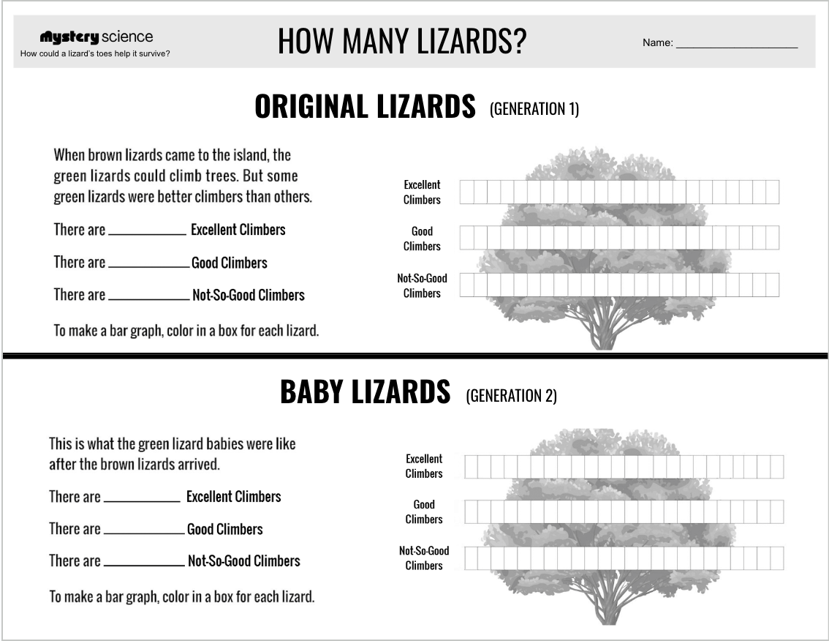

- To make a graph from the numbers, color in a box for each Excellent climbing lizard. Do the same for Good & Not-So-Good climbers.
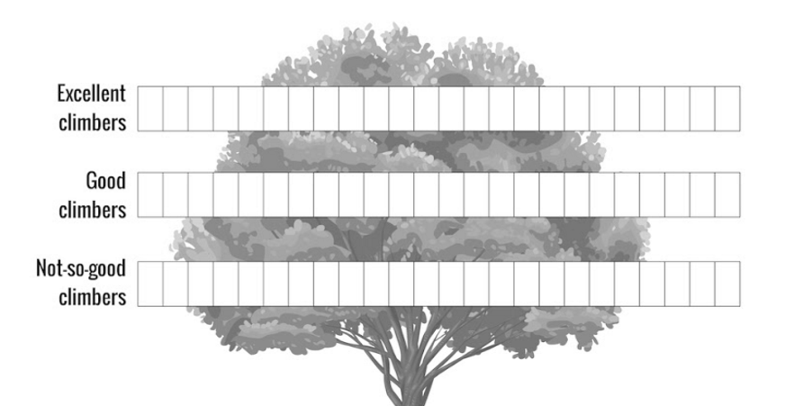

- Watch the video after the first step-by-step to find out what happened to the green anoles after the brown anoles arrived.


- Now it’s time to figure out which green anoles are caught by the brown anoles. Tell your students the following, and take away cards as noted:
- The Not-So-Good climbers are easiest to catch — only two of them survive. Take away 8 of the lizards labeled A, the not-so-good climbers.
- The Good climbers are harder to catch — half of them survive. Take away half of the lizards labeled B, the good climbers.
- The Excellent climbers are the best at getting away — only two of them get caught. Remove 2 the lizards labeled C, the excellent climbers.

- Mix up all the remaining Little Lizard Cards and put them into pairs. Each pair is going to make a lizard family. One is the father lizard and the other is the mother lizard. We have named the families after the mother-father combination. If one lizard parent is a Good Climber (B) and the other parent is an Excellent Climber (C), then this is family BC. Family combinations can be AA, AB, AC, BB, BC, or CC. Each pair of lizard parents will make 4 lizard babies. What kind of climbers will those babies be? Well, that depends on what their parents are like.

- Have your students use the 6 Small Group Baby Lizard Cards to figure out the number of toe scales on the babies from each combination. Once they know that, they can circle the kind of climber those babies are, and figure out how many babies there will be for that combination.

At the bottom of each of these, it says:

- Now it’s time to fill in the second graph on the How Many Lizards printout.
← Fill in the graph on the BOTTOM (Baby Lizards).
- Add up how many babies are Excellent climbers and graph that on the Baby Lizards tree.
- Add up how many babies are Good climbers and graph that on the Baby Lizards tree.
- Add up how many babies are Not-So-Good climbers and graph that on the Baby Lizards tree.

- Watch the final videos.


