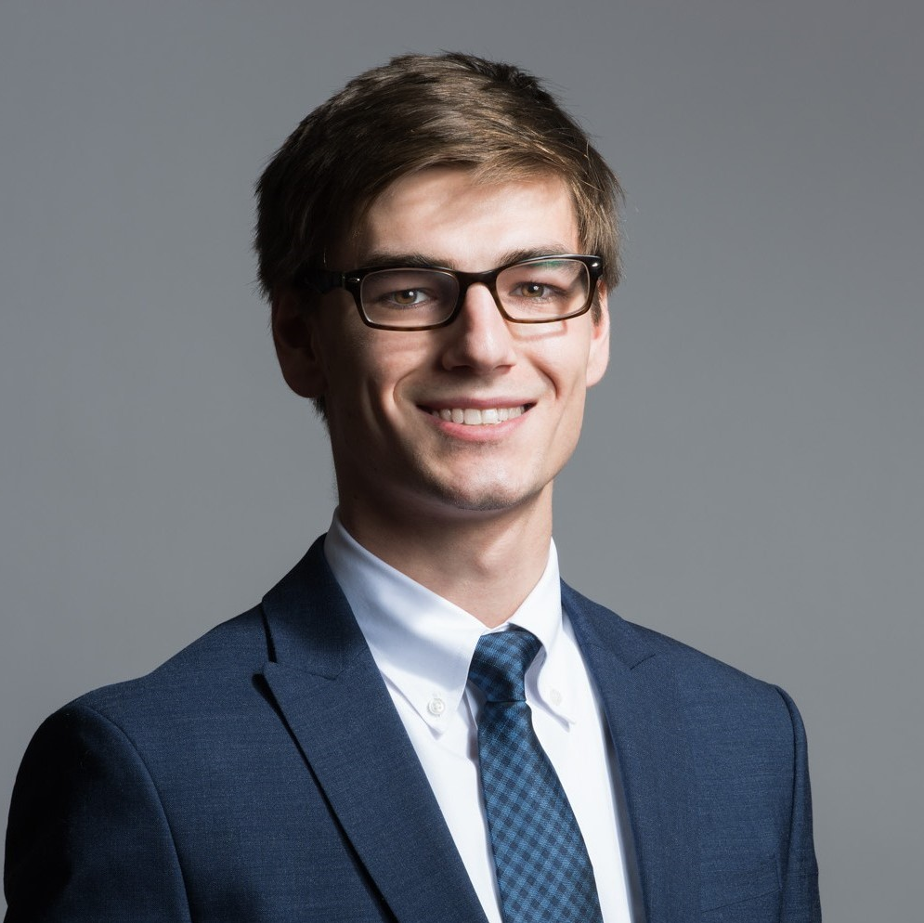

DIPLOMAS Y HOBBIES

Formaciones : Diplomados, Congresos, xxxxxxxxxx xxxxxx xxxxxxxxx xxxxxxxxxxxxxxxxx
Hobbies: xxxxxxxxxxxxxxxxxxxxxxxxxxxxxx
INCLUDEPICTURE "https://lh3.googleusercontent.com/-zZva6319EVE/AAAAAAAAAAI/AAAAAAAAAAA/zKFGBYMviqc/photo.jpg" \* MERGEFORMATINET INCLUDEPICTURE "https://lh3.googleusercontent.com/-zZva6319EVE/AAAAAAAAAAI/AAAAAAAAAAA/zKFGBYMviqc/photo.jpg" \* MERGEFORMATINET INCLUDEPICTURE "https://lh3.googleusercontent.com/-zZva6319EVE/AAAAAAAAAAI/AAAAAAAAAAA/zKFGBYMviqc/photo.jpg" \* MERGEFORMATINET INCLUDEPICTURE "https://lh3.googleusercontent.com/-zZva6319EVE/AAAAAAAAAAI/AAAAAAAAAAA/zKFGBYMviqc/photo.jpg" \* MERGEFORMATINET INCLUDEPICTURE "https://lh3.googleusercontent.com/-zZva6319EVE/AAAAAAAAAAI/AAAAAAAAAAA/zKFGBYMviqc/photo.jpg" \* MERGEFORMATINET INCLUDEPICTURE "https://lh3.googleusercontent.com/-zZva6319EVE/AAAAAAAAAAI/AAAAAAAAAAA/zKFGBYMviqc/photo.jpg" \* MERGEFORMATINET INCLUDEPICTURE "https://lh3.googleusercontent.com/-zZva6319EVE/AAAAAAAAAAI/AAAAAAAAAAA/zKFGBYMviqc/photo.jpg" \* MERGEFORMATINET INCLUDEPICTURE "https://lh3.googleusercontent.com/-zZva6319EVE/AAAAAAAAAAI/AAAAAAAAAAA/zKFGBYMviqc/photo.jpg" \* MERGEFORMATINET INCLUDEPICTURE "https://lh3.googleusercontent.com/-zZva6319EVE/AAAAAAAAAAI/AAAAAAAAAAA/zKFGBYMviqc/photo.jpg" \* MERGEFORMATINET INCLUDEPICTURE "https://lh3.googleusercontent.com/-zZva6319EVE/AAAAAAAAAAI/AAAAAAAAAAA/zKFGBYMviqc/photo.jpg" \* MERGEFORMATINET INCLUDEPICTURE "https://lh3.googleusercontent.com/-zZva6319EVE/AAAAAAAAAAI/AAAAAAAAAAA/zKFGBYMviqc/photo.jpg" \* MERGEFORMATINET INCLUDEPICTURE "https://lh3.googleusercontent.com/-zZva6319EVE/AAAAAAAAAAI/AAAAAAAAAAA/zKFGBYMviqc/photo.jpg" \* MERGEFORMATINET INCLUDEPICTURE "https://lh3.googleusercontent.com/-zZva6319EVE/AAAAAAAAAAI/AAAAAAAAAAA/zKFGBYMviqc/photo.jpg" \* MERGEFORMATINET INCLUDEPICTURE "https://lh3.googleusercontent.com/-zZva6319EVE/AAAAAAAAAAI/AAAAAAAAAAA/zKFGBYMviqc/photo.jpg" \* MERGEFORMATINET INCLUDEPICTURE "https://lh3.googleusercontent.com/-zZva6319EVE/AAAAAAAAAAI/AAAAAAAAAAA/zKFGBYMviqc/photo.jpg" \* MERGEFORMATINET INCLUDEPICTURE "https://lh3.googleusercontent.com/-zZva6319EVE/AAAAAAAAAAI/AAAAAAAAAAA/zKFGBYMviqc/photo.jpg" \* MERGEFORMATINET INCLUDEPICTURE "https://lh3.googleusercontent.com/-zZva6319EVE/AAAAAAAAAAI/AAAAAAAAAAA/zKFGBYMviqc/photo.jpg" \* MERGEFORMATINET INCLUDEPICTURE "https://lh3.googleusercontent.com/-zZva6319EVE/AAAAAAAAAAI/AAAAAAAAAAA/zKFGBYMviqc/photo.jpg" \* MERGEFORMATINET INCLUDEPICTURE "https://lh3.googleusercontent.com/-zZva6319EVE/AAAAAAAAAAI/AAAAAAAAAAA/zKFGBYMviqc/photo.jpg" \* MERGEFORMATINET INCLUDEPICTURE "https://lh3.googleusercontent.com/-zZva6319EVE/AAAAAAAAAAI/AAAAAAAAAAA/zKFGBYMviqc/photo.jpg" \* MERGEFORMATINET INCLUDEPICTURE "https://lh3.googleusercontent.com/-zZva6319EVE/AAAAAAAAAAI/AAAAAAAAAAA/zKFGBYMviqc/photo.jpg" \* MERGEFORMATINET INCLUDEPICTURE "https://lh3.googleusercontent.com/-zZva6319EVE/AAAAAAAAAAI/AAAAAAAAAAA/zKFGBYMviqc/photo.jpg" \* MERGEFORMATINET INCLUDEPICTURE "https://lh3.googleusercontent.com/-zZva6319EVE/AAAAAAAAAAI/AAAAAAAAAAA/zKFGBYMviqc/photo.jpg" \* MERGEFORMATINET INCLUDEPICTURE "https://lh3.googleusercontent.com/-zZva6319EVE/AAAAAAAAAAI/AAAAAAAAAAA/zKFGBYMviqc/photo.jpg" \* MERGEFORMATINET INCLUDEPICTURE "https://lh3.googleusercontent.com/-zZva6319EVE/AAAAAAAAAAI/AAAAAAAAAAA/zKFGBYMviqc/photo.jpg" \* MERGEFORMATINET INCLUDEPICTURE "https://lh3.googleusercontent.com/-zZva6319EVE/AAAAAAAAAAI/AAAAAAAAAAA/zKFGBYMviqc/photo.jpg" \* MERGEFORMATINET INCLUDEPICTURE "https://lh3.googleusercontent.com/-zZva6319EVE/AAAAAAAAAAI/AAAAAAAAAAA/zKFGBYMviqc/photo.jpg" \* MERGEFORMATINET INCLUDEPICTURE "https://lh3.googleusercontent.com/-zZva6319EVE/AAAAAAAAAAI/AAAAAAAAAAA/zKFGBYMviqc/photo.jpg" \* MERGEFORMATINET INCLUDEPICTURE "https://lh3.googleusercontent.com/-zZva6319EVE/AAAAAAAAAAI/AAAAAAAAAAA/zKFGBYMviqc/photo.jpg" \* MERGEFORMATINET INCLUDEPICTURE "https://lh3.googleusercontent.com/-zZva6319EVE/AAAAAAAAAAI/AAAAAAAAAAA/zKFGBYMviqc/photo.jpg" \* MERGEFORMATINET INCLUDEPICTURE "https://lh3.googleusercontent.com/-zZva6319EVE/AAAAAAAAAAI/AAAAAAAAAAA/zKFGBYMviqc/photo.jpg" \* MERGEFORMATINET INCLUDEPICTURE "https://lh3.googleusercontent.com/-zZva6319EVE/AAAAAAAAAAI/AAAAAAAAAAA/zKFGBYMviqc/photo.jpg" \* MERGEFORMATINET INCLUDEPICTURE "https://lh3.googleusercontent.com/-zZva6319EVE/AAAAAAAAAAI/AAAAAAAAAAA/zKFGBYMviqc/photo.jpg" \* MERGEFORMATINET INCLUDEPICTURE "https://lh3.googleusercontent.com/-zZva6319EVE/AAAAAAAAAAI/AAAAAAAAAAA/zKFGBYMviqc/photo.jpg" \* MERGEFORMATINET INCLUDEPICTURE "https://lh3.googleusercontent.com/-zZva6319EVE/AAAAAAAAAAI/AAAAAAAAAAA/zKFGBYMviqc/photo.jpg" \* MERGEFORMATINET INCLUDEPICTURE "https://lh3.googleusercontent.com/-zZva6319EVE/AAAAAAAAAAI/AAAAAAAAAAA/zKFGBYMviqc/photo.jpg" \* MERGEFORMATINET INCLUDEPICTURE "https://lh3.googleusercontent.com/-zZva6319EVE/AAAAAAAAAAI/AAAAAAAAAAA/zKFGBYMviqc/photo.jpg" \* MERGEFORMATINET INCLUDEPICTURE "https://lh3.googleusercontent.com/-zZva6319EVE/AAAAAAAAAAI/AAAAAAAAAAA/zKFGBYMviqc/photo.jpg" \* MERGEFORMATINET INCLUDEPICTURE "https://lh3.googleusercontent.com/-zZva6319EVE/AAAAAAAAAAI/AAAAAAAAAAA/zKFGBYMviqc/photo.jpg" \* MERGEFORMATINET INCLUDEPICTURE "https://lh3.googleusercontent.com/-zZva6319EVE/AAAAAAAAAAI/AAAAAAAAAAA/zKFGBYMviqc/photo.jpg" \* MERGEFORMATINET INCLUDEPICTURE "https://lh3.googleusercontent.com/-zZva6319EVE/AAAAAAAAAAI/AAAAAAAAAAA/zKFGBYMviqc/photo.jpg" \* MERGEFORMATINET INCLUDEPICTURE "https://lh3.googleusercontent.com/-zZva6319EVE/AAAAAAAAAAI/AAAAAAAAAAA/zKFGBYMviqc/photo.jpg" \* MERGEFORMATINET INCLUDEPICTURE "https://lh3.googleusercontent.com/-zZva6319EVE/AAAAAAAAAAI/AAAAAAAAAAA/zKFGBYMviqc/photo.jpg" \* MERGEFORMATINET INCLUDEPICTURE "https://lh3.googleusercontent.com/-zZva6319EVE/AAAAAAAAAAI/AAAAAAAAAAA/zKFGBYMviqc/photo.jpg" \* MERGEFORMATINET INCLUDEPICTURE "https://lh3.googleusercontent.com/-zZva6319EVE/AAAAAAAAAAI/AAAAAAAAAAA/zKFGBYMviqc/photo.jpg" \* MERGEFORMATINET INCLUDEPICTURE "https://lh3.googleusercontent.com/-zZva6319EVE/AAAAAAAAAAI/AAAAAAAAAAA/zKFGBYMviqc/photo.jpg" \* MERGEFORMATINET INCLUDEPICTURE "https://lh3.googleusercontent.com/-zZva6319EVE/AAAAAAAAAAI/AAAAAAAAAAA/zKFGBYMviqc/photo.jpg" \* MERGEFORMATINET INCLUDEPICTURE "https://lh3.googleusercontent.com/-zZva6319EVE/AAAAAAAAAAI/AAAAAAAAAAA/zKFGBYMviqc/photo.jpg" \* MERGEFORMATINET
NAME

SURNAME

Psychologist

PROFESSIONAL EXPERIENCE
PROFILE

Dedicated and compassionate Psychologist with over 8 years of experience in providing psychological assessments, individual and group therapy, and mental health support. Skilled in Cognitive Behavioral Therapy (CBT), crisis intervention, and research-based treatment approaches. Seeking to contribute to international healthcare organizations or academic institutions by delivering high-quality psychological care and training.
Senior Psychologist – Al Salam International Hospital (2018 –Present)
- Provide psychological assessments and therapy sessions for patients with depression, anxiety, and trauma.
- Supervise junior psychologists and interns.
- Collaborate with multidisciplinary teams to ensure comprehensive
Psychologist – Hope Mental Health Center (2014 – 2018)
CONTACT
- Conducted individual and group therapy sessions.

- Designed treatment plans tailored to patient needs.
name.sn@mail.com
- Organized community awareness workshops on mental health.
+1 222 222 222

Education
©AZURIUS – Modelos-de-curriculum.com

New York
Knitting
Contemporary Dance

©AZURIUS – Hoja-de-vida.co

©AZURIUS - My-resume-templates.com

Master’s Degree in Clinical Psychology – Ain Shams University, Egypt – 2016

SKILLS

Bachelor’s Degree in Psychology – Cairo University, Egypt – 2012
Cognitive Behavioral Therapy (CBT)
Psychological assessment and diagnosis
Strong communication and empathy
Stress and trauma management
Team leadership and supervision

Training & Certifications

Certificate in Trauma Counseling – 2020

Advanced CBT Workshop – 2018

Crisis Intervention Skills – 2017

Publications & Research
- Published research on the impact of CBT in treating adolescent depression, 2019.
- Co-author of a paper on family therapy approaches in multicultural contexts, 2021.

