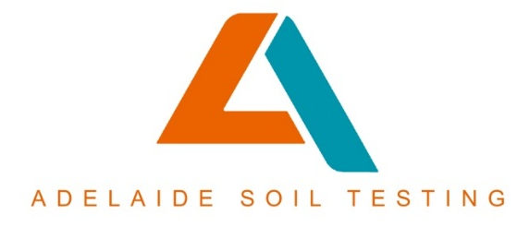
Soil Test Booking Form
Adelaide Soil Testing Pty Ltd
ABN: 27663403236 / ACN: 663403236
37 Mayfair Drive, Andrews Farms SA
E: drilling@adelaidesoiltesting.com.au

JOB NUMBER | Click here to enter text if required.
Engineer/Builder Company | Click here to enter text.
Engineer/Builder Contact Name & Number | Click here to enter text.
Owner Contact Name | Click here to enter text.
Owner Contact Number | Click here to enter text.
Owner Email Address | Click here to enter text.
Site Address | Click here to enter text.
Purpose of Soil Testing (New House, New Commercial Building, Extension, Granny Flat, Shed, Pool etc) | Click here to enter text.

Is there a house or building on site? | Click here to enter text.
Are there underground services on site? (Power, Water, Gas, Irrigation etc) | Click here to enter text.
Will an underground service locator be required to avoid damage to services & injury to drilling technicians? (Additional costs apply. Not usually required if block is completely vacant) | Click here to enter text.

Number of Boreholes & Depth | Click here to enter text.
Is a Site Classification/Ys Value Required? | Click here to enter text.
Do you have a Site Plan? (please attach) | Click here to enter text.
Is a Site Photo Required? | Click here to enter text.
Is DCP Testing Required? (Please add quantity if so. Additional costs apply) | Click here to enter text.

Are the drillers required to call for access? | Click here to enter text.
Is there a rental tenant in the house? | Click here to enter text.
Tenant contact number (if applicable) | Click here to enter text.
Are the drillers required to call tenant for access? | Click here to enter text.
1

Thank you for filling out the booking form. Please return to drilling@adelaidesoiltesting.com.au and a booking will be made with the drillers, who will make direct contact to organise a date/time as well as an underground service locator if one is required.

