
European long-term ecosystem, critical zone and socio-ecological systems research infrastructure PLUS

Guidelines for data collection

Technical Document
on
Data Provisioning using B2SHARE

Version 2

13. July 2023

(on the basis of Version 1 from 05. October 2020)

Author(s) and affiliations:
Johannes Peterseil¹, Ulf Mallast²

¹ Umweltbundesamt GmbH (EAA), Spittelauer Lände 5, 1090 Vienna, Austria
¹ Helmholtz Zentrum für Umweltforschung GmbH (UFZ), Permoser Str. 15, 04318 Leipzig, Germany



What is B2SHARE?
eLTER uses B2SHARE in order to share and publish metadata files. B2SHARE is developed by the EUDAT2020 project in order to provide a common data infrastructure for European research data.
When uploading data files to B2SHARE a PID (Persistent Identifier) and DOI (Digital Object Identifier) is created to allow an unambiguous identification of the file including a resolution service for the PID. B2SHARE supports an open data policy, allowing implementing a retention period. The data is deposited in Finland at the Finnish IT Center for Science. More precisely it is stored on servers in Kajaani, a newly-built and environmentally-friendly data centre using the most advanced and modern data centre technology. EUDAT retains the right of archiving, i.e. creating replicas at trusted centres to take care of long-term persistence.
The below given sequence of steps is based on the B2SHARE User Documentation [link] and adapted directly to eLTER requirements.

How to upload a data file
Register as user  If you are not yet registered, please click on the Login or Register link (green rectangle) on the B2SHARE website. You will be referred to the B2ACCESS website where you can register your new user account.  Click on the "Register a new account" link and fill out the registration form for a new B2ACCESS account.  A confirmation email will be sent to the email address of the newly created account. More information on B2ACCESS is available from the User Documentation pages. | 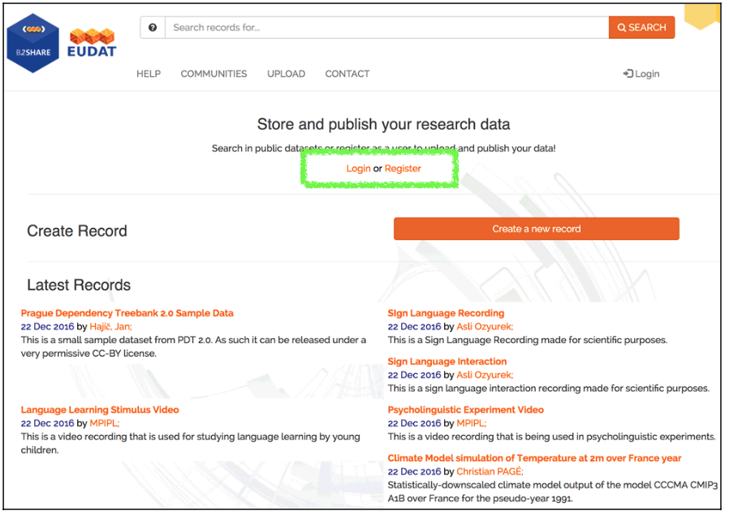
Log in  To log in, click on the link "Login" on the home page and choose your method of authentication (B2ACCESS ID, social ID or organisational ID). If required, fill in your username and password directly and click the link "Authenticate" beneath the fields. You might be redirected to the login portal of your own institution. | 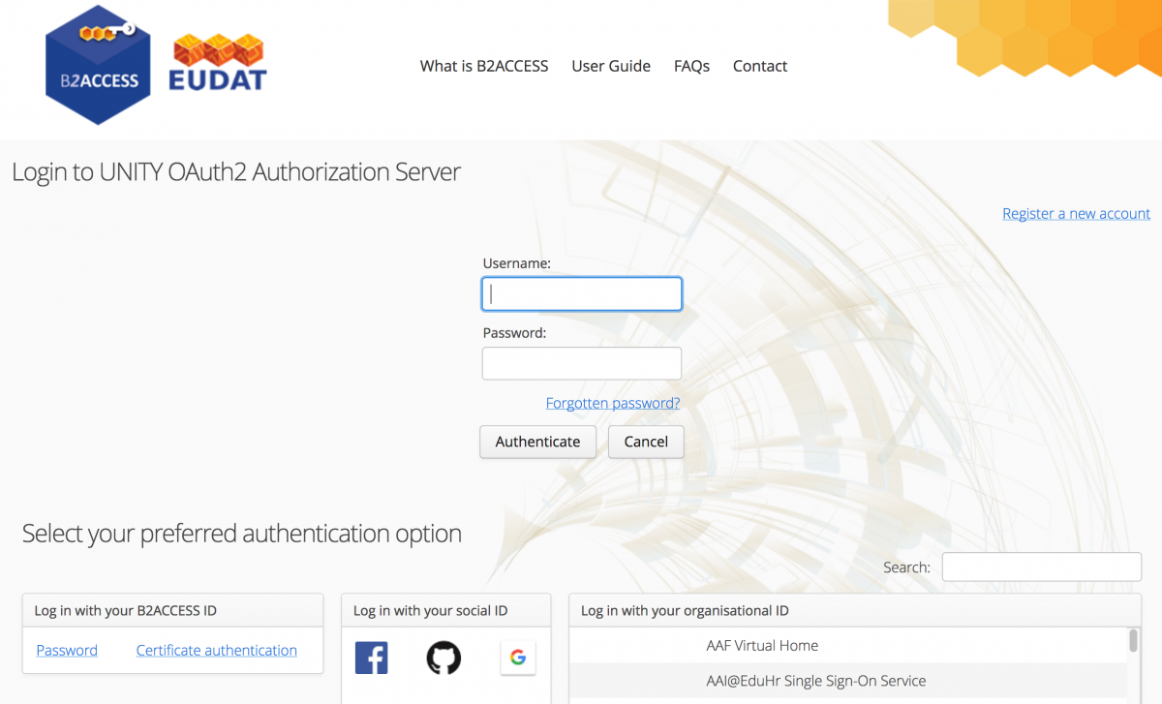
Create a new record  Only registered users can create new records and upload data into them.  To create a record, sign in to B2SHARE if you haven't already. Then click on "Create a new record" button on the right side to create a draft record which you will prepare to become a fully published record in B2SHARE. Now follow the subsequent four steps. | 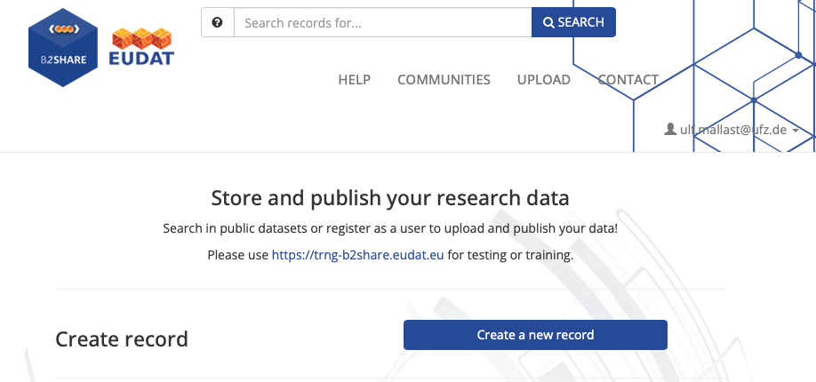  Note that the maximum size for a record is 20 GB; and the maximum size for a file is 10 GB.)
1. Step:  Enter the title of your new record and select “LTER” as community. Then click on “create draft record” on the end of the page. | 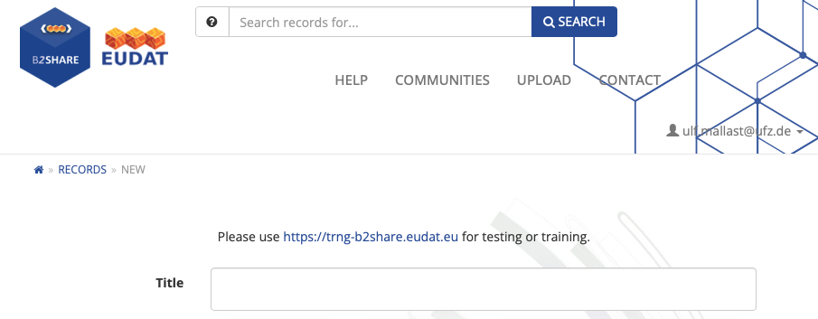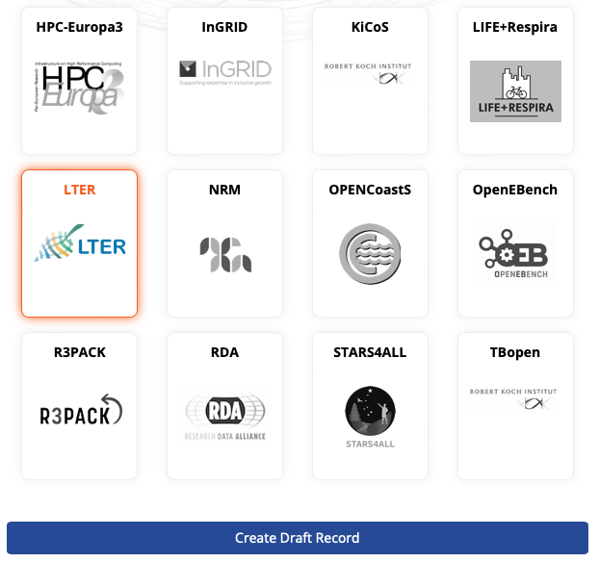
2. Step:  Upload one or several data resources by dragging and dropping from your file browser window to the field marked "Drop files here, or click to select files" or click that same box and select a file to upload in the pop-up file browser window.  If you make a mistake, it is possible to remove the uploaded copy by clicking the red cross to the right of the file name | 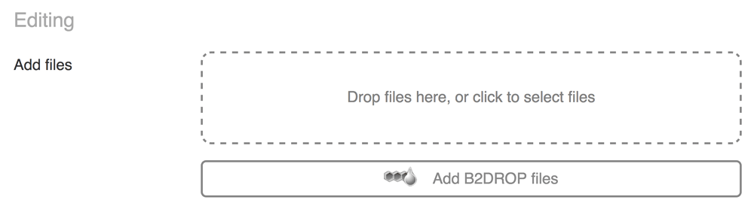
3. Step:  Fill in the basic metadata fields.  Mandatory fields to fill are:  - Title (copy of the file name)  - Descriptions (first, select as type “abstract” and provide an abstract for the dataset (what, where, how many). Second, click on “add” and in the newly added field select as type “methods” and provide a short description of the methods used to collect the dataset(devices used, method of observation, applied calibration procedure)  - Creator (add the name of the person entering the information in B2SHARE)  - License (we recommend to use CC-BY - but you can also use the built-in wizard to select the license most appropriate for your needs)  - Keywords (minimum needs are the keywords:  Data/Project calls: eLTER data call, Data Call.ID (e.g. DataCall_2023_01)) and include the variables covered by the dataset  TA-RA projects:  TA-RA project.ID (e.g. TA_RA.01), project title, and include the variables covered by the dataset  - Contact email (add the contact of the person that retrieved the information/is the owner of the data)  Note: now click on “show more details” just below the contact email field and fill in the further mandatory fields  - Ressource type: please select “Dataset” from the drop down menu  - Spatial coverages:  - Place (add here the DEIMS.ID of your site)  - Boxes (add here the the geographic bounding box for the dataset)  - Temporal coverages: please provide the start and end date for your dataset.  LTER Metadata  - Metadata URL (add here the DEIMS.ID of the site, where data has been obtained)  Optional fields to fill:  - funding references (add here e.g. project grant agreement numbers of eLTER PLUS 871128 | 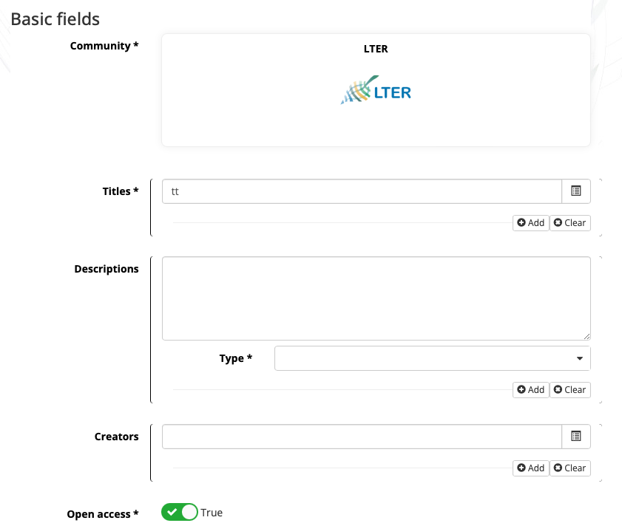  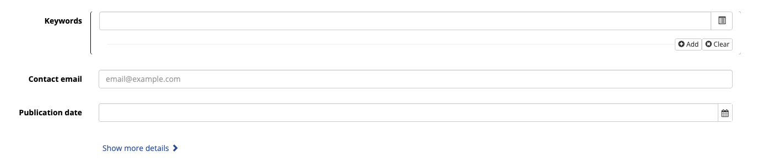
4. Step:  To finalise your draft record, check the 'Submit draft for publication' box and click 'Publish record'. If you just want to save your draft and edit it later, click 'Save draft' directly. The draft record will be visible in your account's draft record list. | 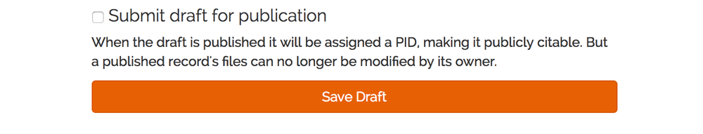
Logging out
To log out from the service, click on your user name or email address visible on the home page, and select "Logout" in the drop down menu.

Checking  To prove your entries you can search for the data set or your name and check your entries.  In case you encountered missing or wrong entries you can click on “Edit Metadata” on the end of the page and conduct your changes. | 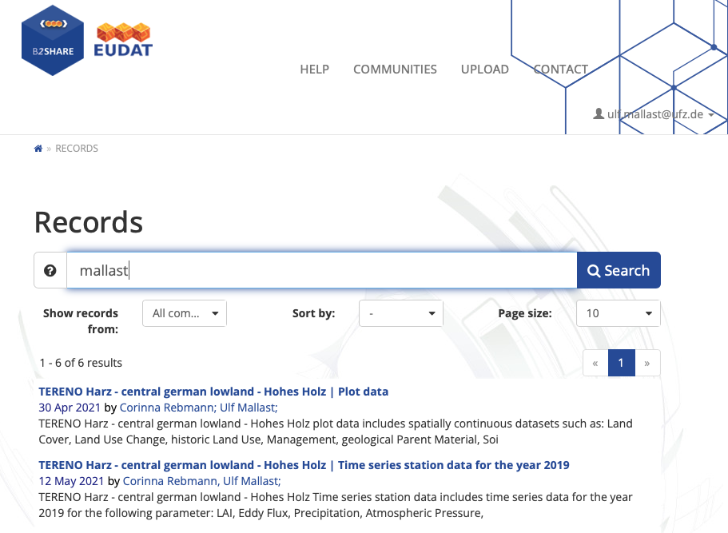
Training instance  For training and testing purposes, the training instance of B2SHARE can be used: https://trng-b2share.eudat.eu. | This instance requires a separate user registration. You are free to create test records through the website or the API. Please remember that all data and metadata created in this service is publicly accessible and viewable by others.

