# **Microfire LLC Mod-NTC Datasheet**

## 

## **Release Information**

Copyright © 2023 Microfire LLC

This documentation is licensed under a [Creative Commons Attribution-NoDerivatives 4.0 International (CC BY-ND)](https://creativecommons.org/licenses/by-nd/4.0/).

## **Release History**

| **Release** | **Date** | **Description** |
| --- | --- | --- |
| 1.0.0 | 4/20/2023 | Initial |

## **Legal Disclaimer**

TECHNICAL AND RELIABILITY DATA FOR MICROFIRE LLC PRODUCTS (INCLUDING DATASHEETS) AS MODIFIED FROM TIME TO TIME (“RESOURCES”) ARE PROVIDED BY MICROFIRE LLC "AS IS" AND ANY EXPRESS OR IMPLIED WARRANTIES, INCLUDING, BUT NOT LIMITED TO, THE IMPLIED WARRANTIES OF MERCHANTABILITY AND FITNESS FOR A PARTICULAR PURPOSE ARE DISCLAIMED. TO THE MAXIMUM EXTENT PERMITTED BY APPLICABLE LAW IN NO EVENT SHALL MICROFIRE LLC BE LIABLE FOR ANY DIRECT, INDIRECT, INCIDENTAL, SPECIAL, EXEMPLARY, OR CONSEQUENTIAL DAMAGES (INCLUDING, BUT NOT LIMITED TO, PROCUREMENT OF SUBSTITUTE GOODS OR SERVICES; LOSS OF USE, DATA, OR PROFITS; OR BUSINESS INTERRUPTION) HOWEVER CAUSED AND ON ANY THEORY OF LIABILITY, WHETHER IN CONTRACT, STRICT LIABILITY, OR TORT (INCLUDING NEGLIGENCE OR OTHERWISE) ARISING IN ANY WAY OUT OF THE USE OF THE RESOURCES, EVEN IF ADVISED OF THE POSSIBILITY OF SUCH DAMAGE.

MICROFIRE LLC reserves the right to make any enhancements, improvements, corrections or any other modifications to the RESOURCES or any products described in them at any time and without further notice.

The RESOURCES are intended for skilled users with suitable levels of design knowledge. Users are solely responsible for their selection and use of the RESOURCES and any application of the products described in them. User agrees to indemnify and hold MICROFIRE LLC harmless against all liabilities, costs, damages or other losses arising out of their use of the RESOURCES.

HIGH RISK ACTIVITIES. MICROFIRE LLC products are not designed, manufactured or intended for use in hazardous environments requiring fail safe performance, such as in the operation of nuclear facilities, aircraft navigation or communication systems, air traffic control, weapons systems or safety-critical applications (including life support systems and other medical devices), in which the failure of the products could lead directly to death, personal injury or severe physical or environmental damage, or business loss (“High Risk Activities”). MICROFIRE LLC specifically disclaims any express or implied warranty of fitness for High Risk Activities and accepts no liability for use or inclusions of MICROFIRE LLC products in High Risk Activities.

Microfire LLC Mod-NTC Datasheet

Release Information

Release History

Legal Disclaimer

About the Mod-NTC Module

Mechanical Specification

Pinout

Surface Mounting

Operating Conditions

Electrical Specification

Power Supply

Power Isolation

Power Consumption

I²C Interface

Additional Circuitry

I²C Address

I²C Write

I²C Read

Design Incorporation

Power

Ground

Probe Connection

Considerations

Unused Pins

Temperature Measurements

Measurement Details

NTC Types

Calibration

Steinhart-Hart Coefficients

I²C Interface

Registers

Register Listing

Tasks

Task Listing

MEASURE_TEMP_TASK - Temperature Measurement

Required Registers

Response Parameters

BETA_TASK - I²C address change

Required Registers

Response Registers

I2C_TASK - I²C address change

Required Registers

Response Registers

Certificate of Compliance

RoHS 3 Directive 2015/863/EU

Justin Decker

# About the Mod-NTC Module

A module for interfacing with 10K NTC temperature sensors. It has been designed to be flexible and simple to incorporate into new or existing electrical designs.

* Resolution 0.125°C
* [I²C](https://docs.google.com/document/d/1DSG9bdEHDt9mdQInVfCWy4qiohi6sVeEy7QbvBfUmU0/edit#heading=h.lykmcx66bc4l) with software definable address
  + Default address 0x0C
  + 10kHz, 100 kHz, 400 kHz, 1 MHz compatible
* 25 mm wide x 15 mm high x 0.8mm thick
  + Material type: FR-4 TG155
  + DIP and castellated edges

# Mechanical Specification

The Mod-NTC module is a single-sided 25x15 mm 0.8 mm thick PCB with dual castellated/through-hole pins around the east and west edges. It is designed to be usable as a surface mount module as well as in Dual Inline Package (DIP) type format, with the 12 pins on a 2.54mm pitch grid with 0.9mm holes.

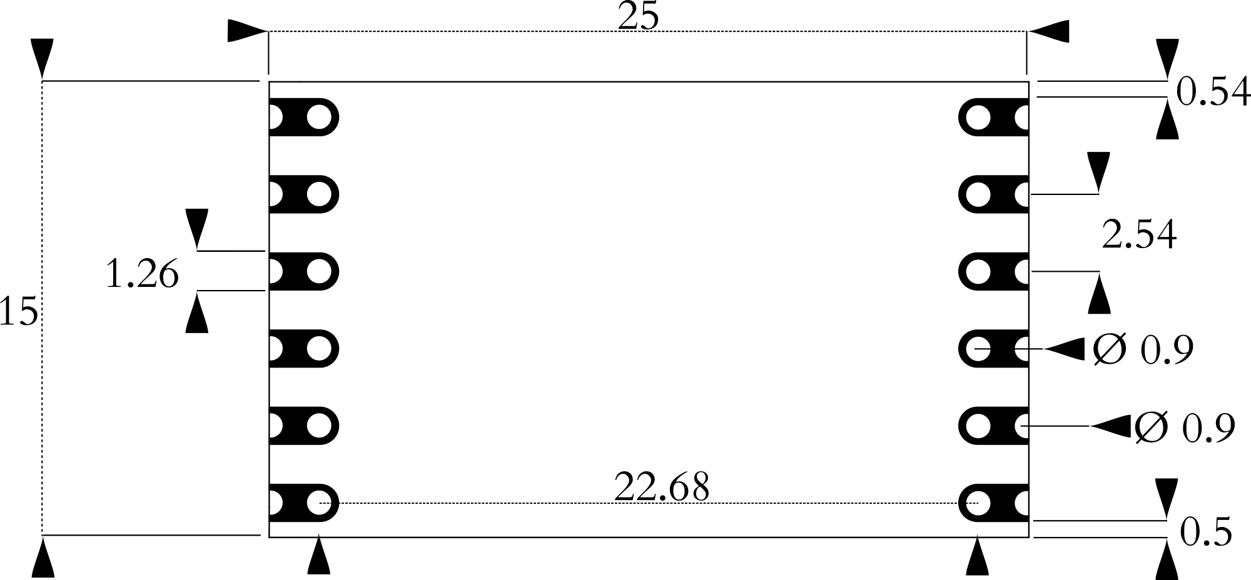

Figure 1. Physical dimensions of the module.

## Pinout

The pinout of the module has been designed to provide as many interface options as possible.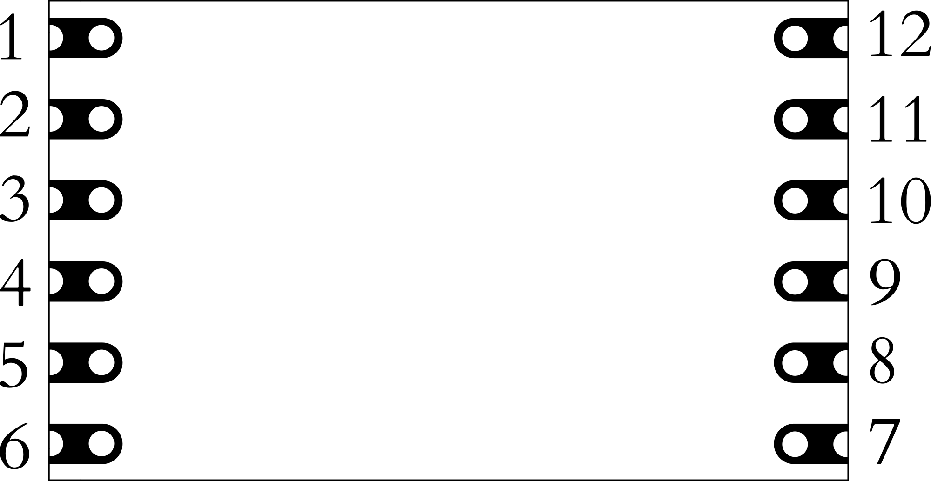Figure 2. Pinout of the module.

**Pin 1**: Probe 1 input. Provides a connection to either wire of the NTC.

**Pin 2**: Probe 2 input. Provides a connection to the other wire of the NTC.

**Pin 3**: Not used in this module.

**Pin 4**: Not used in this module.

**Pin 5**: Not used in this module.

**Pin 6**: Not used in this module.

**Pin 7**: Not used in this module.

**Pin 8**: Not used in this module.

**Pin 9**: I²C SCL. Clock line for I2C interface.

**Pin 10**: I²C SDA. Data line for I2C interface.

**Pin 11**: VIN. 3.3-volt power supply.

**Pin 12**: Ground. Ground for the module.

## Surface Mounting

The following figure shows the recommended footprint for mounting the module through reflow processes. It provides for a Class 1 connection (*IPC-A-610G § 8.3.4 Castellated Termination*s).

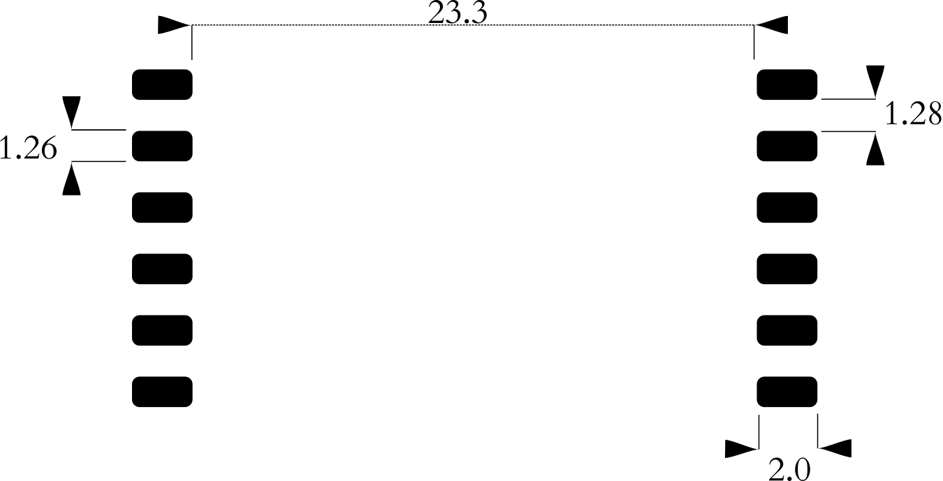

It is recommended that the stencil be 8 mils in thickness to ensure enough solder paste can flow into the castellations.

The module is assembled with [Chip Quik SMD291SNL50T3](https://www.chipquik.com/datasheets/SMD291SNL50T3.pdf) (Sn96.5/Ag3.0/Cu0.5) solder paste, a lead-free paste with a 249-degree Celsius peak reflow temperature. Reflowing the module multiple times can cause malfunction, to avoid the issue, if it is possible, use a lower melting-point temperature solder paste.

## Operating Conditions

**Temperature**:

* **Absolute**:
  + **Maximum**: 85 C
  + **Minimum**: -40 C
* **Recommended**:
  + **Maximum**: 50 C
  + **Minimum**: 10 C

When approaching the absolute temperature ratings, it should be noted that the module’s temperature will begin to affect measurements, the extent of which will need to be characterized to the specific environment the module will be deployed in.

Voltage:

* **Absolute Maximum**: 5.5 volts
* **Absolute Minimum**: 1.8 volts (3.3 volts is required for proper operation)

# 

# Electrical Specification

## Power Supply

The module requires 3.3 volts for proper operation. It can be supplied with less and still communicate through the various peripheral interfaces, but this will not allow the analog circuitry to operate properly. Voltage should not exceed 5.5 volts.

There is no reverse polarity protection on the module.

### Power Isolation

Isolation is not required for this module.

### Power Consumption

All modules are designed to be low-power. Power usage has been characterized at two points, idle and active sensor measurement.

* Current use is typically 0.15 mA

# 

# I²C Interface

The module supports speeds of 10kHz, 100 kHz, 400 kHz, and 1 MHz at 3.3 volts.

The I²C interface uses the following pins:

* **Pin 9 SCL**: serial clock
* **Pin 10 SDA**: data

### Additional Circuitry

The module has no pullup resistors on the I²C bus. For reliable communication, appropriate resistors must be chosen for the SDA and SCL lines.

### I²C Address

The default address is 0x0C by default. It can be changed through firmware.

### I²C Write

Writing is done by sending a start condition followed by the module’s address with the write bit set. The master device then sends data 8 bytes at a time. The first byte received is considered to be the register address. Successive writes will automatically increment the register address by one byte. Transmission is finished with a stop condition.

### I²C Read

Reading is done by sending a start condition followed by the module’s address with the read bit set. The master sets the register to read from, then requests data. The device then sends the appropriate number of bytes as determined by the register being read.

# 

# Design Incorporation

Adding the module is a straightforward process.

## Power

A suitable power supply must be supplied. Ideal solutions will provide a low-ripple, low-EMI, 3.3 volt supply.

## Ground

The module operates at the same ground potential as what **Pin 11**: Ground is connected to, so a low-impedance connection is needed.

## Probe Connection

An NTC probe that is compatible with the module consists of two wires. This is most commonly provided for with a BNC, SMA, or U.FL connector.

## Considerations

* **Pin 1**: Probe 1 input and **Pin 2**: Probe 2 input pins should be on their own island plane pour or otherwise isolated by no pour surrounding them.
* **Pin 1**: Probe 1 input and **Pin 2**: Probe 2 input pins should be as short as possible.
* If the PCB is 4 or more layers, consider routing **Pin 1 and Pin 2** traces on internal layers to protect the probe input signal from interference.
* Avoid routing other traces near **Pin 1** and **Pin 2**.
* Flux residue on **Pin 1, Pin 2** and at the probe connection must be removed. This is ideally accomplished by using a “no-clean” solder paste, and/or through mechanical means such as an ultrasonic bath.

## Unused Pins

Any unused pins should be left unconnected to any other trace or net.

# 

# Temperature Measurements

## Measurement Details

An NTC (Negative Temperature Coefficient) is a thermistor, a resistor whose resistance changes with temperature. The resistance of NTC will decrease as the temperature increases. The amount the resistance decreases can be related to a constant, commonly referred to as beta, or ß.

## NTC Types

NTCs come in various configurations, materials, and specifications. Mod-NTC is intended for room temperature ranges using 10K sensors. The 10K specification signifies the sensor will read 10,000 Ohms at 25 degrees Celsius.

## Calibration

NTC sensors typically come with a value called beta. The beta value is used in a formula to convert the NTC’s output to a temperature value.

## Steinhart-Hart Coefficients

Some NTC probes will come with Steinhart-Hart coefficients. They are typically presented as three numbers: A, B, and C. The formula to use the coefficients with Mod-NTC is simple. Call the following function, passing resistance.

| **float** **SH_calculation**(**float** _resistance) {  **float** logRt = log(_resistance);  **float** _tempK, _tempC, _tempF;  _tempK = (1.0 / (A + B * logRt + C * logRt * logRt * logRt));  _tempC = _tempK - 273.15;  _tempF = _tempC * 1.8 + 32;   **return** _tempC; } |
| --- |

# 

# I²C Interface

The module’s I²C interface operates similarly to many common I²C sensors. There are several registers that hold values such as temperature or version information. The registers are used to pass information both to the module and the controlling device. Tasks are performed by writing a specified value to a certain register.

## Registers

All registers are either 1 byte or a float which is 4 bytes formatted as an IEEE 754 32-bit floating point, little-endian. The firmware will allow the registers to be read and written.

### Register Listing

| **Register Name** | **Value** | **Type** | **Description** |
| --- | --- | --- | --- |
| HW_VERSION_REGISTER | 0 | byte | Hardware version |
| FW_VERSION_REGISTER | 1 | byte | Firmware version |
| TASK_REGISTER | 2 | byte | Task register |
| STATUS_REGISTER | 3 | byte | Status of measurement |
| BETA_REGISTER | 4 | float | Beta value for connected sensor |
| TEMP_C_REGISTER | 8 | float | Measured temperature in Celsius |
| TEMP_K_REGISTER | 12 | float | Measured temperature in Kelvin |
| TEMP_F_REGISTER | 16 | float | Measured temperature in Fahrenheit |
| RESISTANCE_REGISTER | 20 | float | Resistance of the temperature sensor in ohms |
| BUFFER_REGISTER | 24 | float | Buffer used for passing information |

## Tasks

When a particular value is written to TASK_REGISTER, it starts an operation within the module.

Temperature measurement is performed when MEASURE_TEMP_TASK is written to the TASK_REGISTER register. To read the resulting measurement, you would read the TEMP_C_REGISTER, TEMP_F_REGISTER, TEMP_K_REGISTER or RESISTANCE_REGISTER register**.**

### Task Listing

| **Task Name** | **Duration** | **Value** | **Description** |
| --- | --- | --- | --- |
| MEASURE_TEMP_TASK | 150 ms | 40 | Temperature measurement |
| BETA_TASK | 1 ms | 20 | Beta change |
| I2C_TASK | 1 ms | 2 | I²C address change |

### 

### MEASURE_TEMP_TASK - Temperature Measurement

Starts a temperature measurement.

#### Required Registers

| Register | Description |
| --- | --- |
| None |  |

#### Response Parameters

| **Parameter** | **Description** |
| --- | --- |
| **TEMP_C_REGISTER** | The solution-under-test’s temperature in degrees Celsius. |
| **TEMP_F_REGISTER** | The solution-under-test’s temperature in degrees Fahrenheit. |
| **TEMP_K_REGISTER** | The solution-under-test’s temperature in Kelvin. |
| **RESISTANCE_REGISTER** | The resistance in ohms as measured from the temperature sensor. |
| **STATUS_REGISTER** | An error code for the measurement. Can be one of the following:  **0**: no error  **1**: no probe  **2**: system error |

### 

### 

### BETA_TASK - I²C address change

Changes the device’s beta value.

#### Required Registers

| Register | Description |
| --- | --- |
| BUFFER_REGISTER | Used to temporarily store the new beta value. |

#### Response Registers

| Register | Description |
| --- | --- |
| None |  |

### 

### I2C_TASK - I²C address change

Changes the device’s I²C address.

#### Required Registers

| Register | Description |
| --- | --- |
| BUFFER_REGISTER | Used to temporarily store the new I²C address. |

#### Response Registers

| Register | Description |
| --- | --- |
| None |  |

| **Microfire LLC**  **ㅡ**  **Justin Decker, CEO**  61190 Deronda Ave  Whitewater, CA 92282  <https://microfire.co>  justin@microfire.co | horizontal line 17 May 2021 **Certificate of Compliance**RoHS 3 Directive 2015/863/EU Microfire LLC certifies to the best of its knowledge and belief that the products listed herein conform with RoHS 3 Directive 2015/863/EU and its subsequent amendments. This declaration further certifies that Microfire LLC has obtained RoHS Certificates of Compliance from each applicable supplier of materials and parts used in the assembly and manufacture of these goods.  **Modules**  Mod-EC  Mod-pH  Mod-ORP  Mod-ISO  Mod-NTC  **Development Boards**  Isolated Dev Board  Mod-EVAL  Mod-EVAL_ISO  **Probes**  Industrial pH Probe  Industrial EC Probe  Industrial ORP Probe  Lab pH Probe  Lab EC Probe  Lab ORP Probe **Justin Decker** |
| --- | --- |