5-steps to Monitoring with Ellevation Forms
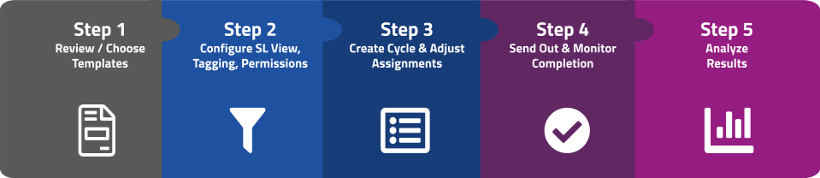

⚠  Please read first | - New to using Ellevation Forms? Follow this click sheet to set up your Monitoring (aka Teacher Input) Forms in Ellevation, then check out our Forms Rollout Toolkit to get your district started with templated emails, videos, turnaround training, Ellevation Academy eLearning courses, and more.  - If you have any questions along this 5-step journey, refer to the additional resources for each step or reach out to our Ellevation Support Team at support@ellevationeducation.com.  - This document is designed to be used online to access all the linked resources to get started, follow along, and check off as you complete the steps. However, it can also be printed as a ~10-page document.  - To make a personal copy of this clicksheet to check off steps as you go, please go to File > Make a copy or click here (note that you will not see any Ellevation updates with your copied version).

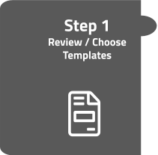 | The first step is to review and choose a Forms template. Ellevation has pre-built templates ready to use, based on best practices and aligned with how monitoring is conducted in your state.
- Find those templates in Ellevation by selecting the ⚙️ Admin Settings menu > Forms Settings > Templates. (Get started)
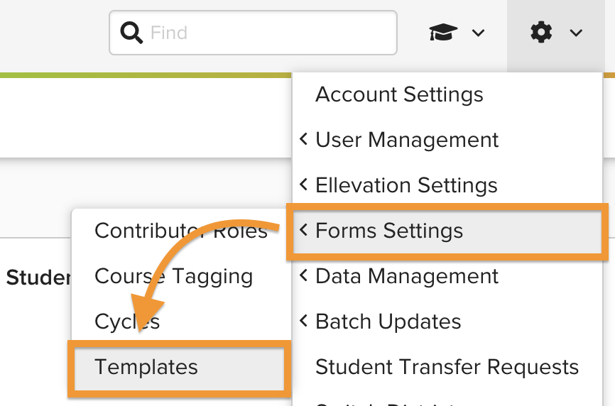
- Choose a template by clicking on the template name. If the template looks good, you’re done with this step (you’ll need to remember the template name in Step 3).
- Optionally you can add, configure, or remove sections in our Forms builder. Once your template is ready, click Save. (Get started)
If you checked at least the top two boxes, you’re done with the first step! 🎉
Additional resources for Step 1
⏯️ Review and Choose a Template, including how to configure templates (short video)
📘 Configure Form Templates (Resource Center article)

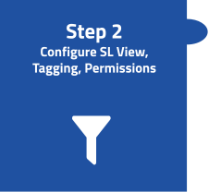 | The second step is to set up the correct student and teacher criteria, ensuring that…  - the correct students are selected by using a Student List view  - Teachers, specialists, and others have the correct permissions to work with forms as their role requires  - course names are tagged to the right subject areas so the correct teachers receive forms
Ensure the correct students are selected
Determine which students should be included in the monitoring cycle. Create a Student List view so the cycle knows exactly which students to include. (If you already have a saved view with the correct students, you can skip this step and move on to permissions)

- Navigate to Students > Student List > add filters (on the left) to narrow your list. (Get started)
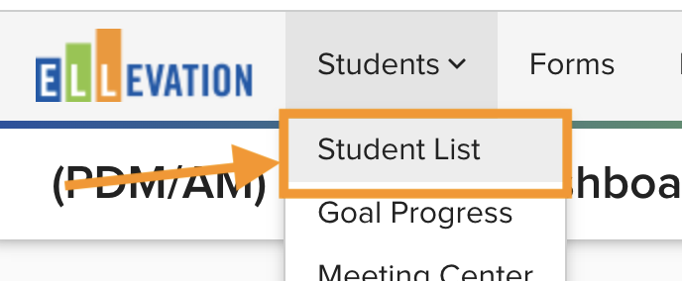
- Once you have filtered for the correct students, click the “Save As” button to name and save your view.
🏆Pro Tip: Name your view something easy to remember and find (ex. Forms: Exited-Student Monitoring).
Ensure correct permissions by role
Adjust your forms permissions so that teachers have the correct permissions to access and complete their assigned forms. You may also need to adjust permissions for EL Specialists, Principals, or other site leaders who will manage or support monitoring workflows in Ellevation, and need access to some or all Forms features.

- Navigate to ⚙️ Admin Settings menu > User Management > Permissions. (Get started)
- Scroll to find “Form Assignments”, and edit permissions so that each account type has the appropriate permissions.
- As needed, review and adjust other Form permissions (i.e. Form Cycles, Form Templates, Contributor Management, Course Tagging) based on who else in your district will manage or support these workflows in Ellevation.
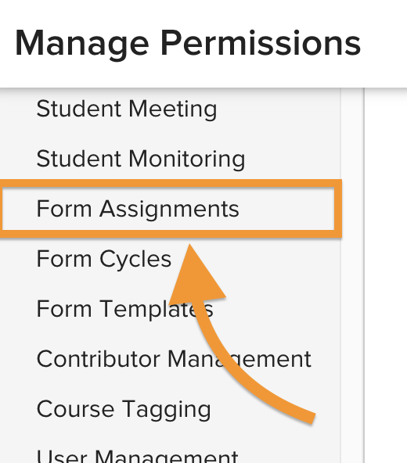
🏆Pro Tip: Typically teachers have permission to ‘View’ Form Assignments, allowing them to only access and complete their assigned forms.
Ensure course names are tagged to the right subject areas
Each course in a cycle must be assigned to a subject area. This ensures that the right teachers are matched to the right forms.

- Navigate to ⚙️ Admin Settings menu > Form Settings > Course Tagging. (Get started)
- Ellevation recommends starting with auto-tagging your courses. To auto-tag courses, click the blue auto-tag button. This will cycle through your courses and automatically tag most of them. However, it's always a good rule of thumb to review the courses after auto-tagging. Once auto-tagging is complete, you will see the report that lets you know how many courses were tagged, and how many courses are left untagged.
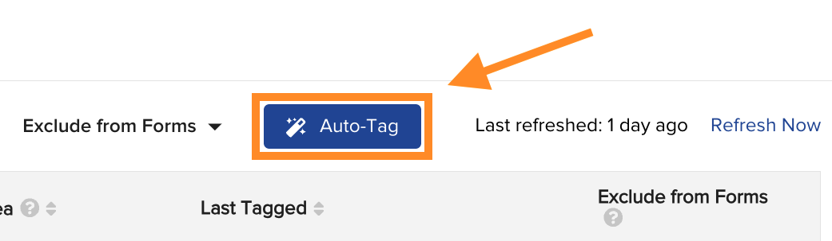
- For any remaining untagged courses, you can tag courses individually or bulk tag multiple courses at a time. Use the Search bar to search for keywords (ex. ELA, English, Band, Algebra, US Hist, Chem, etc.) to find groups of similar courses. To bulk tag, check the box to the left of “Course Name” and then select Bulk tag > [choose a Content Area] > Tag Courses.
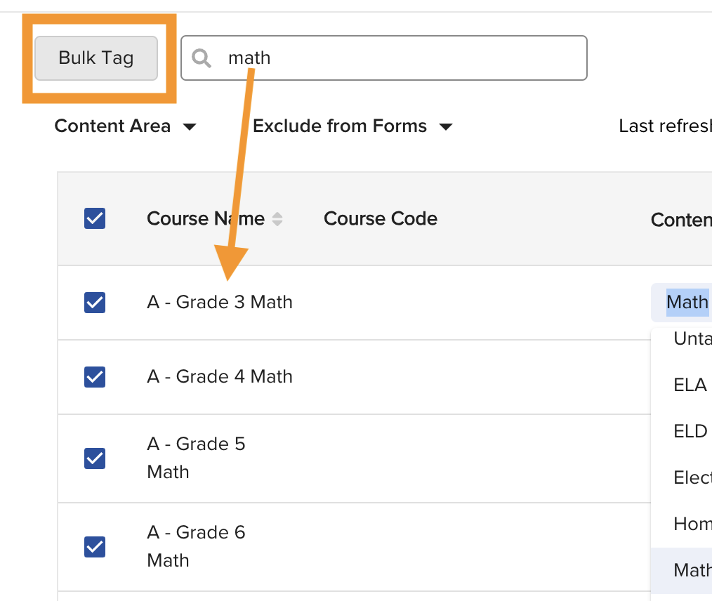
If you have your saved Student List View(s), your Forms Permissions are all set,
and you completed Course Tagging - you’re done with the second step.
Now all the pieces should fit together! 🎉
Additional resources for Step 2
⏯️ Student List Overview (short video)
⏯️ Create a Student List View for forms (short video)
⏯️ Course Tagging in Ellevation, including how to configure templates (short video)
📘 Configure Course Tags (Resource Center article)

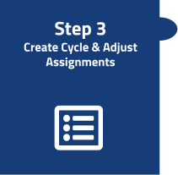 | The third step is to create a time-bound “cycle” for your form, and match teachers to their assigned forms.
Create a new cycle
- Select Forms from the main Ellevation navigation/masthead. (Get started)
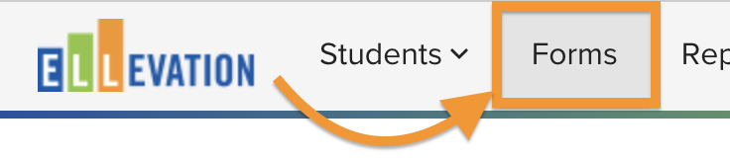
- Click the “New Cycle” button at the top right.
Fill out the basic details:
  - Cycle Name: Name the Cycle in a way that you will be able to differentiate between the current Cycle and future Cycles (i.e., 25-26 Semester 1 Secondary Exited Student Monitoring).
  - Form Template: Use the template you selected or created in Step 1.
  - Require Meeting Date: Leave this unchecked as it’s not necessary for monitoring workflows.
  - Student List View: Use the one you selected or created in Step 2.
  - Due Date: Select the date that you’d like for teachers to submit their input by.
  - Click Next: Configuration
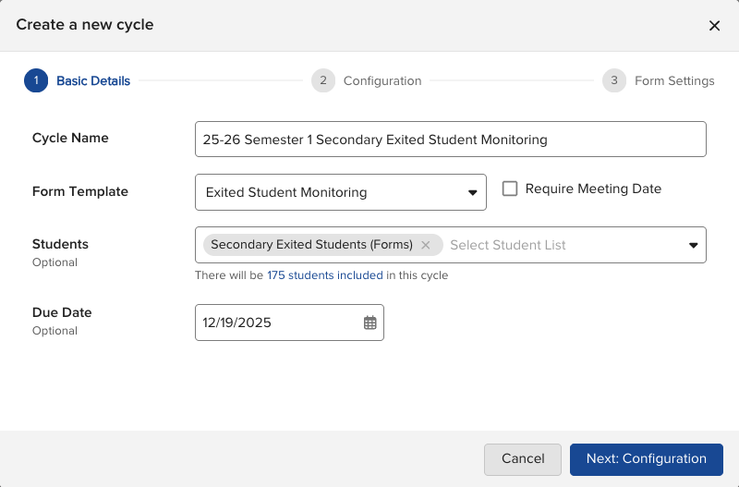
Select Configurations:
  - Digital Signatures: Leave the toggle on or turn the toggle off depending on your preference to collect electronic signatures or not. If you choose to collect them, you can select Standard or Strict for signature:
    - Standard: Allows teachers to sign and submit at different times
    - Strict: Requires teachers to sign and submit at the same time
  - Include Done Editing Status: Leave the toggle on or turn the toggle off depending on your preference:
    - ON: (Recommended) Allows teachers to sign in bulk (Get Started)
    - OFF: Will not allow teachers to sign in bulk
  - Click Next: Form Settings
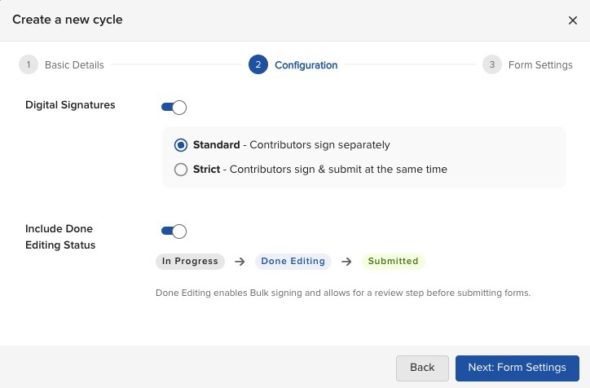

Determine Form Settings:
  - Forms per Student: Select how many Forms should be created for each student.
  - Roles per Form: Recommended to select Roles under “Match Supported” when collecting classroom teacher input.
  - Set Signature Requirements: Toggle the paper and pencil icon to assign the signature setting for each Role.
    - Solid icon: Signature for that Role is required in order to submit.
    - Outlined icon: Signature for that Role is optional.
  - Advanced Settings: If you would like, you can set the minimum number of signatures required per Form in order to submit.
  - Click Create your cycle
🏆 Tip: To determine Forms per student, consider the teachers who you need feedback from. For example, if students need monitoring forms completed by their ELA and Math teachers, you would select 2 Forms per student, and for each Form, you would select the corresponding ELA and Math ‘Role’ (see screenshot).
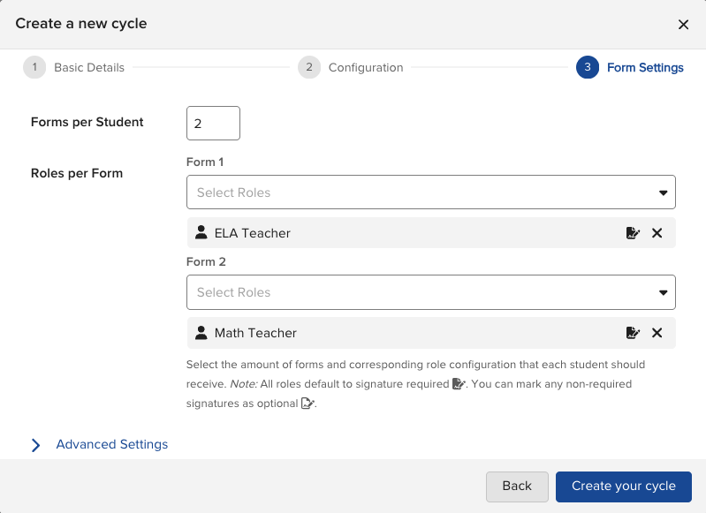
Match forms to teachers
Once you have created a new cycle, you can “match” forms with specific teachers (aka contributors). If a teacher appears on a student’s schedule for a tagged course, that teacher will be matched (aka, assigned) to the form during the match process. This will allow teachers to receive email reminders and easily access the form.
⚠️ This is best done right before you launch your cycle (Step 4) to ensure course schedule data is accurate.

- From your newly-created cycle page, click the “Match” button. For monitoring forms, we typically recommend you select ‘Create a separate form for each contributor’ selected, and click Yes, Match.
- Review the matched results in the Contributors column.
- As needed, manually match contributors by checking one or more form(s) and selecting Manage Contributors from the Actions menu. Then add, edit, or remove contributors.
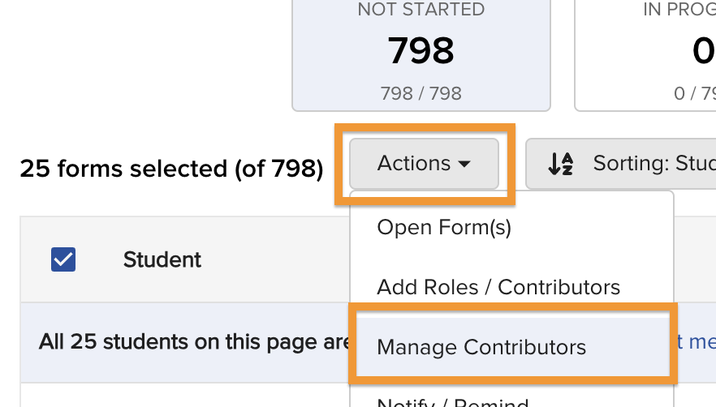
If you created new cycle(s) and matched your contributors,
you’re nearly ready to send out forms to educators! 🎉
Additional resources for Step 3
⏯️ Create a Cycle (short video)
📘 Create Form Cycles (Resource Center article)
📘 Generate Matches and Assign Forms (Resource Center article)

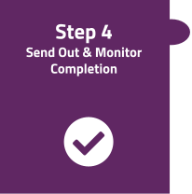 | The fourth step is to launch your cycle!
Set your cycle from Draft to Live mode
- From your newly-created cycle page, click the Draft/Live/Closed button (will be set to “Draft”).
- From the dropdown, select ⚈ Live.
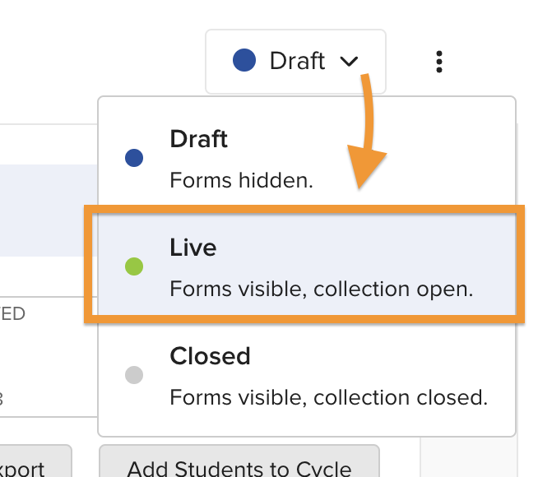
Once your cycle is live, the forms will be viewable to all educators assigned or permissioned to view them.
(if you set your cycle live by accident, simply set it back to Closed mode until you are ready to launch, then re-set it back to Live)
Send reminders
The final step is to send reminders to teachers so that they know that they have forms to fill out. We have resources you can share to help them with this, in the Additional resources section below.

- Check one or more forms for which you would like to send reminders within the cycle page (to select all forms, check the box next to ‘Student’ AND click “Select all students that meet this search across pages.”)
- Click the “Actions” button and select “Notify/Remind.” This will send an email to each teacher who has forms to fill out, directing them to fill out their forms in Ellevation.
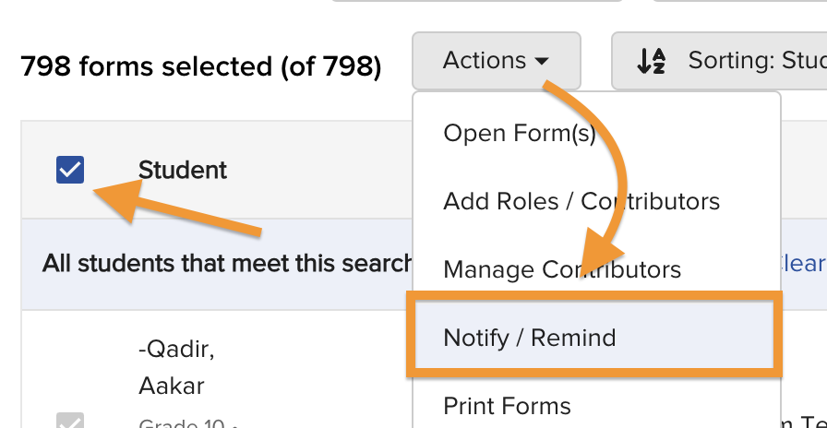
🏆 Tip: Educators assigned to more than one form will only receive one email per notification.

🏆 Tip: Educators do not require the link from the email to access their assigned forms (though that may be easier for them). All educators with forms assigned can view them in Ellevation by clicking Forms from the main menu.
Monitor forms progress
As forms are being completed you can use the clickable status ‘buckets’ on your cycle page to review which forms are not started, in progress, done, or submitted.
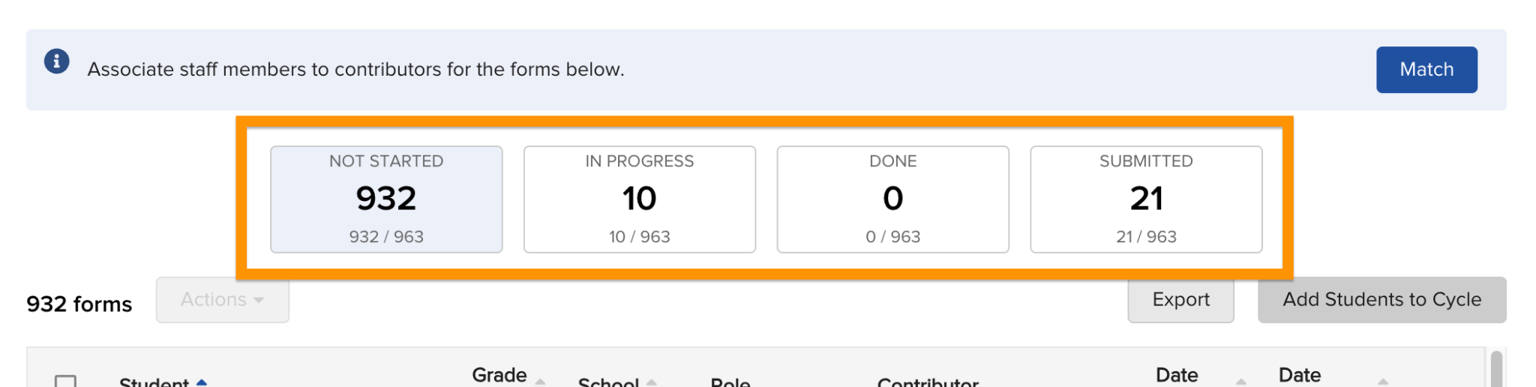
As needed, re-send reminders to teachers to complete forms (see steps above).

If you set your cycle(s) to Live, your forms have been sent! Now just wait for the data to roll in! 🎉
Additional resources for Step 4
⏯️ Launch and monitor a Cycle (short video)
📘 Generate Matches and Assign Forms (Resource Center article)
🧑‍🏫Share this resource with teachers: Complete Forms in Ellevation (short video)
🧑‍🏫Share this resource with teachers: Complete Forms (Resource Center article)

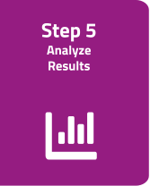 | The final step is to analyze the results.
Use the additional resources below to help you analyze form results in the Student List by…
- filtering for specific responses
- visually charting by form data
- viewing or exporting your Student List view as a spreadsheet / CSV
- making dashboards to visualize your data, and share with others

Congrats! You completed a monitoring cycle using Ellevation Forms and have actionable data to inform instruction and improve your student outcomes! 🎉
Additional resources for Step 5
⏯️ Use Forms Data in Dashboards (short video)
⏯️ Taking action on Forms in the Student List (short video)
📘 Take action with Forms using the Student List and data dashboards (Resource Center article)

