ADDITION REACTION
ADDITION REACTION TO ALKENES
Although the electrons in the sigma bond framework are tightly held, the pi bond is delocalized above and below the sigma bond. The pi bonding electrons are spread further from the carbon nuclei, and are more loosely held. A strong electrophile has an affinity for these loosely held electrons. It can pull them away to form a new bond, leaving one of the carbon atoms with only 3 bonds and a positive charge, a carbocation. In effect, the double bond has reacted with a nucleophile, donating a pair of electrons to the electrophile.
This reaction involves a second step in which a nucleophile attacks the carbocation forming a stable addition product. In the product, both the electrophile and the nucleophile are bonded to the carbon atoms that were connected by the double bond. It requires a strong electrophile to attract the electrons of the pi bond and generate a carbocation in the rate limiting step. This is known as electrophilic addition reaction.
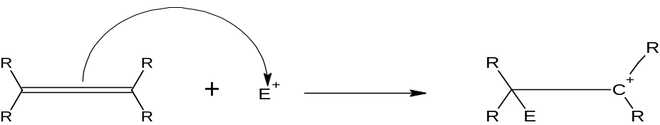
Step 1: Attack of the pi bond by the electrophile produces a carbocation
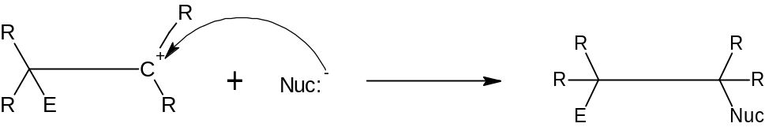
Step 2: Attack by the nucleophile gives the addition product.

Example: Addition of HBr To But-2-ene
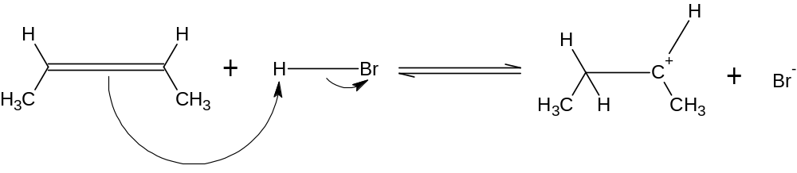
Step 1: protonation of the double bond to produce a carbocation
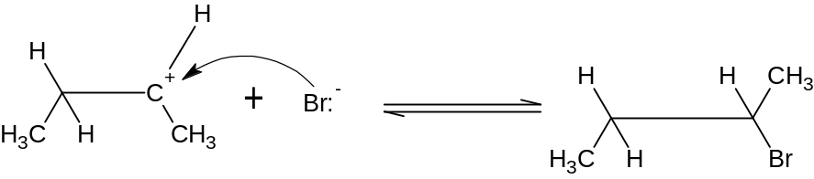
Step 2: Bromide ion attacks the carbocation
There are different types of addition reaction however not all are electrophilic addition reaction. Below is some example of type of addition reaction
- Hydration
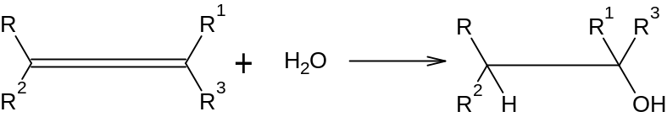

- Hydrogenation
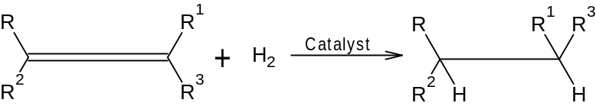

- Dihydroxylation
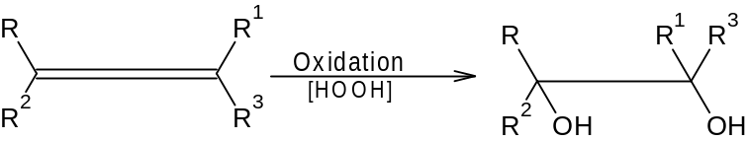

- Oxidative cleavage
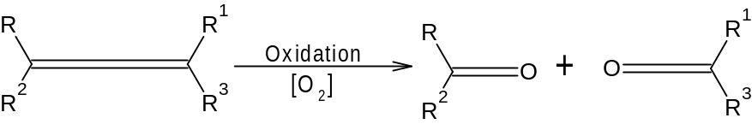

- Epoxidation
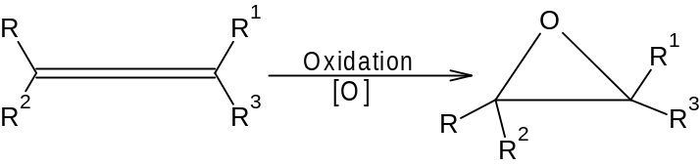

- Halogenation
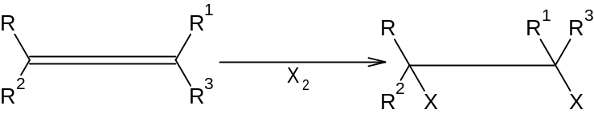
- Halohydrin formation
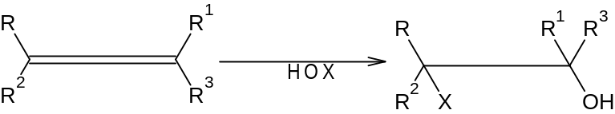

- Hydrohalogenation
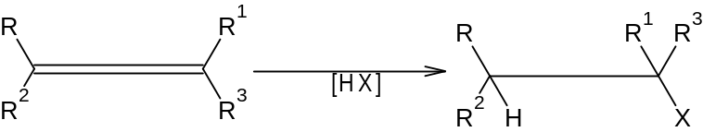

- Cyclopropanation
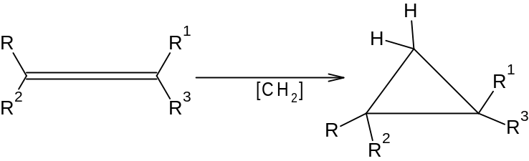

- Reaction with concentrated H₂SO4
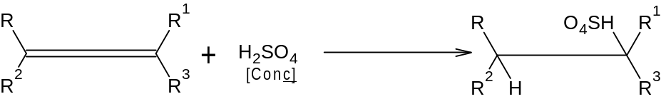

ADDITION OF ALKYLHALIDES TO ALKENES
The order of reactivity of alkylhalides in alkene addition is as follows:
HI>HBr>HCl>HF
Based on the mechanism of reaction, one might be able to predict the product expected. E.g is addition of HBr to 2-methylbut-2-ene. This could result in the formation of 2 products however only one is most likely to be observed.
H₃CCH=C(CH₃)₂ + HBr → H₃CCH₂CBr(CH₃)₂ + H₃CCHBrCH(CH₃)₂
Observed Not observed
This is known as Markovnikov addition reaction. It follows Markovnikov’s rule which was formulated by Russian chemist Vladimir Markovnikov in 1870. One way to state Markovnikov’s rule is to say that in the addition of the alkyl halides to the alkene, the hydrogen atom combines or add to the carbon atom of the double bond that already has the greater number of hydrogen atoms (directly attached to the carbon).
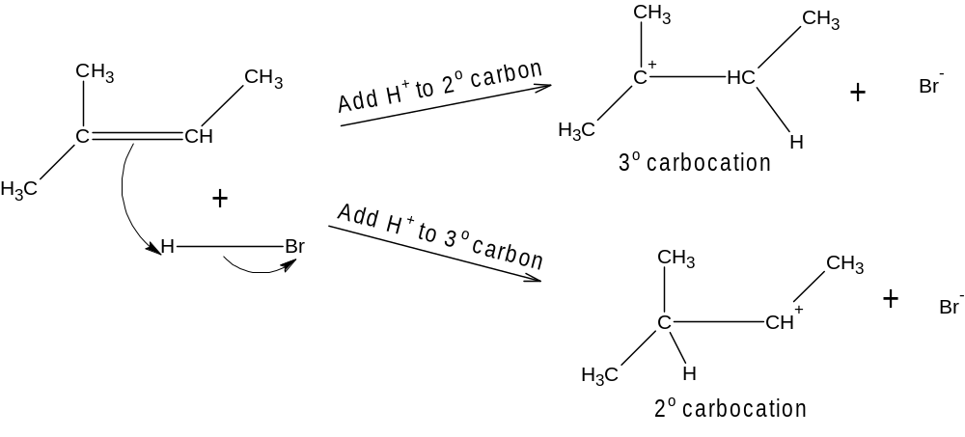
Stability of carbocations
3º>2º>1º>⁺CH3
An electrophile adds to a double bond to give the most stable carbocation which is the intermediate.
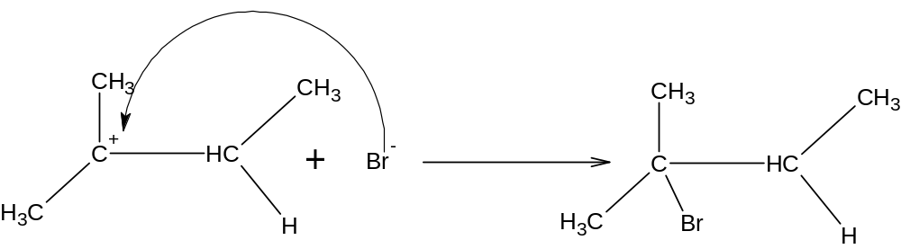

ACID-CATALYZED HYDRATION OF AN ALKENE
It involves the protonation of the double bond to give a carbocation, followed by nucleophilic attack with water and finally a loss of a proton to give the alcohol
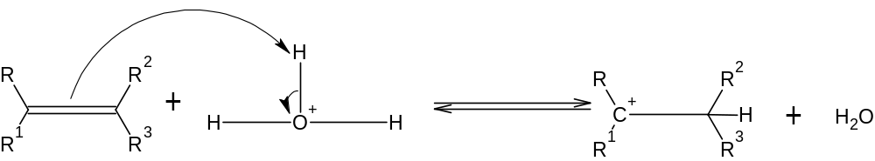
Step 1: Protonation of the double bond gives a carbocation. The carbocation is usually the more substituted carbon
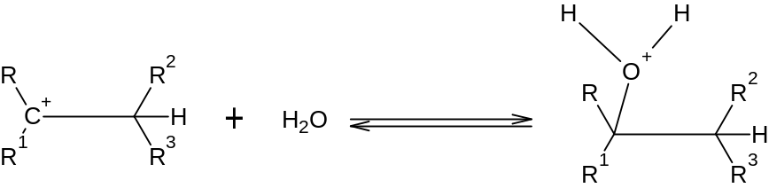
Step 2: Nucleophilic attack by water gives a protonated alcohol
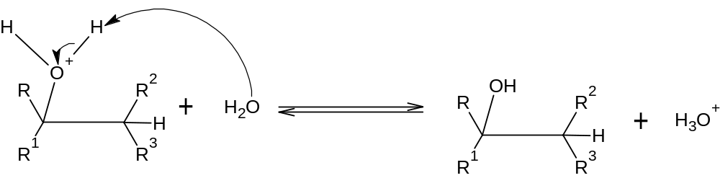
Step 3: Deprotonation gives the alcohol
This reaction also follows Markovnikov’s rule.

ADDITION OF HALOGENS TO ALKENES
Halogens add to alkenes to form vicinal dihalides. Halogens are electrophilic and nucleophile (pi electrons) attacks the electrophilic nucleus and the other ion serves as leaving group. A halonium ion is formed which is a 3-membered ring that is electrophilic. A nucleophile causes the opening of the ring to form a stable product.
Example: Addition of Bromine molecule to Propene
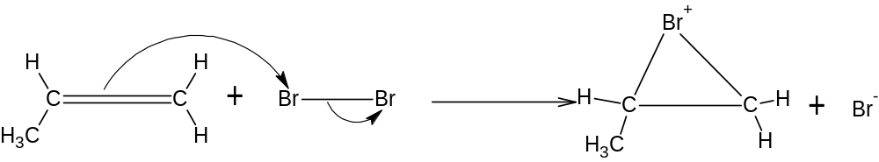
Step 1: Electrophilic attacks forms a bromonium ion
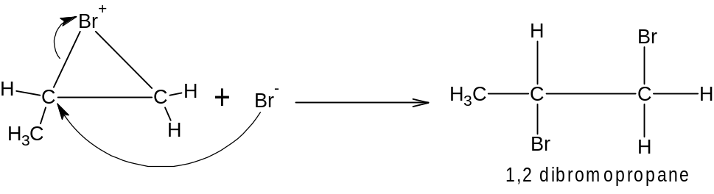
Step 2: Bromide ion opens the bromonium ion ring.
STEREOCHEMISTRY OF ADDITION REACTION
Nucleophilic attack of the bromine molecule causes inversion as it attacks from the back-side. The anti addition of a halogen to an alkene gives an example of a stereospecific reaction which is a reaction in which a particular stereoisomeric form of the starting material react in such a way to give a specific stereoisomeric form of the product.
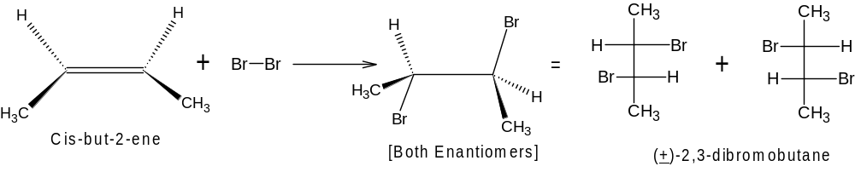

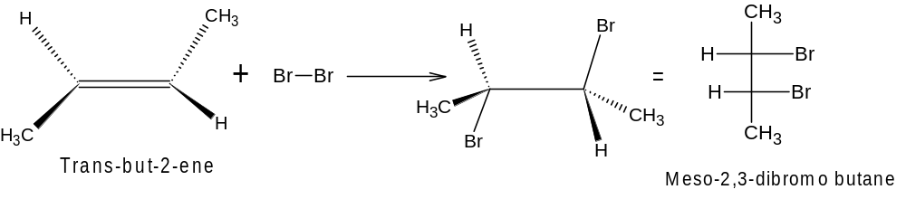

ADDITION REACTION OF ALKYNES
The reactions are similar to that of alkenes. They both have π bonds which are electron rich. This reaction converts the 2 π bond to σ bonds hence 2 molecules could be added across the double bond
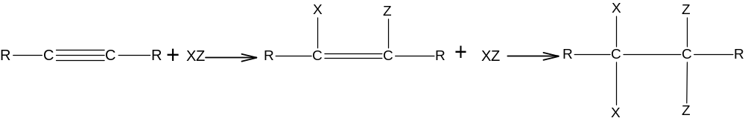
Some conditions may allow the reaction to stop after a single addition reaction while other conditions allow double addition. In the presence of a suitable catalyst, hydrogen adds to an alkyne, resulting in the formation of alkane. Example of catalysts are platinum, Palladium, Nickel etc.
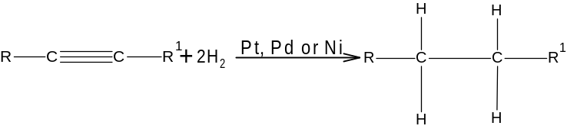
Addition reaction of hydrogen to but-1-yne
It occurs at 2 stages, with alkene intermediates. With efficient catalysts, it is usually impossible to stop the reaction at the alkene stage.

CATALYTIC HYDROGENATIOON TO CIS ALKENES
Hydrogenation of an alkyne can be stopped at the alkene stage by using a “poisoned” (partially deactivated) catalyst made by treating a good catalyst with a compound that makes the catalyst less effective. Lindlar catalyst is a poisoned Palladium catalyst, which comprises of powdered barium sulphate coated with Palladium, poisoned with Quinoline. It causes simultaneous addition of 2 hydrogen atoms and ensures syn stereochemistry resulting in cis products.
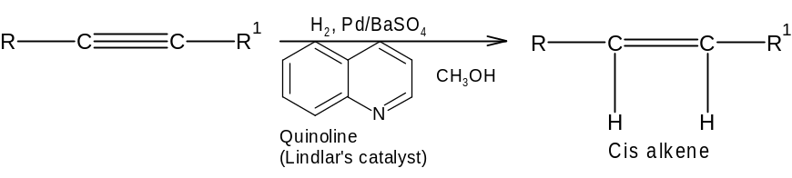

Other examples of addition reaction of alkynes includes
- Metal-Ammonia reduction to trans alkenes
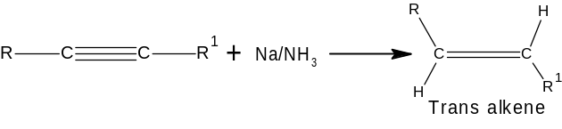

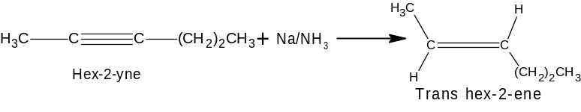
- Addition of halogens
It results in the formation of alkene which could be cis or trans
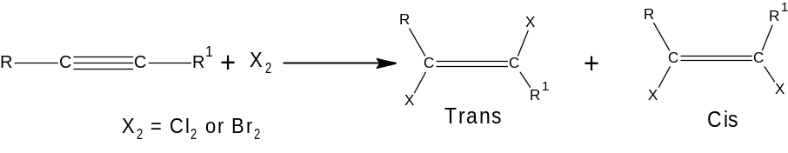
Example
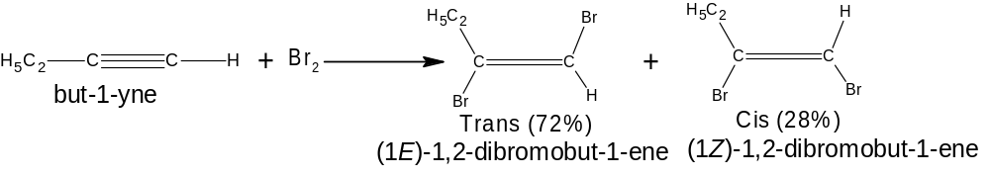

This occurs when 1 mole of halogen is added to 1 mole of alkynes. When 2 mole is added, a saturated alkyl halides are formed.
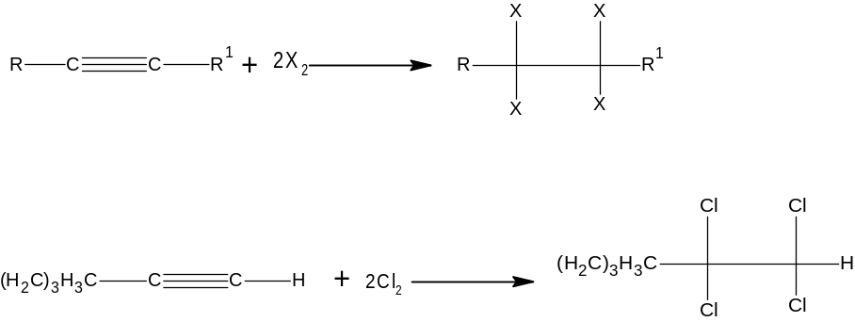

- Addition of alkyl halides
This follows Markovnikov’s rule as well
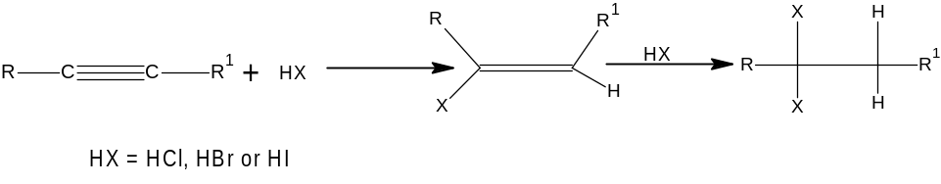

- Hydration of alkynes to give ketones and aldehyde
Alkyne undergo acid-catalyzed addition of water across the triple bond in the presence of mercuric ion as a catalyst. It follows Markovnikov’s orientiation
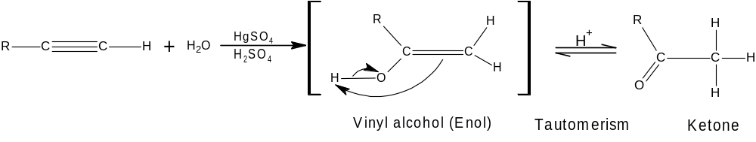

- Oxidation of alkynes
When alkyne is treated with cold, aqueous potassium permanganate under nearly neutral conditons, an α-diketone results
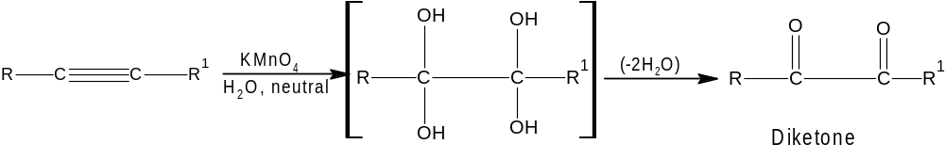
- Ozonolysis
Ozonolysis of an alkyne, followed by hydrolysis, cleaves the triple bond and gives 2 carboxylic acids. Either permanganate cleavage or ozonolysis can be used to determine the position of the triple bond in an unknown alkyne.
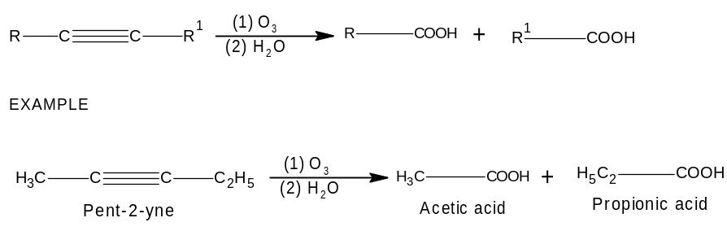

ELECTROPHILIC AROMATIC SUBSTITUTION
Like alkene, benzene has a clouds of pi electrons above and below its sigma bond framework. Although benzene pi electrons are in a stable aromatic system, they are available to attack a strong electrophile to give a carbocation. This resonance-stabilized carbocation is called a sigma complex because the electrophile is joined to the benzene ring by a new sigma bond. They are called Arenium ion and are not aromatic because the SP3 hybrid carbon atom interrupt the ring of the P orbitals. Loss of aromaticity contributes to the highly endothermic nature of this first step. The sigma complex regains aromaticity either by reversal of the first step or by loss of the proton on the tetrahedral carbon leading to the aromatic substitution product.
The overall reaction is the substitution of an electrophile (E+) for a proton (H+) on the aromatic ring. This class of reactions includes substitution by a wide variety of electrophilic reagents. Because it enables us to introduce functional groups directly onto the aromatic ring.

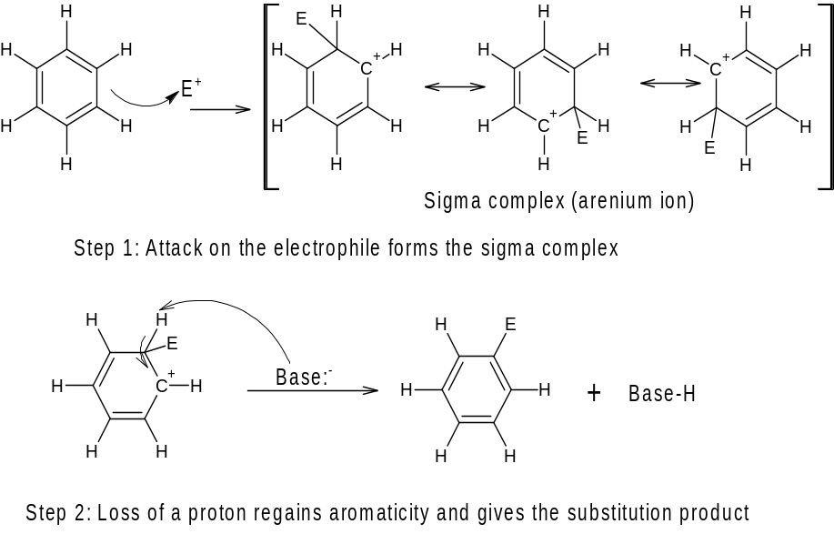

HALOGENATION OF BENZENE
Bromination of Benzene: bromine itself is not sufficiently electrophilic to react with benzene and the formation of Br+ is difficult. A strong lewis acid e.g FeBr3 acts as a catalyst by forming a complex with Br2 that reacts like Br+. Bromine donates a pair of electrons to FeBr3, forming a stronger electrophile with a weakened Br-Br bond and a partial positive charge on one of the bromine atoms. Attack by benzene forms the sigma complex. Bromine ion from FeBr4- acts as a weak base to remove a proton from the sigma complex, given the aromatic product.

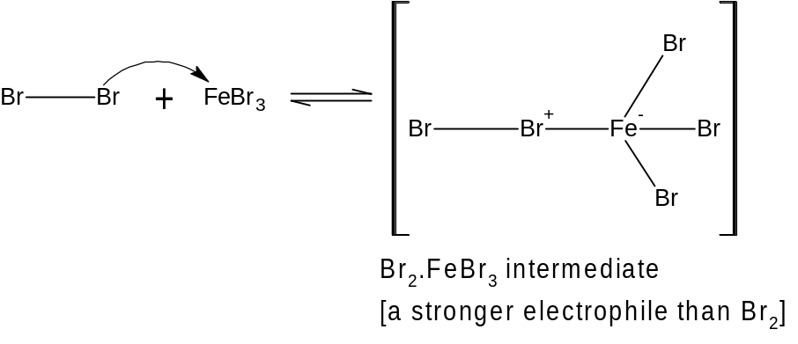
Step 1: Formation of a stronger electrophile
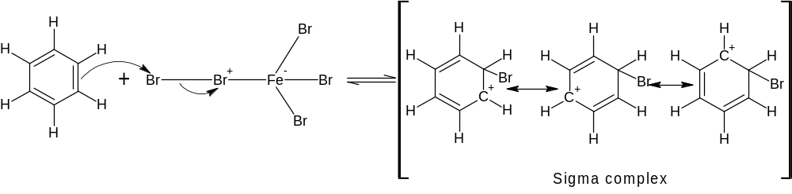
Step 2: Electrophilic attack resulting in the formation of the sigma complex
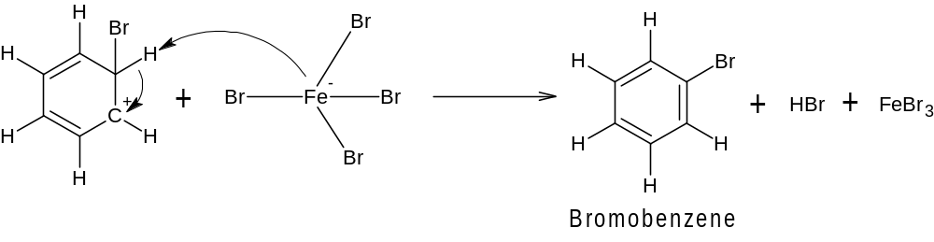
Step 3: Loss of a proton gives the product

NITRATION OF BENZENE
Nitric acid possesses a hydroxyl group which can be protonated and leaves as water, this is similar to the dehydration of an alcohol.
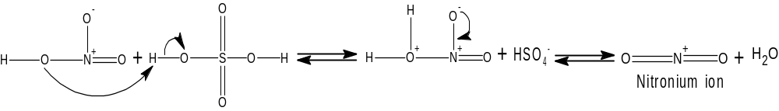

Preliminary steps: Formation of the nitronium ion, NO₂⁺
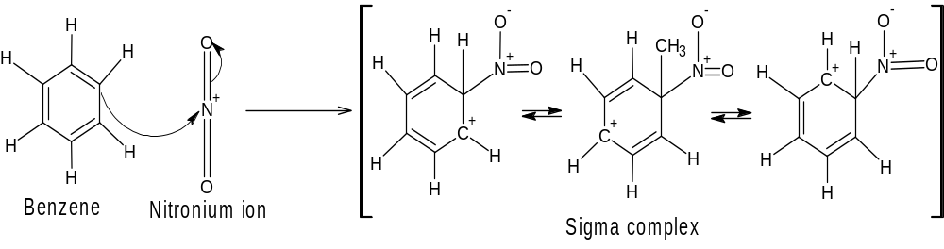
Step 1: Attack on the electrophile forms the sigma complex
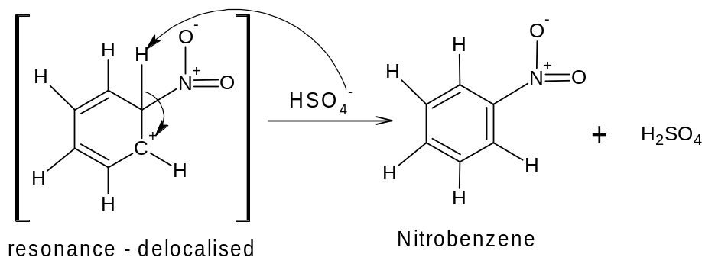
Step 2: Loss of a proton gives nitrobenzene

SULPHONATION OF BENZENE

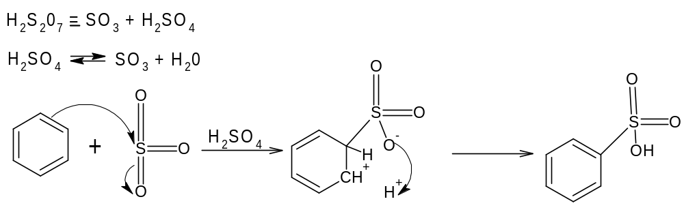

FRIEDEL-CRAFTS ALKYLATION
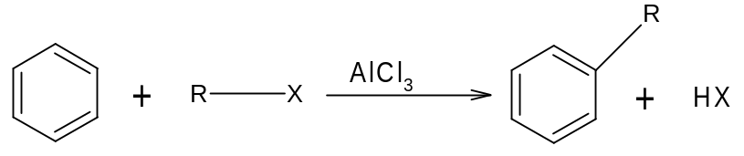
The mechanism starts with the formation of a carbocation. The carbocation then acts as an electrophile and attack the benzene ring to form an arenium ion. The arenium ion then loses a proton.
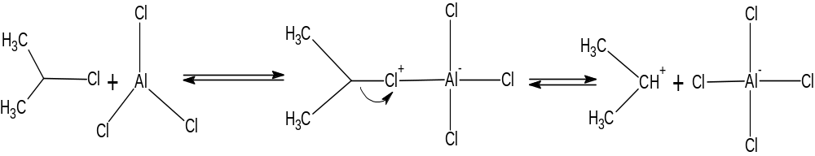
Step 1: Formation of carbocation
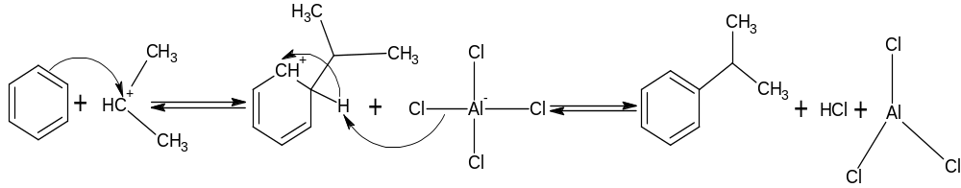
Step 2: Product is formed

FRIEDEL-CRAFTS ACYLATION
Two common acyl groups are the acetyl group and the benzoyl group
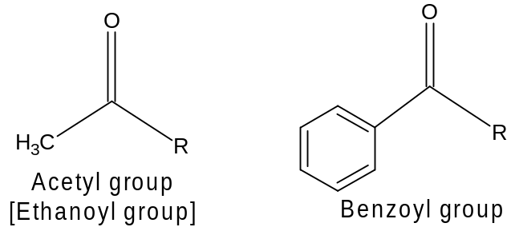
The reaction is often carried out by treating the aromatic compound with an acyl halide (often an acyl chloride). Unless the aromatic compound is one that is highly reactive, the reaction requires the addition of at least one equivalent of a lewis acid (AlCl₃). The product is an aryl ketone.
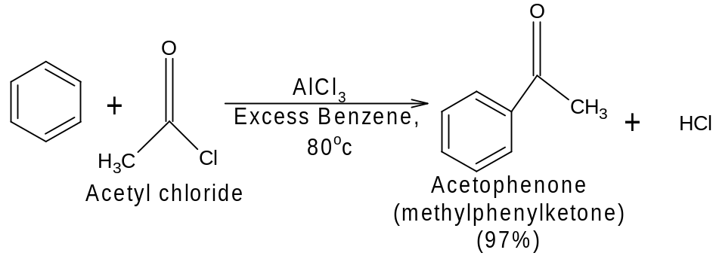
Acyl chloride (Acid Chlorides) are easily prepared by treating carboxylic acids with thionyl chloride [SOCl₂] or phosphorus pentachloride [PCl₅]
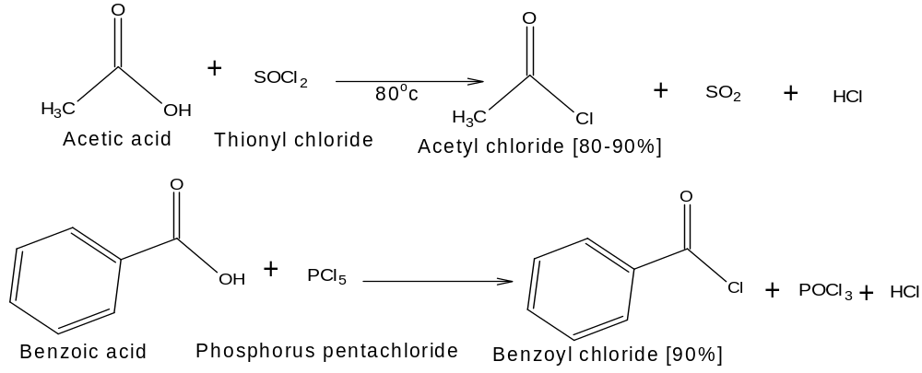
Friedel-crafts acylations can also be carried out using carboxylic acid anhydrides.
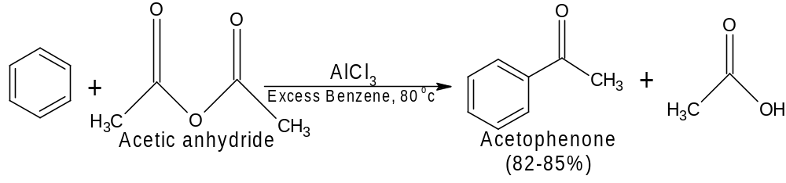
Mechanism of action

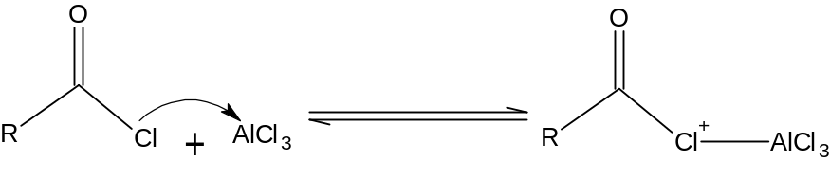
Step 1: Formation of a complex
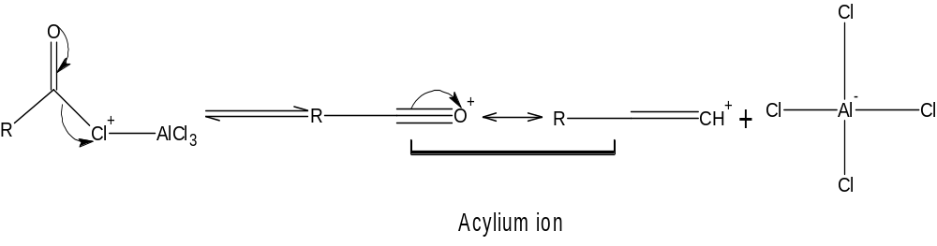
Step 2: Formation of acylium ion
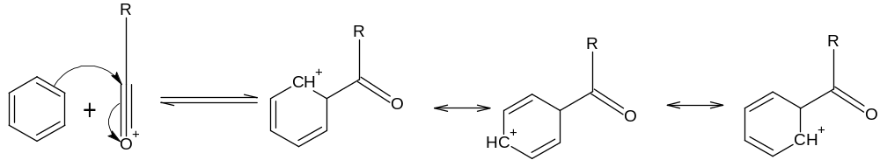
Step 3: The acylium ion, acting as an electrophile, reacts with benzene to form the arenium ion
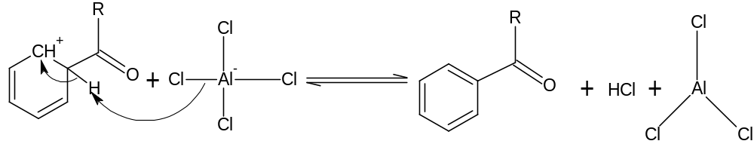
Step 4: A proton is removed from the arenium ion, forming the aryl ketone
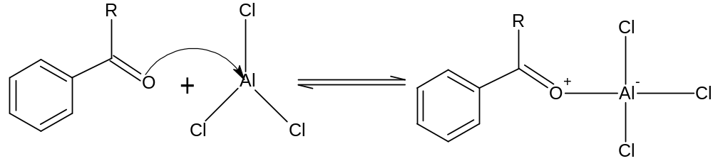
Step 5: The ketone, acting as a lewis base, reacts with aluminium chloride (a lewis acid) to form a complex
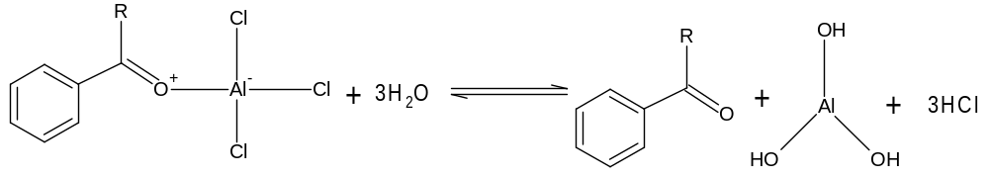
Step 6: Treating the complex with water liberates the ketone and hydrolyses the lewis acid
Limitations of friedel-crafts reaction
- When the carbocation formed from an alkyl halide, alkene or alcohol can rearrange to one or more carbocations that are more stable, it usually does so, and the major products obtained from the reaction are usually those from the more stable carbocations
- The reactions usually give poor yields when powerful electron-withdrawing groups are present on the aromatic ring or when the ring bears an amine group
- Aryl and Vinylic halides cannot be used as the halides component because they do not form carbocations readily
- Polyalkylations often occur
EFFECT OF SUBSTITUENTS ON THE REACTIVITY OF THE BENZENE RING AND ORIENTIATION OF INCOMING GROUP
A substituent group already present on a benzene ring can affect both the reactivity of the ring toward electrophilic substitution and the orientation or position that the incoming group takes on the ring. There are 2 types
- Activating groups: - are substituents that donates electrons to the benzene ring making it more reactive i.e they react faster than benzene. They direct all incoming groups to the ortho or para position (they are ortho-para directors). Examples includes alkyl groups, amino groups, hydroxyl, alkoxyl, amides, esters or nitrogen directly bonded to the ring.
- Deactivating groups: - are substituents that withdraws electrons from the benzene ring making it less reactive i.e they react slower than benzene. They direct all incoming groups to the meta position (they are meta directors). Examples includes nitro group, C=N, CF₃, -SO₃H. There is an exception which are the halogens which are weakly deactivating groups and direct all incoming group to ortho or para positions (they are ortho-para directors).

NUCLEOPHILIC AROMATIC SUBSTITUTION
It is difficult for a nucleophile to attack an aromatic ring because of the repulsion by the pi bonds of the ring and the inability of the negatively charged intermediate to be stabilized by resonance as found with the cyclohexadienyl cation in electrophilic aromatic substitution.
In spite of this, nucleophilic substitution takes place under certain conditions, particularly when electron-withdrawing groups are present on the ring.
The nucleophile displaces the halides ion from arylhalides, particularly if there are strong electron-withdrawing groups ortho or para to the halide
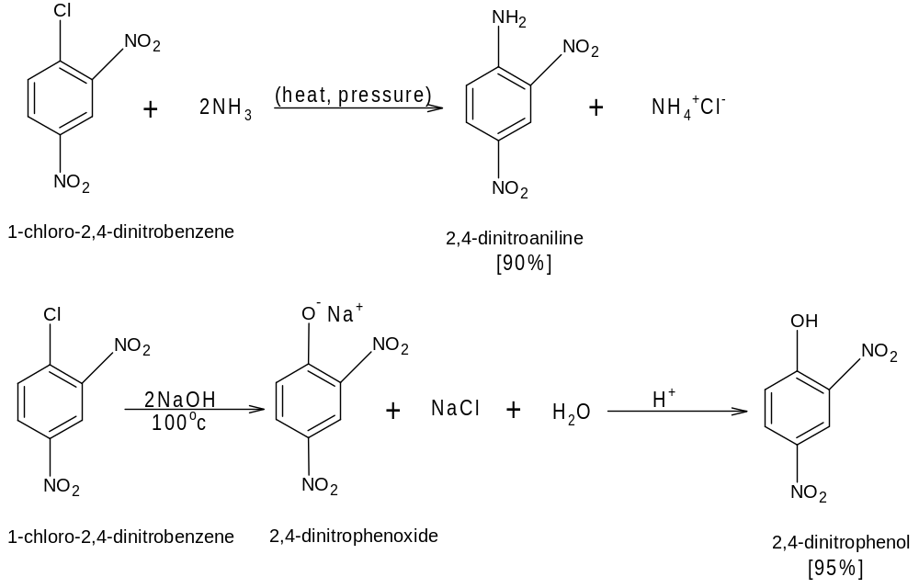
Depending on the reactants, either of 2 mechanisms maybe involved
- Addition-Elimination mechanism
It requires strong electron-withdrawing groups to stabilize a negatively charged sigma complex
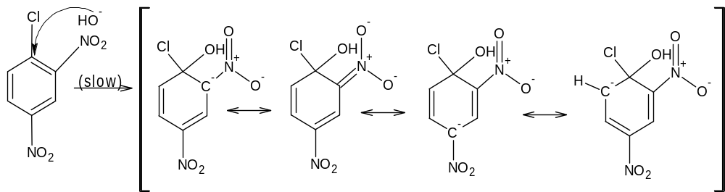
Step 1: Attack by the nucleophile gives a resonance-stabilized sigma complex
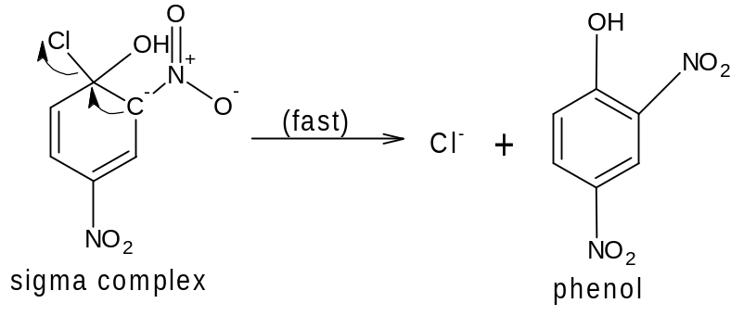
Step 2: Loss of the leaving group gives the product
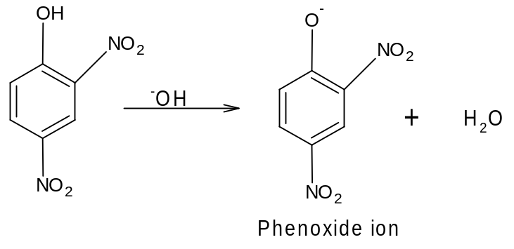
Step 3: The product (a phenol) is acidic, and is deprotonated by the base
After the reaction is complete, acid would be added to reprotonate the phenoxide ion to give the phenol
- Benzyne mechanism: Elimination -Addition
It requires no strong electron-withdrawing substituents on the aromatic ring. Under extreme conditions, however, inactivated halobenzenes react with strong base
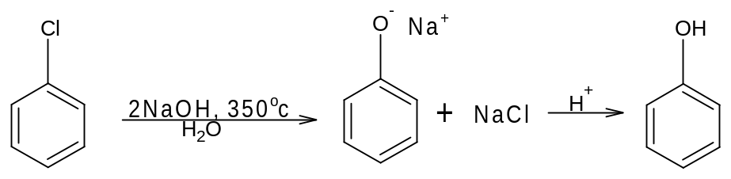
It requires a powerful base or high temperature
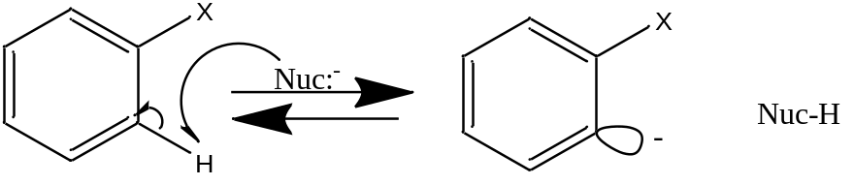
Step 1: Deprotonation adjacent to the leaving group to gives a carbanion
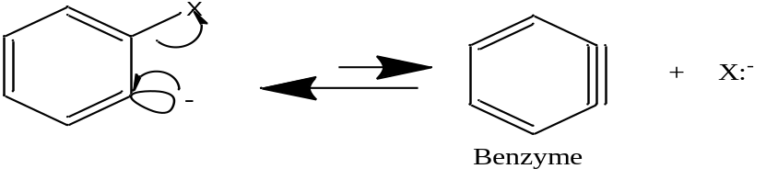
Step 2: The carbanion expels the leaving group to give a “benzyme” intermediate
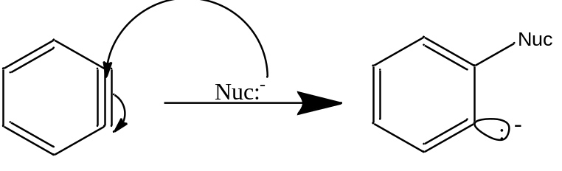
Step 3: The nucleophile attacks at either end of the reactive benzyme triple bond.
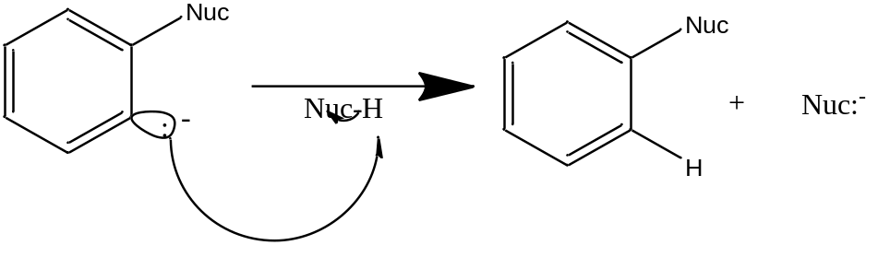
Step 4: Reprotonation gives the product
With strong electron-withdrawing groups ortho or para, the addition-elimination mechanism is more likely. Without these activating groups, stronger conditions are required, and the benzyme mechanism is likely.

NUCLEOPHILIC ADDITION TO CARBONYL COMPOUNDS
It involves the addition of a nucleophile and a proton across the C=O double bond. The reactivity of the carbonyl group arises from the electronegativity of the oxygen atom and the resulting polarization of the C=O double bond. The electrophilic carbonyl carbon atom is SP₂ hybridized and flat, leaving it relatively unhindered and open to attack from either face of the double bond.
As a nucleophile attacks the C=O group, the carbon atom changes hybridization from SP₂ to SP₃. The electrons of the pi bond are forced out to the oxygen atom to form an alkoxide anion, which protonates to give the product of the nucleophilic addition e.g Griginard reagent reaction with ketone.
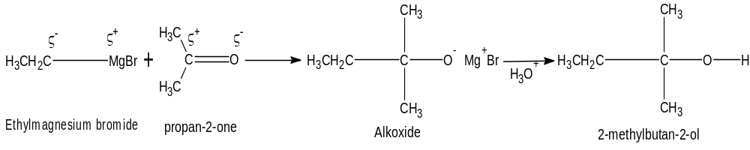
Hydride reduction of ketone is another example of nucleophilic addition with hydride ion (H:⁻) serving as the nucleophile.

BASIC CONDITIONS (STRONG NUCLEOPHILE)

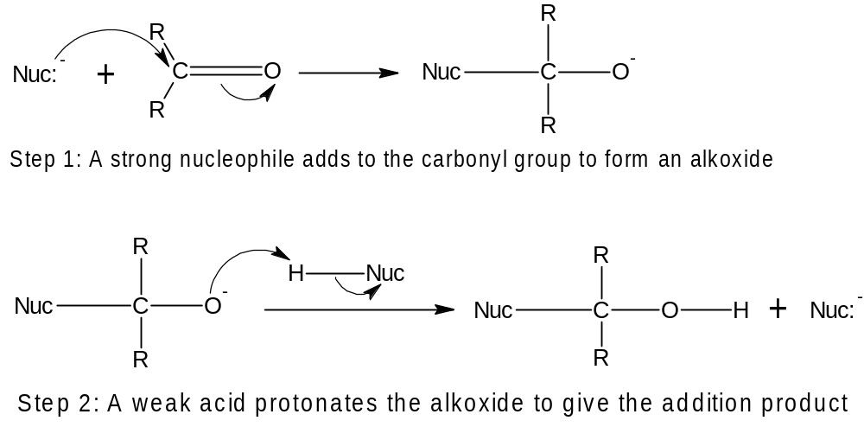

Example
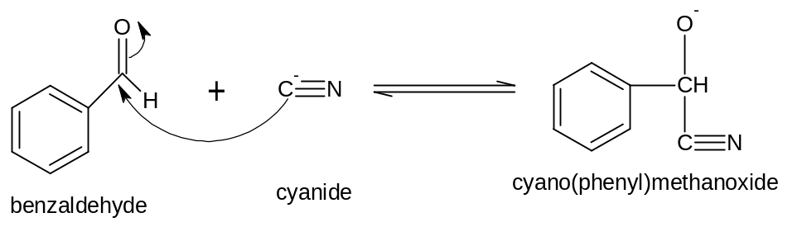
Step 1: A strong nucleophile adds to the carbonyl group to form an alkoxide

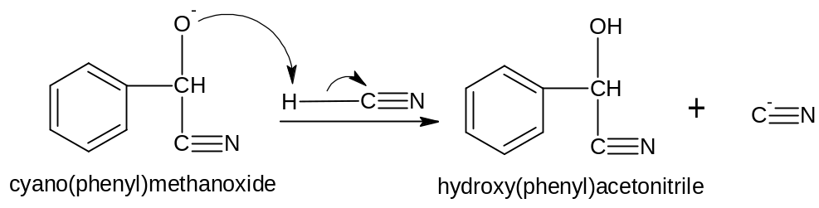
Step 2: A weak acid protonates the alkoxide to give the addition product

ACIDIC CONDITIONS (WEAK NUCLEOPHILE, ACTIVATED CARBONYL)
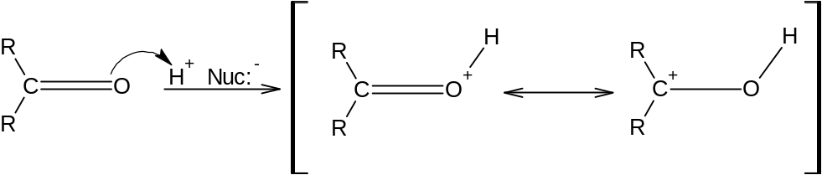
Step 1: Protonation activates the carbonyl group toward nucleophilic attack
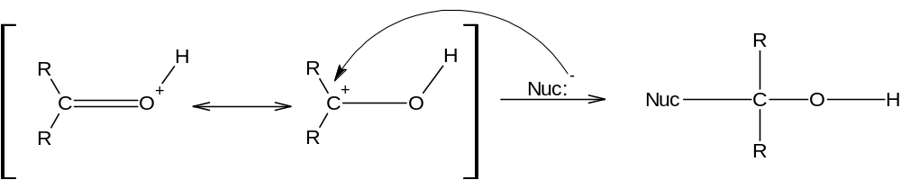
Step 2: A weak nucleophile adds to the activated (protonated) carbonyl group

Example: Formation of a hemiacetal
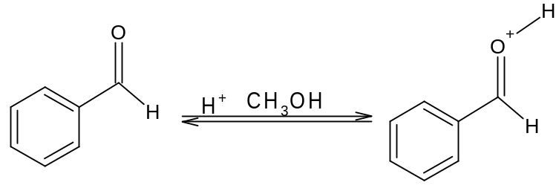
Step 1: Protonation activates the carbonyl group toward nucleophilic attack
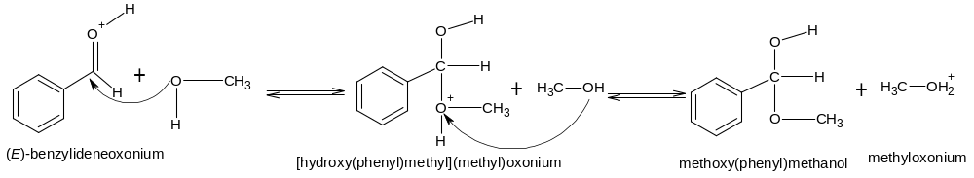
Step 2: A weak nucleophile adds to the activated (protonated) carbonyl group. Deprotonation of the product gives the hemiacetal

FREE RADICAL REACTIONS
Free radicals are reactive species (atoms or group) with odd unpaired lone electrons on them
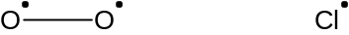
Free radicals are formed by homolytic cleavage of neutral molecules and are usually accomplished by photolysis, thermolysis or by redox reaction. They can also be produced by reaction of molecules with other free radicals.
- Photolysis: - occurs when compounds absorb radiation in the ultraviolet or visible range e.g Acetone at wavelength of 320nm
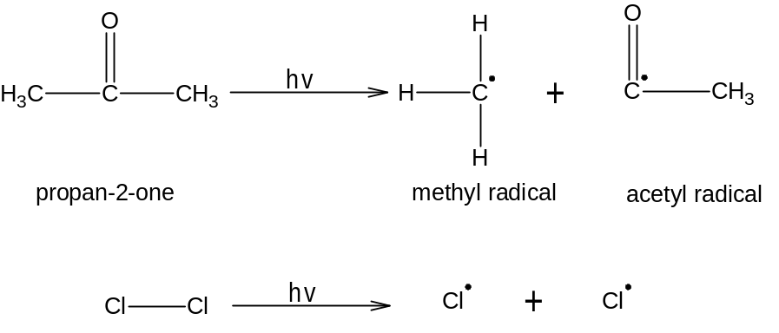
- Thermolysis: - occurs in the gas phase or solution in non-polar solvents with any compound with sufficiently high temperature
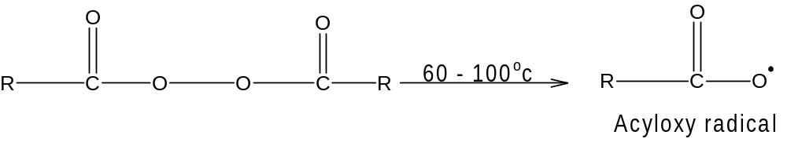
- Redox reaction: - involve one electron transfer in generating the radicals
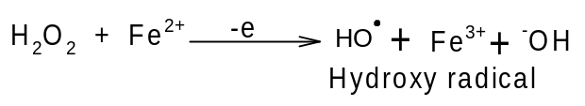
- Abstraction of a hydrogen atom from a molecule by a free radical
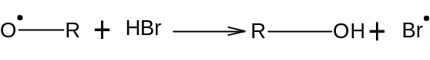
Alkoxy radical reacts with HBr to form alcohol and bromide radicals. Radicals are classified according to the carbon that bears the unpaired electron. Primary radicals have unshared electron on the 1º carbon, 2º radicals on the 2º carbon and 3º radical on 3º carbon. Alkyl group stabilizes radicals the same way they stabilize carbocation by hyper conjugation.
The differences in the relative stabilities of the radicals are much smaller than in carbocations

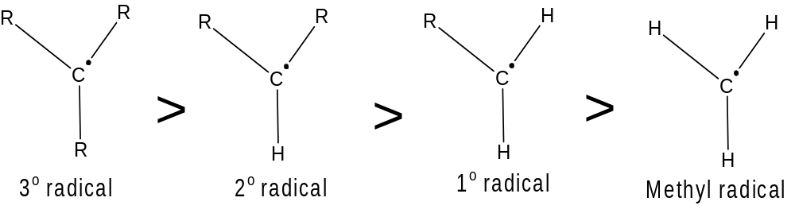

STEPS OF FREE RADICAL CHAIN REACTION
A free radical chain reaction comprises of 3 steps:
- Initiation step: - It generates a reactive intermediate e.g is the reaction of chlorine with methane, blue light absorbed by chlorine results in the splitting of chlorine molecules into chlorine atom.
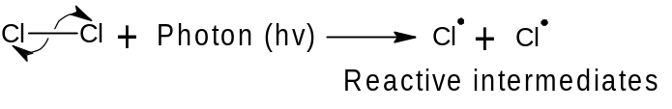
The radicals are short-lived species that is never present in high concentration because it reacts as quickly as it is formed. The unpaired electron is called odd electron or radical electron.

- Propagation step: - In this stage, the reactive intermediate reacts with a stable molecule to form a product and another reactive intermediate, allowing the chain to continue until the supply of reactants is exhausted or the reactive intermediate is destroyed.
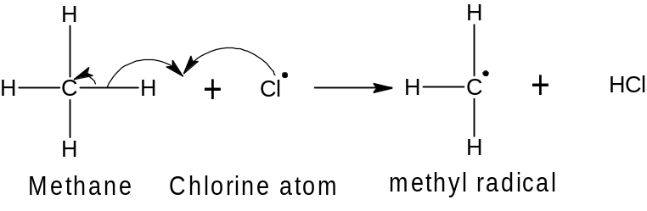
First propagation step
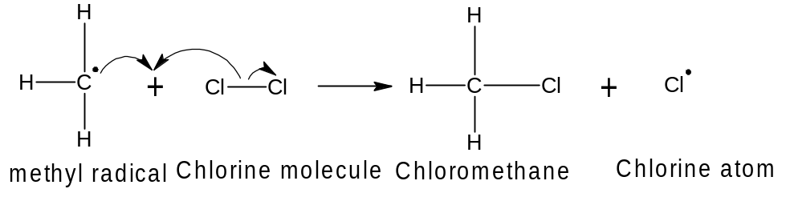 Second propagation step

- Termination step: - This involves side reactions that destroy reactive intermediate and tend to slow or stop the reaction. It involves reaction of radicals with themselves or with the container housing the compounds or radicals until all the free radicals are completely used up.
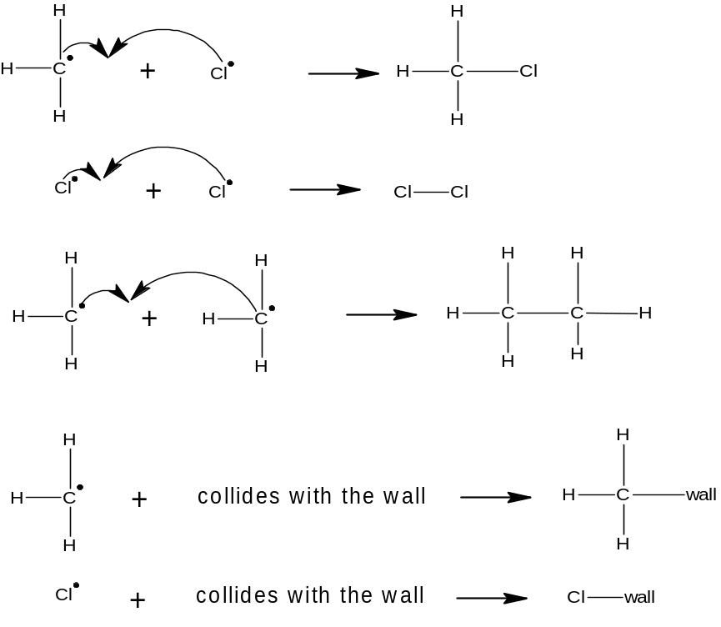
The following are some of the possible termination reactions in the chlorination of methane.

REACTION OF FREE RADICALS
- Addition of radicals to an alkene
This is anti-Markovnikov addition and the halogen molecules is made electrophilic by the presence of peroxide. The electrophile adds to the SP2 carbon that is bonded to the most hydrogens.
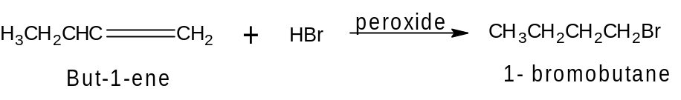
The peroxide is the radical initiation because without it, the above reaction would not occur. Polymers are also formed. Polymers are substances that consist of very large molecules called Macromolecules that are made up of many repeating subunits. The molecular subunits that are used to synthesize polymers are called monomers and the reactions by which monomer are jointed together are called polymerization. Many polymerizations can be initiated by radicals.
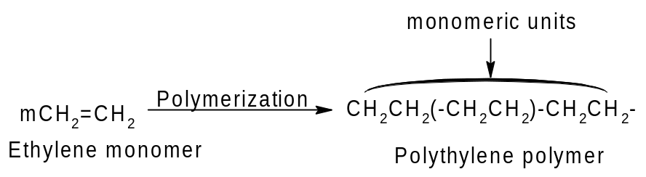

- Substitution reaction
A typical example is the halogenation reaction at saturated carbon atoms. The method is unsuitable for preparative purpose because it leads to a mixture of alkanes.
Bromination occur less readily than chlorination while iodine does not react at all.
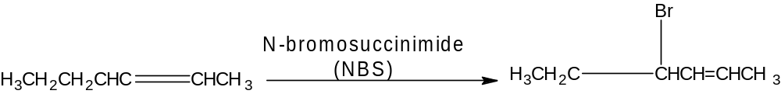

- Oxidation
Oxidation of organic compounds in air proceeds by free radical pathways. The slow oxidation of organic materials in the presence of oxygen (which leads to their deterioration) is referred to as autoxidation. This takes place in rubbers, plastics, foods, drugs etc. the process occurs mainly by free radical addition of O2 to allylic position of double bonds to give peroxides which break down to give highly reactive free radicals that perpetrate the degradation.
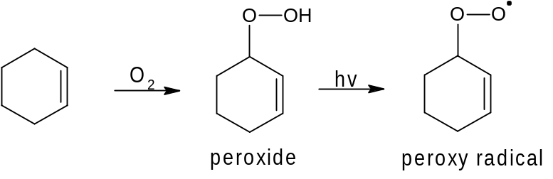
The mopping up of such peroxy radical is the basis for the addition of antioxidants such as butylated hydroxytoluene [BHT] and butylated hydroxyanisole [BHA] to food and other preparation for stability. The highly reactive peroxy radicals abstract the phenolic proton from BHT and BHA to give the less reactive phenoxyl radical interrupting its disruptive chain process.

