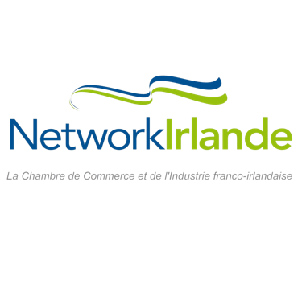
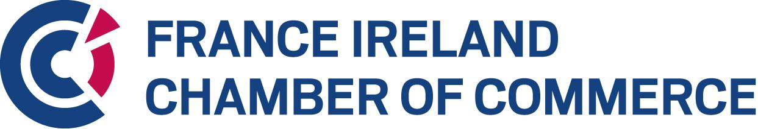
Ireland France
Business Awards 2026

The Best French Company in Ireland
Sponsored by

The annual Franco-Irish Business Awards recognising excellence in the economic relationship between Ireland and France

ENTRY FORM

Please return completed Entry Form to info@franceireland.ie
All information received will be treated in confidence.

Companies who do not provide all the information on this entry form, including financial figures, will be excluded.

Please be aware that the content of the Entry Form will be the content by which your application will be judged.

You may include a PDF file of additional information (max 10 pages) to provide visuals and details on your products and/or services. The PDF file should not include any links to websites.
Thank you for your nomination. Award recipients shall be selected by a jury in a 2-step evaluation process, chaired by Eoin Scott (Company Secretary, France Ireland Chamber of Commerce).

Company Details

Name of Company _______________________________________________________________
Address______________________________________________________________________________________________________________________________________________________________________________________________________________________________________
Confirm that country of registration is France by ticking this box
Company registration number: ________________
Name of CEO ___________________________________________________________________
Contact for the Awards ___________________________________________________________
Position ________________________________________________________________________
Telephone ___________________________Email______________________________________
Website ________________________________________________________________________

Business Profile
Describe your business in general. Include information in the table below on annual turnover, profit, and employees in the last two years (2024 & 2025) and projecting to 2026 (200 words). If you are a subsidiary of a larger group please fill in Group figures and if a stand-alone company please fill in figures for French Company.

 |  |  |  |  |  |  |  | Forecast
Group |  | French Company |  |  |  | 2024 | 2025 | 2026
(Tick box for information supplied) |  |  |  | Annual Turnover | €
 |  |  |  | EBIT | €
 |  |  |  | Employee Numbers

Description of business in general:

Financial Success
Demonstrate the overall growth in sales/profitability, and development of business activity in Ireland (Years 2024, 2025 and projected 2026) (100 words)

Indicate level of investment committed to the Irish market (employees, external consultants, office space....) (100 words)

Innovation
Describe the unique selling proposition of your product/service that has secured your success on the Irish market (200 words)

Employment – Current and Future
Present the employment strategy of your company into the future, supported by employment figures in France and Ireland, and a general overview of the employment policy (200 words)

Demonstrate that the company is a high-quality employer (working environment, employment benefits, HR management) (100 words)

Demonstrate that the employment between France and Ireland has increased positively from the viewpoint of both countries (100 words)

Corporate Social Responsibility
Describe your Company’s commitment to CSR (200 words)

Sustainability
Describe your Company's commitment to sustainability, including climate action (200 words)

