Title of the Manuscript: 15 words (The title should be concise and informative. It is often used in information retrieval systems. Avoid the use of abbreviations and formulas whenever possible.)
First Author^{1*}, Second Author²,… (11pt bold)
¹ Department Name, Name of Organization, City, Country (9pt)
² Department Name, Name of Organization, City, Country
*Corresponding author email: author@mail.com
Article Info |  | ABSTRACT
Article history:  Received: dd-mm-yy  Revised: dd-mm-yy Accepted: dd-mm-yy |  | The abstract should be written briefly and factually in English. The abstract contains a clear elaboration of the research purpose, results, and conclusion. The abstract should be written separately from the article. References should not be written in the abstract, but if it is indispensable, the authors' names and publication years should be cited. The nonstandard abbreviation should be avoided, but if it is indispensable, the full name should be specified in its initial mention. (150 words minimum) [10pt]
Keywords:

First keyword, Second keyword, Third keyword
Keywords:  First keyword, Second keyword, Third keyword |  | Copyright © 2025, The Author(s).  This is an open access article under the CC–BY-SA license
- INTRODUCTION
An effective introduction serves the dual purpose of stimulating the reader’s interest while providing the foundational context required to comprehend the manuscript in its entirety. To accomplish this, the introduction must be structured as a logical progression from a broad context to a specific focus, presented as a single, cohesive narrative without the use of subsections.
Commence by establishing the broader context and significance of the problem under investigation. This step aims to articulate the importance of the research and engage the reader with the critical question being addressed.
Subsequently, the narrative should transition to a focused review of pertinent literature. Avoid a comprehensive historical survey; instead, cite seminal works that directly elucidate an existing controversy, an unanswered question, or a distinct knowledge gap. This identified gap then serves as the primary justification for your study.
At this point, you must explicitly state the research objective—the central and most crucial component of the introduction. This declaration of purpose should be accompanied by a clearly articulated hypothesis, an overview of the variables investigated, and a succinct summary of the methodology employed to address the research question, alongside definitions for any specialized terminology or abbreviations.
Finally, the introduction should conclude by providing a concise preview of the manuscript's major findings and principal conclusions. Explicitly state their contribution to the broader field of research and potentially identify new questions that have emerged from the study. Throughout this entire section, the writing must remain concise and rigorously structured, efficiently orienting the intended audience to the core arguments and evidence presented in the manuscript [12pt Calisto MT].
- METHODS
  - Research Design
This subsection should state the overall research design. Specify your approach (e.g., quantitative, qualitative) and the specific design employed (e.g., cross-sectional survey, case study, SLR).
  - Population and Sampling
Clearly define the target population of the study. Detail the sampling technique used to recruit participants or select data, along with a justification for its appropriateness.
  - Instrument
In this section, describe the instrument (e.g., questionnaire, interview guide) used. Name its source or developer and provide evidence of its validity and reliability. Immediately following this, outline the procedure, which includes the chronological, step-by-step process of data collection and its timeframe.
  - Data Analysis
Clearly outline your data analysis plan. Specify the statistical software and describe the specific statistical tests or analytical techniques used to address each research question, citing advanced methods where necessary.
- RESULT AND DISCUSSION
Results and discussion should be presented in a single, clear, and concise section. The discussion section must explain the significance of the research findings, rather than repeating the results. Combining results and discussion into one section helps to avoid overly lengthy quotations. Tables or figures should present distinct findings. The results of data analysis must be reliable in addressing the research problem. References in the discussion section should not repeat those used in the introduction. Comparisons with previous research findings must be included.
  - Presentation of Figures

Figures, which include all visual materials such as graphs, diagrams, and photos, must be presented clearly and informatively. Each figure must be numbered sequentially (e.g., Figure 1, Figure 2). A descriptive caption is placed below the figure, prefixed with its number, and must explain all elements within it so it can be understood independently. It is important to ensure that every figure has been referred to in the narrative text before the figure is displayed. For publication purposes, figures must have a high resolution, a minimum of 300 DPI for photos and 600 DPI for line graphs, and all labels or text within them must be clearly legible. If a figure is adapted or cited from another source, the source citation must be included at the end of the caption.

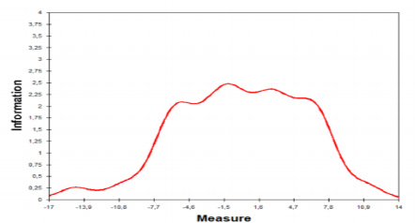

Figure 1. Test Information Function (11 pt)

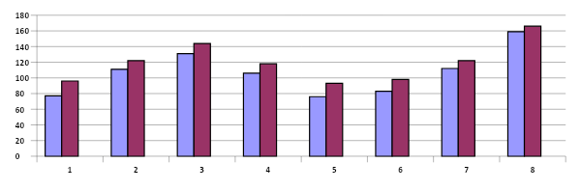

Figure 2. Improvement in management development.
  - Presentation Of Tabel

Tables are used to present numerical or textual data systematically in a row and column format. Each table must be numbered separately from figures (e.g., Table 1, Table 2) and accompanied by a brief yet informative title placed above the table. Just like figures, every table must be referred to in the text before it is displayed. For a professional format, the use of vertical lines should be avoided, and horizontal lines should be used minimally—typically only above and below the column headers and at the end of the table. Footnotes can be added below the table to provide explanations for abbreviations, statistical symbols, or to list the source if the data is adapted from another work.
Table 1. Experimental Design
Group | Pretest | Treatment | Posttest
Experiment 1 (Feedback attributional Oral) | T1 | Xa | T2
Experiment 2 (Feedback attributional Posts) | T1 | Xb | T2
Experiment 3 (Feedback attributional Confirmation) | T1 | Xc | T2
control (without treatment) | T1 | - | T2

- CONCLUSION
The main conclusions of the study may be presented in a short Conclusions section, which may stand alone or form a subsection of a Discussion or Results and Discussion section. Suggestion placed after the conclusion contains a recommendation on the research done or an input that can be used directly.
ACKNOWLEDGEMENT (Optional)
If any, authors wishing to acknowledge assistance or encouragement from colleagues, special work by technical staff or financial support from organizations should do so in an unnumbered Acknowledgments section immediately following the last numbered section of the paper.
REFERENCES
The bibliography is based on the APA 7th (American Psychological Association) model. Very nested using Reference manager (end note, mendeley, zetero etc) to facilitate the editing and review. Referenced sources and at least 80% come from journal of the last 10 years of publications. [Calisto MT 12 pt].

Bai, H. (2019). Preparing teacher education students to integrate mobile learning into elementary education. TechTrends, 63(6), 723–733. https://doi.org/10.1007/s11528-019-00424-z
Du, L., & Lv, B. (2024). Factors influencing students’ acceptance and use generative artificial intelligence in elementary education: An expansion of the UTAUT model. Education and Information Technologies, 29, 24715–24734. https://doi.org/10.1007/s10639-024-12835-4
Simonson, M., Zvacek, S. M., & Smaldino, S. (2019). Teaching and learning at a distance: Foundations of distance education 7th edition.

