Title (Capitalize Each Word/(font size 14 pt))

Author(s)¹, and Corresponding Author(s)^{2*} (font size 11 pt)

¹Department, Institution, Regency, Country (font size 10 pt)
²Department, Institution, Regency, Country ((if the department is different from the author))
*e-mail: (Corresponding Author Email)

Received: xxx. Accepted: xxx. Published: xxx
Abstract: Insert abstract text here. ((Abstracts should be 250 to 300 words in length excluding spaces. Please ensure your abstract is written so that it can be regarded as a single entity, such as in abstracting services. Background and research objective should be clearly described. Methods are briefly explained and the main finding(s) need to be stated. Novelty of approach and/or finding(S) is properly highlighted. Abstract is a summary of the conclusion. Significance of the finding and immediate perspective or future works are suggested.))
(font size 10 pt)

Keywords: keyword 1; keyword 2; keyword 3; keyword 4; keyword 5

Introduction (font size 11 pt)

Main Text Paragraph.xxxxxxxx xxxxxxxx xxxxxxxx xxxxxxx xxxxxxxxx [1]. xxxxxxxx xxxxxxxx xxxxxxx. xxxx xxxxxxxxx xxxxxxxxxx xxxxxxxxxx xxxxxxxxxx xxxxxxxx xxxxxxxxx (font size 10 pt).

Research Methods (font size 11 pt)

Main Text Paragraph [2]. xxxxxxxx xxxxxxxx xxxxxxxx xxxxxxx xxxxxxxxx xxxxxxxx xxxxxxxx xxxxxxx xxxx xxxxxxxxx xxxxxxxxxx xxxxxxxxxx xxxxxxxxxx xxxxxxxx xxxxxxxxx
Main Text Paragraph.xxxxxxxx xxxxxxxx xxxxxxxx xxxxxxx xxxxxxxxx xxxxxxxx xxxxxxxx xxxxxxx xxxx xxxxxxxxx xxxxxxxxxx xxxxxxxxxx xxxxxxxxxx xxxxxxxx xxxxxxxxx (font size 10 pt).
(Subsection headings may be added without numbering)

Results and Discussion (font size 11 pt)

Main Text Paragraph [3]. xxxxxxxx xxxxxxxx xxxxxxxx xxxxxxx xxxxxxxxx xxxxxxxx xxxxxxxx xxxxxxx xxxx xxxxxxxxx xxxxxxxxxx xxxxxxxxxx xxxxxxxxxx xxxxxxxx xxxxxxxxx (font size 10 pt).

(Subsection headings may be added without numbering)
((Insert Figure here. Note: Please do not combine figure and caption in a textbox or frame.))
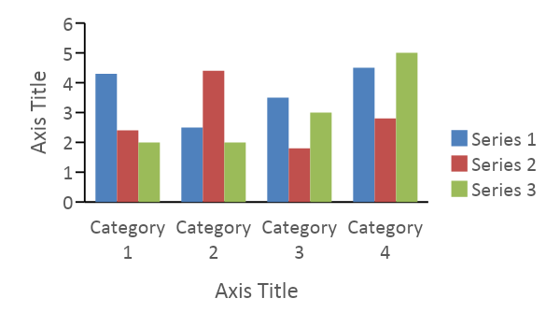
Figure 1. Figure Caption.
((how to set the chart is to double-click the cart. Then follow the following path: Chart Design -> Quick Layout -> Layout 7))

Main Text Paragraph.xxxxxxxx xxxxxxxx xxxxxxxx xxxxxxx xxxxxxxxx xxxxxxxx xxxxxxxx xxxxxxx xxxx xxxxxxxxx xxxxxxxxxx xxxxxxxxxx xxxxxxxxxx xxxxxxxx xxxxxxxxx (font size 10 pt).

Table 1. Table Caption. ((Note: Please do not include the table in a textbox or frame))
Head 1^{[a]} | Head 2 | Head 3^{[b]} | Head 4^{[c]}
Column 1 | Column 2 | Column 3 | Column 4
Column 1 | Column 2 | Column 3 | Column 4
[a] Table Footnote. [b] … ((optional)) (font size 10 pt).

Conclusion (font size 11 pt)

Main Text Paragraph.xxxxxxxx xxxxxxxx xxxxxxxx xxxxxxx xxxxxxxxx xxxxxxxx xxxxxxxx xxxxxxx xxxx xxxxxxxxx xxxxxxxxxx xxxxxxxxxx xxxxxxxxxx xxxxxxxx xxxxxxxxx (font size 10 pt)..

Author’s Contribution (font size 10 pt)
Author name1: xxxxxxx; Author name2: xxxxxxx; et. al ((font size 10 pt)

Acknowledgements (font size 10 pt)
Acknowledgements Text. (font size 10 pt)

References (font size 11 pt)
(the use of reference with an IEEE style (font size 10 pt)
[1] A. Poorebrahim et al., “Using Mindful Attention Awareness Scale on male prisoners: Confirmatory factor analysis and Rasch models,” PLoS One, vol. 16, no. 7 July, Jul. 2021, doi: 10.1371/journal.pone.0254333.
[2] D. Ardianto, B. Rubini, and I. D. Pursitasari, “Assessing STEM career interest among secondary students: A Rasch model measurement analysis,” Eurasia Journal of Mathematics, Science and Technology Education, vol. 19, no. 1, p. em2213, Jan. 2023, doi: 10.29333/ejmste/12796.
[3] H. Z. Abdussamad and M. S. Sik, Metode Penelitian Kualitatif. CV. Syakir Media Press, 2021.

