Click here, type the title of your paper, Capitalize first letter only (not all words), Please type: do not copy & paste

First Author[1]*, Second Author2   
(Please type: do not copy and paste)

*1First affiliation (Faculty/College/Department/Unit/Centre, University/Agency/Institute), City Area Code, City and Country (Please type: do not copy and paste)*

*2Second affiliation (Faculty/College/Department/Unit/Centre, University/Agency/Institute), City Area Code, City and Country (Please type: do not copy and paste)*

*Citation:*

Vincent, V., Boodlal, D., Alexander, D., Jaggernath, P., & Maharaj, R. (2024). Renewable energy system design and evaluation: A case study. *Journal of Smart Science and Technology*, *4*(2), 83–101.

| ARTICLE INFO |  | ABSTRACT |
| --- | --- | --- |
| *Article history:*  Received dd Month Year  Revised dd Month Year  Accepted dd Month Year  Online first  Published dd Month Year |  | The abstract word count should not be more than 300 words. Please format your abstract using the ‘Abstract’ style in the styles gallery.  The **line numbers** on the left allow easier referencing and communication between the author and reviewers during double-blind peer review. Please **do not remove** the line numbers.  Please **do not edit or remove** any texts or objects highlighted in red colour.  Please **read the content of this guideline entirely**. Failure to adhere to this guideline shall lead to manuscript rejection at the desk evaluation stage. |
| *Keywords:*  keyword1  keyword2  keyword3  keyword4  keyword5  keyword6  *DOI:*  10.24191/jsst.v#i#.# |  |

1. **insert heading LEVEL 1 (do not copy paste from manuscript). introduction**

Manuscript must be in MS Word file and written in British English. The paragraphs start from here and are only separated by headings, subheadings, images and formulae. Symbols for quantities in the main text should be italic. Define abbreviations and acronyms the first time they are used in the main text.

New paragraph should be indented at 1 cm. There is no line spacing between paragraphs. Use single spacing, spacing before 0pt, and spacing after 12pt for paragraphs under level 1 heading and spacing after 6 pt for paragraphs under level 2 heading, Times New Roman font size 10 for main text throughout the manuscript. The paper setting is A4 sized with margins top 1.33 cm, bottom 2.5 cm, left 2.1 cm, and right 2.1 cm.

* 1. **Insert Heading Level 2 (Do Not Copy Paste from Manuscript). Structure of MS Word Formatting**

Files should be formatted for direct printing. Figures and tables should be embedded and not supplied separately. Please make sure that you use as much as possible normal fonts in your documents. Special fonts, such as fonts used in the Far East (Japanese, Chinese, Korean, etc.) may cause problems during processing. To avoid unnecessary errors, you are strongly advised to use the ‘spellchecker’ function of MS Word. Follow this order when typing manuscripts: Title, Authors, Affiliations, Abstract, Keywords, Main text (including figures and tables), Acknowledgements/ Funding, Conflict of Interest, Authors’ Contribution, Appendices or Supplementary Material, References. Collate acknowledgements in a separate section at the end of the article and do not include them on the title page, as a footnote to the title or otherwise.

*Insert heading level 3 (do not copy paste from manuscript). Formatting*

Please do not alter the formatting and style layouts which have been set up in this template document. As indicated in the template, papers should be prepared in single column format. Do not number pages on the front, as page numbers will be added separately for the preprints and the Proceedings. Leave a line clear between paragraphs. All the required style templates are provided in this document with the appropriate name supplied. **Please refer to page 7 for complete guide on styles.**

*Bullet*

Bulleted lists may be included and should look like this:

1. First point
2. Second point
3. And so on

Ensure that you return to the ‘Main Text’ style, the style that you will mainly be using for large blocks of text, when you have completed your bulleted list.

* 1. **Section headings**

All headings should be left justified. The section headings (headings level 1) are arranged by numbers, use Times New Roman font size 10 bold uppercase. Subsection headings (headings level 2) are arranged by numbers, use Times New Roman font size 10 bold sentence case. Sub-subsection headings (headings level 3) use Times New Roman font size 10 italic sentence case. Number the sections of the main text as 1, 2, …, and subsections as 1.1, …, and so on. The spacings before and after for section headings are both 12pt, for subsection headings are 12pt and 6pt respectively, for sub-subsection headings are 12pt and 3pt respectively.

* 1. **Tables**

Tables should be supplied as **editable** tables, not pasted as images. All tables should be numbered with Arabic numerals. Headings should be placed above tables, left justified, sentence casing. Leave one line space between the heading and the table. Only horizontal lines should be used within a table, to distinguish the column headings from the body of the table, and immediately above and below the table. Tables must be embedded into the text and not supplied separately. Table legends should be concise but comprehensive. All abbreviations must be defined in footnotes without reference to the text. Below is an example which authors may find useful.

Table 1. An example of a table (**Font = 8**; Click ‘Caption A’ on the Styles Gallery)

| An example of a column heading | Column A (*t*) | Column B (*T*) |
| --- | --- | --- |
| And an entry | 1 | 2 |
| And another entry | 3 | 4 |
| And another entry | 5 | 6 |

Source:

1. **General guidelines for the preparation of your text**

Avoid hyphenation at the end of a line. Symbols denoting vectors and matrices should be indicated in bold type. Scalar variable names should normally be expressed using italics. Weights and measures should be expressed in SI units. Please title your files in this order firstauthorname.docx.

* 1. **Footnotes**

Footnotes should be avoided if possible. Necessary footnotes should be denoted in the text by consecutive superscript letters. The footnotes should be typed single spaced, and in smaller type size (8pt), at the foot of the page in which they are mentioned and separated from the main text by a short line extending at the foot of the column. The ‘footnote’ style is available in this template for the text of the footnote.

* 1. **Referencing and citation style**

Citation should be indicated in the text by a superscript Arabic number. For example, statement (author, year) should be written as statement1 in this journal. Example for narrative citation: Einstein2 said that the true sign of intelligence is not knowledge but imagination. All references should be grouped together at the end of the manuscript and numbered consecutively in the order in which they are first mentioned in the text.

The manuscript’s references should be written using the APA 7th edition style. Please refer to the following website for further details on APA 7th edition referencing style: <https://libraryguides.vu.edu.au/apa-referencing> References should be listed at the end of the paper, and **numbered consecutively in the order in which they are first mentioned in the text**.

Some examples of how your references should be listed are given at the end of this template in the ‘References’ section which will allow you to assemble your reference list according to the correct format and font size.

1. **Author artwork**

All figures should be numbered with Arabic numerals (1,2,...n). All photographs, schemas, graphs, and diagrams are to be referred to as figures. Line drawings should be good quality scans or true electronic output. Low-quality scans are not acceptable. Figures must be both embedded into the text and all images should met the minimum requirement of 500 × 500 pixels. Lettering and symbols should be clearly defined either in the caption or in a legend provided as part of the figure. Figures should be placed at the top or bottom of a page wherever possible, as close as possible to the first reference to them in the paper.

* 1. **Figures**

Figures can be in the form of framework, process flow, chart, or any visual aids that are meant to support the written text. Any diagrams built using Microsoft Word or Microsoft Power Point’s Smart Art Graphic Tool needs to be embedded as editable or vector-based objects (instead of image objects). Diagrams attached using bitmap-based images (jpeg., png., and other formats) need to be in high resolution (at least 300 pixels per inch). Figure legends should be concise but comprehensive. All abbreviations must be defined in footnotes without reference to the text.

*Texts embedded in figures*

The font used for labels or indicators inside the figure needs to be formatted as **Times New Roman** **with** **font size set at 9**. It must not be bold, italicized or underlined.

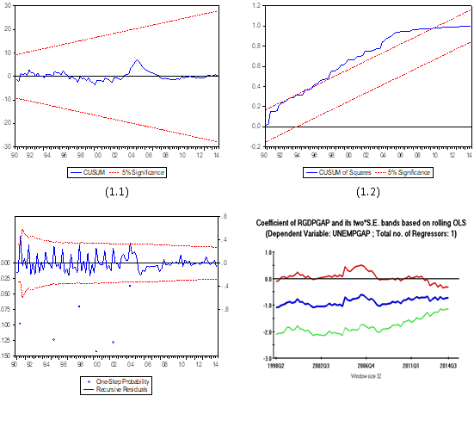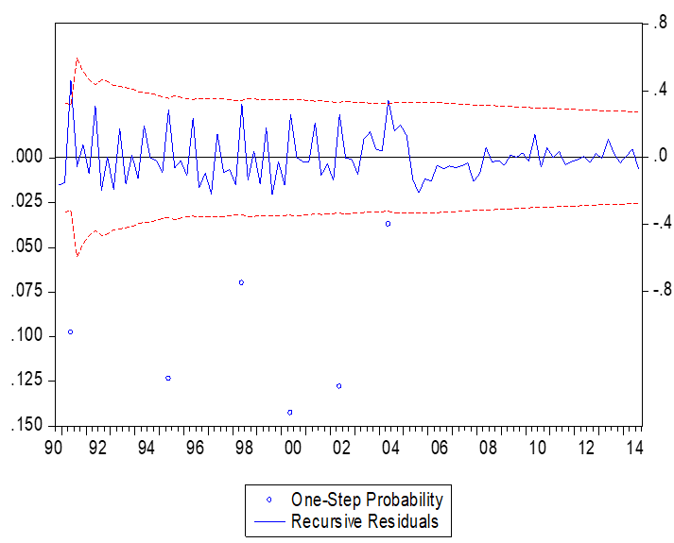

Fig. 1. (left) this figure is blurry, which is unacceptable; (right) this figure has a higher resolution. However, the labels are not formatted using **Times New Roman font**. (Font = 9; Click ‘Caption B’ on the Styles Gallery).

Source:

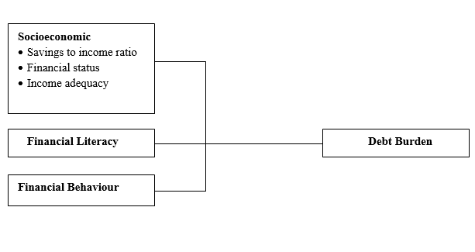

Fig. 2. (left) this framework is a non-editable diagram, appears blurry and hence, is unacceptable;   
(right) this framework is built using Ms Word illustration tools, has higher resolution and is acceptable.   
(Font = 9; Click ‘Caption B’ on the Styles Gallery)

Source:

Please use the ‘drawing canvas tool’ in MS Word before inserting any images or figures into the document. When constructing a conceptual/theoretical framework, please use editable or vector-based figures. Draw figures using MS Word’s Smart Art Graphic Tool (textboxes, labels, arrows, legends, etc.) rather than embedding non-editable image objects. Ensure that all the figures have a good resolution (minimum 300dpi) and are not fuzzy or blurry.

* 1. **Captions**

The figure number and caption should be typed below the illustration in 9pt and left justified, sentence casing. Artwork has no text along the side of it in the main body of the text. However, if two images fit next to each other, these may be placed next to each other to save space, see Fig 1. They must be numbered consecutively, all figures, and all tables respectively.

1. **Equations and formulas**

Equations and formulae should be typed and numbered consecutively with Arabic numerals in parentheses on the right-hand side of the page (if referred to explicitly in the text). They should also be separated from the surrounding text by one space. If you chose to use the Equation Editor, please ensure that the manuscript is saved using .docx format (rather than .doc), and Compatibility Mode is turned off. Use a long dash rather than a hyphen for a minus sign. Equations should be numbered with Arabic numbers. For example, use captions (1), (2), …, but mention as Equation 1, Equation 2, in the text.

Rt = K EP = 93.02 (±9.62) – 13.45 (1)

**Acknowledgements/ Funding**

This section is compulsory. The **research project grant name and grant number** must be provided if the authors want to acknowledge funding sources. The following is an example of an acknowledgement statement:

The authors would like to acknowledge the support of Universiti Teknologi Mara (UiTM), Cawangan Negeri Sembilan, Kampus Kuala Pilah and Faculty of Applied Sciences, Universiti Teknologi MARA, Shah Alam, Selangor, Malaysia for providing the facilities on this research.

**Conflict of interest**

This section is compulsory. The following is an example of a conflict-of-interest statement:

The authors agree that this research was conducted in the absence of any self-benefits, commercial or financial conflicts and declare the absence of conflicting interests with the funders.

**Authors’ contributions**

This section is compulsory. Each author contribution must be stated clearly reflecting each contribution to the body of the work and manuscript. Authors can refer to [CRediT](http://credit.niso.org/) (Contribution Roles Taxonomy) for the detailed information about individual contributions to the work.

Conceptualisation: First name initial Last name

Data curation: First name initial Last name

Methodology: First name initial Last name

Formal analysis: First name initial Last name

Visualisation: First name initial Last name

Software: First name initial Last name

Writing (original draft): First name initial Last name

Writing (review and editing): First name initial Last name

Validation: First name initial Last name

Supervision: First name initial Last name

Funding acquisition: First name initial Last name (Please use “Not applicable” if the study is self-funded.)

Project administration: First name initial Last name

**Appendices or Supplementary Material**

This section is optional. List the supplementary material such as questionnaire, data, source codes, description of complex equipment, images etc. here.

Multiple appendices should all have headings in the style used above. They will automatically be ordered A, B, C etc. There is also the option to include a subheading within the Appendix.

1. *Example of a heading within an appendix*
   1. *Example of a sub-heading within an appendix*

**References**

1. Mettam, G. R., & Adams, L. B. (1994). How to prepare an electronic version of your article. In B. S. Jones, & R. Z. Smith (Eds.), *Introduction to the electronic age* (pp. 281–304). E-Publishing Inc.
2. Strunk, W., Jr., & White, E. B. (1979). *The elements of style*. (3rd ed.). Macmillan.
3. Van der Geer, J., Hanraads, J. A. J., & Lupton R. A. (2000). The art of writing a scientific article. *Journal of Scientific Communications*, *163*(1), 51–59.
4. Dusuki, A. W. & Dar, H. (2007). Stakeholder's perceptions of corporate social responsibility of Islamic banks: Evidence from Malaysian economy. In M. Iqbal, S. S. Ali & D. Muljawan (Eds.), *Proceedings of the 6th International Conference on Islamic Economics and Finance* (pp. 249–277). Jeddah, Saudi Arabia: Islamic Development Bank.

**Style Formatting: Special Instruction to Authors (Please read this)**

* Authors are required to edit the template using Microsoft Word 2010 onwards.
* Authors must use the ‘Styles Gallery’ to format the written contents of the article.
* The Styles Gallery is located within the Home Ribbon, in the Styles Pane.

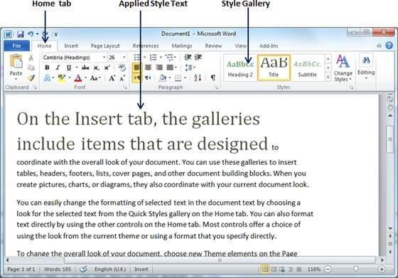

* The ‘Styles Gallery’ appears as follows:
* Please utilize the Styles Gallery when formatting your article.
* Please avoid doing the following:
  + adjust the paragraph parameters
  + add numbering to headings
  + increase or decrease indentation
  + create new headings
* If the formatting appears to stray away from the requirements, select the affected paragraphs/headings, and click the “Clear Formatting” icon at the ‘Font’ section of the ‘Home’

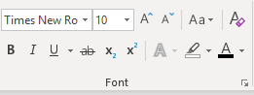



* 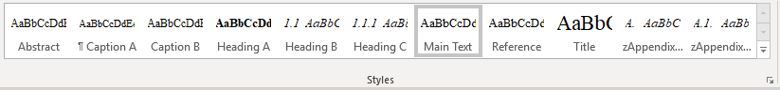The formatting will be reset. Again, apply the intended formatting by clicking the specific style using the Styles Gallery.

Please refer to the table below to understand the target use of each of the specific style.

| **Style Name** | **Targeted Use** |
| --- | --- |
| Title | Main title |
| Author | Authors’ names *\*corresponding author’s details are located at the footnote section of the first page* |
| Affiliation | Author’s institutional affiliation |
| Footnote | Corresponding author’s e-mail address (use institutional e-mail address instead of free e-mail such as Gmail, Yahoo etc.) |
| Heading A | Main header with numbering (1,2,3…) |
| Heading B | Second level header (e.g. 1.1, 1.2, …) |
| Heading C | Third level header (e.g. 2.2.1, 2.2.2, …) |
| Main Text | The write-up of the article |
| Caption A | Caption for Table |
| Caption B | Caption for Figure |
| Reference | Bibliographic reference with indentation |
| Appendix Heading 1 | Appendix header with lettering (A. B, C …) |
| Appendix Heading 2 | Appendix second-level header with alphanumeric coding (e.g. B1. B2, B3 …) |

* If you successfully adhere to this instruction, your article will be generated into a bookmarked PDF that is easy to be navigated by readers.
* 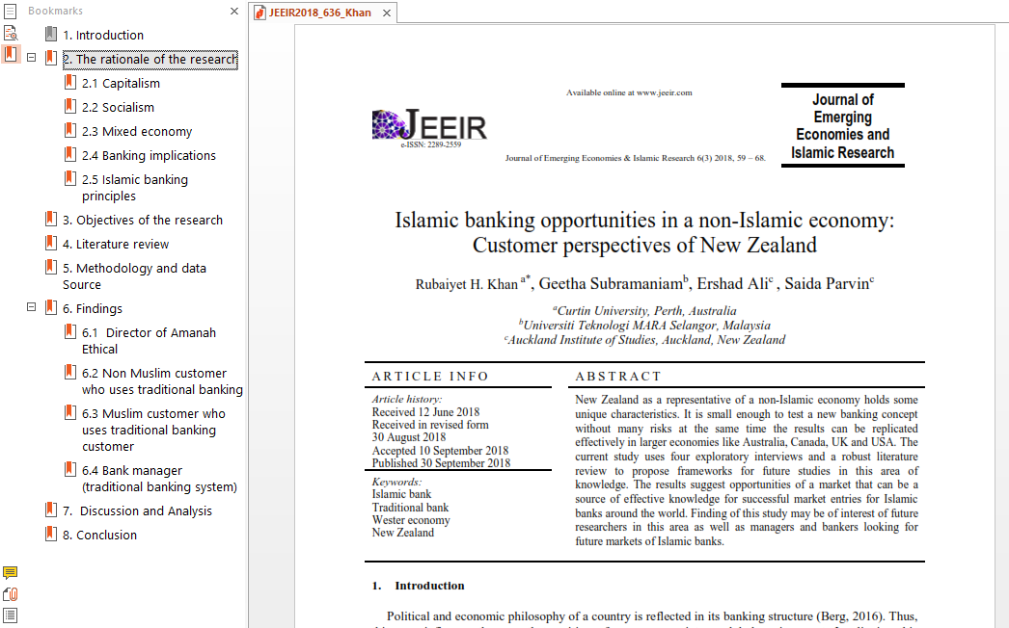
* This journal is a double-blind peer-reviewed open access journal that does not charge any publication fees. The journal is managed by volunteering academics of UiTM whose responsibilities include teaching, research, supervision, administration, and other academic obligations. Hence, your adherence to this guideline when submitting your manuscript is highly appreciated.

*Prepared by:*

*Jawatankuasa Kecil Semakan Format Penerbitan*

*Universiti Teknologi MARA (UiTM), Malaysia*

*December 2021*

1.