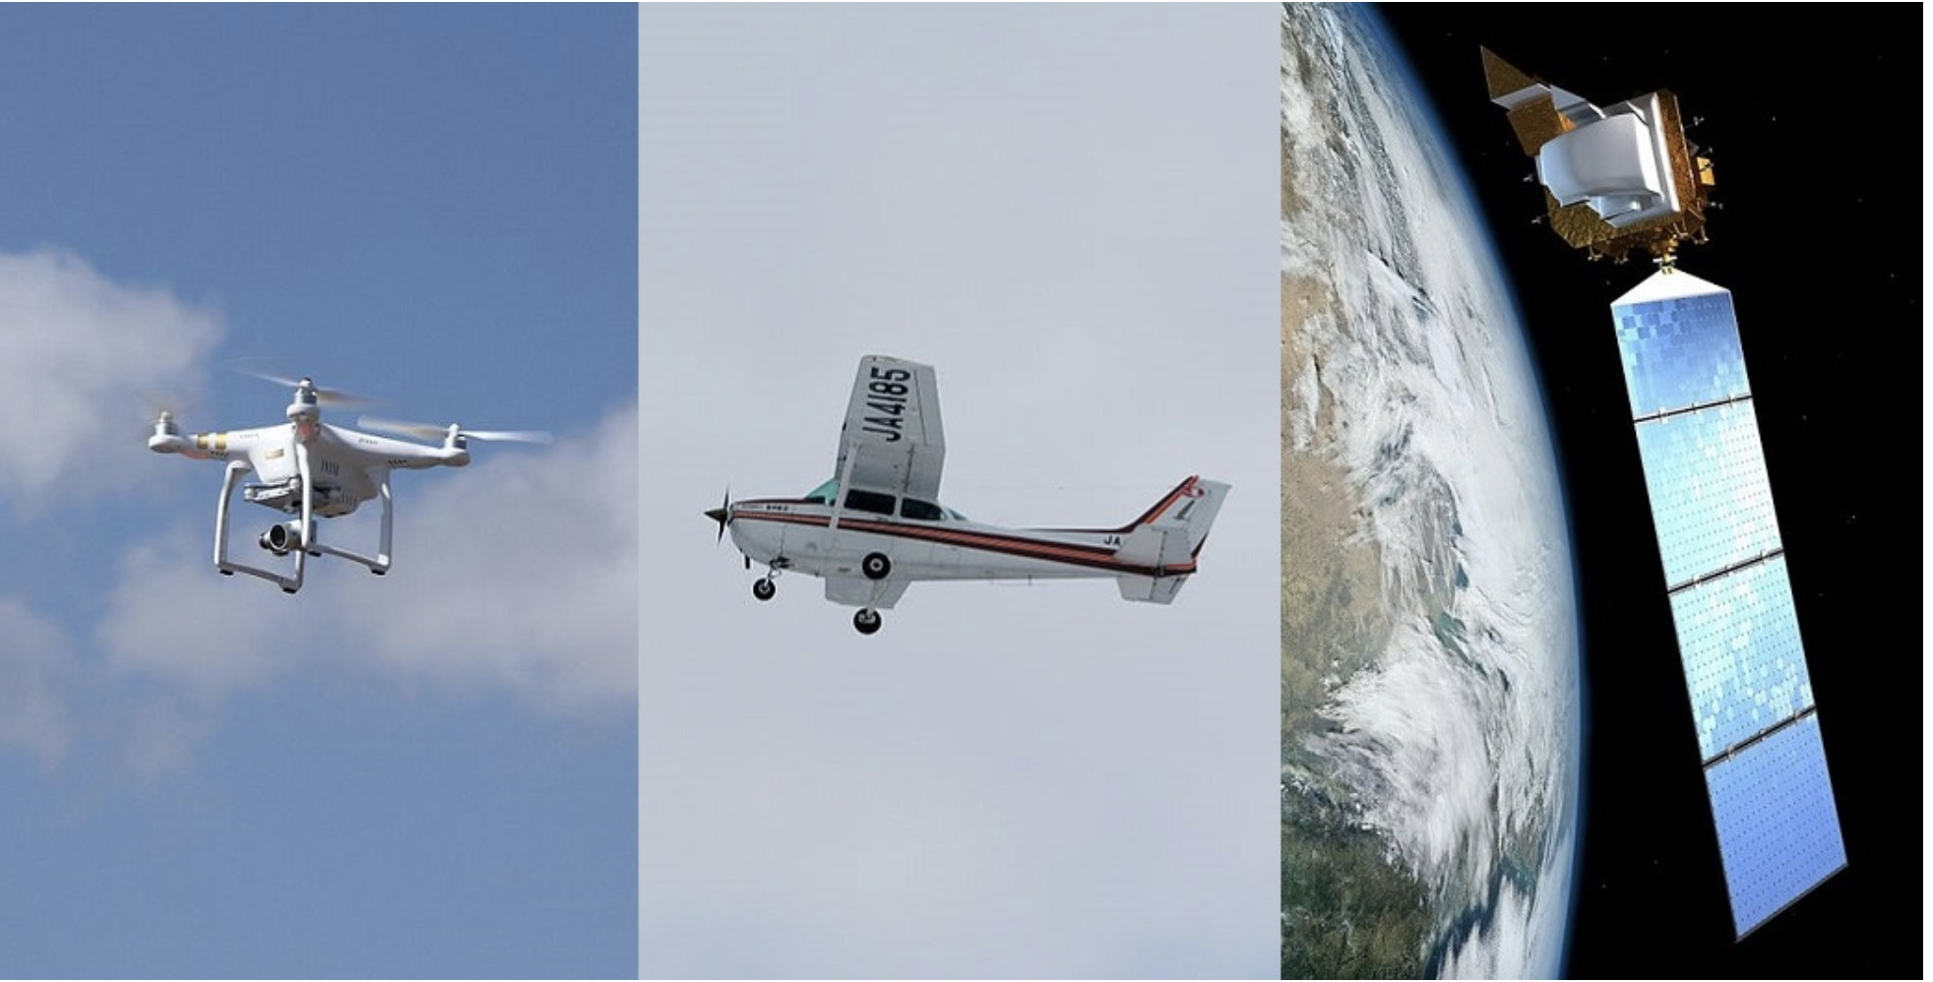

[Source](https://droneapps.co/price-wars-the-cost-of-drones-planes-and-satellites/)

Remote sensing imagery

### Can you use existing imagery rather than conducting your own surveys?

1. There may be adequate imagery already available from public sources and you may be able to access imagery for free. Here is a partial list of public imagery collections from satellite and aerial sources - you can also check state agencies and GIS archives at universities.
   1. [The National Map](http://nationalmap.gov/viewer.html)
   2. [USGS EarthExplorer](http://earthexplorer.usgs.gov/)
   3. [Sentinels Scientific Data Hub](https://scihub.copernicus.eu/dhus) - this is from the European Space Agency
   4. [NASA’s Earthdata Search](https://search.earthdata.nasa.gov/)
   5. [NOAA Data Access Viewer](https://coast.noaa.gov/dataviewer/#)
   6. [Google Earth Engine Timelapse](https://earthengine.google.com/timelapse/)
   7. [Google Earth Engine](https://earthengine.google.com/)
   8. [Google Earth Pro](https://www.google.com/earth/versions/) use the [timeslider to access imagery from different dates](https://support.google.com/earth/answer/148094?hl=en)
   9. [National Agriculture Imagery Program (NAIP)](https://www.fsa.usda.gov/programs-and-services/aerial-photography/imagery-programs/naip-imagery/)
   10. [USDA Aerial Photography](https://www.fsa.usda.gov/programs-and-services/aerial-photography/imagery-products/index)
2. You may also be able to access imagery collections from paid services at a lower cost than conducting your own surveys. Check with your Tribal GIS office or with a university GIS program for advice on how to purchase imagery.

### Should you use a UAV, or should you use aerial or satellite imagery?

This will depend on a number of factors such as:

* What resolution do you want?
* How large is the area that you want to cover?
* Do you want to use certain sensors?
* Do you want imagery taken on a specific date and time?
* How often do you want to take the imagery?
* Are you looking for imagery from restricted airspace or culturally or environmentally sensitive areas?

**Resolution**: Generally speaking, the larger the area you wish to survey the lower the resolution you will be able to obtain, although this is changing with new, high resolution satellite imagery.

Another thing to consider is processing time, since high resolution imagery will give you larger file sizes and longer processing times. You can use a number of techniques to better manage your imagery, but be aware that this will take some thought and planning to make sure you can get the information you want at a reasonable cost and within a reasonable timeframe. Depending on your technical skills and available computational capacity (cloud storage space, software, etc.) you may have to pay to have the imagery processed and stored (more about this in the [imagery analysis session](https://www.cynthiaannett.org/workshops/2019-tlef/uav/uav-imagery)).

Although satellite imagery is rapidly evolving to provide higher resolution imagery, as a general rule the higher the altitude the lower the resolution. Therefore satellite imagery will tend to be lower resolution than aerial imagery taken from a plane, and UAVs will give you higher resolution imagery than planes. Assuming you don’t have a helicopter at your disposal, if you want high resolution imagery you will want to use a UAV. Also, it may be difficult to get satellite imagery that is not obscured by clouds, and UAVs fly below the clouds.

**Area size and characteristics:** Unless you have special training and a waiver, you can only operate a UAV within line of site and with an observer (not through the camera on the UAV). This means there are practical limitations on the size of the area you can survey with a UAV. For larger areas it will likely be more practical to conduct the survey from a plane or use satellite imagery.

Be aware that the larger the size of the area the larger the image file size. You may wind up with image files that are too large to be practical given limitations on time and computational capacity. You may need to break your survey up into a series of smaller segments to make it easier to deal with the image files. It is a good idea to think through the design of your survey and how you will process and analyze the imagery before flying the survey.

You may wish to get imagery in an area that is not accessible to planes or satellites. For example, you can fly a UAV under a tree canopy or in a building.

**Sensors**: There are a number of different sensors you can use to get different kinds of information. These sensors vary in size and cost, and are therefore more likely to be available only on certain platforms. For example, it is more likely to have LiDAR flown from a plane than a UAV. If you plan to use a UAV check to make sure you can get the type of data you need (for example by using an RGB, NDVI or thermal sensor).

**Time sensitivity**: If you want to specify when the imagery is taken - for example, you want to get imagery during an emergency, or at a certain stage of cleanup and redevelopment - you will need to have more control over scheduling than may be available from public satellite and aerial image archives. This may require you to have a service on call, or to own your own plane or UAV. Depending on your budget and the amount of lead time you have, you may want to have a licensed UAV pilot on call with a dedicated UAV. This may be a good arrangement for an emergency response program, but be aware that additional training and permissions are needed to operate a UAV during an emergency or natural disaster.

**Frequency:** Think through how often you will need to fly surveys since this will determine whether it is cost effective to purchase your own UAV and go through the licensing and regular relicensing process. If you will not use a UAV very often, you may want to collaborate with another agency within your tribe (for example, your THPO may have a UAV and be willing to fly surveys for you), share with other tribes, or contract with a consultant.

If you believe that you will use a UAV on a regular basis, it may be more cost effective to build the capacity within your tribal office to have a licensed commercial pilot with access to a UAV. Be prepared to justify this to your funding agency.

**Restricted airspace or cultural/environmental sensitivity:** There may be good reason to have appropriate agencies within your tribe fly UAV surveys rather than contracting out the work. For example, you may want imagery from a culturally sensitive location, and your tribe might be more willing to have an appropriate tribal staff member fly the survey and process the imagery rather than hiring a consultant.

Be aware that there are many restrictions on where you can fly UAVs. You can use the FAA [B4UFly app](https://www.faa.gov/uas/recreational_fliers/where_can_i_fly/b4ufly/) to determine if you are in restricted airspace. If you have the proper training and go through the necessary steps to obtain a waiver, however, it is possible to fly in airspace that may otherwise be restricted. For example, tribal law enforcement and first responders may receive permission from the FAA to fly UAVs during disaster response.

Other restrictions on UAV use include a prohibition on flying over gatherings of people and a requirement that you must fly under 400’ and within your line of site. There are also restrictions on flying over sensitive wildlife and in parks and refuges (check with wildlife and parks personnel at the site for regulations).

### Should you develop a tribal UAV program or hire consultants?

1. **Time and Cost:** There are a number of things to consider beyond the cost of the UAV itself. For example, to use a UAV for work (as opposed to a strictly recreational use), you must have a [commercial pilot’s license](http://knowbeforeyoufly.org/for-business-users/) and go through relicensing every two years. To use UAVs during emergency response and for government use you must also have a [Certificate of Authorization from the FAA](http://knowbeforeyoufly.org/for-public-entities/). You must [register your UAV](https://faadronezone.faa.gov/#/) and have [liability insurance](https://uavcoach.com/drone-insurance-guide/). If you have a [commercial license](https://www.faa.gov/uas/commercial_operators/) and want to fly in restricted airspace, you must get a [waiver from the FAA](https://www.faa.gov/uas/commercial_operators/part_107_waivers/).

If you don’t have the funding and capacity to operate your own UAV program, you might consider partnering or contracting with someone who has all the necessary licenses, waivers, etc.

1. **Technical difficulty:** Although flying UAVs is becoming increasingly easy due to automation and improved sensors, there still are a number of technical issues you will need to deal with. For example, determining whether there are restrictions on airspace, determining the proper sensors to use and how to most effectively operate them, etc. Perhaps the most challenging aspect is processing and analyzing the imagery, but this can be done by various online services separate from purchasing and operating your UAV.
2. **Capacity building, privacy and sovereignty:** One compelling argument for developing your own UAV program is tribal sovereignty. Controlling access to sensitive sites, maintaining control of data and imagery, and building capacity to fly surveys whenever and wherever needed are all important considerations to balance against the cost and effort of developing your own program. Another consideration is whether it might be possible to hire out your personnel and equipment to help offset costs.
3. **Maintenance, insurance and licensing:** Be aware that there will be the need to find funding to sustain a program. For example, pilots must take their [initial exam at specific facilities](https://www.faa.gov/training_testing/testing/media/test_centers.pdf), incurring travel costs as well as time away from work. Once licensed, a pilot must undergo relicensing every two years (this can be done online, but time must be allocated for studying and testing). You will need to get liability insurance for your UAV, and deal with the costs of repairs and maintenance. You will also need to service and calibrate any sensors you use. Additionally, you may need to pay a service to process your imagery.

### Sources

[Price wars: counting the cost of drones, planes and satellites](https://droneapps.co/price-wars-the-cost-of-drones-planes-and-satellites/)

[15 Free Satellite Imagery Data Sources](https://gisgeography.com/free-satellite-imagery-data-list/)

### Resources

[Kansas State University Polytechnic Campus Unmanned Aerial Vehicle Training Program](https://ksu-uas.com/)

[K-State Polytechnic UAS 101 Webinar - YouTube](https://www.youtube.com/watch?v=AgUzxyYWVCA&feature=youtu.be)

[Practical Uses for Drones on Tribal Lands - YouTube](https://www.youtube.com/watch?v=ZhD0eaVu5gg&feature=youtu.be)

[Establishing a Tribally Operated Drone Program](https://www.bia.gov/sites/bia.gov/files/assets/public/pdf/2C-ESTABLISHING_TIRBALLY_OPERATED_DRONEPROGRAM.pdf)

[Know Before You Fly](http://knowbeforeyoufly.org/)

[Airman Knowledge Testing Center List](https://www.faa.gov/training_testing/testing/media/test_centers.pdf)

[FAA Drone Registration](https://faadronezone.faa.gov/#/)

[FAA Rules and Laws for UAV Operations](https://www.faa.gov/uas/resources/policy_library/#107)

[FAA B4UFly Mobile app](https://www.faa.gov/uas/recreational_fliers/where_can_i_fly/b4ufly/)

[Drone Laws by State](https://uavcoach.com/drone-laws/)

[Drone Insurance](https://uavcoach.com/drone-insurance-guide/)