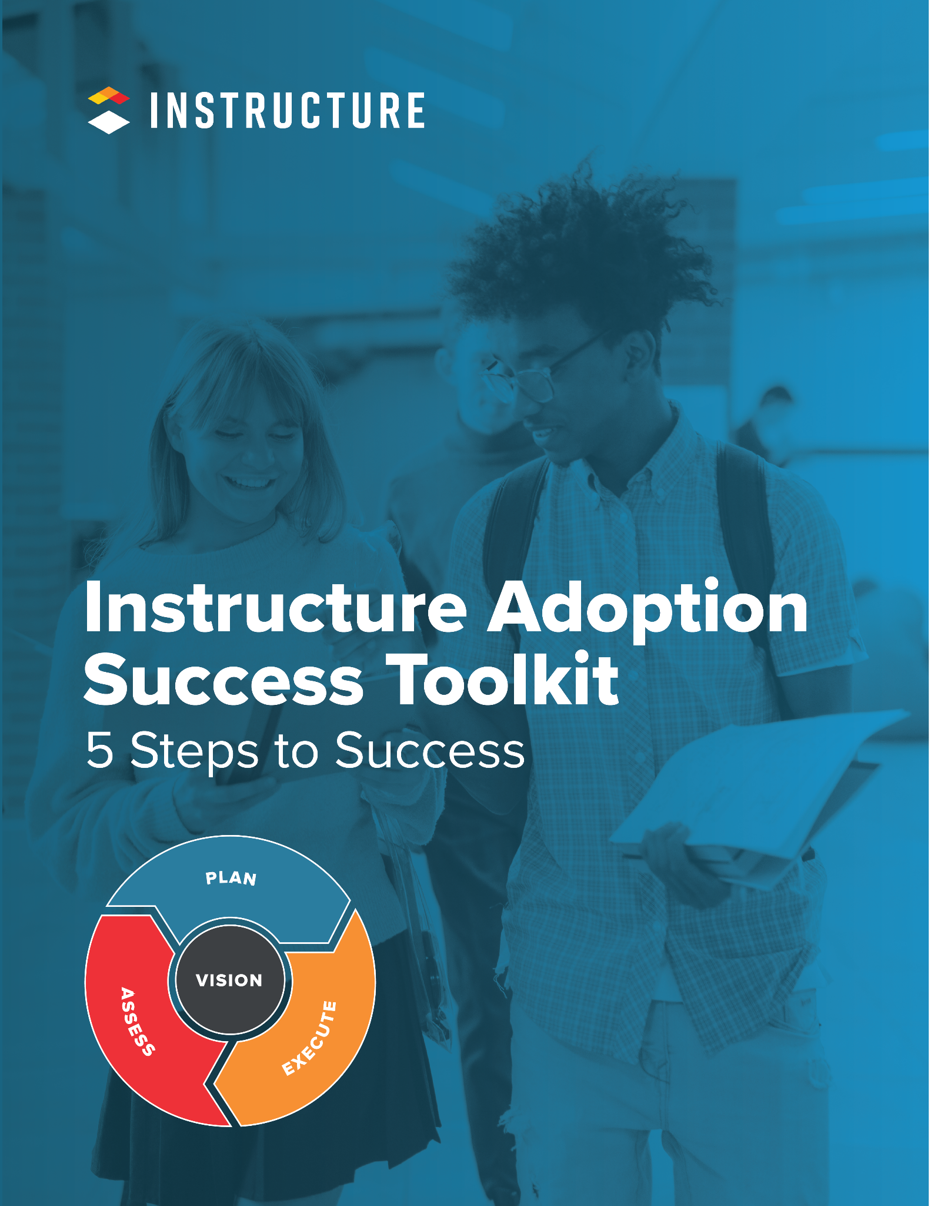

5 Steps to Success

1 | Bring the leaders of people together.
Form an Adoption Team with leaders and stakeholders within your organization to assess your current processes and begin planning for the future.

2 | Create and share the vision.
Start your visionary leadership journey and define the “why” to engage your organization in a shared vision of success.

3 | Plan for the short and long term.
Construct plans for communication, training, and engagement to prepare for challenges that will arise and empower leaders to support adoption.

4 | Execute and deepen experiences.
Implement plans with fidelity and flexibility to allow for responsive shifts that meet the needs of your stakeholders while honoring your vision.

5 | Assess progress and amplify wins.
Evaluate your adoption progress to share successes, set goals, and continue your evolution with the Instructure Learning platform.

The Instructure Success Checklist
Hello and welcome to the Instructure family!
This checklist is intended to provide you and your team with the core components of a successful implementation and adoption plan and to support your visionary leadership with the Instructure Learning platform.
We want to be clear: Instructure has a suite of tools, and they work best when matched with the proven practices outlined in The Instructure Success Model by committed educators and visionary leaders like you. We know the process outlined in this checklist works; we’ve done it ourselves, and we’ve helped others achieve success by utilizing these best practices.
The Instructure Success Model provides the core structure you need to help you seamlessly transition your people to the Instructure learning platform so it can be used meaningfully to drive teaching and learning. By following our model of success, you will increase the speed of adoption, optimize utilization, and improve the overall student experience. As you transition, you can use the checklist to identify and define your plans, reference best practices while executing the next steps, and evaluate your progress.
Whether you are an experienced member of the Instructure family or a new user, the checklist is meant to support your visionary leadership and deepen your adoption. You may choose to engage with it from front to back as a comprehensive planning toolkit for your team. Or, you may have prioritized topics you want to deeply engage with first, then engage with other sections later to flesh out details.

Key Terms
- Implementation:
The sequential process of configuring the connections and settings between your institution’s technology ecosystem and the technical components of Instructure products.
- Adoption:
The empowerment of school leaders to plan for intentional shifting of user’s knowledge, comfort, and confidence in using Instructure products to deepen teaching and learning.

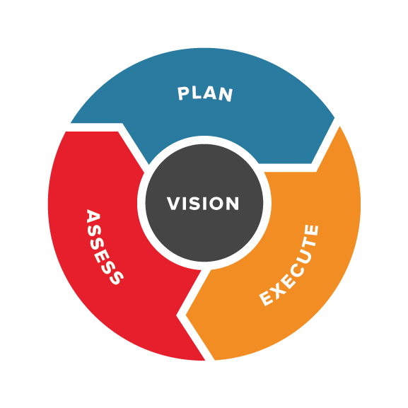
Instructure Success Model | Checklist
Our Instructure Success Model gives you a simple process and helpful tools for visionary leadership as you guide your team through seamless implementation and adoption. Our model and checklist will help you execute the following steps:
- Increase the speed and deepen the level of adoption
- Optimize platform utilization
- Improve user experience
While we encourage you to follow this model from the start of your platform adoption, it can also be used in years two, three, and beyond to plan for new initiatives.

▶︎ Your Leadership Team | Activities: 1-30 Days
Assemble your Adoption Team to develop a vision that will center the planning, execution, and evaluation of how you will shift your people to adopt the Instructure Learning Platform.
Yes ✓ | Criteria
 | Identify the members for your leadership team
 | Assemble your implementation team (technical side)
 | Assemble your adoption team (people side)
 | Determine the audiences impacted by the change

▶︎ Vision | Activities: 1-30 Days
Realizing your vision is the most important part of a successful adoption. A clear vision and measurable goals help you lay a solid foundation for future change and provide clear direction for your team.
Yes ✓ | Criteria
 | Analyze your current state
 | Define your vision (your “why”)
 | Set success measures | SMART Goals

▶︎ Plan | Activities: 30-60 Days
Planning is an integral part of this success model. This process helps you identify your current state, make decisions, and allocate the necessary resources to achieve the end goals.

▸ Communication Plan
Yes ✓ | Criteria
 | Identify audiences for communication
 | Develop key messages and timing
 | Determine content, delivery method, frequency, and sender
 | Put communication plan into action, then review and adjust

▸ Training Plan
Yes ✓ | Criteria
 | Consider the big picture connections to your institution
 | Tie training to your vision for teaching and learning and desired outcomes
 | Identify the audiences that need training
 | Create and communicate a plan for ongoing training

▸ Engagement Plan
Yes ✓ | Criteria
 | Identify and empower the people who lead the people
 | Predict and plan for addressing concerns
 | Develop and communicate an incentive plan that engages leaders and followers

▶︎ Execute | Activities: 60-180 Days
A plan is only as good as its execution. When it comes time to execute plans, internal leaders remain active and visible to help drive change.
Yes ✓ | Criteria
 | Create and implement a cohesive development plan
 | Drive adoption through the communication, training, and engagement plans
 | Follow up and monitor progress

▶︎ Assess | Activities: 180-240 Days
To ensure your success, evaluate your progress and set new goals for future growth.
Yes ✓ | Criteria
 | Aggregate quantitative and qualitative data to assess usage and utilization
 | Assess the success of communication, training, and engagement plans
 | Review goals and celebrate milestones
 | Define new future state and set goals

Leaders of People | Introduction

1 | Bring the leaders together.
We're excited to introduce you to our Strategic Services experience with Step 1 of our toolkit, entitled "Bring the Leaders of People Together." This initial step is designed to guide you in visioning and planning with your team, laying the groundwork for success. To embark on this journey, simply make a copy of Step 1 of our toolkit.
If you have any questions or require assistance with the remainder of the checklist, please reach out to your Customer Success Manager. They'll provide insights into our Strategic Services and how utilizing our consulting can enhance the speed of adoption, deepen and refine usage, and enrich the overall student experience at your educational institution. In addition, take a look at everything our Strategic Services team has to offer for Canvas, Mastery, and Impact.

