Name(s)_______________________________________________ Period ______ Date ___________________

|  | **Activity Guide - Representing Numbers** |  |
| --- | --- | --- |

## Binary Number Cards

Work with your group to figure out which cards should be face up or face down to get the correct number of dots. Put a “U” under a card that should be face up and a “D” under a card that should be face down. The first one has been done for you.

| | How many dots? |  |  |  |  | | --- | --- | --- | --- | --- | | 13 | U | U | D | U | | 5 | D | U | D | U | | 10 | U | D | U | D | | 2 | D | D | U | D | | What’s the lowest number you can make?  _____________0_________________________  What’s the highest number you can make?  ______________15________________________ |
| --- | --- | --- | --- | --- | --- | --- | --- | --- | --- | --- | --- | --- | --- | --- | --- | --- | --- | --- | --- | --- | --- | --- | --- | --- | --- | --- |

## Using the Pattern

You can use the same pattern even without the cards. Shade over the cards you do NOT want to use to make your number. The first one has been done for you.

| 7 | |  |  |  |  | | --- | --- | --- | --- | |  | 3 | |  |  |  |  | | --- | --- | --- | --- | |
| --- | --- | --- | --- | --- | --- | --- | --- | --- | --- | --- | --- | --- |
| 12 | |  |  |  |  | | --- | --- | --- | --- | |  | 6 | |  |  |  |  | | --- | --- | --- | --- | |

You can use the same pattern even without the dots! Answer the questions by shading in the squares.

| Image result for ant  1. How many legs does an insect have?  Image result for siblings clip art  2. What grade are you in?  3. How many sisters and brothers do you have?  4. Make up a question…  ____________________________________________  ____________________________________________? | |  |  |  |  | | --- | --- | --- | --- |  |  |  |  |  | | --- | --- | --- | --- |  |  |  |  |  | | --- | --- | --- | --- |  |  |  |  |  | | --- | --- | --- | --- | |
| --- | --- | --- | --- | --- | --- | --- | --- | --- | --- | --- | --- | --- | --- | --- | --- | --- | --- |

The highlighted answers will be different from student to student.

Use the online widget to help you answer the following questions.

## 5-bit Numbers

| 1. | | ? | 8 | 4 | 2 | 1 | | --- | --- | --- | --- | --- | | In this 5-bit system for binary numbers,  what number should go in the left-most box? _______16____________ |
| --- | --- | --- | --- | --- | --- | --- | --- |

2. How would you make...

| 16? | |  |  |  |  |  | | --- | --- | --- | --- | --- | | 27? | |  |  |  |  |  | | --- | --- | --- | --- | --- | | 31? | |  |  |  |  |  | | --- | --- | --- | --- | --- | |
| --- | --- | --- | --- | --- | --- | --- | --- | --- | --- | --- | --- | --- | --- | --- | --- | --- | --- | --- | --- | --- |

## 6-bit Numbers

1. In a 6-bit number system, what’s the biggest number that you can make? _____63__________

| 2. | The record for most skips by a dog and person in one minute is 59. How would you encode 59 in binary? | |  |  |  |  |  |  | | --- | --- | --- | --- | --- | --- | |
| --- | --- | --- | --- | --- | --- | --- | --- | --- |

## Decoding Multiple Numbers

1. What is the most number of people lifted and thrown in two minutes? ____12___________

2. What is the most canned drinks opened by a parrot in one minute? ____44__________

3. How many inches is the longest tail on a dog? ____30__________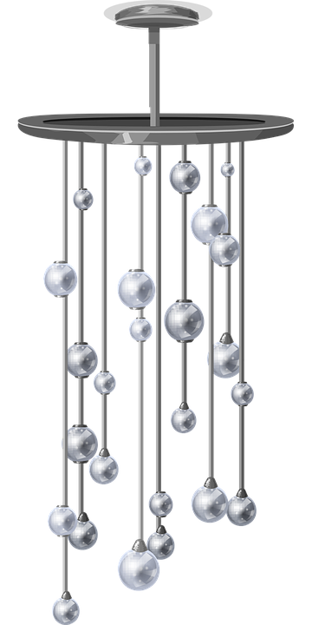

4. What’s the most number of spoons balanced on someone’s face? ____31___________

5. How many feet long is the longest wind chime? ___42___________

6. What’s the furthest flight, in feet, of an arrow shot with someone’s feet? ___20___________

## Reflection

Why is it important to have a set bit length for your numbers when you send information in binary?

_____Because if you don’t know the bit length of each_____ number, then you can’t tell where each number starts and stops, so it could be different numbers depending on____ where you start and stop reading each number._________

Use the 8-bit binary system to send a question and binary answer to a classmate.

Question: _______What’s the average number of legs for a centipede? ___________________________________________________________________

| Answer: | |  |  |  |  |  |  |  |  | | --- | --- | --- | --- | --- | --- | --- | --- | |
| --- | --- | --- | --- | --- | --- | --- | --- | --- | --- |