Judul Artikel Dalam Bahasa Indonesia Dengan Maksimal Enam Belas Kata
Nama Penulis Pertama¹, Penulis Kedua², Penulis Ketiga², Penulis Keempat³
¹ Afiliasi Institusi Penulis Jurusan, Institusi, Kota/Kabupaten, Provinnsi, Kode Pos, Negara
² Afiliasi Institusi Penulis Jurusan, Institusi, Kota/Kabupaten, Provinnsi, Kode Pos, Negara
Penulis Korespondensi: Nama Penulis (email: author@academic.org)
[Diserahkan 25 Desember 2024; Direvisi 1 Januari 2025; Diterima 1 Februari 2025]

ABSTRAK — Dokumen ini berfungsi sebagai pedoman bagi penulis secara tertulis naskah mereka untuk publikasi Aplikasi Informatika Dan Multimedia (Japtika). Penulis diharuskan untuk mematuhi pedoman yang diuraikan dalam dokumen ini, atau penulis perlu mengedit naskah mereka. Penulis dapat menggunakan dokumen ini baik sebagai pedoman penulisan atau templat, yang dapat segera diisi dengan konten naskah yang tepat. Judul harus ditulis dalam huruf besar dan kecil, tidak semua huruf besar. Hindari menulis formula panjang dengan subskrip dalam judul; Namun, rumus pendek yang mengidentifikasi elemen -elemennya baik -baik saja (mis., “Nd -Fe -B”). Nama lengkap penulis diperlukan di bidang penulis. Nomor superskrip yang mengikuti nama penulis menunjukkan afiliasi penulis. Abstrak harus menjadi refleksi ringkas namun komprehensif dari apa yang ada dalam naskah. Secara khusus, abstrak harus mandiri, tanpa persamaan matematika, bahan tabel, kutipan, atau referensi. Abstrak ditulis dalam bahasa Indonesia dan panjangnya sekitar 200-250 kata. Abstrak berisi setidaknya lima bagian. Bagian pertama adalah pengantar yang mencakup seperempat abstrak. Bagian kedua mendefinisikan tujuan penelitian. Bagian ketiga menjelaskan metodologi penelitian. Bagian keempat adalah penjelasan dari hasil penelitian, dan bagian terakhir adalah implikasi/kesimpulannya.
KATA KUNCI — Kata kunci harus terdiri dari minimal 3 dan maksimal 7 istilah, dipisahkan oleh koma, dengan setiap istilah dimulai dengan huruf kapital.

Article Title Written in English with Maximum of Sixteen Words and Avoiding Unofficial Abbreviations
ABSTRACT — This document serves as a guideline for authors in writing articles for the Journal of Technology & Applied Sciences (JTAS) publication. Authors must comply with the guidelines outlined in this document, or else they need to edit their manuscripts accordingly. Authors may use this document either as a writing guideline or template, which can be immediately filled with the appropriate content of manuscripts. The titles should be written in uppercase and lowercase letters, not all uppercase. Avoid writing long formulas with subscripts in the title; however, short formulas that identify the elements are fine (e.g., “Nd–Fe–B”). Full names of authors are required in the author field. The superscript number following the author's name indicates the author's affiliation. The Abstract must concisely yet comprehensively reflect what is in the manuscript. In particular, the Abstract must be self-contained, without mathematical equations, tabular materials, citations, or references. The Abstract is written in English and is approximately 200–250 words long. The Abstract contains at least five sections. The first section is an introduction covering a quarter of the Abstract. The second section defines research purposes. The third section explains the research methodology. The fourth section explains the research result, and the last section is the conclusion.
KEYWORDS — Keywords should consist of 4–8 terms, separated by commas, with each term starting with a capital letter.
- PENDAHULUAN (Font Helvetica 9)
Dokumen ini merupakan templat. Salinan elektroniknya dapat diunduh dari situs web Journal of Technology & Applied Science (JTAS). Untuk pertanyaan apa pun tentang panduan penulisan, silakan hubungi tim redaksi melalui email, seperti yang tertera di situs web. Informasi tentang pengiriman makalah juga tersedia di situs web Journal of Technology & Applied Science (JTAS). (https://journal.aptika.org/index.php/jtas).
- FORMAT HALAMAN
Cara termudah untuk memenuhi persyaratan format penulisan adalah dengan menggunakan dokumen ini sebagai templat, lalu mengetik teks Anda di dalamnya.
Ukuran halaman harus sesuai dengan ukuran halaman A4, yaitu lebar 210 mm (8,27 inci) dan panjang 297 mm (11,69 inci). Batas margin ditetapkan sebagai berikut:
- Top = 23 mm (0.90")
- Bottom = 18 mm (0.70")
- Left = right = 13 mm (0.51")
Article writing must be in a two-column format with a space of 7.1 mm (0.28") between columns.
- STYLE HALAMAN
Semua paragraf harus terorganisir dengan baik dan harus dibenarkan, artinya paragraf harus disejajarkan secara merata di sepanjang margin kiri dan kanan..
Document Letters
Paragraf isi harus menggunakan font Times New Roman atau Times. Font tipe 3 tidak boleh digunakan. Font lain dapat digunakan jika diperlukan untuk tujuan khusus. Fitur ukuran font dapat dilihat pada Tabel 1.
Tabel 1. Detail Ukuran Font 9
Font Type | Font Size | Font Style
Font Type | Font Size | Regular | Bold | Italic
Helvetica | 7 | Gambar caption | Gambar label
Helvetica | 9 | Heading level 3 | List of author names, abstract heading, heading level 1, heading level 2, | Heading level 2
Helvetica | 20 |  | Title
Times New Roman | 8 | Author affiliation
Times New Roman | 8 | Tabel caption (in small caps), reference items, | Tabel header, Tabel sub header | Tabel sub header
Times New Roman | 9 | Cell in Tabels
Times New Roman | 10 | Abstract content, body paragraph

Gaya pemformatan Tabel lainnya dapat dilihat di Tabel 2.

Tabel 2. Detail Ukuran Font 9
Regular | Bold | Italic
Gambar caption | Gambar label | Heading level 1
Heading level 3 | List of author names, | Heading level 2
Heading level 3 | List of author names, | Heading level 2
Tabel caption | Tabel header, Tabel subheader | Tabel subheader
Tabel caption, | Tabel header, Tabel subheader | Tabel subheader
Tabel caption (in small caps), reference items, | Tabel header, Tabel subheader | Tabel subheader

- Judul dan Penulis
The title must be in Helvetica, 18-point font. Author's name must be in Helvetica, 9-point font. The maximum number of words for the title is 16.
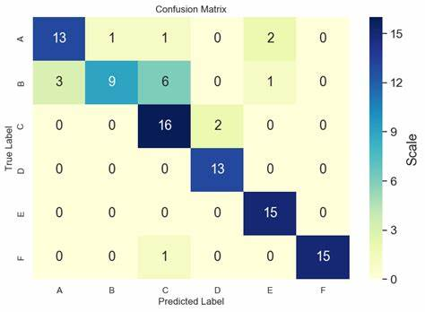
(a)
(b)
Gambar 2. Example of image with different resolutions, (a) in low resolution, (b) in high resolution.
Title and author name must be in a double column format and left-aligned. Each initial letter of words in the title must be in uppercase, except for particles, prepositions, and conjunctions such as “a/an,” “and,” “in/on/at,” “by,” “for,” “from,” “or,” and its kind. Author’s name writing may not indicate a position (e.g., Supervisor lecturer), an academic degree (e.g., Dr.) or membership from any professional organization (e.g., IEEE Senior Member).
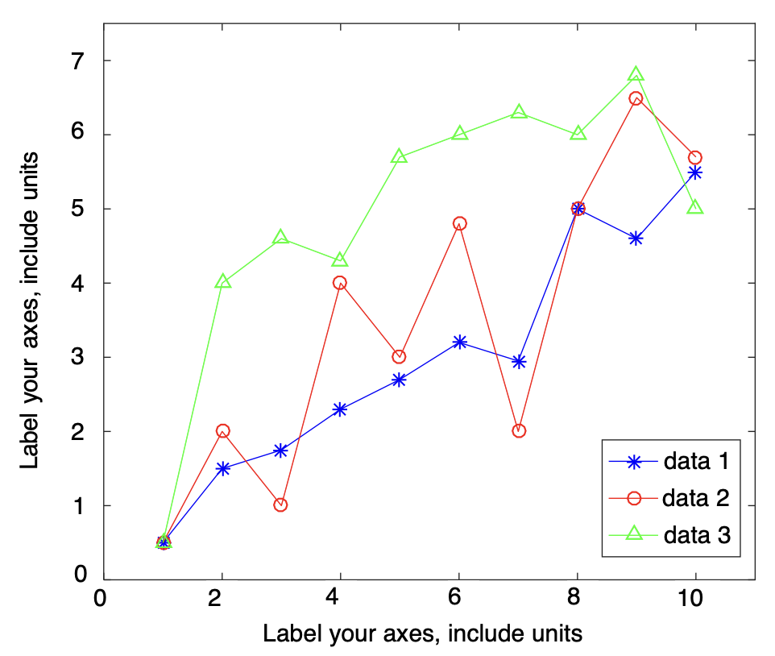
Gambar 1. Example of line chart with well contrast color on the computer screen.

Every affiliation must be included, at least company and country name of the author (for example: SWA Medical Centre Pty Ltd, INDONESIA). In the manuscript, email address is required for the corresponding author.
Under author and affiliation information, the received date specifies the date the manuscript passes the initial screening and plagiarism check stage and is eligible for the review stage. The revised date indicates the date the author submits revision after the editorial decision. Meanwhile, accepted date indicates the letter of acceptance (LOA) issuance date.
- Heading Section
We recommend that there are no more than 3 levels for heading. All headings must be in Helvetica, 9-point font. Each letter in the heading must be in uppercase.
- Level 1 Heading
Level 1 heading must be in uppercase, bold, left-aligned, and use Roman numerals as numbering. For example, see the “3. PAGE STYLE” heading from this document. Level 1 headings that are not preceded by a Roman numeral are Conflicts of Interest, Authors’ Contribution, Acknowledgment, References, and Appendix(es).
- Level 2 Heading
Level 2 heading must be in uppercase, bold, italics, left-aligned and numbered using uppercase alphabets. For example, you can see the heading of “3.2. Heading Section” above.
- Level 3 Heading
Level 3 heading must in uppercase, left-aligned, and numbered with Arabic numbers followed by right parentheses. The contents of the level 3 section are under the heading title as a new paragraph. For example, this section starts with heading level 3.
- GAMBAR DAN TABEL
Tabel, Gambar, and chart must be at the top of the page. Large charts and Tabels can be stretched in both columns. Colored charts are permitted. Use solid color that contrasts well for display on the computer screen, as shown in Gambar 1.
Gambar 2(a) shows example of a low-resolution image that is not in accordance with the provisions, while Gambar 2(b) shows an example of an image with sufficient resolution. Make sure that the image resolution is high enough so that the images’ details, such as texts in images, are visible. Please check all the images in your paper, ensure that:
- the color is in a high contrast,
- the image is clear,
- all the images’ texts are legible.
Typefaces and type sizes should be consistent in all your graphics and Tabels. The font used in graphics is Helvetica, while Times New Roman is used in Tabels. In graphics, the font size should appear approximately 8 points when displayed at full size, while for Tabels, it should be set to 9 points.
- Gambar Label dan Caption
Gambars are labeled with Arabic numerals. Gambar label must be in bold and Helvetica, 7-point font. The single-line caption (e.g., Gambar 1) is centered, while the multiline caption must be justified (e.g., Gambar 2). Gambar caption and label must be placed after the related image, as shown in Gambar 2.
- Tabel Label dan Caption
Tabels are labeled using uppercase Roman numerals. Tabel label is centered and must be in small caps and Times New Roman, 8-point font. Each initial letter of words in the Tabel caption uses capital letters (except for particles, prepositions, and conjunctions as listed in section III B) and must be in small caps. Tabel caption is placed before the related Tabel, as shown in Tabel I.
- Gambar Resolution and Color
The proper resolution of your Gambars should be a minimum of 300 ppi. Gambars in color are available in both online and printed versions.
- SINGKATAN DAN AKRONIM
Define abbreviations and acronyms the first time they are used in the text, even after they have already been defined in the abstract. Abbreviations such as IEEE, AC, and DC do not have to be defined. Abbreviations that incorporate periods should not have spaces: write “C.N.R.S.,” not “C. N. R. S.” Do not use abbreviations in the title unless they are unavoidable.
- REKOMENDASI LAIN
Use one space after periods and colons. Hyphenate complex modifiers: “zero-field-cooled magnetization.” Avoid dangling participles, such as, “Using (2), the distance was calculated.” It is not clear who or what used (2). Write instead, “The distance was calculated by using (2).”
A parenthetical statement at the end of a sentence is punctuated outside of the closing parenthesis (like this). In American English, periods and commas are within quotation marks, like “this period.” Other punctuation is “outside”! Avoid contractions; for example, write “do not” instead of “don’t.” The serial comma (Oxford comma) is preferred: “A, B, and C” instead of “A, B and C.”
Prefixes such as “non,” “sub,” “micro,” “multi,” and “ultra” are not independent words; they should be joined to the words they modify, usually without a hyphen. There is no period after the “et” in the Latin abbreviation “et al.”, which is also italicized. The abbreviation “i.e.,” means “that is,” and the abbreviation “e.g.,” means “for example” (these abbreviations are not italicized).
- LINKS AND BOOKMARKS
All hypertext links and bookmarks sections will be deleted. If the paper needs to refer to the email address or URL in the article, the full address or URL must be typed in a normal font.
- PENULISAN RUMUS
Number equations consecutively with equation numbers in parentheses flush with the right margin, as shown in (1) below. Separate the equation and its equation number using a tab space. Use the equation editor to make the equation. To tighten your equation, use the right slash sign (/), rank function, or appropriate rank. Use parentheses to avoid confusion in writing fraction number. Punctuate equations when they are part of a sentence.
$X\left(ω\right)=\int_{-∞}^{∞}{{x\left(t\right)∙e}^{-jωt} dt}.$ (1)
Make sure that the symbols in the equation have been defined before the equation or follow the equation directly after it appears. Symbols are typed in italics (T is for temperature, but T is for Tesla). When referring to an equation, write it as “(1),” not “Eq. (1),” or “equation (1),” except for the beginning of the sentence: “Equation (1) is …”
- PAGE NUMBERS, HEADERS, AND FOOTERS
Page Number, header, and footer will be added accordingly by the Journal of Intelligent Systems Technology and Informatics (JISTICS) editorial team.
- REFERENCE SECTION
Title in Reference section may not be numbered. All reference items are in 8-point font. Please write each reference in accordance with each source category as listed in Reference section. Numbering of reference items is typed sequentially in square brackets (for example [1]).
References are written according to IEEE standards/styles. When you refer to a reference item, please use a reference number, for example “[2].” Do not use “Ref. [2]” or “Reference [2],” except for the beginning of the sentence, for example, “Reference [2] indicates that ...” In the use of several references, each number is typed with separate brackets (for example [2], [3], [4]-[6]). Some examples of reference items with different categories are shown in the References section which includes:
- example of book in [1],
- example of book series in [2],
- example of journal article in [3],
- example of seminar paper in [4],
- example of patent in [5],
- example of website in [6],
- example of a web page in [7],
- example of manual database in [8],
- example of datasheet in [9],
- example of master’s thesis in [10],
- example of technical reports [11], and
- example of standard in [12].
Please provide each reference item with DOI. Wikipedia, personal blog, and nonscientific websites must not be used as references. The main reference should be within the last five years and the minimum number of references is 20 with 80% of the total number of references being primary references. Tools such as Zotero, Mendeley, or EndNote may be used for reference management.
- KESIMPULAN
Most of the formatting instruction in this document are adapted form IEEE Access article templates.

KONFLIK KEPENTINGAN
Para Penulis menyatakan konflik kepentingan atau menyatakan "penulis menyatakan tidak ada konflik kepentingan." Penulis harus mengidentifikasi dan menyatakan keadaan atau kepentingan pribadi apa pun yang dapat dianggap sebagai tidak tepat mempengaruhi representasi atau interpretasi hasil penelitian yang dilaporkan.
KONTRIBUSI PENULIS
Penulis harus memberikan paragraf singkat yang menjelaskan kontribusi masing-masing. Pernyataan berikut harus digunakan: “Konseptualisasi, Nama Penulis Pertama dan Kedua; metodologi, Nama Penulis Pertama; perangkat lunak, Nama Penulis Pertama; validasi, Nama Penulis Pertama, Kedua, dan Ketiga; analisis formal, Nama Penulis Pertama; investigasi, Nama Penulis Pertama; sumber daya, Nama Penulis Pertama; kurasi data, Nama Penulis Pertama; penulisan—persiapan draf asli, Nama Penulis Pertama; penulisan—peninjauan dan penyuntingan, Nama Penulis Pertama; visualisasi, Nama Penulis Pertama; supervisi, Nama Penulis Pertama; administrasi proyek, Nama Penulis Pertama; perolehan dana, Nama Penulis Kedua,” dll. Kepengarangan harus dibatasi hanya kepada mereka yang telah berkontribusi substansial terhadap karya yang dilaporkan..
UCAPAN TERIMA KASIH
Penulis harus memberikan pengakuan kepada semua pihak yang terlibat dalam penelitian misalnya penyandang dana penelitian, organisasi dll bukan kepada penulis sendiri atau pembimbing. Jika tidak ada boleh dihapus.
REFERENSI
- M. Metev and P. Veiko, Laser Assisted Microtechnology, 2nd ed., R.M. Osgood, Jr., Ed. Berlin, Germany: Springer-Verlag, 1998, doi: 10.1007/978-3-642-87271-6.
- J. Breckling, Ed., The Analysis of Directional Time Series: Applications to Wind Speed and Direction, ser. Lecture Notes in Statistics. Berlin, Germany: Springer, 1989, Vol. 61, doi: 10.1007/978-1-4612-3688-7.ss
- S. Zhang, C. Zhu, J.K.O. Sin, and P.K.T. Mok, “A Novel Ultrathin Elevated Channel Low-Temperature Poly-Si TFT,” IEEE Electron Device Lett., Vol. 20, pp. 569–571, Nov. 1999, doi: 10.1109/55.798046.
- M. Wegmuller, J.P. von der Weid, P. Oberson, and N. Gisin, “Highresolution Fiber Distributed Measurements with Coherent OFDR,” Proc. ECOC’00, 2000, paper 11.3.4, pp. 109.
- R.E. Sorace, V.S. Reinhardt, and S.A. Vaughn, “High-Speed Digital-to-RF Converter,” U.S. Patent 5 668 842, Sept. 16, 1997.
- (2002) The IEEE website. [Online], http://www.ieee.org/, access date: 16-Sep-2014.
- M. Shell, (2002) IEEEtran homepage on CTAN. [Online], http://www.ctan.org/texarchive/macros/latex/contrib/supported/IEEEtran/, access date: 16-Sep-2014.
- FLEXChip Signal Processor (MC68175/D), Motorola, 1996.
- “PDCA12-70 data sheet,” Opto Speed SA, Mezzovico, Switzerland.
- A. Karnik, “Performance of TCP Congestion Control with Rate Feedback: TCP/ABR and Rate Adaptive TCP/IP,” Master’s thesis, Indian Institute of Science, Bangalore, India, Jan. 1999.
- J. Padhye, V. Firoiu, and D. Towsley, “A Stochastic Model of TCP Renocongestion Avoidance and Control,” Univ. of Massachusetts, Amherst, MA, CMPSCI Tech. pp. 99–02, 1999.
- Wireless LAN Medium Access Control (MAC) and Physical Layer (PHY) Specification, IEEE Std. 802.11, 1997.
LAMPIRAN (Optional)
Lampiran, jika diperlukan, muncul setelah referensi. Lampiran berisi materi tambahan yang bukan merupakan bagian penting dari teks itu sendiri tetapi dapat membantu dalam memberikan pemahaman yang lebih komprehensif tentang masalah penelitian dan/atau merupakan informasi yang terlalu rumit untuk dimasukkan dalam isi naskah. Selain itu, lampiran juga dapat berisi Gambar yang terlalu besar jika ditempatkan di badan paragraf. Hal penting yang perlu diingat ketika Anda menulis lampiran adalah bahwa informasi tersebut tidak penting; jika dihilangkan, naskah akan tetap dapat dipahami.
Lampiran sebaiknya disertakan jika penggabungan materi dalam badan karya akan membuatnya tidak terstruktur dengan baik atau terlalu panjang dan terperinci. Selain itu, lampiran digunakan untuk memastikan penyertaan materi yang bermanfaat, mendukung, atau penting yang jika tidak akan mengacaukan atau memecah alur naratif naskah, atau akan mengganggu pembaca.

