**SUMMATIVE TEST NO. 2**

**GRADE V – MATH**

**SKAI KRU**

|  |  |  |  |  |
| --- | --- | --- | --- | --- |
| **Objectives** | **CODE** | **Percentage** | **No. of Items** | **Item Placement** |
| describes and compares properties of polygons, regular and irregular polygons. | (**M5GE-IIIc-20)** | **33.33%** | **5** | **1-5** |
| visualizes, names, describes and draws polygons with 5 or more sides. | **(M5GE-IIIc-19)** | **33.33%** | **5** | **6-10** |
| identify the terms related to a circle | **(M5GE-llld-23.2)** | **33.33%** | **5** | **11-15** |
| draw circles with different radii using a compass | **(M5GE-llle-24)** | **33.33%** | **5** | **16-20** |
| **Total** |  | **100** | **20** | **1 – 20** |

**SUMMATIVE TEST NO.2**

**GRADE V – MATH**

**SKAI KRU**

Name :____________________________________________________ Grade and Section:_________

I.A. Identify the type of polygon presented by each of the following figures. Write your answer on a sheet of paper.

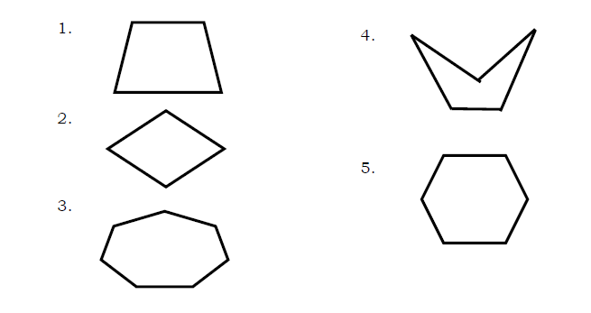

B. Count the number of sides of each polygon and classify what type of polygon is it based on its number of sides.

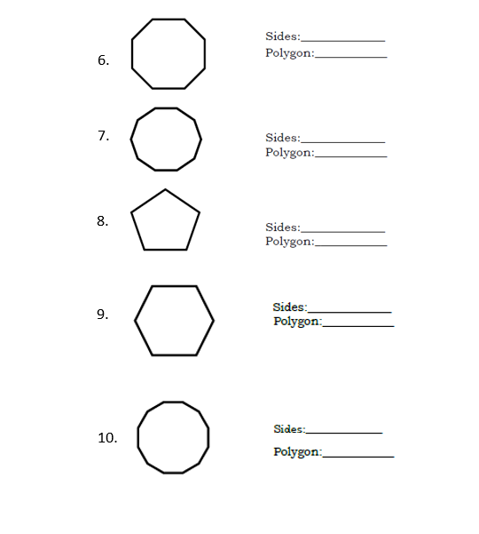

II. Choose the letter of the correct answer.

II. A. Choose the letter of the correct answer.

11. It is a set of points having the same distance from the center.

A. chord B. circle C. radius D. vertex

12. It is a line segment joining two points in a circle.

A. circle C. radius B. chord D. vertex

13. It is a line segment from the center to a point on the circle.

A. chord C. radius B. diameter D. segment

14. It is a line segment whose endpoints are in the circle passing through the centerpoint.

A. chord C. radius B. diameter D. segment

15. If the radius is 20 cm, what is the diameter of the circle?

A. 10 cm C. 61 cm B. 40 cm D. 84 cm

B.Use a real compass or an improvised one to draw circles with these given radii. Do this on a sheet of paper.

16. 4 cm

17. 3.5 cm

18. 10 cm

19. 7.5 cm

20. 1.5 dm

***SUMMATIVE TEST 2 ANSWER KEY:***

I.

A.

1. Irregular

2. Convex

3. Simple

4. Concave

5. Regular

B.

1. 8, Octagon

2. 10, Decagon

3. 5, Pentagon

4. 6, Hexagon

5. 12, Dodecagon

II.

A.

1. B

2. B

3. C

4. B

5. B

B. Drawing circles