Name(s)_______________________________________________ Period ______ Date ___________________

 | Activity Guide - Licensing Your Work | 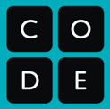

Challenge
The Creative Commons license allows content creators to specify exactly the permissions and restrictions of their creation. After exploring the components of the Creative Commons license, we’ll look through some different examples of content creators and try to identify the best license for each.

Vocab
Attribution - Credit given to the original author of a licensed work.
Derivative - Modifying a licensed work to make a new creation. The process of creating a derivative work is often called “remixing.”

License Components
The Creative Commons license is made up of multiple components that you can mix and match to customize the restrictions you want to place on your work. For each component of the license in the table below, come up with a list of reasons a content creator might want to include this restriction in their license.

Icon | Abbr | Description | Reasons to Include
 | BY | Attribution: Others who use this work must credit original author. The content author may specify how they would like credit given, but the attribution does not imply endorsement by the original author.
 | NC | Non-Commercial: Others may only use this work for non-commercial purposes. Commercial uses include selling products that use this content or using the content to promote commercial goods or services.
 | SA | Share-Alike: Users of this work must distribute any derivative works under the same license, including all the same restrictions.
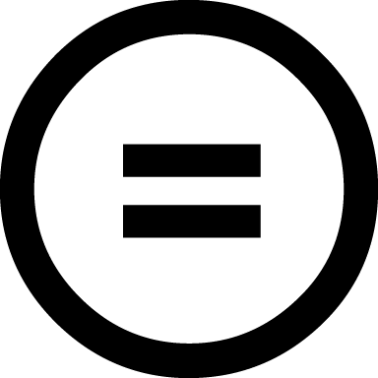 | ND | No Derivative Works: Users may only use this work as is and may make no modifications.

Choosing the Right License
For each of the scenarios below identify the least restrictive Creative Commons license that meets the need of the content creator and explain why you chose that license.

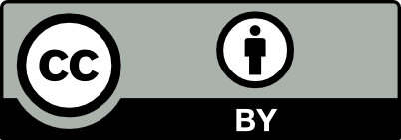  CC-BY | 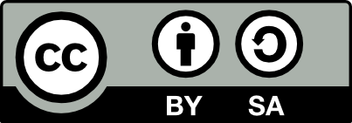  CC-BY-SA | 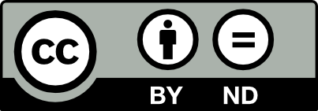  CC-BY-ND
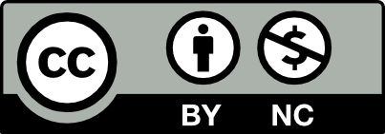  CC-BY-NC | 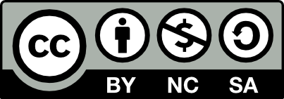  CC-BY-NC-SA | 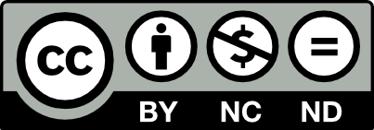  CC-BY-NC-ND

Scenario 1
Miranda made a short film that she’s really proud of. She’d like as many people to see it as possible, but she just wants to make sure that nobody tries to sell it without her permission - after all, if it’s going to be sold she’d like to have a cut of the profit!

- What is the least restrictive CC license that ensures Miranda’s rights are preserved? Why?

Scenario 2
Ernesto loves to sketch and posts all of his drawings on his art blog. Lately people have been taking his art and turning them into memes by adding snarky text to the bottom. Ernesto likes the idea of people sharing his work more broadly, but he doesn’t want people to mess with his original art.

- What is the least restrictive CC license that ensures Ernesto’s rights are preserved? Why?

Scenario 3
Maggie and Eric record short keyboard and guitar riffs which they trade with each other to make larger songs. They dream of one day having a real musician sample their riffs in a song, they just don’t want people to use their recordings without giving them credit.

- What is the least restrictive CC license that ensures Maggie and Eric’s rights are preserved? Why?

