# **Microfire LLC Mod-EC Datasheet**

## 

## **Release Information**

Copyright © 2023 Microfire LLC

This documentation is licensed under a [Creative Commons Attribution-NoDerivatives 4.0 International (CC BY-ND)](https://creativecommons.org/licenses/by-nd/4.0/).

## **Release History**

| **Release** | **Date** | **Description** |
| --- | --- | --- |
| 2.0.0 | 3/24/2023 | Updates for version 2 of hardware. |
| 1.1.0 | 8/13/2021 | Added additional reflow procedures. |
| 1.0.0 | 4/23/2021 | Initial |

## **Legal Disclaimer**

TECHNICAL AND RELIABILITY DATA FOR MICROFIRE LLC PRODUCTS (INCLUDING DATASHEETS) AS MODIFIED FROM TIME TO TIME (“RESOURCES”) ARE PROVIDED BY MICROFIRE LLC "AS IS" AND ANY EXPRESS OR IMPLIED WARRANTIES, INCLUDING, BUT NOT LIMITED TO, THE IMPLIED WARRANTIES OF MERCHANTABILITY AND FITNESS FOR A PARTICULAR PURPOSE ARE DISCLAIMED. TO THE MAXIMUM EXTENT PERMITTED BY APPLICABLE LAW IN NO EVENT SHALL MICROFIRE LLC BE LIABLE FOR ANY DIRECT, INDIRECT, INCIDENTAL, SPECIAL, EXEMPLARY, OR CONSEQUENTIAL DAMAGES (INCLUDING, BUT NOT LIMITED TO, PROCUREMENT OF SUBSTITUTE GOODS OR SERVICES; LOSS OF USE, DATA, OR PROFITS; OR BUSINESS INTERRUPTION) HOWEVER CAUSED AND ON ANY THEORY OF LIABILITY, WHETHER IN CONTRACT, STRICT LIABILITY, OR TORT (INCLUDING NEGLIGENCE OR OTHERWISE) ARISING IN ANY WAY OUT OF THE USE OF THE RESOURCES, EVEN IF ADVISED OF THE POSSIBILITY OF SUCH DAMAGE.

MICROFIRE LLC reserves the right to make any enhancements, improvements, corrections or any other modifications to the RESOURCES or any products described in them at any time and without further notice.

The RESOURCES are intended for skilled users with suitable levels of design knowledge. Users are solely responsible for their selection and use of the RESOURCES and any application of the products described in them. User agrees to indemnify and hold MICROFIRE LLC harmless against all liabilities, costs, damages or other losses arising out of their use of the RESOURCES.

HIGH RISK ACTIVITIES. MICROFIRE LLC products are not designed, manufactured or intended for use in hazardous environments requiring fail safe performance, such as in the operation of nuclear facilities, aircraft navigation or communication systems, air traffic control, weapons systems or safety-critical applications (including life support systems and other medical devices), in which the failure of the products could lead directly to death, personal injury or severe physical or environmental damage, or business loss (“High Risk Activities”). MICROFIRE LLC specifically disclaims any express or implied warranty of fitness for High Risk Activities and accepts no liability for use or inclusions of MICROFIRE LLC products in High Risk Activities.

Microfire LLC Mod-EC Datasheet

Release Information

Release History

Legal Disclaimer

About the Mod-EC Module

Mechanical Specification

Pinout

Surface Mounting

Operating Conditions

Electrical Specification

Power Supply

Power Isolation

Power Consumption

I²C Interface

Additional Circuitry

I²C Address

I²C Write

I²C Read

Design Incorporation

Power

Ground

Probe Connection

Considerations

Unused Pins

EC Measurements

EC Theory

Units

Siemens

TDS

Mho

Considerations

Response Time

Interference

Temperature

Temperature Compensation

Calibration

Procedure

Calibration Types

Single Point

Dual Point

Triple Point

Precedence

Probe Selection

I²C Interface

Registers

Register Listing

Tasks

Task Listing

MEASURE_EC_TASK - EC Measurement

Request Parameters

Response Parameters

CALIBRATE_LOW_TASK - Low Point Calibration

Required Registers

Response Registers

CALIBRATE_MID_TASK - Middle Point Calibration

Required Registers

Response Registers

CALIBRATE_HIGH_TASK - Middle Point Calibration

Required Registers

Response Registers

CALIBRATE_SINGLE_TASK - Single Point Calibration

Required Registers

Response Registers

I2C_TASK - I²C address change

Required Registers

Response Registers

Certificate of Compliance

RoHS 3 Directive 2015/863/EU

Justin Decker

# About the Mod-EC Module

A module for interfacing with EC probes. It has been designed to be flexible and simple to incorporate into new or existing electrical designs.

* EC range of 0.05 µS/cm² to 10 mS/cm²
  + Accuracy ±0.1 mS/cm²
  + Temperature compensated
* [I²C](https://docs.google.com/document/d/1rW58vraZr-1KPePC5H5gn_YmC0Y-y494UADyD-pW1-s/edit#heading=h.lykmcx66bc4l) with software definable address
  + Default address 0x0A
  + 10kHz, 100 kHz, 400 kHz, 1 MHz compatible
* 25 mm wide x 15 mm high x 0.8mm thick
  + Material type: FR-4 TG155
  + DIP and castellated edges
* Calibration options include:
  + Single point
  + Dual point
  + Triple point

# Mechanical Specification

The Mod-EC module is a single-sided 25x15 mm 0.8 mm thick PCB with dual castellated/through-hole pins around the east and west edges. It is designed to be usable as a surface mount module as well as in Dual Inline Package (DIP) type format, with the 12 pins on a 2.54mm pitch grid with 0.9mm holes.

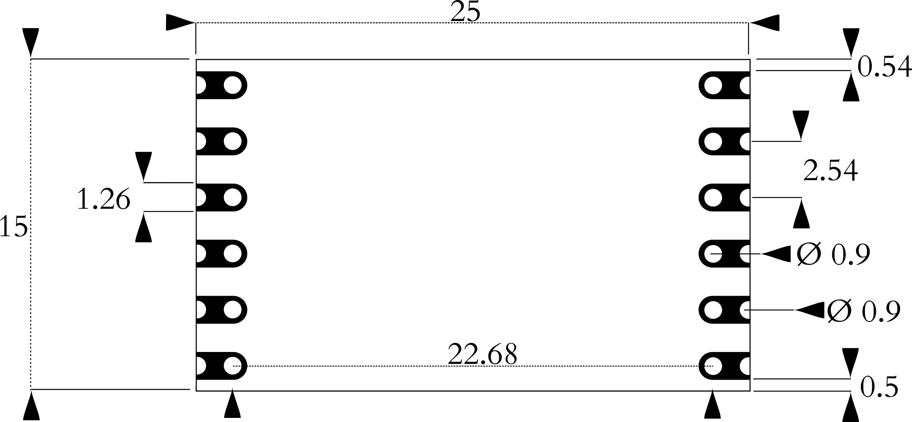

Figure 1. Physical dimensions of the module.

## Pinout

The pinout of the module has been designed to provide as many interface options as possible.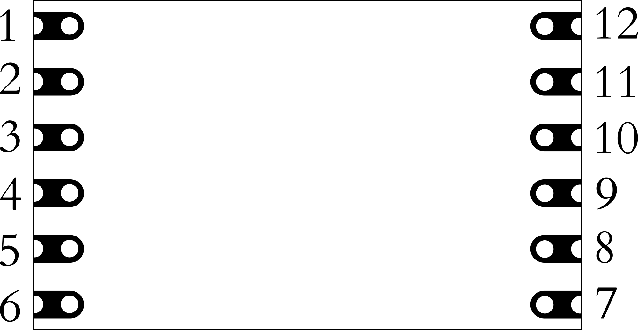Figure 2. Pinout of the module.

**Pin 1**: Probe 1 input. Provides a connection to the first electrode of a EC probe.

**Pin 2**: Probe 2 input. Provides a connection to the second electrode of a EC probe.

**Pin 3**: Not used in this module.

**Pin 4**: Not used in this module.

**Pin 5**: Not used in this module.

**Pin 6**: Not used in this module.

**Pin 7**: Not used in this module.

**Pin 8**: Not used in this module.

**Pin 9**: I²C SCL. Clock line for I2C interface.

**Pin 10**: I²C SDA. Data line for I2C interface.

**Pin 11**: VIN. 3.3-volt power supply.

**Pin 12**: Ground. Ground for the module.

## Surface Mounting

The following figure shows the recommended footprint for mounting the module through reflow processes. It provides for a Class 1 connection (*IPC-A-610G § 8.3.4 Castellated Termination*s).

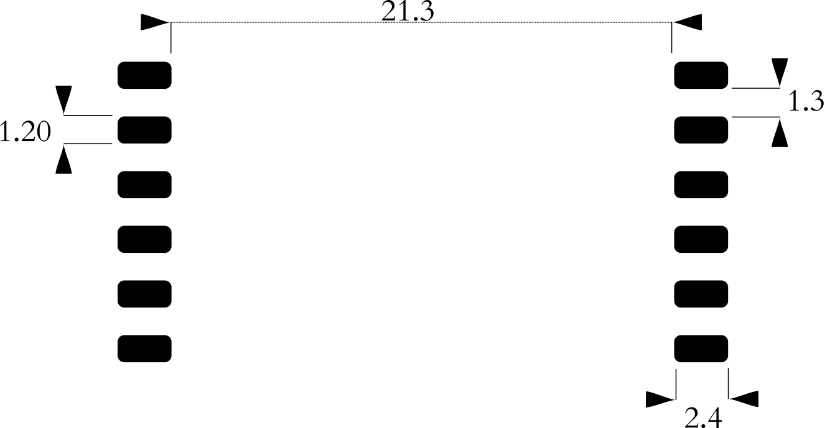

It is recommended that the stencil be 8 mil in thickness to ensure enough solder paste can flow into the castellations.

The module is assembled with [Chip Quik SMD291SNL50T3](https://www.chipquik.com/datasheets/SMD291SNL50T3.pdf) (Sn96.5/Ag3.0/Cu0.5) solder paste, a lead-free paste with a 249-degree Celsius peak reflow temperature. Reflowing the module multiple times can cause malfunction, to avoid the issue, if it is possible, use a lower melting-point temperature solder paste.

## Operating Conditions

**Temperature**:

* **Absolute**:
  + **Maximum**: 85 C
  + **Minimum**: -40 C
* **Recommended**:
  + **Maximum**: 50 C
  + **Minimum**: 10 C

When approaching the absolute temperature ratings, it should be noted that the module’s temperature will begin to affect measurements, the extent of which will need to be characterized to the specific environment the module will be deployed in.

Voltage:

* **Absolute Maximum**: 5.5 volts
* **Absolute Minimum**: 1.8 volts (3.3 volts is required for proper operation)

# 

# Electrical Specification

## Power Supply

The module requires 3.3 volts for proper operation. It can be supplied with less and still communicate through the various peripheral interfaces, but this will not allow the analog circuitry to operate correctly. Voltage should not exceed 5.5 volts.

There is no reverse polarity protection on the module.

### Power Isolation

Due to the nature of electrochemical sensors, galvanic isolation between the probe from other parts of the circuit is needed to eliminate or reduce interference from external sources. The simplest way to achieve this is to use an isolated power supply and isolated peripheral coupler device.

### Power Consumption

All modules are designed to be low-power. Power usage has been characterized at two points, idle and active sensor measurement.

* Active current use is typically 0.25 mA

# 

# I²C Interface

The module provides an I²C interface.

The module supports speeds of 10kHz, 100 kHz, 400 kHz, and 1 MHz at 3.3 volts.

The I²C interface uses the following pins:

* **Pin 9 SCL**: serial clock
* **Pin 10 SDA**: data

### Additional Circuitry

The module has no pullup resistors on the I²C bus. For reliable communication, appropriate resistors must be chosen for the SDA and SCL lines.

### I²C Address

The default address is 0x0A by default. It can be changed through firmware.

### I²C Write

Writing is done by sending a start condition followed by the module’s address with the write bit set. The master device then sends data 8 bytes at a time. The first byte received is considered to be the register address. Successive writes will automatically increment the register address by one byte. Transmission is finished with a stop condition.

### I²C Read

Reading is done by sending a start condition followed by the module’s address with the read bit set. The master sets the register to read from and then requests data. The device then sends the appropriate number of bytes as determined by the register being read.

# 

# Design Incorporation

Adding the module is a straightforward process.

## Power

A suitable power supply must be supplied. Ideal solutions will provide an isolated, low-ripple, low-EMI, 3.3-volt supply.

## Ground

The module operates at the same ground potential as what **Pin 11**: Ground is connected to, so a low-impedance connection is needed.

## Probe Connection

An EC probe that is compatible with the module consists of two wires. This is most commonly provided with a BNC, SMA, or U.FL connector.

## Considerations

* **Pin 1**: Probe 1 input and **Pin 2**: Probe 2 input pins should be on their own island plane pour or otherwise isolated by no pour surrounding them.
* **Pin 1**: Probe 1 input and **Pin 2**: Probe 2 input pins should be as short as possible.
* If the PCB is 4 or more layers, consider routing **Pin 1 and Pin 2** traces on internal layers to protect the probe input signal from interference.
* Avoid routing other traces near **Pin 1** and **Pin 2**.
* Flux residue on **Pin 1, Pin 2,** and at the probe connection must be removed. This is ideally accomplished by using a “no-clean” solder paste and/or through mechanical means such as an ultrasonic bath.

## Unused Pins

Any unused pins should be left unconnected to any other trace or net.

# 

# EC Measurements

## EC Theory

Conductivity is the ability of water to conduct electricity, which is determined by the concentration of ions present. In the ocean or hydroponics, the ions of interest are typically chloride, but they can come from many other sources. The higher the ion concentration, the higher the conductivity.

## Units

Conductivity has been a useful measure of water for a long time. During this time, there have been many techniques and advancements in the measurement. Due to this history and varied methods, there are several units of measure.

### Siemens

The modern SI unit of conductivity is Siemens per meter, notated as S/m. Like any SI unit, it can be specified in larger or smaller units like micro- or milli- Siemens. Typically, micro or millisiemens are used.

There is a length aspect of the measurement. It is due to the fact that resistance is dependent on the length of a conductor, so a set length needs to be specified for results to be reproducible and standardized. In practical use, the length portion is determined by the probe geometry and is nearly always in centimeters.

Because conductivity is heavily influenced by temperature, it is an important element of the measurement. There are no standards for notating measurements, but oftentimes, if no temperature is associated with a conductivity measurement, 25 C can be assumed. When conductivity measurements are given with a specific temperature, it is referred to as specific conductance.

### TDS

TDS stands for total dissolved solids and is typically notated in parts-per-thousand, or part-per-million. TDS is determined by taking a specific measure of water, allowing it to dry, and weighing the remnants. TDS can be roughly converted into Siemens through various conversion factors. The factor can vary based on the main constituent of the water but can also vary based on where in the world it is taken (for example, in the US, 500 is most often used, regardless of what is being measured). Due to the inherent uncertainty of this conversion factor and that it is typically derived from a Siemen unit-of-measure anyway, this unit of measurement should be avoided.

### Mho

Mho is equivalent to Siemens. It is Ohm spelled backward since ohm measures resistance, and conductivity is the reciprocal of resistance. This unit is redundant as it is essentially the same thing as a Siemen but with a different name. It is somewhat commonly used despite not being in the International System of Units.

## Considerations

Measuring EC is relatively straightforward, but it is important to keep some things in mind.

### Response Time

EC probes are electrochemical devices. They don’t react instantly as a purely electrical device would. The probes need some time to reach an equilibrium. This is especially true when calibrating since it moves the probe through a very wide range of values.

### Interference

An EC probe operates in the millivolt range. The signal is then carried through the wire of the probe, where it is measured. This leaves a lot of opportunities for the signal to experience interference. Other probes, faulty electrical equipment, poor grounding, strong sources of EMI, and any number of other sources may contribute to a faulty reading. Isolation can help with some sources, but not all of them.

### Temperature

The temperature of a solution strongly affects the EC. For example, a solution at 25°C may measure 1.413 mS/cm, and the same solution at 20°C may be 1.29 mS/cm. The change in conductivity is affected by the nature of the ions in the solution. Generally, conductivity increases with an increase in temperature. The change is typically characterized by a percentage change in conductivity per degree change in temperature. With this characterization made, a temperature compensation factor can be formulated.

### Temperature Compensation

Since the same solution can measure over a relatively wide range as the temperature changes, it is difficult to compare the measured value to some other value. As an example, suppose a tank of water is needed to maintain an EC value of 1.0 mS/cm. The tank is exposed to the weather, and the temperature increases and decreases throughout the day. The conductivity will also increase and decrease throughout the day with the temperature. To have a reliable method of comparing the current conductivity to the setpoint, the temperature must be compensated for. This is done by choosing a particular temperature to adjust all readings to. This is typically 25 °C. The compensation would have the effect of changing the conductivity measurement taken at the current temperature and adjusting it so that it would represent what it would have been at 25 °C.

Several points of data are needed for this calculation:

* The solution’s current temperature
* The temperature to adjust to
* The temperature coefficient

The solution’s temperature and the temperature to adjust to have been discussed above. The temperature coefficient is the percent change per degree. The coefficient is different for every solution and is determined by its composition. Sometimes the solution being measured is known, and a temperature calibration characterization can be done, oftentimes the exact composition isn’t known, and an estimation is required. For freshwater, the most typical coefficient is 0.019. For seawater, it is around 0.021, and for pure water, 0.052.

Because the coefficients are estimations, they introduce a small amount of uncertainty. It is important to note that a chart of the measurement won't be perfectly flat, indicating that all the temperature effects have been fully eliminated. It will still move with the temperature, but not nearly as much.

The module uses the following formula to calculate the compensated conductivity measurement.

where EC is the uncompensated measurement, is the coefficient, and T = is the solution’s temperature.

## Calibration

Calibration is needed to obtain accurate measurements. Each module is very slightly different from the next, and each EC probe will have a slightly different response from another. For these reasons, neither modules nor probes are interchangeable without both being calibrated together.

### Procedure

Following good lab procedures is important to obtain the best results while also staying safe. Aside from safety considerations, the following is a step-by-step process calibration:

1. Collect all the materials needed: calibration solutions, clean water, towels, equipment, etc.
2. Rinse the probe in clean water. RO/DI, deionized, or distilled water is best. Tap off excess water drops trapped in the probe tip and blot dry.
3. Pour some calibration solution into a separate container. It should be enough to fully submerge the tip of the probe, then submerge the probe.
4. Continually take measurements, watching for the measurement to stabilize. Eventually, only the third decimal place will vary from measurement to measurement. When the reading stabilizes, have the module calibrate itself for the solution.
5. Safely dispose of the calibration solution and clean or dispose of the container.
6. Repeat steps 2 through 5 for each calibration point.

When calibrating, use the labeled value, not the temperature-adjusted value.

### Calibration Types

The module supports three methods of calibration.

### Single Point

Single point is the least useful and should generally not be used. It uses one point and is only accurate for a small range around that one point.

### Dual Point

Dual point calibration is used for measuring between two set points. To determine the points, decide on the lowest point to be measured and the highest point. After calibrating between those two points, the measurements can be expected to be very accurate between them. Outside the two points, the measurements will get increasingly inaccurate the further from the calibration points the measurement gets.

### Triple Point

The module’s response is not perfectly linear throughout the entire range of possible measurements. To get the most accurate measurements over the widest range, triple point calibration can be used. It is similar to dual point, but uses three points rather than two. A good starting point for a very large range would be a low of 0.1 mS, a mid of 1.0 mS, and a high point of 10.0 mS.

### Precedence

The module will select the best calibration type from the available calibrated points as follows:

1. If there are high, mid, and low points, it will use triple-point calibration to calculate the result.
2. If there are high and low points, it will use dual-point calibration to calculate the result.
3. If there is a single-point calibration data, it will use single-point calibration to calculate the results.
4. No calibration points used will result in an uncalibrated measurement.

### Probe Selection

Conductivity probes come in several different cell-constants (K). A cell-constant allows current to flow more or less easily, thereby allowing different ranges of conductivity to be measured. To measure high conductivity, a probe with a cell-constant of K10 is chosen. The electrodes of a K10 probe are small and spaced further apart than a K1 probe which is typically used for mid-range measurements.

The choice of which cell-constant to use is heavily based on the hardware reading the probe. For Mod-EC use, the following table should be used for the selection:

| **Measurement Range** | **Cell-constant** |
| --- | --- |
| 0.05 to 5 uS | 0.01 |
| 2 to 100 uS | 0.1 |
| 0.1 to 20 mS | 1 |
| 10 mS to 1 S | 10 |

# I²C Interface

The module’s I²C interface operates similarly to many common I²C sensors. There are several registers which hold values such as calibration, EC and temperature, or version information. The registers are used to pass information both to the module and the controlling device. Tasks are performed by writing a specified value to a certain register.

## Registers

All registers are either 1 byte or a float which is 4 bytes formatted as an IEEE 754 32 bit floating point, little-endian. The firmware will allow the registers to be read and written.

### Register Listing

| **Register Name** | **Value** | **Type** | **Description** |
| --- | --- | --- | --- |
| HW_VERSION_REGISTER | 0 | byte | Hardware version |
| FW_VERSION_REGISTER | 1 | byte | Firmware version |
| TASK_REGISTER | 2 | byte | Task register |
| STATUS_REGISTER | 3 | byte | Status of measurement |
| MS_REGISTER | 4 | float | Measured conductivity in mS |
| PSU_REGISTER | 8 | float | Practical Salinity Units |
| TEMP_C_REGISTER | 8 | float | Measured temperature in Celsius |
| CALIBRATE_REFLOW_REGISTER | 16 | float | Reference-low calibration data |
| CALIBRATE_READLOW_REGISTER | 20 | float | Read-low calibration data |
| CALIBRATE_REFMID_REGISTER | 24 | float | Reference-mid calibration data |
| CALIBRATE_READMID_REGISTER | 28 | float | Read-mid calibration data |
| CALIBRATE_REFHIGH_REGISTER | 32 | float | Reference-high calibration data |
| CALIBRATE_READHIGH_REGISTER | 36 | float | Read-high calibration data |
| CALIBRATE_SINGLE_OFFSET_REGISTER | 40 | float | Single-offset calibration data |
| COEFFICIENT_REGISTER | 44 | float | Temperature coefficient |
| CONSTANT_REGISTER | 48 | float | Temperature constant |
| K_REGISTER | 51 | float | Probe cell-constant |
| KPA_REGISTER | 56 | float | Pressure in kilopascals |

All the CALIBRATE_* registers are automatically saved when written.

## Tasks

When a particular value is written to TASK_REGISTER, it starts an operation within the module.

For example, an EC measurement is performed when MEASURE_EC_TASK is written to the TASK_REGISTER register. To read the resulting measurement, you would read the EC_REGISTER register**.**

### Task Listing

| **Task Name** | **Duration** | **Value** | **Description** |
| --- | --- | --- | --- |
| MEASURE_EC_TASK | 750 ms | 80 | EC measurement |
| CALIBRATE_LOW_TASK | 750 ms | 20 | Low-point calibration |
| CALIBRATE_MID_TASK | 750 ms | 10 | Mid-point calibration |
| CALIBRATE_HIGH_TASK | 750 ms | 8 | High-point calibration |
| CALIBRATE_SINGLE_TASK | 750 ms | 4 | Single-point calibration |
| I2C_TASK | 1 ms | 2 | I²C address change |

### 

### MEASURE_EC_TASK - EC Measurement

Starts an EC measurement. It takes 750 ms to complete a measurement.

#### Request Parameters

| **Parameter** | **Description** |
| --- | --- |
| **TEMP_C** | The solution-under-test’s temperature in Celsius. If the temperature is unknown, pass 25.0 |
| **TEMP_COEF** | The temperature coefficient is used for temperature compensation. Typically 0.019 for freshwater and 0.021 for seawater. |
| **TEMP_CONSTANT** | The temperature constant used for temperature compensation. |
| **CELL_CONSTANT** | The cell-constant, or K value of the attached EC probe. Typically 0.1, 1.0, or 10.0. |
| **PRESSURE_KPA** | The pressure in kilopascals at which the measurement is being made. Used in salinity and density calculations. If salinity or density measurements aren’t needed, 0 can be used. |

#### Response Parameters

| **Parameter** | **Description** |
| --- | --- |
| **EC_MS** | The solution-under-test’s conductivity in mS/cm². Formatted as a floating point number with up to 3 decimal places. |
| **PSU** | Practical Salinity Unit. Calculated according to PSS-78. 0 returned if the calculated salinity is less than 2 or greater than 40. |
| **DENSITY** | Density in g/cm3. Calculated according to EOS-80. 0 returned if salinity is 0. |
| **STATUS** | An error code for the measurement. Can be one of the following:  **0**: no error  **1**: no probe detected or outside range  **2**: system error  **3**: config error |

### 

### CALIBRATE_LOW_TASK - Low Point Calibration

Performs a low-point calibration. It takes 750 ms to complete a measurement.

#### Required Registers

| Register | Description |
| --- | --- |
| EC_REGISTER | The calibration solution’s conductivity in mS/cm². |
| TEMP_C_REGISTER | The calibration solution’s temperature in Celsius. If the temperature is unknown, pass 25.0 |

#### Response Registers

| Register | Description |
| --- | --- |
| CALIBRATE_REFLOW_REGISTER | Reference-low calibration data |
| CALIBRATE_READLOW_REGISTER | Read-low calibration data |
| STATUS_REGISTER | An error code for the measurement. Can be one of the following:  **0**: no error  **1**: no probe detected or outside range  **2**: system error  **3**: config error |

### 

### CALIBRATE_MID_TASK - Middle Point Calibration

Performs a mid-point calibration. It takes 750 ms to complete a measurement.

#### Required Registers

| Register | Description |
| --- | --- |
| EC_REGISTER | The calibration solution’s conductivity in mS/cm². |
| TEMP_C_REGISTER | The calibration solution’s temperature in Celsius. If the temperature is unknown, pass 25.0 |

#### Response Registers

| Register | Description |
| --- | --- |
| CALIBRATE_REFMID_REGISTER | Reference-mid calibration data |
| CALIBRATE_READMID_REGISTER | Read-mid calibration data |
| STATUS_REGISTER | An error code for the measurement. Can be one of the following:  **0**: no error  **1**: no probe detected or outside range  **2**: system error  **3**: config error |

### 

### CALIBRATE_HIGH_TASK - Middle Point Calibration

Performs a high-point calibration. It takes 750 ms to complete a measurement.

#### Required Registers

| Register | Description |
| --- | --- |
| EC_REGISTER | The calibration solution’s conductivity in mS/cm². |
| TEMP_C_REGISTER | The calibration solution’s temperature in Celsius. If the temperature is unknown, pass 25.0 |

#### Response Registers

| Register | Description |
| --- | --- |
| CALIBRATE_REFHIGH_REGISTER | Reference-high calibration data |
| CALIBRATE_READHIGH_REGISTER | Read-high calibration data |
| STATUS_REGISTER | An error code for the measurement. Can be one of the following:  **0**: no error  **1**: no probe detected or outside range  **2**: system error  **3**: config error |

### 

### CALIBRATE_SINGLE_TASK - Single Point Calibration

Performs a single-point calibration. It takes 750 ms to complete a measurement.

#### Required Registers

| Register | Description |
| --- | --- |
| EC_REGISTER | The calibration solution’s conductivity in mS/cm². |
| TEMP_C_REGISTER | The calibration solution’s temperature is Celsius. If the temperature is unknown, pass 25.0 |

#### Response Registers

| Register | Description |
| --- | --- |
| CALIBRATE_SINGLE_OFFSET_REGISTER | Single-offset calibration data |
| STATUS_REGISTER | An error code for the measurement. Can be one of the following:  **0**: no error  **1**: no probe detected or outside range  **2**: system error  **3**: config error |

### 

### I2C_TASK - I²C address change

Changes the device’s I²C address.

#### Required Registers

| Register | Description |
| --- | --- |
| EC_REGISTER | Used to temporarily store the new I²C address. |

#### Response Registers

| Register | Description |
| --- | --- |
| None |  |

| **Microfire LLC**  **ㅡ**  **Justin Decker, CEO**  61190 Deronda Ave  Whitewater, CA 92282  [https://microfire.co](https://ufire.co)  justin@microfire.co | horizontal line 17 May 2021 **Certificate of Compliance**RoHS 3 Directive 2015/863/EU Microfire LLC certifies to the best of its knowledge and belief that the products listed herein conform with RoHS 3 Directive 2015/863/EU and its subsequent amendments. This declaration further certifies that Microfire LLC has obtained RoHS Certificates of Compliance from each applicable supplier of materials and parts used in the assembly and manufacture of these goods.  **Modules**  Mod-EC  Mod-pH  Mod-ORP  Mod-ISO  Mod-NTC  **Development Boards**  Isolated Dev Board  Mod-EVAL  Mod-EVAL_ISO  **Probes**  Industrial pH Probe  Industrial EC Probe  Industrial ORP Probe  Lab pH Probe  Lab EC Probe  Lab ORP Probe **Justin Decker** |
| --- | --- |