Title of Manuscript
(short and clear, implies research results, center, bold, 16 pt, max 15 words)

First Author*, Second Author**, Third Author* (12 pt, bold)
* Department of ………, ……………………..University (12 pt)
** Department of ……, ………………………University (`12 pt)

Article Info |  | ABSTRACT (10 pt)
Keyword (12 pt):  First keyword  Second keyword  Third keyword  Fourth keyword  Fifth keyword |  | A well-prepared abstract enables the reader to identify the basic content of a document quickly and accurately, to determine its relevance to their interests, and thus to decide whether to read the document in its entirety. The Abstract should be informative and completely self-explanatory, provide a clear statement of the problem, the proposed approach or solution, and point out major findings and conclusions. The Abstract should be 150 to 250 words in length. The abstract should be written in the past tense. No literature should be cited. The keyword list provides the opportunity to add keywords, used by the indexing and abstracting services, in addition to those already present in the title. Judicious use of keywords may increase the ease with which interested parties can locate our article. Keywords should be written in the form of a “word” or a “phrase”. The Abstract is presented in two languages, English and Indonesian.
 |  | ABSTRAK (10 pt)
Corresponding Author:  Email: …………………….. |  | Abstrak yang disiapkan dengan baik memungkinkan pembaca untuk mengidentifikasi konten dasar suatu dokumen dengan cepat dan akurat, untuk menentukan relevansinya dengan minat mereka, dan dengan demikian memutuskan apakah akan membaca dokumen secara keseluruhan. Abstrak harus informatif dan sepenuhnya jelas, memberikan pernyataan yang jelas tentang masalah, pendekatan atau solusi yang diusulkan, dan menunjukkan temuan dan kesimpulan utama. Panjang abstrak harus 150 hingga 250 kata. Abstrak harus ditulis dalam bentuk lampau. Tidak ada literatur yang harus dikutip. Daftar kata kunci memberikan peluang untuk menambahkan kata kunci, yang digunakan oleh layanan pengindeksan dan abstrak, selain yang sudah ada dalam judul. Penggunaan kata kunci yang bijaksana dapat meningkatkan kemudahan pihak yang berkepentingan dapat menemukan artikel kami. Kata kunci harus ditulis dalam bentuk "kata" atau "frasa". Abstrak disajikan dalam dua bahasa, Inggris dan Indonesia.

INTRODUCTION (12 pt)
The main text format consists of a flat left-right columns on A4 paper (quarto). The margin text from the left and top are 2.5cm, right and bottom are 2 cm. The manuscript is written in Microsoft Word, single space, Time New Roman 12pt and between 15 to 25 pages.

The title of the article should contain fewest possible words that accurately describe the content of the paper. Indexing and abstracting services depend on the accuracy of the title, extracting from it keywords useful in cross-referencing and computer searching. An improperly titled paper may never reach the audience for which it was intended, so be specific.

The introduction should provide a clear background, a clear statement of the problem, the relevant literature on the subject, the proposed approach or solution, and the new innovative value of the research. Organization and citation of the bibliography should be made in accordance to The Oxford University Standard for the Citation of Legal Authorities (OSCOLA) style. The terms in foreign languages should be written italic (italic). The text should be divided into sections, each with a separate heading and numbered consecutively. The section/subsection headings should be typed on a separate line, e.g., Introduction. Authors are suggested to present their articles in the section structure: Introduction - Methods - Results and Discussion – Conclusion - References.

The introduction should provide the foreground of the issue that is discussed in the paper. This section should provide an elaboration on the background or situation that results in the urgency to write the paper, as well as a concise preliminary literature review to highlight the existing solution or research that will be contrasted or developed further through the findings and results of the author in the current research. As such, this section should also address clearly the problem that has not been answered in any other work, or the limitation of the previous researches in addition to the objectives that the research aim to achieve. Novelty and state of the art nature of the manuscript should be discussed in this section.

METHODS (12 pt)
This section should elaborate the approach, type, and data sources used in finding the answers to the problems presented in the previous section. For researches that utilize empirical method, the data gathering techniques as well as the method of data analysis should also be elaborated in detail to explain to other researchers about how the research results came to be. This section should as much as possible give an idea to the reader about the methods employed. The description of the course of research should be supported references, so the explanation can be accepted scientifically.

Tables and Figures are presented center, as shown below and cited in the manuscript.

Table 1. The Performance of ...
Variable | Speed (rpm) | Power (kW)
x | 10 | 8.6
y | 15 | 12.4
z | 20 | 15.3

Figure 1. Effects of selecting different switching under dynamic condition

RESULTS AND DISCUSSION (12 pt)
The result and discussion section serves as the focal point and the most important section of the manuscript. Analysis and results of the research should be presented in a clear, direct and concise manner, whereas it should highlight the scientific findings rather than expanding in great detail. Attention should also be paid to the differences between the author’s results or findings in contrast with other researches or publications that have been published by other authors. The novelty nature and state of the art of the manuscript that have been discussed in the introduction may be further elaborated.

- Sub-heading 1
The result and discussion section should be organized further into several sub-headings in order to ensure clearer discussion flow. Excessive citations and discussion of published literatures should be avoided.

1.1. Subsection of Sub-heading of the Discussion
Where necessary, the sub-heading may be further divided into several subsections. Note that the format of the result and discussion section should remain as narrative paragraphs and cannot be in the form of numbered lists.

1.2. Subsection of Sub-heading of the Discussion
Where necessary, the sub-heading may be further divided into several subsections. Note that the format of the result and discussion section should remain as narrative paragraphs and cannot be in the form of numbered lists.

- Sub-heading 2
The result and discussion section should be written in narrative paragraphs, and where applicable, supported by relevant tables, graphs, or charts to present the data analysis. All tables, graphs, and charts should be presented horizontally, and should ensure legibility and readability of all tables, graphs and charts.

Tables and Figures are presented center, as shown below and cited in the manuscript.

Table 1: Extraordinary General Meetings of Shareholders of Publicly Listed Manufacturing Companies in Tangerang Regency Area in 2020

No. | Company Name | Number of EGMS
1. | PT. Adiprakarsa Jaya, Tbk. (APJA) | 4
2. | PT. Diamanta Berlian Maju, Tbk. (DIBM) | 1
3. | PT. Honi Madu Nusantara, Tbk. (HONI) | 6
4. | PT. Baja Baratanata Steel, Tbk. (BABA) | 9
Source: Indonesian Stock Exchange (2020)

Graph 1: Extraordinary General Meetings of Shareholders of Publicly Listed Manufacturing Companies in Tangerang Regency Area in 2020
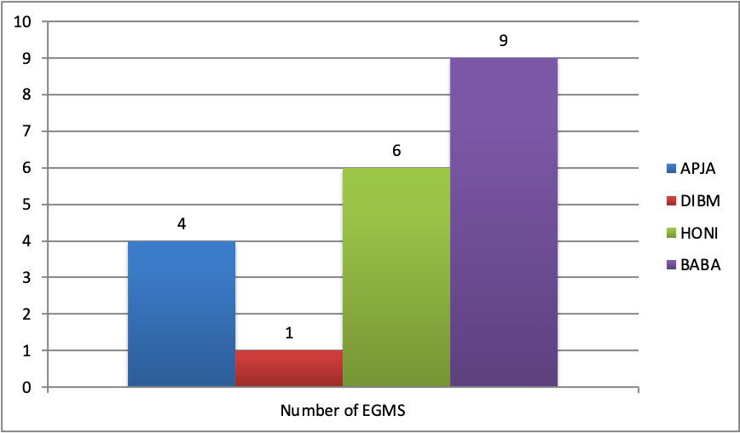
Source: Indonesian Stock Exchange (2020)

CONCLUSION (10 PT)
Provide a statement that what is expected, as stated in the "Introduction" chapter can ultimately result in "Results and Discussion" chapter, so there. Moreover, it can also be added the prospect of the development of research results and application prospects of further studies into the next (based on result and discussion).

ACKNOWLEDGEMENTS (10 pt)
The acknowledgments section seeks to provide space for the authors to give thanks and convey gratitude for the people or parties that have assisted in the course of duration of writing the article. This may include acknowledging supervisor or research group’s contributions, funding bodies, or collaboration with industries or external parties that significantly support the paper.

REFERENCES (12 pt)

The main references are international journals and proceedings. All references should be to the most pertinent and up-to-date sources. Please use a consistent format for references – see examples below (12 pt). CTLR use OSCOLA style as reference format writing. We also provide you a reference quick guide available https://www.law.ox.ac.uk/sites/files/oxlaw/oscola_4th_edn_hart_2012quickreferenceguide.pdf. References should be published within the last 10 years.
The style to be used is as follows:

OSCOLA Quick References Guide

Primary Sources
Do not use full stops in abbreviations. Separate citations with a semi-colon.

Cases
Give the party names, followed by the neutral citation, followed by the Law Reports citation (eg AC, Ch, QB). If there is no neutral citation, give the Law Reports citation followed by the court in brackets. If the case is not reported in the Law Reports, cite the All ER or the WLR, or failing that a specialist report.
Corr v IBC Vehicles Ltd [2008] UKHL 13, [2008]
1 AC 884
R (Roberts) v Parole Board [2004] EWCA Civ 1031, [2005] QB 410
Page v Smith [1996] AC 155 (HL)
When pinpointing, give paragraph numbers in square brackets at the end of the citation. If the judgment has no paragraph numbers, provide the page number pinpoint after the court.
Callery v Gray [2001] EWCA Civ 1117, [2001] 1
WLR 2112 [42], [45]
Bunt v Tilley [2006] EWHC 407 (QB), [2006] 3
All ER 336 [1]–[37]
R v Leeds County Court, ex p Morris [1990] QB 523 (QB) 530–31
If citing a particular judge:
Arscott v The Coal Authority [2004] EWCA Civ 892, [2005] Env LR 6 [27] (Laws LJ)

Statutes and statutory instruments
Act of Supremacy 1558
Human Rights Act 1998, s 15(1)(b)
Penalties for Disorderly Behaviour (Amendment of Minimum Age) Order 2004, SI 2004/3166

EU legislation and cases
Consolidated Version of the Treaty on European Union [2008] OJ C115/13
Council Regulation (EC) 139/2004 on the control of concentrations between undertakings (EC Merger Regulation) [2004] OJ L24/1, art 5
Case C–176/03 Commission v Council [2005] ECR I–7879, paras 47–48

Secondary Sources

Books
Give the author’s name in the same form as in the publication, except in bibliographies, where you should give only the surname followed by the initial(s). Give relevant information about editions, translators and so forth before the publisher, and give page numbers at the end of the citation, after the brackets.
Thomas Hobbes, Leviathan (first published 1651, Penguin 1985) 268
Gareth Jones, Goff and Jones: The Law of Restitution
(1st supp, 7th edn, Sweet & Maxwell 2009) K Zweigert and H Kötz, An Introduction to
Comparative Law (Tony Weir tr, 3rd edn, OUP
1998)

Contributions to edited books
Francis Rose, ‘The Evolution of the Species’ in Andrew Burrows and Alan Rodger (eds),
Mapping the Law: Essays in Memory of Peter Birks
(OUP 2006)

Encyclopedias
Halsbury’s Laws (5th edn, 2010) vol 57, para 53

Journal articles
Paul Craig, ‘Theory, “Pure Theory” and Values in Public Law’ [2005] PL 440
When pinpointing, put a comma between the first page of the article and the page pinpoint.
JAG Griffith, ‘The Common Law and the Political Constitution’ (2001) 117 LQR 42, 64

Online journals
Graham Greenleaf, ‘The Global Development of Free Access to Legal Information’ (2010) 1(1) EJLT < http://ejlt.org//article/view/17 > accessed 27 July 2010

Command papers and Law Commission reports
Department for International Development, Eliminating World Poverty: Building our Common Future (White Paper, Cm 7656, 2009) ch 5
Law Commission, Reforming Bribery (Law Com No 313, 2008) paras 3.12–3.17

Websites and blogs
Sarah Cole, ‘Virtual Friend Fires Employee’ (Naked Law, 1 May 2009) <www.nakedlaw. com/2009/05/index.html> accessed 19 November 2009

Newspaper articles
Jane Croft, ‘Supreme Court Warns on Quality’
Financial Times (London, 1 July 2010) 3

Submission Preparation Checklist
As part of the submission process, authors are required to check off their submission's compliance with all of the following items, and submissions may be returned to authors that do not adhere to these guidelines.
Privacy Statement
The names and email addresses entered in this journal site will be used exclusively for the stated purposes of this journal and will not be made available for any other purpose or to any other party.

