Directions for compost collection

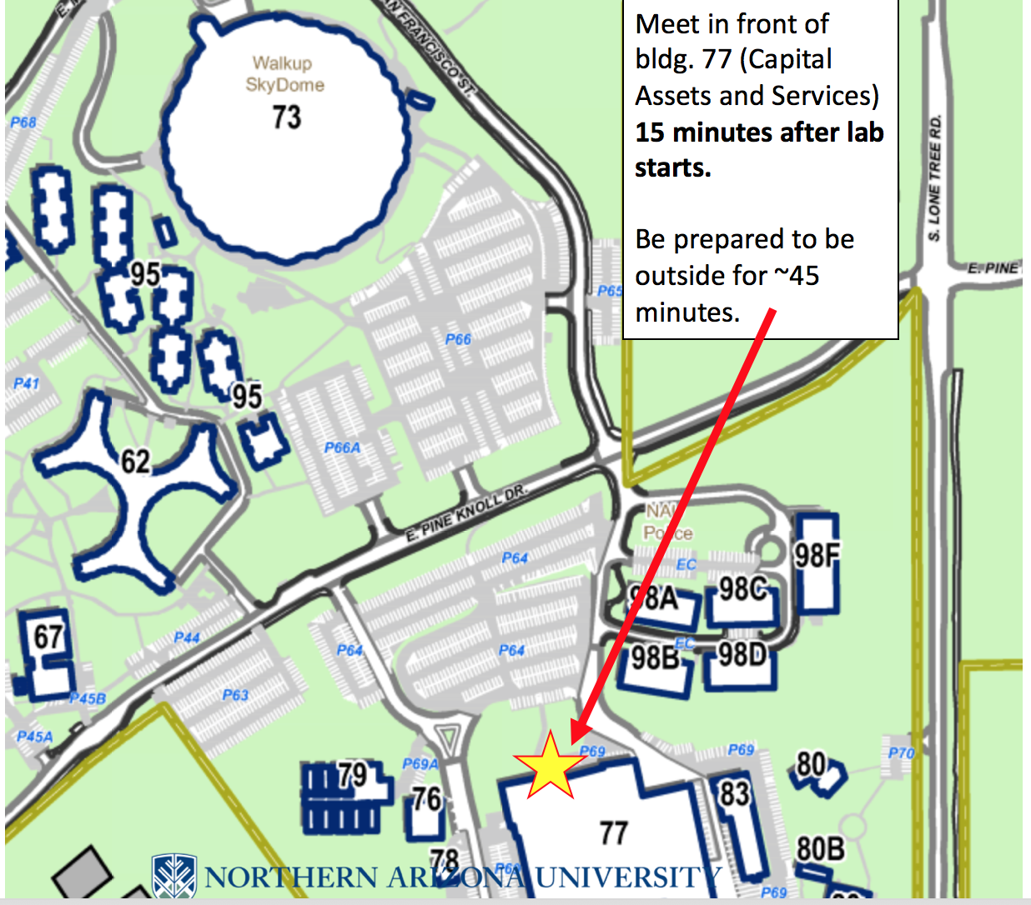

If you are running late, meet at the compost pile:
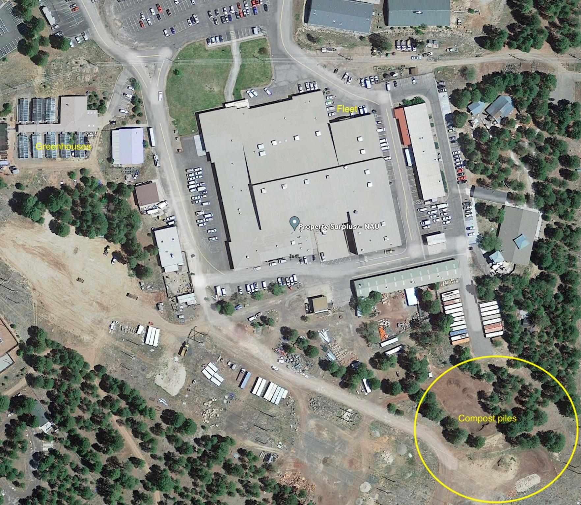

You go around fleet (you can park behind it in a little temporary parking area for property surplus) and walk down the hill to the compost piles

Take the compost for the lab from a pile that still has active decomposition happening (should be warm inside, not too big and not too small).

