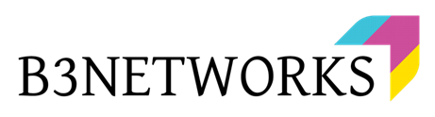

B3Networks
Product Specification for Developer Hub

Table of Contents
Product Summary 4
Product Features 4
CPaaS License Requirements 7
Functional Specs 7
● CPaaS Developer Programmable Flow 8
● CPaaS Robocall/SMS Campaign 8
Workflow 9
● Using Open API - Voice API 9
● Using Programmable Flow 9
Use Cases in Various Industries 9
E-Commerce 9
Insurance 10
Banking 10
Taxi Booking 10

Document control versioning

Document History
Date | Version | Applicable BMOs | Author | Comments
8 Nov 2022 | Version 1.0 | All | Wulan | Document creation
11 Nov 2022 | Version 1.1 | All | Hallie | Amendment
16 Nov 2022 | Version 1.2 | All | Kevin | Certification

Product Summary
Developer Hub provides a robust suite of tools for users to create a project with multiple advanced Programmable Flows to automatically manage calls, SMS, and other services. Technically, Programmable Flow is a flexible workflow that lets customers request a flow that fits the company's needs and works with the company's system without having to be hard coded. Integration could be done through a programmable flow, such as integration with the CRM’s company itself or other software, depending on what the company needs.
Even though the desired call flow is complicated, programmable flow could make the call flow easier. Developer Hub is much needed for the company because most of its demands are different and varied, and creating a flexible Developer Hub helps a lot to customize the creation of workflows based on the company's needs.

Product Features
Features |  |  | Description
Project | Voice |  | Voice capability for Project
Project | Message |  | SMS capability for Project
Project | Workflow |  | Workflow capability for Project
Overview |  |  | Display all the information related to the created Project
API Keys |  |  | Allow the developers to create, view, and reset API Keys to call B3Networks Open API
IP Whitelist |  |  | Allow specific IP addresses to call the Open APIs
Webhook |  |  | Allow the developers to receive HTTPS notification on certain occurrences
Form |  |  | Create note templates that can be used multiple times within the flows
Log |  |  | Display all the execution history of the Flow
Flow | Create |  | Create a new Flow
Flow | Configure |  | Set up the created Flow
Flow | Rename |  | Rename the created Flow
Flow | Delete |  | Delete the created Flow
Flow | Deploy |  | Deploy the created Flow
Flow | Edit |  | Edit the configuration of the deployed Flow
Flow | Export |  | Export flows to download and save from a project
Flow | Import |  | Import a saved flow into your project
Flow | Test |  | Test the created Flow
Events | API - General Purpose |  | Receive API data from outside to execute the flow with the predefined information
Events | API - Incoming Call |  | Receive an incoming call request from Open API and start the Flow
Events | API - Outgoing Call |  | Receive an outgoing call request from Open API and start the Flow
Events | Automated Cron Trigger |  | Trigger the flow automatically with a Cron expression
Events | Call Detail Updated |  | Trigger the flow when Call details from other communication applications within the organization are available
Events | Call Ended |  | Trigger the flow when any calls made within the account are ended
Events | Incoming Call to Phone Numbers |  | Trigger the flow when there are incoming calls to the assigned numbers.
Events | Missed Call |  | Trigger the flow when there is any missed call
Events | Robocall Campaign Outgoing Call Answered |  | Trigger the flow when the Callers answer the Robocall Campaign
Events | SMS Campaign Started |  | Trigger the flow when the SMS Campaign started
Events | Trigger by other flow |  | Subroutine that works with the Main Flows
Actions | Split Flow |  | Determine which branch will be executed based on the predefined conditions
Actions | Transform | Generate Random UUID | Create random UUID
Actions | Transform | Get Current Timestamp | Get the current date time
Actions | Transform | Format Datetime | Define how date and time values should be formatted
Actions | Transform | Format Number to E164 | Change the number format to E164
Actions | Transform | Get Country Code | Get the country code of the numbers
Actions | Transform | Get Region Code | Get the region code of the numbers
Actions | Transform | Get Number Type | Get the type of the numbers
Actions | Transform | Spell | Spell the outputs of the previous actions
Actions | Transform | Get String Length | Calculate the length of the string of text or numbers
Actions | Transform | Check if String Matches A Regex Pattern | Check if a regular expression matches an entire string
Actions | Transform | Replace String | Replace a specified string with another specified string
Actions | Transform | Add Two Numbers | The digits are stored in reverse order, and each of their nodes contains a single digit. Add the two numbers and return the sum as a linked list.
Actions | Iterate over a List |  | Iterate items one-by-one from a list
Actions | Add a Custom Tag |  | Add a custom key-value tag to the call details
Actions | Get a Tag by Name |  | Get the value of the tag
Actions | Record Voicemail |  | Record voicemail message
Actions | Play a Message |  | Play text-to-speech or audio message
Actions | Gather Input |  | Gather the input through the DTMF signal
Actions | Make Outgoing Call |  | Make Outgoing Call to a number
Actions | Connect Call |  | Connect the call to a number
Actions | Hang up |  | Hang up the current call
Actions | Notify New Call |  | Send call notification to the Developer's Webhook Endpoint
Actions | Send SMS Message |  | Send out SMS Message
Actions | Gather SMS Input |  | Gather input via SMS message reply
Actions | Add Note |  | Add a response to a predefined form
Actions | Memory |  | Store and Share data within executions of the same flow or among different flow
Actions | Custom Action |  | Actions HTTP designed by developers

CPaaS License Requirements

SKU Name | SKU Type | Unit Of Measure
Developer | Base License | Per organization per month
Developer Concurrent Call | Add-on License | Per concurrent call per month
Number (optional) | Add-on License | Per organization per month
SMS (optional) | Add-on License | Per organization per month
SMPP (optional) | Add-on License | Per organization per month

Functional Specs
Developer Hub has several features that can manage the integration with third party systems needed to pull and transmit data.

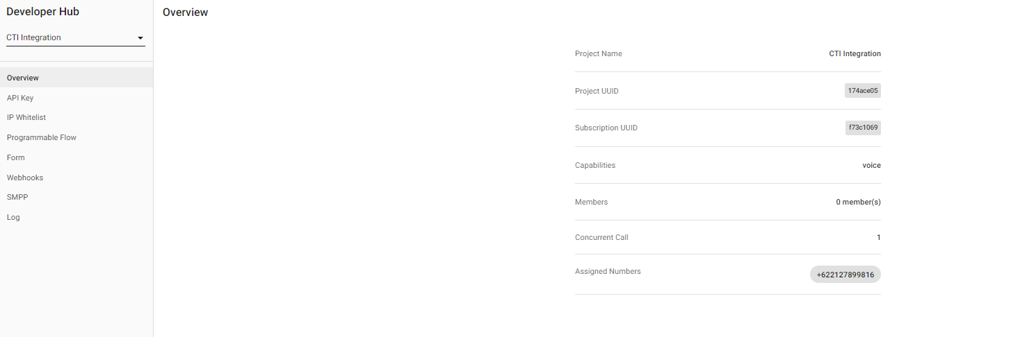

Elements

CPaaS Developer Programmable Flow
Programmable Flow creates automated workflows by combining resources and taking actions on a variety of services. You can also use these flows to connect to third-party systems that are needed to pull and send data.

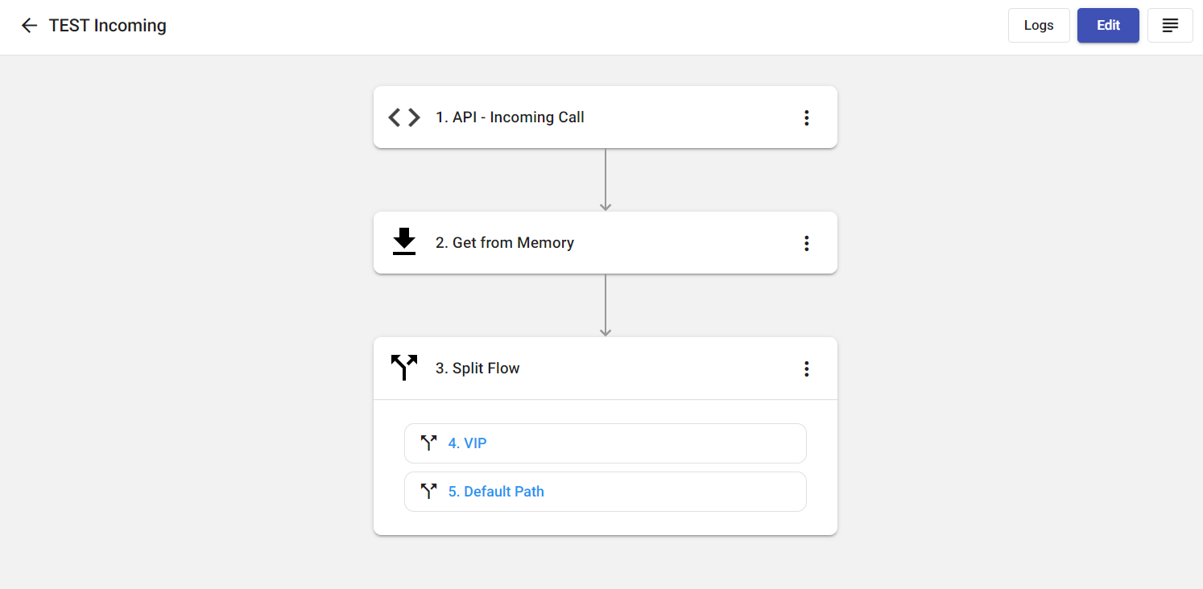

CPaaS Robocall/SMS Campaign
Developer Hub also has services for making robocalls and sending SMS campaigns. With a single click, you can make calls or send SMS to multiple destinations automatically, and then perform actions you have configured in Programmable Flow.

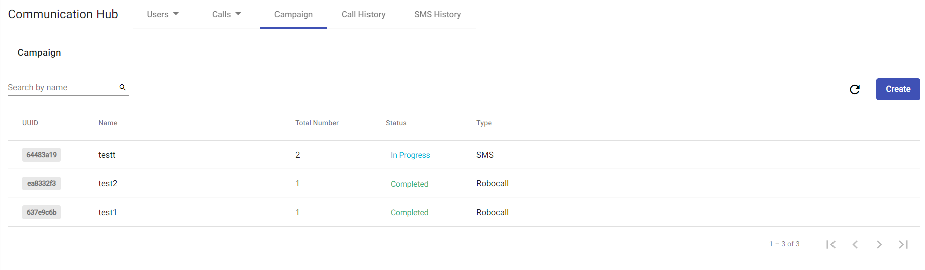

Workflow

Using Open API - Voice API

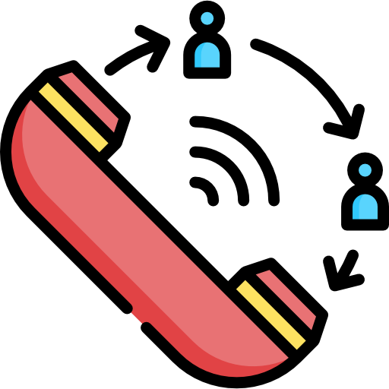

External System
CRM, HRIS, SAP, ERP, Internal Company System
Telephony System - CPaaS
Programmable Flow
Destination Number
Open API - Voice API
Make an Outgoing Call

Using Programmable Flow


Customers pick up the call
Automatically outgoing call
Customers create account
Customers input the OTP verification code
OTP verification code message

Use Cases in Various Industries

E-Commerce
E-commerce companies can send messages to customers informing them of monthly promotions and deals.

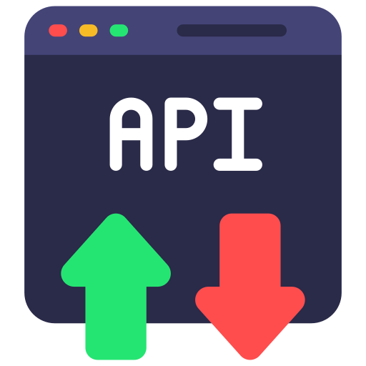

Schedule time to
send message
Send message
Get API
Customer receives message

Insurance
Insurance companies can set up call flows that send out customer surveys and get feedback about how happy customers are with the services the company provides.



Customer
picks up call
Customer gives Satisfaction Ratings
Agent makes outgoing call
Agent receives Service Survey Results

Banking
Banking companies can create call streams that send OTPs to new users upon registration.

Send OTP Message
Customers receive OTP message
Get API Key

Taxi Booking
Our solution provides a Programmable Flow to connect the customers with the taxi driver without leaking their personal information, such as their phone number.

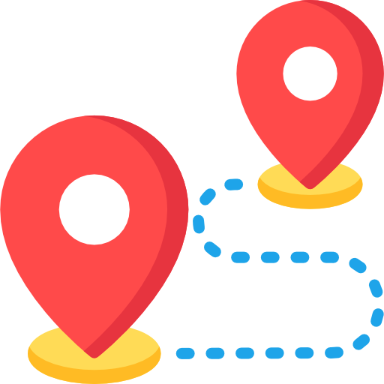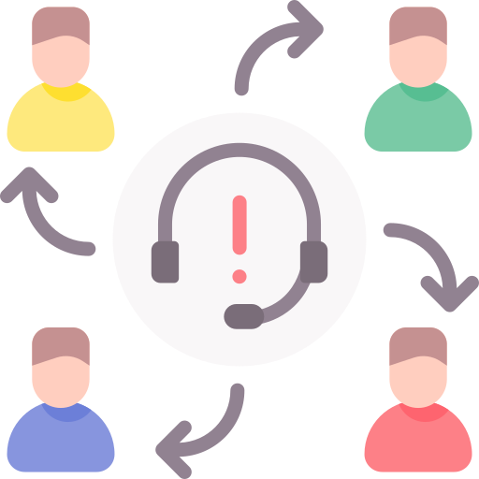

Phone Booking
Online Booking
Taxi Services Server
Routing for available
Customers
Taxi Drivers
Customers and Drivers are connected without knowing each other’s Caller ID.

