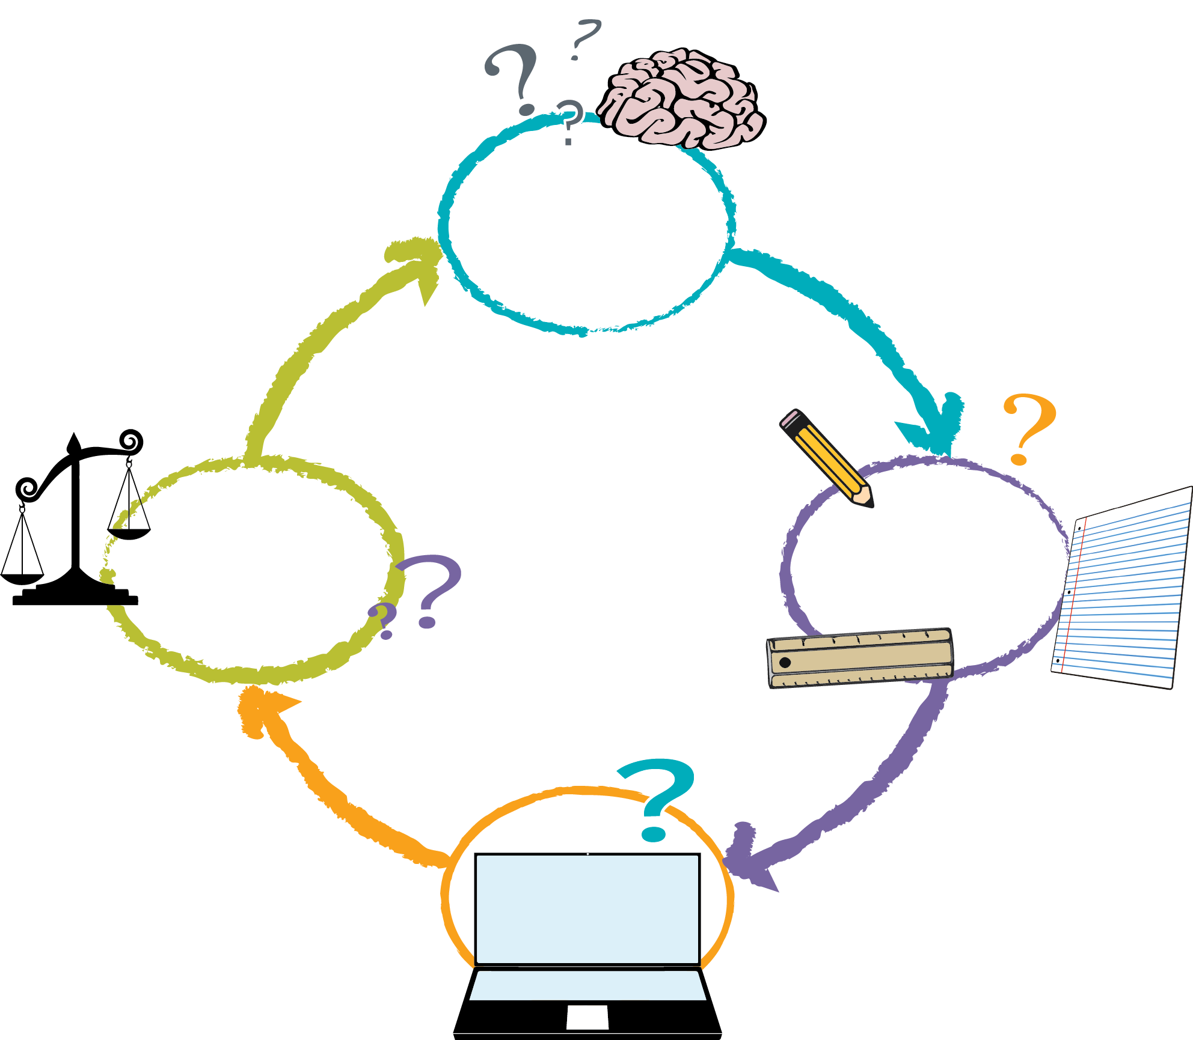
define
prepare
try
reflect
Use this worksheet to make sure you are following the right steps to get your final project completed correctly and on time. If more space is needed for answers, you can use the back of the paper.

Day 1: Define & Prepare
Time to plan the details of your final project!

Section A: Determine your project style
1) What type of project will you be creating? | Sprite Lab or Artist  (skip section B) (skip section C)
2) Do you want this to be a showcase piece or an interactive game? | Showcase Piece or Interactive App  (skip section D) (skip section E)
3) Is your project a remix or brand new?
(If remix, add URL of original)
4) Describe in three to five sentences what your project will be.

Section B: Artist Project
1) Will your drawing be a planned, detailed image which is the same each time, or change each time it’s run?
2) If your drawing stays the same each time it’s run, what is the design you are trying to build, and why does it make an interesting project?
(More room on back of sheet.)
3) If your drawing changes each time it is run, describe why it changes and how the program will make that happen.

Section C: Sprite Lab Project / Other
1) How many characters will your game have?
2) Will your app be a story that plays the same way each time it is run, or is it meant to change each time?
3) If your app is a story that runs the same way each time, describe the story it will be telling and the scene where it will take place.
4) If your app is meant to change each time it is run, describe why it changes and how the program will make that happen.

Section D: Interactive App
1) In what way does your app require audience interaction?
2) For this type of app, you must use at least two of these suggested items.  Circle the items you think you will use and describe what you might do with them.  (5th grade concepts in red) | - Random  - Conditionals with both `if` and `else`  - Nested Loops  - Functions  - Variables  - For Loops

Section E: Showcase Piece
1) For this type of app, you must use at least two of these suggested items.  Circle the items you think you will use and describe what you might do with them. | - Random  - Functions  - Nested Loops  - Variables  - For Loops

Day 2: Try
Coding day! Be sure to refer back to your table from day 1 to make sure your finished product represents the project that you said you were going to make.

Section F: What is going well?
1) What parts of your project are turning out just the way you thought they would?
2) What are you learning about the concepts or blocks that you’re using?

Section G: What is not going well?
1) Is there anything that you planned to do that you needed to change? Why did you need to change it?
2) Are there any blocks or concepts that you don’t understand how to use? Which ones?

Day 3: Reflect and Edit
Time to make your project the best it can be. Pass this sheet to a classmate, then have them try your app and fill out the boxes below. Your classmates will have 20 minutes to review your app, then you will have the rest of the class period to fix any issues that they found.

Share your project URL:

Section H: The app in general
1) What do you like about this app?
2) Is there anything about this app you don’t understand?
3) Name two things you might change about this app if you were the one creating it.

Section I: Assessing the app
1) Does the app match the description from day 1?
2) Does the app use at least 2 of the concepts from the required category?
3) Does the app feel like it was well-planned?

Day 4: Present
Great computer scientists need to be able to show off their accomplishments. It’s time to present your work.

Share your project URL:

Section J: Describe your work
1) Why did you decide to create this specific project?
2) What does your project do?
3) Which of the required ideas did you use, and how did you use them?

Section K: Reflect on the process
1) What did you learn in creating this project?
2) What was the most challenging part about this experience? How did you overcome that challenge?
3) What part of this experience was the most fun?
4) Describe a time that something did not go as planned and you had to be persistent to get everything to work out in the end.
5) Is there anything that you would try to change if you had extra time?
6) How well did you and your partner/team work together?

Were you able to make compromises in order to end up with a project that you were both happy with?
7) What else do you want people to know about your project?

