**Isabela State University Linker:**

**Journal of Engineering, Computing, and Technology**

Volume 2, Issue 2

ISSN (Print): 3082-3676 ISSN (Online): 3082-3684

Publisher: Isabela State University, Desktop Publishing, Echague, Isabela

**Title of the Paper**

**Name of the Lead Author**1**, Other Authors**2

*Affiliation (department, institution, city, state, postal code, and country) of lead author 1*

*Affiliation (department, institution, city, state, postal code, and country) of other authors 2*

* Corresponding author’s email (e.g., [juandelacruz@isu.edu.ph](mailto:juandelacruz@isu.edu.ph))

|  |  |
| --- | --- |
| **RESEARCH ARTICLE INFORMATION** | **ABSTRACT** |
| **Received:** (Please indicate the date of submission to the journal)  **Reviewed:**  **Accepted:**  **Published:**  Copyright © 2025 by the Author(s). This open-access article is distributed under the Creative Commons Attribution 4.0 International License. | It should only contain 200 to 250 words, encompassing the following significant parts of your manuscript: Introduction of research topic, context, gap, and major contribution of your study; General research objective and/or question; Research methodology (design, sample or participants, data collection techniques, and data analysis); Major findings of research (i.e., significant data points, trends, or outcomes that are central to your research, as well as significant implications of your study); and Conclusion and key recommendation from the study’s findings. |
| **Keywords:** | *keyword 1, keyword 2, keyword 3, keyword 4, keyword 5* |

**Introduction**

The introduction of your research paper should explain the research problem, including a discussion of previous and current studies related to the issue, thereby highlighting the research gap your study aims to fill. Likewise, the purpose of why you have conducted your research must be highlighted in this section including the potential contribution of the article.

The objectives of the study should be clearly stated in this section of your paper. Literature citations should follow in-text citations following the 7th Edition of the APA Format.

**Methods**

This part of the research article should have a detailed discussion of the following aspects: research design, participants/respondents, locale of the study, research instruments, data collection procedure, analysis of data, and ethical considerations of your study. Separate paragraph/s should be written for each aspect of the research methods.

In making subsections of this part of your paper, it should follow the prescribed level of heading based on the 7th Edition of APA Format, particularly level 2.

**Ethical Considerations**

This is a distinct subheading of this section of your paper. In the ethical considerations section of the paper, especially if you deal with human participants, the research article should discuss different aspects to ensure the integrity of the research process and protection of participants such as informed consent, confidentiality and anonymity, ethical approval (accentuate the decision and/or major evaluation results from an Ethics Review Committee or Institutional Review Board or any kind of evaluation conducted to review the research process of the paper in relation to the rights of research participants), conflict of interest, and acknowledgment of participants’ rights.

**Results and Discussion**

It should contain the key answers to the research objectives. The findings of the study should be supported by figures and tables. Please do not send tables and figures in separate files and should be embedded in the paper itself. It should also include an interpretation of the results, a literature review to support your claims, and their implications for the broader field, potential applications, and future research directions.

For qualitative studies and the results and discussion would feature short and long quotations from transcriptions, for quotations of fewer than 40 words, add quotation marks around the words and incorporate the quote into your textual presentation. On the other hand, start a block quotation on a new line and indent the whole block 0.5 inches from the left margin. For more information about formats on quotations, kindly refer to this link: <https://apastyle.apa.org/style-grammar-guidelines/citations/quotations>. Below is just an example of short and block quotations:

*Of course, for students at the collegiate level, very often we ask them to write compositions in the various reading genres, and various forms of discourse – narrative, persuasive write-up, an expository paper, or a descriptive one – tasks include writing workshops wherein their classmates can critique and enrich another students’ work.* (Teacher Participant 4)

***This is an example of a block quotation.

As a result, other researchers have proposed that the utilization of psychometric criteria for technical adequacy may lead to comparisons that reflect unfairly on the new forms of performance assessment, such as the integrated assessment, which are “more time-consuming and subjective than standardized tests and may not meet the statistical assumptions for some forms of analysis” (Brindley, 2001, p. 400).

***This is an example of a short quotation.

For table and figure setups, the research article should follow the following format:

**Table 1. Respondents of the Study**

|  |  |  |  |  |  |  |  |
| --- | --- | --- | --- | --- | --- | --- | --- |
| **Program** | | **Number of Respondents** | | **Sample Size** | | **Percentage** | |
| BSEd | 320 | | 101 | | 38.00 | |
| BEEd | 240 | | 75 | | 28.00 | |
| BPEd | 160 | | 50 | | 19.00 | |
| BTLEd | 120 | | 38 | | 15.00 | |
| **Total** | **840** | | **264** | | **100** | |

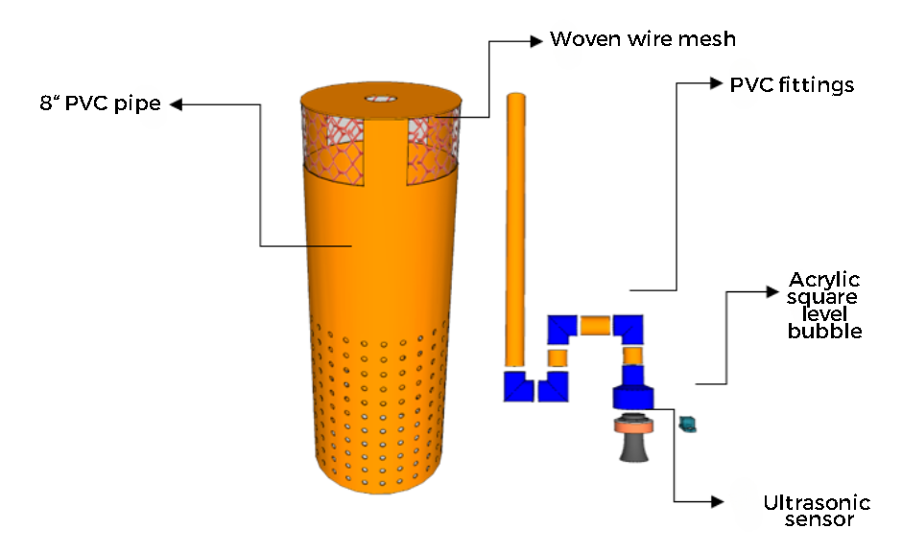

**Figure 3.** *The PVC Pipe and Ultrasonic Sensor Assembly*

***Note: Tables should neither be screenshots nor in any form of pictures, use the appropriate table format.

**Conclusion and Future Works**

This section of the research paper should highlight the study’s practical implications, emphasizing their relevance and contribution to the current body of knowledge.

It should also include acknowledgement of the study’s limitations of the paper and the potential impact of the results to allow other researchers to look into other possibilities of another research problem.

**References**

1. Bird, F. (2020). A defense of objectivity in the social sciences, rightly understood. *Sustainability: Science, Practice and Policy, 16*(1), 83-98. <https://doi.org/10.1080/15487733.2020.1785679>.
2. Calonzo, A. (2020, October 23). Philippine covid cases drop as testing falls below target. *Bloomberg.* <https://www.bloomberg.com/news/articles/2020-10-23/philippine-covid-cases-drop-as-testing-falls-below-target>
3. Douglas, D. (2014). *Understanding language testing.* In B. Comrie & G. Corbett (Eds), Understanding Language Series. Routledge. <https://doi.org/10.1177/0265532210373604>
4. Pedro, M. (2020, February 18). *Alternative solutions to school closure in Arab countries to ensuring that learning never stops.* United Nations Educational, Scientific, and Cultural Organization. <https://en.unesco.org/news/alternative-solutions-school-closure-arab-countries-ensuring-learning-never-stops>

***Note: Refer to the APA 7th Edition Guidelines for the proper format of all types of APA Style references. Refer to these examples: <https://apastyle.apa.org/instructional-aids/reference-examples.pdf>

**Acknowledgement**

This section of the paper includes acknowledgments to individuals whom the author wishes to thank or to the collaborating agency that provided funding for the realization of the study. In case no acknowledgment will be given to someone or any organization, you may delete this section of the paper.

**Conflict of Interest**

This section of the paper is a declaration of personal and institutional financial and non-financial interests, review and editorial conflicts, funding and support transparency, institutional policies and procedures, and measures to mitigate the conflicts. Declaring any conflict of interest to provide comprehensive and transparent information helps build trust in the research process and ensures that any potential biases are appropriately managed. If there is no conflict of interest, you may consider the following statement for this section: The authors declare that there are no conflicts of interest regarding the publication of this paper.

**Artificial Intelligence (AI) Declaration Statement**

An AI declaration in a manuscript is essentially a statement in which authors disclose the extent to which artificial intelligence (AI) tools were used during the research, writing, or preparation of the manuscript. Kindly include the following elements as content of this section: identification of AI tools used in the study, extent of use to explain how the AI tools were utilized, and verification process to describe the steps taken by the authors to verify, review, and edit any AI-generated content.