Plexus User Guide

[Customer] is using Plexus!
We’ve started using Plexus to simplify contract management and legal matter management across our organisation. From Plexus, you can expect:
- A structured process for all things contract management and contract storage
- Approval and signing logic for our Delegation of Authority
- Digital contract signing
- Automated notifications to help with key contract dates
- Contract and matter reporting
- An audit trail on all contract related activity
- Centralised Requests: All legal support requests are managed in one place for easier tracking and management.
First time using the platform? Here’s a handy guide we’ve pre-prepared to assist you through the steps.

Contents
- Getting Started
- The Dashboard
- The Main Menu
- Uploading a Document for Storage
- Uploading a Document with Review, Approval and Signing Workflows
- Viewing your Contract
- Document Previews
- Negotiation
- Version Control
- The Contract Workflow
- Signing in DocuSign
- Process for a Fully Signed Document
- Requesting Legal Support
- Locating Your Matters
- Managing Your Matters
- Accessing Support

Getting Started

In order to start using Plexus, you’ll first need to set up your account.

Access by Single Sign On
Once we’ve enabled Single Sign On, you’ll be able to log in using your regular email address and password used at work and across other websites. Enter your work address and follow the prompts. Where you did not previously have a Plexus account, one will be created for you upon filling in your work email and details.
Once logged in, you’ll have a range of prompts to enter your first and last name. You’ll need to read and accept the Plexus Terms and Conditions of use. Plexus will also ask you to answer a few questions, such as your department and reason for using the platform.

Example below – Single Sign on enabled. Simply enter your work email address at this Plexus login page to continue to the Plexus dashboard.

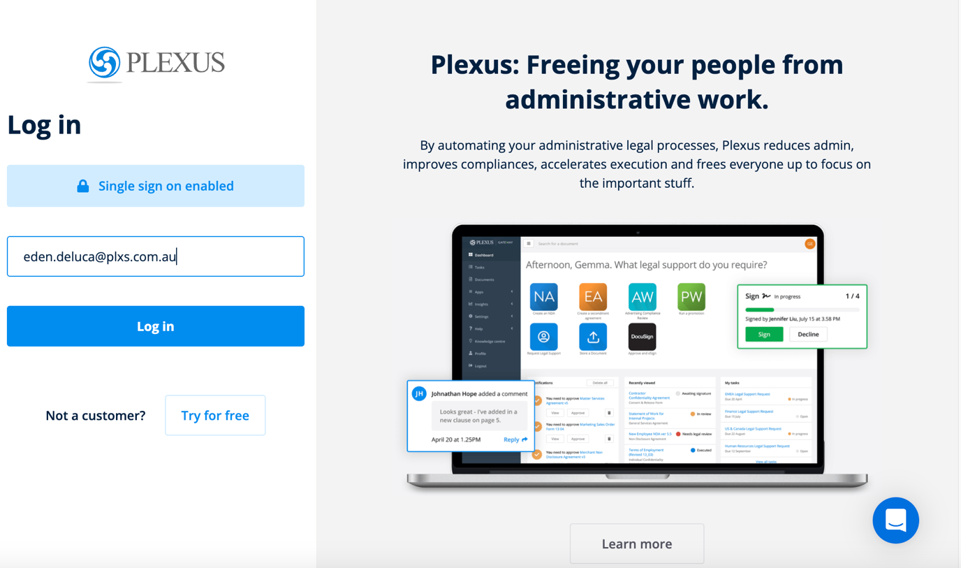

The Dashboard
Access all of our Plexus applications and more from the Dashboard.
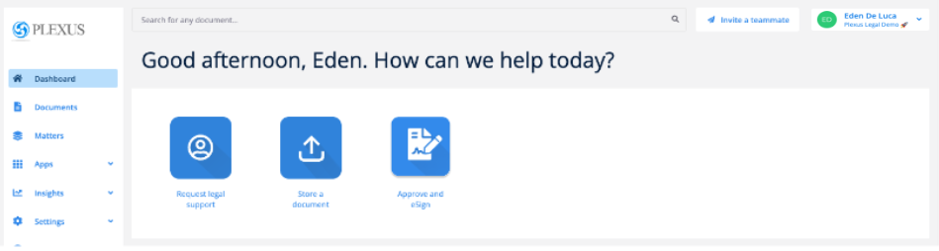

Notifications
You’ll receive all notifications via your email when there’s something for you to action in Plexus. A copy of these notifications are also found on the Dashboard.

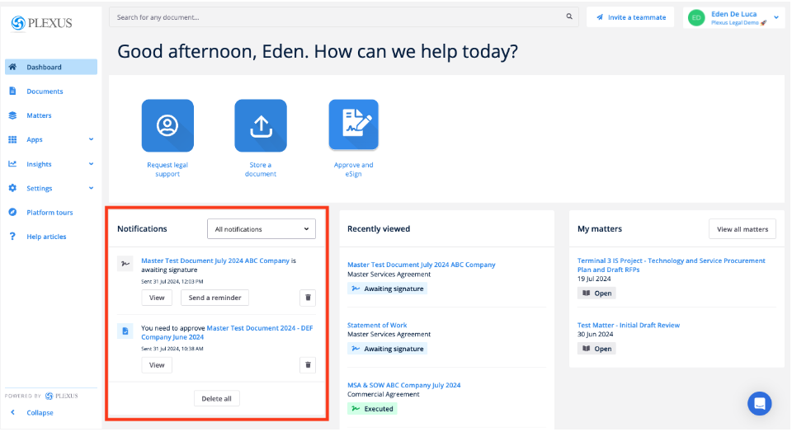



Recently Viewed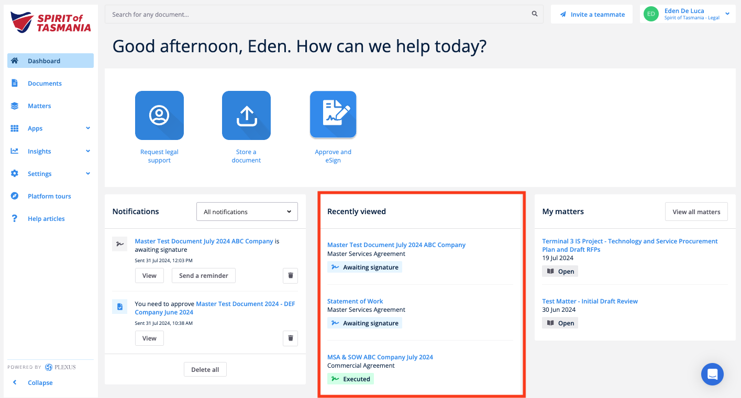

If you recently clicked into a document, the direct link to that file will show on the Dashboard too.

My Matters
All Matters that you’ve recently submitted to the legal team to review will show here with a brief status update.

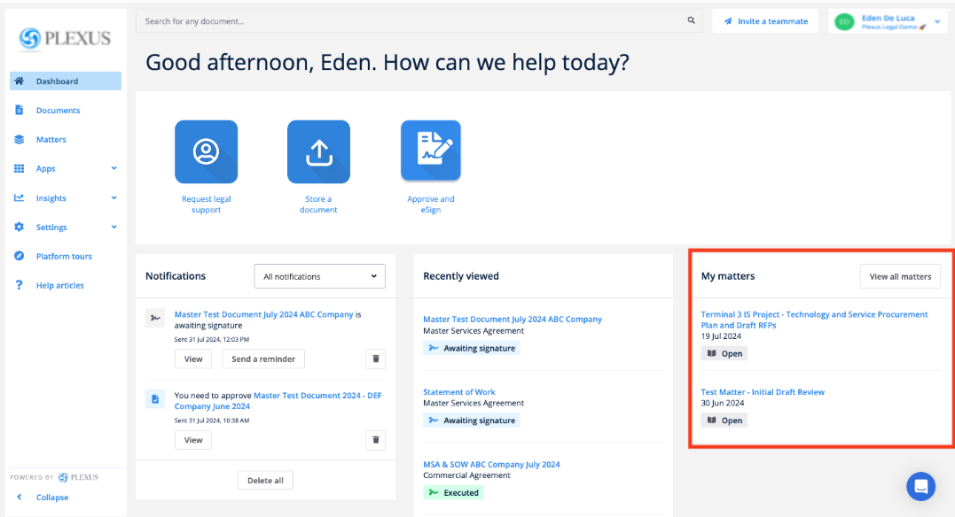

Search bar
Search through all your available documents at the top of the screen.
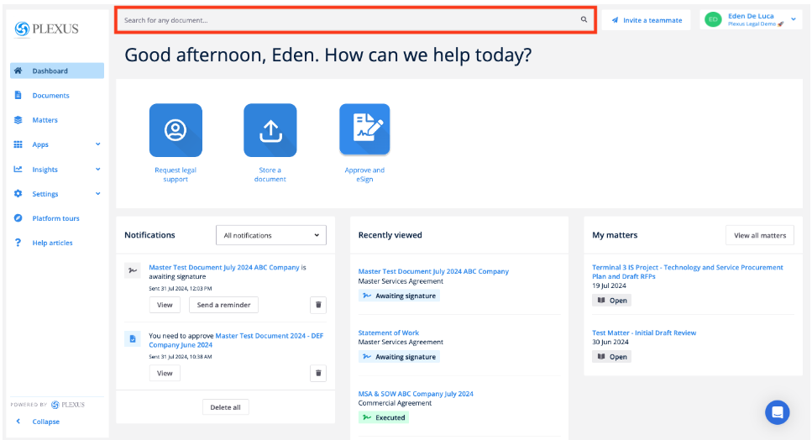

Invite a Teammate
Invite your team members to collaborate with you in Plexus from the top right hand corner of your screen!

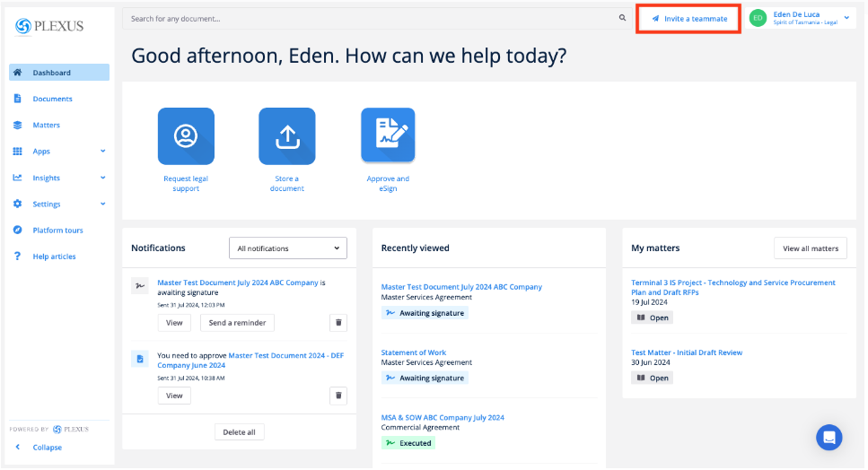

The Main Menu
Access all key areas of Plexus from your main menu.

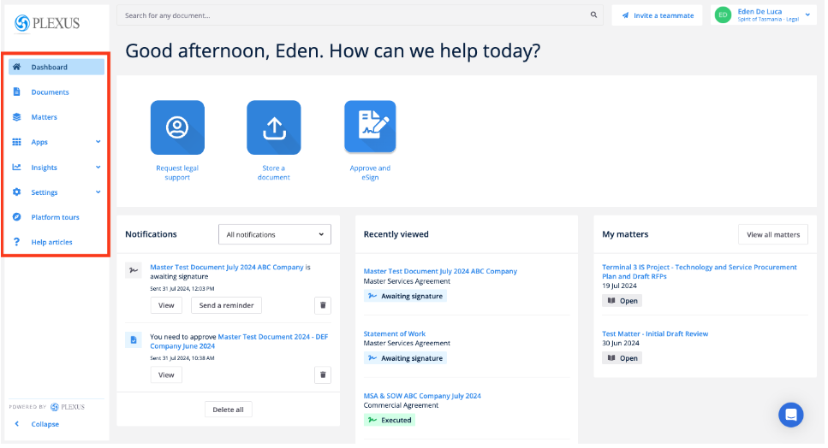

Documents List
From the Documents menu, you can view all documents that you have uploaded in Plexus. Any documents shared with you for viewing, approval and/or signing will also show in this list.
General users will only be able to view the documents they uploaded into the platform. Teams may have super users (usually managers or lawyers) who will be able to access all documents for their business unit.

Matters List
From your Matters list, you’ll be able to see all matters created by the Request Legal Support application tile.

Platform Tours
Access quick platform tours to help you find your bearings in the tool.

Help Articles
Find the answers to your questions using Plexus-generated help content online.

Chat
Use the chat tool in the bottom right-hand corner of the screen to speak directly with Plexus support.

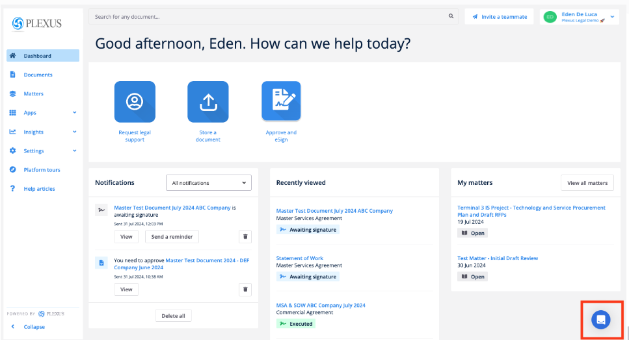

Uploading a Document for Storage
Store legacy documents in Plexus by using the Store a Document tile. Any existing documentation signed outside of Plexus can be stored via this app for future use! If you’re looking to create a workflow with legal review, approval and signing, skip to the next section for more detail.

Step 1
Click on the Store a Document tile on the Dashboard.
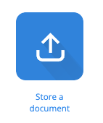

Step 2

Upload your file into the system by clicking Browse. You’ll notice a dropdown to add both a Main and supporting documentation as either a Sub-document or Internal document attachment type.
- Note that any file that you upload in a ‘Sub-Document’ format will be visible by all parties including external counterparties upon sharing. If you’re after a way to upload documentation that will be internally facing only, use the attachment type ‘Internal document’

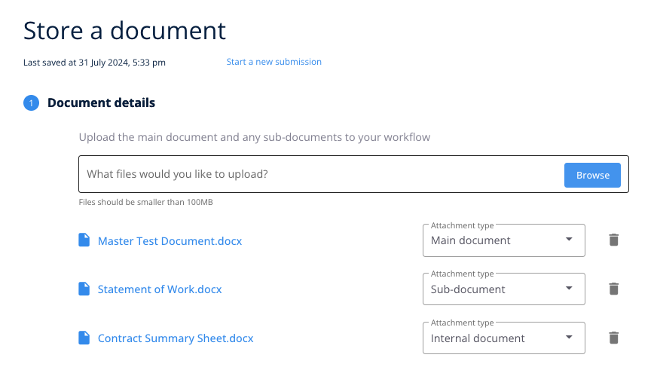

Step 3
Enter all key details about your contract including:
- Document title
- Document type
- Has the document been executed (if yes, enter a date)
- Start and end dates
- Document value and currency
- Owner - someone who you’re uploading the document for & who requires visibility over your work
- Is another party involved/ Counterparty details - this is where you enter the supplier and contact details. Fill this out where you can as it will strengthen our reporting!
You’ll notice that we may have included specific questions based on the type of document you are uploading.
Be sure to add as much information as possible as this will assist you with finding your document later.
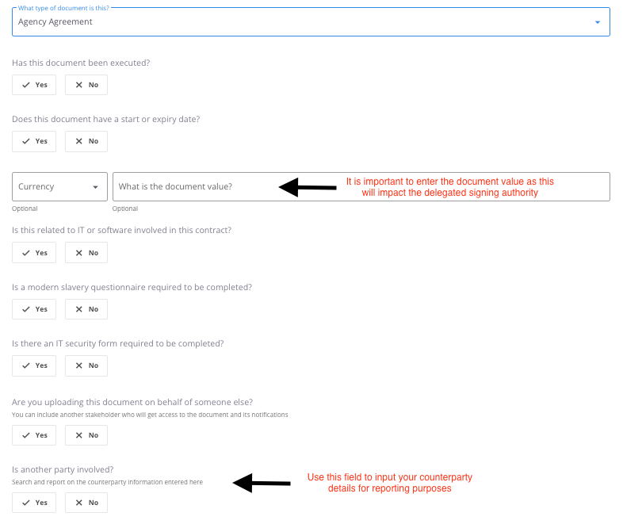

Step 4
Add document reminders if you’d like to be notified, either before the nominated expiry date, or on a specific date.
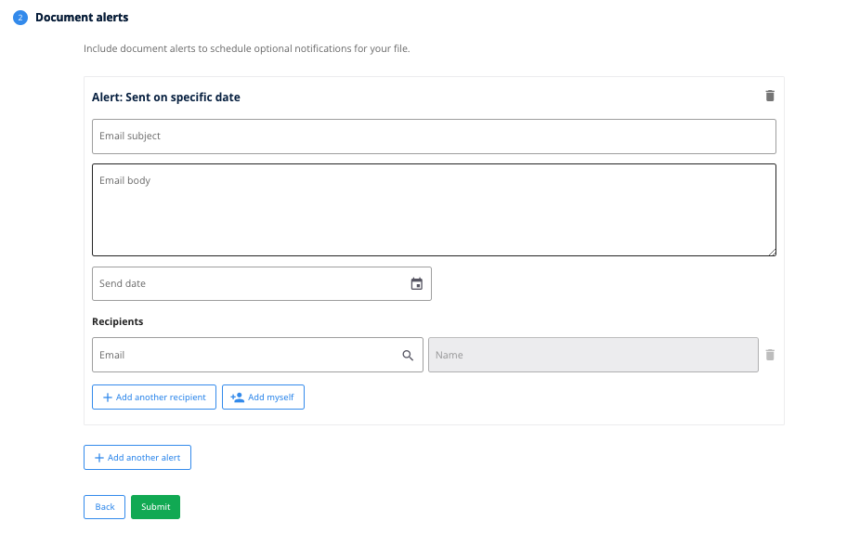

Step 5
Click Submit to finish loading your document into Plexus!

Uploading legacy documents into the platform is just that easy! If you’re interested in creating documents with approval and signing workflows, read on for more information on the Approve and eSign app.

Uploading a Document with Review, Approval and Signing Workflows
We’ve made it super easy to have documents uploaded for expedited legal review, approval and signing, and we’ve taken a lot of the guesswork away from you when deciding who exactly across the organisation needs to see and action a file! Better yet, all documents that run through a Plexus workflow will be stored alongside the legacy contracts uploaded via the previous section, creating a single source of truth for our contracts!

Step 1
Click on the Approve and eSign tile on the Dashboard. This is where you’ll upload all documents to have items reviewed, approved and signed by internal and external counterparties!
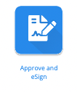

Step 2

Upload your file into the system by clicking Browse. You’ll notice a dropdown to add both a Main and supporting documentation as either a Sub-document or Internal document attachment type.
- Note that any file that you upload in a ‘Sub-Document’ format will be visible by all parties including external counterparties upon sharing. If you’re after a way to upload documentation that will be internally facing only, use the attachment type ‘Internal document’

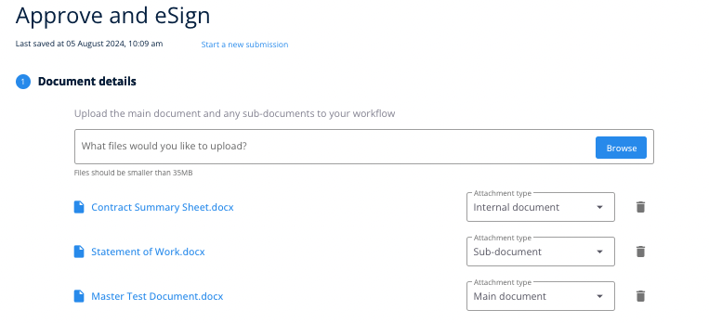

Step 3
As per the previous section, you’ll need to enter all key details about your contract including:
- Document title
- Document type
- Start and end dates
You’ll notice that we may have included specific questions based on the type of document you are uploading.
Be sure to add as much information as possible as this will assist you with finding your document later! In the Approve and eSign app, the details you fill in here will also influence your document’s workflow and delegation of authority.
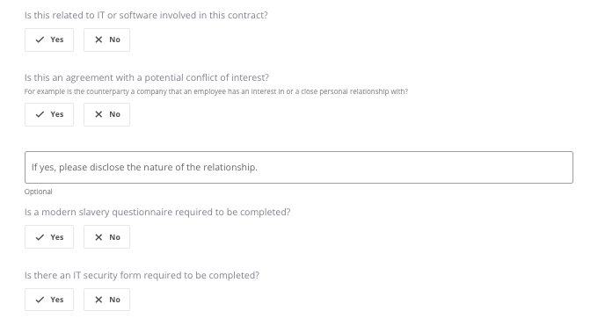
A few additional fields to keep your eye on are:
- Document value and currency - filling this out will strengthen our reporting!

- Owner - someone who you’re uploading the document for & who requires visibility over your work
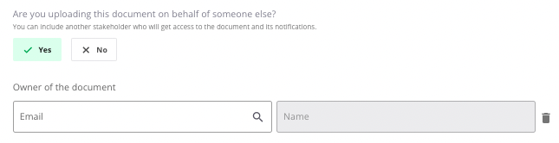
- Counterparty - this is where you enter the supplier and contact details. Fill this out where you can as it will strengthen our reporting!
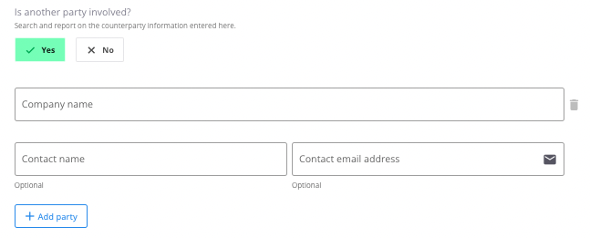
- Receive a copy of the final signed agreement - if yes, enter the email of all individuals who need to receive the copy of the signed file.
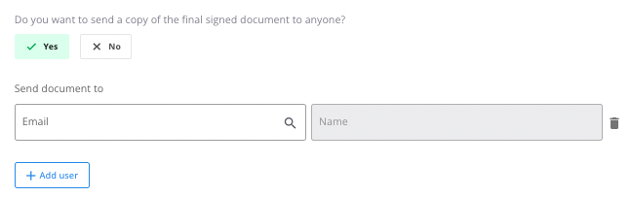
A copy of the final signed document can be sent to an internal Plexus user or external recipient.
As the document author, you will automatically receive a final signed copy by email when the document has been fully executed. A final signed copy will also be saved in the system, accessible to all internal users (i.e. approvers and signers) who were part of the document workflow.

Step 3A - Templated Workflows TO BE COMPLETED ONCE DOA ADDED
Based on the information entered in Step 2, the legal reviewer, approver(s) and person(s) authorised to sign the document will be allocated to the document’s workflow.

You may add additional approvers and signers to the list where required, or you may keep the template as it is. Note that you won’t be able to remove any templated approvers based on what we’ve set up for you.

Step 3B - Non-Templated Workflows
If you find that these fields are empty, you’ll be able to template your own approvers and signers in this section.
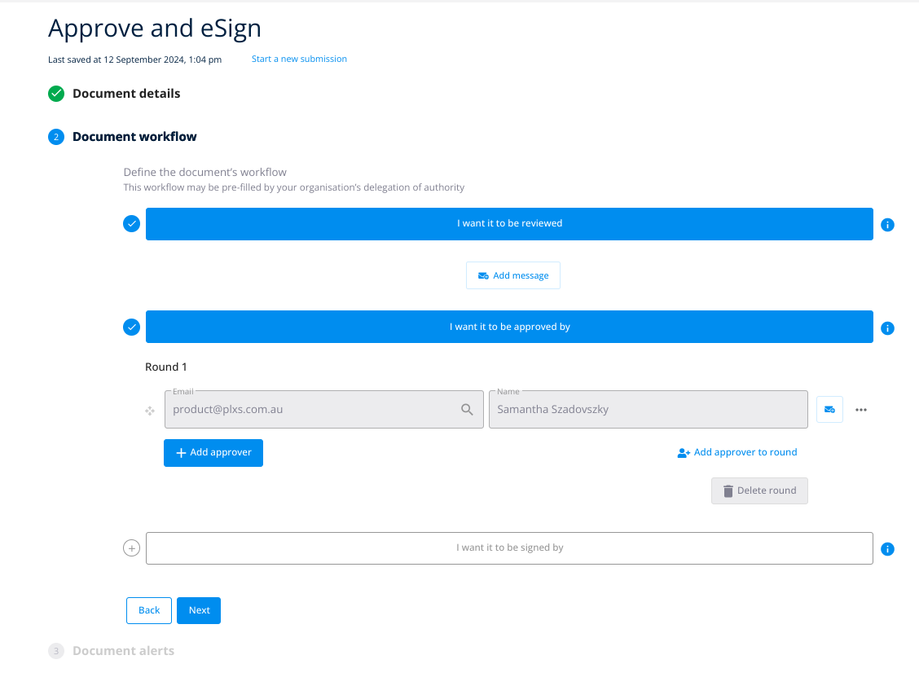
Click on the buttons to review, approve or sign to activate each. Once activated, the section will show in blue.
- If you select the review stage, the document will be sent to the legal team by default;
- If you select the approve stage, type in the email address of an internal or external approver. You can add as many approvers as you wish at this stage;
- If you select the sign stage, type in the email address of an internal or external signer. You can add as many signers as you wish at this stage.
Click Next once you’re done!

Step 4
Click if you would like to Add signature locations. Drag and drop the placeholders into the correct spot(s) on the document.

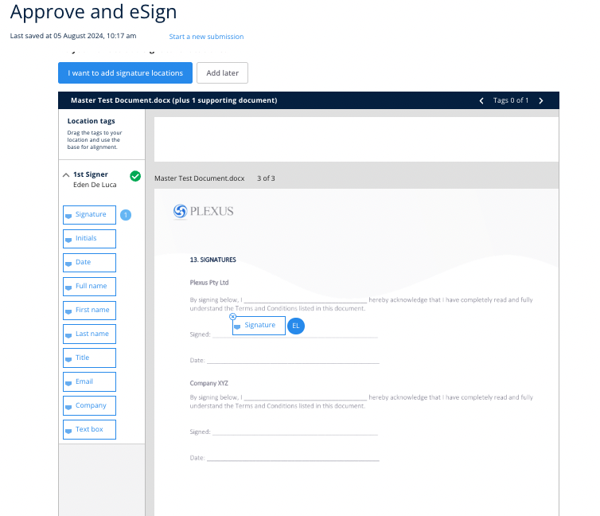

You will need to complete this for each signer that’s been templated on your workflow.

Step 5
Add document reminders if you’d like to be notified, either before the nominated expiry date, or on a specific date.
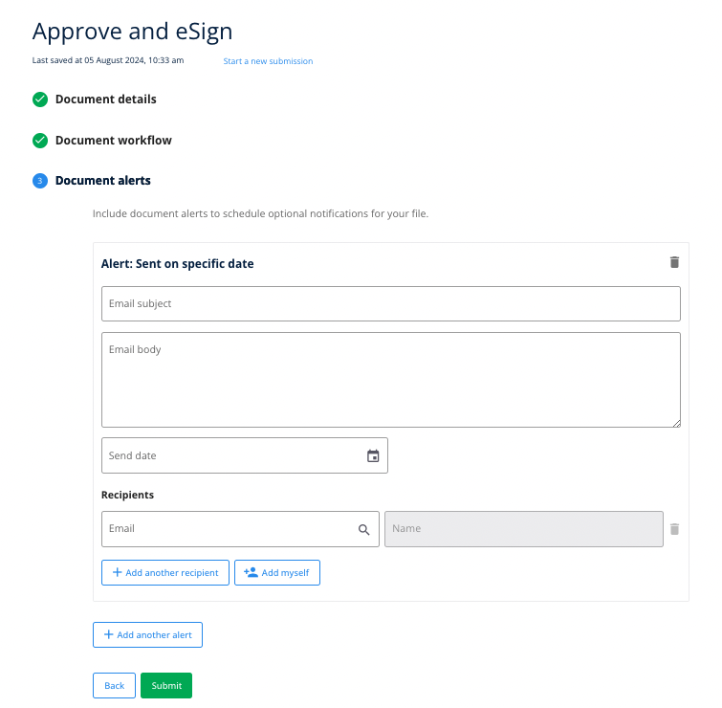

Step 6
Click Submit to finish loading your document into Plexus. The document will automatically enter your first nominated stage of the workflow, and an email notification will be sent to the person who first needs to action the document.

Accessing Documents
All documents will be stored in Plexus under a single menu for ease of searching. You’ll be able to harness the search, filter and sorting features to the best of their abilities to create meaningful ways to look at your contracts!

Viewing the Documents List
Click the Documents menu to access a full list of your documents. Most recently created documents will show at the top of your list by default.
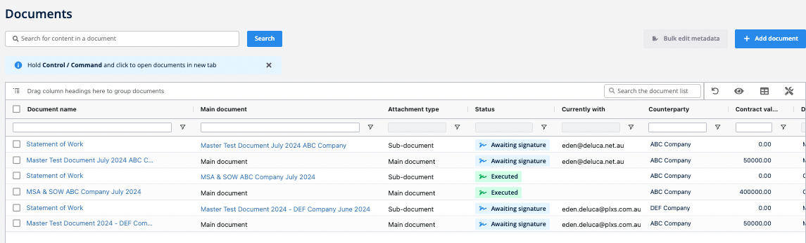

Searching the Document List
Think of the document list like an Excel Spreadsheet. Each column is searchable, can be filtered, and clicked to be sorted in ascending or descending order.
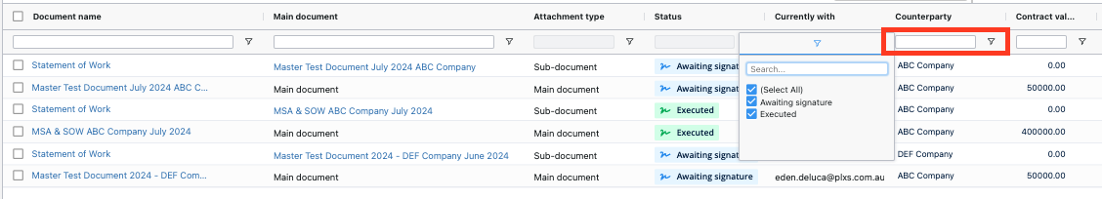
You can also drag and drop a column into your preferred order to prioritise the fields you’d like to see first.
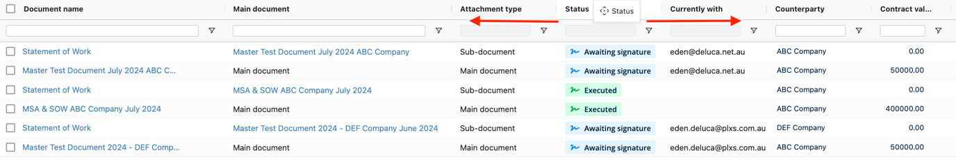
You can click the document’s name to access more information on that file.

Creating document groups
You can create document groups by dragging and dropping any column to the top of the table, as pictured, to create folders based on that column type.

E.g. below: Drag and drop the Counterparty column heading to the Grouping field.
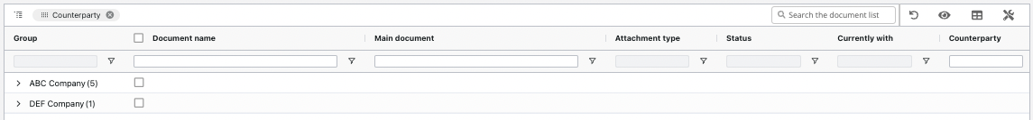

Customising Columns
Show or hide columns by clicking the table icon at the top right-hand corner of the documents list.
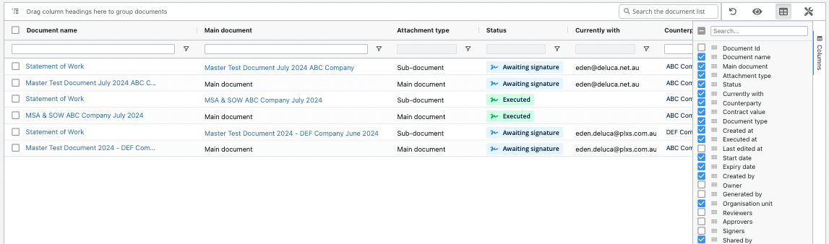

Saving Views
Once you have found a view that you like, you can click the Eye Icon to Save View. Once you have multiple views saved, you can toggle between different views by clicking the Eye Icon and Switch View.
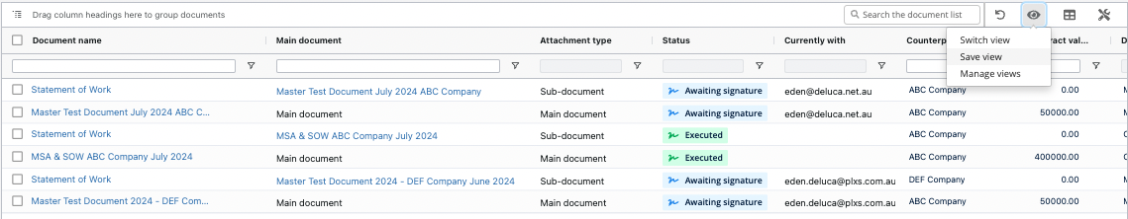

Print or Export to CSV
You can print or export the current document list selection by clicking the Screwdriver Icon.
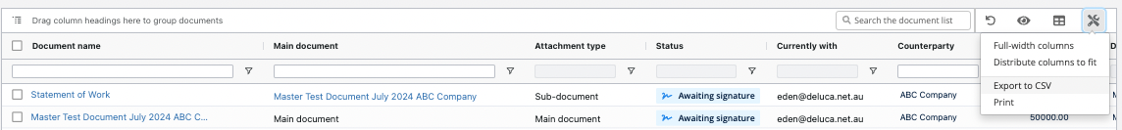

Viewing your Contract
Plexus will assist our business with keeping everyone on top of their contract workflows, so there’s no guesswork when it comes to determining who has and hasn’t viewed or actioned a document. With an integrated audit trail for each and every file, Plexus will increase the transparency of our contracts, whilst decreasing the time to execution.

To view a contract’s workflow, head to the Documents list and click the document’s name to access more information on that file. 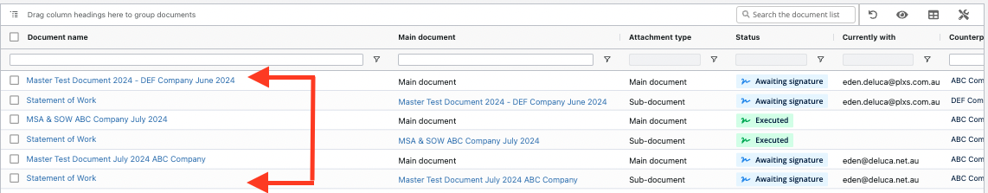

Workflow Timeline
You can view where a document is sitting in its workflow using the timeline at the top of the screen. Expand on the timeline to view more information and to Remind people about open requests where required.
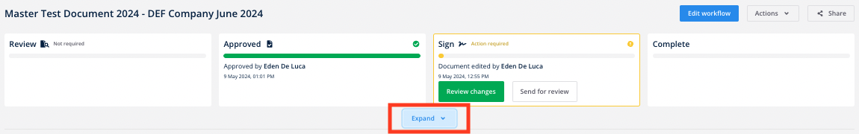
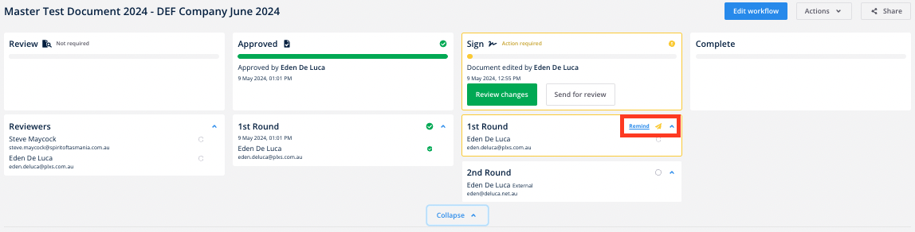

Supporting Material

You can view existing supporting documents or upload additional supporting material from here.

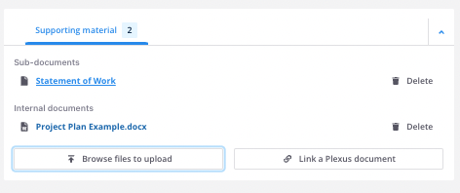

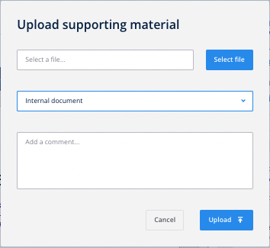

Note: If your workflow has already commenced past the Review stage you will only be able to upload additional Internal documents.

Linking a Plexus Document
Linked documents allows users to highlight the relationships between files by linking related documents for instant access under the supporting material section. You can link any main or sub-document to your document, excluding any documents or sub-documents already associated with the file.
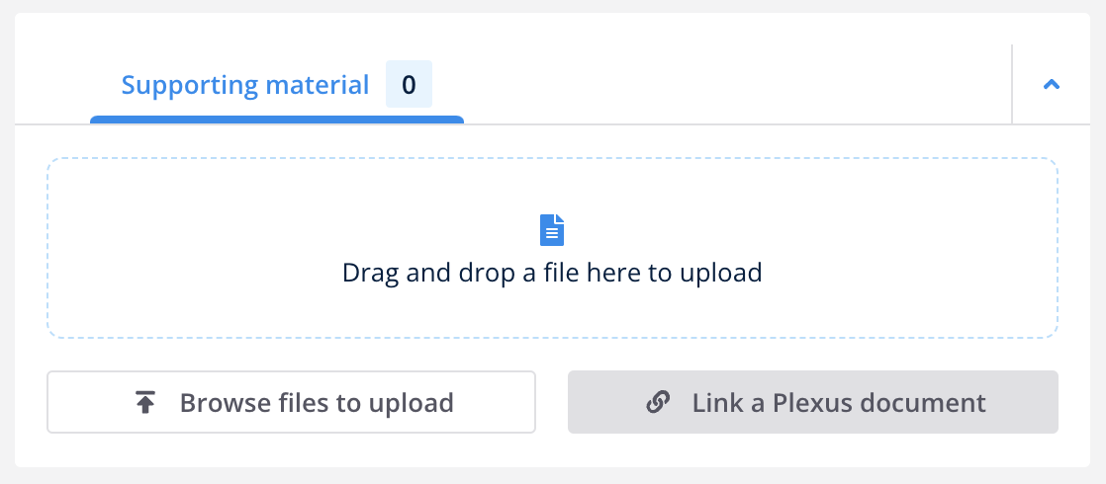
Click Link a Plexus document and then type the name of the file in the search bar. Select the file that you would like to link. You can search for and select multiple files.
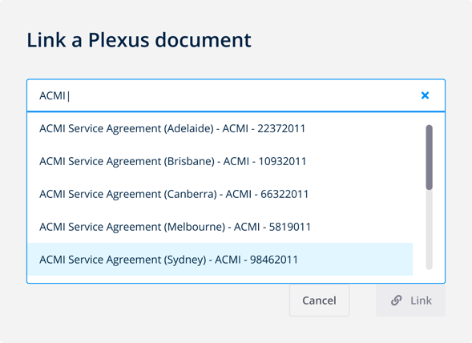
For further instructions on linking Plexus documents, review this Plexus Help Article.

Activity Feed
You can view a document’s audit trail and create Internal/External comments that sit alongside your document.

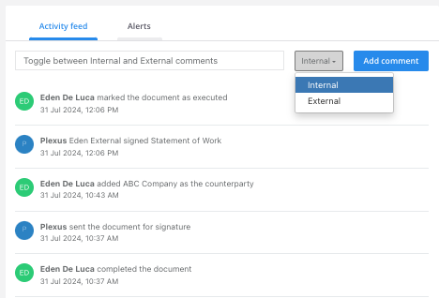

Creating Alerts
You can create additional alerts based on conditional logic from the Alerts tab, found next to the audit trail. Our top tip is to click on the Advanced Editor for additional options when creating your alerts.
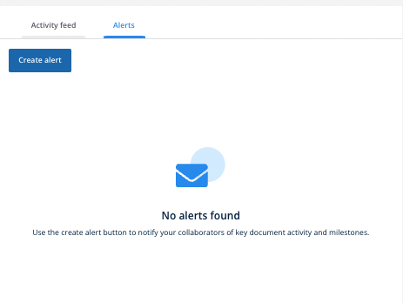

Document Previews
A preview of the document, its facts and signature locations are available for the team to work with. Note that external parties will have a reduced document preview.

Document
Scroll and view through the document as required.
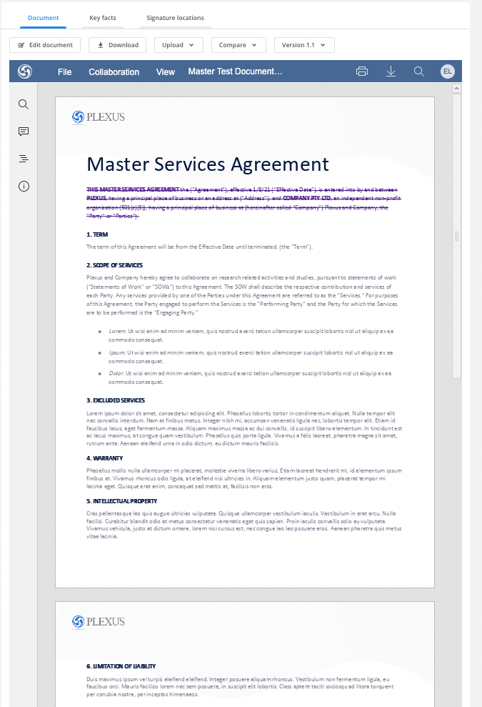

Document Summary

A document summary is a common artefact that's typically sent to key stakeholders to support the executive review, approval and signing of contracts.

Plexus AI-generated summaries will give lawyers a starting point for a summary, where they can make any amendments as they choose, to refine or further explain details.

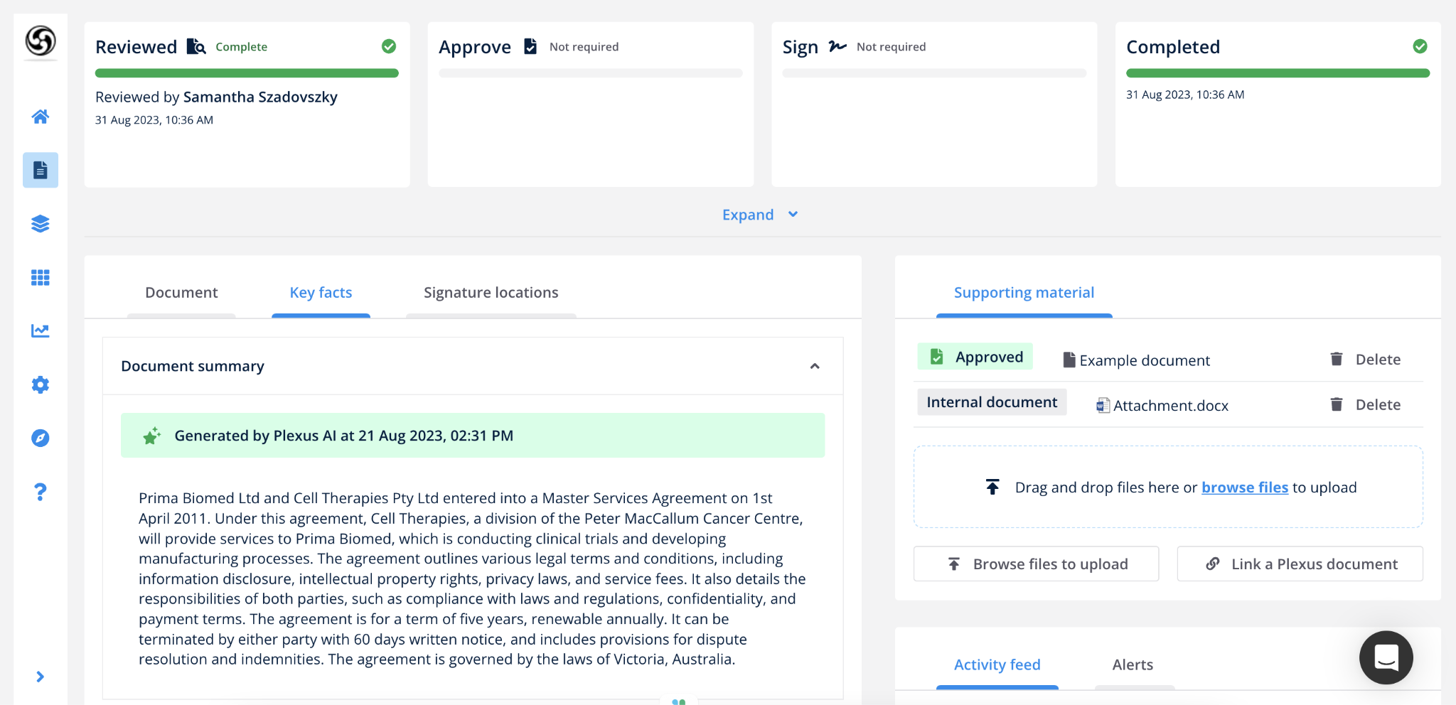

All summaries can be edited by anyone with access to the document. This allows lawyers to review and modify the summary as required. It also allows general users to highlight where changes may have occurred on the document, during the course of negotiations.

Hover your mouse over the text area, and click to edit the summary.

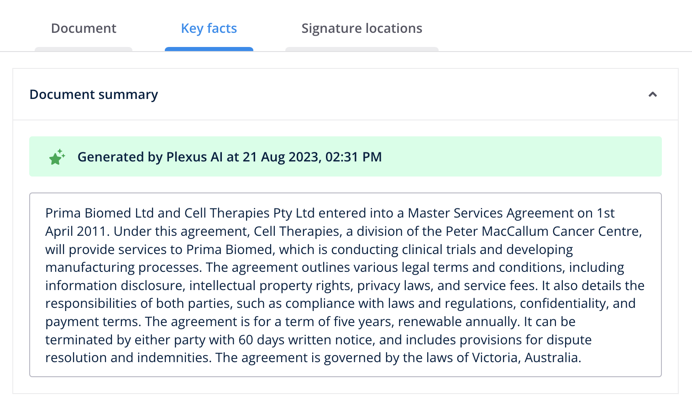

Key Facts
Click the Key Facts tab to find a list of all the information you entered when uploading the file. You can also click the Pencil Icon to make further edits.
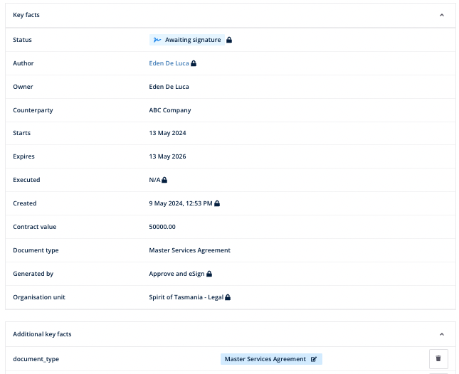
Note that edits from this page will not automatically update the document’s workflow.

Signature Locations
If your document has a signature stage, you’ll be able to add, edit and remove placeholders from this tab as required.

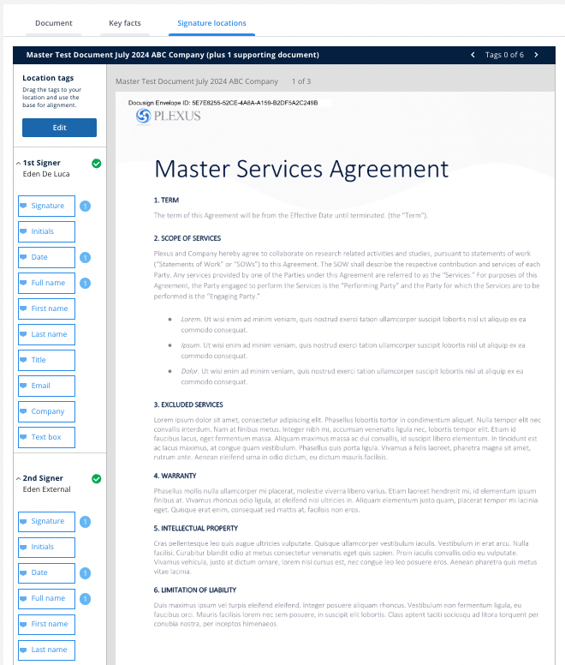
Click Edit to make your changes. Then drag and drop new and existing placeholders or click the X on an existing placeholder to remove it. Remember to click Save once you’re done.

Negotiation
Plexus will allow us to negotiate non-PDF files using (a) the internal editor, or by (b) uploading amendments.
From the Document tab, you’ll be able to negotiate on the document should you require it. The document type provided must be an editable file type (eg .docx).

Editing a Document
Click Edit Document to edit the document in the platform. You’ll be able to edit the document using the Open Office word processor. Each change will be tracked and another member of the team will need to Accept that change.
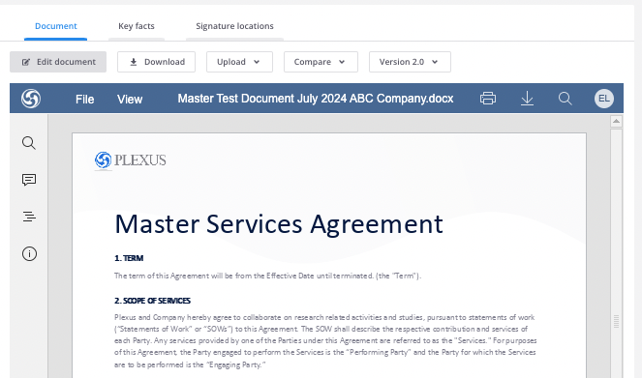
Saving your changes
Once you have finished editing, close the editing tab. From the document details page, you will be prompted to choose what happens next in your workflow. This may be a combination of:
- Sending for review, often with your legal team
- Restarting the entire approval stage
- Continuing the workflow

For mor information on editing documents in Plexus, review this Plexus Help Article.

Uploading New Versions
From the Document tab, you’ll have the option to Download the document out of the platform and Upload a New Version once you’ve finished editing.
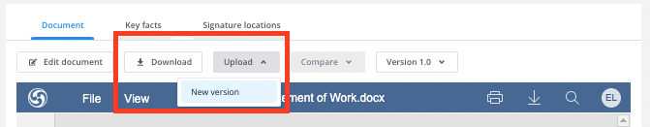

Version Control
Plexus will allow us to have better control over versioning, ordering, tracking, and visibility of versions in the system.

Comparing Files
If your document has more than one version available in the system, you’ll be able to use compare mode to compare any two versions of work side by side.
From the Document Details screen, click Compare just above your document's preview. Using the provided Checkboxes, click on any two versions of work and click Run Comparison.
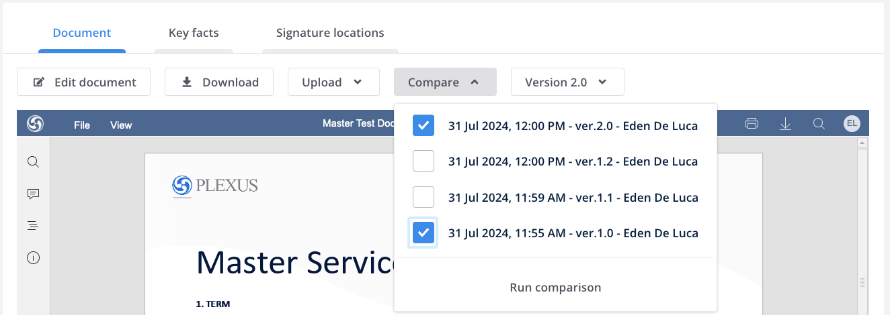
Comparison
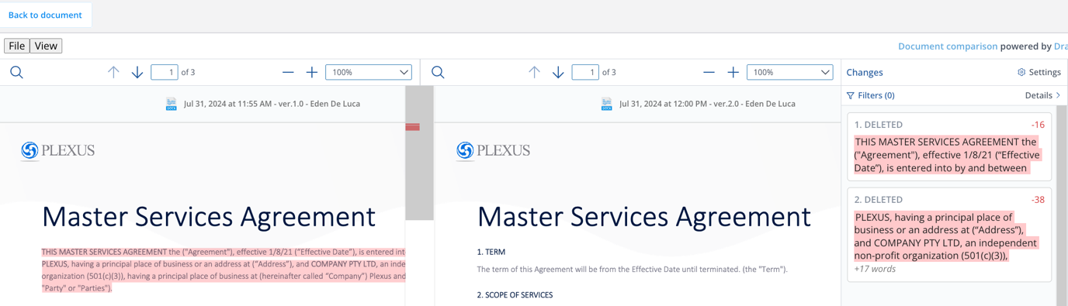

We'll show you those two versions of work, side by side with any changes highlighted as follows:
- Any words or phrases removed between the two versions will be highlighted in red
- Any words or phrases added between the two versions will be highlighted in green.
- A handy quick-view panel down the centre of the screen will allow you to toggle directly to the changes highlighted in the document.
- A handy side-panel will highlight what exactly those text changes were.

Versioning
The Versions button allows you to toggle back to previous versions of the file. It also allows greater flexibility over what external counterparties can see.
Within the Versions dropdown, there's an eye icon that indicates whether or not that version of work is visible to an external recipient when they're sent your contract.
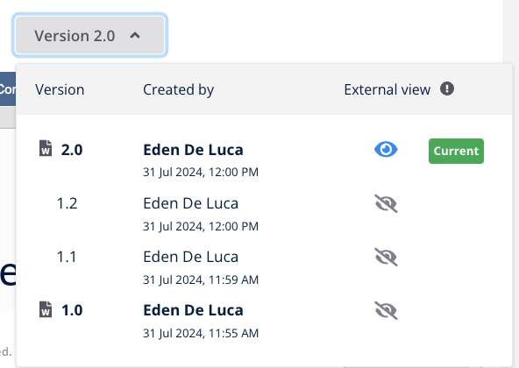

If the eye icon is grey, the document will be hidden from external recipients outside of your organisation. If the eye icon is blue, that version of your file will be shown to those external parties who have access to the file. Clicking on the eye icon will toggle the external view option on and off.

Sharing Files
Sharing Files is a great way to collaborate with internal and external parties without including them in the workflow.

Sharing Files
In the top right hand corner of the Document Details page, click Share.
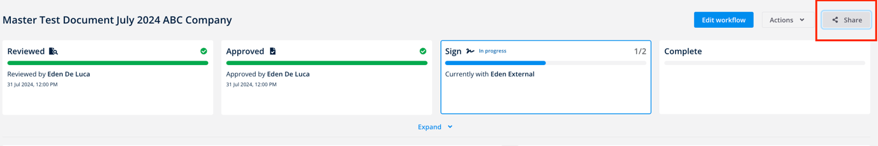

List the recipient(s) you'd like to share your document with. Note that if your shared user is an external user, you’ll need to add their details under the button for a New Contact.

You can also Add a message to your recipients. This will email all added recipients your message and a link to access the file.
Once you are happy, click Share.
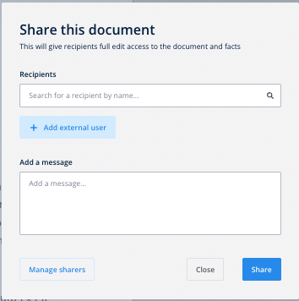

Managing Shares
You can unshare a document anytime by clicking Manage Shares in the top right-hand corner of the pop up screen.
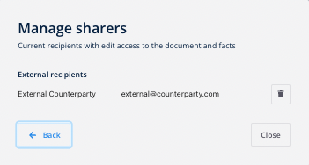

The Contract Workflow
Progressing a workflow is best managed from the workflow timeline. Where your action is required, Plexus will let you know via an email, and an actionable button in the timeline view.
Once a contract has finished legal review, and once all mark-ups and comments have been resolved, it can progress through to the next stage of the workflow.
After approvals are provided, the document will progress to the signing stage, which is managed inside DocuSign.
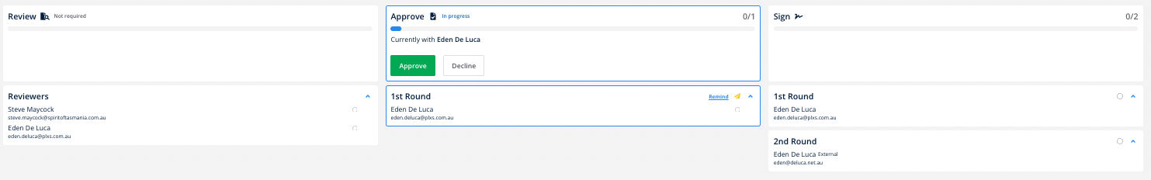

Signing in DocuSign
Obtaining digital signatures in Plexus will be a breeze.
If you’ve been nominated as a signer in a document, you’ll receive an email notification to let you know. Before you sign the contract, you may like to navigate to the document to review all key details about that file. Once you’re ready to sign, click Sign from your document timeline.
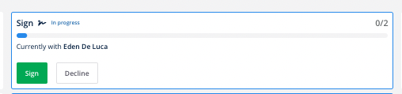
Plexus will take you through to DocuSign where you’ll need to click the checkbox to agree to use electronic records and signatures. Click Continue to progress further.
You’ll then be able to click the Sign button where you can follow the yellow buttons to insert your signature and any other required information.
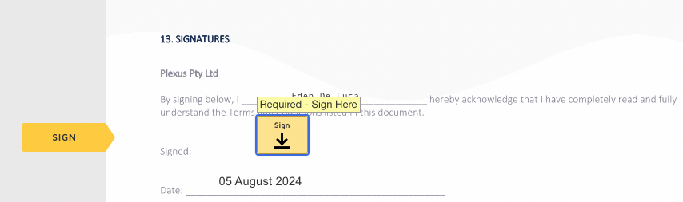
When you sign the document, DocuSign provides three options to:
- Select a Signature (stylised by DocuSign)
- Draw
- Upload a Signature
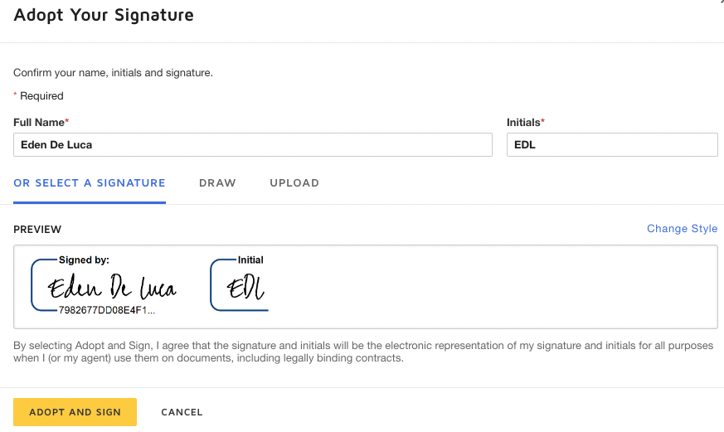

Choose the option that you wish to use and click Adopt and Sign to execute the document. Click Finish to finalise your signing stage.

Process for a Fully Signed Document
A strong process for fully executed documentation is coming our way!
Once a document is signed, the document will either be sent to the next required signer in the workflow, or if no additional signers are required, the document will move to the Executed phase and the following users will be notified via email:
- Author - you
- Owner - nominated at upload stage
- Internal shared users - where you have used the Share function to share a document
- Signers - nominated in the signing round
When the document has been signed, DocuSign will send you a copy of the fully signed document. You’ll also be able to Download a DocuSign certificate of completion from the Download button should you require it.
The fully signed document will be automatically stored in your Documents list with an Executed status.

Requesting Legal Support
It’s now easier than ever to get in touch with Legal at TT-Line. The Request Legal Support app is designed to help teams to fully capture legal matters digitally, whilst enhancing transparency with the legal team for the duration of the interaction.

Step 1
Click on the Request Legal Support tile on the Dashboard.


Step 2
Lodge your matter by adding a title for your request and selecting the categories from the available dropdown fields. This will help the legal team to triage the query to the right person. Click Next once you're done.
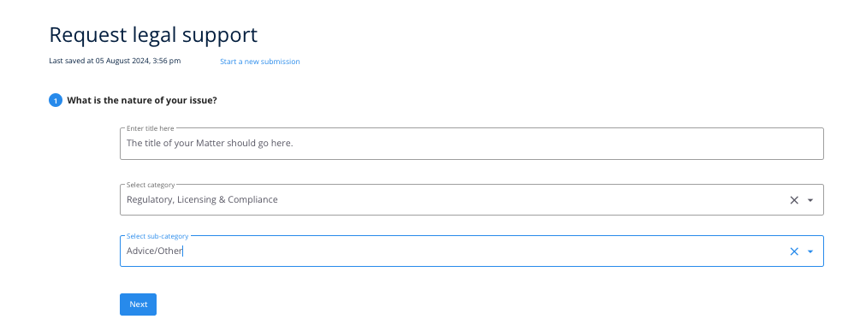

Step 3
In the following section, provide as much detail about your matter as you can. Fill in:
- What you need help with
- When you need a response by
- Financial value
- Whether any other parties are involved
- Whether you're lodging a query on behalf of someone else ('owner')
- Whether you have any relevant documentation, or existing Plexus documents to upload with your query.
Note that both you and the Legal team will have the ability to make changes to this section later.
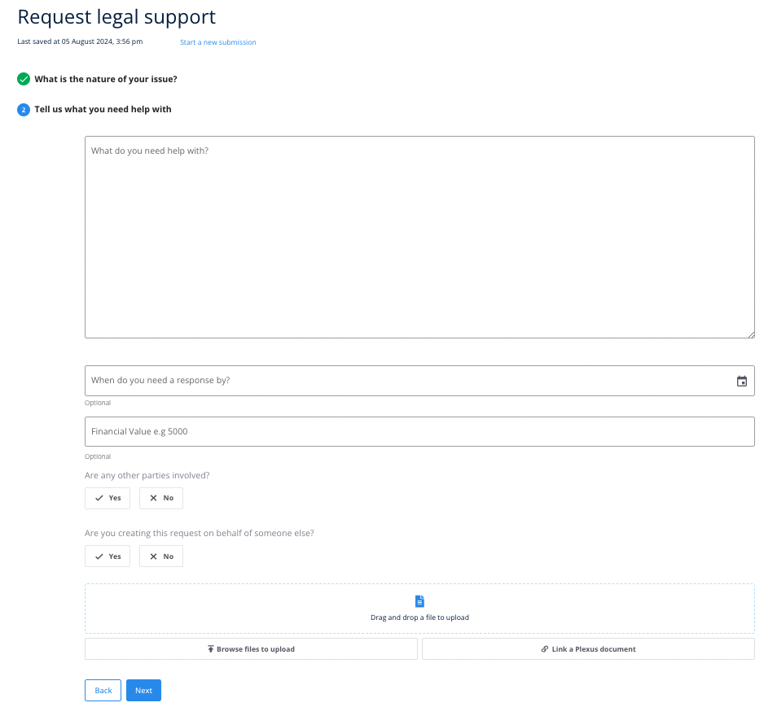

Step 4

PlexusAI will generate personalised questions related to your legal matter. Answering these questions will assist with reducing the time spent going back and forth with the legal team about questions related to your matter.
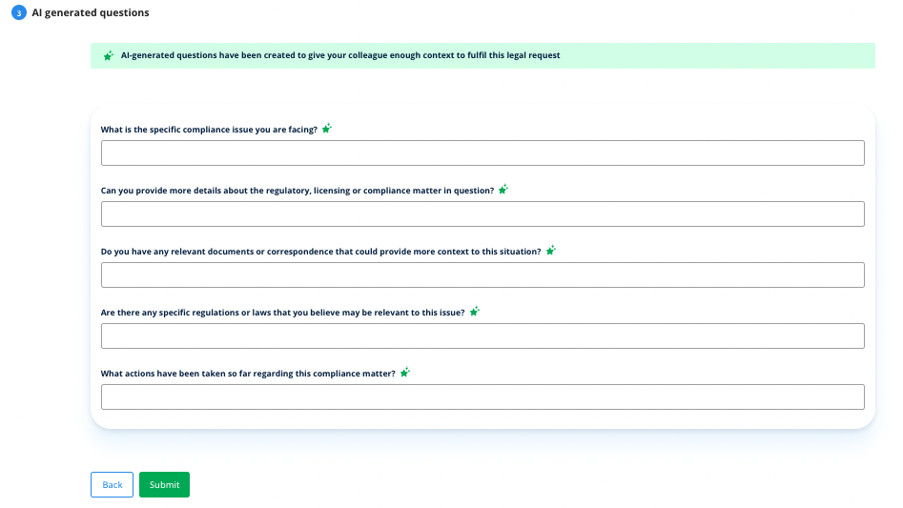

Step 5
Click Submit once you’re done.
You will then be automatically redirected to view the Matter you created. Your matter will also be available from the Matters panel in the bottom right-hand corner of your Dashboard. You can also access it from the Matters list.

Locating Your Matters
View your legal requests in an easy to view spreadsheet-style table.
From the Matters list, you’ll see all matters that you’ve submitted to legal along with their key details. You’ll also see any matters that have been assigned to you by someone else.

Searching the Matters List
Think of the document list like an Excel Spreadsheet. Each column is searchable, can be filtered, and clicked to be sorted in ascending or descending order.
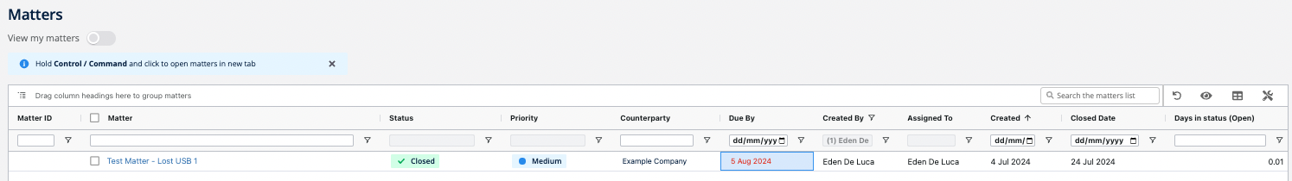
You can also drag and drop a column into your preferred order to prioritise the fields you’d like to see first.
You can click the Matter’s name to access more information on that file.

Grouping Matters
You can create a folder like format by dragging and dropping any column to the top of the table, as pictured to create folders based on that column type.
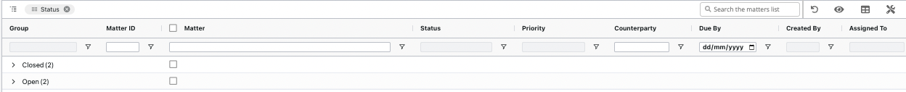

Customising Columns
Show or hide columns by clicking the table icon at the top right-hand corner of the matters list.
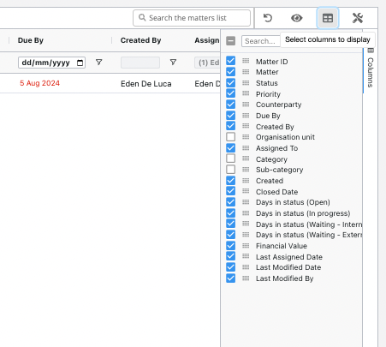

Saving Views
Once you have found a view that you like, you can click the Eye Icon to Save View. Once you have multiple views saved, you can toggle between different views by clicking the Eye Icon and
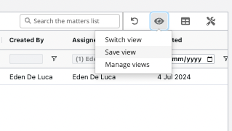
Switch View
Switch between your saved views or any company-wide views as required.
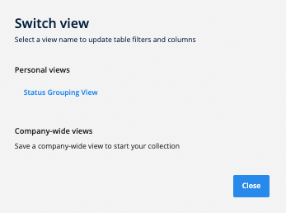

Reset View
Should you need to, you can also reset your view back to default settings by clicking the Reset icon
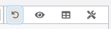

Print or Export to CSV
You can print or export the current matter list selection by clicking the Screwdriver Icon.
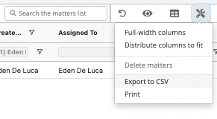

Managing Your Matters
Create a single view to manage your entire matter.
From the Matter Details page, you’ll be able to manage each and every element of your legal support matter.
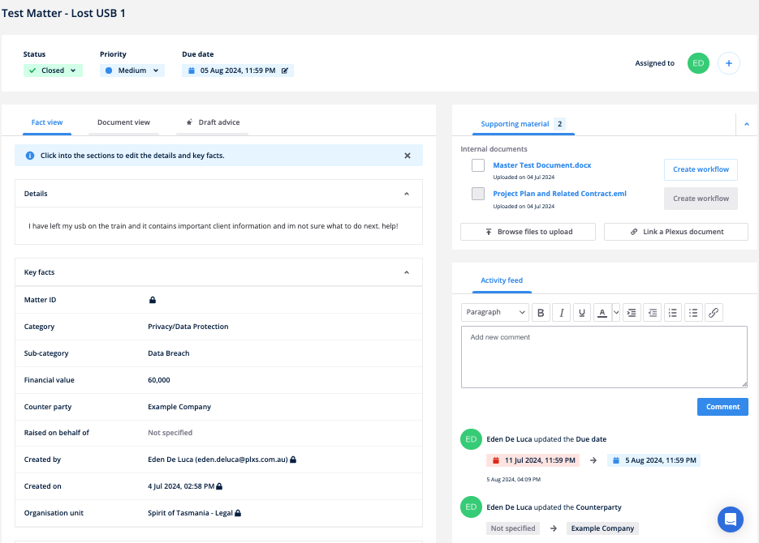

Renaming Matters
Once you have an existing Matter in the platform, you'll be able to rename your matter from the Matter List. Click into that matter to find the matter details page.
If you hover over the name of the matter, you'll be able to click to Edit the title.

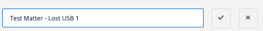
Click the tick to save your changes, or the cross to cancel your edits.

Editing Matter Details
From the Fact View, you’ll be able to view and/or alter crucial details about your matter including:

- Due date - You can edit the due date using a calendar picker. Use the arrows to toggle between the months, and select your new due date as required.
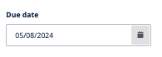
- Status - You can mark a matter as open, in progress, closed or cancelled. This change will be reflected in your Matter List. Note that for auditing purposes, you cannot delete a matter once it's been created, however you can cancel it.
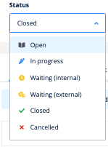

- Priority - From the priority field, you can view whether a matter has been marked as Low, Medium, High or Urgent in priority. Note that only the legal team will be able to change the priority of a matter.
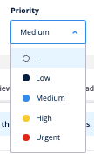
- Assignee - From the assignee field, you can view who a matter has been assigned to. Note that only the legal team will be able to change the assignees on a matter.

- Key facts - To edit the matter's description, click into the description box to Edit. You may also hover over and click into each of the related facts to edit further details directly. Note that fields with the lock symbol are not editable.
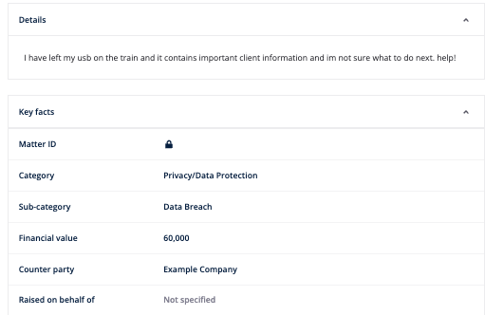
Click the Tick to save your edits per fact.

Uploading Supporting Material
Typically, supporting material for a matter is uploaded when you create the matter.
Any supporting material loaded to the matter is found to the right-hand side of the Matter Details screen under the heading for Supporting Material.
You can also upload a file from here too. To do so drag and drop the file into the box provided or Browse your computer to upload additional files as required.
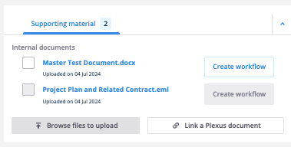
Linking a Plexus document
Use the Linking feature to highlight the relationship between documents and matters. This will allow you to Link an existing Plexus document to your Matter by searching the document name. You can do this for up to 50 documents, both sub-document and main document types.
Viewing Supporting Material
Once a matter has supporting material attached to it, you can click the Name of the document to open up a preview of that file in Plexus. When you click the name of the document, Plexus will open the Document View tab.
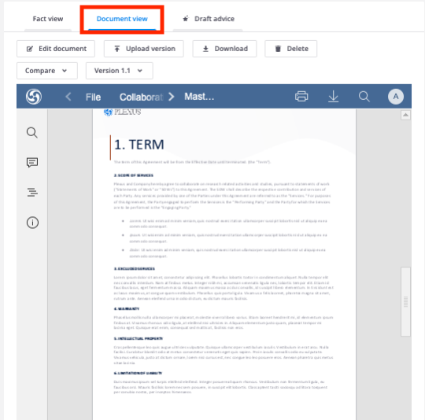
You'll also find quick access to the Document View next to the Fact View.
From the Document View, you can:
- Edit your document and collaborate with other people within Plexus
- Upload Versions of the document from your computer
- Download the file out of the system
- Delete the file
- Compare files if there are 2 or more versions of work
- View Versions if there are 2 or more versions of work loaded
If you would like to have a document in your supporting material signed or approved, simply click Create Workflow from the right-hand side of the screen to send the file to the Approve and eSign App.
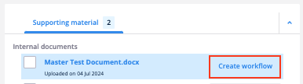

Using the Audit Trail
Each matter saved in Plexus has a unique activity feed that keeps track of each of the key actions made against a matter, including:
- Edits to the name of the matter
- Edits to the matter's key facts, including status, assignees and due dates
- Comments
All activity on the matter is time-stamped and added to the activity log for reference.
Any comment that's added to the activity feed is accompanied by a notification that's sent to:
- The author of the matter
- The assignee
- The contact - where another "Owner" of the matter was indicated upon matter submission
- The triage member where a matter has no assignee (Lawyers only)
To leave additional comments on the Activity Log, simply type away into the textbox and click Comment in order to submit it.
Anyone with access to the matter will be able to view and Reply to that comment as required.

Accessing Support
If you need assistance from Plexus during the process, reach out using the Chat Bubble in the bottom right hand corner of your screen or email support@plexus.co. Otherwise, reach out to our Adoption Champion, [client Adoption Champion name] for further assistance.


