SUMMATIVE TEST NO. 4
Objectives | CODE | Percentage | No. of Items | Item Placement
Use / Respond appropriately to polite expressions | (EN1OL-IIIa-e-1.5); | 50% | 5 | 1-5
talk about one’s personal experiences | (EN10L-IIIb-c-1.3.3) | 50% | 5 | 6-10
Total |  | 100 | 10 | 1 – 10
GRADE I – ENGLISH
SKAI KRU

SUMMATIVE TEST NO.4
GRADE I – ENGLISH
SKAI KRU

Name :_____________________________________ Grade and Section:_________

I. Write the letter of the correct answer on a sheet of paper.
1. Your brother gave you a gift on your birthday. What do you say?
a. Good Afternoon!
b. Good Evening!
c. Thank you!
2. After eating breakfast, your school service arrives, and you leave for school. What do you say to your parents?
a. Bye mom and dad see you later!
b. Good night mom and dad!
c. Good evening mom and dad!
3. You accidentally stepped on your sister’s foot. What will you say?
a. I’m sorry!
b. Good evening!
c. Good Afternoon!
4. You are about to sleep at night, what do you say to your family?
a. Goodbye!
b. Goodnight!
c. So long!
5. You see your grandfather carrying heavy loads of pail. What will you say if you want to offer help?
a. Good Evening!
b. May I help you, Lolo?
c. Goodnight!

II. Draw a heart inside the box if the picture shows your experience in your Kindergarten class and a triangle if it is not. Write your answer in your answer sheet.
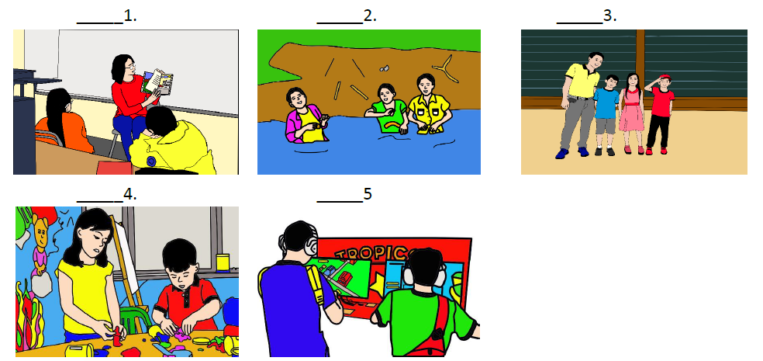

SUMMATIVE TEST 4 ANSWER KEY:
I.
1. C
2. A
3. A
4. B
5. B
II.
6. HEART
7. TRIANGLE
8. HEART
9. HEART
10. TRIANGLE

