

Resume example
Hello Valued Applicant,
Creating a standout resume has never been easier! Our resumes feature clean, modern designs tailored to make a lasting impression. Crafted by certified resume writers and optimized for ATS compatibility, they’re built to help you succeed in today’s competitive job market.

Here’s how we can help you:
Build Your Resume – Our simple tool makes creating a standout resume quick and stress-free.
Browse Resume Templates – Choose from modern, eye-catching designs tailored to impress.
Explore Resume Examples – Get inspired by samples made for every industry and role.
Write the Perfect Cover Letter – Complete your application with a compelling cover letter that wins interviews.
Job Search – Visit our blog for expert tips and strategies to help you land your dream job.
Take the guesswork out of job applications and start creating your future today. We’ll make sure you’re ready to seize every opportunity with confidence!
Your next chapter starts here – let’s get started.

Warm regards,
The Resume Example Team

How to Write a Web Developer Resume

1. Header (Personal Information)
✔ Clearly display your name at the top.
✔ Include your job title (e.g., Web Developer, Front-End Developer).
✔ Provide professional email, phone number, LinkedIn, and portfolio/GitHub link.
✔ Avoid including a photo, home address, or unnecessary personal details.

2. Resume Title
✔ Use a specific and professional title relevant to your expertise (e.g., Front-End Web Developer | React & JavaScript Expert).
✔ Align the title with the job description.

3. Summary or Objective Statement
✔ If experienced, write a resume summary:
- Highlight key web development skills, technologies, and achievements.
- Example: "Results-driven Full Stack Developer proficient in React, Node.js, and MongoDB, with experience in building scalable web applications."
✔ If entry-level, write a resume objective:
- Focus on career goals, technical knowledge, and eagerness to learn.
- Example: "Passionate Web Developer with hands-on experience in JavaScript and Python, eager to apply technical skills in a professional environment."

4. Work & Internship Experience (Reverse Chronological Order)
✔ Include:
- Job Title (e.g., Junior Web Developer)
- Company & Location
- Dates of Employment
- Responsibilities & Achievements (use bullet points, action verbs, and metrics)
✔ Example Bullet Points:
- Developed a responsive e-commerce website using React and Node.js, increasing conversion rates by 30%.
- Implemented performance optimizations, reducing website load time by 2.5 seconds.
✔ If lacking experience, highlight freelance work, open-source contributions, internships, or personal projects.

5. Education (Reverse Chronological Order)
✔ If a recent graduate, place education before experience.
✔ Include:
- Degree & Major (e.g., BSc in Computer Science)
- University & Graduation Year
- Relevant Coursework (Data Structures, Web Development, Database Management)
- GPA (only if above 3.5)
✔ Bootcamps and online courses (e.g., Udemy, Coursera, Harvard CS50) can be listed under additional education.

6. Skills Section (Hard & Soft Skills)
✔ Technical Skills (Hard Skills):
- Programming Languages: JavaScript, Python, PHP, Java, TypeScript
- Front-End: HTML5, CSS3, React, Angular, Vue.js, Bootstrap
- Back-End: Node.js, Express.js, Django, Laravel, Ruby on Rails
- Databases: MySQL, PostgreSQL, MongoDB, Firebase
- Version Control & Deployment: Git, Docker, AWS, CI/CD
✔ Soft Skills:
- Problem-Solving
- Communication & Collaboration
- Time Management
- Attention to Detail
✔ Match your skills with job descriptions for ATS optimization.

7. Projects & Portfolio (Highly Recommended)
✔ Showcase personal projects, open-source contributions, and freelance work.
✔ Provide GitHub links, live website URLs, or portfolio site.
✔ Example:
- Built a portfolio website with Next.js and Tailwind CSS (github.com/username/portfolio).

8. Certifications & Additional Sections (Optional but Recommended)
✔ Certifications:
- Google UX Design Certificate
- AWS Certified Developer – Associate
✔ Languages: (English – Fluent, Spanish – Intermediate)
✔ Extracurricular Activities:
- Coding bootcamps, hackathons, open-source contributions

9. Formatting & ATS Optimization
✔ Simple, clean layout (avoid tables, graphics, or complex formatting).
✔ Use bullet points for readability.
✔ Stick to professional fonts (Arial, Calibri, Times New Roman).
✔ Optimize for Applicant Tracking Systems (ATS) by matching keywords from job descriptions.
✔ Save as PDF unless otherwise requested.

10. Cover Letter (Highly Recommended)
✔ Tailor to the specific job role.
✔ Highlight relevant projects, technologies, and achievements.
✔ End with a call to action (e.g., Looking forward to discussing my application in an interview.).

Web Developer Resume Example

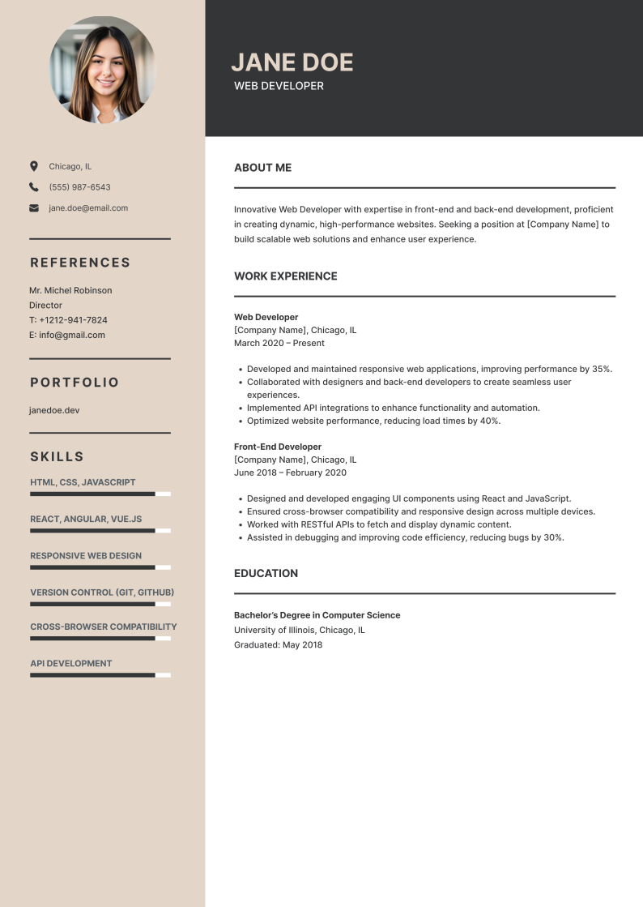

Web Developer Resume Checklist

Check your web developer resume to see if it has all the critical elements:

✅ Header includes name, job title, contact info, LinkedIn, portfolio/GitHub, and a professional email address.
✅ Resume title is specific and aligns with the job role (e.g., Front-End Web Developer, Full-Stack Developer).
✅ Summary/objective effectively highlights technical skills, experience, and career goals.
✅ Work experience with job titles, companies, dates, and key achievements are listed in reverse chronological order.
✅ Projects & portfolio section includes GitHub links, live websites, or personal coding projects.
✅ Education section lists degree, school name, graduation year, and relevant coursework (if applicable).
✅ Skills section covers hard skills (programming, frameworks, databases) and soft skills (problem-solving, teamwork).
✅ Certifications & additional sections include relevant credentials, languages, extracurricular activities, or hackathons.
✅ ATS-friendly formatting with bullet points, professional fonts, and job-relevant keywords.
✅ Resume is tailored to match the job description, using relevant skills and technologies.
✅ A cover letter is included to explain qualifications and enthusiasm for the role further.

If you're unsure about writing your resume or want to save time, we're here to help.
Use our resume builder to create a professional, ATS-friendly resume in minutes—boosting your chances of landing an interview and securing your dream job.

Good Luck!

