

B3Networks
Product Specification for CPaaS CTI Solution

Table of Contents
Product Summary 4
Product Features 5
● Key Features 5
● Generic Features 6
● Auto Attendant 7
● Contact Center 9
● Third-party Ticketing System 11
Product License Requirements 13
CPaaS License Requirements 13
Third-party Requirements 13
Functional Specs 13
Elements 14
● CPaaS Auto Attendant 14
● CPaaS Contact Center 14
● CPaaS Developer 15
● Third-party Ticketing System 15
Workflow 16
Use Cases In Various Industries 16
Banking 16
Insurance 17
Delivery Service 17

Document control versioning

Document History
Date | Version | Applicable BMOs | Author | Comments
20 Sept 2022 | Version 1.0 | All | Hanifa | Document creation
29 Sept 2022 | Version 1.1 | All | Hallie | Amendment

Product Summary
CTI is a technology that integrates information technology applications with telecommunications infrastructure. This technology is used as a call center agent who interacts with customers through web phone calls that generate tickets with complete customer call details to increase call agent productivity.
With this solution, agents can handle tickets and place calls from a single platform. They can simultaneously generate and open tickets for clients while taking calls on the web phone. The CTI solution is a useful tool that frees up agents to focus on solving issues rather than simultaneously launching numerous applications. When processing a call, agents will have call ticket information that shows if tickets are still open or closed.


Product Features

Key Features

Feature | Description
Ticket management | Create ticket automatically when doing outbound calls, auto-renew tickets after outbound and inbound calls end
Customer contact | Create contact automatically
Call notification | Incoming and outgoing call notifications sent to email
Auto attendant | Personalize customer journeys and offer self-service voice options with a graphic, flexible IVR solution
Queue management | A plethora of features to optimize queue management in your contact center. Service-level, skill attribution, personalized queues, automatic callback options, etc.
Advanced call routing | With this feature, you can make use of Ring All / Round Robin / Skill-based Routing / Sticky Agent
Dashboard | Custom dashboards turn a matrix of numbers into actionable insights that match the customer's unique needs. Organize data with custom dashboards and reports
Communication Hub | Monitor your call center data when the agents are on the call to make quick decisions and improve your operating efficiency
Supervisor tools | With special tools, supervisors have access to active call monitoring (call barge, call spy, whisper), queue management, with a detailed agent performance history

Generic Features

Feature | Description
Extension Key | - User's Phone Extension Number  - Each user can have only one extension number
Multiple DIDs per user | Allow more than one DID to be set for a single user
Internal Call | Able to make internal calls from Extension to Extension
Call Transfer | Able to perform call transfer to an extension number or external number using blind or attended transfer
Call Hold/retrieve | Able to put the call on hold/retrieve
Supports calls to International Numbers, Toll-Free, Landline, and Golden Numbers | Able to make outgoing calls to different types of numbers
Flexibility to manage outgoing Caller ID / Private Caller ID | Able to select the caller ID (Assigned / Private)
Call Recording (purchased license) | - Auto record all calls to queues  - 1-year unlimited call recording storage on the Cloud  - Play & Download Call Recording Files
Call Return (Last Number Redial) | Able to redial the last number on Mobile App, Desktop App, or IP Phone.
Organization Link | Interconnect two or more Organizations so that each Organization can communicate with each other via Extension Number
VIP mode | Able to hide the VIP users on the sharing Call Directory list
***NOTE: These features are applicable to All Countries.

Auto Attendant
Feature | Supervisor | Agent | Description
Unlimited layers of automated phone attendant | ✅ | ❌ | Able to create multiple layers of call flow
Visual call flow designer | ✅ | ❌ | The call flow can be created via visual flow
Supports TTS or MP3 file upload for IVR message | ✅ | ❌ | - Max MP3 File Size - 5MB  - 1 MP3 file is allowed per message
Customizable language and speech settings | ✅ | ❌ | 34 different languages with multiple accent options
Call hunting - ring queue and ring group | ✅ | ❌ | A business phone system strategy that connects calls to multiple phone lines either simultaneously or one after the other
Call transfer | ✅ | ❌ | Ability to transfer the call from Auto Attendant to extension user, queue, or external number
Missed call notification with voicemail | ✅ | ❌ | Missed call notification via email
Missed call notification via SMS (purchased license) | ✅ | ❌ | Missed call notification via SMS
Gather caller’s input | ✅ | ❌ | - Play a message and gather the input from the caller to route the call accordingly.  - Support exact matching, no matching, list matching, or pattern matching.
Forward | ✅ | ❌ | Forward the call to any previous block
Set conditions for your call flow | ✅ | ❌ | Define the matching condition and open different call flow branches depending on the result of it.  Available matching parameters:  - Caller's input  - Caller's calling day in a week  - Caller's calling time  - Caller ID
Number black-list management | ✅ | ❌ | With this being activated, the number, either anonymous or inserted number, will be blocked from accessing the hotline
Office hours, After Office hours and Holiday customization | ✅ | ❌ | Ability to customize different flows for working hours, after working hours, and holidays
Show multiple version histories for reverting purposes | ✅ | ❌ | Fallback features which allow the previous flow to be re-activated
Backup and restore flows | ✅ | ❌ | - Export the call flow to a JSON file to backup  - Import the JSON file to restore
Third-party integration | ✅ | ❌ | Custom Third-Party Software (CRM/Ticketing System) Integration [e.g. Freshdesk, Zendesk, AgileCRM] via Webhook for Data Push /HTTPS integration only
Schedule / Real-time deployment | ✅ | ❌ | Deploy a specific flow at specific time or opt to deploy it real time
Holidays settings | ✅ | ❌ | Set public holidays so that inbound call will react based on the setting of public holidays

***NOTE:
- These features are applicable to All Countries.
- The Auto Attendant can be managed by the Admins (the admin does not need to be always the supervisor). In this document, for the purpose of the Inbound Contact Center illustrations, we put the supervisor as the admin to manage the Auto Attendant.

Contact Center

Feature | Supervisor | Agent | Description
Queue Management
Queue priority | ✅ | ❌ | Queue priority settings based on business value
Max queue size & wait time configuration | ✅ | ❌ | Allow to request a callback when the max queue size or the max wait time is reached
Assignment of agents to multiple queues | ✅ | ❌ | Agents can be added to multiple queues
Callback | ✅ | ❌ | Automated callback with a valid number
Queue code | ✅ | ❌ | Allow agents to transfer calls to a queue using a queue code
User management
User status update | ✅ | ✅ | Update user status with reasons
Ring time per agent | ✅ | ❌ | Able to set max ring time per agent in a queue (in seconds)
Inbound call assignment | ✅ | ❌ | Only assign inbound calls to agents with “Available” status
Call control & Note taking
Inbound call pop-up | ✅ | ✅ | Pop-up on the desktop app for incoming calls to queue and to fill in a predefined note template
Advance call routing
Ring all | ✅ | ❌ | Assign the incoming call to all available agents.
Round robin | ✅ | ❌ | - Distribute calls evenly among the team.  - The call is first routed to the agent who is in the first position on the pre-decided order, and if the agent is not available, it is transferred to the second agent, and so on.  - The last ring agent is remembered. The next call received rings the next agent on the list.
Proficiency Level | ✅ | ❌ | The incoming call will be assigned to the agent with the highest proficiency
Sticky agent | ✅ | ❌ | Call will be transferred to the last assigned agent if the caller calls for the second time onwards
Announcement message
Message configuration | ✅ | ❌ | - Adjustment of no. of times a message is repeated  - Text to speech / MP3 file upload for interactive response  - Multilingual capabilities & speech settings
Communication Hub
Agent Performance Reports | ✅ | ❌ | View user status and SLA statistics to get insight on individual performance
Agent Activity Logs | ✅ | ❌ | Real-time in-queue agent activity logs report
Active call management | ✅ | ❌ | - Call barge  - Call spy  - Call whisper  - Force hangup
Callback request management | ✅ | ❌ | Keep track of all queues' callback requests.
Call history | ✅ | ✅ | Comprehensive call history with call details and voicemail/call recording file
Dashboard
User State Overview | ✅ | ❌ | Real-time user state report
Advanced Call Reporting | ✅ | ❌ | Real-time report for completed calls in the organization
Inbound Queue Performance Reports | ✅ | ❌ | Real-time dashboards & reports on queue and agent level with customizable metrics
Active Calls Report | ✅ | ❌ | Monitor your call queue in real time

***NOTE: These features are applicable to All Countries.

Third-party Ticketing System

Feature | Description
Automatically Generate Ticket | On incoming/outgoing calls, tickets will be generated automatically
Open, Update, Merge and Close Ticket | Tickets that have been created can be changed status, merged, and deleted
Reply Ticket | Tickets that have been made can be replied and sent to email
Call Notifications Send by Email | On incoming/outgoing calls that are made automatically send notifications to the user's email
Cancel or Reject Call | Incoming calls can be rejected, and outgoing calls can be canceled
Call Recording | Calls made will automatically be recorded, and the results can be downloaded on the ticket
Webphone Dial Pad | Entering a number when making a call
Show All Call History Call | See all tickets that have been created
Settings Menu | Menu on web phone to do web phone settings
Mute or Unmute Call | Mute or unmute during a call
Enable Notification | Enable incoming call notification
Test Networks | To check network speed
Test Microphone | To check the sound captured by your mic
Test Speaker | To check that you can hear the sound

Product License Requirements

CPaaS License Requirements
SKU Name | SKU Type | Unit Of Measure
Phone System
Phone System | Basic License | Per user per month
Call Recording | Addon License | Per user per month
Contact Center | Addon License | Per user per month
CTI | Addon License | Per user per month
Auto Attendant
Auto Attendant | Basic License | Per organization per month
Concurrent Call | Addon License | Per concurrent call per month
Number | Addon License | Per organization per month
Developer
Developer | Basic License | Per organization per month
Developer Concurrent Call | Addon License | Per concurrent call per month

Third-party Requirements
- Your account must have admin privileges to access the third-party admin portal
- Account information:
- Org UUID
- Domain URL
- API Key
- Email Admin (app maker)

Functional Specs
The CTI comprises the following elements that work together to give a unique CTI solution.

Elements

CPaaS Auto Attendant
A graphic, flexible IVR solution offers self-service voice options, manages mandatory input webhooks, and personalized customer journeys.
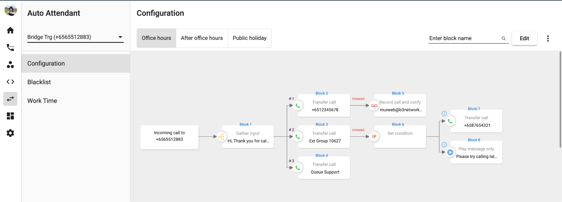

CPaaS Contact Center
Skill attribution, personalized queues, automatic callback options, service-level, and many more options. A wealth of features to optimize the queue management of your Contact Center.
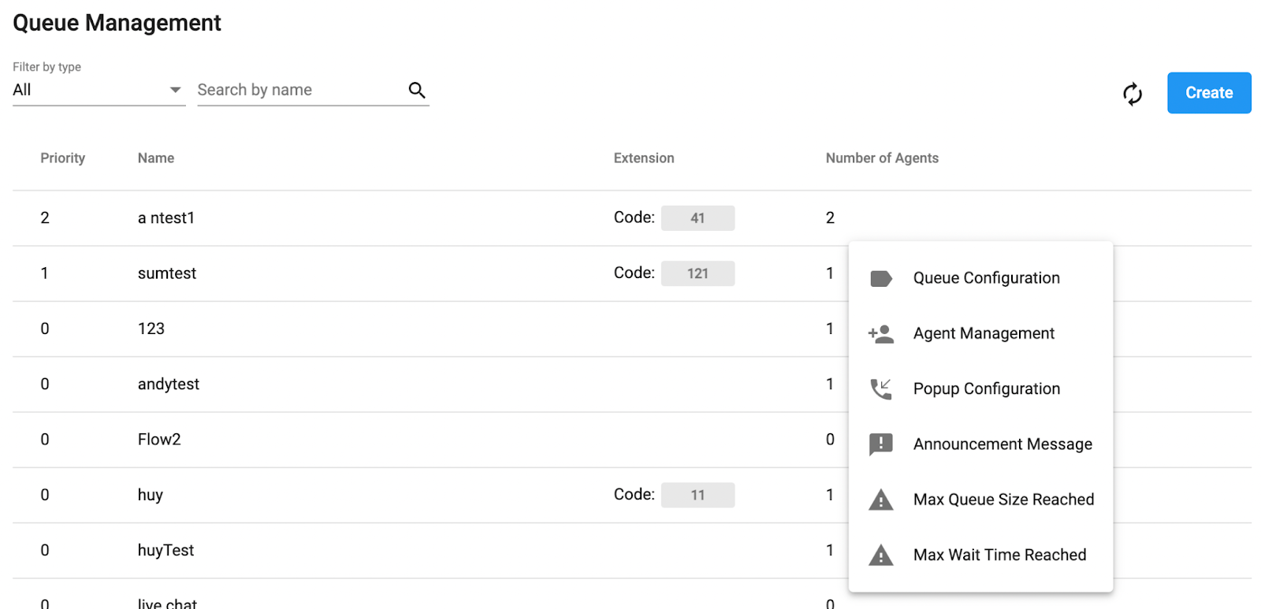

CPaaS Developer
Create automated workflows by gathering resources and performing actions on a diverse set of services. This flow is used to integrate with the required third-party system in order to update call details accordingly.
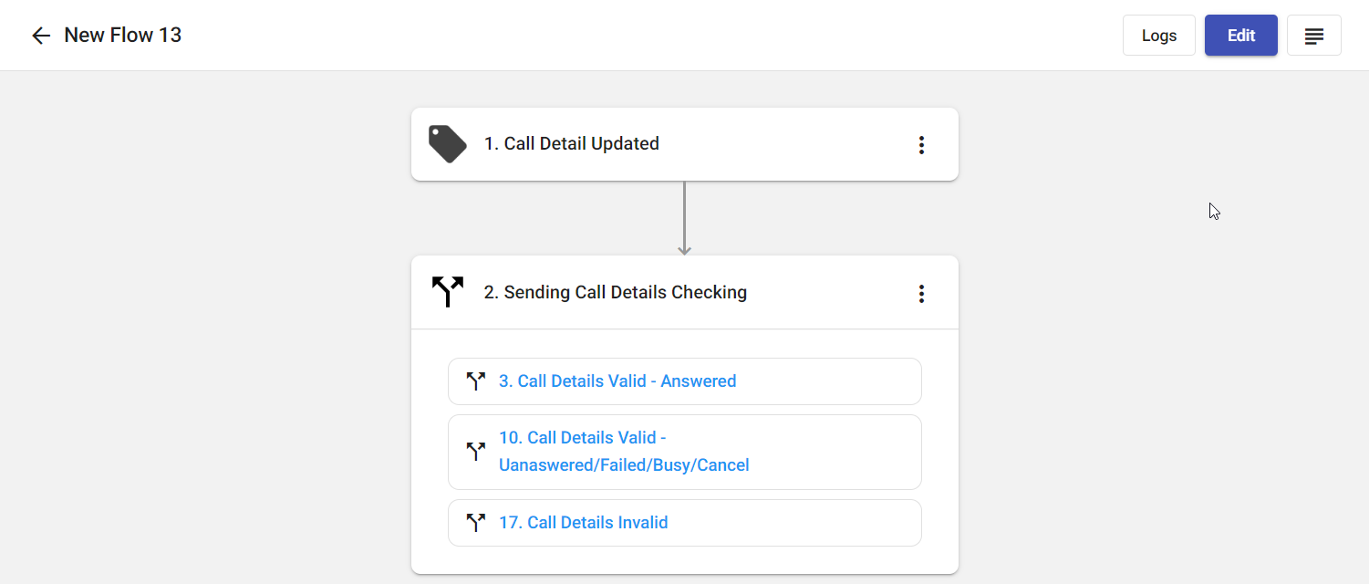

Third-party Ticketing System
CTI webphone will be added to the third party’s system in order for the users to make and receive calls directly from the third party’s platform.
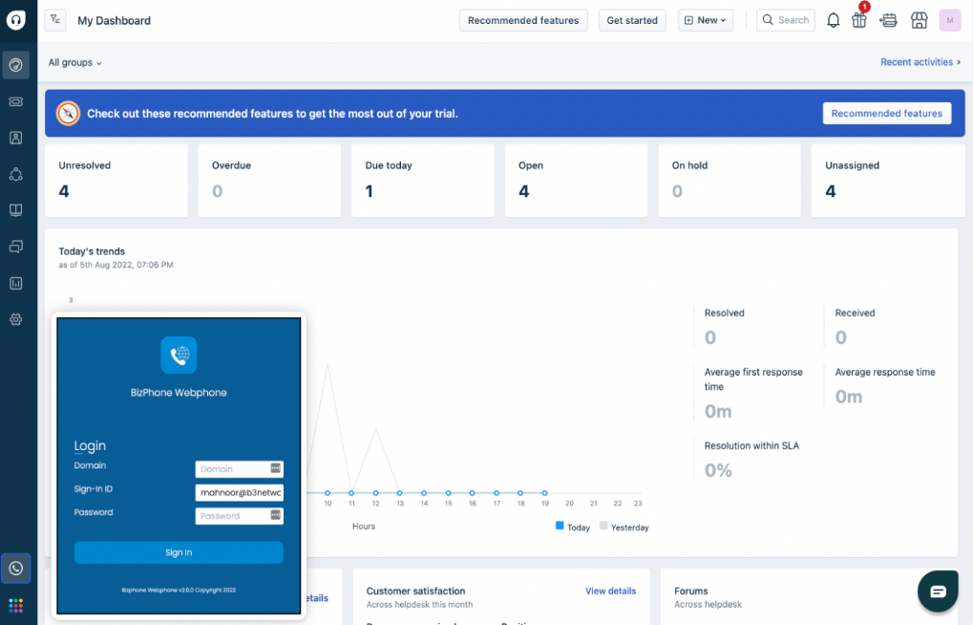
(Freshdesk)

Workflow

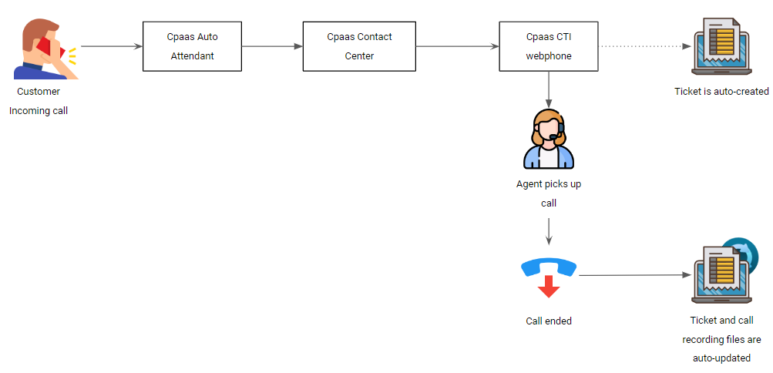

Use Cases In Various Industries
CTI can be a solution for you in dealing with customers by making it easier and more flexible to work so that you can optimally handle problems that arise from customers. This CTI is very suitable for use by industries that are especially engaged in customer service or those related to call centers.

Banking
In the banking industry, CTI can be used to manage customer complaints by creating queues based on the kind of problem that occurs so that agents can handle tickets appropriately based on the queue type.
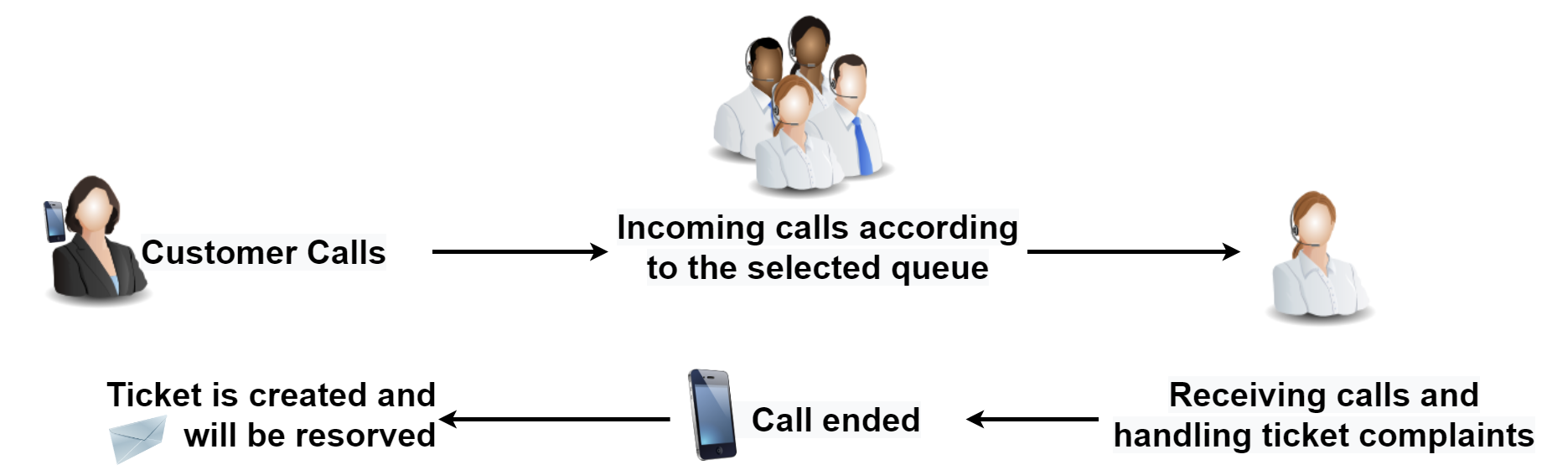

Insurance
CTI can be used in the insurance industry as a form of an agent in offering insurance to customers. The ticketing system enables agents to input and store customer information about the type of insurance the customer chooses to provide them with effective support.
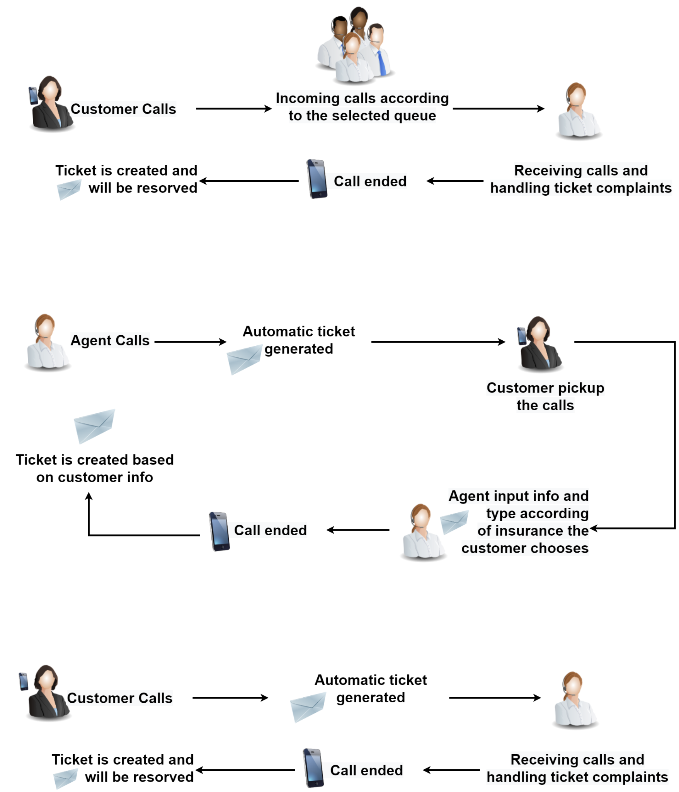

Delivery Service
By creating tickets that are associated with the customers and updating them as necessary until the issue is fully resolved, CTI solutions can assist the delivery industry in managing and supporting customers if there are any complaints about the package delivery process, etc. in an effective manner.

