Apple & the iPhone
Business Case Study
2026 edition

Finance Assessment Task

Note: Pages 1-5 are given to students prior to the assessment
Contents: Pages
Comparative Income Statements for Apple Inc. 2023 – 2025 2
Breakdown of sales revenue by product and region between 2024 and 2025 3-4
Breakdown of expense changes between 2024 and 2025 4
Comparative Balance Sheets for Apple Inc. 2024 - 2025 5
Finance Assessment task including ratios, financial objectives, influences and
strategies for addressing Apple’s financial performance in recent years. 6 - 11

Income Statements, Apple Inc. for financial years of 2023 to 2025 (in millions)

 |  |  | Years ended
 | September 27,  2025 |  | September 28,  2024 |  | September 30,  2023
Sales:
Products | $ 307,003 |  | $ 294,866 |  | $ 298,085
Services | 109,158 |  | 96,169 |  | 85,200
Net sales | 416,161 |  | 391,035 |  | 383,285

Cost of Goods Sold (COGS):
- Products | 194,116 | 185,233 | 189,282
- Services | 26,844 | 25,119 | 24,855
Total Cost of Goods Sold (COGS) | 220,960 | 210,352 | 214,137
Gross profit | 195,201 | 180,683 | 169,148

Operating expenses:
Research and development | 34,550 |  | 31,370 | 29,915
Selling, general and administrative | 27,601 |  | 26,097 | 24,932
Total operating expenses | 62,151 |  | 57,467 | 54,847
Operating income | 133,050 |  | 123,216 | 114,301
Other income/(expense), net | (321) |  | 269 | (565)
Provision for income taxes | 20,719 |  | 29,749 | 16,741
Net profit | $ 112,010 |  | $ 93,736 | $ 96,995

Fiscal Highlights for 2024 /2025
Apple’s revenue rose from about $391 billion in 2024 to roughly $416 billion in 2025, an increase of around 6.5%.
Several factors drove these changes. The launch of the iPhone 17 in the September 2025 quarter helped push quarterly revenue above 100 billion dollars for that period, supporting full-year growth in iPhone sales. Mac revenue achieved solid growth, and Services revenue increased by around 14%.
Sales revenue from the Greater China segment declined in the given period, offset by growth from other regions (particularly in Services and higher-value devices).
Apple has undertaken a share repurchase scheme for the past decade, which involves buying back shares from existing shareholders. This enables higher earnings per share as profit is being divided amongst fewer shareholders.
Note: the value of shares in the balance sheet actually increased due to the price of the shares increasing. However, the number of shares has decreased due to the share repurchase scheme.

 | 2025 |  |  | 2024 |  |  | 2023
Basic earnings per share | $ | 7.49 | $ |  | 6.11 | $ |  | 6.16

Sources: Apple Inc. 2025 Annual Report

Breakdown of Apple’s sales by product
The following table shows net sales by product for 2023, 2024 and 2025 (dollars in millions):

 | 2025 |  | Change |  | 2024 |  | Change |  | 2023
iPhone | $ 209,586 |  | 4 % |  | $ 201,183 |  | — % |  | $ 200,583
Mac | 33,708 |  | 12 % |  | 29,984 |  | 2 % |  | 29,357
iPad | 28,023 |  | 5 % |  | 26,694 |  | (6)% |  | 28,300
Wearables, Home and Accessories | 35,686 |  | (4)% |  | 37,005 |  | (7)% |  | 39,845
Services (1) | 109,158 |  | 14 % |  | 96,169 |  | 13 % |  | 85,200
Total net sales | $ 416,161 |  | 6 % |  | $ 391,035 |  | 2 % |  | $ 383,285

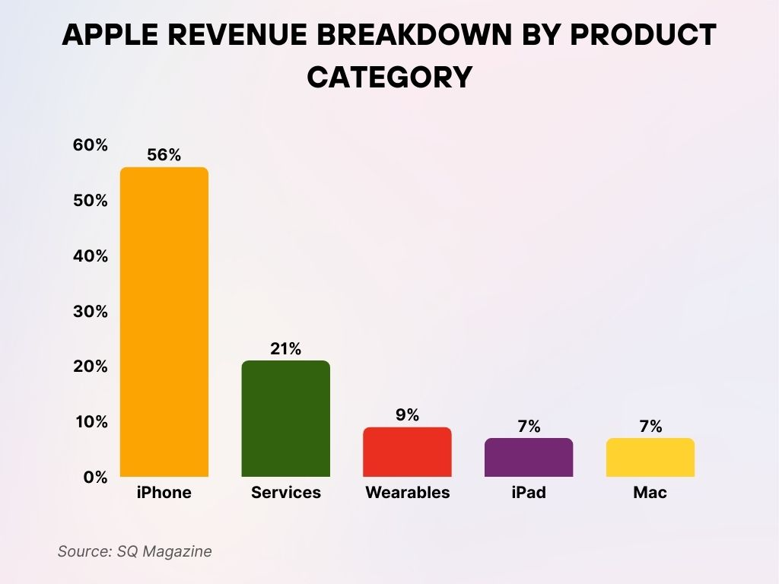
Profitability management strategies:
“The 2024 financial year saw a 2% revenue increase to $391 billion; while iPhone sales remained largely flat.
The 2025 financial year saw a return to stronger sales growth (6.4% increase to $416.2 billion), driven by a 4.1% rise in iPhone revenue ($209 billion). Given the significance of the iPhone (contributing 56% of total sales revenue for Apple), the success of this product is critical to Apple’s financial performance.

Revenue Controls
The strong increase in sales revenue for the iPhone in 2025 indicated effective revenue controls due to:
- Growth in emerging markets, particularly India, where localised manufacturing and competitive pricing for older models helped boost overall iPhone sales. Apple seeks to increase market share in the high growth Indian market where sales are projected to growth 6-8% in the next decade. The company is focusing on lower-cost models and targeting festive promotions (further details on page 75 of the case study).
- Government influences: The stimulus on page 3 identifies that some iPhone purchases were triggered by panic buying due to threat of tariffs linked to US trade policy (around 1% of revenue growth attributed to this threat).
- Effective marketing mix: The iPhone 17 Pro and Pro Max models were well-received as high-quality, premium devices. Furthermore, Apple discontinued older models and focused on a product lineup (including the 17 Pro/Air) that encouraged customers to choose mid-to-high tier options. The use of iOS upgrade to make older models redundant was also effective in forcing replacement purchases.
As a result, Apple led the global smartphone market with a 20% share and a 10% year-over-year growth in 2025, surpassing Samsung in annual shipments for the first time in 14 years.
Beyond the iPhone, Apple achieve a substantial 12.7% increase in Mac sales in 2025, indicating that consumers were undertaking premium product upgrades, alongside continued Services growth exceeding $100 billion.
The combination of these factors ultimately led to Apple achieving record profits in 2025.

TASK:
Refer to pages Refer to pages 75-76 of the Apple & the iPhone Business Case Study, 2026 edition to summarise Apple’s revenue controls related to established markets (US and Europe), emerging markets (such as India), and the highly fluctuating market of Greater China.

________________________________________________________________________________________________________________________________________________________________________________________________________________________________________________________________________________________________________________________________________________________________________________________________________
________________________________________________________________________________________________________________________________________________________________________________________________________________________________________________________________________________________________________________________________________________________________________________________________________
________________________________________________________________________________________________________________________________________________________________________________________________________________________________________________________________________________________________________________________________________________________________________________________________________
________________________________________________________________________________________________________________________________________________________________________________________________________________________________________________________________________________________________________________________________________________________________________________________________________________________________________________________________________________________________________________________________________________________________________________________________________________________________________________________________________________________________________________________________________________________________________________________________________________

Breakdown of Operating Expenses between 2023 and 2025 (dollars in millions):

 | 2025 |  | Change |  | 2024 |  | Change |  |  | 2023
Research and development | $ 34,550 |  | 10 % |  | $ 31,370 |  |  | 5 % |  | $ 29,915
Percentage of total net sales | 8% |  |  |  | 8% |  |  |  |  | 8%
Selling, general and administrative | $ 27,601 |  | 6 % |  | $ 26,097 |  |  | 5 % |  | $ 24,932
Percentage of total net sales | 7% |  |  |  | 7% |  |  |  |  | 7%
Total operating expenses | $ 62,151 |  | 8 % |  | $ 57,467 |  |  | 5 % |  | $ 54,847
Percentage of total net sales | 15% |  |  |  | 15% |  |  |  |  | 14%

A significant increase in expenses related to research and development has led to an overall increase in Apple’s expenses in the given period. This has been attributed to an increase in the number of employees in R&D (increasing the costs of wages and salaries) as well as growing costs for engineering programs.
However, it can be seen in the data above that the Percentage of total net sales in all categories of expenses increased proportionately to sales revenue in the given period. This means that whilst expenses increased by 5-8% each year, there was an equivalent percentage increase in sales revenue in the given period.
Ideally, a company wants to grow sales revenue whilst keeping expenses controlled to improve profit margins and the efficiency of managing expenses. Reducing expenses as a percentage of sales (or average costs) by growing would mean that economies of scale are being achieved.
Source: Apple Inc. 2025 Annual Report
TASK:
Refer to pages 77-78 of the Apple & the iPhone Business Case Study, 2026 edition to summarise how Apple implements cost controls (COGS and expenses) in the company’s profitability management strategies.

________________________________________________________________________________________________________________________________________________________________________________________________________________________________________________________________________________________________________________________________________________________________________________________________________
________________________________________________________________________________________________________________________________________________________________________________________________________________________________________________________________________________________________________________________________________________________________________________________________________
__________________________________________________________________________________________________________________________________________________________________________________________________________________________________________________________________________________________________________________________________________________________________________________________________________________________________________________________________________________________________________
Apple Inc. Balance Sheets
(In millions, except number of shares which are reflected in thousands and par value)

 |  | 2025 | 2024
ASSETS:
Current assets:
Cash and cash equivalents |  | $ 35,934 | $ 29,943
Short-term investments |  | 18,763 | 35,228
Accounts receivable |  | 39,777 | 33,410
Inventories |  | 5,718 | 7,286
Other current assets |  | 47,765 | 47,120
Total current assets |  | 147,957 | 152,987
Non-current assets:
Long-term investments |  | 77,723 | 91,479
Property, plant and equipment, net |  | 49,834 | 45,680
Other non-current assets |  | 83,727 | 74,834
Total non-current assets |  | 211,284 | 211,993
Total assets |  | 359,241 | 364,980
LIABILITIES AND SHAREHOLDERS’ EQUITY:
Current liabilities:
Accounts payable |  | 78,328 | 85,750
Other current liabilities |  | 41,549 | 45,888
Total current liabilities |  | 119,877 | 131,638
Non-current liabilities:
Long-term debt | 78,328 |  | 85,750
Other non-current liabilities | 41,549 |  | 45,888
Total non-current liabilities | 119,877 |  | 131,638
Total liabilities | 285,508 |  | 308,030
Owners’ equity:
Common stock and additional paid-in capital: 50,400,000 shares | 93,568 | 83,276
Other equity | (19,835) | (26,326)
Total Owners’ equity | 73,733 | 56,950
Total liabilities and Owners’ equity | $ 359,241 | $ 364,980

Note: the value of shares in the balance sheet actually increased due to the price of the shares increasing. However, the number of shares has decreased due to the share repurchase scheme.
The Balance Sheet reflects the accounting equation:
ASSETS = LIABILITIES + OWNERS EQUITY
This illustrates how the assets of the business have been financed - by either debt or owners’ equity.
Financial Assessment Task
- Using the financial statements provided on pages 2 and 5, calculate the following financial ratios for Apple Inc in 2025. Show all working.

Financial year ending September | 2023 | 2024 | 2025
Liquidity: Show working & answers in column below
Current ratio  Current Assets / Current Liabilities | 0.99 : 1 | 0.87 : 1
Gearing (solvency):
Debt to equity ratio  Total Liabilities / Owner’s equity | 467 %  4.67 : 1 | 541 %  5.41 : 1
Profitability:
Net profit ratio  Net Profit / Sales Revenue | 25.3 % | 24 %
Gross profit ratio  Gross Profit / Sales Revenue | 44.1 % | 46.2 %
Return on Owner’s equity  Net Profit / Owner’s equity | 156 % | 165%
Efficiency:
Expense Ratio  Expenses / Sales Revenue | 14.3 % | 14.7 %
Accounts Receivable Turnover  - Sales / Accounts Receivable = times  - 365 / turnover times = turnover days | 13 times  28 days | 11.7 times  31.2 days
Total / 7 marks

Refer to the data provided on pages 2-7 to complete the following:
Liquidity

- Define liquidity and how it is measured using the current ratio.

________________________________________________________________________________________________________________________________________________________________________________________________________________________________________________________________________________________________________________________________________________________________________________________________________

/ 2 marks

- Assess the change in Apple’s liquidity between 2023 and 2025 and identify 2 possible strategies that Apple can employ to improve working capital. Tip: Refer to information on pages 6 – 7 and pages 71-73 of the Apple & the iPhone Business Case Study, 2026 edition

________________________________________________________________________________________________________________________________________________________________________________________________________________________________________________________________________________________________________________________________________________________________________________________________________________________________________________________________________________________________________________________________________________________________________________________________________________________________________________________________________________________________________________________________________________________________________________________________________________

/ 4 marks

Solvency: A summary of Apple’s liabilities and owner’s equity for 2023, 2024 & 2025
(US$ in millions)
 | 2023 | 2024 | 2025
Total liabilities | 290,437 | 308,030 | 285,508
Total Owners’ equity | 62,146 | 56,950 | 73,733
Total liabilities and Owners’ equity | $ 352,583 | $ 364,980 | $ 359,241

Source of extract: Apple’s 2023 Annual Report
Between 2014 and 2024, Apple significantly increased its holding of long-term debt in response to historically low interest rates, particularly following Covid. The expense of interest payments (cost of debt finance) was cheaper than paying dividends (cost of equity finance).
In recent years, rising inflation and interest rates have increased the expense of borrowing (interest payments). Apple’s more recent gearing strategy has been to reduce total liabilities and increase equity, leading to a significant improvement in the debt-to-equity ratio.

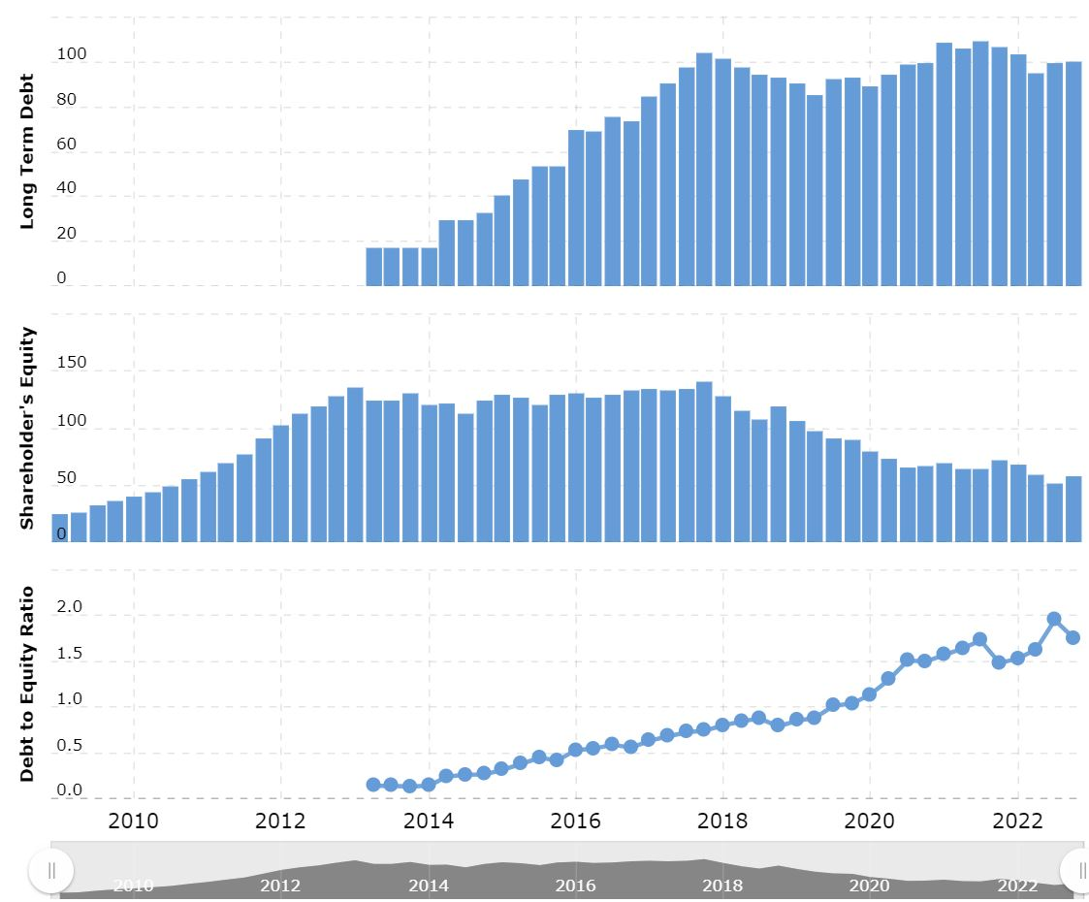

4. Define solvency and evaluate the change in Apple’s solvency (debt to equity ratio) between 2024 and 2025. Refer to the data above as well as the ratios calculated on page 7.
Hint: explain the changes for each component of the debt-to-equity ratio.

________________________________________________________________________________________________________________________________________________________________________________________________________________________________________________________________________________________________________________________________________________________________________________________________________________________________________________________________________________________________________________________________________________________________________________________________________________________________________________________________________________________________________________________________________________________________________________________________________________
/ 5 marks
Profitability
- (a) Refer to the Income Statements provided on page 2 and circle increased or decreased to indicate the changes in Apple’s profitability between the financial years of 2024 and 2025:

- Net Sales increased/decreased

- Cost of goods sold increased/decreased

- Total Operating expenses increased/decreased

- This resulted in an overall increase/decrease in net profit after tax / 2 marks

- (b) Assess the effectiveness of Apple’s revenue controls (profitability management strategies) between 2024 and 2025. Refer to the data on pages 2-5 and 7 including the summary task on page 4.

__________________________________________________________________________________________
__________________________________________________________________________________________
__________________________________________________________________________________________
__________________________________________________________________________________________
__________________________________________________________________________________________
__________________________________________________________________________________________
__________________________________________________________________________________________
__________________________________________________________________________________________
__________________________________________________________________________________________
__________________________________________________________________________________________
__________________________________________________________________________________________
__________________________________________________________________________________________
__________________________________________________________________________________________
_________________________________________________________________________________________ / 4 marks

- (c) With reference to the data on pages 4-5, outline two types of cost controls (COGS and expenses) related to Apple’s profitability management strategies.

__________________________________________________________________________________________
__________________________________________________________________________________________
__________________________________________________________________________________________
__________________________________________________________________________________________
__________________________________________________________________________________________
__________________________________________________________________________________________
__________________________________________________________________________________________
__________________________________________________________________________________________
__________________________________________________________________________________________
__________________________________________________________________________________________

/ 4 marks

6. (a) Apple Inc. return on owner’s equity increased/decreased from 165% in 2024 to _________% in 2025.

/ 1 mark

- (b) With reference to the ratio, explain the change in Apple’s Return on Owner’s equity between 2024 and 2025.
__________________________________________________________________________________________
__________________________________________________________________________________________
__________________________________________________________________________________________
__________________________________________________________________________________________
/ 3 marks

Efficiency:
Circle correct answer and fill in the missing data
7. (a) Summarise the following changes in the Apple’s efficiency ratios between 2024 and 2025:
- Apple’s expense ratio increased/decreased from 14.7% in 2024 to _________% of net sales in 2025.

- This represents an overall improvement / decline in Apple’s efficiency between 2024 and 2025.

- Apple’s accounts receivable turnover days increased/decreased to_________ days in 2025.

- This led to an overall decrease/increase in the turnover times of accounts receivable, to ______________ times per year in 2025.

/ 4 marks

7. (b) Explain the key reasons for increases in Apple’s expenses in recent years. Refer to the information on page 4 – 5 in your response.
__________________________________________________________________________________________
__________________________________________________________________________________________
__________________________________________________________________________________________
__________________________________________________________________________________________
__________________________________________________________________________________________
__________________________________________________________________________________________
__________________________________________________________________________________________
__________________________________________________________________________________________
/ 4 marks

Total / 40 marks

