  GRADES 1 to 12  DAILY LESSON LOG | School: | DepEdClub.com | Grade Level: | V
 | Teacher: | File Created by Ma’am AMILEEN M. MALVAR | Learning Area: | MAPEH
 | Teaching Dates and Time: | NOVEMBER 7 - 11, 2022 (WEEK 1) | Quarter: | 2ND QUARTER

 | MONDAY | TUESDAY | WEDNESDAY | THURSDAY | FRIDAY
I. OBJECTIVES
A. Content Standards | Recognizes the musical symbols and demonstrates understanding of concepts pertaining to melody | Demonstrates understanding of lines, colors, space, and harmony through painting and explains/illustrates landscapes of important historical places in the community (natural or man-made)using one-point perspective in landscape drawing, complementary colors, and the right proportions of parts | Demonstrates understanding of the different changes, health concerns and management strategies during puberty | Demonstrates  understanding of  participation in and  assessment of physical  activity and physical  fitness | CLUSTER MEET
B. Performance Standards | Accurate performance of songs following the musical symbols pertaining to melody indicated in the piece | Sketches natural or man-made places in the community with the use of complementary colors.  draws/paints significant or important historical places | Demonstrates health practices for self-care during puberty based on accurate and scientific information | Participates and assesses  performance in physical  activities.
C. Learning Competencies/ Objectives Write the LC code for each | 1. recognizes the meaning and uses of  F-Clef on the staff  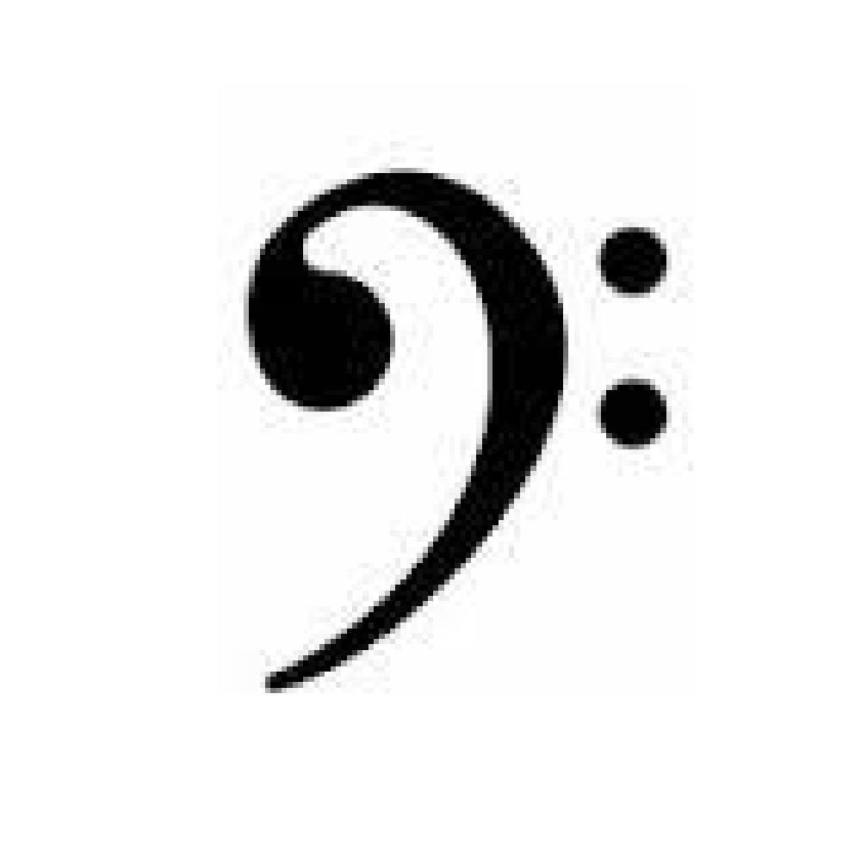 MU5ME-IIa-1 | 1. identifies the importance of natural and historical places in the community that have been designated as World Heritage Site (e.g., rice terraces in Banawe, Batad; Paoay Church; Miag-ao Church; landscape of Batanes, Callao Caves in Cagayan; old houses inVigan, Ilocos Norte; and the torogan in Marawi)  A5EL-IIa | Describes the physical, emotional and social changes during puberty  H5GD-Ia-b-1 | Describes the Philippines  physical activity pyramid  PE5PF-IIa-16
II. CONTENT | MELODY | I. Elements:  1. LINE  1.1 straight and curved  2. COLOR  2.1 complementary  3. SPACE  3.1 one-point perspective In landscape drawing | Changes during Puberty | Assessment of  physical  activities and  physical fitness  Invasion games  (agawan base, lawin at sisiw,  laglag panyo
III. LEARNING RESOURCES
A. References
1. Teacher’s Guide pages | K TO 12 TG pp. | K TO 12 TG pp | K TO 12 TG pp | K TO 12 TG pp
2. Learner’s Material pages | K TO 12 LM pp. | K TO 12 LM pp. | K TO 12 LM pp. | K TO 12 LM pp.
3. Textbook pages
4. Additional Materials for Learning Resource Portal | Mp3 player, speakers | Posters of tourist spot in the Philippines | Posters of a child and teenagers | Mp3 player, speakers
B. Other Learning Resources
IV. PROCEDURES
A. Reviewing previous lesson or presenting the new lesson | Show a rhythmic pattern on the board. Let the pupil clap their hands for each note. | What are the old buildings found in the Philippines? | What is emotional health? mental health? social health? | Ask pupil to give examples of larong Pinoy
B. Establishing a purpose for the lesson | Play a song on the MP3 player. Allow pupils to listen to it thoroughly | Introduce about straight and curve line | Tell the objective of the new lesson  Original File Submitted and Formatted by DepEd Club Member - visit depedclub.com for more | Play the song “Sabay-sabay tayo by Marian Rivera and ask pupil to do 2 minutes fitness exercise/ warm up
C. Presenting examples/ instances of the new lesson | Show the symbol of a F-clef | Show pictures of different tourist attraction in the country like Banaue Rice terraces | Show a picture of a child and a teenager. | Demonstrate some movement performed in work or at play
D. Discussing new concepts and practicing new skills #1 | Discuss the meaning and uses of F-clef | Demonstrate how to sketch | Ask pupil to say what they observe from the pictures | Discuss the Philippines physical activity pyramid
E. Discussing new concepts and practicing new skills #2 | In a cartolina, show a staff with a missing F-clef. Allow pupils to draw the F-clef | Apply the straight and curve lines in sketching | Explain about Puberty | Demonstrate the movement
F. Developing mastery  (Leads to Formative Assessment 3) | Group the class into four. Tell pupils to write down the use of F-clef in a metacard. | Ask what is the importance of historical places in the counry? | Ask pupil to get a partner. List down the changes of the body during puberty | Ask pupil to imitate the movement shown
G. Finding practical application of concepts and skills in daily living | Let the pupil identify the F-clef in the staff | Skills demonstration; Let pupils sketch the rice terraces | Group the pupil. Let them Roleplay on taking care of their body during puberty | Group the pupil to play agawan base. Explain the mechanics of the game
H. Making generalizations and abstractions about the lesson | What is a F-clef? | What are the lines used in our sketch? | What are the changes in your body during puberty? | What is a Physical activity pyramid?
I. Evaluating learning | Complete the sentence. Today I learnt about ________. | Let pupil draw using straight and curve line | Give 5 items seatwork | Ask pupil to sight 5 examples given in the physical activity pyramid
J. Additional activities for application or remediation | Draw a F-clef in a given staff | Pupils will draw the old houses in Vigan | Essay: Describe the changes during puberty | Group the pupils. Let them create their own exercise movement
V. REMARKS
VI. REFLECTION
A. No. of Learners who earned 80% in the evaluation
B. No. of Learners who require additional activities for remediation who scored below 80%
C. Did the remedial lessons work? No. of Learners who have caught up with the lessons
D, No. of Learners who continue to require remediation
E. Which of my teaching strategies worked well? Why did these work?
F. What difficulties did I encountered which my principal or supervisor can help me solve?
G. What innovation or localized materials did I use/discover which I wish to share with other teachers?

