Plexus x [Customer] Configuration Guide Document

Welcome to your configuration journey with Plexus!
This admin guide has been provided with the order in which configuration should be completed in mind. Please complete each step to the best of your ability before progressing to the next.
Note that, Plexus configuration is completely customisable and able to continue to be iterated upon. We are aiming for progress over perfection in these early stages of onboarding in order for us to continue moving forward. As we continue to test and learn together, we will likewise keep updating the configuration.
Plexus works with a ‘train the trainer’ model meaning that you will be asked to complete certain configuration items yourselves. The reason for this is to ensure that you will be able to continue to maintain your Plexus instance moving forward to ensure that Plexus can adapt and change with your business.

You have a whole team dedicated to the success of your Plexus Project! Please reach out to the following team members at any time:
Technical Support – for any technical support queries you can either utilise the blue bubble in the bottom right hand corner to reach out to our support team directly or email them on:
Email: support@plexus.co

Your Senior Consulting and Configuration Specialist – for all things custom-app and integration related:
[Name]
Email:
Mobile:

Your Implementation Manager – for standard app configuration, training and adoption related queries:
[Name]
Email
Mobile:
Your dedicated Customer Success Manager – your overall account manager
[Name]
Email:
Mobile:

Contents

- Configuring your Organisation Unit Structure
- Managing your Account’s User Roles
- Customising your Account’s Document Types
- Creating Custom Questions for Documents
- Creating and Editing Delegation Rules
- Customising your Document List View
- Editing Matter Categories and Sub-Categories
- Creating Custom Questions for Matters
- Managing your Matters List Settings
- Managing your Userbase: Assigning Users to Organisation Units and Roles
- Plexus Standard un-editable questions
- Plexus’ AI Security Fact Sheet
- Definition of a “Professional User” within Plexus

Configuring your Organisation Unit Structure
To view a video tutorial on Organisation Units you can go to this link.
Organisation units in Plexus allow you to replicate your organisation's company structure. From the company structure tab, you can add users to specific organisation units or teams, whilst maintaining secure and limited visibility of the documents and matters stored in the platform.
Organisations units can be siloed, or they can dictate oversight over other areas of the platform.
After establishing the company hierarchy basics, this guide will talk through the adding, editing and removal of your organisation units.

Establishing the hierarchy basics - definitions
The following section will talk through the hierarchy basics using illustrations to discuss the definitions and theory behind:
- Root organisations
- Parent and child (sub-unit) organisations
- Siloing organisation units

Definition 1. The root of the company structure
All organisation units on Plexus are connected to a root or base organisation.
​
The root organisation controls all the user roles, document types, matter categories, custom questions, delegation rules and applications that are associated with your Plexus account.
​
In most company hierarchies on Plexus, users cannot log into the root organisation. Here is an illustrated an example organisation unit structure:
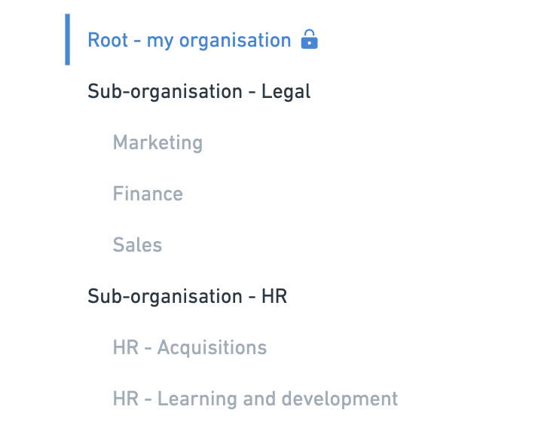
Definition 2. Parent versus child organisation units
Throughout this guide, a unit stemming from another will be referred to as a child unit. The unit it stems from will be referred to as the parent unit.
Parent and child units are visualised as indents in the company structure.


A parent unit usually has oversight over a child unit.
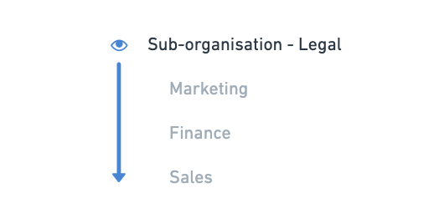
When a unit has oversight over another child or sub-organisation unit, a reviewer or manager role who has the permissions to view all documents will be able to see downwards into the collection of documents stored in child units. The same is true for a legal user having access to matters.
We'll go into these implications in more detail in the next section.

Definition 3. Siloed organisation units
Units at the same level of indentation in the company structure are siloed from one another.

When units are siloed, the documents and matters associated with that unit can be kept entirely separate from other organisation units, regardless of the roles and access a given user might have.
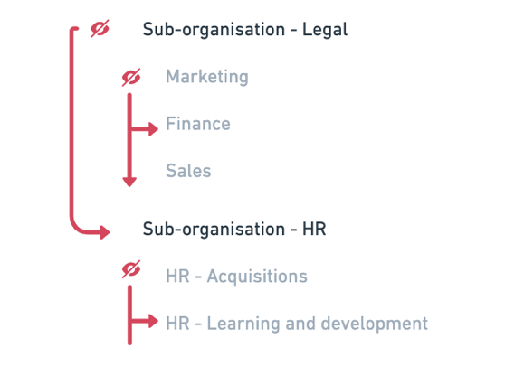
It is recommended that at least one company administrator has some access to any siloed units, so that users can be added to those organisations. If document visibility is a concern, ask your onboarding expert about configuring a custom role with access to settings, without visibility of all documents.

User access to company units
All Plexus users can be given access to one or more organisation units.
If an individual is added to multiple units, then the individual user can select which unit to work in when they sign into the platform.
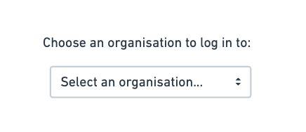

User roles and document visibility across the hierarchy
Units and roles work together to provide access to documents and matters across the platform.
Default manager and reviewer roles in a given unit can see any documents or matters created down the hierarchy into child units, but they will not have access to documents that are created up or across the hierarchy.

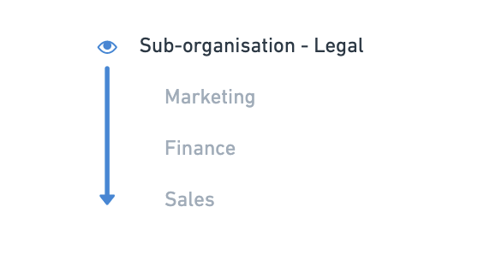

For example, a manager or reviewer role in Sales will not be able to see upwards in their organisation hierarchy.

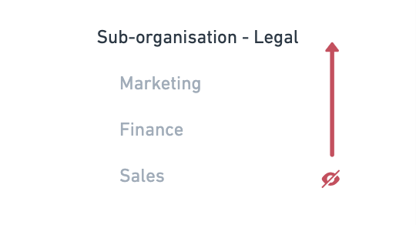

A general user will only have access to the files that they have created or the files that have access to via a workflow or shared document.
We'll go through examples of these concepts using screenshots of the platform below.

Adding units to your company structure
To add units to your company structure, click the Settings menu, then click Account. The first tab will show your company structure. This is where you will be able to make the appropriate changes to your company structure in the platform.

By default, you will see the root organisation highlighted with your company's billing details to the right of the page.

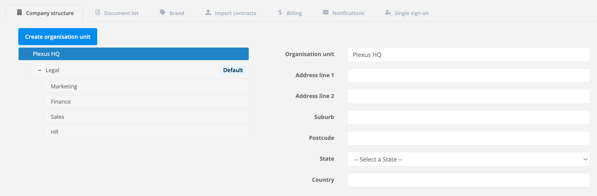

The units listed underneath the root organisation represent any organisation unit that your users can log into. You may continue to expand upon any units with a + until the full organisation structure is revealed.
You will notice that any child organisations are indented on the above structure. In this example Finance, Marketing, Operations and Procurement are all child organisations. The parent organisation is Legal.
Therefore, a manager/reviewer account in the Legal unit will be able to see the files created in any of those organisations on their document list.
Any organisations that sit on the same level of indentation (for example HR and Legal) will be siloed, and manager/reviewer accounts will not be able to see across into those units unless they're given express access to both units.
Using the diagram above, if you are a manager or reviewer in Marketing:
- You will not be able to see the documents in Legal because it is the parent organisation.
​
- You will not be able to see the documents in Finance, Operations or Procurement because they have the same level of indentation
​
- If there was a unit underneath Marketing (see below for the examples B2B Marketing and Digital Marketing), then a manager or reviewer in the marketing unit would have oversight into the documents found in those child units.
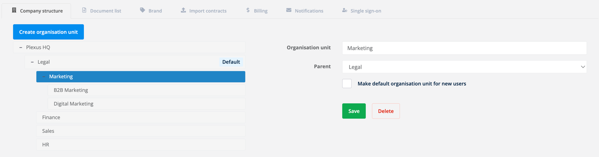

To add a new organisation unit to the company structure, click Create organisation unit. To the right of the page, you'll be prompted to fill in the new organisation unit's name and nominate the parent unit.
Organisation unit. The name of your new unit
Parent. The name of the existing unit that your new unit will sit underneath.

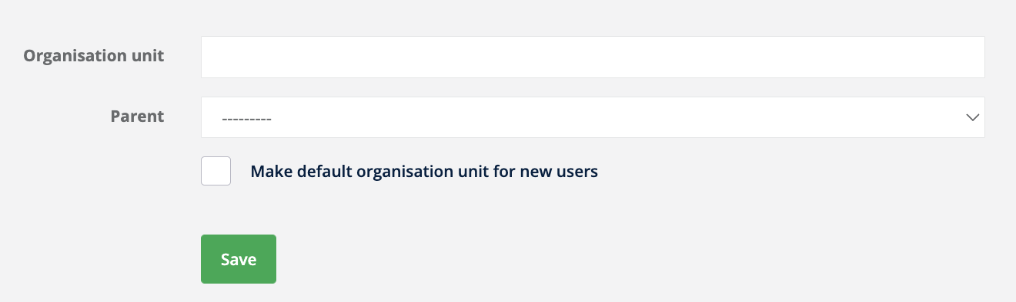
Top tip! In most company structures created for the purposes of Plexus, Legal is often a parent organisation unit for a number of other units, indicating enhanced visibility over any documents loaded to the child units, provided that the user on the Legal unit has the right permissions.

You can also make your new unit the default unit for new non-invited users within your organisation.

Click Save once you're happy with your inputs.

The new organisation unit will automatically slot into the company structure.

Editing existing units in your company structure

To edit an existing organisation unit, locate and click the desired unit on your company structure. From the right hand side of the page, you will be able to edit the existing unit's name, and its parent by choosing from the dropdown list as required.
Remember to click Save once you're done.

Removing organisation units from your company structure
To remove an organisation unit from your company structure, select an existing unit on your company structure. From the right hand side of the page, you'll see a red button to Delete an organisation unit.
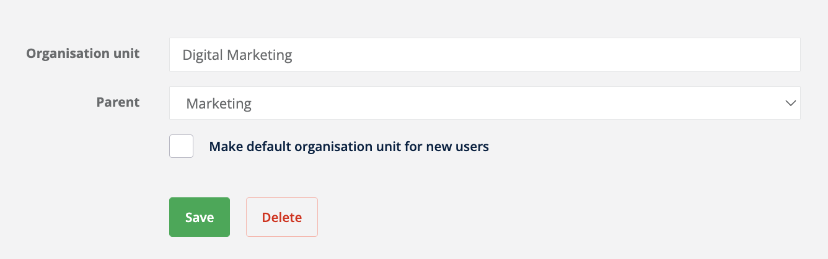

Top tip! If you have users within the organisation units that you're trying to delete, we will prompt you to reassign those users to another unit.

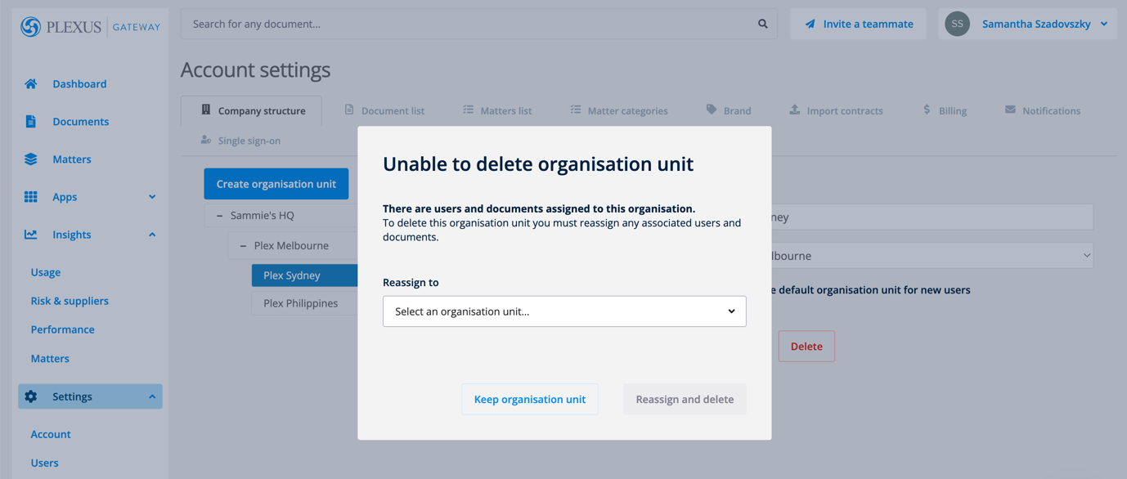

Another tip! You will not be able to delete a default unit from the company structure. Please nominate a new default organisation before attempting to delete your default organisation unit.
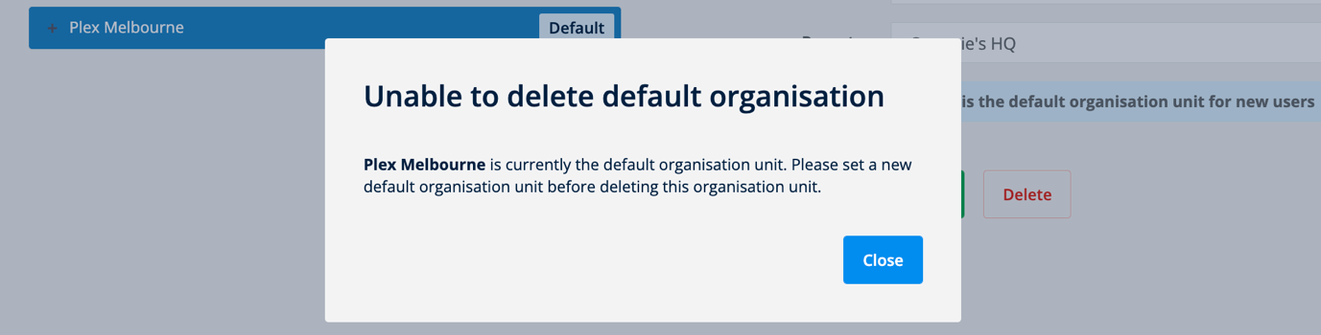

Managing your Account’s User Roles
To view a video tutorial on managing your user roles you can go to this link.
Each account in Plexus has a set of roles attached to their account. These roles allow each account to have:
- Access to specific platform features
- Access to specific applications on the Dashboard
- Permissions related to specific document types
The new roles functionality gives admins the ability to manage the different sets of permissions given to the different accounts in your organisation.
By default, an organisation in Plexus will have 3x roles that come as standard with your set-up.
- Basic (older accounts will have the reference to "User")
- Manager
- Reviewer (older accounts will have the reference to "Owner")
The Basic role is often given to most accounts on Plexus, whilst the Reviewer is the most senior role in the platform by default.
From the Roles page in Plexus, you can manage the different permissions and levels of access given to each role. We'll go into this in more detail below.

Managing roles
To manage roles, you'll need admin access to Plexus. Under the Settings menu, click into the Roles tab.
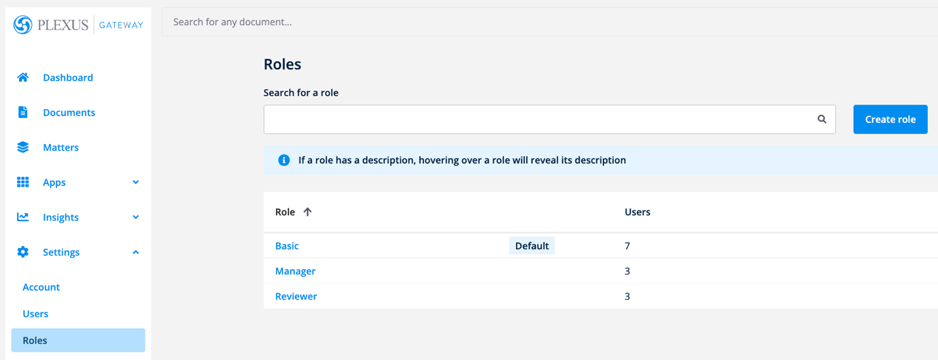
From here, you'll see:
- A list of all roles associated with your organisation
​
- Your default roles which are automatically assigned to new accounts
​
- The number of users associated with a given role
You'll be able to sort by ascending or descending order by clicking the column headings for each of the above fields.
You can use the Search bar to start typing the name of the role. Click the role to edit.

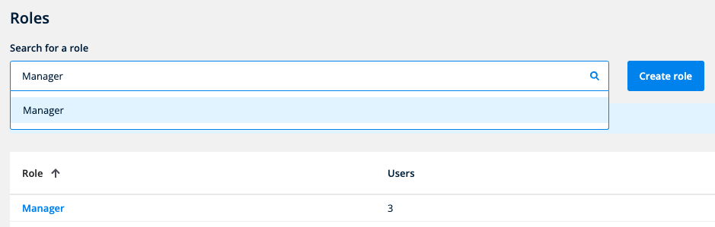

From the roles list, you can click Create role or click the name of any existing role from the list to edit its permissions.
Managing roles
On the resulting page, you'll see.a page allowing you to edit all key elements of a given role.
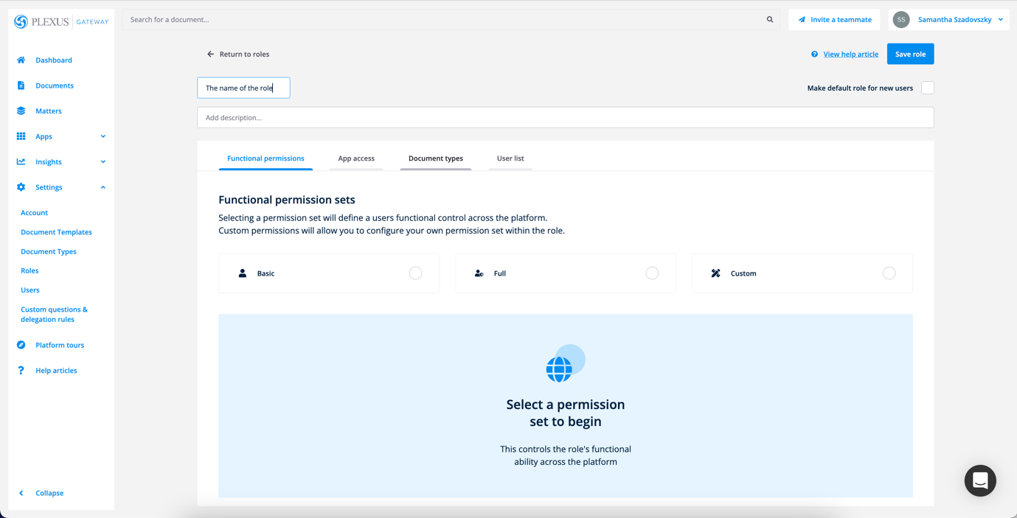

Click the heading to edit the name of a given role. You can also add a brief description to
help you to find the role later.
The checkbox option to Make default role for new users on the top right hand side of the page will update the default role for new accounts signing up to the platform.
Ticking this button means that when new individuals are invited to the platform, they will be assigned this role by default.

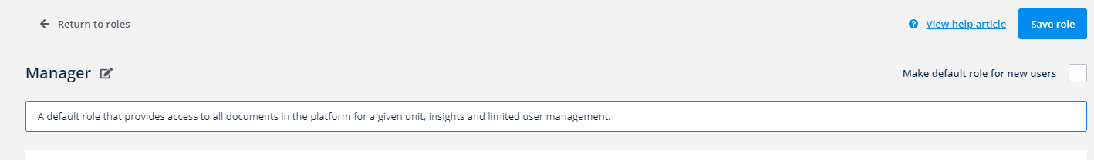

Note that you can Save role in the top right hand corner of the top right hand corner of your screen. We recommend clicking this when making major changes to the role.
When creating or editing a role in the system, you'll have the ability to configure the following aspects of the role.
- Functional permissions
- App access
- Document types
- User lists



Functional permissions

The Functional permissions tab defines a role's access to different features in the platform.
By default, an account in plexus would be able to:
- Create documents (for the apps that the role has access to)
- Edit own documents
- View own documents
- Delete own documents unless they are executed
- Log into different business units, where you have access to multiple units
In addition to these default permissions, there are three types of permission sets that you can configure from this roles page.

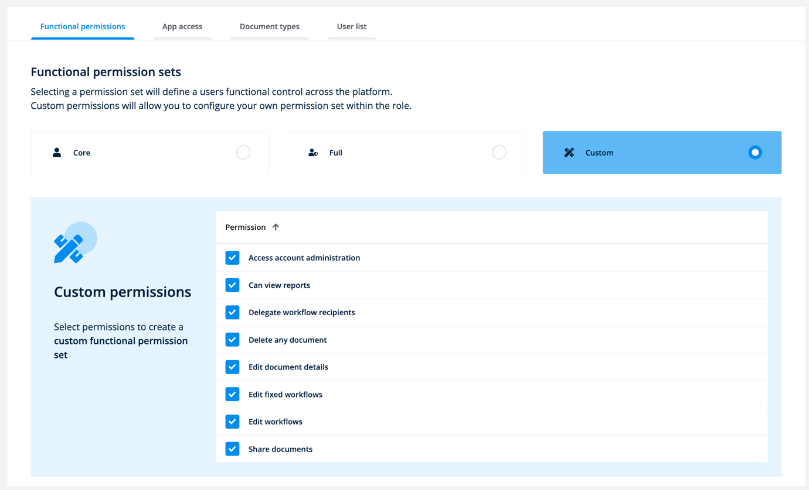
- Core - provides a group of the essential features that a role should be able to access in the platform including:
​
  - Delegating workflow recipients
  - Editing document details
  - Editing unlocked workflows
  - Sharing documents
  - Viewing the knowledge centre (for legacy clients only)
​
- Full - provides a group of all available permission sets on the page including:
​
  - Accessing account administration including the User list
  - Viewing reports
  - Delegating workflow recipients
  - Deleting any document including executed documents
  - Editing document details
  - Editing fixed workflows
  - Editing the knowledge centre (for legacy clients only)
  - Editing workflows
  - Sharing documents
  - Viewing the knowledge centre (for legacy clients only)
​
- Custom - allows you to pick and choose which permission sets you would like available for a given role.

Don't forget to Save role after making major changes to this section.

App access
The App access tab highlights the applications that the role will have access to from the Dashboard. Use the checkboxes to select or unselect the applications that you would like this role to access from the Dashboard.
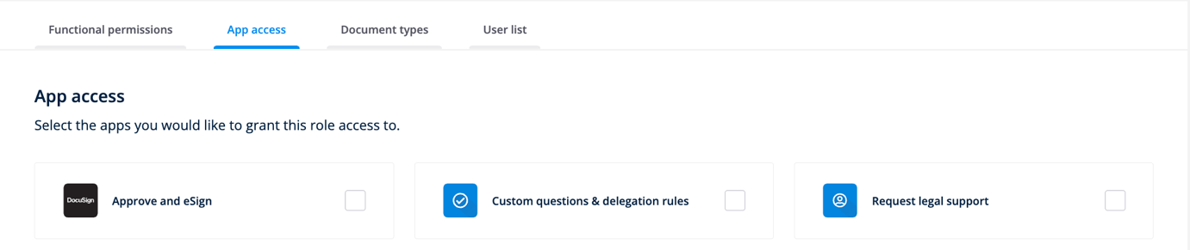

Document types
The Document types tab determines what level of access or visibility that accounts with this role will have for a given document.
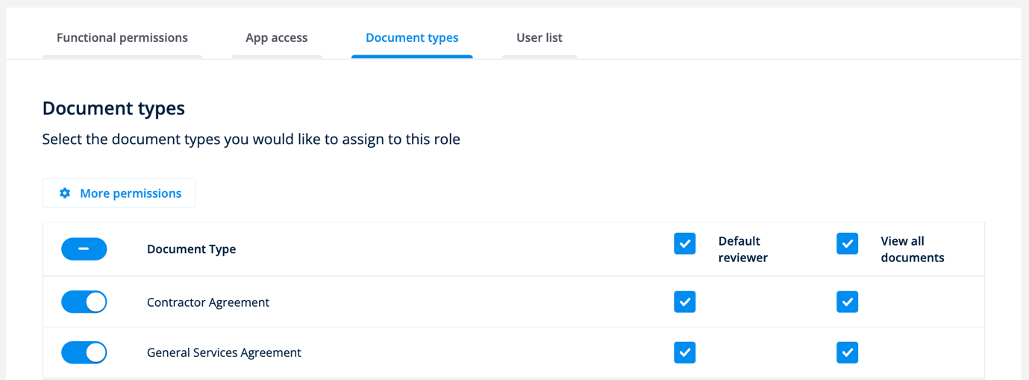
Toggle a document type on to manage the document-specific settings for this role. For each document type, you'll be able to choose whether this role will be able to:
- Review files of each document type where a document workflow uses the default reviewers.
​
  - Important! Default review is a feature reserved for licensed users. Therefore any accounts linked to a role will require a paid licence if Reviewer is ticked on this screen.
​
- View all files of this document type in line with your company structure

If both of these buttons are unticked, accounts with this role will still be able to:

- Select this document type from their dropdown list when uploading a new file. The intake form dropdown list is not managed or limited by roles.
- Advance the workflow by approving or signing, if they're approvers or signers listed on an Approve and eSign workflow.

User lists
You may already be across how to assign roles to an individual in Plexus. This section goes one step further and details how an administrator might bulk assign or bulk remove a number of accounts from a given role.
Last but not least, you can use the User list tab to add accounts to the role in bulk. Use the search bar to add accounts to the role, then click Add user to add them to the list.

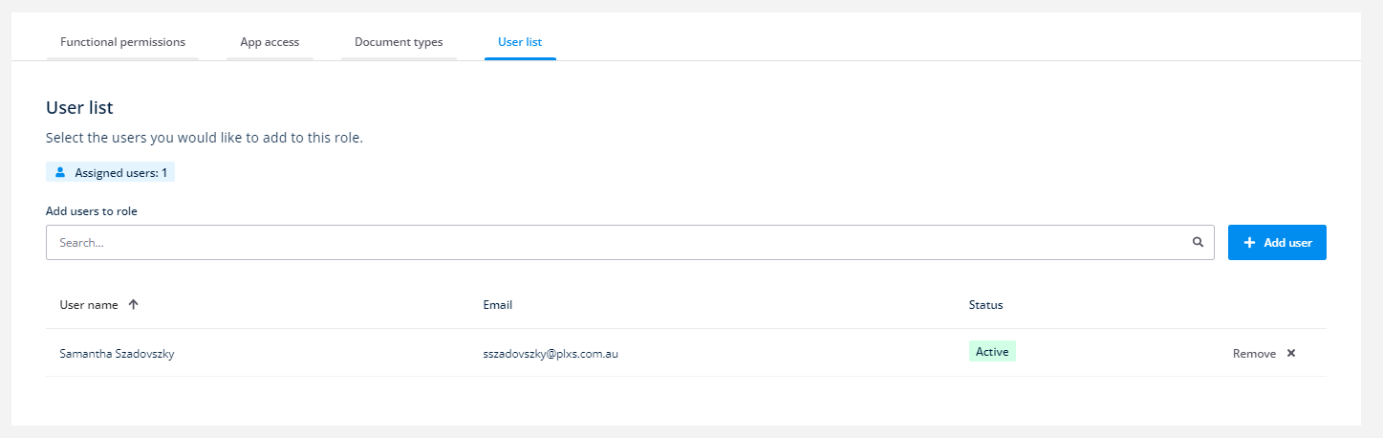

You can then view a list of individuals attached to the role, using the column headings to sort by user name, email and status as required.
You can also click Remove to remove each unneeded individual from the role.
Click Save role after making major changes to this section.

Deleting roles
From the roles list, you can delete any existing roles by clicking into the desired role. Then click the Delete role button at the bottom of the screen to confirm your changes.
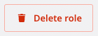

Customising your Account’s Document Types
Each document that's uploaded into Plexus must be given a document type. By categorising files with a document type, you can:
- Facilitate the searching and filtering of documents in line with your company structure
- Show or hide specific documents from users in line with your company structure by using organisation roles
- Determine who needs to view reporting for documents using roles
- Determine who needs to review documents using roles or delegation rules
- Creating specific conditions for your custom questions and delegation rules

Client administrators are able to add and remove their company's document types from the Settings menu.

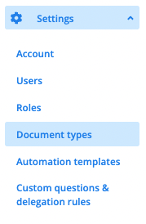
From the menu for Document types, you'll see a list of all document types available in the platform. You'll also see:
- the number of roles with access a given document type
- the number of documents assigned to that document type
- the number of users who have the roles to access that document type.

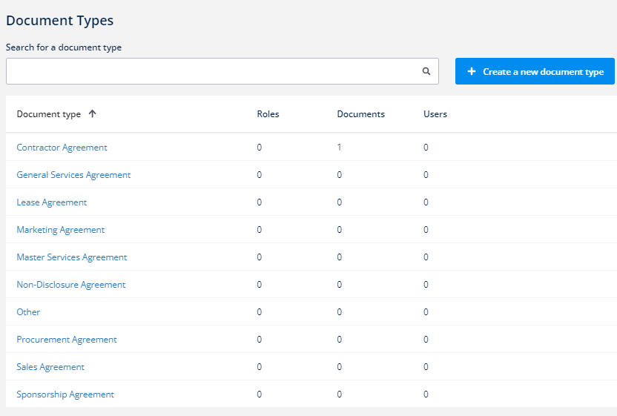

From this document list, you can search for a document type in the list, or you can look at:

Adding new document types
To add new documents to the platform, click the button to Create document type.

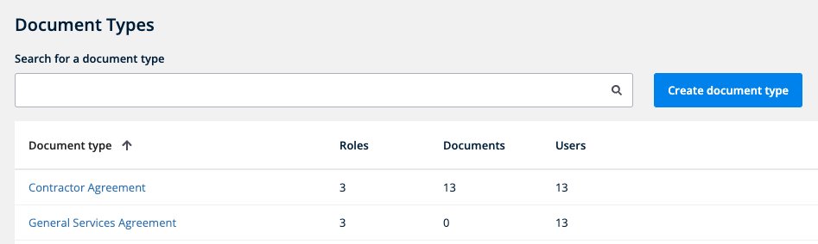

Enter the name of your new document type but choose wisely, because you'll be unable to change this once you save your changes.

Top tip! If you need to rename your document type, please create a new document type with the updated name, then delete and reassign any pre-existing documents accordingly.

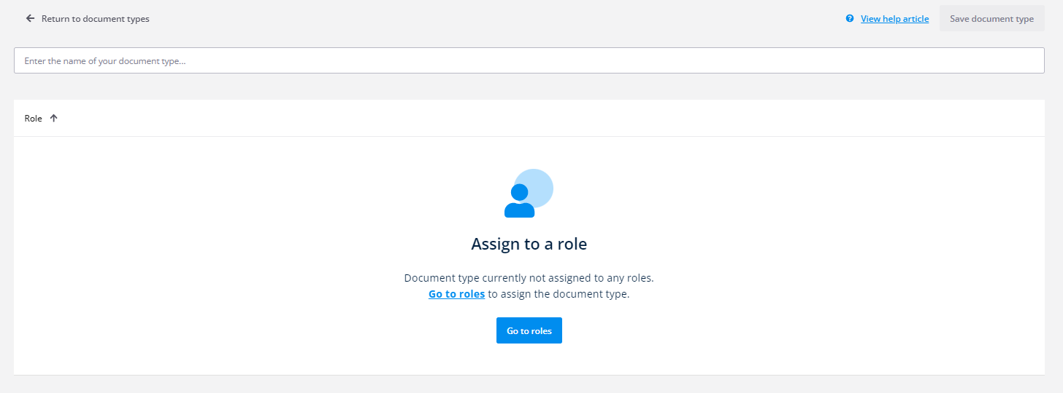

Don't forget to Save document type in the top right hand corner of the screen once you're done. The new document type will appear in your list.
You'll then need to assign your new document type to your existing roles so that your end users will have the correct level of access to any documents created with this document type in the system.

Editing the roles with access to document types

To edit the roles with access to a specific document type, click any document type that features in the document type list.

On the resulting page, you'll find a list of all roles that have access to that document type. You'll be able to remove access by clicking the Remove button on the far right hand side of the screen.
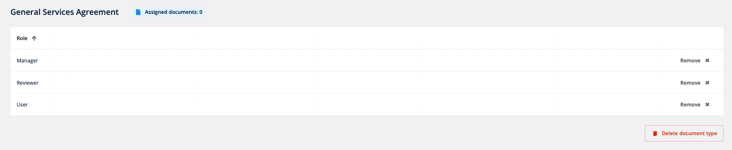

You'll need to head to roles if you would like specific changes to role visibility or if you'd like to add an additional role to this list.

Deleting document types
To delete a document type from the platform, click Delete document type from the bottom of the screen.

Where the document type has assigned documents, we'll prompt you to reassign those documents to another document type. Select a document type from the list, then click Reassign and delete to save your changes.
If you've changed your mind, you can instead click Keep document type to cancel.

Creating Custom Questions for Documents
For applications like Store a Document and Approve and eSign, you can use our out-of-the-box questions, or you can enhance them with additional custom questions for documents.
Custom questions allow you to ask additional questions on your document intake forms, that might be specific to your organisation or document type. This guide will allow you to configure those custom questions for your intake forms.
Note that only those roles with app access to Custom questions & delegation rules will be able to access this page.
Access to your custom question settings
From the Settings dropdown, click Custom questions & delegation rules.

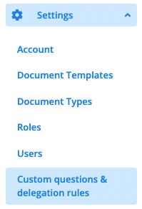
From this page, you can manage both your custom questions and delegation rules. You will have an extra tab on this screen if you use the Request Legal Support app, and can click here to manage custom questions for matters instead.
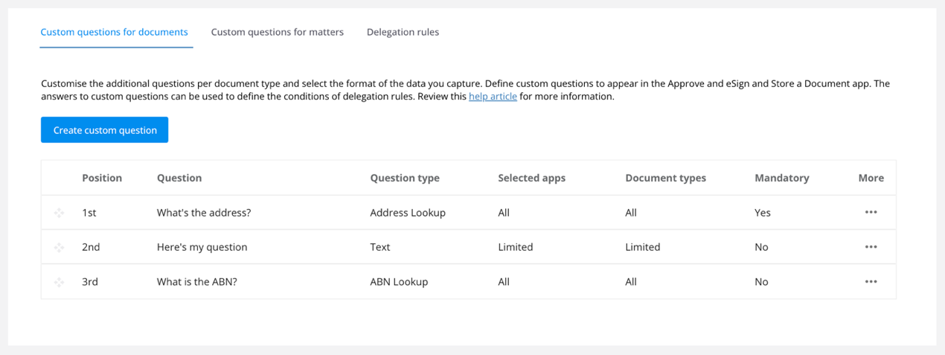
Custom questions allow you to create targeted fields for your contract management apps, allowing you to further sort and search through your data for contracts stored in the platform.

Creating new custom questions for documents
To get started, click Create custom question.
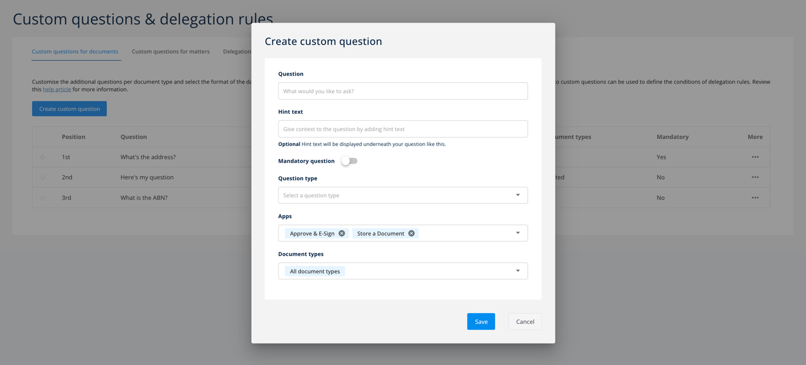

From here, start listing out the customised questions for your end users to answer when uploading files to Approve and eSign or Store a document.
We'll briefly go through the different fields you'll need to fill in when creating a new custom question.

Question. For any new field, you'll be asked to enter a question to display in the Approve and eSign intake form.
Hint text. If you'd like to add any guiding or help text underneath your question for context, you can include it in the section below.
Mandatory. Turn the toggle on or off to determine whether the question is mandatory and needs to be answered.
Question type. The question type indicates how your user will be able to respond to your question. The available out-of-the-box question types are:
- Text - provides a free text field for answering the question
- Date - provides a calendar picker for answering the question
- Number - allows users to enter a number to answer the question
- List - allows users to choose from a pre-defined list of answers
- Yes/No - allows users to select options for Yes or No
- ABN Lookup - allows users to search for businesses and provides their Australian Business Numbers
- Companies House Lookup (UK) - allows users to search for businesses and provides their UK Company House number.
- Address Lookup - allows users to search for a specific address, using a tool that's powered by Google Maps

Apps. You can opt to ask specific questions for Approve and eSign, Store a Document or Advertising Wizard if you have them available on your organisation's set up.
Document types. Each custom field can be associated to a specific document type. This gives you the flexibility to create a unique set of questions for each document type in your organisation.
Click Save once you are ready to create your question.
Editing existing custom questions
You can edit your existing custom questions by clicking the Menu icon under the column for More. Then click Edit.

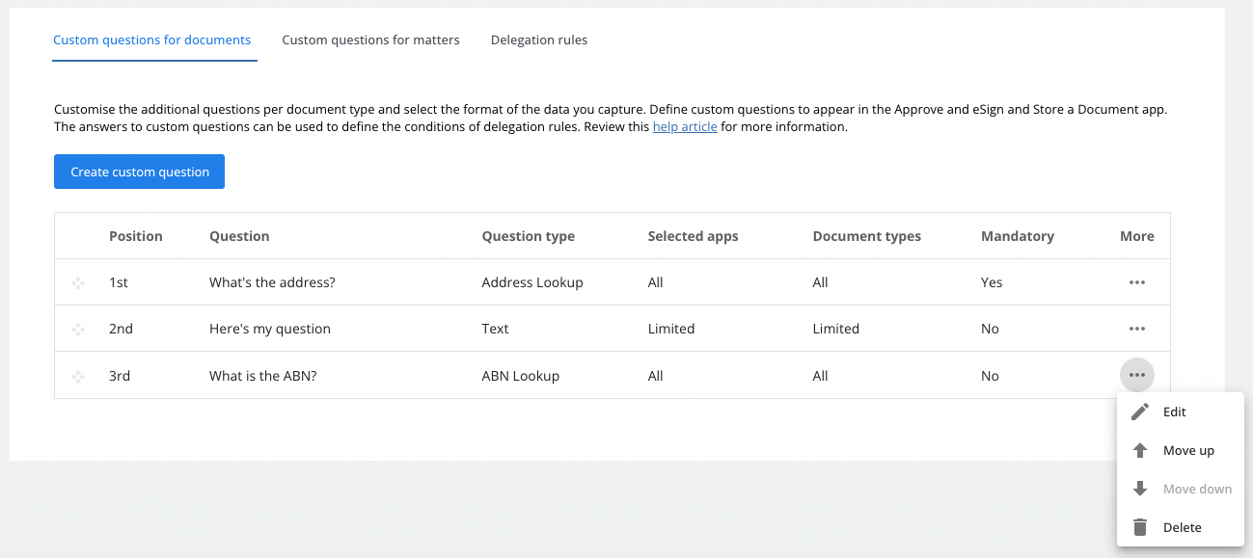

Edit any details about your custom question as required.

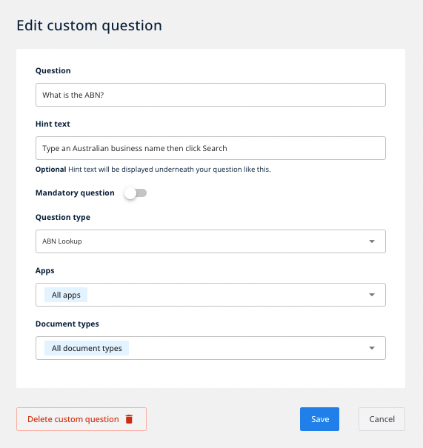
Then click Save at the bottom of the screen once you are happy with your changes.
Prioritising custom questions
You can prioritise the ordering of your existing custom questions by clicking the Menu icon under the column for More. Then click Move up or Move down in accordance with the direction that you would like to change the custom question.

You can also drag and drop your question into the correct order on the list.
Deleting custom questions
You can delete your existing delegation rules by clicking the Menu icon under the column for More. Then click Delete.

Click Delete again to confirm your decision.
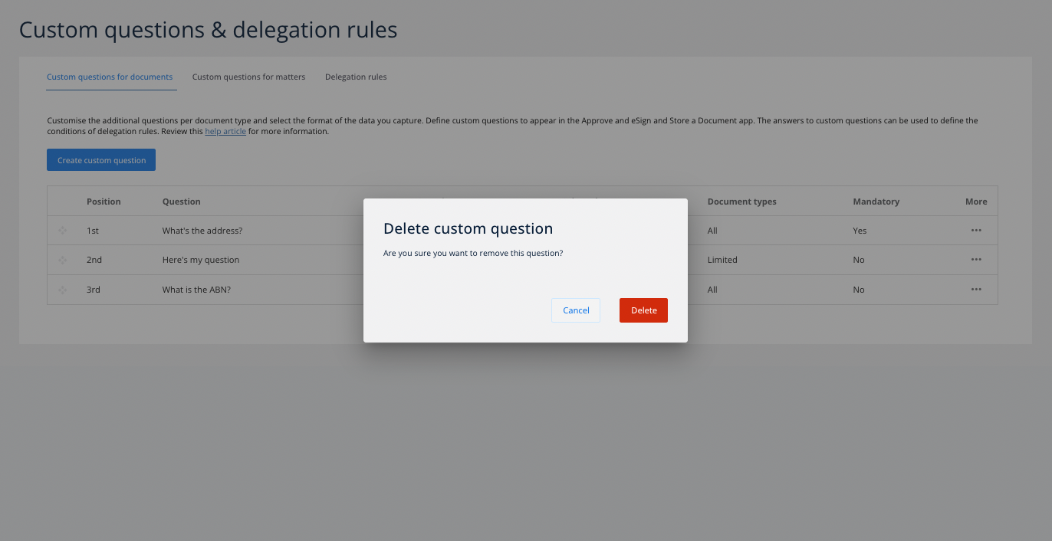

Top tips for determining your custom questions
To get the most value out of our applications, we suggest using a combination of our standard fields and the custom fields you have created to create rules that align with delegation logic specifically for your organisation.
- Less is more. A shorter and more succinct question set will help to achieve an effortless experience for your users. Too many questions will result in frustration, so it's important to find a balance.
- Make sure any custom questions resonate with your users. Will your users know how to find and provide what you are asking of them?

Creating and Editing Delegation Rules
Take the guesswork out of document approval workflows by creating delegation rules. Delegation rules allow teams to replicate their organisation's delegation of authority, and ensure that the right people within your organisation approve and sign different contracts at the right time.

Only those roles with app access to Custom questions & delegation rules will be able to access this page.

Creating new delegation rules

Step 1. Navigate to the Settings menu. From Custom questions & delegation rules, select the tab labelled Delegation rules.

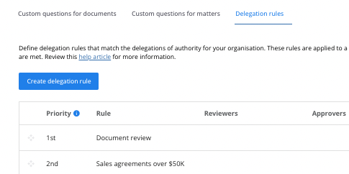

You will have an extra tab on this screen if you use the Request Legal Support app, and can click here to manage custom questions for matters instead.

Step 2. Click Create delegation rule. The resulting page will allow you to list your delegation rule conditions, reviewers, approvers and signers.

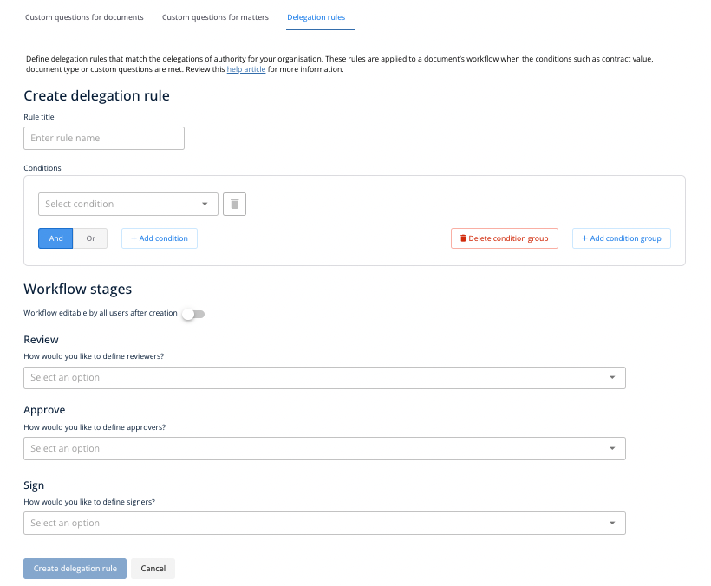

Step 3. Name your new rule. The rule title should be something descriptive that provides enough detail to easily distinguish between your different rules if you need to edit anything later.
Perhaps consider the requirements for that rule first and let that dictate the name, for example:
- All contracts over $100,000 must be approved by the CFO. In this case, you may like to consider naming your rule, "All Contracts > $100K Approved by CFO"
​
- Influencer Agreements over $25,000 must be approved by the CMO. In this case, you may like to consider naming your rule, "Influencer Agreements > $25K Approved by CMO"
Step 4. Add conditions for your rule. Select a condition from the dropdown list that should be met to initiate this rule. The available conditions are:
- Specific document type(s) selected
- Specific contract value listed
- Any custom question with a definitive answer such as a List or Yes/No answer

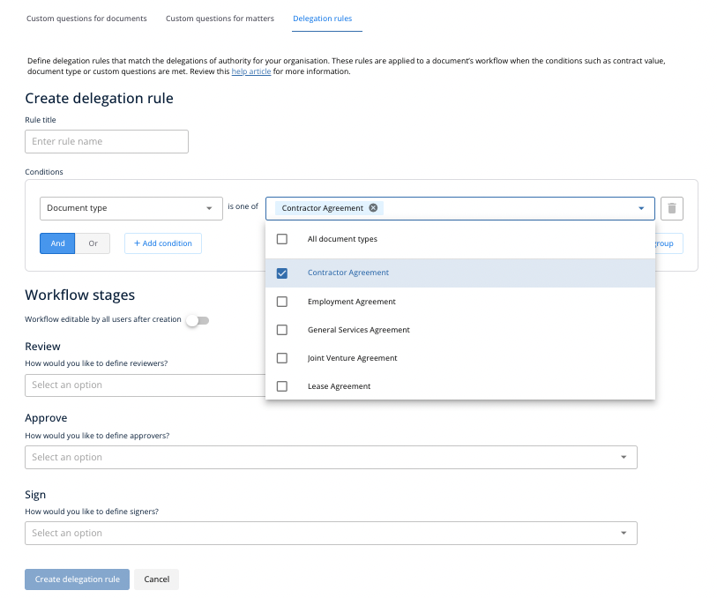

You can also click Add condition to create additional sets of conditions, using and/or logic to combine certain conditions as well.
- If and is selected, then all conditions must be met
- If or is selected, then either specified condition must be met

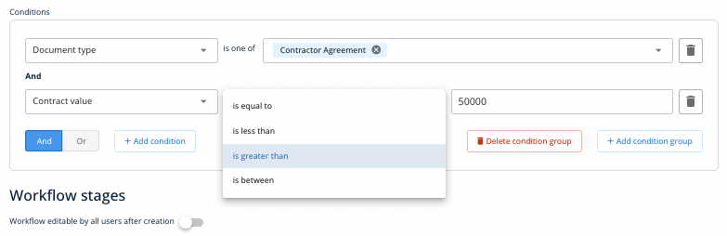
You can add as many conditions as you would like, however note that only one combination of and/or can be used per condition group. To combine sets of And/or conditions, you might like to Add condition group.
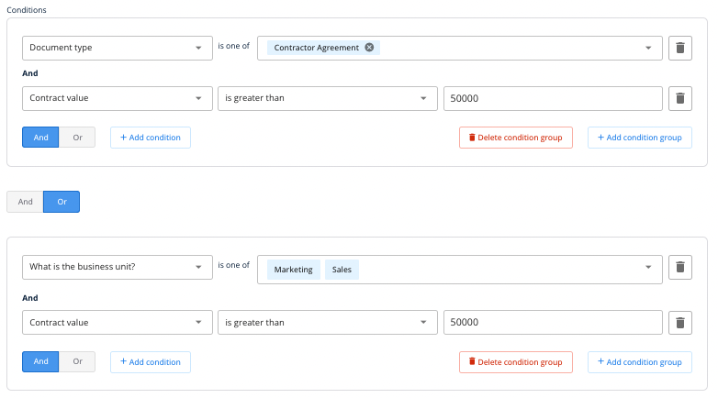

You can also Delete condition group when unneeded.

Step 5. List whether your workflow should be editable by all users after creation. Delegation rules enforce at a minimum who needs to review, approve or sign a document. Therefore, whilst end-users will be prevented from removing the individuals that have been defined in a delegation rule, they may continue to add additional reviewers approvers and signers to these rules where additional action is required for a given document. They can do this right up until that document has been uploaded into the platform.

Once that document is uploaded into Plexus, you have a greater say in just how editable that document's workflow is for the rest of the flow. You can control this from the next section of your delegation rule set up.

If the Workflow stages edit toggle is turned on, any internal user with base access to the file will be able to edit your templated workflow once it's in the platform.


If this toggle is turned off, only accounts with the owner role will be able to make such changes.

Step 6. Define your review stage. We'll then ask you how you'd like to define your reviewers. Choose your desired option from the dropdown list.
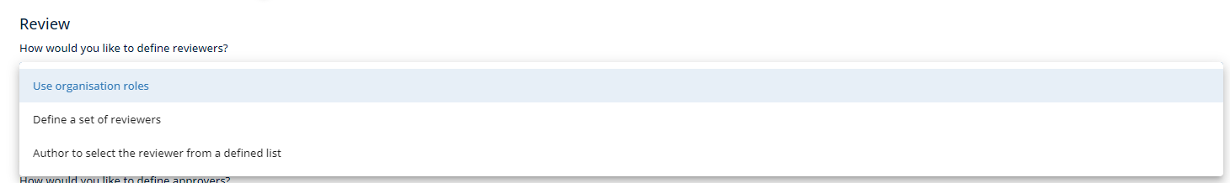

There are three options for templating the review stage:
- Use organisation roles. This option automatically notifies all "Owner" roles at the Review stage. Plexus will not display specific names to the end user and it would be inferred that the correct group of people would be sent the document to review based on your roles. This option is the default option that's used for teams without delegation rules. No further customisation is required once this option is selected.
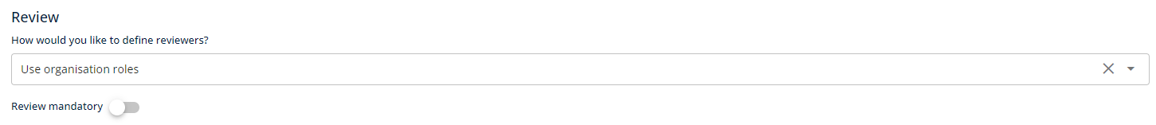

Define a set of reviewers. This option gives you the ability to add specific reviewers to the workflow. Set up this option by searching from a list of all existing users. Click Add reviewer to name additional reviewers at this stage.

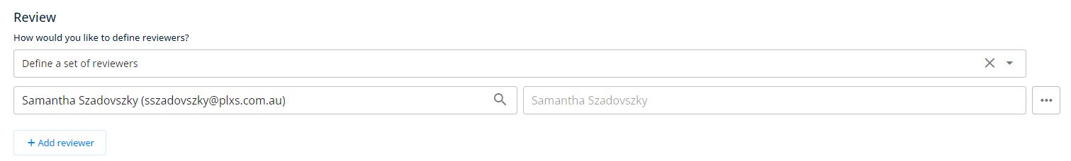
- Whilst you can name multiple names at the Review stage, only one listed user will be required to progress the document to the next stage. The end-user will not be able to change your inputs when creating their document workflow, however they can still add additional names to the list by searching from a list of internal users.
​
- Author to select the reviewer from a defined list. This option gives you the ability to select specific users from a dropdown list. The list of selected users will be the only options for your end-user to choose from when selecting their first reviewer.
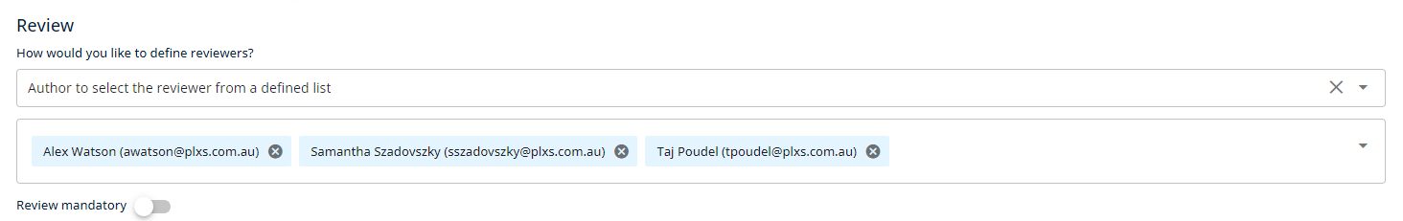

Step 6. Determine whether review is mandatory. If review is mandatory for your document, you can enforce it ensuring that the Review mandatory toggle is on.

Top tip! You may like to review this guide to visualise the end-user experience for each review option.

Step 7. Nominate approvers and signers. Nominate the full names and emails of all approvers and signers. There are two options for templating the approve and signing stages.
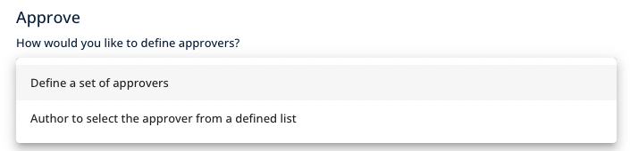
The two options are:
- Define a set of approvers/signers. Search an internal user list for emails, or type out the full emails and names of external users. Then click Add approver or Add signer to add to your list. Each recipient will be required to action the work in the order that they're listed on screen.
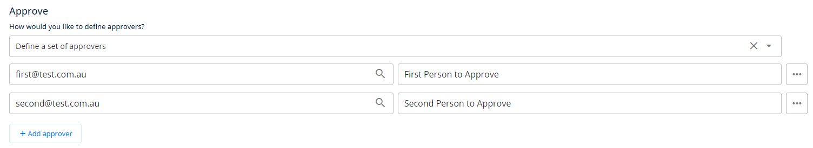

You can also use the 3 horizontal dots to update the ordering or remove somebody from the rule if you have made a mistake.
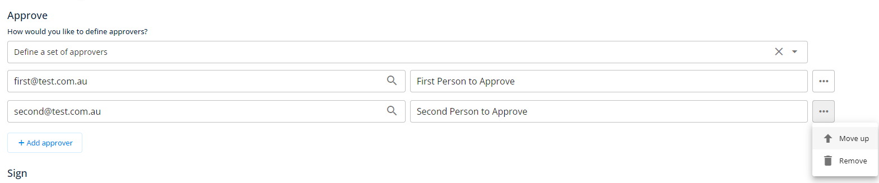

- Author to select the approver/signer from a defined list. This option gives you the ability to select specific internal users from a dropdown list. The list of selected users will be the only options for your end-user to choose from when selecting their first approver/signer. They will be able to search from the full list for any additional approvers/signers on their workflow.
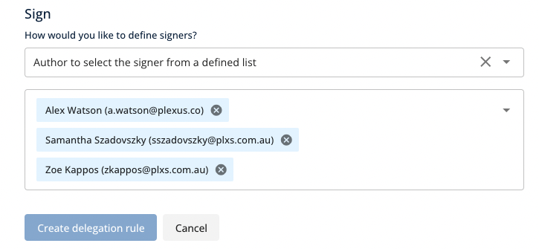
Top tip! You can select the X if you have changed your mind about defining approvers/signers from a list.

Step 8. Review your requirements and click Create delegation rule.
You can repeat these steps to add as many delegation rules as you would like.

Editing delegation rules

You can edit your existing delegation rules by clicking the Menu icon under the column for More. Then click Edit.

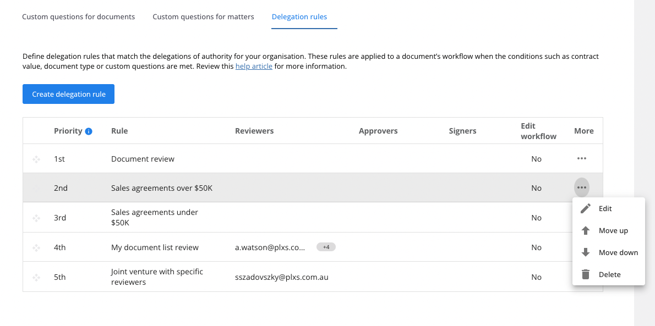

From the resulting page, you'll be able to edit all details about your delegation rule. Click Save at the bottom of the screen once you are happy with your changes.

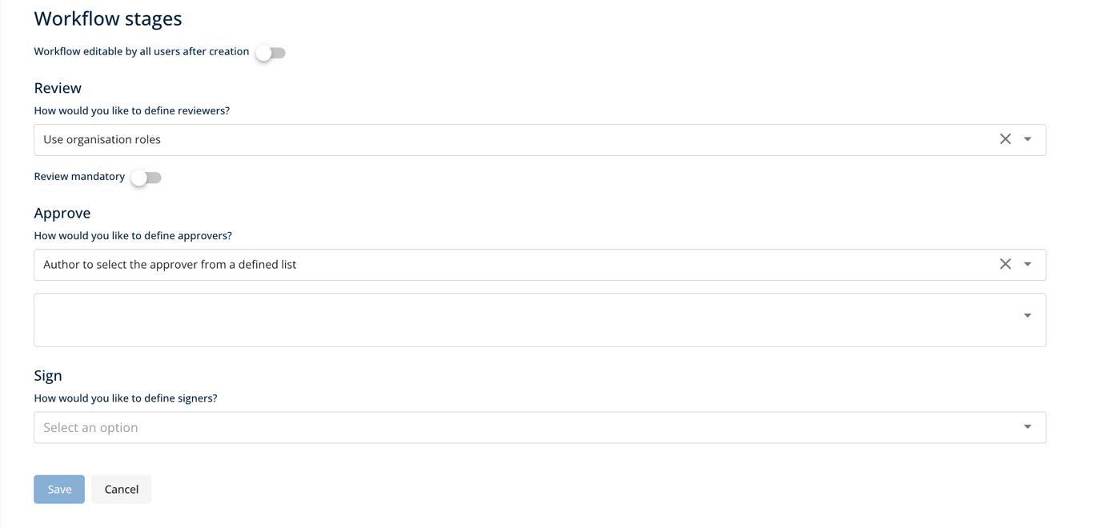

Note that if there are any empty workflow stages within your delegation rules as a result of a deleted or inactive user, we will show a red icon to highlight where your delegation rules need to be amended.

You can also drag and drop each row to re-prioritise your rules.
The priority field is most important when you have multiple rules which utilise similar conditions. The highest priority item will initiate when the condition(s) are met, and lower priority items may be ignored, depending on how your rules are prioritised in the list. For example:
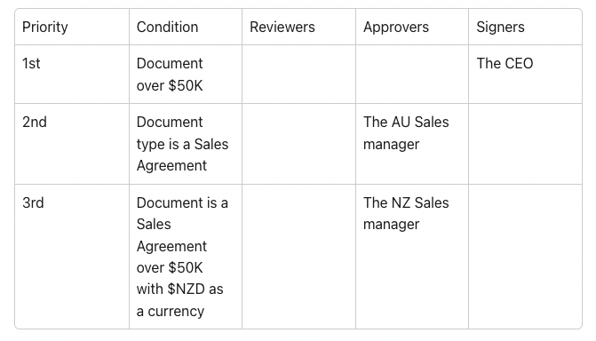

If I have a sales agreement that is over $50K in NZD, your delegation rules would:
- Combine the signer from Rule 1 (CEO) and
- The approver from Rule 2 (AU Sales manager)
In this instance, the 2nd priority item has not listed a currency, and therefore the rule listing the Australian sales manager has taken priority. This is incorrect.
Ideally you'd need to take one of two routes to ensure that the correct rule is initiated in future.
Option 1. Ensure that Rule 2 makes it clear that the document lists $AUD as a currency
Option 2. Swap the priority so that the third rule is initiated prior to rule two. The $NZD currency rule will be initiated first and the correct approver will be applied to the rule wherever $NZD is selected as a currency. The Sales Agreement document type then acts as a fallback rule for any documents that do not include the $NZD currency.

Deleting delegation rules
You can delete your existing delegation rules by clicking the Menu icon under the column for More. Then click Delete.
Click Delete again to confirm your decision.
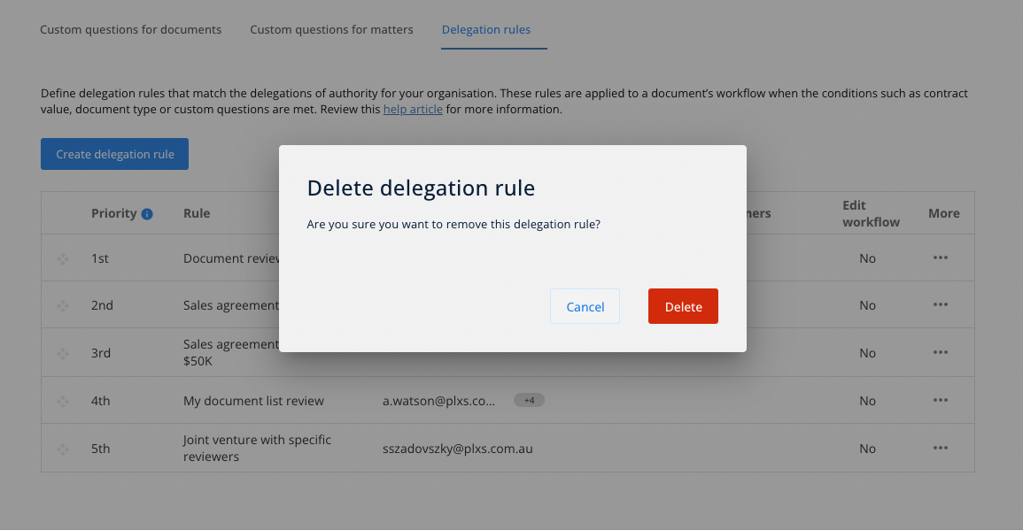
Top tips for determining your delegation rules:
- Simplification. To get the most value out of our applications, we suggest using this opportunity to simplify your delegation of authority. Looking at your current set of rules, is there any area that you might like to simplify?
​
- Verified with your managers. Remember to get any proposed changes to the delegation of authority signed off from the correct decision makers in your business.
​
- Combined rules. Our new rules will enable you to create flexible delegation rules for your business. Can you combine any rules together to minimise your ongoing admin and maintenance work?

Customising your Document List View
The document list contains all documents uploaded to Plexus. Specific documents may be shown on or hidden from your document list depending on your account access and permissions and your organisation unit.
Making a column visible on the Document List
From the Document list settings tab, you can make a custom question visible as a new column on the Document List.
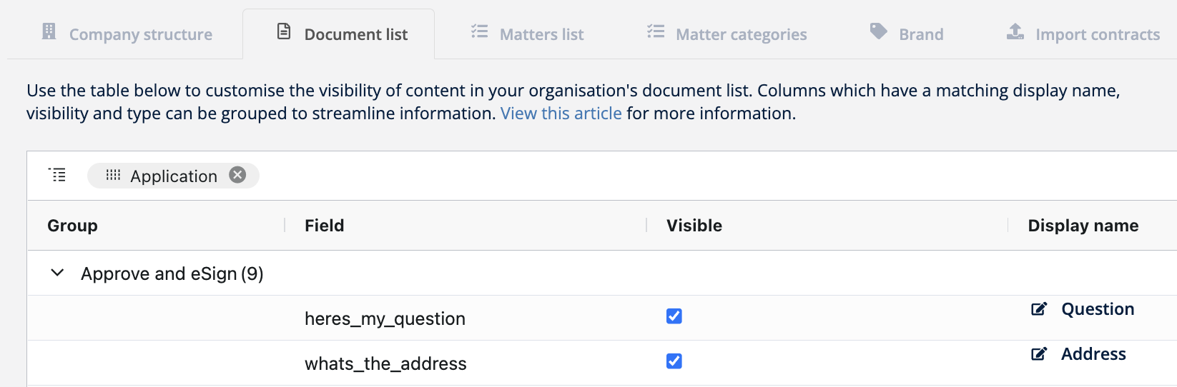
All fields are grouped by the app used to generate them. Expand on a given app to show the available list of questions. To make a field visible, used the checkbox in the visible column, then update the display name and data type.
Top Tip! Only questions linked to existing documents are shown. Where custom questions are missing from this list, it's likely that your organisation is yet to create a document using that custom field.
Remember to click Save in the top right corner of your screen to save your entries if you are finished.

Updating a column's display name
When a custom field is made visible on the document list, you'll see an option to edit the display name. The Display name will mirror the field name by default, but you may update this to a name or column heading instead.
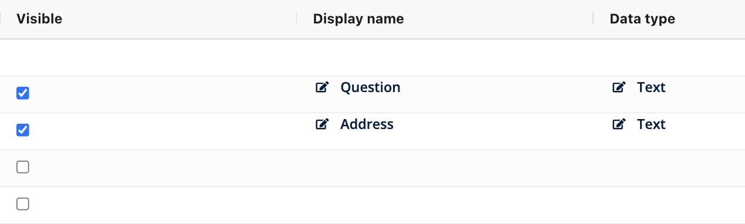
To update a column's display name, click the field's current display name. You'll have the option to make your edits from here, staying within a certain character limit. Once you're done, click Enter on your keyboard or click outside of the field to confirm your edits.
Remember to click Save in the top right corner of your screen to save your entries if you are finished.
Editing a column's data type
For each custom field in your document list, you can set a column's data type as any one of the following:
- Text
- Date
- Number
- List
The data type field determines the filtering options available to your users when they search against the column in the document list
For example, the Text field will allow users to filter by options that contains, starts with or ends with a given word or phrase.
For each custom field in your document list, you can set a column's data type as any one of the following:
- Text
- Date
- Number
- List
The data type field determines the filtering options available to your users when they search against the column in the document list
For example, the Text field will allow users to filter by options that contains, starts with or ends with a given word or phrase.
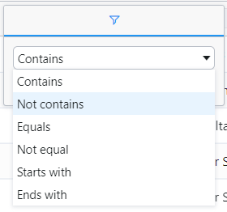
The List field is used when there is only a set number of options a field is likely to have. The List data type provides the user with a checkbox to select and filter against any existing list options.
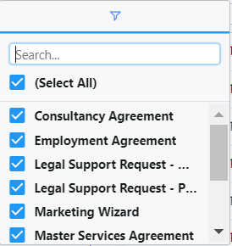
The Number data type will prompt you to perhaps filter by a number greater or less than another number in the system.
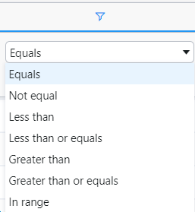

Like the number field, the Date data type fields allow users to filter by dates equal to, before, on or after a specified date. You can also search by range.
Remember to click Save in the top right corner of your screen to save your entries if you are finished.
Accessing the Document list
To access your Document list, select the Documents option from your main menu on the left hand side of your screen.
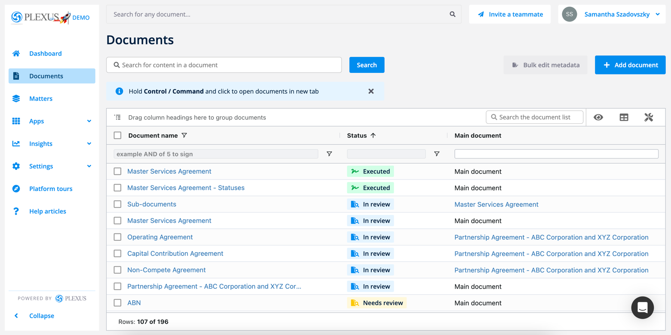
Your Document list is similar to an Excel Spreadsheet, with each field showing the searchable data that's entered by users when they upload files via approve and eSign, store a document, advertising wizard or a purpose-built custom app.
Top tip! Want to view a document whilst browsing? Hold Control / Command and click to open documents in new tab.
From the Document list, you might expect to see information such as:
- Document ID
- Document name
- Document status
- Counterparty
- Contract value
- Document type
- Created at / executed at / last edited at
- Start date / expiry date
- Created by
- Owner
- Generated by (Application)
- Organisation unit
- Reviewers / approvers / signers / currently with (User)
- Shared by (User)
- Custom questions specific to your organisation's set up
You can search by this information to best find, sort and filter your documents in your list. To make sure that your view is unique to you, we've created a list of the different ways to customise your Document list and to find the files you need:
- Adding a document from the Document list
- Editing key facts from the Document list
- Searching your Documents list
- Filtering your Documents list
- Showing and hiding columns
- Resizing columns
- Dragging and dropping columns into order
- Grouping documents in nested folders
- Visualising sub-documents
- Saving your preferred view
Top tip! Want to pick up from where you left? Plexus will automatically remember your changes to the above settings on the Document list.
Editing facts from the Document list
From the Document list you can edit select key facts for your documents in bulk. Editable facts include:
- Name
- Document type
- Organisation unit
- Counter party
- Contract value
- Start date
- End date
- Executed date - for documents with an Executed status only
- Owner
To edit a key fact from the Document list, you can double click the eligible field, or click the corresponding edit icon.
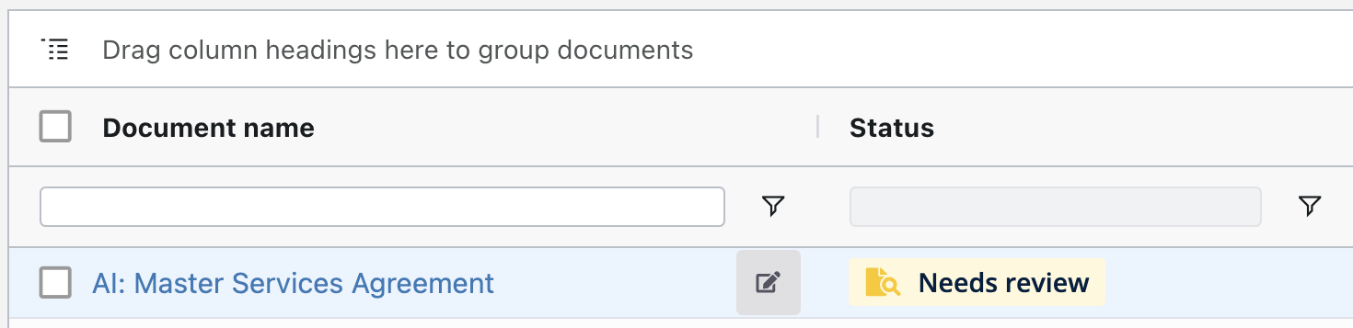
Make your changes in the available pop-up. Then click the Tick to save your changes.
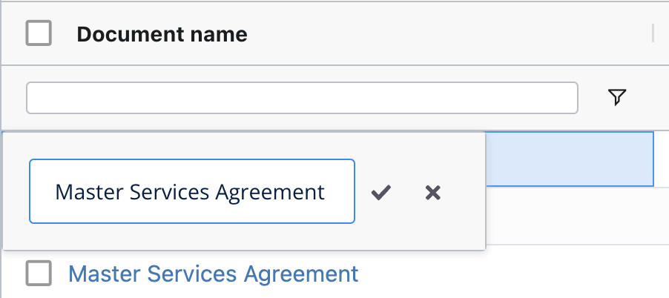

You can also edit the key facts for multiple documents in bulk.
Searching your documents list
To help find your files, we have four powerful searching tools available from this page.
1. Universal search. Located on most pages, this field allows you to search for a document. You may search for a document's name or within its content and metadata.

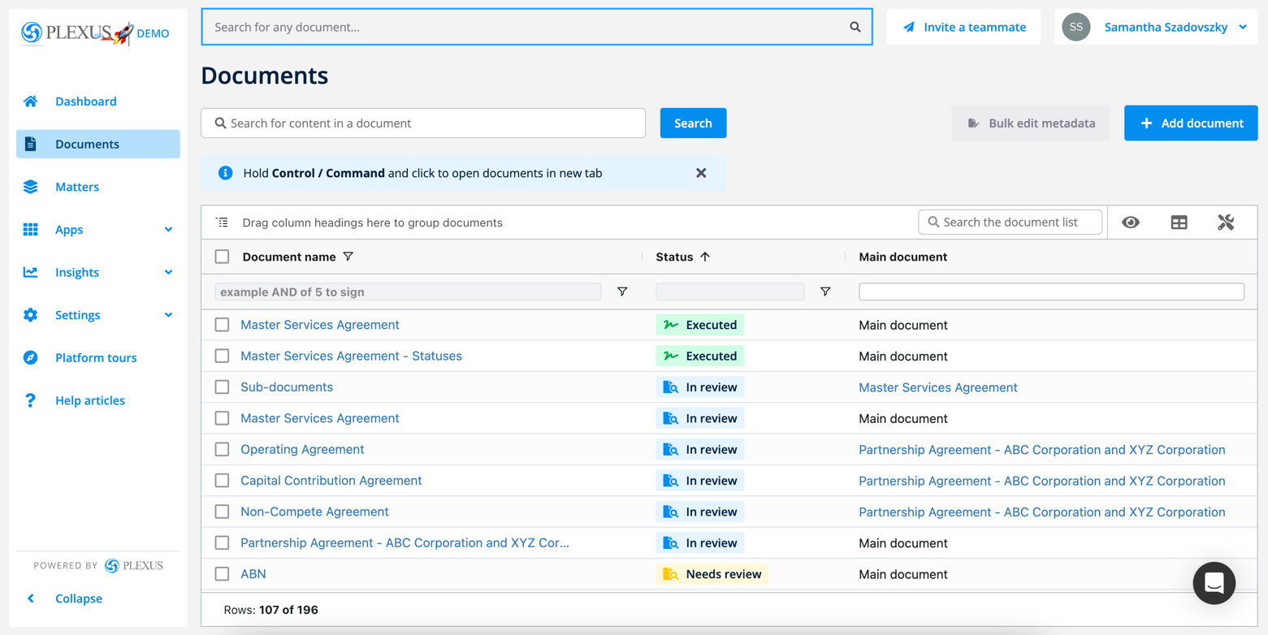
​2. Search a document's content. Located just below the Documents heading, this field allows you to search for any word, phrase field, clause or precedent located within a document.
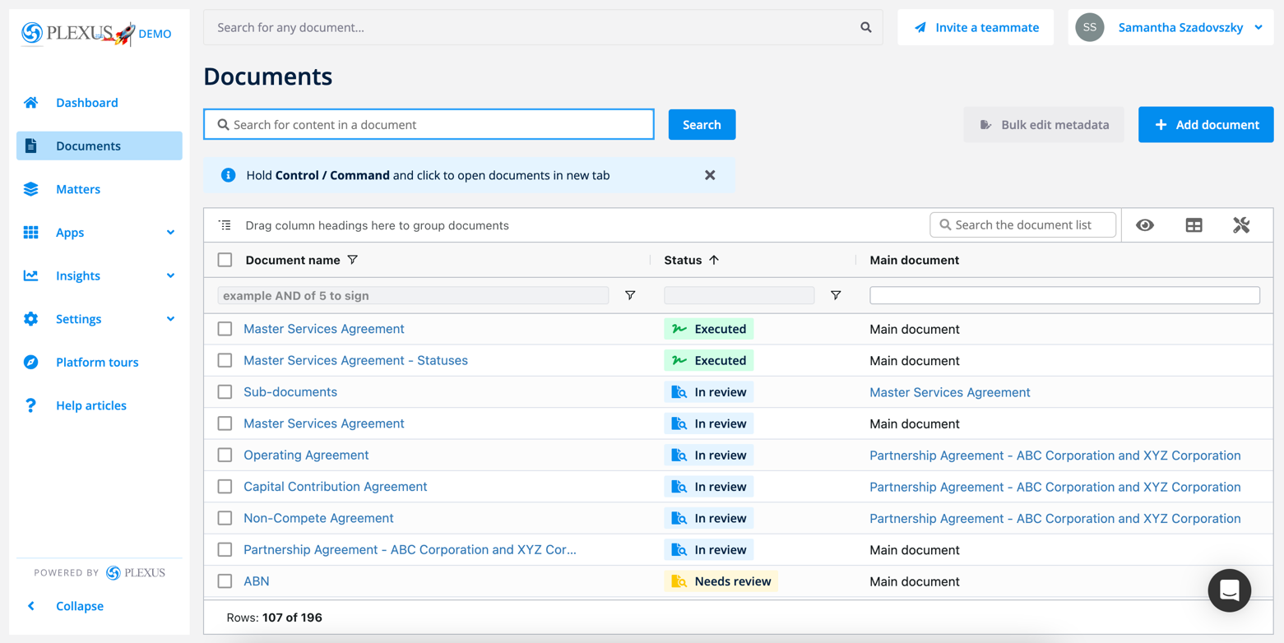
​3. Search all table fields. This field is located to the right of your document table and allows you to search for any word, number or phrase that can be found within this table view, related to your document's metadata.
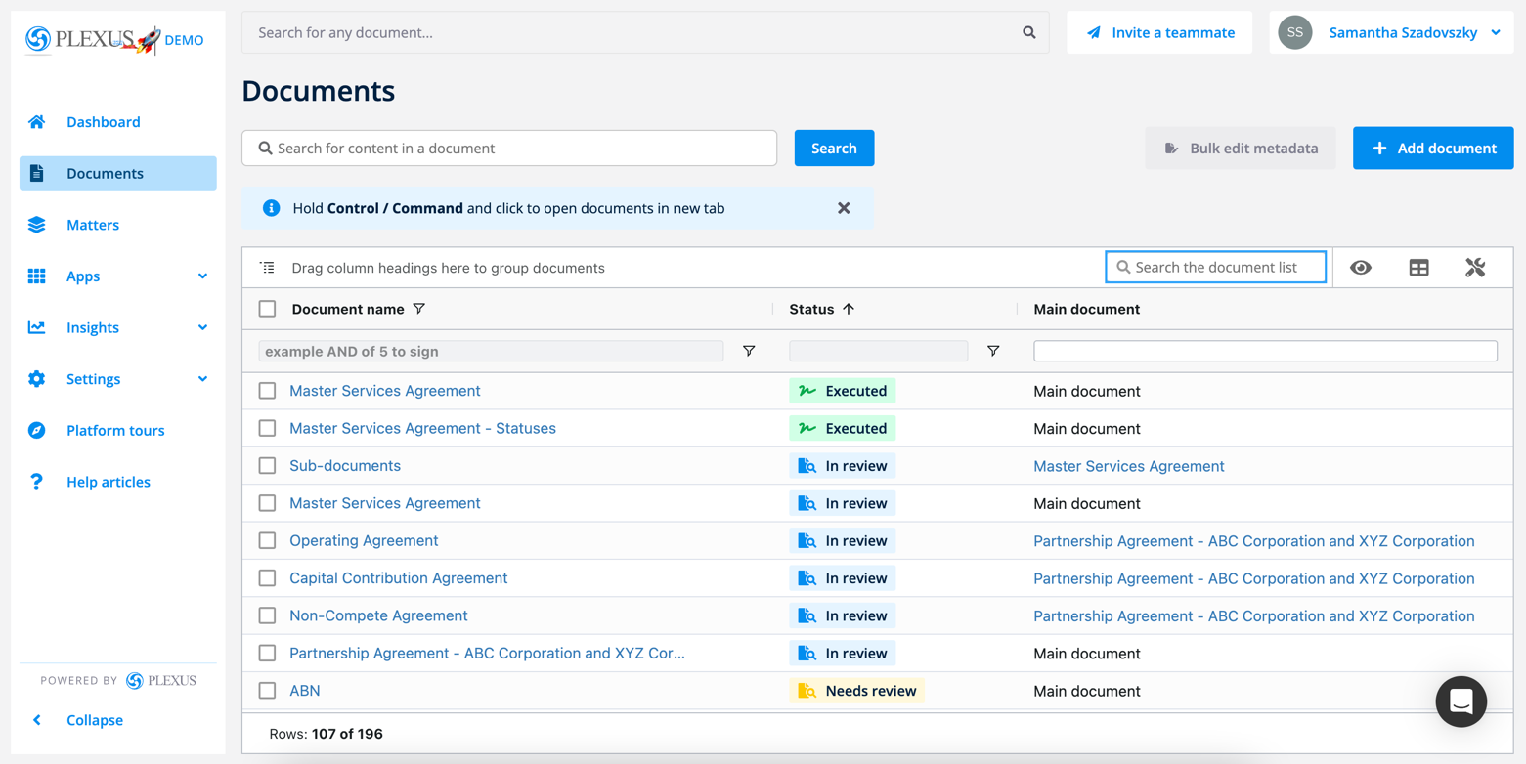
​4. Search a column's fields. This field is located below the heading for each and every column, and allows you to search vertically through your documents list. This field is most helpful to use when you're only interested in searching for the information in a given column (i.e. document name).

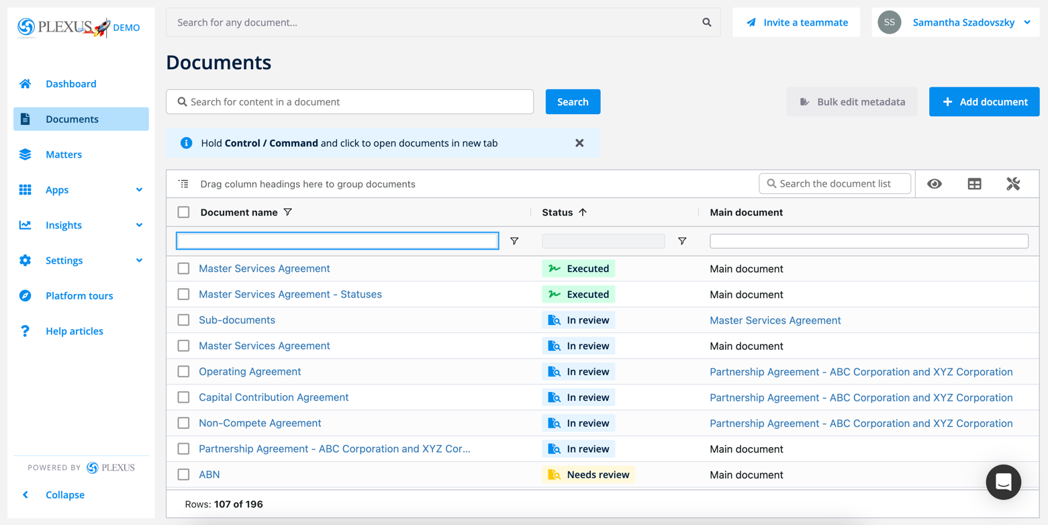

Editing Matter Categories and Sub-Categories
Matter management allows users to brief, triage, track, collaborate, search, store and report on all matters seamlessly via a single integrated platform.
​
To ensure that you are getting the most out of our matter management module, requesting legal support can be customised to provide your users with a list of relevant categories and sub-categories within your organisation.
Accurate and specific categories allow your team to capture knowledge and provides deep insights into your team's productivity via targeted reporting.
Accessing your matter category settings
You can manage your matter management categories in your settings menu if you are a platform administrator. This is permission based. If you are not able to manage your matter category settings, please check with your team for permission or contact us via live chat or support@plexus.co.
Step 1. To get started, head to your Settings tab in your menu, then click Account.
Step 2. From the available list of tabs, click Matter categories.
With the matter categories tab, you can:
- Add new legal team members to manage matters, including priority and assignees
- Add, edit categories and sub-categories
- Update the ordering of categories and sub-categories
- Rename categories
- Remove categories and sub-categories
- Make specific matter categories visible for certain users only
- Automatically notify specific lawyers on new matters
- Automatically assign matters based on category
- Specify default recipients for new matter notifications
Creating your legal team
Legal teams have the ability to triage matters as a lawyer, including the ability to prioritise matters and assign matters to other users in the system. Whilst regular business users will be able to see the changes, it's only these nominated legal users who can initiate that change. To designate your legal team members for matter management:
Step 1. Directly under the heading for Legal team, you'll see a list of users. Click the pencil on the right hand side to add any individuals to this list.
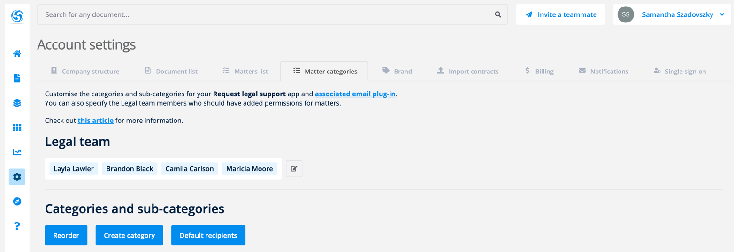
Step 2. Then click the tick to save your changes.
Adding and editing categories and sub-categories
Having relevant matter categories and sub-categories will greatly enhance your reporting on matters. We'll provide you with an out-of-the-box list of categories to use, however you may like to edit these over time.
Directly under the legal users section, you will find a table of all categories and sub-categories currently available in the system.
Step 1. From the matter categories page, you can click the blue Create category button to add to the existing categories on this list.
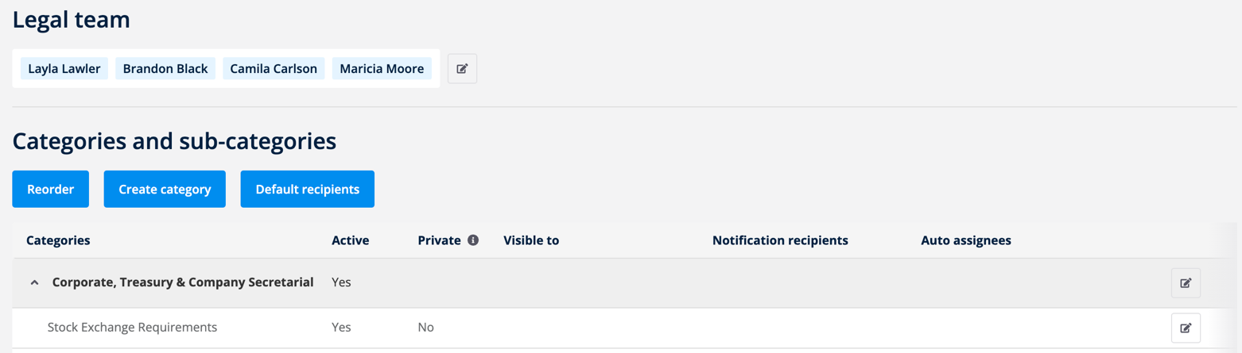
Step 2. Fill in the new category name. Then add any additional sub-categories by clicking the + icon. Click Create category once you have created your list.

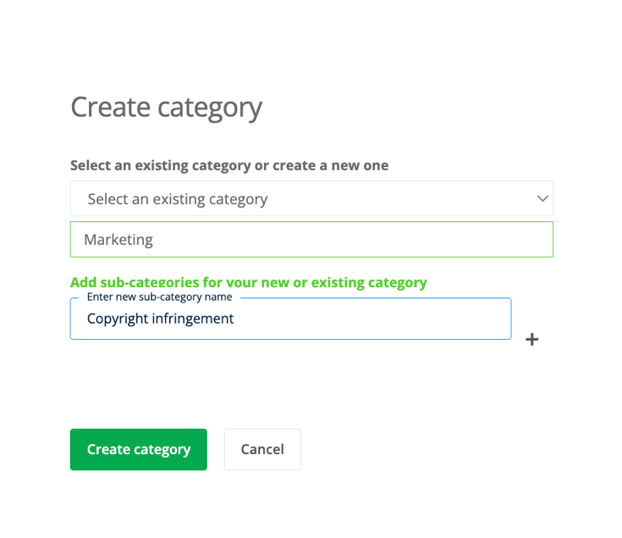
You may also remove a sub-category at this point by clicking the minus icon next to the desired sub-category.
Changing the order of categories and sub-categories
Whether your preference is to order your categories by priority, in alphabetical order or by relevance, you can Reorder your list of categories and sub-categories as you desire.
Step 1. Click the blue button to Reorder.
Step 2. Square icons will appear to the very far right for each row of your category list, where you'll be able to drag and drop each row into its correct spot.
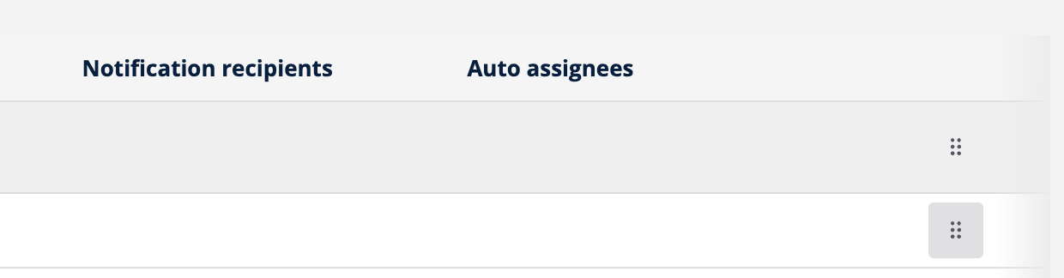
This functionality is available for both the categories and sub-categories.
Step 3. Click Save in the top left hand corner once you are happy with your order.
Renaming categories
If you'd like to rename any of your existing categories, you can do so by editing them accordingly.
Step 1. Click the Edit icon to the very far right hand side of your category or sub-category row.
Step 2. You'll be able to edit the name field for your categories and sub-categories accordingly.
Step 3. Click the Tick at the end of the row to save your changes.
Any existing matters attached to that renamed category or sub-category will also update.
Removing categories and sub-categories
Whilst you don't have the ability to remove categories, if you have any categories that are no longer relevant to your organisation, you can make them inactive. Any existing matters created with the inactive category will still maintain the original category details unless updated.
Step 1. Click the Edit button to the very far right hand side of your category or sub-category row.
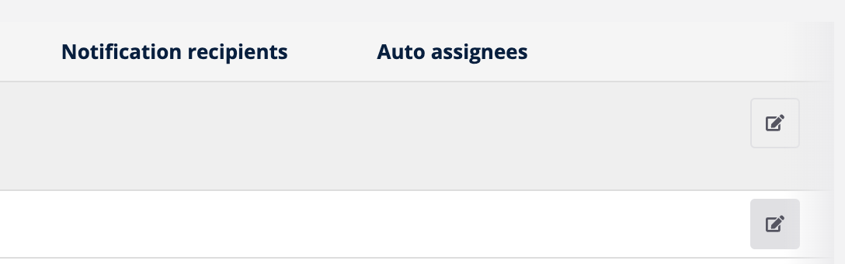
Step 2. Next to the row labelled Active, change the setting from Yes to No.
Step 3. Click the Tick at the end of the row to save your changes.
If you wish to replace a category inclusive of any existing matters, you may opt to rename the category you wish to replace instead.
Privatising matter categories and managing matter visibility
By default, all users can see matters that they created, are assigned to, or are a labelled contact for. In addition to this, lawyers can see all matters that were created in any of the organisational units that they are assigned to.
You may wish to make a sub-category private so that only designated lawyers within the organisational unit can see matters created under those categories.
Note that this functionality is available to sub-categories only.
Step 1. Click the Edit button to the very far right hand side of your sub-category row.
Step 2. Next to the row labelled Private, change the setting from No to Yes.
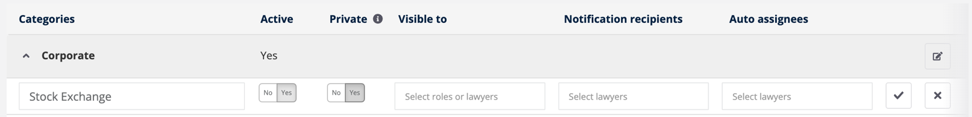
Step 3. The field labelled Visible to will appear.
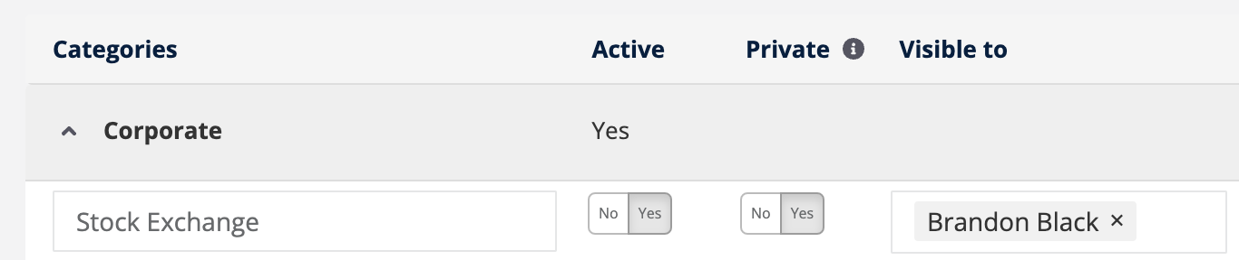
Specify the specific lawyers and/or roles that will have the ability to see the category. Name those individuals or roles here.
Optional. You may also like to ensure that these individuals are notified when this kind of matter is created. If this is the case, ensure to add that individual or role to the Notification recipients column too.
Step 4. Click the Tick at the end of the row to save your changes.
Auto-notifying lawyers for specific categories
You can determine who's notified when a new matter is created for a specific category or sub-category. To do so:
Step 1. Click the Edit button to the very far right hand side of your category or sub-category row.
Step 2. In the Notification recipients column, add the name(s) of the individual(s) who you'd like to notify when these matter categories are submitted through the system. Note that only the names of the Legal Management users will show in this list.
Step 3. Click the Tick at the end of the row to save your changes.
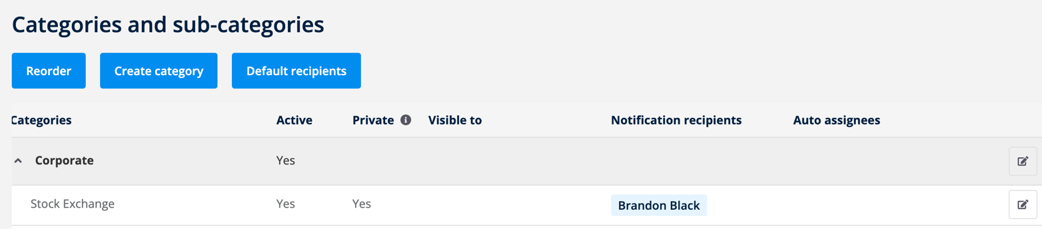
Auto-assigning matters to lawyers
Each matter that comes through Plexus will need to be assigned to a given user. You can take the double handling out of this matter by auto-assigning lawyers depending on the matter's category.
If you auto-assign matters to lawyers on the category level, the assigned lawyer will be assigned for any of the sub-categories underneath. If you wish to go a level deeper, you may highlight a specific auto-assignee for each sub-category instead.
Step 1. To the right hand side of the category list, click the Edit button to the very far right hand side of your category or sub-category row.
Step 2. In the Auto assignees column, add the name(s) of the individual(s) who you'd like to assign when matters of this categorisation are submitted through the system. Note that only the names of the Legal Management users will show in this list.
Step 3. Click the Tick at the end of the row to save your changes.
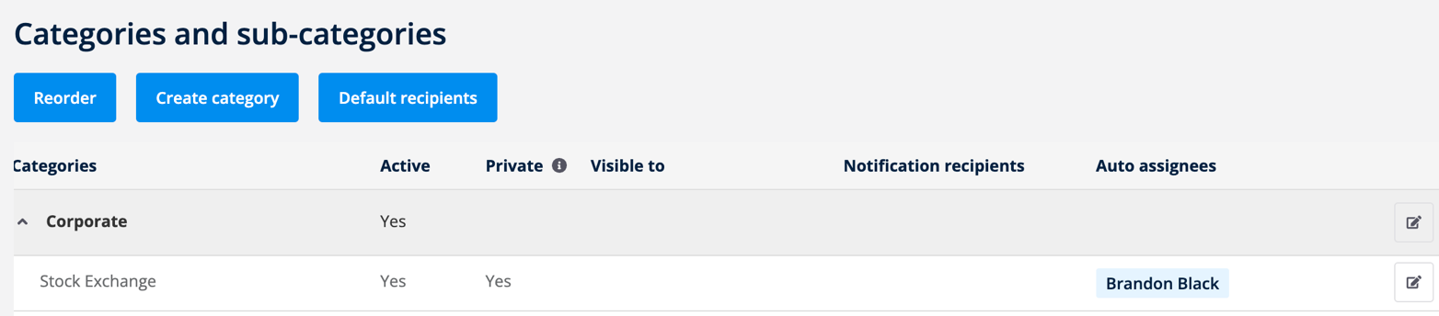
Assigning default recipients for new matter notifications
Where you haven't specified notification recipients for categories, we'll use the default recipients to notify these users instead. We highly recommend adding a default recipient in this section, because it's also used for the default "Other" category as well.
Step 1. To assign your default recipients for matter notifications, click the blue Default recipients button.
Step 2. Enter the name(s) of the individuals who should be notified at this stage.
Step 3. Click Save once you're happy with your inputs.

Creating Custom Questions for Matters
Custom questions allow you to create targeted questions for your matter management intake forms. By creating questions that are specific to your organisation or a matter category, lawyers can ensure that they’re getting the right information from the matter up-front, therefore saving time following up on standard questions and reducing cycle times.
Likewise, by setting up custom questions for matters in Plexus, business users can have confidence that they're providing all the right information so that the Legal team can get started on their request right away.
For gathering information on new matters, you can continue to use our out-of-the-box questions, or you can enhance them with these additional custom questions. This guide will allow you to configure those custom questions for your intake forms.
Note that only those roles with app access to Custom questions & delegation rules and those with the Request legal support app will be able to access this page.

Access to your custom question settings:
From the Settings dropdown, click Custom questions & delegation rules.
From this page, you can manage both your custom questions for documents, matters and delegation rules. Click the tab to manage Custom questions for matters.
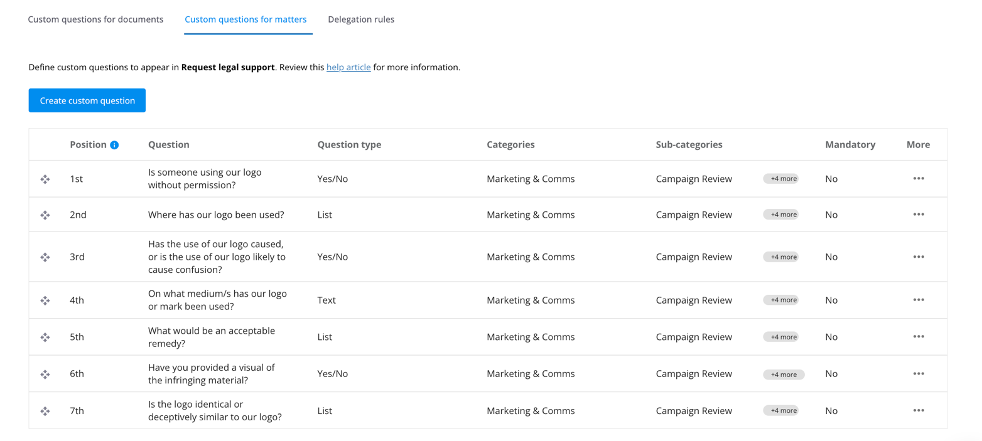
Creating new custom questions for matters
To get started, click Create custom question.
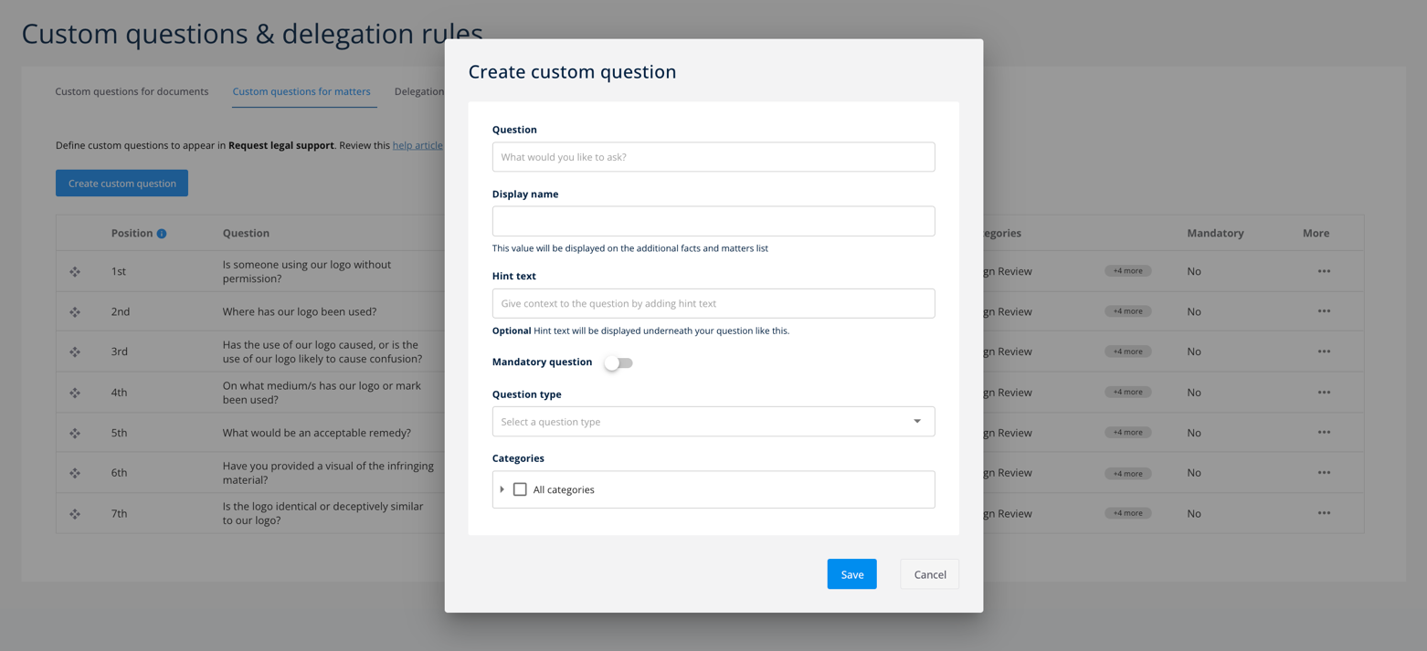
From here, start listing out the customised questions for your end users to answer when creating a new matter in Request legal support.
We'll briefly go through the different fields you'll need to fill in when creating a new custom question.
Question. Enter a custom question to display in the Request legal support intake form.
Display name. Choose the heading you'd like the answers to display next to, when this question is viewed from your additional facts and matters list.
​
​Hint text. If you'd like to add any guiding or help text underneath your question for context, you can include it in this section.
Mandatory. Turn the toggle on or off to determine whether the question is mandatory and needs to be answered.
Question type. The question type indicates how your user will be able to respond to your question. The available out-of-the-box question types are:
- Text - provides a free text field for answering the question
- Date - provides a calendar picker for answering the question
- Number - allows users to enter a number to answer the question
- List - allows users to choose from a pre-defined list of answers
- Yes/No - allows users to select options for Yes or No
- ABN Lookup - allows users to search for businesses and provides their Australian Business Numbers
- Companies House Lookup (UK) - allows users to search for businesses and provides their UK Company House number.
- Address Lookup - allows users to search for a specific address, using a tool that's powered by Google Maps
Categories. Each custom field can be associated to a specific category or sub-category. This gives you the flexibility to create a unique set of questions, depending on the category of matter selected. Use the arrows to expand on the eligible set of categories and sub-categories.
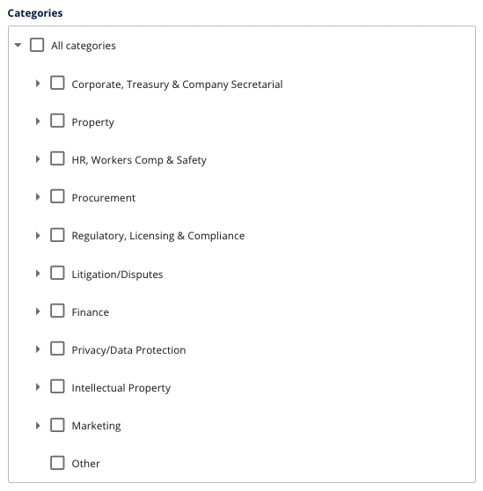
Tick the checkboxes to select all eligible categories where this question should show.
Then click Save once you are ready to create your question.
Editing existing custom questions
You can edit your existing custom questions by clicking the Menu icon under the column for More. Then click Edit.
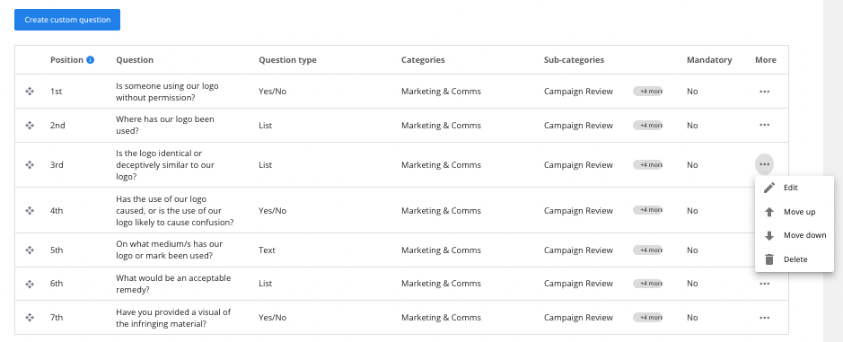
Edit any details about your custom question as required.
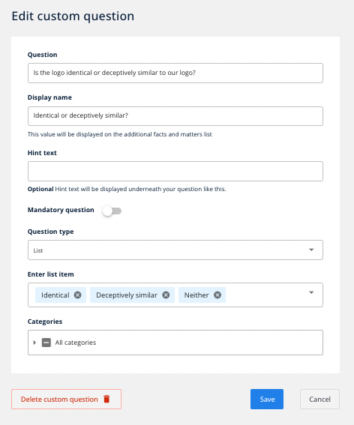
Then click Save at the bottom of the screen once you are happy with your changes.
Prioritising custom questions
You can prioritise the ordering of your existing custom questions by clicking the Menu icon under the column for More. Then click Move up or Move down in accordance with the direction that you would like to change the custom question.
You can also drag and drop your question into the correct order on the list.
Deleting custom questions
You can delete your existing delegation rules by clicking the Menu icon under the column for More. Then click Delete.
Click Delete again to confirm your decision.
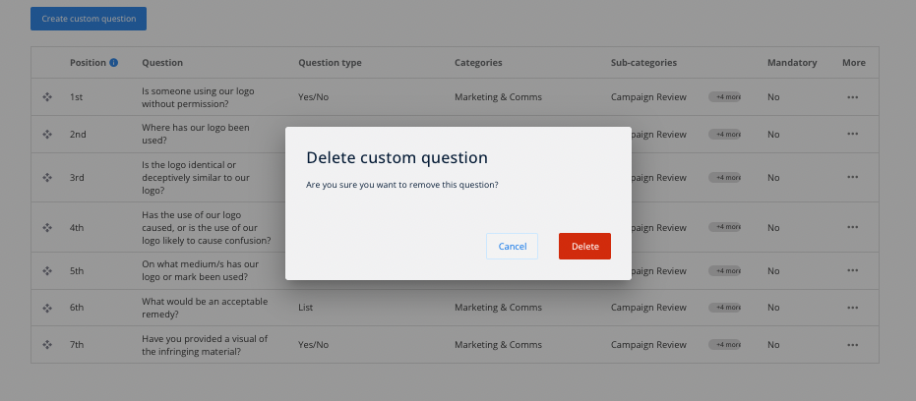
Note that you can also Delete custom question from the bottom of the edit screen.

To make these questions visible on your matters list, you'll need to head to the matters list settings page.
Top tips for determining your custom questions
To consider which custom questions to create for your matters, consider the standard questions that you tend to ask the business when you're presented with a new matter.
- What questions do you need to keep asking?
- Are these questions recurring for a specific category?
- What questions will save that 15-minute Zoom call or email?
- Which questions does the business need to answer to allow me to get this matter closed quickly?
The aim is to arm the legal team with the information needed to get started on a matter sooner.

Managing your Matters List Settings
Custom questions allow you to create targeted questions for your matter management intake forms. By creating questions that are specific to your organisation or a matter category, lawyers can ensure that they’re getting the right information from the matter up-front.
When you create a new matter in Plexus, all answers to any custom questions are stored on the matter details page by default under the Fact view.
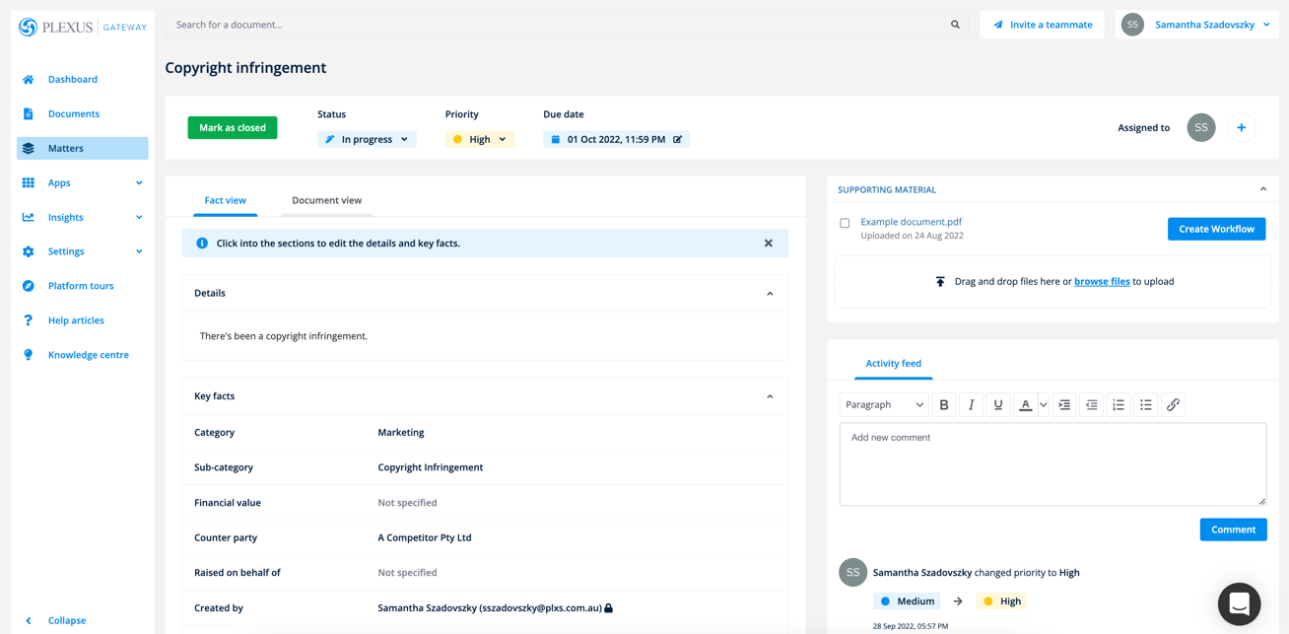
All users with access to a given matter can also use custom questions to search, sort and filter matters on the task list. However, in order to see the answers to your custom questions on the task list, an administrator needs to make those answers visible from the settings menu.
Accessing your matters list settings
To access your matters list settings, head to the Settings menu and then click Account.
On the resulting page, select the tab for Matters list.
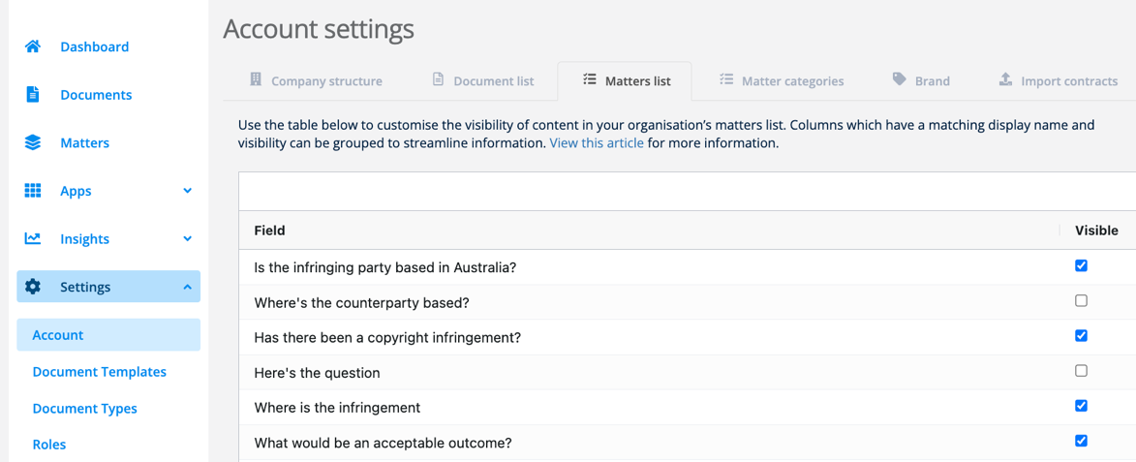
Note that only those roles with access to Access account administration and those with the Request legal support app will be able to access this page.
Making custom questions visible on the matters list
From the Matters list settings tab, you can make a custom question visible as a new column on your matters list.
For each field that you would like to display on the Matters list, click the related checkbox for Visible.
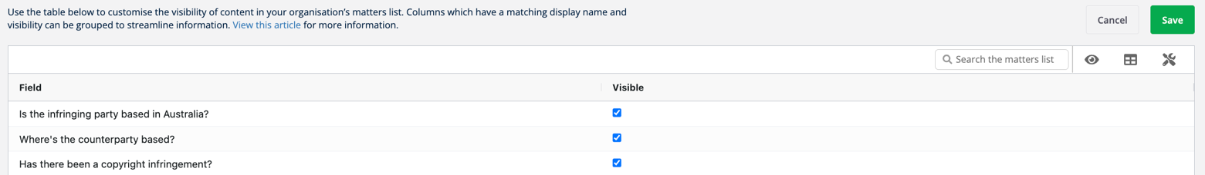
Then click Save in the top right hand corner to confirm your changes.
Top Tip! Only questions linked to existing documents are shown. Where custom questions are missing from this list, it's likely that your organisation is yet to create a matter using that custom field.

Once you've saved your changes, click to the Matters List to view your new custom columns to the right of the list.
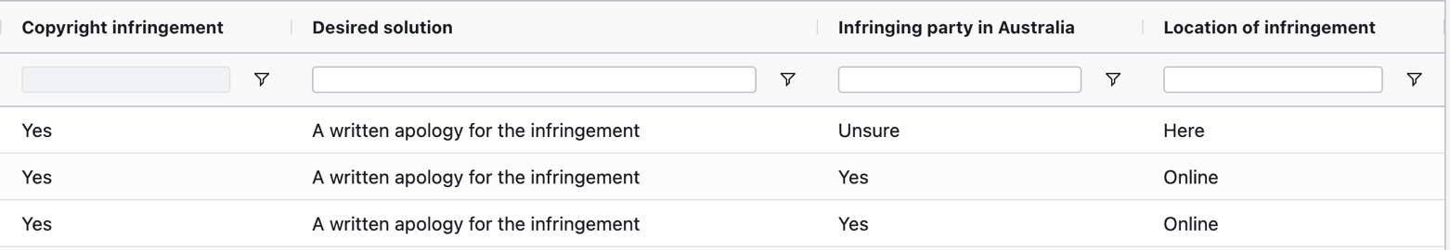
If you'd like to change the column heading, please edit the Display name for that question from the Custom questions for matters tab.

Managing your Userbase: Assigning Users to Organisation Units and Roles
To manage users, you'll need admin access to Plexus. Under the Settings menu, click into the Users tab.
On the resulting page, you'll see a list of all users associated with your Plexus account. The user list will show:
- User's details including name and email address
- The organisation units and sub-units that the user is part of
- The roles allocated to that user
- An active or invited status
- Search and filter options
- The option to edit

This guide will go into more detail on the key user list functions including:
- Viewing and searching for users on the user list
- Editing a user
- Deleting a user
- Exporting information from the user list
Viewing the user list
The user list will show a complete list of all users with access to Plexus.
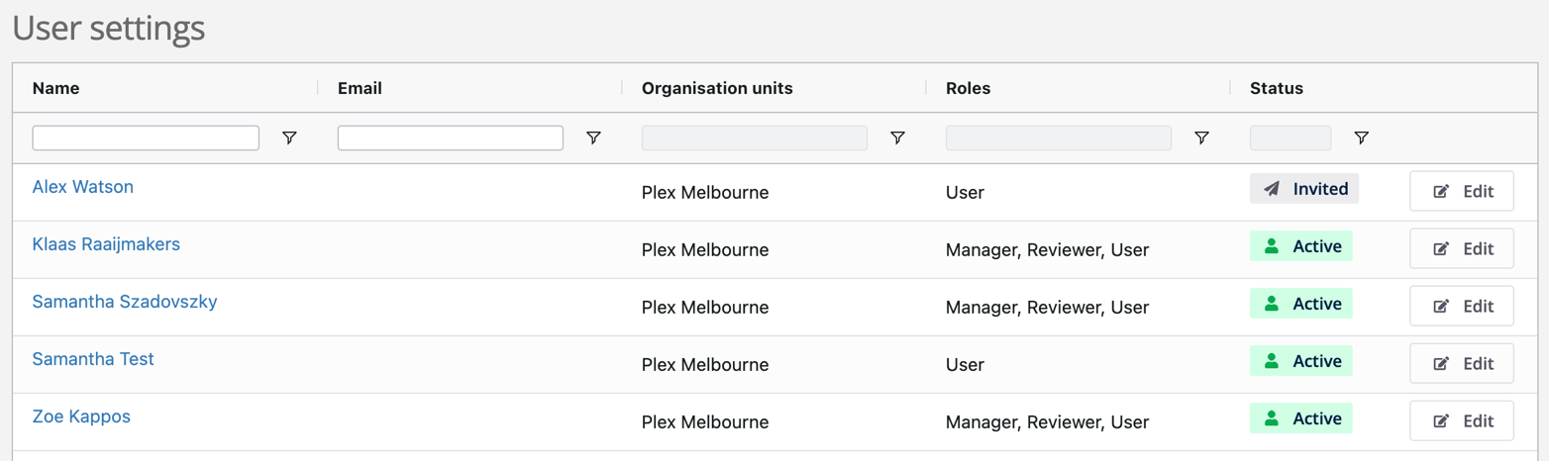
You'll be able to use the search bar at the top of each column to search for any of the following:
- Name
- Email
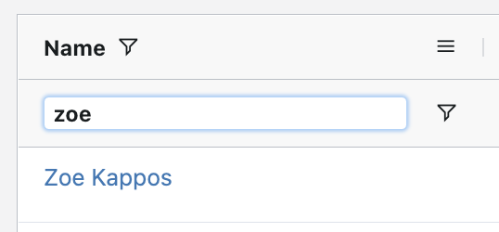
You'll also be able to add filters by clicking the filter icon next to each column to search across a particular:
- Name
- Email
- Organisation unit
- Role
- Status
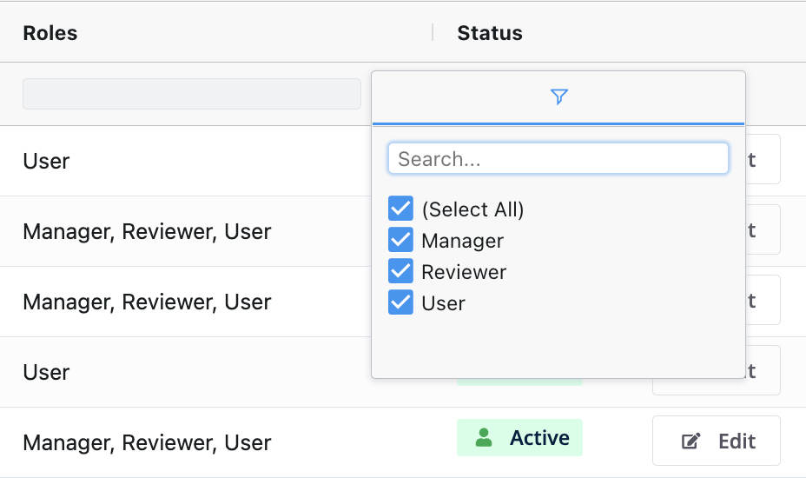
With the right permissions, you'll be able to access and edit details about each user, by clicking the hyperlink on their name.
You can also click the Edit button on the far right hand side of the user list to edit each user's most basic details.
Note: If you don't have the correct level of admin access, you'll only be able to click a hyperlink or edit button for your own name.
Editing a user
If you click the hyperlink under a user's name, you'll be able to edit a user's assigned roles and units.
You'll also find an alternate entry point to edit a user's basic details by clicking the Edit button located under the user's name.
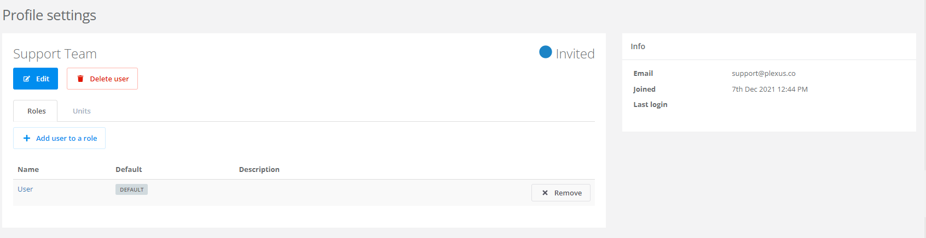
On the edit page, you'll be able to edit a user's first name and last name. You'll be able to view, but not edit the associated email address for that account.
You'll also be able to toggle the ability to receive non-workflow specific notifications in the system by clicking the checkbox.
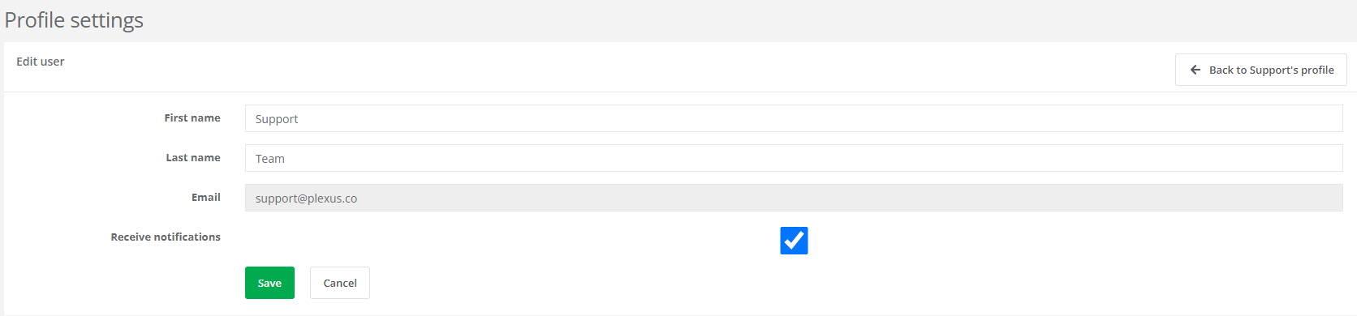
Deleting a user
If you click the hyperlink under a user's name, you'll be able to edit a user's assigned roles and units. You'll also find a Delete user button located under the user's name.
If you click the Delete user button, a user will be deactivated in Plexus so that they cannot login. Whist inactive users will not show in the user list by default, you can use status filters to show inactive users.
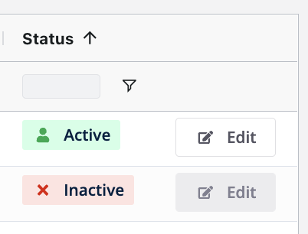
It's important to note that a user account can be reactivated if needed. Simply re-invite the user using the exact same email address to reinstate their access.
Exporting information from the user list
To export information from the user list, drag and drop your mouse over the email addresses that you would like to copy out of the system. As you do so, the column should highlight in blue for the selected details. Right click and copy these emails.
You can paste the information in a CSV or Excel file for further analysis.
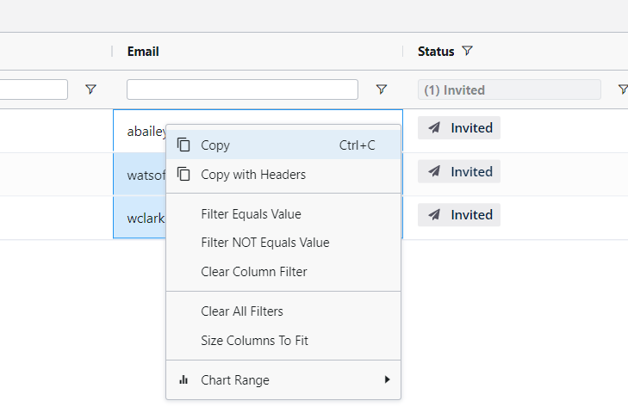
Need help managing your users? Reach out to support@plexus.co or use the live chat to get in touch!

Plexus Standard un-editable questions
By default, Plexus has a number of standard, uneditable questions built into core applications such as Approve and eSign, Store a Document and Request Legal Support.
To assist with your process of configuring custom questions within your document and matter intake form process, these questions along with their status as either mandatory or optional, are listed below:

APPROVE AND ESIGN:

PLEXUS STANDARD QUESTION (un-editable) | MANDATORY/OPTIONAL
What files would you like to upload?  (Option to add 1x Main document and additional supporting material as either a sub- or internal document.) | Mandatory
What is the document title?  (Title defaults to the file name of your Main document uploaded however is editable) | Mandatory
What type of document is this?  (Document type determines the subsequent custom questions) | Mandatory
Does this document have a start or expiry date?  If yes:  Optional start date & expiry date fields appear if ‘yes’ is selected | Optional
Currency  What is the document value? | Optional

{{CUSTOM QUESTIONS}}

Are you uploading this document on behalf of someone else?  You can include another stakeholder who will get access to the document and its notifications. | Optional
Is another party involved?  Search and report on the counterparty information entered here. | Optional
Do you want to send a copy of the final signed document to anyone? | Optional

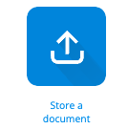
STORE A DOCUMENT:
PLEXUS STANDARD QUESTION (un-editable) | MANDATORY/OPTIONAL
What files would you like to upload?  (Option to add 1x Main document and additional supporting material as either a sub- or internal document.) | Mandatory
What is the document title?  (Title defaults to the file name of your Main document uploaded however is editable) | Mandatory
What type of document is this?  (Document type determines the subsequent custom questions that will appear) | Mandatory
Has this document been executed?  Mandatory executed date fields appear if ‘yes’ is selected | Mandatory
Does this document have a start or expiry date?  Optional start date & expiry date fields appear if ‘yes’ is selected | Mandatory
Currency  What is the document value? | Optional

{{CUSTOM QUESTIONS}}

Are you uploading this document on behalf of someone else?  You can include another stakeholder who will get access to the document and its notifications. | Optional
Is another party involved?  Search and report on the counterparty information entered here. | Optional


REQUEST LEGAL SUPPORT:
PLEXUS STANDARD QUESTION (un-editable) | MANDATORY/OPTIONAL
What is the nature of your issue?  Enter title here | Mandatory
Select category | Mandatory
Select sub-category | Mandatory
Tell us what you need help with  What do you need help with? | Mandatory

{{CUSTOM QUESTIONS}}

PLEXUS STANDARD QUESTION (un-editable) | MANDATORY/OPTIONAL
When do you need a response by?  Date picker provided | Optional
Financial Value e.g. 5000 | Optional
Are any other parties involved?  Yes/No  If yes, Company or individual name appears | Optional
Are you creating the request on behalf of someone else?  Yes/No  If yes, select name from dropdown list of users | Optional
Please upload any relevant documentation | Optional

{{AI GENERATED QUESTIONS}}

Plexus’ AI Security Fact Sheet
Plexus features the world’s leading Generative AI technology from OpenAI, used by global companies such as Microsoft, Morgan Stanley and Duolingo.
For more information on Plexus AI please follow the link in the title above.

Definition of a “Professional User” within Plexus

Professional User means a User that has the right to perform activities using the Services, beyond that of a General User. The additional activities that a Professional User can perform include any of the following:
- Be assigned as the Default Reviewer of any document type
- Manage legal matters (assign, be assigned, change status or priority)
- Perform any administrative function on the platform (user, role, organisation management, document list customization, branding, matter management configuration, Approve & eSign settings control, delegation rules and custom questions).

