
Install WebGoat

BACKGROUND
WebGoat is an open source tool used to demonstrate common website security vulnerabilities.

DESCRIPTION
This exercise will walk through the installation of WebGoat.

REQUIREMENTS
Java 15 or newer (installation of JDK 17 is covered earlier in this chapter). A web browser (preferably Chrome) is also needed. This exercise assumes you’re running an instance of Linux (either virtualized or other). This exercise will run in Google Cloud Shell.

PART I: Download and Run WebGoat
- WebGoat is distributed as a runnable JAR file. JAR files are Java ARchive files. A JAR file is similar to the more commonly known ZIP file, but does have a specific internal structure. The file can be downloaded from the command line, using wget:
wget https://github.com/WebGoat/WebGoat/releases/download/v8.2.2/webgoat-server-8.2.2.jar

- The WebGoat JAR file is runnable; once started, a web server will be launched on your machine. If you are using the Google Cloud Shell you are much safer. This warning comes directly from the WebGoat creators and should not be taken lightly:
WARNING
While running this program your machine will be extremely vulnerable to attack. You should disconnect from the Internet while using this program. WebGoat’s default configuration binds to localhost to minimize the exposure.

NOTE: If you are running in Google Cloud Shell, you do NOT need to disconnect as Google protects your system by requiring authentication.

Note that while Google Cloud Shell provides protection from unauthorized users, Google Cloud Shell users should still be judicious with their use of WebGoat.
Start the web server by issuing this command:
java -Dfile.encoding=UTF-8 -Dserver.port=8080 -Dhsqldb.port=9001 -jar webgoat-server-8.2.2.jar

EVIDENCE #1
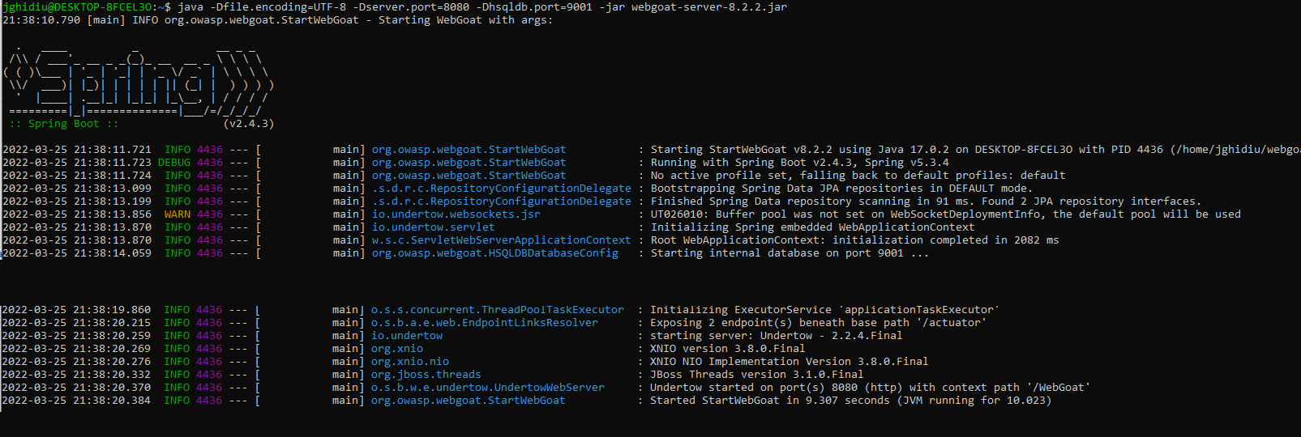
PASTE AN IMAGE OF WebGoat RUNNING

PART 2: Create a user account
- Open a browser and create an account. The URL will be different depending on your setup, but here are some guidelines:
  - Traditional Linux systems will be reachable via: http://localhost:8080/WebGoat
  - Google Cloud Shell systems are a bit different; a "web preview" will need to be opened. Click the "Web Preview" button:
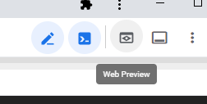
Next, make sure that the web preview port matches the port that WebGoat was launched from (Part 1, step 2). The default is 8080.
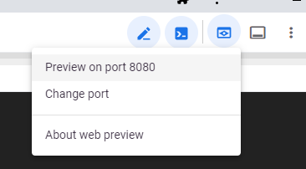
With Google Cloud Shell, you will need to alter the URL that is launched. The default URL will be something like:
https://8080-cs-65291530751-default.cs-us-east1-pkhd.cloudshell.dev/?authuser=0
You MUST change:
- The FIRST part of the URL - this instance ID will be unique every time you start the server
- The last part (?authuser=0) of the URL to "WebGoat". Continuing the example, this is what a Google Cloud Shell URL would look like:
https://8080-cs-65291530751-default.cs-us-east1-pkhd.cloudshell.dev/WebGoat

- Click the "Register new user" and create a user. Note that the user is local to your machine
- Fill in the new user form: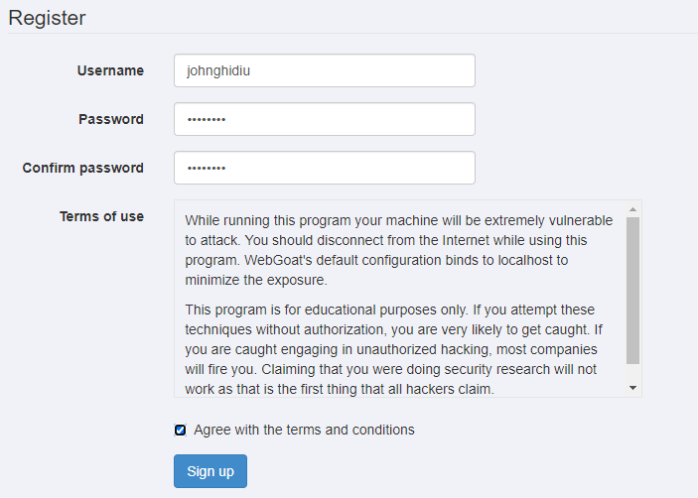

EVIDENCE #2
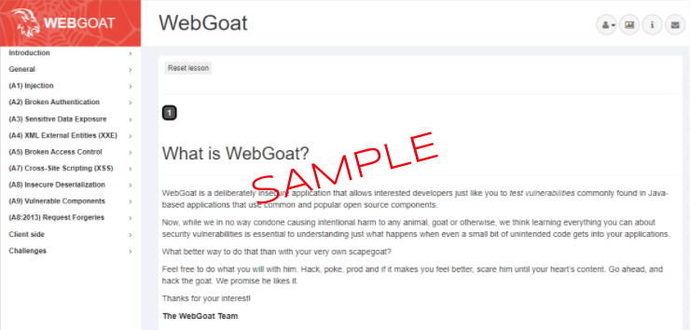
PASTE AN IMAGE OF THE WebGoat HOME PAGE FOR LOGGED IN USERS

PART 3: Walk through a lesson
- WebGoat provides a number of lessons, each illustrating one aspect of security. Each lesson has one or more steps. Note the different colors: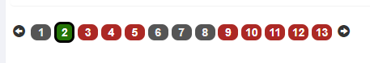
The GRAY steps denote a LEARNING step. These steps often have some reading or a link to additional information.
The RED steps denote an INCOMPLETE ACTION step. These steps have specific actions that need to be completed but the actions have not been successfully completed.
The GREEN steps denote a COMPLETE ACTION step. The actions on these steps have been completed satisfactorily.
CAREFULLY READ the instructions for subsequent lab exercises as not all steps will need to be completed in order to get full credit.
- Select the "(A2) Broken Authentication" topic on the left navigation bar.
- Complete the “Secure Passwords” lesson. There is one ACTION step (step 4).

EVIDENCE #3
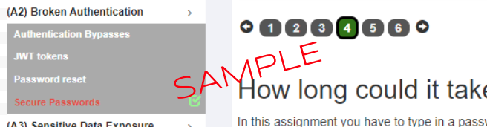
PASTE THE IMAGE OF THE SECURE PASSWORDS EXERCISE WITH A GREEN STEP 4

