Essays & LORs (Scholarships & Grants: Part 2)

Student Worksheet

Learning Objectives
- What are common scholarship essay questions?
- What are common supporting documents that scholarships require?
- How to write a good scholarship essay
- How to request a Letter of Recommendation (and get a good one!)
- How to create a résumé when you have limited (or no) job experience
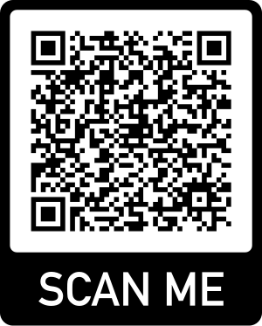

Want to find and apply for scholarships? Sign up for Going Merry!
Scan the QR code to sign up for a free Going Merry account.

NOTES
Resources | Topic & questions
10 most common scholarship essay questions  16 common scholarship essay themes | Common Scholarship Requirements (10 mins)  Which of the common essay questions do you find easiest to answer? Which do you find the most difficult? Why?  Beyond essays, what are some accompanying documents a scholarship might request? Which of these documents have you not prepared yet?  How do these document requirements compare to college applications?
6 Scholarship Essays That Worked  Featured scholarship winners & essays  Best friend scholarship video winner (2:40) | Writing a good scholarship essay  Did you like the essay you read? Why or why not? Why do you think it was successful in winning a scholarship?  What did you think of the video? Why do you think it was successful in winning a scholarship?  Would you prefer to write an essay or submit a video?  NOTE: Need more help with personal statements? You may want to check out this article in your own time, with examples and step-by-step instructions on how to choose a topic.
How to ask for a LOR | PRACTICAL EXERCISE: Requesting a Letter of Recommendation  Do you know who should write your Letter of Recommendation (LOR)? Why did you pick this person (or these people)?  What do you think is the right way to ask for a LOR?  Activity (follow the worksheets!)  - Identify possible good recommenders here.  - Create a plan to ask them to write LORs for you.  - Fill out a brag sheet, to be able to private your recommender.
Tips for high school resumé writing | Student resumés:  What are key elements that should appear on your resumé?  What should students focus on, given limited work experience?  What are some “do’s” and “dont’s” of student resumés?
Student resumé sample & complete writing guide (Zety)  Student resumé template and writing tips (Resume Lab)  Canva Resume Templates  Google Doc templates | HOMEWORK: Create your resumé.  - Read through the two longer articles about creating a student resumé  - Create your own resumé. You might look at Canva’s resume templates or another resume builder website like Google templates. Otherwise, you can start from scratch to make your own!  Choose a template and fill it out with your personal information.

