The Design Process - Lesson 6
Name(s)_______________________________________________ Period ______ Date ___________________
 | Activity Guide - Improve a Screen | 

Potential Improvements

Using the feedback you categorized in the last activity, what improvements could your group make to the app? For each improvement, identify which category of feedback you are addressing.

Proposed Improvement | Feedback Addressed
Allow users to add more grandchildren and allow them to edit the information for their grandchildren  Add a home button on every screen  Change the name of the app  Can change the text size in the settings of the app | Adding and changing grandchildren information  Making it easier to get back home without all these steps  Would make it easier to find the app to download  People who have trouble reading and seeing it would have a better time.

Screen Redesign

Each group member will select one of the screens, and one of the improvements. Using the page for your chosen screen, sketch out what your improved user interface will look like. Describe changes to the user experience by writing descriptions or drawing arrows to the changes you’ve made in the space below. How will buttons, inputs, etc. work differently on this updated screen?

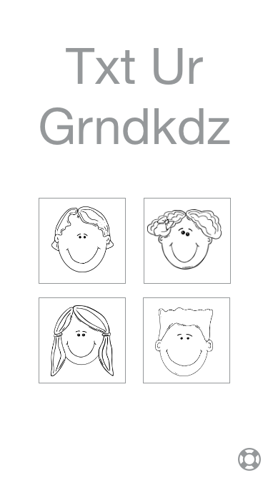
Text Your
Grandkids

Add a button to add kids
Change the spelling of the app

