Unit 5 Lesson 16
Name(s)_______________________________________________ Period ______ Date ___________________
Project Guide - Solve a Data Problem

Overview
In this unit you’ve seen how data can be used to solve all kinds of problems. Now it’s your turn to use data to help someone. In this project, you will use data to make a recommendation to a classmate.

You will…
- Work with a partner
- Define a problem that could be addressed by a recommendation
- Identify the data you need and create a survey to collect it
- Interpret the data to find relationships between survey answers
- Create an algorithm to make a prediction based on data
- Test your algorithm
- Present your work to your classmates

You will submit…
- Completed Project Guide (this document)
- Completed Peer Review
- Any materials used to present your work

Starting Off

Before you start your project, look at the example recommendation app online.

What choice does the app help the user to make?

What data does it use to make that recommendation?

How do you think the creators of the app decided on the algorithm that they used to make the choice?

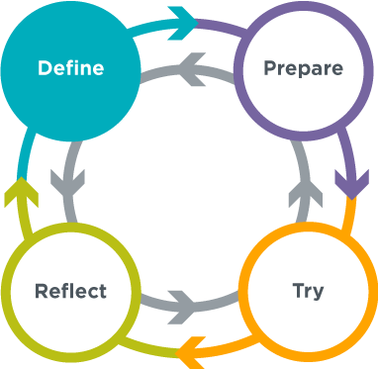
Project Steps

Step 1 - Define Your Problem

In the sample app, the recommender helped the user to decide where to go on vacation. With your partner, decide what type of problem your recommender will solve.

What question will your recommender answer for the user?

What possible recommendations should it choose from?

1. ________________________________________ 3. ________________________________________

2. ________________________________________ 4. ________________________________________
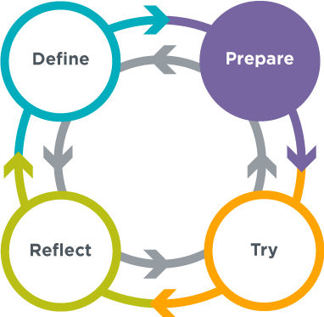

Step 2 - Decide What Data You Need

In the sample app, the recommender used data about a user’s food, superpower and animal preferences to decide what to recommend.

What data might help you make a recommendation?

Type of Data  Describe the kind of information you want to collect | Possible Questions and Answers  Describe the questions and answer choices you might put in a survey

Step 3 - Create Your Survey

Look at the kinds of data you’ve decided you need to collect. Use them to create survey questions

Question 1

Answer Choices

1. | 3.
2. | 4.

Question 2

Answer Choices

1. | 3.
2. | 4.

Question 3

Answer Choices

1. | 3.
2. | 4.

To figure out how these answers relate to the recommendation you want to make, you’ll also need to ask everyone their preference for what you want to recommend.

Preference Question

Answer Choices

1. | 3.
2. | 4.

Step 4 - Collect Your Survey Data

Now that you have a survey, you’re ready to collect your data. Give your survey to at least twenty different people, and record their answers here. You’ll use this data to figure out how the answers to the first three questions can predict a person’s preference.

# | Answer 1 | Answer 2 | Answer 3 | Preference
1
2
3
4
5
6
7
8
9
10
11
12
13
14
15
16
17
18
19
20
21
22
23
24
25
26
27
28
29
30

Step 5 - Interpret your Data
Use cross tabulation to find out how the answers to each of the three questions relate to the preference that you want to recommend. Label each chart with the question you asked, then fill it in with the answers in with the answers from the survey. Once you’ve put your data into the table, try to find some relationships that will help you make your recommendation algorithm.
Question 1  __________________________________  Question 2  __________________________________  Question 3  __________________________________ | What relationships could help you make a rule?  1. __________________________________________  __________________________________________  2. __________________________________________  __________________________________________  What relationships could help you make a rule?  1. __________________________________________  __________________________________________  2. __________________________________________  __________________________________________  What relationships could help you make a rule?  1. __________________________________________  __________________________________________  2. __________________________________________  __________________________________________

Step 6 - Define your Algorithm

Now that you’ve found some interesting relationships between the answers to the questions and user preferences, you can use them to make your algorithm. For each question, list the possible answer choices and explain the instructions for adding points to the relevant recommendation choices.

 | Answer | Instructions
Question 1
Question 2
Question 3

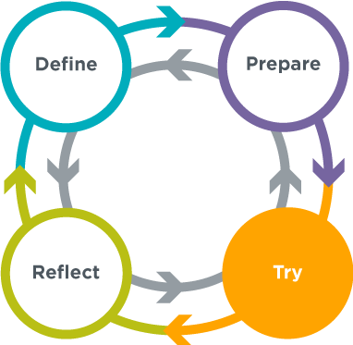
Step 7: Try out your Algorithm
Test your algorithm by trying to make a recommendation for three classmates who did not take your original survey. For each classmate, list the four possible recommendations in the first row of the table, then use the second row to tally the points each recommendation gets from that classmate’s survey answers.

Classmate 1

Answer 1:______________________ Answer 2:______________________ Answer 3: ______________________

Recommendation
Points

What is the recommendation? __________________________________________________________________

Classmate 2

Answer 1:______________________ Answer 2:______________________ Answer 3: ______________________

Recommendation
Points

What is the recommendation? __________________________________________________________________

Classmate 3

Answer 1:______________________ Answer 2:______________________ Answer 3: ______________________

Recommendation
Points

What is the recommendation? __________________________________________________________________

Did your users agree with the recommendations that you made? Explain.

Are there any changes that you think you should make to your algorithm?

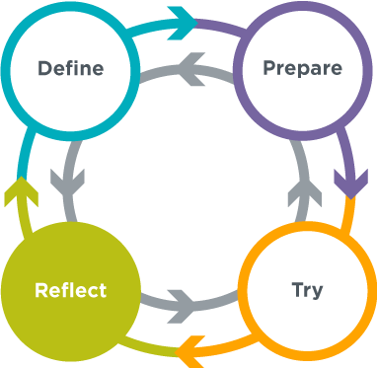
Step 8: Peer Review
Your teacher will provide you with a Peer Review sheet. Trade projects with another group and complete the peer review. As part of this process you should develop new ideas for how you can improve your recommendation.

Step 9: Finalize and Present
Based on the results of your peer feedback make any additions or changes you need to make to how you defined your problem, the data you want to collect, or the way it will be analyzed. Then prepare a presentation of your solution to share with your peers. It should include:

- What choice you are helping the user to make
- The types of data you collect to help the user make that choice
- The relationships that you found when interpreting your survey data
- The way you used this information to create your recommendation algorithm
- The results of testing the algorithm on users

You should be able to find all this information inside your project guide.

