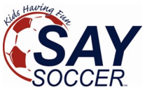
Medical Consent
Every player within your organization MUST have a parent or guardian sign off on this statement.
If you have any questions, please contact your SAY Administrator
prior to completing this agreement.
________________________________________________________________________________________________Consent for Emergency Medical Treatment
We the parents of, give permission for emergency medical treatment of our child for illness or accident if we cannot first be contacted.
Emergency Parent or Guardian:
Phone:
Email:
Emergency Secondary Contact: (other than parent)
Name:
Phone:
Cell:
Email:
Does your child have any allergies or require special medication: Yes_______NO_______ Explanation:

Signature (Parent/Guardian)
Date

