Install (or access) a Linux Environment


BACKGROUND
Linux is an open source operating system (Windows and MacOS are examples of other operating systems that are not open source). Most people involved in networking, cybersecurity, and IT rely on Linux daily.
There are many different flavors of Linux (Ubuntu, Kali, RedHat, or Mint). We will be using Ubuntu this semester.
Some of the ways to use Linux include:
- Install Linux on a virtual machine
- Install Linux on a computer
- Boot Linux from a USB drive
- Install Linux using the Windows Subsystem for Linux
- Activate Linux on a Chromebook
- Use a cloud-based Linux machine
In this exercise, you will install Linux (or use a cloud-based solution). You will have the option of choosing any of the above options. If you plan on going into the field of Networking and Cybersecurity, you will encounter virtual machines all the time, and this is a good option for you to gain experience.
If you have Windows 10, you might elect instead to use the WSL (Windows Subsystem for Linux). This is a frictionless installation and sufficient for the work we will be doing this semester.
However, if you run into problems with those two options, you can always use a cloud-based machine.
For this lab, you will need evidence of a working Linux shell (command line interface).

REQUIREMENTS
Depending on your method of installation, you may need a computer capable of virtualization.

PART I: Install Linux
There are a number of different methods of installation; you need to choose one (or more than one if you want to poke around!). If you are pursuing a career in Networking and Cybersecurity, you’ll want to use a virtual machine (because you’ll need to do it later on in your program). But if you’re not quite ready for that, choose the WSL method or a cloud-based version.

METHOD I: Install Linux on a Virtual Machine
A virtual machine (VM) is software that can leverage the hardware of the host computer and run a different operating system. This should not be confused with emulation, which is software that imitates other software, without a need to talk to most of the hardware of the computer.
There are a number of advantages to a VM. A virtual machine is sandboxed (runs in a restrictive environment). A virtual machine can have its state saved. And a virtual machine can allow one computer (such as a Mac) to run multiple operating systems (MacOS, Linux, ChromeOS, and Windows, for instance).

STEP 1: Install virtual machine software
- You can choose between VirtualBox or VMWare Player (I prefer VirtualBox, but many people swear by VMPlayer; either one will work).

STEP 2: Install Ubuntu on the virtual machine
- Download the Ubuntu image as an ISO from Ubuntu.
- Use your virtualization software to install Ubuntu.
      - IMPORTANT: If using a version of VirtualBox which allows unattended installs, be sure to SKIP the unattended install by checking the appropriate box: 
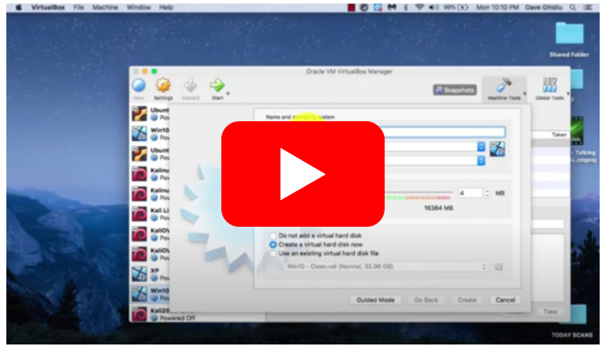
Link to video

METHOD II: Install Linux on a computer
To install Ubuntu on a computer, use the instructions provided by the people at Ubuntu.

METHOD III: Boot Linux from a USB drive
To boot Ubuntu from a USB, use the instructions provided by the people at Ubuntu.

METHOD IV: Install Linux using the Windows Subsystem for Linux

STEP 1: Understand the WSL
This is an easy method of accessing Linux. The Windows Subsystem for Linux is a little different than a full-blown virtual machine (if you are super nerdy and want to know the differences, check out this reddit thread, a deep dive into the WSL by Microsoft, or this reply from Quora).

STEP 2: Install Ubuntu from the Microsoft Store
Go to the Microsoft Store (an app that is on Windows 10), search for “Ubuntu”, and then install it. The search may yield several different options. There are two things to know:
- LTS means “Long Term Support” (and Ubuntu will offer updates for two years on these versions)
- The versioning follows the scheme YEAR.MONTH (for instance, 20.04 is the April release from 2020, and 20.10 is the October release from 2020).
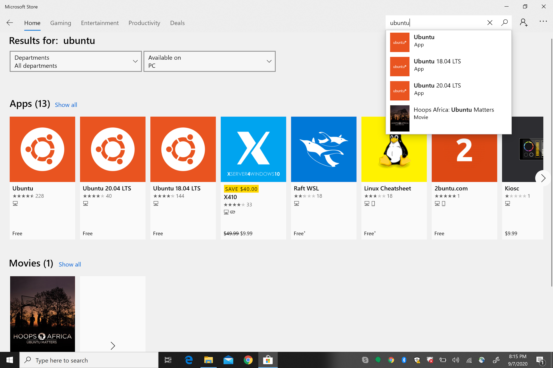
For a video demonstration of installation, check out this YouTube video (only the first four minutes are relevant; the remainder of the video is a brief introduction to Linux).

METHOD V: Activate Linux on a Chromebook
Chromebooks can run a version of Linux called Debian (actually, Ubuntu is also a Debian derivative). To activate Linux on a Chromebook, check out this video.

METHOD VI: Use a cloud-based Linux machine
If you cannot use any of the methods above, you can access a Linux shell via Google Cloud. Simply go here. You can even install it as a PWA (standalone progressive web app) on your computer - check out this video.

Take a screenshot of a Linux distribution running on your virtual machine. Make sure that there is a way to identify it as your machine from the image (your name is in the terminal, for instance):

EVIDENCE #1
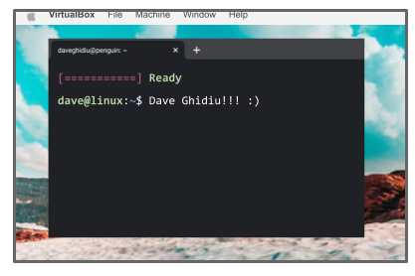
PASTE THE IMAGE OF YOUR VERSION OF LINUX
MAKE SURE THERE IS IDENTIFYING INFORMATION IN THIS IMAGE
(LIKE YOUR NAME TYPED IN THE TERMINAL)

