DOKUMEN SANGAT RAHASIA

UTAMA
03/U/PTSGs/VIII/20..

PENILAIAN TENGAH SEMESTER GASAL
SMPN MEDIAEDUKASI.MY.ID
TAHUN PELAJARAN 20../20..

LEMBAR SOAL

Mata Pelajaran : Bahasa Inggris Hari, Tanggal :
Kelas : VIII ( Delapan ) Waktu : ..........................................

PETUNJUK UMUM :
1. Tulislah lebih dahulu nama, nomor peserta dan kelas pada lembar jawab yang telah tersedia!
2. Bacalah lebih dahulu setiap soal, sebelum Anda mengerjakan!
3. Kerjakan lebih dahulu soal-soal yang Anda anggap mudah!
4. Periksalah kembali pekerjaan Anda sebelum diserahkan kepada pengawas!

PETUNJUK KHUSUS PILIHAN GANDA
Choose the correct answer by crossing ( X ) A, B, C, or D, do it on your answer sheet!

1. Adin : What are you doing, Krisna?
Krisna : I’m having my snack.
Adin : Have you washed your hands? Krisna : Upsss, I’m afraid I haven’t.
Adin : You must wash your hands before eating to get rid of any virus or bacteria.
Krisna : Thanks for reminding
In the dialogue, Adin expresses a/an …. A. Opinion
B. Obligation C. Suggestion D. Willingness

2. Mom : Don’t forget to wear mask if you want to
This following dialogue is for no. 3 and 4.

Mr. Adnan : Look! The doctor is coming. Mrs. Adnan : Help me, doctor! My son is
running out of breath. He was fine when we’re on our way here.
Doctor : I’ll do my best, ma’am. Please, stay outside and we’ll take care of your son.
You don’t have to be worried too much.

3. The dialogue might take place at a/an ….
go out, Santi. |  | A. | Hematology unit
Santi : | Should I, mom? | B. | Emergency unit
Mom : | Yes, dear. You must put on your mask. | C. | Radiology unit
Santi : | I cannot breathe quite well with the mask. | D. | Pharmacy unit

Mom : You don’t want to have corona virus, do
you?
The expression telling an obligation is ….
A. Don’t forget to wear mask if you want to go out, Santi.
B. You don’t want to have corona virus, do you? C. I cannot breathe quite well with the mask.
D. You must put on your mask.

4. According to the doctor, Mrs. Adnan must be ….
A. Sorrowful B. Worried C. Happy
D. Calm

This dialogue is for no. 5 - 6.

Teacher : Attention, please! In this webinar meeting, I’d like to share some important information.
Sarah : Yes, Sir. We’re listening.
Teacher : During this COVID 19 pandemic, you are obliged to keep staying at home. You are not allowed to go to public area for unnecessary things. The teaching and learning will be conducted in online mode. That’s why, you don’t have to go school. Next, you need to eat healthy food and you have to do sport at home. Stay safe and healthy, everyone!

5. The expression of a must is ….
A. You are not allowed to go to public area for unnecessary things.
B. The teaching and learning will be conducted in online mode.
C. You are obliged to keep staying at home. D. You don’t have to go school.

6. Based on the dialogue, the students are prohibited to ….
A. Do exercise
B. Go to school
C. Eat healthy food
D. Study from home

This text is for no.7 and 8.

These are some terms on the study from home of SMP Persada Semarang.
1. Students don’t have to go to school.
2. Generally, the teaching and learning is conducted in online system.
3. Students must join a virtual class for each subject.
4. Students are not allowed to miss any task on their class.
5. Students are also prohibited to skip online meeting which is held twice a week.
6. Students must confirm their class teacher if they have any troubles on their learning.
7. Parents need to support this online teaching and learning in such ways.

7. The text aims to … in the study from home.
A. Inform the dos
B. Inform the don’ts
C. Inform the dos and the don’ts
D. Inform the don’ts and the need
8. Things which are not allowed to do by the students are ….
A. Miss any task, go to school, and support the online class.
B. Go to school, skip the twice a week online meeting, and miss any task
C. Skip the twice a week online meeting, join virtual classes, and miss any task
D. Go to school, skip the twice a week online meeting, and confirm their learning troubles

This text is for no. 9 and 10

Ahsan : Hello, Hilmy. Your voice sounds terrible. Do you have any problem, buddy?
Hilmy : Yes, you are right. Have you submit the English assignment in our classroom?
Ahsan : I have. How about you?
Hilmy : Good to hear that, Ahsan. I’m in a mess now. I haven’t finished some tasks in many subjects.
Ahsan : Well, you had better manage your time from now on. Make your time line to finish them all. I’m ready anytime you need a help. But don’t forget, you should keep your health also. One more thing, you should be relax.
Hilmy : I will. Thanks, Ahsan.

9. Ahsan suggests Hilmy by saying ….
A. Your voice sounds terrible.
B. Do you have any problem, buddy? C. I’m ready anytime you need a help.
D. You had better manage your time from now on.

10. “… you should be relax.”
This expression shows that Hilmy doesn’t need to be ….
A. Angry
B. Sad C. Panic D. Sick

11. Andin : Whatshallwe dotoprevent the COVID 19 spread?
Amira : We have to do healthy life style and we
… put on mask anytime we go out. A. Can
B. Will C. May D. Must

12. Candra : I’m happy we are in new normal now.
Hanif : Me too. Let’s keep our environment clean, wash hands using soap regularly, and do positive things.
Candra : You are right. But … forget to eat nutritious food too.
18. The due date for the last assignment is today before 5 pm. ….
A. We must submit it tomorrow. B. We must not submit it late. C. We should submit it late.
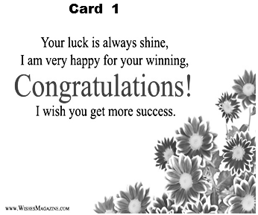D. We should not submit it.
A. Do
B. Does
C. Don’t
D. Doesn’t

13. Hasan : What … I do if I failed joining the online class meeting?
Harun : Check your internet network, please. A. Have
B. Need C. Might D. Should

The text is for no.14 and 15.

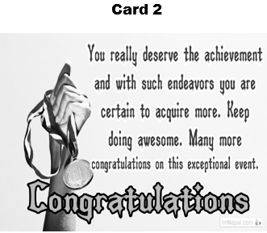19. Pay attention on these two cards.
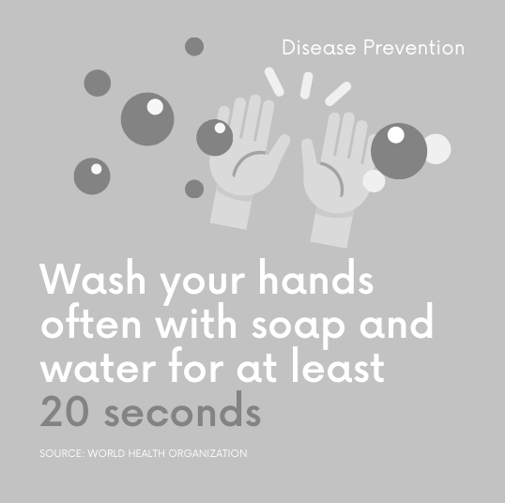

14. The suitable expression based on the text is ….
A. It is no need to wash hands often. B. We must not wash hands regularly. C. It is unnecessary to wash hand often
D. We should wash hands with soap regularly.

15. Lita : How long should we wash our hands with soap, Lisa?
Lisa : …
A. We should wash them for at least 20 seconds. B. We would wash them for at least 20 minutes. C. We would wash them for at least 20 seconds. D. We should wash them for at least 20 minutes.

16. Corona Virus Disease 2019 (COVID 19) outbreak has driven the world order to such a mess. People are struggling to fight the virus. They … support their government to get rid of the virus.
A. may B. shall C. might
D. should

17. All students are obliged to keep their personal hygiene. They … take a bath twice a day.
A. must B. may C. can D. will

20.

Both of the cards aim to congratulate one’s …. A. winning
B. wishing C. shining D. hoping

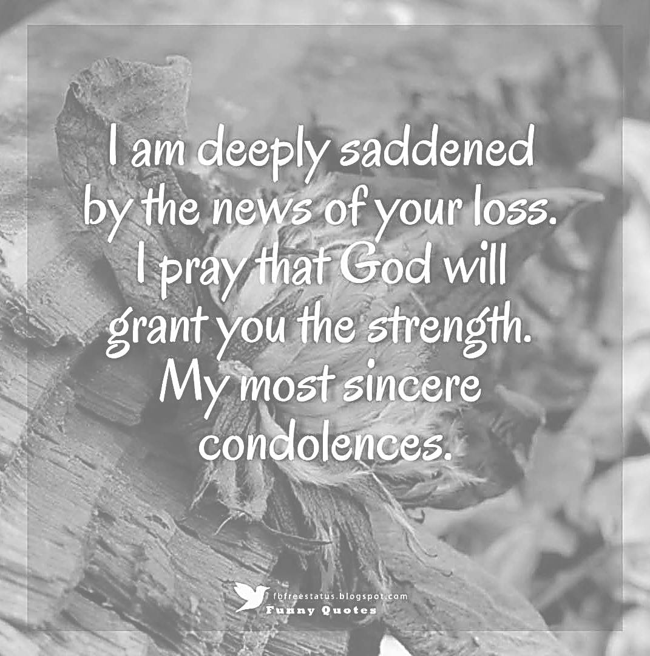
The card is sent in order to …
A. express sympathy on one’s life
B. express sympathy on one’s death
C. express sincerity on one’s disappointment. D. express sincerity on one’s appointment.

21. Pay attention on this following card!

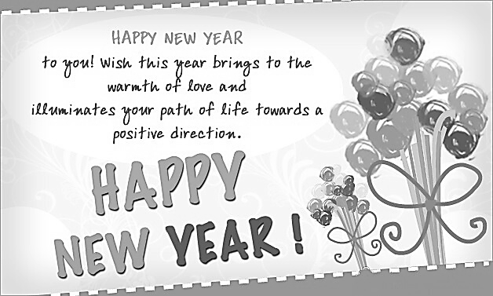

The true statement based on the card is …. A. The card is sent in a bad year.
B. The card is sent in a happy moment.
C. The card is sent on a sorrowful moment. D. The card is sent at the middle of a year.

22. Notice these two following cards!
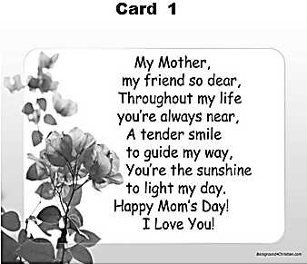

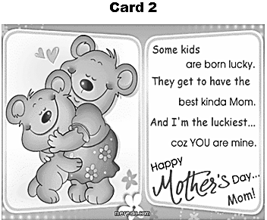

The cards differ in term of their …. A. occasion
B. receiver C. sender D. layout
This text is for no. 23 and 24

Dear Hana,
We are glad that finally you leave your high school. Keep learning at your college, as you’ll see many things out there just like what your siblings, Hasna, Hani, and Hanum have experienced. As always, you are special for us. Proud to have you, girl!
Love
Mom and Dad

23. The receiver of the card is….
A. Hanum B. Hasna C. Hani
D. Hana

24. What do you think the relationship between the sender and the receiver of the following card?
A. Parents and sibling B. Siblings and friend C. Teachers and friend
D. Parents and daughter

25. 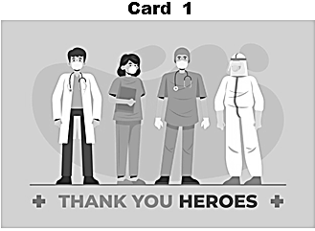

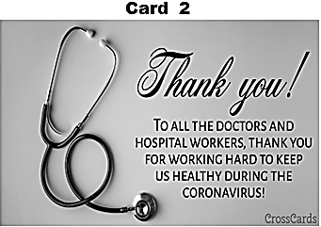
Both of these cards aim to …. A. Show pride
B. Show ability
C. Show gratitude
D. Show sympathy

26.

27.



The expression on welcoming a new baby born is ….
A. This world is ready to show you all its love
B. May your journey through life be happy
C. Memorable and forever hopeful! D. Welcome, little baby girl!
This text is for no. 29 and 30

To : The Principal of SMP N 06 Sukabumi

I would like to congratulate SMP N 06
Sukabumi on its anniversary in 2020. May the school reach its ultimate achievement this year and be the best school in this city. I still remember when we had to work really hard at the very first time this school was built in 1978. Congratulations once again on your school
anniversary. May God bless us as always!

From : Mr. Ahmad Sanjaya, M.Sc.

29. The card is sent in a/an … atmosphere.
A. joyless and sad B. Awful and bad C. joyful and proud
D. awkward and proud

30. How long does SMP N 06 Sukabumi exist? It exists for … years.
A. 41
B. 42
C. 43
D. 45

31.

28.
The word “begins” can be best replaced with …. A. finals
B. starts C. goes D. ends

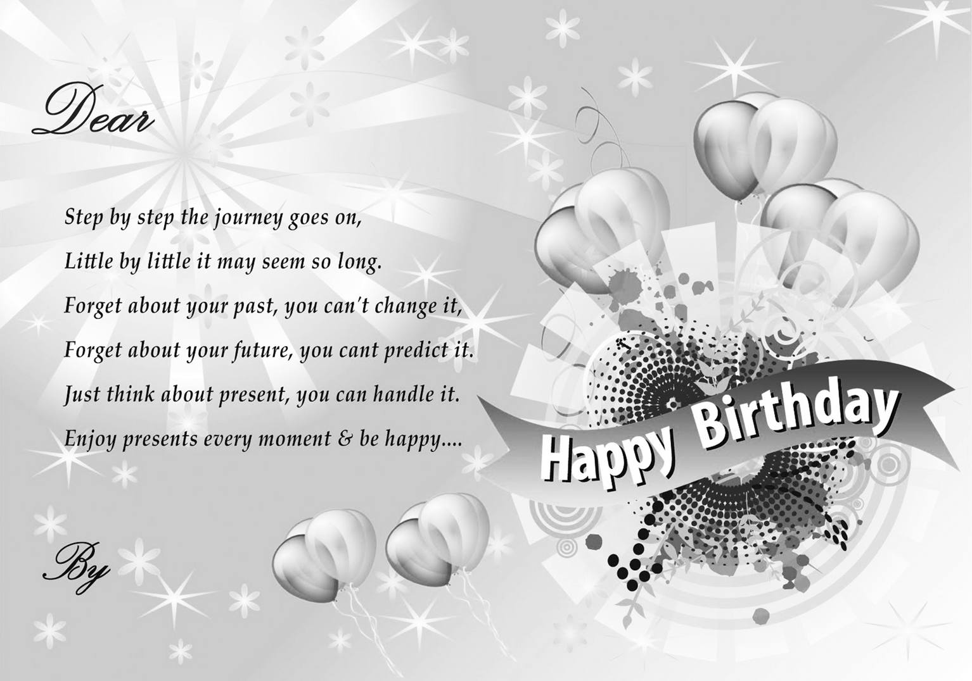

“Little by little it may seem so long.” The underlined word refers to ….
A. the journey
B. moment
C. future
D. step

32.
HAPPY 75TH INDEPENDENCE DAY OF INDONESIA

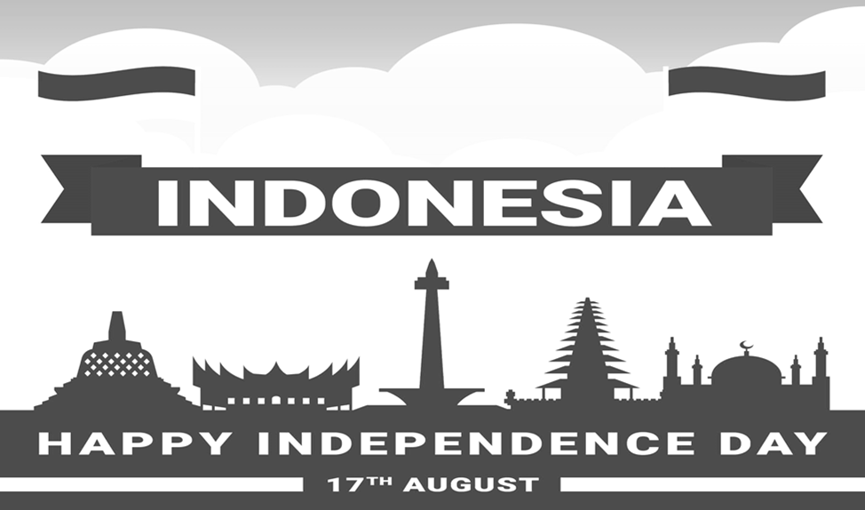MAY INDONESIA … A PROSPEROUS AND ADVANCED NATION WITH MUCH PRIDE ON ITS PEOPLE

The suitable word to complete the blank on the following card is ….
A. become B. became C. becomes D. becoming

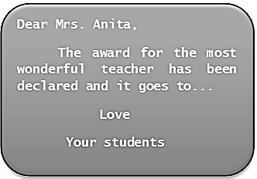
The blank on this card can be best filled with …. A. they
B. you C. she D. we

33.
35.

Dear Rendra, Congratulations on winning the English speech contest. ⋯.
Best buddy,

Roger

To : Hama

I wish you a very happy birth day.
May you be a better person with (33) ... future.

Warm regards, Shanum

The best word to fulfill the blank is …. A. bright
B. brighter C. brightest D. brightful

34. Pay attention on this picture!



The suitable greeting card for the picture is a/an
… card
A. winning B. gratitude C. graduation
D. anniversary

36.

The blank can be best filled with …. A. I hope you win it.
B. You did a very good job
C. Good luck with the contest. D. Wish you will be the winner

To : Andrea
Sari and I hope you will get well soon.
(36) .... feel sorry for being late to see you. Wish you get your health back immediately.
Best regards, Sarah

The proper word for the blank is …. A. You
B. She C. We D. I

37.

C.

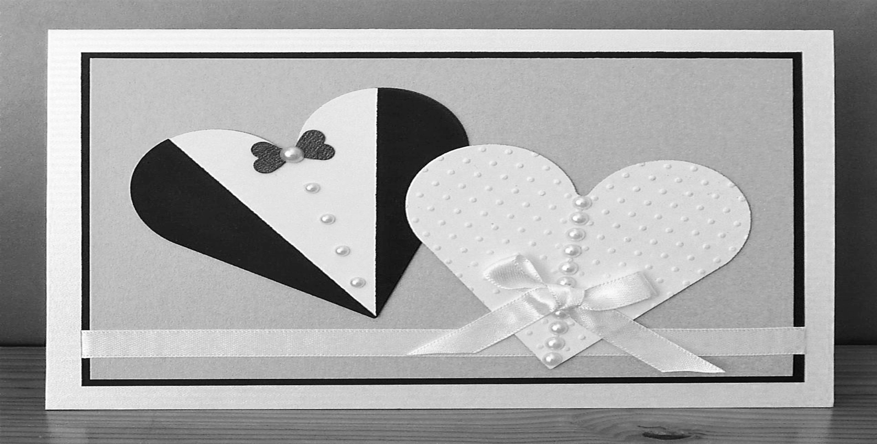Dear Tom and Jenny,

I wish you both a very happy marriage ever. Congratulations on your wedding. (37) ....

Monica

The blank can be filled with …. D. A. I’m really happy for you both.
B. I’m really upset with you both. C. I’m really curious with you both. D. I’m really interested in you both.

38. It’s December 25th. Some people are going to celebrate a special day. The suitable card is ….

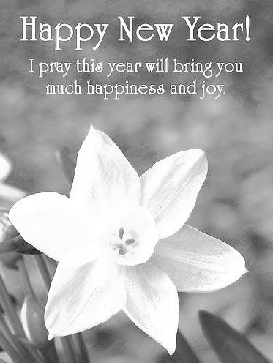A.

39. To : Mr. Anwar
We feel (39) … for your help. We are so lucky to have a neighbor like you as you can support us every time even if we are in the worst condition. Thank you for the help you always give us.
Mr. Agus and family
The suitable word for the blank is …. A. careful
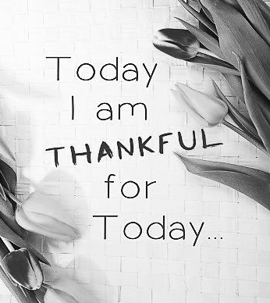B. B. grateful
C. wonderful
D. thoughtful

40. Dear Maya,
Congratulations on being the best student this year. I bet for sure you’ve done all things hard. (40) ….

Hasna
The best sentence to fulfil the card is …. A. You are the best.
B. You are the better.
C. You are the luckiest. D. You are just lucky.

II. URAIAN
Untuk soal nomor 41 s.d. 45, jawablah soal-soal berikut dengan jawaban yang benar dan jelas pada lembar jawab yang tersedia!

41. Complete the dialog below with the suitable expression!
Dian : Do you know that this COVID 19 outbreak is getting worse in this town? Shinta : Yes, I know that.
That’s why we must obey all of the health procedure issued by our government. Dian : The health procedure? What must we do?
Shinta : We must wear (a) _, (b) hand and keep (c)
Dian : I see.

42. This is the end of September. Students will have their mid-term test soon. What should they do to get good scores?

43. Write suggestions based on the problems! Number one has been done for you.

No | Problems | Suggestions
1 | I have a headache | You should go to the doctor.
2 | I want to go to Hendro’s house by motorcycle | (a) ............................................
3 | I failed my English test | (b) ............................................
4 | I feel boring at home | (c) ............................................

44. Fill the blank with the suitable words!

Dear Ana,

I’ve noticed your winning on the latest science competition. Please, accept my warmest (a) …. I
always believe that you are such a (b)... student. I’m really (c) ... of you.
Best regards, Sofia

This text is for no. 45

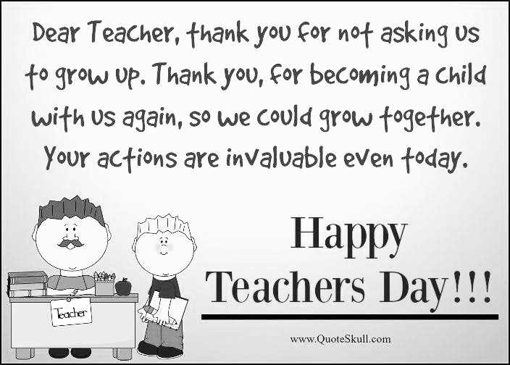

45. Complete the following statements based on the text above!
a. The card is about .....
b. The sender of the card is probably ….
c. The sender sends the card in order to ….

-----@%@-----

DOKUMEN SANGAT RAHASIA

UTAMA
03/U/PTSGs/VIII/20..

PENILAIAN TENGAH SEMESTER GASAL
SMP
TAHUN PELAJARAN 20../20..

KUNCI JAWABAN

Mata Pelajaran : Bahasa Inggris
Kelas : VIII ( Delapan )

I. PILIHAN GANDA
1. | B | 11. | D | 21. | B | 31. | A
2. | D | 12. | C | 22. | D | 32. | B
3. | B | 13. | D | 23. | D | 33. | B
4. | D | 14. | D | 24. | D | 34. | C
5. | C | 15. | A | 25. | C | 35. | B
6. | B | 16. | D | 26. | D | 36. | C
7. | C | 17. | A | 27. | B | 37. | A
8. | B | 18. | B | 28. | A | 38. | C
9. | D | 19. | A | 29. | C | 39. | B
10. | C | 20. | B | 30. | B | 40. | A

NORMA PENILAIAN : BETUL x 10

II. URAIAN

41. a. | a mask
b. | wash
c. | social distancing
42. They should study hard / Saran yang lain yang sejenis

43. a. You should wear a helmet / saran lain yang sejenis b. You should study harder / saran lain yang sejenis
c. You should still stay at home / You should watch TV programme at home / saran lain yang sejenis

44. a. congratulation b. smart / clever c. proud

45. a. a congratulation card b. a student
c. to congratulate her/his teacher in Teachers Day

-----@%@-----

